From New York to Seoul: Conversations with Princess Yi Haegyŏng
Juancho L. Baylon

I first met Princess Yi Haegyŏng, the granddaughter of Emperor Kojong, in New York City on November 26, 2005, a cloudy autumn day, wherein she shared with me personal stories from when she was a child raised in Sadong Palace¹ and during the time when North Korean troops entered her country’s capital more than 70 years ago.
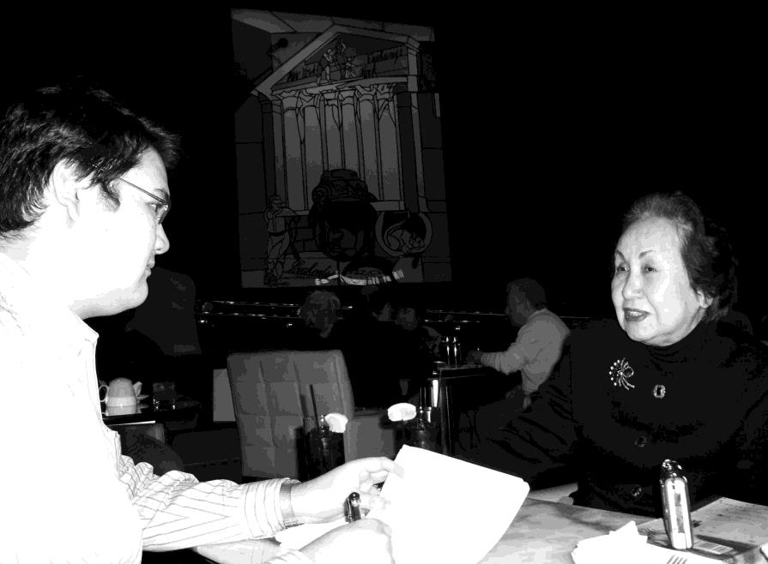
Juancho L. Baylon, left, interviews Princess Yi Haegyŏng in New York City, November 26, 2005.

During the interview over afternoon tea at the 35th-floor lobby lounge of the Mandarin Oriental hotel, with its sweeping view of Central

¹ Sadong Palace is nonexistent today. It was located across the street from Chogye Temple between Ujŏngguk-ro and Insadong. There is a marker commemorating the site of the palace.

Park, Princess Yi Haegyŏng was both thoughtful and graceful. Her regal bearing and refinement was palpable through the indelible mark of her royal upbringing.
Princess Yi Haegyŏng, born in 1930, is the daughter of Prince Yi Kang and his royal consort Kim Kŭm-dŏk, a lively, spirited and ambitious woman who was one of the prince’s many concubines. Kim Kŭm-dŏk was born in Hadong, South Kyŏngsang Province. She went to Seoul at the age of seventeen to pursue higher education as a nursery school teacher in one of the few colleges open to women. After graduation, Kim Kŭm-dŏk entered the male-dominated profession of selling insurance during the late 1920s. Being smart and enterprising, Kim Kŭm-dŏk thought she would be able to rake in huge profits if she could sell insurance to the royal family. She was able to coax the palace servants to allow her to enter Sadong Palace with her voguish ensemble: her eye-catching permanent wave hairstyle, dashing Western-style clothing and high-heeled shoes, all of which were uncommon for a woman in Seoul at that time. Once inside the palace, Kim Kŭm-dŏk caught the roving eye of the prince, who became smitten with her. Kim Kŭm-dŏk’s background was investigated promptly by palace officials, and once the prince found out that she had training as a nursery school teacher, he offered her a position as a palace governess with a lucrative salary that was much higher than what she was earning. It was not long before Kim Kŭm-dŏk became the prince’s consort, but unlike other concubines who only shared his royal bed, Kim Kŭm-dŏk and the prince engaged in recreational outdoor activities together like playing golf, horseback riding, and evading the palace servants and guards to sneak out through the back palace gate for some rest and relaxation as a couple outside the palace walls — a rare sight between a man and a woman in those days, and all the more so between a prince and his concubine. It was Kim Kŭm-dŏk’s maverick nature which made her attractive to the prince. However, the thrill soon fizzled out. In 1932, Kim Kŭm-dŏk went to Japan with their two-year-old daughter, Princess Haegyŏng, to confront the prince over his infidelity. Kim Kŭm-dŏk, with Haegyŏng on her back, berated the prince in front of his current mistress. The prince felt humiliated by being publicly rebuked in front of other people and was thus ‘dishonored.’ He immediately sent a telegram to his official wife, Princess Kim Su-dŏk, to take Princess Haegyŏng away from her birth mother once the two returned to Seoul from Japan, leading eventually to Kim Kŭm- dŏk’s permanent expulsion from Sadong Palace. Kim Kŭm-dŏk would not be able to see her daughter again for more than ten years. She would recall years later to her daughter that the three years she spent time with Prince Yi Kang in the palace were the happiest years of her life, and she

reminisced about the days she played golf with the prince and how her pet monkey would place all her golf balls in the hole.
It is Princess Kim Su-dŏk — the official wife of her father and the woman who raised her from early childhood to adulthood and instilled in her the virtues, etiquette and strict adherence of being a Confucian palace woman — whom Princess Haegyŏng refers to as her “mother.”
As a young girl in the palace, Princess Haegyŏng recalled how her father, Prince Yi Kang, would always mess up her hair while they were eating at the table as a sign of affection, saying she was a cute little girl. He also teased her, saying that he would marry her off to a Chinese man with braided hair and long fingernails who made dumplings. “My father enjoyed kidding me,” Princess Haegyŏng said.
Princess Haegyŏng described the vivid recollections told to her by her foster mother, Princess Kim, including the painful details that haunted Emperor Kojong, who would pace back and forth in his palace room all night long thinking about the fate of his country on the eve of the annexation of Korea to Japan in 1910. He had thought the United States was going to help him and Korea, but his plight went unnoticed.
Prince Yi Kang was against the annexation, and was a highly patriotic man and the first member of the royal family to be educated abroad in the United States. He made an attempt to escape to Shanghai in November 1919 in order to join the Korean Provisional Government, but his attempted escape was nipped in the bud by the Japanese authorities who placed him under house arrest in Sadong Palace guarded by police officers. Princess Haegyŏng also remembers the glass panels leading to the door of her father’s bedroom in the palace; she was told they were used by the Japanese police to closely monitor her father.
Queen Yun, the reclusive widow of Princess Haegyŏng’s uncle, Emperor Sunjong, was also very fond of the young princess. “Queen Yun lived a life controlled by fate,” the princess said. “She lived as an unhappy puppet in the palace and tried her best to survive, which I did not know at that time when I was little, but now I know because that is the history of the royal family. But I liked her personally and respected her so much.”
Queen Yun would ask Princess Haegyŏng to sing and dance at her private salon inside Naksŏnjae during family gatherings in Changdŏk Palace. She would then give her cookies and the expensive rotating dolls fashionable in the 1930s.
I also inquired about Princess Yi Pangja, the Japanese-born wife of her uncle, Prince Yi Un. “Every time I would visit Korea from the United States, I would personally visit her in Naksŏnjae accompanied by my sister-in-law, Princess Park Ch’an-ju, the wife of my brother, Prince

Yi U, who died in Hiroshima. Princess Yi Pangja would invite us for dinner afterwards at her private salon in Naksŏnjae. After that, every time I returned to Korea, I would visit her but it was always a formal visit. She was a very formal lady. Princess Yi Pangja came to New York a few times and we travelled together to Boston and Florida. My feeling towards her was always sympathy and that she tried her best to live her ‘given’ life.”
Princess Haegyŏng’s foster mother Princess Kim played a significant role in her life. “I was raised very strictly because my mother was teaching me all the etiquette of the royal family, yet she told me not to be a ‘royal’ too much. She always told me to be humble and not to emphasize that I am a princess when outside,” she said. “I was told to be the same as the other schoolgirls, not to act differently, yet I was treated differently. The palace ladies and servants would bring lunch and I would eat separately from my classmates, in another room.” When she came home from school, she changed into royal clothing and was taught calligraphy and ceremonial bows by her royal relatives in Unhyŏn Palace. Asked of her memories in the palace as a schoolgirl, she replied,
“It’s very hard to say because I hated it, but come to think of it, I had a very pampered life in the palace that a lot of girls do not have.” Princess Haegyŏng also recalled an instance she went over to the house of her schoolmate who was from a highly respected yangban family, and how shocked she was to hear her friend’s sisters’ language which sounded so crude to her royal ears; the yangban manner of speech was polite and refined but it was still very different from the inflection of speech, cadence, rhythm, intonation, emphasis and accentuation of the royal family.
Princess Haegyŏng was both active in school sports and in the arts and was thus offered a lead role by a Japanese film company, which made her foster mother Princess Kim furious and resulted in her putting her foot down, stating that the royal family was still the royal family. During the Chosŏn Dynasty, clowns and entertainers were seen as belonging to the dregs of society.
Contrary to popular belief, palace food was not that intricately prepared, though it contained more meat than what a wealthy family normally ate. Palace cuisine was bland in taste according to Princess Haegyŏng. She told me a little tidbit about her grandfather: Emperor Kojong had a disdain for spicy foods. The kimchi served in the palace was made from the white part of the cabbage only, even though vitamin C is mostly in the greens. The kimchi was so bland that her mother, Princess Kim, would always ask for the maids’ kimchi, stating that she grew up in the countryside and liked that kimchi better.
One incident that is painfully etched in her heart was during the

war. “I went out with my friend that day and we heard a crazy sound from the north, like a cannon or fighting sound. Everybody was so surprised. A few minutes later, we saw a lot of turmoil...a lot of trucks going to the north and people saying that war had started. My friend and I decided to go to a nice and fancy pastry shop to eat. We said to each other, ‘Let’s eat a nice cake before we die.’ We did not think anything serious then, since we were young.”
It was later at nighttime that the horrors of war sank in. “During nighttime, we could hear fighting sounds getting closer and closer. All of us got together in one room of the palace and we could hear North Korean tanks coming into Seoul. The next morning, I could see from the palace, a red flag being hoisted on the dome of the capitol building. I saw North Koreans with red armbands picking up and arresting people who were against communism around the city. It was a very terrible time. My mother wanted me to burn the family pictures right away and she wanted me to destroy all the medals and decorations that she and my father had. She did not want the communists to know who we were. ‘We would die if they found out,’ my mother told me. She did not want the same fate of the Russian imperial family happening to our family.” When things took a turn for the worse as the Chinese communists crossed the 38th parallel and were advancing toward Seoul, the royal family had to flee southwards to the United Nations perimeter.
Princess Haegyŏng narrated that as the communist troops entered Seoul, the palace became increasingly treacherous. She was able to secure two tickets to Pusan, one for her and one for her foster mother, Princess Kim. However, she gave the other ticket to her cousin who was also living in the palace at that time and informed that cousin to take Princess Kim to Pusan. Prior to the communist takeover of Seoul, Princess Haegyŏng had been a member of the United States Army Choir and was able to secure a ride to Taegu, and from there hitched a ride with a friend on a United States Army Convoy to Pusan. In Pusan, she found her father with Princess Kim and another concubine of her father’s in a tiny room there. Princess Kim suggested to Princess Haegyŏng that she stay for the night, but Princess Haegyŏng declined, opting instead to spend the night with school friends, whom she met in Pusan at one of the teahouses owned by the family of one of her friends. Her birth mother, Kim Kŭm-dŏk, found her the next day in Pusan and took her back to Taegu, where the princess found a job at a U.S Army post exchange, which later paved the way for an Army library position in Seoul.
Queen Yun was forced to abandon her decades-long life of seclusion in Naksŏnjae inside Changdŏk Palace and escape clandestinely.

It was said that the queen had to walk several hundred miles with her retinue of loyal palace ladies.
In retrospect, Princess Haegyŏng wistfully told me: “When things happen like that, you get a lot of guts you did not know you had.”
In 1956, a year after her father died, Princess Haegyŏng went to the United States to pursue her studies in a university in Texas on a scholarship. She has been a permanent resident of New York City for decades now.

Remarkable coincidence or fate?
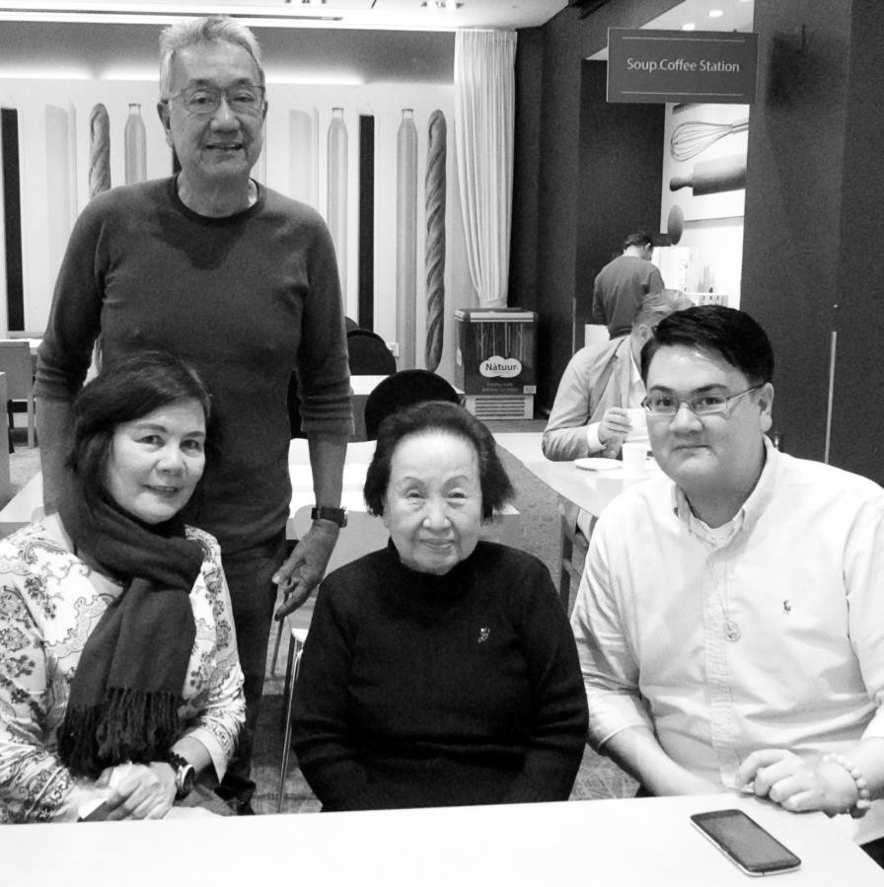
Juancho L. Baylon, right, with Princess Yi Haegyŏng, center, and his parents Manuel and Cecilia Baylon, during a chance encounter in Seoul, October 20, 2017.

In October 2017, I was on vacation in Seoul from Canada with my parents.

We were having a relaxing alfresco lunch on the open rooftop terrace at one of the ritzy art galleries in P’yŏngchang-dong on a crisp, sunny, autumn Thursday. One of our conversation topics was the life of Princess Yi Haegyŏng, whom I had the privilege of meeting in New York City almost 12 years earlier. Little did I know what jaw-dropping surprise awaited me the next morning, October 20.
As I was having my breakfast at the lounge area of the hotel where my parents were staying in the Chongno area, in walked a lady very familiar to me: It was Princess Yi Haegyŏng herself! What a remarkable surprise. I had no inkling whatsoever that she was also in Seoul in the very hotel where my parents were billeted, and that we would meet again almost 12 years later — from New York to Seoul. No plans. No anything. It was only later, when my parents and I said hi to her as she was sitting with her other companions, that Princess Yi Haegyŏng informed us that she was in Seoul for a short vacation from New York to attend a school commemorative event. Yes, she still remembered me. Her memory is still excellent for her age. She said to me in parting: “It is because of fate that we meet again.”

Juancho L. Baylon was born in Bacolod City on the Philippine island province of Negros Occidental. He first started writing for the student newspaper Green Beacon of the University of St. La Salle. He has a double degree from said university: Bachelor of Science in Commerce Major in Business Management and Bachelor of Science in Nursing. He is presently living and working in Calgary, Alberta, Canada.

