ROYAL ASIATIC SOCIETY KOREA

President’s Annual Report for 2021
Our immediate past president, Brother Anthony of Taizé, who served five consecutive two-year terms — the longest in our 120-year history — passed the metaphorical gavel to me at midnight on December 31, 2020. On January 1, 2021, my first act as president was to grant Brother Anthony the status of President Emeritus. He’s a tough act to follow. All the officers and councilors of RAS Korea are delighted to honor his service in this way.
We are grateful that Asia Development Foundation renewed our grant for the third year. We thank our program coordinator, Dr. Joanne Hong, for her dozens of hours of work writing grant reports and proposals, doing budgets, and working with the ADF staff.
Late in 2021, glimmers of hope for emerging from the pandemic were dashed with overwhelming spikes in COVID-19 infections, hitting record levels of severe hospitalizations and deaths. Excursions and the annual garden party were put on hold for the foreseeable future. We continue to conduct our lectures, literature club, and colloquium online.
We welcomed Jenny Byun to our team of volunteers. Jenny became the literature club coordinator early in the year. She has studied abroad and brings a delightful perspective to our readings and discussions. We thank Hong Yonjoo for her many years of faithful leadership.
We had a full schedule of lectures that included lecturers worldwide during the year. The internet has allowed us to expand our potential lecturers and increase our global attendance. We’ve had attendees from Britain, the USA, Australia, India, Indonesia, Pakistan, Italy, France, Germany, China, Japan, several places in Eastern Europe, and attendees in other parts of Korea who would not otherwise be able to join us in Seoul on Tuesday evenings. Several editions of the colloquium were conducted, and the literature club met monthly, considering a wide variety of books and short stories.
We enjoyed a renewed relationship with the “mother” organization, the Royal Asiatic Society of Great Britain and Ireland. An intern at the RAS library in London launched a project to make a comprehensive database of RAS Korea’s lectures and excursions. Ms. Min Jung also made an index of the “Korean Mission Field,” a missionary journal published between 1905 and 1941. Many of the early Korean studies greats are published in that journal. Edward Weech, the Society’s librarian, coordinated Ms. Min’s work. We are grateful to them both.

Weech also invited RAS Korea to take part in its blog.
We thank Ms. Park Ji-Young, one of our office volunteers. RAS Korea inherited an extensive collection of color slides of Korean Buddhist temples and art taken by the late Dr. Jon Carter Covell. The collection of more than 2,000 frames has been digitized and organized electronically by Ms. Park. Her work took several months. The next step will be to make the slides available online, which may take a few more months.
We were deeply saddened by the sudden death of long-time RAS member, councilor, and past president Peter E. Bartholomew. Bartholomew and I shared many long conversations about Korean history and shared experiences of having arrived in Korea during the Park Chung- hee era. Bartholomew’s passion for traditional Korean architecture made him famous. He almost single-handedly took charge of all the red tape about 20 years ago when the organization needed to formalize its registration with the government, draft new articles of incorporation, deal with banking, tax matters, and myriad other tasks.
RAS received Bartholomew’s Korea-related collection of several hundred books, which Ms. Park is helping our librarian, Prof. Michael Welles, process. Bartholomew also had an extensive slide photo collection that will be digitized. He also kept copies of RAS Korea newsletters (when we used to use paper and the post office) that will also be digitized.
In July, three RAS council members traveled to Dongducheon Foreign Language High School (DFL) to meet with the RAS Dongducheon branch. I was joined by council members Matt VanVolkenburg and Jon Dunbar. We enjoyed meeting the principal of the school, the head English teacher, and the officers of RAS Dongducheon. Due to COVID-19 restrictions, the attendees were limited to about 60.
Ms. Shin Suhyeon, a senior at DFL, served as RAS Dongducheon president for 2021. She is interested in Korean history and culture and will take the DFL branch into its third year. Suhyeon is from Uijeongbu. She is majoring in English with a minor in Japanese. She hopes to major in English literature at university but is interested in working in a field to help promote Korea.
I was invited to interview at two Korean language radio stations in Seoul during the summer. I was asked about our late president Peter Bartholomew, RAS Korea, and our work. The Traditional Music Radio station had me for a live interview, while the Buddhist Broadcasting Service did two half-hour prerecorded interviews. RAS is always grateful for opportunities to network with others.
In October, as RAS Korea president, I was invited to give a lecture to the Jeju-based campus of Korea International Middle School. More than

200 students, gathered in their classrooms and connected by the internet, spent about an hour discussing the importance of Hangeul as we commemorated the annual holiday for October 9.
In mid-November, I lectured on Korean banknotes to an audience in Gwangju, organized by the Gwangju International Center (GIC) — an organization with similar goals as RAS Korea. Jon Dunbar, a RAS council member, had been invited to speak a few months earlier, and he suggested that I might do so, too. As the folks from GIC and I talked, they told me they hoped more RAS lecturers would share their expertise with them. I asked several to get engaged further.
Our annual holiday book sale on the first Saturday of November was an enormous success. Hundreds of books found new homes, where we hope they will bring joy and interest for years to come. We were honored to have Brother Anthony autograph his new book of translations of St. Andrew Kim’s letters, and Woosung Kang personalized his Korean Cultural Dictionary. To top it off, Brian Park, a member from Jeju, came to Seoul with his personalized roasted coffee beans and four of his tea and coffee students to be our on-site baristas for the morning. Park is the chair of the International Beverage Education Foundation.
In late November, we were introduced to former RAS General Manager Sue Bae’s hidden artistic talent at her first solo exhibition in Insadong. Although she studied fine art in university, her first job was with RAS in the late 1960s. As RAS continued to grow through the 1970s, Sue married, raised a family, and before anyone realized it, she had been running RAS for more than 40 years. After retirement, Sue decided to take up the brush again a few years ago. She exhibited more than 40 landscapes and floral paintings. What a delight to see another side of Sue’s passion.
President Emeritus Brother Anthony was chosen to receive the annual Dosan Ahn Chang-ho education award this year. Although Korean by citizenship, Brother Anthony is the first non-ethnic Korea to be honored. Dosan Ahn Chang-ho is one of Korea’s most important independence advocates who was active in the early decades of the 20th century. A foundation in his honor was established decades ago and has been honoring select individuals who have contributed significantly to Korea’s development in various fields. As the most prolific translator of Korean poetry and other literary forms, Brother Anthony has made a significant contribution. In his acceptance speech, Brother Anthony dedicated his award to RAS Korea. We are honored.

Rev. Steven L. Shields, President
December 31, 2021

ROYAL ASIATIC SOCIETY KOREA

Librarian’s Report for 2021
We lament the passing of our fellow council member and former RAS Korea President Mr. Peter Bartholomew, whose estate has bequeathed to us his massive library, which includes several rare and first edition texts. It will take us the better part of this year to sort and process our new acquisitions. In fact, we have removed all the duplicate editions of texts in order to better accommodate Mr. Bartholomew’s books.
We regret that, due to space limitations, we are unable to set aside a separate area for a Peter Bartholomew Memorial Library, but Reverend Shields has kindly made Ex Libris bookplates to identify each of the books from Mr. Bartholomew’s estate.
We are pleased to report that, as of February 2022, the RAS Library currently has over 3,500 items. We welcome any additional contributions from our members to help our collection grow. The library catalogue can be found at www.tinyurl.com/RASKB-Library.
If our members have any books of interest that they would like to donate to the RASKB, please contact me at the address below or contact our office manager at royalasiatickorea@gmail.com.

Michael T. Welles
Librarian Royal Asiatic Society Korea mtwelles@gmail.com

ROYAL ASIATIC SOCIETY DONGDUCHEON

President’s Report for 2021
This report will summarize what Dongducheon Foreign Language High School (DFL) branch of RAS Korea did in 2021. Two main activities took place. First, we hosted a lecture, and second, we chose officers and team members for the 2022 academic year.
In 2020, lectures could not be conducted because DFL strictly restricted visitors due to COVID-19. But for 2021, despite the continuous rampant spread of COVID-19, we wanted to provide students with various experiences. So, we proceeded with thorough quarantine guidelines. On July 9, 2021, a lecture event was held for about two hours from 2 p.m. Steven L. Shields, Jon Dunbar, and Matt VanVolkenburg visited DFL. Steven L. Shields explained the history of the Royal Asiatic Society as well as the history of the Korean Peninsula, especially the Daehan Empire. Jon Dunbar gave a lecture on North Korean food. The theme of the lecture by Matt VanVolkenburg was “Popular Music and Youth Culture in the 1970s.”
Steven L. Shields’ lecture reminded students of how historically important RAS Korea is. As a compère, there is something I said at the beginning of the lecture. “Thank you for studying Korea from the perspective of foreigners for a long time. It is a great honor to be part of the long history of the Royal Asiatic Society Korea Branch.” As the Korean Peninsula has experienced a lot of incidents in modern times, there was a high possibility of having a historical gap. However, RAS Korea filled this gap and we felt grateful for that. In the case of Jon Dunbar, he gave a lecture on North Korean studies the year before last, but this time he introduced North Korean food. North Korea is geographically the closest country to us, but at the same time, it is also the farthest in some ways. It is difficult to learn about North Korea in our daily lives, but thanks to Jon Dunbar's lecture, we were able to learn about North Korean food. Through the lecture of Matt VanVolkenburg, students were able to learn about many Korean songs, pop songs, and their reasons for being censored during the military regime of the 1970s. After the lecture, we divided into small groups and had time to share questions. I walked around and took pictures of them. Almost half a year later, I still cannot forget the eyes of the students who were shining in Q&A time.
My last activity as president in 2021 was to elect new members.

The president for 2022 is Kim Min-Jae, a senior majoring in Japanese. Seven members, including the president, were selected through interviews. Until now, DFL branch was organized only with the third graders. However, since the second graders were not able to see a lecture due to COVID-19, first graders with experience in lectures were also recruited. We tried to select people who can commit to a study of Korean history and culture. There were many opinions such as making an English magazine and holding a Night for History and Culture. In particular, incoming President Kim Min-Jae said she wants to explore Korean literature. It is expected that a deep understanding of historical events will be possible if the new members explore the literature on the Korean Peninsula, which has undergone many wars and invasions since the founding of Gojoseon.
It was an undeserved honor to be able to lead the DFL branch for one year in 2021 and to be with RAS Korea. Expecting that there will be more colorful 2022 RAS DFL activities, I would like to wrap up my role as president for 2021.

Shin Suhyeon RAS Dongducheon President, 2021 Academic Year Dongducheon Foreign Language High School

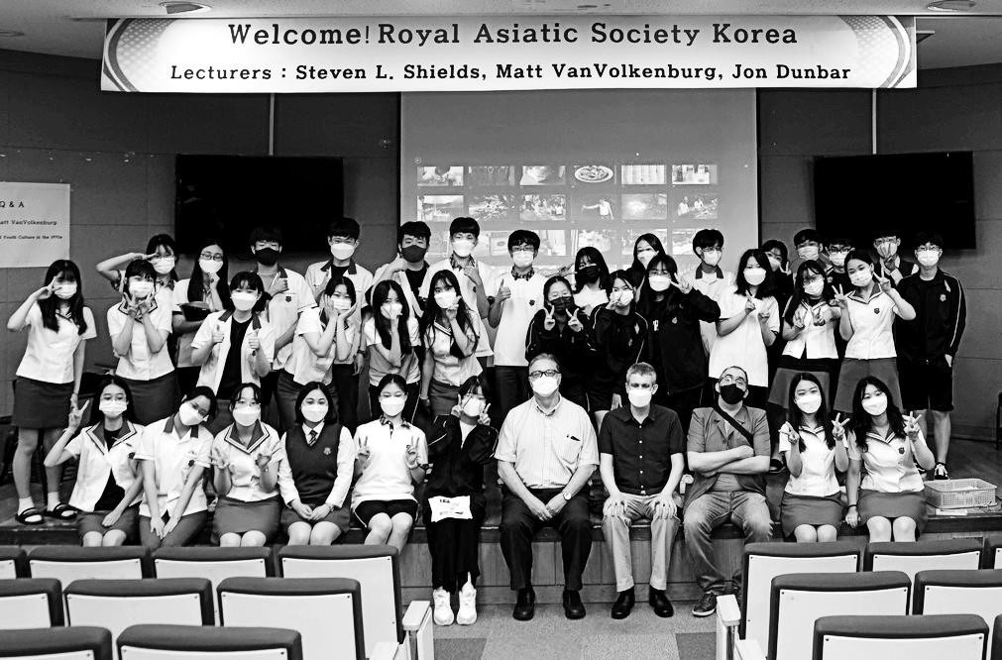

RAS Korea Lectures 2021
January 12: Michael Seth, North Korea – A Failed Revolution if not a Failed State January 26: George Kallander, Years of Living Dangerously: The Diary of 1636
and the Manchu Invasions of Korea
February 9: John Everard, North Korea – The Conundrum with a Human Face February 23: David Tizzard, K-Pop and the Korean Wave: Deconstructed
March 9: Martin Limón, G.I.s in the Morning Calm: The American military in Korea, 1968 through 1986
March 23: Sujeong Lee, Reading Korean Buddhist art is ‘easy peasy lemon squeezy’
April 13: Robert Fouser, Ondol Goes to America: Frank Lloyd Wright’s Korea- Inspired Dream
April 27: David A. Mason, Four Golden Ages: A Study of Korean History and UNESCO World Cultural Heritage Sites
May 11: Pierre-Emmanuel Roux, From Clandestine Go-between to Superstar: The Life and Afterlife of Fr. Andreas Kim Taegeon (1821-1846)
May 25: Thomas Duvernay, Sinmiyangyo Sesquicentennial: The 1871 US-Korea Military Conflict After 150 Years
June 8: Ágota Duró, The South Korean atomic bomb victims’ seven-decade quest for recognition assisted by Japanese grassroots circles: A comprehensive study
June 22: Kim Chung-bae, Strategy between city development and heritage conservation: from passive conservation into active use
July 13: Seulkee Nam & Cameron Pyke, A Passion for a Worthwhile Life – Yi Pangja’s social welfare work in Korea (1963-1989)
July 27: Steven L. Shields, Money, Money, Money: Korea’s History Through its Banknotes
August 10: Ryan Berkebile, The Bulldozed Future: Exploring Korea’s Urban Redevelopment
August 24: Brother Anthony, An Adventurous Life: The Journeys of St. Andrew Kim Dae-geon seen through his Letters
September 14: Becky White, Remember Half-Koreans Like Us Existed September 28: Jon Dunbar, Dingy Basements: Human and Environmental Factors
of Korea’s Live Music Venues
October 12: Vladimir Hlasny, Jaroslav Bařinka: Reflections on Czechoslovak- Korean Cold-War Encounters
October 26: Fyodor Tertitskiy, The unknown stories from the first weeks of North Korea’s history
November 9: Christopher Roberts, British Extraterritoriality in Korea November 23: Kongdan Katy Oh, North Korea in a Nutshell
December 14: Rob York, The Status Quo and its Discontents: The legacy of Donald Trump’s “America First” and the future of the US-Korea relationship

Business & Culture Club 2021
March 9: Where is the center of Seoul? Jun YK Shin
April 13: Deoksugung Palace in spring time, Jacco Zwetsloot
May 11: 'Gojong’s Road': a walk around the outside of Deoksugung Palace, Jacco Zwetsloot
June 15: Gwanghwamun Plaza Renovations, Jon Dunbar November 16: Sewoon Urban Regeneration, Jon Dunbar

Colloquium 2021
March 25: Instrumentalizing Cartographic Voids and Visions in Neo-Confucian Choson and Renaissance France (15th-16th centuries), Jérémie Eyssette
April 22: Korean artists in France: Why they went there and what they did there, Mael Bellec
June 10: Korean Poetry and Fiction in English Translation: A Personal Survey, Brother Anthony
September 9: Kim Tschang-Yeul (1929-2021), an asceticism caught in the turmoil of history, Simon Kim
November 18: The Iconography of Justice in Korea: Historical Analysis of a Hybridization Process, Christophe Duvert

Literature Club 2021
Hosted by Jenny Byun & Brother Anthony
February 18: “Vertigo” by Kim Se-hee
March 18: “Almond: A Novel” by Won-pyung Sohn April 22: “Loving” by Jeong Ho-seung
May 20: “Hwangt’ogi” by Kim Dong-ni June 17: “Tower” by Myunghoon Bae
July 22: “Bluebeard’s First Wife” by Ha Seong-nan; Trans. Jane Hong August 19: “Birth of a Rat” by Kim Soom; Trans. Brother Anthony September 23: “Untold Night and Day” by Bae Suah; Trans. Deborah Smith October 28: “Castella” by Park Min-gu; Trans. Sora Kim-Russell November 18: “No one writes back” by Jang Eunjin; Trans. Jung Yewon

Special Events in 2021
July 1: First-ever release of Seoul Jeong-dong Audio Tour by Matt VanVolkenburg
July 3: English Essay Competition Ceremony
July 9: RAS Korea – RAS Dongducheon Special Lectures with Steven L. Shields, Matt VanVolkenburg, Jon Dunbar
November 6: RAS Korea Book Sale

Walking Tours in 2021
Due to the pandemic, no walking tours were scheduled.

