RAS After Dark
Jon Dunbar

RAS Korea has started holding in-person lectures again, after more than two years off due to the pandemic.¹ It was the responsible thing to do, especially considering the health condition and advanced age of many of our life members. But as much as holding lectures virtually on Zoom introduced new advantages, including the ability to invite lecturers and listeners based around the world, it’s good that RAS Korea is resuming meetings in one room again.
For our first lecture back, a hybrid lecture held on May 24 in the ground floor of the Christian Building where the RAS Korea office is located, a considerable amount of effort was put toward finding a suitable place for a “duipuli” (afterparty) or “2cha” (second place). Dr. Joanne Hong, our office manager, apparently found a suitable makgeolli place nearby, which our President Steven L. Shields reported was “easy to get to and the staff there were good, the food was good, and there was wonderful conversation around the table until the wee hours,” adding that he caught the second-last train of the night and arrived home at 12:30 a.m.
When I started going to RAS Korea lectures in early 2011, at some point within that first year, I realised that the fun didn’t stop when the lecture ended and all the Q&As had been Qed and Aed. After, there would be some quick socialising as we all delayed clearing out of the Somerset’s second-floor lounge, and then many of us would wander off to a nearby restaurant for drinks. In fact, even if the lecture was a total flop, I could sit through it because I knew it would make for entertaining conversation fodder afterwards.
The afterparties were a chance to bump elbows with Korean studies scholars I’d previously thought would be unapproachable, outside

¹ The last in-person lecture was held at the Somerset Palace on Feb. 11, 2020, by James D. Hillmer, titled “Punishing the traitor, producing the citizen: South Korean prison reform 1945-61”

of maybe office hours at some university office. All those who stuck around were clearly getting something out of it, whether it was food or drink (sometimes lots of drink), or a chance to discuss and digest the contents of the night’s lecture, or to catch up with friends, or just to speak English to someone. The diversity of participants was often remarkable, and you could meet people of all ages, from teenager to geezer, from all walks of life, all corners of the world, all ideologies, religions, races.
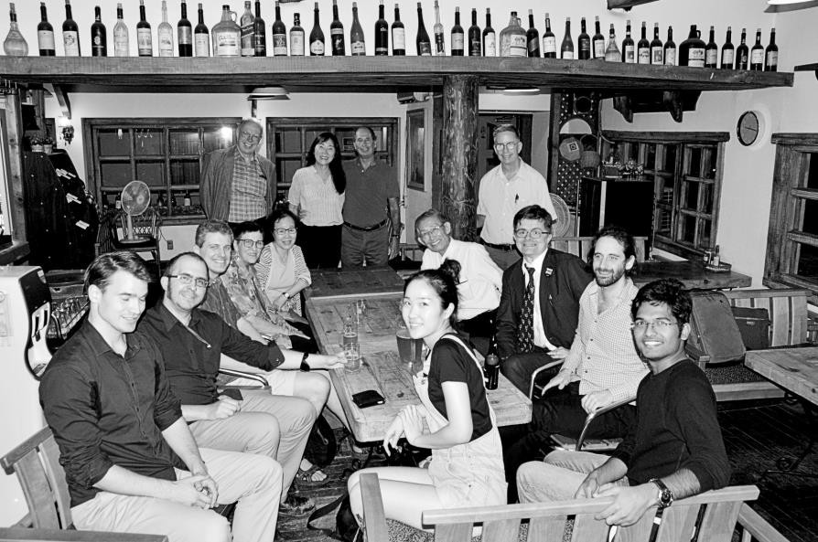
Figure 1. An average-sized group, on June 28, 2016.

In one of my favourite anecdotes, we met a Peace Corps volunteer from the early 1970s who was visiting for a Friends of Korea event, co-organised by RAS Korea Vice President Suzanne Crowder Han. Below is my recollection of our conversation:

Me: What are you doing in Korea?
Guy: I served in the Peace Corps here in the early 70s. Friend: Did you know Suzanne?
Guy: No there were thousands of us.
Me: Did you know Peter [Bartholomew]? Guy: Yes! He trained me!
*phone rings*
Me: Hold on someone is calling me. Hello? Peter: Jon I have a question about cats.

Some of my elder colleagues on the Council have stressed the need to present RAS Korea’s image as fresh and new. But as one of the younger Council members, I have urged them to see it from our perspective: we don’t get many opportunities to socialise with elder non- Koreans and long-term foreign residents, and doing so gives younger attendees a feeling of home and of continuity. These afterparties were also a great venue for networking, and I believe I’m not the only one who owes at least one job, including my current position, to connections made and fostered at what I’ve come to call RAS After Dark.
A study into RAS After Dark’s previously ignored history quickly became a look back at RAS Korea’s prior lecture venues, in an attempt to link these venues with nearby nightlife. This was not easy, as no one seems to have considered it useful enough to record lecture venues throughout the decades. With help from long-term members and newspaper archives, we were able to reconstruct a loose timeline of lecture venues (Appendix 1), but no one had memories specifically of going out afterward, especially as a routine thing.
As best as anyone can remember, RAS After Dark didn’t start until sometime after lectures moved to the Somerset Palace, which happened in 2008. Our go-to restaurant was Jacob’s, a quaint little mostly Italian restaurant located in the alley behind the Somerset. It was a rickety old two-storey building, with wooden floorboards that sometimes felt like they might give way. When it got too crowded, they would move us up a narrow staircase to a second-floor space. The food menu was mostly pasta and other Italian-inspired fare, all well-priced. I particularly liked the lasagna, and I tried to make it catch on to shorten the word to “gna” (pronounced “nya”). There was also a good wine selection and they served draught beer, but it was lacking makgeolli.
The thirst for makgeolli would sometimes lead some of us to a 3cha after Jacob’s closed, usually a makgeolli bar over in Insadong or farther. These included Pureun Byeul (Blue Star), Nuruk Namu (Yeast Tree), Unni Sarangbang, and Chuang Tzu’s Butterfly, all of which were located in Hanoks. Sometimes we would encounter musicians at these places and be treated to a performance, including one time some spontaneous pansori singing at Pureun Byeol. Another time that only I seem to remember, I believe at Nuruk Namu, we were treated to a Daegeum Sanjo performance, but it kept going on and on longer than our patience could last. Once in 2015, we ran into a group of Korean punks at Pureun Byeol, and ended up drinking beer on a nearby rooftop.

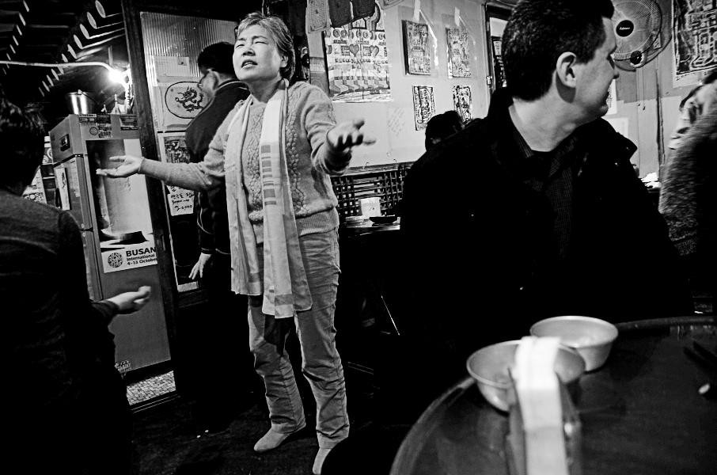
Figure 2. A woman sings pansori at Pureun Byeol, March 13, 2013.

For years, our ritual was to attend lectures at Somerset followed by food and drinks at Jacob’s, which we treated as our own personal RAS clubhouse. Brother Anthony and Jang Song-hyon typically treated the lecturer of the day to a meal at Jacob’s before the main event, and after walking by and observing them there, I got into the habit of joining them too. While I and likely many others associated these places with RAS Korea, this was only the result of circumstances subject to change. And then in 2017, a For Sale sign appeared in the window, which left us wondering. One day, Brother Anthony and I were having dinner at Jacob’s prior to a lecture, when a middle-aged woman we’d never seen before bussed our table. She was taking great interest in the workings of the restaurant and our satisfaction there, and she introduced another woman as a prospective buyer of the place. It turned out that Jacob’s owner had throat cancer and was in the hospital. I believe we sent flowers or something to the former owner on behalf of RAS Korea. Jacob’s closed down and underwent renovation. When it reopened, it looked classier, but it was no longer the cramped little Jacob’s we knew, with tables we could push together. We never went back. The restaurant there now is called Gyeongseong Chicken.

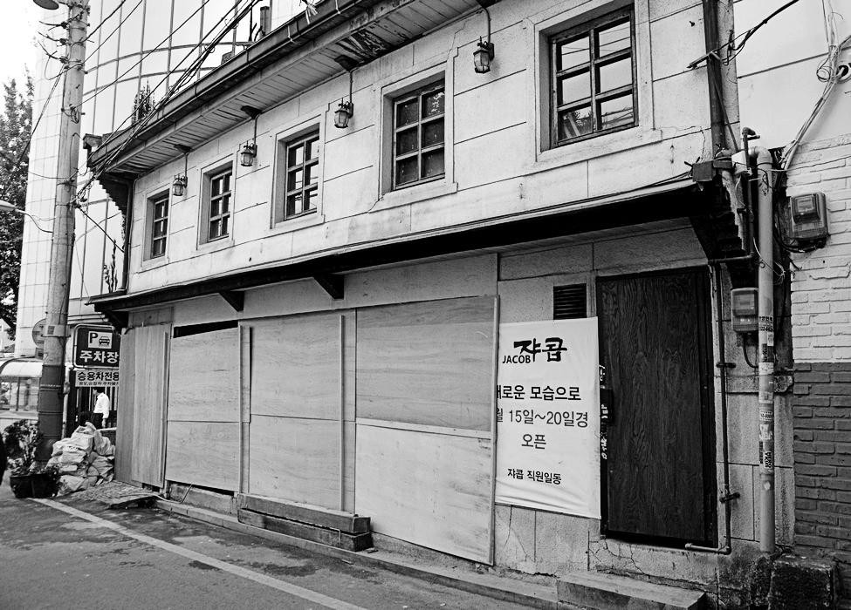
Figure 3. Farewell to Jacob's, which is seen boarded up on May 10, 2017.

After Jacob’s, we tried out a series of other restaurants also on the same alley. It had to be somewhere close by and easy to find, because there would always be new people who would need directions. Typically Brother Anthony, RAS Korea president at the time, would end lectures by inviting people to go out drinking afterward, and people would mingle in the room a while longer, as some were ready for RAS After Dark, while some needed some convincing, and others weren’t going and it took a while to say goodbye. So we would trickle into the afterparty venue, rarely showing up all at once, which made it tough to estimate our numbers until the slowest people arrived.
The first new place we tried was Pumasi, a makgeolli place that served our tastes just fine. It was cramped, even moreso than Jacob’s, and I recall the washroom being extremely difficult to use. But after a few months there, it was changed into a Japanese-style izakaya, and so we moved on.
Next we went to Jeon-seonsaeng Gyodong, a makgeolli bar in a two-storey yellow building across the street. Its menu was also fine, but the space was limited and our group usually ended up getting separated between the two floors, which was quite disappointing.

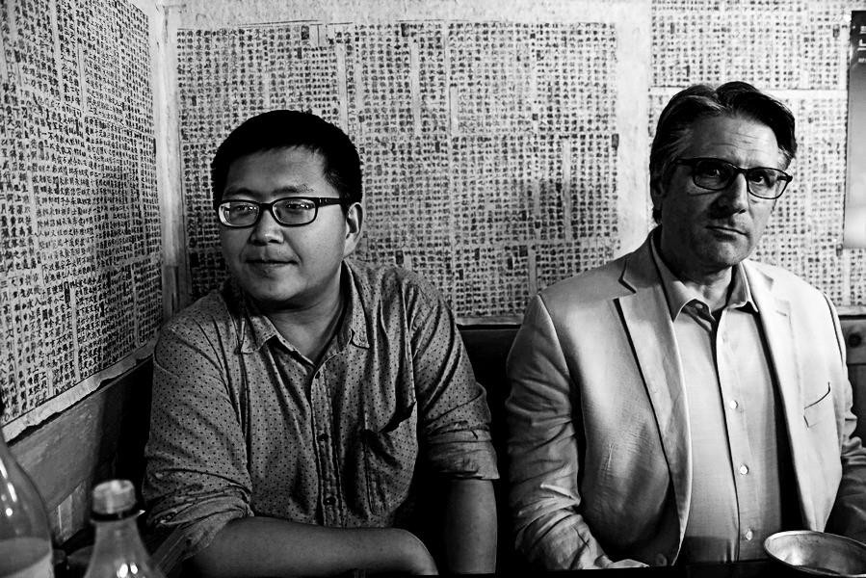
Figure 4. Crammed into the backroom of Pumasi, Oct. 17, 2017.

And that led us to Morang, a hipper basement bar serving makgeolli, draught beer, and a pleasing food menu. It had big tables and rarely was that crowded. Plus the washrooms were usable, and there was an elevator down to the basement for those of us who preferred not to brave the stairs. Morang was RAS After Dark’s preferred afterparty venue, right up until the pandemic ended in-person lectures at the Somerset.
We also had RAS After Dark following other events, such as excursions, book sales, the Garden Parties, and even Council and committee meetings. I began adapting my walking tours so we would make a point of ending up at a particular restaurant or bar of note.
After I led a Songdo tour in 2015, we went to The Cinder Bar, where we saw a performance by a bluegrass band. A pretty surreal experience in the middle of Korea’s most futuristic dystopic city.
When I do Hongdae tours, we always end up at Duriban, a restaurant that had been the center of an eviction struggle, resulting in a sit-in protest lasting over 520 days. Its former location is a prominent part of the tour, and so it’s natural we end up where it relocated. Of course, it being Hongdae, I make sure there’s a concert we can go to after. In 2018, I took a group including the EU ambassador to Prism Live Hall to see a reggae and ska concert. And in 2022, I accompanied Michael Duffy, an Irishman, to Club FF for their St. Patrick’s Day concert, the highlight of which was the all-Korean “Irish” punk band Daddy O Radio.

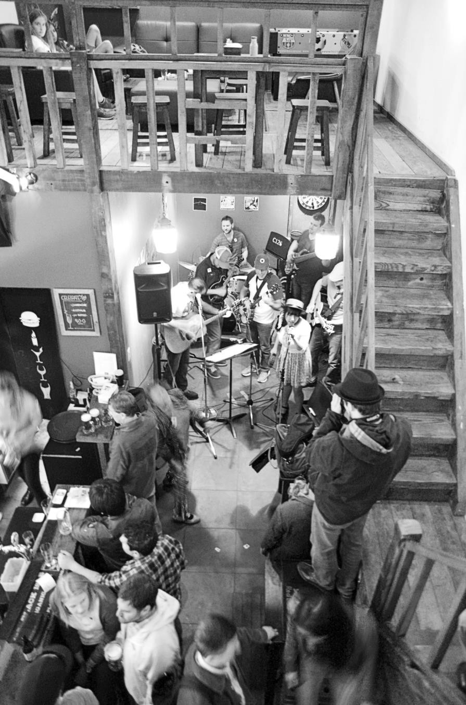
Figure 5. John Patrick Starling’s bluegrass band plays at The Cinder Bar in Songdo, April 25, 2015.

When Professor Boudewijn Walraven and I led an excursion to Sungkyunkwan for the Seokjeon Daeje Confucian ritual, we were invited along with the Confucianists to the basement of Yurim Hall next door, where we were served Korean food and charyeju, the rare traditional alcohol served during rituals.
After our first visit to Dongducheon Foreign Language High School in 2019, I went alone after to check out the ville in Bosan-dong outside Camp Casey. I ended up in a restaurant serving pizza and burgers, and while I ate, I overheard a group of English teachers talking nearby. Soon, I realised they were talking about me, as they were DFL teachers and one of them had been there for my lecture on North Korea.
The weirdest place we ended up for RAS After Dark was after a visit to Kyung Hee University’s Museum of Natural History in 2016. We went to Chicken Toilet, a toilet-themed chicken hof where the food is served in squatter toilets. The novelty wears off quick, although the chicken was pretty good, served with a curry dipping sauce placed on a mini porcelain squatter. Unfortunately it’s now closed.
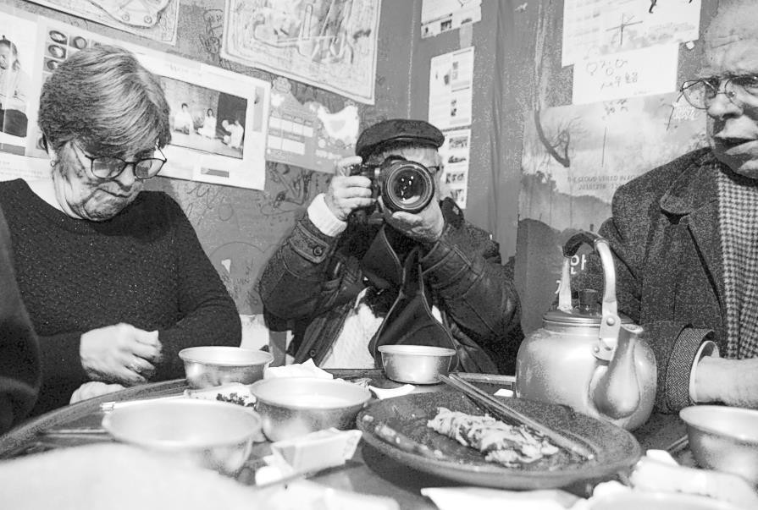
Figure 6. A feast at Pureun Byeol, Dec. 15, 2015.

At the end of a meal, or just when people started to leave, it was necessary for someone to take care of money. Nobody wanted to be the last one there, suddenly having to foot the bill. Typically one person would find themselves suddenly in charge of collecting all the cash and making

sure the bill gets paid, and sometimes that would be me. Often people would just throw in some cash rounding up to the nearest 10,000 won, and most of the time it fell to one person to collect all the money. At times when I was in charge of paying the bill, I would find that people had given me too much money, and I ended up collecting the surplus, which would either find its way back into my wallet or be spent at the 3cha.
This country has a strong afterparty culture, buoyed by a vibrant nightlife with many different places to go for food and/or drink even late at night, although our events are a little different, probably due in large part to a lack of soju, not to mention a strict social hierarchy. Through RAS After Dark, we have learned – and probably forgotten – a great deal about Korea, its food and drink culture, and each other. Everyone who has joined probably has interesting memories, and I would like to keep gathering information on where this has led.
As society is starting to return to normal, we have been cautious about resuming in-person gatherings, especially in consideration for the many older members. There was talk of continuing to offer virtual lectures, or hybrid lectures that are in person but broadcast online, but Brother Anthony articulated our thoughts perfectly:
“I have a strong feeling that RAS Korea can only continue to survive with identity and life if it has at least twice a month a physical event bringing members together socially, since the interaction before and after the lecture is essential to a sense of belonging. It is often even more appealing and significant than the lecture itself. The RAS comes alive when we pour makgeolli for one another afterward, not when we see a name in the side column of a Zoom screen.”

Jon Dunbar is the self-declared “president” of RAS After Dark. He is also general editor of this journal and an RAS Korea Council member. He would like to thank everyone who helped gather information about past RAS events and what happened afterward.

Appendix 1: RAS Korea lecture venues

1959-62: lectures were mostly held at Korea House, where dinner was served.
1960: one lecture was held at the Cheil Bank auditorium.
1961-70: lectures were at the National Medical Center located at Euljiro 6-ga. For after a 1963 lecture, attendees were welcomed to the Scandinavian Club next door, where refreshments were served. This has been described as a “huge gated compound with a lot of free parking,” and it was well-known for a smorgasbord on Wednesday evenings.
1971: lectures were held at The Korea Times/Hankook Ilbo building auditorium, across the street from U.S. Embassy Compound 2, which made it easy for embassy personnel and their families to attend. In James Wade’s “Scouting the City with Alf Racketts” column in The Korea Times, dated March 27, 1971, shortly after the lecture venue had moved here, he talks of the “extremely crowded and awkward situation of the lobby used for the coffee- and-chat sessions after the program.” He suggests this is intentional on the part of the Society, “to expose members to the publication display, sales from which have become a vital part of its revenue, for as long as possible.” He also mentions that the previous meeting place was about 100 yards from the nearest “kaffee-klatsch.” Unfortunately, we know little more. It is unclear when RAS Korea left this location.
Sometime between late 1970s and mid-1980s: lectures appear to have been held in the Chosun Hotel ballroom on the top floor.
1990s: lectures had been hosted at the British Council for a time.
Early to mid-1990s, possibly until 1999: lectures were at the Daewoo Foundation Building.
After that, not sure when: lectures were held at Goethe-Institut, which I’m told was a pretty inconvenient location, and people generally went home right after.
2000s: for a few months, lectures were in a basement auditorium of the KOIS building, what is now the KTO building.
2000s: lectures were in an auditorium at Sogang University for a few months.
2008: lectures moved to the Somerset until 2020.

