‘What is a Dragon, Really?’

Fred Jeremy Seligson

The dragon is the great mystery itself.
He is the spirit of Change, therefore of Life itself
- Kakuzo Okakura, The Awakening of Japan (1905)

The dragon is the emperor of all things.
- M. W. De Visser, The Dragon in China and Japan (1913)

Whatever is excellent the Korean compares to the divinely, virtuous Dragon.
- Ernest Ingersol, Dragons and Dragon Lore (1928)

The elements of the idea of the dragon are the snake of the earth and the stars of heaven. From the relationship of the snake in the water and the stars in heaven, an idea evolved that the dragon is a god which sends down rain; hence the dragon occupied an important position as an agricultural god and it became an object of worship of the mu-dang (shamans) who officiate at the rain-prayer rites. Gradually, such a belief in the dragon-god in Ancient China, together with the Chinese farming culture, was introduced into Korea.
- Ryu Tong-shik, The History and Structure of Korean Shamanism (1975)

2012: One afternoon, I visit Dr. Yoon Yeol-soo, curator of the Gahoe-dong Folk Museum, and ask, “What is a dragon, really?”
“Of course, it’s a creature of fantasy.”
“Yes, for you and me. But what about for others who say there is a dragon and truly believe it?”
“…?”

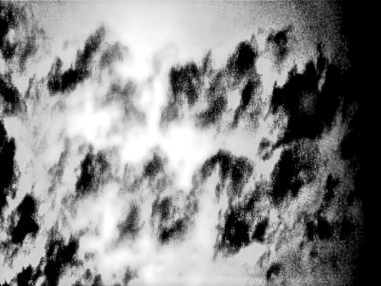
Figure 1. Cloud dragons

2020: At a coffee shop, Miss Song, a professor at a top-ranked university in Seoul, confides, “When I was in third grade, my school held an athletics festival. My parents and siblings attended. There was a thunderstorm, so we took shelter. I stood on one side of the school building with some classmates. Looking up, I saw a dragon flying between the clouds. I have kept this a secret for 25 years. Although it is good luck for someone to see a dragon, it is not if they tell others. Three years ago, during another such storm, I told my mother who had been waiting out the earlier one on the other side of the school building. She said, ‘I saw a dragon, too.’ Last year, I asked my older brother about it. He said, ‘Yes, I saw a dragon there.’”
Professor Song goes on, “I told you because you might believe me.
But if I tell my friends they would call me cuckoo!”
From earliest memory, the denizens of the Korean Peninsula already have a dragon of their own. She is a beaked water goddess named “Mileu,” which also means “waterwheel” and governance of “the future.” She hears the people’s prayers, and sends down rain for drinking and cooking, also for sustaining plants and animals. A symbol of the life force, she dwells in the depths of the Korean soul, is embedded in the language,

and appears in dreams, even today.
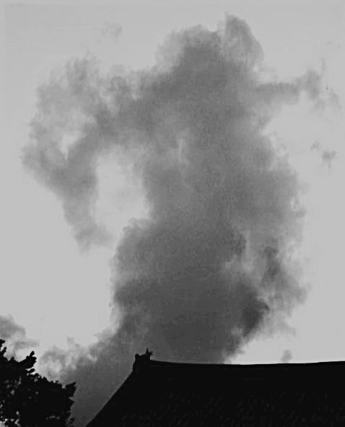
Figure 2. Cloud dragon seen over Bongwon Temple

2711 BCE: A Chinese woman dreams: A yellow dragon leaps out of the Yellow River and down my throat. Of course, I am surprised.
☆ She gives birth to the future Huang-di, Yellow-Gold Emperor, “the father of Chinese civilization.” He introduces inventions and innovations

such as sericulture and the compass, acupuncture and medicinal herbs, wind and string instruments. When he dies, a golden dragon flies him to a purple palace in the region of the Seven Stars and the North Star. Courtiers cling to his beard. One by one they lose their grip and fall off.
The Yellow River, “the mother of Chinese civilization, cascades, meanders and plunges 3,395 miles to the sea. She is one of four dragons who defy Heaven’s discipline by transforming into great rivers to bring water to farmers afflicted by drought.
Similarly, on the Korean Peninsula, the Nakdong (Falling-East) River wanders 320 miles from Taebaek (Big White) Mountain to the south sea. Mr. Yum reports, “My father dreamed my taemong (pregnancy dream): ‘While walking along the Nakdong River, I hear excited people crying out, so I stare at the churning water. A big, yellow dragon splashes up and flies to the sky, writhing noisily.

Surprised, I open my mouth. Suddenly, it dives into my throat. People cry out as I lose my senses.’
My parents have always believed in my future success. I’m trying to become the greatest man who has ever lived.”
☆ Maybe his father knows of the Yellow Emperor’s dream or it is genetic memory. Dynamically hovering between Heaven and earth, the devoted son shows others how to live a rewarding life.
Before humans imagined gods in their own image, like the Yellow Emperor, they are worshipped by shamans as natural forces such as water, wind, fire, earth and metal, and later symbolized as animals, feared and/or admired for singular qualities.

2697 BC: Nine tribes, each worshipping an animal totem, struggle for supremacy in the Yellow River plain. The Yellow Emperor’s tribe conquers and unites them into the Chinese empire, symbolized by the serpentine Yellow Dragon totem. The Yong dragon manifests as the fabulous creature “of nine resemblances.” Originally, these connect a boar’s snout, rabbit’s eyes, camel’s head, deer’s antlers, snake’s neck, carp’s scales, tiger’s palms, eagle’s talons, and frog’s belly.
Nine is the highest single-digit number and also represents infinity. This makes the dragon a conglomerate of the qualities of the nine animals, and also all others. That’s why it’s called “emperor of animals.”
Yong displays a flaming ridge of 117 (9x13) scales along its spine. Eighty-one (9x9) contain yang (Heaven, sunlight and fire, masculine, etc.) qualities and 36 (6x6) yin (Earth, shadow and water, feminine, etc.). They are multiples of the largest yang digit nine, and the smallest yin digit six, a

golden ratio for undulating through the realms of earth, sky and sea. Coiling and uncoiling, its hot, wet body gives off steam. Swinging its tail from side to side, yang to yin and back again, it traverses time and space, circulating the original energy (gi) that gives birth to the universe.
Yong can shrink to the size of a butterfly egg or expand to encompass the cosmos. Lacking wings, it wears a gasbag (chok-mok) on top of its head, which puffs up with steam from its boiling body. Under the hot-air balloon, it glides away on wind currents, drumming its chest and shouting, “Ho! Ho! Ho!”
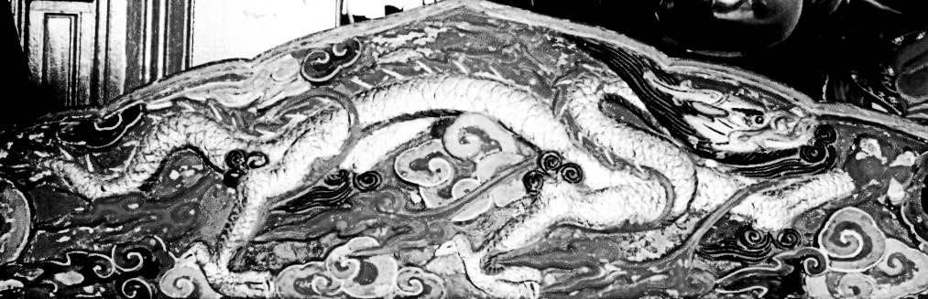
Figure 3. Golden dragon at Bongwon Temple

A dragon follows the flow of things and is an exemplar of play. It is most happy on top of a cloud or at the bottom of the sea, for there it is free. Loving life, it stays relaxed, connected with the original energy (gi) sailing on the currents of wind or water in the spirit of play.
The Daoist sage’s beard and whiskers evidence that Yong also incorporates a human being, the only creature capable of penetrating to the core of things. In fact, “a dragon among humans” is a metaphor for “a great” or “a superior,” talented person as described in the Chinese I Ching (Classic of Changes). S/he lets go of preconceptions, opens the heart and spontaneously grasps the answer to any question. That is why Confucius calls Lao-tzu, the Daoist sage, “a Dragon.” In his forward to the Chinese classic Tao Te Ching (2018), John Minford recounts:

When Confucius returned from this visit to Lao-tzu, he was silent for three days. His disciples questioned him, saying:

“When you met Lao-tzu, what advice did you give him?”

“Finally,” replied Confucius, “I have set eyes on a Dragon! A Dragon that coils to show off the extent of its body, that

sprawls to display the patterns on its scales. A Dragon that rides on the Breath of the Clouds and feeds on the purest Yin and Yang. My mouth simply fell open in amazement. How could I possibly offer such a Dragon advice?”

When Chinese Buddhist missionaries introduce Miruk, the future Buddhist savior, along with the faith-protecting Yong dragon to the 6th century Silla kingdom, the locally worshipped dragon Mileu conflates with Yong into one outlandish creature.
One day, Li Jing, a Chinese student at Yonsei University, approaches me. She says, “I felt saddened for my people’s culture when watching the movie Great Wall of China starring Matt Damon. There, the dragon was evil and wore wings like a Western dragon. But our dragon is different. My grandmother told me her taemong. In it, a golden dragon rose up into the blue sky. It was mild, not evil.”
True, in China, the dragon is associated with Heaven, the paragon of wisdom and benevolence. The nature of Heaven is goodness and so the nature of a dragon, as Heaven’s angel, is good, too.
A dragon is charitable. In the mid-1980s, The Chosun Ilbo newspaper reports that Mr. Kim, an octogenarian and professional ginseng hunter, falls asleep and dreams:

I saw a big blue dragon flying in the sky. It was carrying a baby in its arms. Suddenly the dragon called down, ‘Give to the needy!’

At dawn, I woke up, bathed, put on clean clothes and prayed to the Mountain God (San-sin) for permission to find ginseng. Then I climbed up Seorak (Snow Crag) Mountain and found it near the top.

☆ The story goes on to say that the wild mountain ginseng (san-sam) is valued at 10 billion won (10 million U.S. dollars) for its medicinal qualities. “It is 200 years old, weighs 39 grams and is 65 centimeters long.” Shaped like a beautiful woman, the root is topped by a cluster of about 30 shiny, red berries among sprigs of three and five leaflets.
Obediently, Mr. Kim donates a generous sum to an orphanage.

Fred Jeremy Seligson is a council member of Royal Asiatic Society Korea and adjunct professor of Yonsei University (retired). He is author of Oriental Birth Dreams (1989) and Queen Jin’s Handbook of Pregnancy (2002), and is currently working on Once Upon a Dragon Dream.

References

De Visser, Marinus Willen. The Dragon in China and Japan. New York: Cosimo Classics, 2008.
Ingersoll, Ernest. Dragons and Dragon Lore. London: Longmans, Green and Co., 1928.
Korea Cultural Heritage Foundation. Sin-hwa Sang-sang Dong-mul
[Mythological and Imaginary Animals]. 1980.
Lao-Tzu. Tao Te Ching: The Essential Translation of the Ancient Chinese Book of the Tao. Translated by John Minford. New York: Viking, 2018.
Lee, Eo-ryeong. Sibijisin yong [Chinese zodiac dragon]. Seoul: Saengak ui namu, 2010.
Lee, Hye-hwa. Mireu: yong e gwanhan modeun geot [Mireu: Everything about dragons]. Seoul: Bukbaibuk, 2012.
Lee, Hui-jun. Gyeseo Yadam [Gyeseo Unofficial Historical Tales]. Seoul: Gukhakjaryowon, 2003.
“Encyclopedia of Korean Folk Culture.” National Folk Museum of Korea. https://folkency.nfm.go.kr/en/main.
Yun, Su-yeol. Yong bul-myeol ui sinhwa [Dragon Everlasting Mythology].
Seoul: Daewonsa, 1999.

