A Passion for a Worthwhile Life:

Yi Pangja’s Social Welfare Activities in Korea

Seulkee Nam and Dr. Cameron Pyke

Even by the turbulent standards of the 20th century in Asia, the life of Princess Yi Pangja of Korea (Japanese: Princess Nashimoto Masako) is defined by a remarkable degree of vicissitude. Born into a collateral branch of the Japanese imperial family in 1901, she was selected by the Japanese authorities to marry Yi Ŭn, Crown Prince Ŭimin of Korea, a highly contentious political project which resulted in an ‘anti-fairy tale’ reflecting the ‘biological dimension’ of the Japanese empire.¹ Following her marriage in 1920, Yi Pangja gave birth to two sons, the first of whom, Yi Jin, died in infancy on a visit to Seoul in 1922 under suspicious circumstances, whilst her subsequent first-hand experience of Korea during the colonial period was predominantly mediated through Japanese imperial rule. Following the Japanese defeat in 1945, Yi Pangja and Yi Ŭn, in what transpired as a successful marriage, were effectively suspended in limbo: downgraded to commoner status in Japan by the American occupying authorities and, following the declaration of the Republic of Korea and subsequent election of Syngman Rhee as president in 1948, viewed with official hostility in Korea. In a final twist, the new government of Park Chung-hee began arrangements to naturalise Yi Pangja and Yi Ŭn in 1961, orchestrating their return to Korea in 1963. By this stage Yi Ŭn, aged 66, was permanently incapacitated and would pre- decease his wife by 19 years in 1970. It is at this point, ironically, that the most remarkable final chapter of Yi Pangja’s life began, her voluntary first-hand involvement in the education of children with physical and mental disabilities in Korea and a conscious self-identification as a

¹ For a sympathetic overview of Yi Pangja’s life, see Faye Yan Kleeman, In Transit: The Formation of a Colonial East Asian Cultural Sphere (Honolulu: University of Hawai'i Press, 2014), 88-99.

Korean volunteer in the field of social welfare.
Previous academic literature on Yi Pangja has tended to focus on four topics. Firstly, scholars have made comparisons of various versions of her autobiography.² Kim T’aejun analysed the different prefaces of the Korean and Japanese versions in terms of the audiences’ contrasting views of the same historical events,³ while No Yŏnghŭi examined the contents of Korean, Japanese and English versions in light of the historical context of Yi Pangja’s marriage.⁴ Secondly, Yi Pangja’s cloisonné (Ch’ilbo) skill was examined by Kim Minhŭi, who highlighted the fact that Yi Pangja started to teach cloisonné to Korean women as a means of raising funds for social welfare work.⁵ Thirdly, the poems Yi Pangja wrote in the 1930s have also received some attention.⁶ Lastly, Chi Yŏnhŭi was the first to

² The extent to which Yi Pangja’s autobiography is mediated is unclear. The earliest version was published in 1960, translated from Japanese to Korean: Pangja Yi, Chaeil Yŏngch'inwangbi ŭi sugi [An Essay of a Crown Princess living in Japan], trans. Pang Kihwan (Seoul: Shint'aeyangsa, 1960). After returning to Korea, Yi Pangja published this version as: Pangja Yi, Tongnan chungŭi wangbi [Queen in the tempestuous period] (Seoul: Yŏwŏnsa, 1967). Its Japanese version is Yi Masako, Dōran no naka no ōhi (Tokyo: Kōdansha, 1968). Subsequent editions employ different titles:
- Pangja Yi, Chinaon sewŏl [The Past Years] (Seoul: Yŏbŏmsa, 1967), henceforth YP 1.
- Yi Masako, Sugita saigetsu (Seoul: Chandokkun Rakuzensai, 1973).
- Pangja Yi, The World is One, trans. Sukkyu Kim, ed. Joan Rutt (Seoul & Los Angeles: Taewon Publishing Co., 1973), henceforth YP 2.
- Pangja Yi, Chinaon sewŏl [The Past Years] (Seoul: Namyŏng munhwasa, 1974), henceforth YP 3.
- Pangja Yi, Parambunŭn taero mulgyŏlch'inŭn taero [As the wind blows, as it wavers] (Seoul: Hanjin ch'ulp'ansa, 1980).
- Pangja Yi, Sewŏriyŏ wangjoyŏ [Time and Dynasty] (Seoul: Chŏngŭmsa, 1985), henceforth YP 4.
³ T'aejun Kim, “Tu kae ŭi choguk saie sŏn ‘chaa’” [A Study of the Autography of Yi Pangja standing on two nations], Myŏngjiŏ munhak 14, 1982.
⁴ Yŏnghŭi No, “Yi Pangja ŭi chajŏn ŭl t'onghae bon hant'wiil kŭndaesa e taehan chagak kwa han'gye” [A study on a historical view of Yi Pangja`s biography], Irŏil munhak yŏn’gu 39, 2001.
⁵ Minhŭi Kim, Yŏngch'inwangbi Yi Pangja ŭi ch'ilbo gongye rŭl t'onghan changshin'gu tijain p'yohyŏn yŏn'gu [A Study of the Application of Contemporary Ch’ilbo Jewelry Style based on Yi Pangja’s Ch’ilbo craft], PhD diss. (Daegu University, 2018).
⁶ Sanghyŏn Pang, “Yi Kwangsu ŭi t'eibangja jŏnhaŏgagusugŭnyŏkt'e yŏn'gu” [A Study of Yi Pangja’s poems translated by Yi Kwangsu], Ilbon munhwa hakpo 63,

examine Yi Pangja’s social welfare work, placing her life in the context of the complex history between Korea and Japan and interviewing those who worked closely with her in the field of special needs education.⁷ However, the motivation for this social welfare activity has received little attention beyond Yi Pangja’s own categorisation of it as the fulfilment of her late husband’s wishes.⁸ This article will suggest that the form that it took after 1963 reflected a wider variety of life experience and influences.

Yi Pangja is known for three distinct accomplishments after 1963. The first was the setting up of Myeonghwiwon in 1968, a vocational training centre for the disabled named after her husband’s childhood pen name. It was initially based on the fourth floor of Seoul’s YMCA, within the framework of the latter’s Porinhoe (Association for Helping Neighbours) before acquiring its own building at Insa-dong 243, which opened in 1971 as Myeonghye Hall, a combination of the childhood names of both Yi Pangja and Yi Ŭn. By 1978 it catered to 20 pupils of both sexes in each of its four courses—knitwork, embroidery, woodcraft, and electronics—selected on a first come, first served basis. A majority of pupils were from poor families, so tuition and materials were free. Though there was a board of directors, the bulk of the funding was orchestrated by Yi Pangja herself. ⁹ A contemporary newspaper report succinctly summarised Myeonghye Hall’s activities as follows:

The principal purpose of the center is to provide physically handicapped children, including deaf-mutes and polio victims, with adequate education and training in knitting, embroidery and carpentry work, so that they can cultivate basic skills for self- support in their community… Those children of 13 to 18 years who are physically handicapped and have finished elementary education or equivalent thereto are eligible to be admitted. When students complete the one-year course, they soon get down to producing marketable works of various types…Works turned out by the concerted efforts of instructors and students—Princess Yi included—are displayed at an exhibition or bazaar held once or twice a year… The earnings from the sales are used exclusively

2014.
⁷ Yŏnhŭi Chi, Kahye Yi Pangja ŭi t'ŭksu kyoyuk saŏp yŏn-gu [A Study on the Special Educational Work of Yi Pangja], MA Thesis (Dankook University, 1998).
⁸ YP 2, 14-15.
⁹ Dong-A Ilbo, March 7, 1968; Kyunghyang Shinmun, Jan. 23, 1971.

for the students’ living and the management of the center itself.¹⁰

A further pioneering element of the programme was Yi Pangja’s facilitation of public performance opportunities in dance and music for some of its students, both in Seoul and, under the aegis of the Korea-Japan Cultural Exchange Association for Children with Disabilities, in a range of locations across Japan.¹¹ This reflected Yi Pangja’s conviction that the students of her foundations should be empowered to maximise their talents in order to participate in society, whilst also reflecting the increasingly recognised therapeutic benefits of the creative arts. In this sense, it prefigured the setting up of the Korea Orff Schulwerk Association in 2004.¹²
Yi Pangja’s second achievement, whilst demonstrating a similar emphasis on occupation socialisation, focused on the promotion of the welfare of children with mental health issues. Through Chahaenghoe (Benevolent Deeds Association) which she launched in 1966, this work developed from a very small rehabilitation centre into the partly state- funded Chahye School. Located in Gwonseon-gu, Suwon, it had classrooms, a swimming pool and dormitory, and six qualified special education teachers. The school’s entrance ceremony in 1971 was reported by the correspondent of Kyunghyang Shinmun:

In total, 28 mentally disabled children have enrolled. The Orchid Class (beginner class) consists of 12 children who were not attending elementary school, the Chrysanthemum Class (intermediate class) consists of eight pupils who gave up during elementary school, and the Rose Class (advanced class) consists of eight students who graduated from elementary school but did not enter middle school. The youngest pupil is 7 years old and the eldest student is 18. The range of IQ is between 70 and 90. Their classrooms are equipped with audio-visual textbooks in various colours, and a basketball stand is placed on one side of the classrooms, to sharpen a sense of direction.¹³

¹⁰ Kil-yong Son, “Princess Yi Devotes Life to Aiding Unfortunates,” The Korea Times, April 15, 1973, 4.
¹¹Maeil kyŏngje, May 9, 1974; The Korea Times, Dec. 3, 1976, 8.
¹²See “About Us,” Korea Orff Schulwerk Association, accessed April 4, 2021, http://eng.korff.or.kr.
¹³Kyunghyang Shinmun, March 4, 1971 (author’s translation). For the setting up of Chahaenghoe, see YP 4, 281; Chŏngbok Ŏm, “30 years with Chahaenghoe,”

By 1980 there were 132 pupils at the school, the majority of whom resided in the dormitory. Chahaenghoe also attempted to influence attitudes to ensure the wider protection of children with mental issues: Yi Pangja played a key role in this ‘social enlightenment’ through her participation in and patronage of lectures in Korea. The association also funded research and teacher training, and encouraged parents, designers and performers to visit the school and engage with the pupils and their creative work. This vision was developed by the outstanding educator Kim Tonggŭk (1926-2014) as principal from 1979 onwards. He had previously established Daegu Namyang School, the first special school for mentally disabled children in Korea, and would go on to develop a comprehensive special needs curriculum for use across the country. Following Yi Pangja’s 1989 death, Dr. Oh Sŏnhwan, the chair of Chahaenghoe, would be instrumental in fulfilling her desire to establish a full-scale vocational rehabilitation centre (Subongjaehwarwŏn) for its graduates, which opened in 1991.¹⁴
It is not only this focus on special educational needs which is a distinctive achievement, but also Yi Pangja’s wider contribution to the development of volunteerism in modern Korea, particularly amongst female social welfare activists. In 1968 she articulated that “Only a handful of people participate in charity work and I should like to work to arouse interest in people to give more in helping others.”¹⁵ This was partly born out of a longstanding belief that volunteering is necessary for the cohesion of society. Reflecting on the new democracy of post-war Japan, she and Yi Ŭn

thought there was a problem with the gap between rich and poor. So a rich person should have a certain attitude…towards helping the poor. Of course, this idealistic attitude seems to be very

Chahaeng hoebo 53, spring 1996, 17; Ch’angdŏk Mun, “Looking back on the long years,” Chahaeng hoebo 53, spring 1996, 41.
¹⁴ Kim Tonggŭk, “I hope this relationship will continue to the end of my life!” Chahaeng hoebo 53, spring 1996, 21-22, and “Report on progress of the ground- breaking ceremony of Subong Rehabilitation Centre,” Chahaeng hoebo 42, winter 1990, 5.
¹⁵ “Princess Turns Eye Towards Social Work,” The Korea Times, Jan. 14, 1968. As Otabe Yuji put it, “Today, volunteering is taken for granted in Korean society, but I think Ms. Yi Pangja established a tradition. She was a pioneer in volunteering” (author’s translation). Yuji Otabe, Naksŏnjae ŭi majimak yŏin [The Last Lady who lived in Naksŏnjae], trans. Kyŏngsŏng Hwang (Seoul: Donga ilbosa, 2009), 305.

difficult to practice [but] my husband and I dreamed of helping vulnerable people.¹⁶

After her return to Korea in 1963, this was a matter of necessity as well as conviction, in that government funding was not provided for her social welfare projects. Yi Pangja utilised the skill in cloisonné which she had acquired through expert instruction in Tokyo from 1954, enabling her to draw upon a high-end market for its products amongst Japanese, Koreans and the expatriate community. ¹⁷ Following her return to Korea she undertook further instruction not only in these areas but also from Ewha Womans University in the authentic reproduction of royal garments for charity events.¹⁸ Indeed, in the context of the dramatic economic growth witnessed increasingly by Korea as well as Japan, her causes fortuitously offered a way in which private profit could be squared with traditional Confucian values. ¹⁹ As the number of Japanese tourists to Korea increased after the normalisation of relations in 1965, those invited to the ritual of tea ceremony in her private quarters in Sŏhaenggak at Naksŏnjae (the dowager house compound in Ch’angdŏk Palace; Sŏhaenggak was built in 1927 as residence for Queen Yun, consort to King Sunjong who died in 1926) were thus encouraged to contribute to her social welfare work by purchasing her paintings and calligraphy.²⁰ Yi Pangja’s cloisonné, calligraphy and paintings were also sold at charity bazaars and out of shops in the arcades of the Tokyu Hotel in Seoul and in Tokyo. This all required a prodigious work ethic and a disciplined schedule of calligraphy and drawing at the start of the day, cloissoné classes in her studio at Sŏhaenggak, managerial meetings, and hands-on social welfare work.²¹ Yi Pangja was uncompromising on this point in the final version of her memoirs:

¹⁶ YP 4, 287.
¹⁷ YP 2, 200; Kyunghyang Shinmun, Sept. 11, 1970.
¹⁸ “Princess Yi Gives Art Exhibition,” The Korea Times, March 9, 1977, 6;
Kyunghyang Shinmun, Sept. 13, 1975.
¹⁹ “Princess Yi-Pangja Gets Donation From Japanese for Welfare Activity,” The Korea Times, March 14, 1986, 6; YP 4, 285.
²⁰ YP 4, 286; The Korea Times, Oct. 4, 1983, 3; Maeil kyŏngje, April 30, 1974.
²¹ Kyunghyang Shinmun, Sept. 13, 1975; Helen Dunn, “Over the City Wall,” The Korea Times, July 7, 1978, 7. The wife of the British ambassador to Korea from 1980-3, for example, recalls buying a cushion in aid of one of her charities. Letter to the authors from Lady Angela Morgan, Jan. 11, 2021.

Social work only consists of both working extremely hard and perseverance. However, many think of social work as a hobby. It is easily considered a means of vanity, luxury, or self-show by the rich. So it is the case that many sentimental people step into social work without forethought, and then readily step out when they are bothered and annoyed.²²

This was coupled with a striking willingness to learn from other practitioners in what was then a relatively new field. Kim Tonggŭk, for example, recalled that:

Yi Pangja visited Namyang School in the fall of 1975 and took a deep interest in the school facilities and students’ work, and looked at every corner of the school. She asked many questions, and we shared opinions with each other. The level of content of her opinions was highly specialised, so I was also greatly stimulated.²³

She likewise established a collaborative relationship in the field of special needs education with the Japanese educator Saburō Shochi (1906- 2013), who founded and operated Japan's first day school for children with mental disabilities.²⁴
This relatively high-profile role as a female volunteer, amplified through the contemporary media and the various versions of her autobiography, was not straightforward. Some initially believed that Yi Pangja had hidden assets as a member of the royal family, or mis- interpreted the enterprise as a private business. Even some of her supporters regarded her appearances as a model at fundraising royal court costume shows as compromising her dignity, whilst in other quarters her assiduous elite-level fundraising was viewed with reserve. One reviewer of the first Korean version of her autobiography felt that her “excessive educational intentions give an opaque impression.”²⁵ After 1963 she defined herself in public as plain “Mrs. Pangja Yi” and portrayed herself

²² YP 4, 288 (author’s translation).
²³ Tonggŭk Kim, “I hope this relationship will continue to the end of my life!” 21.
²⁴ Saburō Shochi, “Reflecting on the 7th memorial ceremony for the late Ms. Yi Pangja,” Chahaeng hoebo 53, spring 1996, 7-10.
²⁵ Cesco Honda, Piryŏn ŭi hwangt'aejabi Yi Pangja yŏsa [The Tragic Crown Princess, Ms. Yi Pangja], trans. Sŏkyŏn Sŏ (Seoul: Pŏmusa), 244, 248; Yuji Otabe, Naksŏnjae ŭi majimak yŏin, 290; Chŏngbok Ŏm, “30 years with Chahaenghoe,” 18-19; Dong-A Ilbo, Sept. 21, 1967.

as being unequivocally Korean, wearing Hanbok when attending receptions and participating in television appearances and Yi Dynasty heritage events to raise funds. In this she showed a willingness to live out a public role at a time when political and economic relations between Korea and Japan were undergoing a complex evolution.²⁶ It also required a poised ability to nuance a consistent message to different audiences, including during fundraising visits to communities of first-generation Koreans on the West Coast of the United States in 1974 and to senior members of the Japanese business community.²⁷ Between 1965 and 1986 Chahaenghoe was in fact a bi-national project, drawing upon the support of an élite circle of female supporters from Korea and Japan galvanised both by Yi Pangja and through its Sushinhoe, an aid association which shrewdly balanced fundraising with social activities.²⁸ In all of these activities after her return to Korea, Yi Ŭn’s permanent incapacitation “put on [Yi Pangja’s] shoulders the whole burden of decision and adjustment” and required a considerable degree of resourcefulness and resilience.²⁹ Yi Pangja’s sustained hands-on engagement as a volunteer therefore radically undercut her role as an aristocratic woman defined by the Confucian social order.³⁰ Indeed, from the late 1960s she orchestrated reciprocal exhibitions of contemporary Korean and Japanese artists, including her own work. Yet if this was perceived at the time as a “beautiful sublimation” of the traditional role of a woman, her autobiography’s outrage at the “violent death” of her first son and the “hateful” treatment meted out to Princess Tŏk’hye suggests that it was a hard-won one.³¹
One may consider a number of areas of longer-term motivation for these achievements. The Japanese imperial family had an established tradition of philanthropy through its longstanding patronage of the

²⁶ J.C. Covell, “Korea Cultural History and Japanese Princess,” The Korea Times, Feb. 13, 1981, 4; The Korea Times, May 1, 1982, 5; “Today’s TV Choice,” The Japan Times, April 5, 1971, 6; “Last Crown Princess Honored on 63rd Wedding Anniversary,” The Korea Times, April 29, 1983, 5.
²⁷ “Today’s TV Choice,” The Japan Times, April 12, 1970, 6; “Social events,”
The Korea Times, Feb. 23, 1979, 8.
²⁸ YP 4, 283; Yuji Otabe, Naksŏnjae ŭi majimak yŏin, 285.
²⁹ H.G. Underwood, “Princess Yi Recounts Life,” Korea Journal 13 (7), 1973, 71.
³⁰ E. Salem, “Women Surviving: Palace Life in Seoul after the Annexation,” in Virtues in Conflict: Tradition and the Korean Woman Today, ed. S. Mattielli (Seoul: Royal Asiatic Society, 1977), 76, 88. For the perspective of a volunteer member of Chahaenghoe, see Kim Suim “Chahaenghoe and I,” Chahaeng hoebo 53, spring 1996, 47.
³¹ Dong-A Ilbo, Sept. 21, 1967; YP 2, 108, 167.

Japanese Red Cross and imperial hospitals, and this represents an element of Yi Pangja’s cultural formation. Her mother, Itsuko, and maternal grandmother, Nagako, were highly active in the Japanese Red Cross’s Nursing Women’s Association, albeit this engagement was not exceptional. ³² Indeed, from 1938 Yi Pangja, in common with other Japanese imperial family women, had effectively been enlisted into the wider Japanese war effort as an imperial emissary to army and navy hospitals and, from 1942, was officially supporting soldiers at the front lines from her Tokyo residence, the Akasaka Palace.³³ However, the only specific Japanese influence cited in Yi Pangja’s autobiography is that of Empress Teimei (1884-1951), queen consort of Emperor Taishō. ³⁴ Particularly after the death of her husband in 1926, the dowager empress, often dubbed by Westerners the Queen Mary of Japan, devoted her energies to supporting those suffering from leprosy through private donations and by attending meetings of the directors of leprosaria.³⁵ Empress Teimei, who had defined a meaningful role for herself against the backdrop of the deterioration of Emperor Taishō’s health and the rise of Japanese militarism, offered a powerful counter narrative of personal survival. In transcending the conventional “miserable lot” of imperial family women, both she and Yi Pangja drew inspiration from Japanese high culture and from Buddhist scriptures.³⁶ That said, by the time the first version of Yi Pangja’s autobiography was published in 1960, Teimei had been dead for nearly a decade and the possibility of a direct influence should not be overstated.
More important were the two months she spent in the United Kingdom in 1927 (from Aug. 6 to Oct. 1) as part of the extensive European tour she and Yi Ŭn undertook between May 24, 1927, and April 9, 1928. The backdrop of the entire trip was markedly political. Through visits to military and industrial establishments, and the presence of perhaps the most unequivocal advocate for Anglo-Japanese friendship,

³² Yuji Otabe, Naksŏnjae ŭi majimak yŏin, 24.
³³ YP 2, 142, 145-6. See also The Japan Times, May 9, 1940, 4, for her visit to the First Military Hospital, “presenting flowers and cakes to the wounded soldiers.”
³⁴ YP 2, 66, 166.
³⁵ International Journal of Leprosy 41, no 2, 1973, cited in “Empress Teimei,” International Leprosy Association, accessed Feb. 7, 2021, https:// leprosyhistory.org/database/person118.
³⁶ YP 2, 117; Salem, “Women Surviving,” 9; Kyunghyang Shinmun, Sept. 11,
1970.

Major-General F.S.G. Piggott, it symbolised the endurance of Anglo- Japanese ties, notwithstanding the formal termination of their alliance four years earlier.³⁷ It also presented an image of Japanese-Korean harmony, reinforced by the fact that the royal couple were afforded greater freedom to pursue their own interests than elsewhere on the tour including, for Yi Ŭn, playing several of the best golf courses in the country, and for Yi Pangja, seeing Anna Pavlova dance at Covent Garden.³⁸ The British establishment accepted this image at face value, underpinned by the official Japanese narrative that the 1910 annexation was beneficial to the country after the degeneration of late Yi (Chosŏn) Dynasty rule; the funeral of Emperor Sunjong in 1926 was seen by the British Foreign Office as representing the historical conclusion of the dynasty.³⁹ The royal couple were viewed as progressive and cosmopolitan ambassadors for Japan’s colonial sphere: they were photographed in fashionable European clothes and were fluent in French and, in Yi Ŭn’s case, English.⁴⁰ Their progressive credentials were further reinforced by a distinctive feature of the visit: their first-hand encounter with a range of social welfare projects. The Korean royal couple had previously undertaken instruction in ‘the history, economics, and sociology’ of the countries to be visited by Tokyo University sociology professor Tetsuo Watanuki (1885-1972), and the tour was clearly intended to be educational.⁴¹ Indeed, compared to the visit of the Japanese crown prince to the United Kingdom in 1921 this element was even more prominent, though the latter had attended Boy Scout exercises and a lecture on “The British Royal Family and the People.”⁴² Both visits took place at the

³⁷ Anthony Best, “Maj. Gen. F.S.G. Piggott (1883-1966),” in Britain & Japan Biographical Portraits, vol. VIII, comp. and ed. H. Cortazzi, 102-16. Piggott is incorrectly referred to as “Colonel Pyecott” in YP 2, 213. See also Anthony Best, “A Royal Alliance: Court Diplomacy, 1902-41,” in P. Kornicki, A. Best and H. Cortazzi, British Royal and Japanese Imperial Relations 1868-2018 (Folkestone: Renaissance Books, 2019), 75-140.
³⁸ Westminster Gazette, Sept. 14, 1927, 4, and Oct. 6, 1927, 5.
³⁹ Typewritten carbon copy of letter from John Tilley, British Embassy Tokyo, to Sir Austen Chamberlain, Nov. 23, 1927; V.L.P. Fowke, “Annual Report from British Consul General Seoul,” UK National Archives, FO 262/1688, Jan. 13, 1927, 13.
⁴⁰ Ŭrhan Kim, Chosŏn ŭi majimak hwangt'aeja, Yŏngch'inwang [The Last Crown Prince of Chosŏn, Yŏngch'inwang] (Seoul: Paperroad, 2010), 29.
⁴¹ YP 2, 126.
⁴² Y. Futara and S. Sawada, The Crown Prince’s European Tour (Osaka: Mainichi Publishing, 1926), 77, 79-80.

height of the presentation of the British monarchy as a cohesive force through its support for social welfare, which was seen as complementing its ceremonial and constitutional roles.
Whilst royal philanthropy was not uncommon in the European monarchies in the 20th century, it was much more developed in the United Kingdom, partly reflecting the royal family’s concerns about Bolshevism and the labour movement, which it thought hostile to royalty, coupled with the advent of the mass franchise at the end of World War I. The General Strike of 1926 had further underlined the importance of the social welfare strongly endorsed by King George V and Queen Mary, which Yi Pangja therefore witnessed at its height. ⁴³ She seems to have been particularly impressed by the institution’s combination of down-to-earth accessibility and engaging ceremonial display:

The royal family is quite natural in public and the queen sometimes goes out with the princesses to shop in London stores. The general public never interferes with their private lives, and notes the activities of the royal family with genuine concern and interest…There was no fuss with the police clearing the way for members of the royal family to cross the street or enter shops. It was all so natural…On state occasions the king and queen ride in a horse-drawn carriage and the public cheers them along the street.⁴⁴

This survey of the monarchy included a joint audience with King George V and Queen Mary and the investiture of Yi Ŭn with the Grand Cross of the Order of the British Empire by Prince Henry of Gloucester, the king’s third son. Yi Pangja would recall this occasion in 1984, the year in which Prince Henry’s son became the first member of the British royal family to visit Korea.⁴⁵

⁴³ For a discussion of this theme, see Frank Prochaska, Royal Bounty: The Making of a Welfare Monarchy (New Haven: Yale University Press, 1995).
⁴⁴ YP 2, 214.
⁴⁵ Carol Thatcher, “Role for a Redundant Royal,” Daily Telegraph, Nov. 7, 1984, 19.

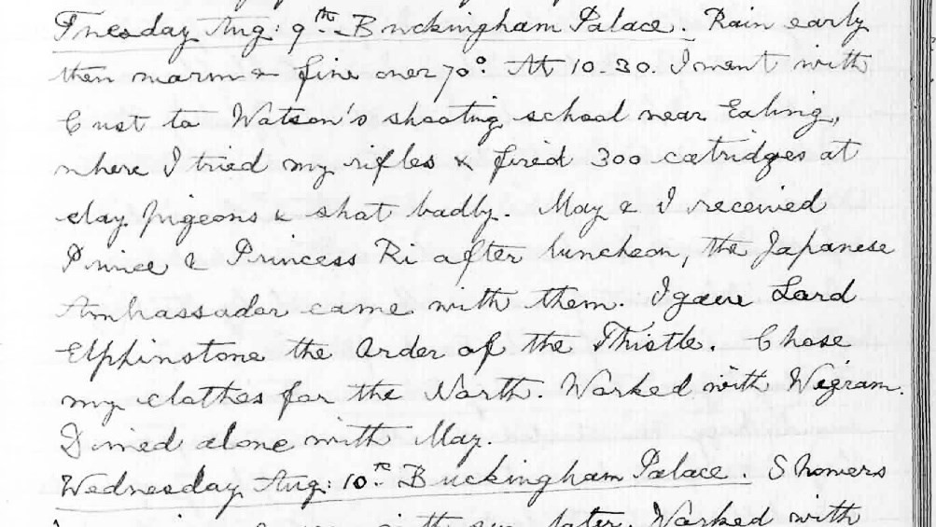
Figure 1. The diary of King George V, recording the visit of Yi Ŭn and Yi Pangja to Buckingham Palace on Aug. 9, 1927 / The Royal Archives / © Her Majesty Queen Elizabeth II, 2021
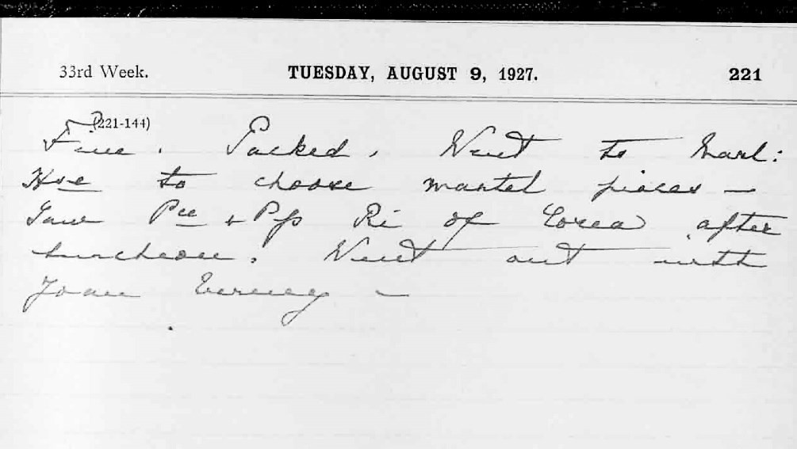
Figure 2. The diary of Queen Mary, recording the visit of Yi Ŭn and Yi Pangja to Buckingham Palace on Aug. 9, 1927 / The Royal Archives / © Her Majesty Queen Elizabeth II, 2021

The programme of social welfare visits took place across three days in September 1927:

On 8 September [1927] Mr. Fujimura [secretary at the Japanese

Embassy] lectured us on England’s various social welfare programmes. We also visited General Booth at the Salvation Army…and Toynbee Hall in the East End…I went to visit St. Bartholomew’s Hospital and Doctor Barnardo’s Home. I learned that most of the aristocrats in England worked to help welfare programmes.⁴⁶

In The Past Years (1967), Yi Pangja elaborated that she visited St. Bartholomew’s Hospital and Dr. Barnardo’s Home on Sept. 9, 1927, and on Sept. 25—with Yi Ŭn—“the Nursing Home for the war wounded near Richmond Park, dormitories for poor secondary students, Toynbee Hall, a workers’ club, the Boy Scouts, [and] a shelter for poor children.”⁴⁷ This then was an intensive programme exposing the royal couple to the British voluntary sector at its height.⁴⁸ St. Bartholomew’s Hospital in central London prided itself as the “Mother Hospital of the Empire” with an 800- year heritage, and, with the Prince of Wales as patron, embodied the royal family’s support for the voluntary hospital sector. The hospital’s expenses, Yi Pangja was told, were covered by “high-society sponsorship associations, a special contract of donations of a certain amount each year.” The home for the war wounded was Queen Mary’s (Roehampton) Hospital. Under the patronage of Queen Mary and a board of aristocratic supporters it provided treatment and training for amputees. By the time of Yi Pangja’s visit, the hospital had started admitting a range of limb patients, including children with congenital conditions.⁴⁹ Dr. Barnardo’s Home—the “National Incorporated Association for the Reclamation of Destitute Waif Children”—also benefitted from the patronage of Queen Mary and endorsed the inculcation of basic training in a range of practical skills amongst its children to prepare them for adult life. Yi Pangja visited the charity’s showcases to the northeast of London, the Girls’ Village

⁴⁶ YP 2, 213-4. “Dr. Bernard Holmes at St. Bartholomew’s Hospital” is a mistranslation of “Dr. Barnardo’s Home and St. Bartholomew’s Hospital.”
⁴⁷ YP 1, 167-8.
⁴⁸ Details of the visits drawn from Osamusaku Shinoda, Ō shū go jun-yū zuikō nikki [Diary of the European visit] (Ōsaka: Yagō shoten, 1928), 150-3, 160-4.
⁴⁹ See M. A. Cloudesley Brereton, “The future of our disabled sailors and soldiers,” Warwick Digital Collections, accessed April 6, 2021, https://wdc. contentdm.oclc.org/digital/collection/tav/id/4047. See also “Queen Mary’s Hospital,” St George’s University Hospitals, accessed April 6, 2021, https://www.stgeorges.nhs.uk/about/history/qmh.

Home in Barkingside and Boys’ Garden City in Woodford Bridge.⁵⁰
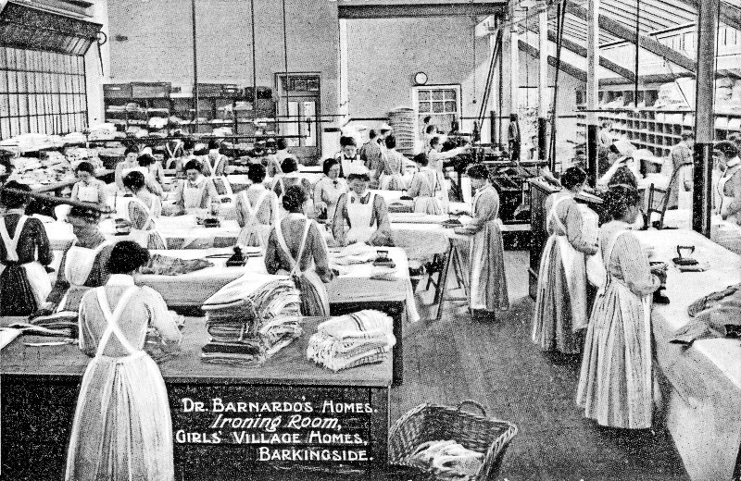
Figure 3. Girls of Dr. Barnardo’s Girls’ Village Home acquire skills in preparation for domestic service (Courtesy of Peter Higginbotham / childrenshomes.org.uk)

Toynbee Hall had been set up in 1884 as a centre for gradualist social reform and research. The essential model was that university undergraduates and public school boys delivered a range of practical classes and activities in ‘settlement houses’ in the East End of London during vacations, a mutual encounter that offered constructive relaxation after a day’s work to the poor and edification to the country’s future leaders. By 1914 it had inspired an international movement as far afield as the United States and Japan.⁵¹ Indeed, it was the visit of the Korean royal couple to a Docklands settlement at Canning Town which received the

⁵⁰ See Peter Higginbotham, “Girl's Village Home, Barkingside, Ilford, Essex,”
Children's Homes, accessed April 1, 2021, http://www.childrenshomes.org.uk
/BarkingsideDB. See also Peter Higginbotham, “Boy's Garden City, Woodford Bridge, Essex,” Children’s Homes, accessed April 1, 2021, http://www.childrenshomes.org.uk/WoodfordBridgeDB.
⁵¹ “The History of Toynbee Hall—A Timeline,” Toynbee Hall, accessed April 4, 2021, https://explore.toynbeehall.org.uk/explore/the-history-of-toynbee-hall-a- timeline. See also “Toynbee Hall,” Survey of London, accessed April 4, 2021, https://surveyoflondon.org/map/feature/379/detail/.

most significant coverage. A stream of VIP guests, from HRH the Duke of York, later King George VI, to the Shōwa Emperor’s brother, Prince Chichibu (1902-53), had been similarly entertained to ensure maximum publicity for aristocratic fundraising.⁵² As with Dr. Barnardo’s Home, the Docklands settlement offered an unequivocal endorsement of the endurance of Edwardian Liberalism in the context of post-war economic uncertainty, and the facilities were made to help the deserving poor escape lifelong poverty. This seems to have had a particular influence on Yi Pangja’s insistence on educating the disabled and mentally ill in utilitarian as well as moral terms:

No matter how low in intelligence, a child will have his own abilities. If he utilises all of the 50 percent of abilities he has, then he is showing 100 percent of his abilities. It may be acceptable to be locked up in the house as long as the parents are alive, but what should the child do after his parents die? We must bring out and nurture the ability of self-reliance remaining in children.⁵³

This philosophy would be powerfully represented over 50 years later in the unveiling of a bronze “Statue of Self Reliance” alongside a “Declaration of the Rights of Children” at Chahye School, emphasising both their rights and contribution as members of society.⁵⁴
The Sunday Times correspondent reported that the royal couple made the visit at the conclusion of their stay in the country, ‘during which they have made a personal study of many of our institutions.’ After observing a spirited boxing match between ‘two very small boys,’ they

signed the visitors’ book as “Prince and Princess Ri-Gin” in English, after writing them in Korean characters—downwards. In the same book are the signatures of the King and Queen, Prince of Wales, the Duke and Duchess of York, Princess Helena Victoria - and Douglas Fairbanks and Mary Pickford.⁵⁵

⁵² “Korean Prince: Visit to Dockland Settlement,” Sunday Times, Oct. 2, 1927. See also Reginald Kennedy-Cox, An Autobiography (London: Hodder and Stoughton, 1931).
⁵³ Quoted in Honda Cesco, Piryŏn ŭi hwangt'aejabi Yi Pangja yŏsa, 242.
⁵⁴ Kyunghyang Shinmun, May 8, 1980.
⁵⁵ “Korean Prince: Visit to Dockland Settlement,” Sunday Times, Oct. 2, 1927.

However, if Yi Pangja regarded the year away from East Asia as fundamental to her intellectual development, how its impact played out in Seoul in the medium term, during the Japanese occupation, is perhaps the most elusive part of this question.⁵⁶ Soon after arriving in London, Yi Ŭn reportedly said, “It is my first visit to Europe, and I wish to crowd in as many impressions as I can, so that I can go back to Tokyo with new ideas of progress and civilisation.”⁵⁷ The Salvation Army’s account of General Bramwell Booth’s visit to Japan and Korea in November 1926 would go further in contrasting the “absolute unity existing among all classes” in Japan with the “illiterate minds, haunted by centuries of fearful heathen beliefs” he encountered on the Korean leg of his tour; this likely received some mention when the royal couple visited him in London.⁵⁸ Saitō Makoto, governor general of Korea in 1919-27 and 1929-31, seems to have promoted the European tour as part of their evolution into non- political figureheads, reinforcing what he saw as the more progressive elements of Japanese rule in Korea in the face of Korean separatism or international Bolshevism.⁵⁹ He had overseen the royal couple’s first visit to Seoul in 1922 and was in London for part of their visit in 1927.⁶⁰ Against this backdrop, and residing in Tokyo, it is difficult to determine what, if any, agency the crown prince and his wife had, or chose to employ, in a colonial context they surely assumed would endure indefinitely. Indeed, it was Syngman Rhee’s assessment that this period represented high-level collaboration, as opposed to inescapable acquiescence in the emasculation of the Yi monarchy (starting from 1910 and severely increased from 1926 following the death of King Sunjong), which would later delay their return to Korea after liberation. Yi Pangja’s autobiography, compiled only as the political situation began to change in the family’s

⁵⁶ YP 2, 132.
⁵⁷ This was probably a translation of the contentious Japanese slogan bunmei kaika (civilisation and enlightenment; munmyŏng kaehwa in Korean). “Pretty Princess From The East,” The Courier and Advertiser, Aug. 13, 1927, 5.
⁵⁸ A.J. Gilliard, “After Japan—Korea. The General Concludes Memorable Campaign in the Land of the Rising Sun,” The War Cry, Nov. 13, 1926, 7. We are grateful to Ruth Macdonald, archivist and deputy director at the Salvation Army International Heritage Centre, William Booth College, London, for this.
⁵⁹ For a discussion of the role of the crown prince and princess during the colonial period, see Christine Kim, “Korean Royal Portraits in the Colonial Archives,” Ars Orientalis, 43 (2013), 102-5.
⁶⁰ YP 2, 102; “Admiral Saito’s Visit,” Daily Telegraph, Aug. 11, 1927, 11; Saitō Makoto, “Keynote of Japan-Korea Amity,” The Japan Times & Mail, March 22, 1923, 4.

favour in 1960, sheds little light on this question beyond what she presents as a joint decision not to respond to a campaign for Yi Ŭn to return to Korea in August-September 1945 in order to stay together.61
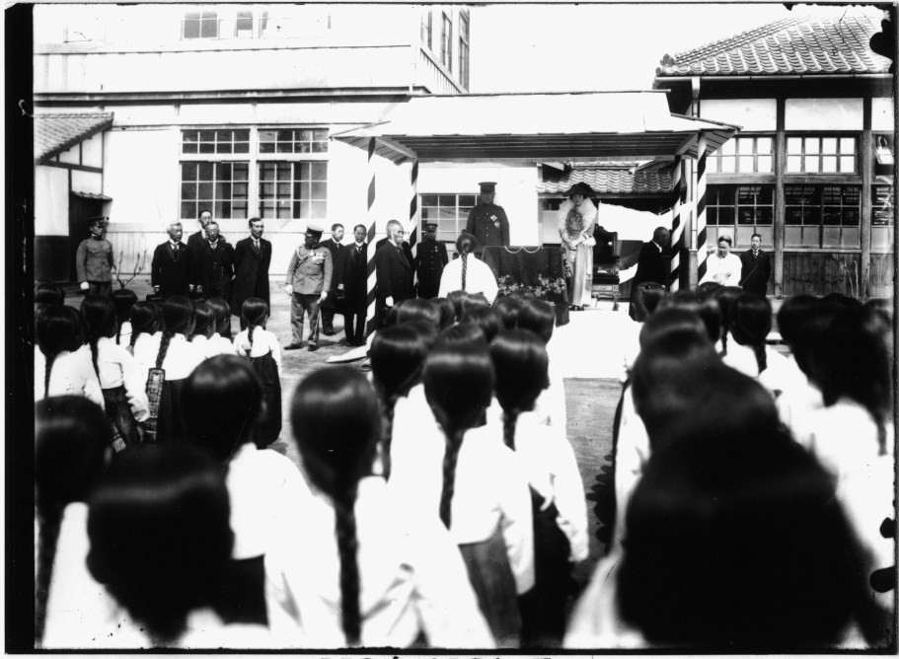
Figure 4. Yi Ŭn and Yi Pangja receive students in Seoul during the colonial era. (© National Museum of Korea, dry plate 29128)

In terms of social welfare, such activity seems to have been given some expression during a series of annual visits to Seoul which took place following the death of Emperor Sunjong in 1926, “either in spring or autumn to pay homage to the ancestral tombs and visit relatives,” each lasting about ten days and continuing until 1943 when the war was turning against Japan’s favour. ⁶² Whilst the frequency of these visits is exaggerated in annual reports compiled in English by Japanese authorities, and research remains to be done on the substance of what Yi Pangja later described as a “strenuous round of royal duties, engagements and hostessing,” the royal couple appear to have used Kyŏnghun'gak, formerly the queen’s residence in the main residential compound of Ch’angdŏk

⁶¹ YP 2, 151.
⁶² YP 2, 137, 146. See also Salem, “Women Surviving,” 72, about the “triennial state visits.”

Palace, as their residence, possibly also employing Sŏhaenggak, newly constructed in Japanese style adjacent to Naksŏnjae, as a reception chamber for Yi Ŭn and Yi Pangja during their annual visits in later years.⁶³ Several photos suggest that prior to Minami Jirō’s assumption of the governor-generalship in 1937 and the increasing mobilisation of Korean people for war, the royal couple were engaged in royal duties which, certainly in the conception of a joint royal audience, seem more drawn from the United Kingdom model than Chosŏn protocol, in which Yi Pangja as queen (chungjŏn) would not have entered the domain together with the king nor entertained his guests.⁶⁴
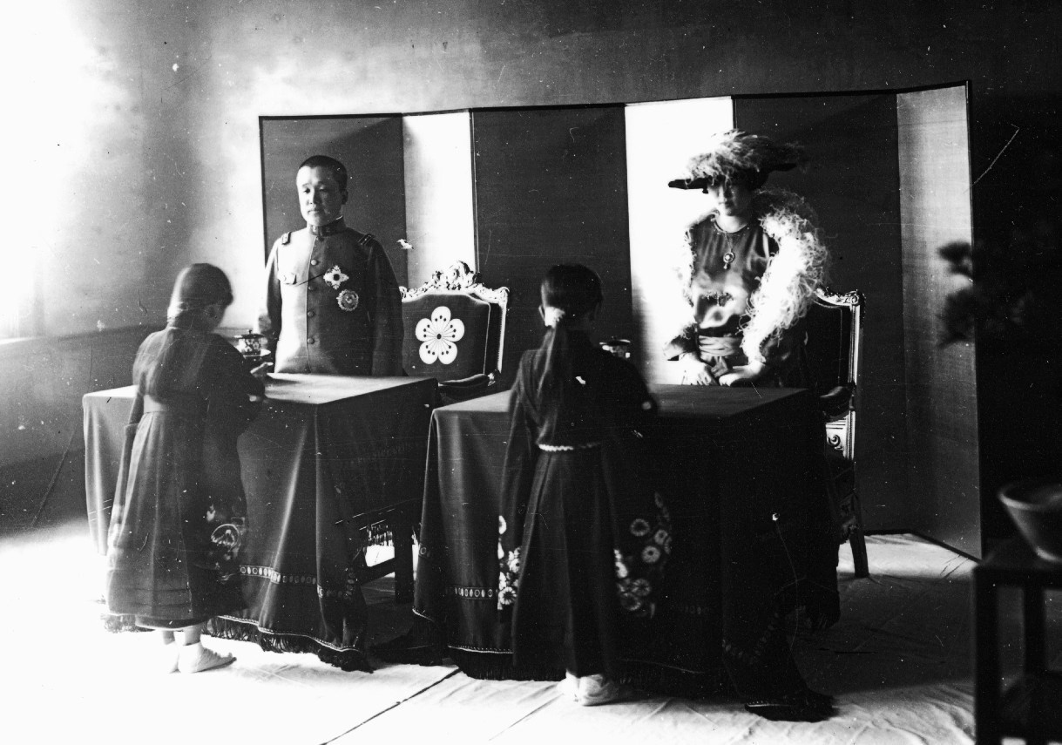
Figure 5. Yi Ŭn and Yi Pangja receive students in Seoul during the colonial era. (© National Museum of Korea, dry plate 29133)

⁶³ Annual Report On Administration Of Chosen, Compiled by the Government- General of Chosen Keijo: 1933-4, 34, and 1934-5, 46; Thatcher, “Role for a Redundant Royal.” We are grateful for Peter Bartholomew for clarifying these architectural points: Sŏhaenggak, built in 1927 as the residence of Queen Yun with her ladies-in-waiting and other retainers and demolished between 2012-14, is possibly the “spacious drawing room which had once been a reception hall in front of Ch’angdŏk Palace” in which Yi Pangja received courtesy calls on her return to Seoul in 1962; YP 2, 188.
⁶⁴ We are grateful for the Revd. Steven Shields for this insight.

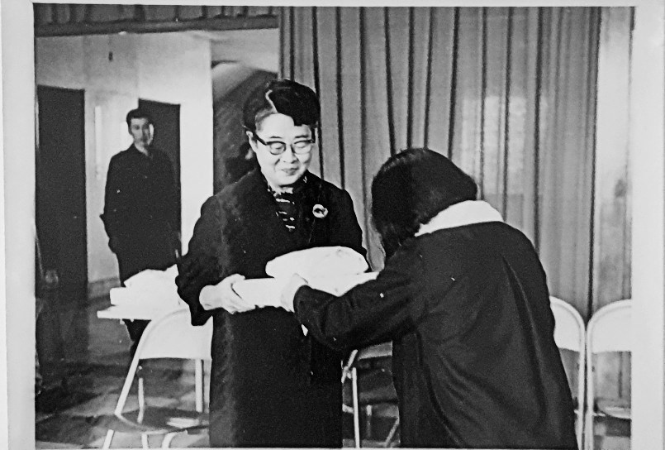
Figure 6. Yi Pangja receives students at the first completion ceremony of Myeonghwiwon in 1969. (Kansa S054-1 Myeonghwiwon Album, 1966-69)
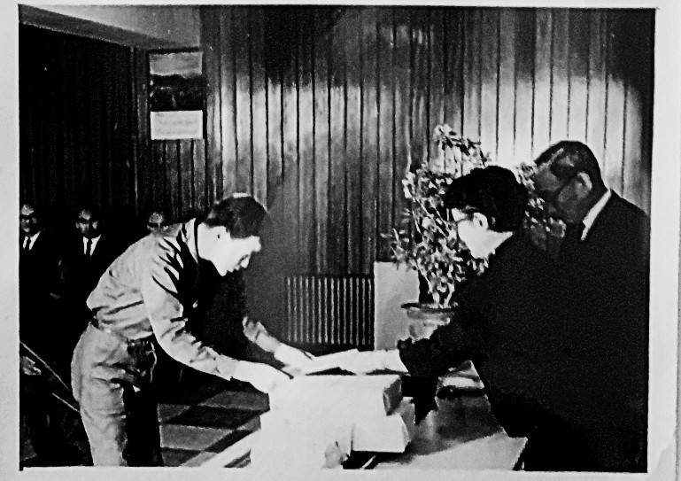
Figure 7. Yi Pangja receives students at the first completion ceremony of Myeonghwiwon in 1969. (Kansa S054-1 Myeonghwiwon Album, 1966-69)

This formula was adapted in Yi Pangja’s visits to her social welfare projects 40 years later and—in that it was never realised—it is poignantly represented in the two wooden chairs for Yi Ŭn and herself in Myeonghwiwon’s current memorial hall.

Whilst this activity could be seen as endorsing the wider politically motivated education drive of the colonial authorities, it also continued the educational patronage of members of the House of Yi from the late 19th century. The royal couple “conceived a grand plan to open a magnificent student hall” at the three schools founded by Yi Ŭn’s mother, Imperial Noble Consort Sunheon (Lady Ŏm): Yangchung Boys School (1905), Jinmyeong Girls’ School (1906), and Myeong-shin Girls’ School (1906).⁶⁵ The latter foundation, originally named after Yi Ŭn’s childhood name Myŏngshinjae but changed in 1948 to Sookmyung, encompassed both a girls’ school and a vocational school:

After she married Yi Ŭn, Yi Pangja became the governor of the two schools, Sookmyung Girls’ School and Sookmyung Vocational School. Sookmyung Girls’ School traditionally selected one of the graduates with excellent grades for the Yihwa Prize. Those awarded the prize were given a gold ring by Yi Pangja.⁶⁶

However, more important as a realised new project was Yi Pangja’s establishment in 1940 of Honghoeryo, a dormitory to accommodate graduates from Sookmyung and Jinmyeong girls’ schools studying in Tokyo, since a number of these, such as Choi Ok-ja, would form the first generation of female college educators in Korea after liberation. Yi Pangja selected the students and gave them personal guidance during their residency. The identity of the 15 alumnae was sufficiently enduring for them to gather with Yi Pangja for commemorative photographs in Seoul in 1962 and 1978.⁶⁷ Certainly, an endorsement of education is a striking

⁶⁵ YP 2, 193.
⁶⁶ Honda Cesco, Piryŏn ŭi hwangt'aejabi Yi Pangja yŏsa, 222-3 (author’s translation).
⁶⁷ YP 2, 143; Hae-Oak Kelly, “I wanted to share some photos of my mother, born in 1923, from the 1940s,” Facebook, Feb. 18, 2021, https://www.facebook.com/ groups/Koheritage/permalink/5306058722745264; Ch'oe Hyesuk, Yŏksa ŭi p'ago rŭl hech'igo [Through the Waves of History] (Seoul: Ch'ŏnjisŏngjisa, 1999), 240, 250; Dong-A Ilbo, June 21, 1962, 3. See also Kang Yongja, Nanŭn taehanjeguk

theme of her later pronouncements: “What is really important for Korea, more so than modernisation, is education,” she would declare in 1982. “Without good education people will not know how to behave properly towards each other.”⁶⁸
1945 to 1948 seem to have represented the greatest personal crisis for Yi Pangja since the death of her first son, with the incarceration of her father for alleged war crimes in 1945-6, the reduction of her family to “a hand-to-mouth way of living” as a result of the removal of their royal privileges in both Korea and Japan, and the progressive realisation of Yi Ŭn’s “inability to cope with changing realities” of the postwar era. Her social welfare work would increasingly be redirected to the vice chairmanship of the newly formed Pan-Japanese Ladies’ Buddhist League and also to “charitable clubs organised by dedicated ladies to help and educate orphans, mentally retarded [sic] children and paralysed children.” ⁶⁹ This partly reflected a wider broadening of imperial charitable activity beyond the wartime focus of the International Red Cross and Red Crescent Movements. Empress Nagako, Princess Chichibu, Princess Mikasa, and Princess Takamatsu all supported charity events in aid of children with mental and physical disabilities in the 1950s, and this was significantly extended by Crown Prince Akihito and his wife Michiko following their marriage in 1959. As part of the Tokyo Olympics of 1964 they adopted the Paralympics and increasingly made helping the physically disabled one of their signature causes. Whilst this did not encompass visiting institutions housing the mentally ill, the difference with previous charitable efforts by the imperial house was that they took particular efforts to bring the physically disabled into the mainstream of Japanese society as much as possible, rather than sending a donation so that they would be comfortable in institutions but hidden.⁷⁰ It is likely, then, that Yi Pangja would have continued to have engaged in aristocratic fundraising in Japan in this area until her death, had not the overthrow of Rhee in 1960 made a permanent return to Korea a realistic possibility.

majimak hwangt'aejabi Yi Masak'o imnida [I am the last Crown Princess o f Taehan Empire, Yi Masako], ed. Kim Chŏnghŭi (Seoul: Chishikkongjakso, 2013), 240.
⁶⁸ E. Adams, “Interview: Princess Lee Bang-ja,” Korean Culture 3:4 (December 1982), 32.
⁶⁹ YP 2, 159-60, 162, 169, 191, 193.
⁷⁰ Kenneth Ruoff, personal communication with author, Feb. 7, 2021. See also Kenneth Ruoff, Japan’s Imperial House in the Postwar Era, 1945-2019 (Cambridge, MA/London: Harvard University Asia Center, 2020), 286-90.

There was a further contextual shift at this stage, in that by the time Yi Ŭn and Yi Pangja did return in 1963, the charitable sphere offered the sole space which Yi Pangja could convincingly occupy. The Republic of Korea government had occupied the public space of the state sufficiently enough for the defunct monarchy to offer an additional source of legitimacy rather than a political threat. ⁷¹ This achieved striking affirmation in the officially endorsed large-scale ceremonial for Yi Ŭn’s funeral in 1970.⁷² Further research remains to be done on Park Chung- hee’s perspective on the monarchy, which had already resulted in the return of Dowager Queen Yun and Princess Tŏk’hye to the Naksŏnjae compound in 1960-2 and the return to Korea and residence at Naksŏnjae Sŏjanggak with Queen Yun of Yi Ŭn, Yi Pangja, and Yi Gu with his wife Julia Yi, not least in the context of the eventual normalisation of relations with Japan in 1965. Certainly, he made public the photographs of his receiving Yi Pangja at Ch’ŏng Wa Dae in June 1962, and it may be that he envisaged a social welfare role for her as complementing the activities of his wife, Yuk Young-soo (1925-74). Indeed, the delayed official opening of Chahye School in 1972 was only able to take place because of Yuk’s substantial personal donation of 10 million won.⁷³ A shared affinity in developing the voluntary sector was confirmed when Yi Pangja mediated the setting up of Goodwill Industries of Korea as a voluntary agency for the rehabilitation of disabled workers in 1971 and first lady Yuk served as its honorary president.⁷⁴ Such official endorsement of Yi Pangja’s own activities as, for example, vice president of “Rehabilitation of Korea” continued unabated following the assassinations of Yuk in 1974 and Park himself in 1979.⁷⁵ By the 1970s, the presence of Yi Pangja was also sympathetically validated by the expatriate community, from

⁷¹ For analysis of this development, see Christine Kim, “The Chŏson Monarchy in Republican Korea, 1945-65,” in Northeast Asia’s Difficult Past: Essays in Collective Memory, ed. M. Kim & B. Schwartz (London: Palgrave Macmillan, 2010), 213-28.
⁷² See the front pages of The Korea Times, May 2 and May 10, 1970. The ceremony included 120 students from Yangjŏng Boys School who accompanied the crown prince’s bier.
⁷³ “School Opens for Mentally Ill Kids,” The Korea Times, Oct. 18, 1972, 4; YP 4
, 282-3.
⁷⁴ Yeo-chun Yun, “Goodwill Industry Movement: Disabled Have Capacity,” The Korea Times, May 16, 1971, 4.
⁷⁵ Park’s assassination caused her to make a hasty return from Europe. Hasun Pak, “In memory of the late Her Majesty Yi Pangja,” Chahaeng hoebo 53, spring 1996, 13.

ambassadors’ wives to the Royal Asiatic Society of Korea.⁷⁶ For example, in 1973 the English edition of her autobiography “The World is One” was edited by Joan Rutt, the wife of RAS Korea President Richard Rutt. Edward Adams thus declared her to be a “living link between the modern progressive Republic of Korea and the impressive Yi dynasty period.”⁷⁷
Whilst Yi Pangja’s own previous activity, through which aristocratic women raised charitable funds through bazaars, offered an adaptable blueprint for social welfare activity in Korea, its specific focus on special education needs only occurred following her return and was not uncontentious. It appears that she initially envisaged a more conventional patronage role, along the lines of Princess Park Chan-ju (1914-95), also an important leader in the establishment of educational institutions for Korean women and girls during the late Japanese occupation period and early Republic of Korea periods. The death of the latter’s husband Yi U, second son of Yi Kang (King Kojong’s second son), in the atomic bombing of Hiroshima, seems to have underscored an affinity between the two women. Park had remained in Korea, retained legal possession of her late husband’s Unhyŏn Palace, and became founder and first chairperson of Chugye University of Arts, Joongang Girls’ High School, and Chugye Elementary School.⁷⁸ Yi Pangja initially hoped to become the new chair of the governing board of Sookmyung Women’s schools, which had been raised to university status in 1955, and thereby continue her longstanding association with this foundation, but this embroiled her in a factional dispute against new board directors who were opposed to her assuming this more traditional Korean role. In light of this, “the only thing left was social work.”⁷⁹ Existing provisions for children with special educational needs and disabilities had largely focused on the blind and deaf and were very limited overall both at grassroots and government agency levels. The stark discrepancy between what then existed and what was needed was increasingly recognised, not least compared to Japan and the United States.⁸⁰ In 1971, Chahye School principal Yi Ch’unsŏp stated that:

⁷⁶ H.G. Underwood, “Princess Yi Recounts Life,” 71.
⁷⁷ E. Adams, “Interview: Princess Lee Bang-ja,” Korean Culture 3:4 (December 1982), 33.
⁷⁸ YP 2, 149, 168-70, 186; Chayu shinmun, May 13, 1950.
⁷⁹ Honda Cesco, Piryŏn ŭi Hwangt'aejabi Yi Pangja Yŏsa, 224, 239. See also Yuji Otabe, Naksŏnjae ŭi majimak yŏin, 283-4.
⁸⁰ For further assessments of provision, see Kyunghyang Shinmun, Aug. 29, 1953, and Dong-A Ilbo, June 8, 1967.

There are about 180,000 children with mental disabilities in Korea, and only 700 of them are receiving special education or protection guidance. The rest of them either reluctantly attend regular schools or they are neglected in the shade of society and spend an unhappy time. Although the reason for this is caused by incomprehension and indifference of society or family, the fundamental reason is that there are very few educational institutions in Korea to teach them. Currently, there are five schools nationwide for mentally disabled children, a total of four protection guidance institutions, and three other institutions, a total of 12.⁸¹

An editorial in The Korea Times two years later went even further in response to a survey carried out by Chahaenghoe assessing the basic level of need across the country:

The fact that the government has lacked even the most basic statistics on the ill-fated children shows that they have been virtually left out of public concern….The Chahaenghoe’s survey, we hope, will provide a stimulus to the government to turn its attention to the ill-fated children who have so far lived a miserable life in the back alleys of society.⁸²

Indeed, the culminating piece of the jigsaw puzzle came in 1973 when Yi Pangja revisited Europe for the first time since 1927, as well as the United States, to learn from social welfare facilities for disadvantaged children in each country. Perhaps ironically, at this stage she drew specific ideas from the facilities of Denmark, Sweden, West Germany, and the United States, which she viewed as superior to those of the United Kingdom:

Even if a child was born with polio or mental disabilities, he could live without worrying. The school facilities were good and the vocational education was subdivided, so learning only one thing was sufficient to help them to live. In West Germany I wanted to make a small donation [but] was put to shame. The institution said that there was no need…because the whole system was in place and there was no need to pay attention to things like business funds. The United States is far behind Europe, but I was

⁸¹ Kyunghyang Shinmun, March 4, 1971 (author’s translation).
⁸² “Mentally Retarded,” The Korea Times, April 29, 1973, 2.

impressed by the development of many ideas for vocational education for children with disabilities. In particular, U.S. institutions were intensively teaching children with disabilities to make simple electrical appliances. I thought that I could apply those ideas in South Korea.⁸³

By way of contrast, an English colleague who co-founded a school for children with special needs in London in 1987 recalls that it was the lack of local and national government support prior to then, in terms of finance and navigating the regulations, which constituted the greatest impediment. When made familiar with Yi Pangja's work, she reflected, “Although there are many pioneering educationalists, there are fewer individuals, and in particular women, who were able to achieve their goal in special education.”⁸⁴
To a degree, in the emerging post-1963 context, there was a complementary circle of influences at play, both present and historical. The initial association of Myeonghwiwon with the YMCA reflected the support of the Yi Dynasty for its promotion of Western-style vocational education in its formative years, Yi Ŭn himself having represented Emperor Kojong at the cornerstone ceremony of the original YMCA building in 1907. From 1965, Myeonghwiwon had the support of Pastor Kim Uhyŏn and the YMCA board, which stated, “The YMCA does not forget the grace of Emperor Kojong, and we wanted to fulfil Yi Ŭn’s hope.”⁸⁵ It may also be that a longer-term religious impulse increasingly underpinned this social welfare activity. Yi Pangja and Yi Ŭn had received a private blessing from Pope Pius XI as part of their European tour in 1927 and Yi Ŭn converted to Catholicism in 1961.⁸⁶ After her return to Korea, Yi Pangja came to enjoy a cordial relationship with Cardinal Stephen Kim Sou-hwan (1922-2009) who baptised her as a Catholic in 1983. Myeonghwiwon moved to its first suburban location in Gyeonggi- do in 1978 and, since 1985, following the arbitration of Kim, it has been run by the Sisters of Our Lady of Perpetual Help. In its current location in Sangnok-gu in Ansan, it not only serves as a school but also supports disabled workers and the mentally ill.⁸⁷

⁸³ YP 4, 287-8.
⁸⁴ Finola Stack, personal communication with author, April 16, 2021.
⁸⁵ Honda Cesco, Piryŏn ŭi hwangt'aejabi Yi Pangja yŏsa, 253.
⁸⁶ Kim Ŭrhan, Chosŏn ŭi majimak hwangt'aeja, Yŏngch'inwang, 325, 332; YP 2,
212.
⁸⁷ Dr. Joo Hyun Sheen, personal communication with author, Dec. 23, 2020.

By the 1980s Yi Pangja was a unique witness of the turbulent century which had shaped her life and the destinies of her and Yi Ŭn’s countries, and this was a role she did not tire of setting down for posterity in her autobiography, interviews and television documentaries. Indeed, the degree of accumulated media coverage of her social welfare work is striking in itself, particularly from the late 1960s onwards.⁸⁸ She was, recalled one who attended a Royal Asiatic Society of Korea garden party at Naksŏnjae in the 1980s, “a very impressive person—extremely gracious, poised, and worldly.”⁸⁹ Together with the death of Princess Tŏk’hye nine days earlier, her own burial alongside Yi Ŭn represents the end of an historical chapter, albeit not of the contentious issues deriving from it.⁹⁰ This was also the case in a practical sense, in that after 1989 a full-scale programme of restoration was undertaken at Naksŏnjae, culminating in the demolition of her colonial-era residence Sŏhaenggak in 1996. To set up two foundations in the area of special needs was undoubtedly pioneering, distinguishing her work from near-contemporaneous royal philanthropists such as Princess Ileana of Romania (1909-91) and Princess Grace of Monaco (1929-82). Indeed, her self-identification with Princess Diana in an interview with Carol Thatcher in 1984—“different culture but almost similar”—might equally apply to the unconventional nature of her chosen causes as much as to the circumstances of her marriage.⁹¹ In some ways the focus of her work prefigures wider shifts, such as the emergence of a ‘social’ rather than medical model of disability and a service philosophy based upon the principles of normalisation in the 1970s. The United Nations’ International Year of Disabled Persons in 1981 and the holding of the Summer Paralympics in Seoul in 1988 also reflect this. Her work also represents something of a one-off in its positioning as an act of atonement for the cultural and other atrocities inflicted upon Korea by her native country, as well as its resourcefulness and specific impact.⁹² Whilst her second son Yi Ku and his wife Julia Mullock appear to have had some

⁸⁸ “Two Made-for-TV Films to be Aired on Japan Tube,” The Korea Times, April 28, 1984, 6, Jang Jae-il, “Beauty of Korean Cloissone Still Shines,” The Korea Times, Sept. 8, 1999, 14.
⁸⁹ Professor Jay Lewis, personal communication with author, Nov. 11, 2020.
⁹⁰ “Pageantry in Seoul marks funeral of Yi Pang Ja, Korea’s ‘last queen,’” The Korea Times, May 9, 1989, 7.
⁹¹ Thatcher, “Role for a Redundant Royal.”
⁹² Helen Atherton, “Unit 3—A History of Learning Difficulties,” 55, from The Learning Exchange, https://lx.iriss.org.uk/sites/default/files/resources/NES_ Unit3.pdf.

involvement in her social welfare projects initially, Yi Ku serving as vice chairman of the Goodwill Industries of Korea and Mullock setting up a workshop for appliqué designs in Sŏkpokhŏn, their residence at Naksŏnjae, this was not sustained after the couple divorced in 1982.⁹³
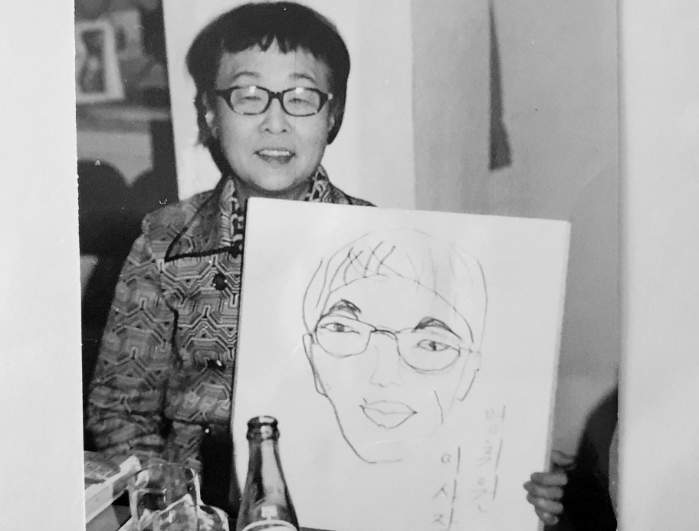
Figure 8. Yi Pangja enjoys a student’s portrait of her in 1971 / Kansa S054-7 Myeonghwiwon Album (1970-71)

The eventual convergence of the various influences considered in this article was perhaps not as linear as suggested by the various versions of Yi Pangja’s autobiography. The financial viability of her projects remained a constant struggle and there were also unrealised plans to support the elderly and the victims of the atomic bombings before she progressively succumbed to cancer after 1983. In one of her final press interviews, she reflected on her efforts: “The social welfare project has

⁹³ Yeo-chun Yun, “Goodwill Industry Movement: Disabled Have Capacity”; Kap-son Yim, “Royal Lady’s Time All Given to Charity,” The Korea Times, Jan. 31, 1971, 4; Woon-young Kim, “Royal Lineage of Yi Era Maintained in Naksunjae,” The Korea Times, July 28, 1982, 5; Julia Lee, “Old-Hand Quilting Recreated,” The Korea Times, Jan. 7, 1981, 4.

been frustrating, embarrassing and desperate for more than 20 years since it started. But every time, if I strived sincerely, people who helped and understood our social work appeared.”⁹⁴ Taken as a whole, Yi Pangja’s life represents a hard-won transformation, whereby her first-hand involvement in the colonial period was re-cast from an anti-fairy tale into a worthwhile life of self-giving service:

The attitude of Yi Pangja was not the same as when she previously consoled the wounded as a member of the royal family. She had the spirit to be close to the weakest in society and to share her life with the vulnerable… She transformed in her later years.⁹⁵

Or, as Yi Pangja herself put it, by 1968 she had come to understand that “Welfare is love.”⁹⁶

Seulkee Nam is a Ph.D. student at SOAS University of London supervised by Dr. Anders Karlsson. She is researching the Anglican Church and social welfare work in Korea in the early 20th century.
Dr. Cameron Pyke is a historian with a professional and personal interest in the education of children with special educational needs and disabilities, including the methodology of Carl Orff and Gunild Keetman.
For their assistance and encouragement, the writers would like to thank: Mr. Peter Bartholomew, Dr. Minh Chung, Sister Han Seyŏl John Francesca, Mr. Jeong Ha-geun, Dr. Anders Karlsson, Professor Christine Kim, Mr. Kim U, Dr. Jungwoo Lee, Professor Jay Lewis, H.E. Cardinal Vincent Nichols, Dr. Joo Hyun Sheen, H.E. Cardinal Andrew Yeom Soo-Jung.
As this article went to press, the authors were deeply saddened to learn of the sudden death of former RAS Korea President Peter Bartholomew. Peter was extremely generous in his encouragement of this research project and we were enriched by a series of memorable conversations via Zoom during the darkest days of the pandemic. His knowledge of the Korean monarchy and its historical and cultural contexts uniquely coupled an ongoing passion for scholarly enquiry with personal experience. We wish to dedicate this article, with respect, gratitude and affection, to his memory.
The views expressed are the writers’ own, as are any errors.

⁹⁴ “At the Westin Chosun,” The Korea Times, Sept. 23, 1983, 2; Chŏngbok Ŏm, “30 years with Chahaenghoe,” 19; Kyunghyang Shinmun, March 18, 1985.
⁹⁵ Yuji Otabe, Naksŏnjae ŭi majimak yŏin, 287-8.
⁹⁶ Saburō Shochi, “Reflecting on the 7th memorial ceremony for the late Ms. Yi Pangja,” 8.

