The Forgotten Korean Labourers on Nauru

Dr. Ron Munro and Alamanda Lauti, BA MBA

“Etunuwewonganiekeow bwa ngan Korea, tuwintuwap de-baike” (Woman, where have you been?
Nowhere, only to Korea(n) camp to buy tobacco)

—a line of a chant or song sung many years ago by a Nauruan lady, as part of her recollections of the Japanese occupation and aftermath, to Dr.
L. Keke, in personal communication dated Aug. 2, 2017

Although the Australian-Korean relationship extends back to the 1880s, even before Australia came into existence as a legal entity, Australia’s contributions have often been overlooked, marginalized or simply overshadowed by the larger powers. This has sometimes occurred despite a contribution being at a crucial junction, such as when Australians encountered Koreans on Nauru at the end of World War II.
Nauru, a small island in the South Pacific east of Papua New Guinea, fell under German control in the late nineteenth century. After World War I, the League of Nations assigned a trustee mandate over Nauru to Australia, which oversaw phosphate mining there by Chinese contract labourers. In August 1942, the Japanese seized the island and exiled two-thirds of the Nauruan population to Truk, where forty percent of them died. Though the Japanese-built airfield on Nauru was bombed by the United States more than once, the island was bypassed by the Allies and was not liberated, ultimately by Australia, until after the war ended.¹
What is largely unknown is the fact that Australia found a relatively large number of Koreans on Nauru. Even less known is the fact

¹ For an overview of this history, see Yuki Tanaka, “Japanese Atrocities on Nauru during the Pacific War: The Murder of Australians, the Massacre of Lepers and the Ethnocide of Nauruans,” Asia-Pacific Journal 8 issue 45 no. 2, Nov. 8, 2010.

that Australia hesitated to clarify the actual status of the Koreans they found there and kept them on the island as a labour force long after the Japanese had been repatriated. Although intended to illuminate an active, if not well known, period of interaction between Australians and Koreans, in order to bring greater attention to Australia’s role, this paper may also, given the paucity of published material on Nauru, indirectly suggest an outline for a case study of the Japanese use of Korean labour during World War II. But this is for a scholar specializing in the field.
The majority of historical research on Nauru during the Japanese occupation and its aftermath has tended, perhaps quite rightly, to have concentrated on the deprivations and sufferings of the Nauruans. It is particularly important to record the event, given the historical amnesia of some of the participants—particularly the Koreans and Japanese,² but for different reasons.³ This historical “forgetting” is aggravated by the fact that Nauruan history is largely in an oral format, sometimes taking the form of songs or Iruwo (a type of chant). Such oral traditions are often not accorded the same respect as written records and in the case of Nauru, written Nauruan records of that time do not really exist as Nauru had no sovereign identity at the time. As more of those living at that time pass away, the opportunity to record and verify the oral tradition lessens.⁴ “Korean records” for Nauru during the war and shortly thereafter, also, do not exist as Korea was also not then a sovereign entity. Most records covering Koreans during this period were held by the Government-

² Initial enquiries to staff at the Japanese Consulate-General in Sydney were met by a statement that no records about the Korean presence on Nauru were kept and that if any did exist it would not be possible to determine which, if any, department, might hold them. Takashi Fujitani described “the Japanese government’s grossly incomplete records of Koreans who served as Japanese servicemen and civilian military employees, as well as its usual unwillingness to cooperate with individual and group efforts to investigate the mobilization of Koreans into the war effort.” Takashi Fujitani, Race for Empire (Berkeley: University of California Press, 2011), 252.
³ For a possible explanation of the reasoning behind the Japanese position, see Tanaka, “Japanese Atrocities on Nauru during the Pacific War.” For Koreans the remote possibility that there may have been some form of collaboration is difficult, as some Koreans have not fully determined what they consider actually constitutes collaboration or are simply wary of this sensitive topic in general.
⁴ Fortunately this is beginning to be rectified. See for example Jamima Garrett, Island Exiles (Sydney, NSW: ABC Books, 2000), and J. M. Gowdy and C. N. McDaniel, Paradise for Sale: A Parable of Nature (Berkeley: University of California Press, 2000).

General of Chosen, and were therefore Japanese records, and many of these have been lost, destroyed, or cannot be located. On the Australian side, records are limited to documents held at the Australian National Archives (AA) or at the Australian War Memorial (AWM). These include the narrative of Gustav Rash⁵ and a list identifying some Koreans on Nauru who had monies owed to them by the army at the time of their repatriation. An additional source, relating to this period, is the diary of the Australian Director of the Nauru Police Force, Thomas Cude. Cude’s diary commences prior to the Japanese occupation and restarts with the early days of liberation but omits the period during which he was evacuated to Australia.⁶
What is interesting about the re-occupation of Nauru is that, rather than merely being a simple contact with Koreans, it forced Australia to consider a response to a situation that on the surface appeared nothing more than a simple Japanese surrender. That Australians should have had some contact with Koreans during and immediately after World War II is to be somewhat expected as Koreans had been conscripted into the Japanese military or had joined its war machine in a variety of roles. Why, then, did Australians retain a relatively large group of Koreans on a small island in the Pacific Ocean some 3,000 km off the Australian coast for eight to nine months after the island had been liberated?
Put simply, the Koreans were part of a larger Imperial Japanese presence, part of which had captured and occupied Nauru and the Christmas Islands to prevent the islands being used as a source of superphosphate by the Allies. That the Japanese were in occupation of the islands was obvious. Allied forces on at least one occasion bombed the island, causing limited damage.
That a significant number of Koreans were part of the garrison there was neither known nor expected, however. Australian troops had come in contact with Koreans throughout the war, but only in small numbers, and for most Australian soldiers there seemed little, if anything, to differentiate them from Japanese soldiers. So why were the Koreans they found not repatriated with the Japanese?

⁵ Gustav Rash, “Narrative of Japanese Occupation, Nauru Island,” Australian War Memorial Collection, AWM 54-5671/1 pt3, Australian War Memorial, Canberra, Australia. Subsequent citations referring to this collection will list only the record number.
⁶ Thomas Cude’s Diary. Digital copy provided by Alamandra Lauti, now held in the manuscript room of the Research School of Pacific Studies, Australia National University, Canberra.

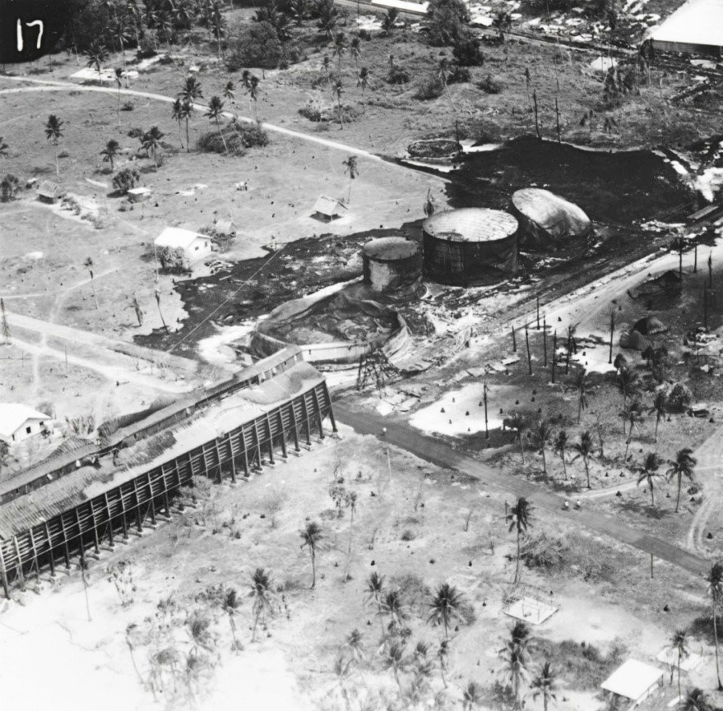
Figure 1. Undated photograph provided by Alamandra Lauti from Archives at USP Campus Nauru, part of Maslyn Williams Collection 151.

Nauru had been administered under a League of Nations mandate since World War I, but after World War II it was transferred to a UN trust territory administered by Australia. The only real industry on the island was phosphate mining and the production of superphosphate, which was used as fertilizer and in munitions. During the interwar period, phosphate mining on Nauru had been managed and directed by the British Phosphate Commission (BPC), which was made up of a triumvirate of UK, Australian and New Zealand representatives.
In the aftermath of World War II, Australia was in desperate need of superphosphate, so it is no surprise it would institute practically any policy to restart an industry that would provide supplies of this much- needed resource. The unexpected fact that there were non-Japanese on the

island must have provided an expedient solution to supply the BPC with short-term labourers who could be employed to jumpstart the industry almost immediately. The presence of Koreans on Nauru at the end of the war would have been a fortuitous situation for the BPC, and many Nauruans felt that the UN trusteeship administered by Australia usually followed the lead of the BPC. Given the subsequent actions of the Australian army in its steps to remove Japanese POWs quickly, there seems little doubt that it would have agreed so readily had all the occupiers been Japanese. Thus the Koreans found on Nauru on Sept. 13, 1945, were retained until they were transported to Rabaul in April or May 1946. From there they were subsequently repatriated. Initially they were under the direct control of the Australian army. This was gradually converted to BPC control with an acknowledgement that control would revert to the army for repatriation.
Within days of the Japanese advising that they were willing to surrender and thus end World War II, the Australian government informed the Secretary of State for Dominion Affairs, London, of its willingness to accept responsibility for liberating Nauru and Christmas Island.⁷ This prompt advice to the Dominions Office by Australia was not only seeking British backing for the Australian action but perhaps hinted indirectly at a more independent position in its foreign policy.
Neither of the islands had any real military or strategic importance, and so General Douglas MacArthur had assigned a very low priority to their liberation. To Australia and New Zealand, however, the islands had a resource of great importance: phosphate. Once the islands had been re- occupied, work could recommence on re-establishing supplies of superphosphate that had ended with the Japanese control of the island. Both Australia and New Zealand were in desperate need of superphosphate to reinvigorate their agricultural sectors, in anticipation of an explosion in the demand for agricultural products following the end of the war. An increase in demand was seen as inevitable resulting from a combination of a desire to regain pre-war production levels and standards of living coupled with an anticipated need for food and supplies by a devastated and war-torn Europe. For Australia and New Zealand at that time, Britain was by far the most important market due to traditional ties.
Once MacArthur’s ego had been coddled through the development of a procedure that would acknowledge both American primacy and MacArthur’s stature, plans were made to permit an

⁷ Department of External Affairs to Secretary for State Dominion Affairs O 2744- 6/751-53, Aug. 21, 1945, AWM123(378).

expeditious occupation of the islands.⁸ Australia was advised by the U.S. that it would have to supply all equipment and personnel because American troops, material and transports were engaged in more important tasks. Australian forces arrived at Nauru at 0600 on Sept. 13, 1945. They did so having little intelligence regarding the size or disposition of the garrison, but they believed that there would be no real or well-organised resistance. Apart from the crew of the frigate HMAS Diamentina, the occupation force consisted of 400 troops transported in the River Class frigate HMAS Burdekin and the minesweeper HMAS Glenelg. On the same day a formal surrender ceremony was held on board HMAS Diamentina, where the Japanese commander was instructed to prepare his troops to board the Burdekin and Glenelg for onward transfer to POW camps in Bougainville in the Solomon Islands.⁹
Initial reports indicated the garrison numbered approximately 2,500. The following day, much to the army’s surprise the Nauru figure was revised by the Japanese to number 3,200 Japanese, 500 Koreans, and 130 hospital inpatients, of whom 40 were stretcher cases.¹⁰ In general, the conditions on the island were reported as good, and the increased Japanese garrison numbers seemed of little concern to the army. The fact that a relatively large number was highlighted as being Korean also seems to have been initially unremarkable. Although the Japanese differentiated themselves from Koreans, this was initially of little concern to the Australian army, which generally considered Koreans to be Japanese in a strict and narrow legal sense, and thus were simply included as part of the overall POW count.¹¹ As hospital patients had not been classified by ethnicity, it might have implied they were all Japanese, or that if there were some Koreans this was of no real concern. It was also believed that in addition to the garrison and Nauruans there were seven identified as

⁸ By negotiation it was agreed that the Australian Commander would sign the instrument of surrender firstly as the representative of the United States Commander Pacific Fleet since it was believed that no U.S. representative would attend given the low priority attached to the islands; after signing on behalf of the U.S., the Australian Commander would then sign a second time, this time representing the territorial power, i.e. Australia. Australia’s sense of urgency insured a lack of forcefulness by Australia in any attempt to challenge General Order Number One. Australian Minister Washington to External Affairs Rec, I 28767 XM 00 55/1, Sept. 6, 1945.
⁹ The Argus, Sept. 14, 1945, copy, AWM MP742/1/0 255/3/944.
¹⁰ Message received from HQ First Australian Army. Sent as a cable to Secretary of State for Dominion Affairs – repeat PM NZ HCs Western Pacific.
¹¹ This lack of differentiation was later displayed in Allied War Crimes Trials.

Europeans, likely Australian BPC employees or administrative staff of the Australian authority on the island. When it was found that they had been killed, this became the army’s primary focus, coupled with the return of two Roman Catholic priests who had been exiled to Truk, a nearby island. Given the widespread suffering of the Nauruans, this might indicate an ethnocentric bias. As well, there were a number of Chinese who had remained after the final evacuation by the Free French frigate Le Triomphant prior to the Japanese occupation, and in their case as well there seemed to be little interest on the part of the Australian army.
Although there may have been some initial confusion regarding the Koreans, the army accepted from a purely legalistic point of view that Korea had been incorporated into Japan, and as such they could be considered subjects of the Japanese Empire and thus members of the occupation force.
From the beginning of the Australian occupation not only was consideration given for civil administration representatives to accompany Australian military forces, the Australian Department of External Territories (DET) was keen for the BPC representatives to do so as well. So eager was the DET for these groups of civilians to get to Nauru and Christmas Island that it was suggested they be sent by air to Torakina in order to be forwarded on board the Glenelg and Burdekin as part of the occupation party. The DET, to reinforce what it saw as a matter of urgency, went so far as stating that it was willing to bear the costs of such transfers.¹² The following day’s agreement was indicated in a Minute Paper from the Deputy Chief General Staff (DCGS).¹³
Just as the DET had worked with the army to ensure that civil administration would commence as early as possible, so too had the BPC similarly engaged in pushing to restart superphosphate exports. The BPC even went to the extent of requesting use of any surplus labour on Nauru not required by the army or civil administration after the removal of enemy subjects. ¹⁴ Such surplus labour was to be employed in superphosphate production until suitable alternative labour could be secured. The BPC would therefore have not only access to superphosphate, but also a potential labour force. It is obvious that the BPC saw the potential labour force as a means of restarting the industry purely along the lines of the pay and conditions in operation prior to the war, a fact

¹² Sept. 14, 1945, AWM5954 453/3.
¹³ External Affairs to DCGS, Aug. 24, 1945, AWM MP742/1/0 (255/13/944).
¹⁴ Minute Paper Aust Military Forces from DCGS, Aug. 25, 1945, AWM MP742/1/0 (255/13/944).

supported by their future actions. Whether it stirred similar emotions among the Nauruans is debatable as some clearly saw the war as serving as a watershed and possibly a catalyst for an independence movement.
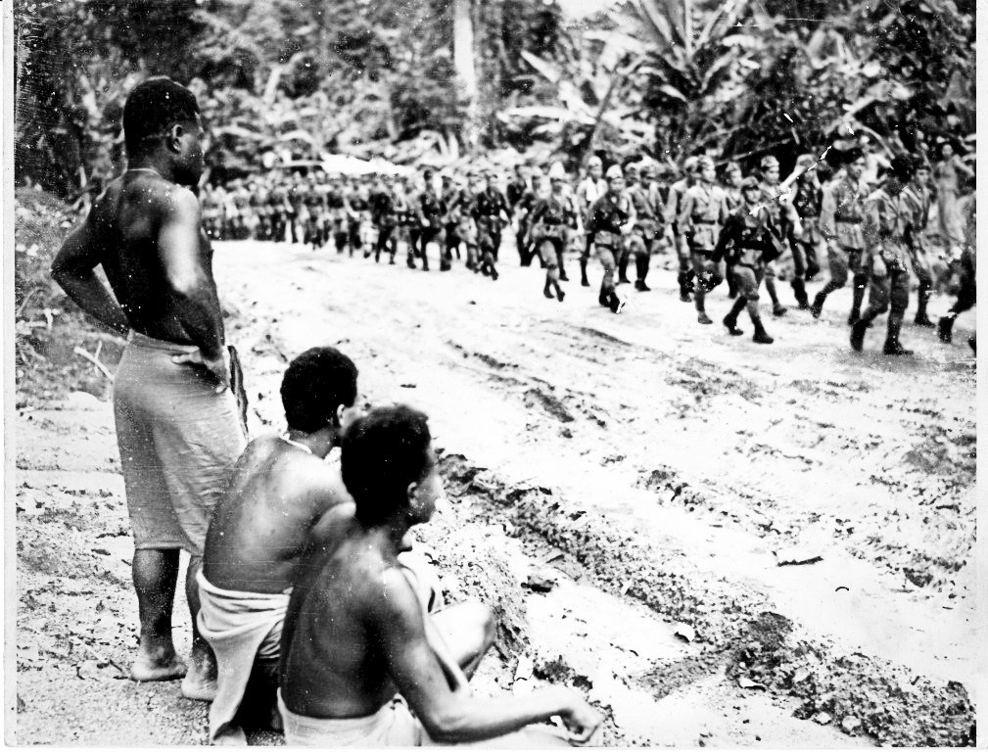
Figure 2. Nauruans watch Japanese troops marching to the embarkation point for repatriation. (USP Nauru Campus archives)

The BPC commissioners explained the basis of their case with a clear statement that labour would be in short supply following an early removal of enemy subjects.¹⁵ A draft cable advised W.V. Bott, one of the BPC commissioners, that the commander of the army on Nauru would be requested to give every consideration to any application requesting labour not needed by the army.¹⁶ The BPC was further advised that any long- term availability of surplus labour, resulting from the retention of POWs, would be subject to the availability of shipping and other administrative factors.¹⁷ Clearly, the army on Nauru looked upon the Koreans as part of

¹⁵ External Affairs to DCGS, Aug. 24, 1945, MP742/1/0 (255/13/944).
¹⁶ Minute Paper Aust Military Forces from DCGS, Aug. 25, 1945, AWM MP742/1/0 (255/13/944).
¹⁷ BPCs to Director Research and Civil Affairs; Dept Army, Aug. 28, 1945,

the occupation force, referring to them frequently as POWs. They were willing to treat them according to the provisions of the Geneva Convention. The BPC, however, won the day by appealing to national interests. The army, for its part, dismantled Japanese fortifications and transferred those considered “Japanese” to Rabaul aboard the HMAS Burdekin where they would be repatriated.
Now with the necessary authority, the BPC started to organise the Koreans in order to rehabilitate the island and its infrastructure.¹⁸ Before any real rehabilitation could be achieved, however, a major health problem loomed, which was due to the Japanese imposition of a policy to retain bodily waste in drums to use as fertilizer to grow pumpkins.
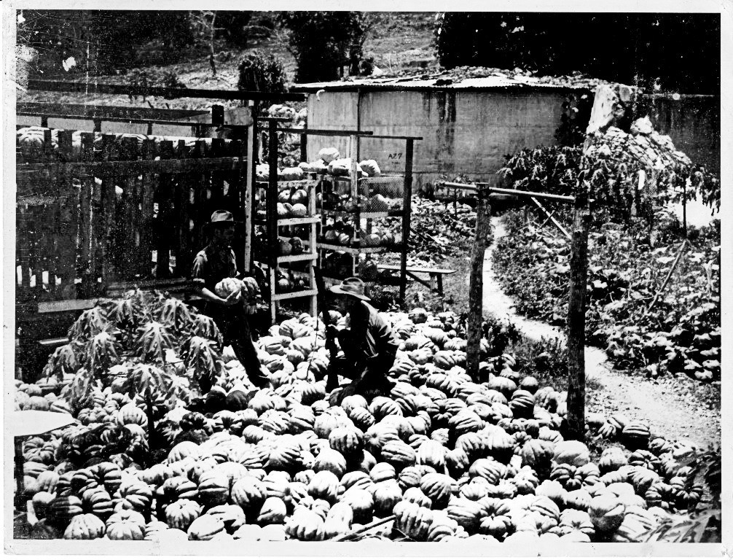
Figure 3. Australian troops inspect pumpkins, the result of Japanese policy administered by Koreans. (USP Nauru Campus archives)

This had resulted in ever-increasing plagues of flies fuelled by the growing swarms of maggots in the drums. This policy had been enforced by exchanging a pumpkin for a bucket of night soil and punishing those

AWM MP742/1/0 (255/13/944).
¹⁸ D of RCA Serial No. 36 to BPC, Sept. 6, 1945, AWM MP 742/1/0.

who failed to collect their night soil. To alleviate the problem, the local population was co-opted to clean up and destroy this potential source of disease.¹⁹ The Nauruans were resentful about this for two reasons. Firstly, the nature of the work was unpleasant, and secondly, it had resulted from a policy in which they had no input, but to which they were forced to conform.²⁰ The general feeling was that the work should be assigned to the Koreans since they had administered it.
When the garrison of “Japanese” prisoners was evacuated, the remaining Koreans were “disarmed” before being mobilized to rehabilitate the island.²¹ The Koreans thus lost direct army protection because their proposed activity was considered to be in line with established convention. For Thomas Cude, Director of Police, the Koreans were not only a source of trouble but evoked great resentment from the local population. Due to the Koreans’ compliance with, or active enforcement of, Japanese policies and actions during the occupation, the Nauruans were unhappy with what they saw as lenient treatment of the Koreans, and this was also expressed in regard to the clean-up of the night soil drums. ²² In addition to the Koreans, Cude expressed his dissatisfaction with the behaviour of certain members of the Australian army, including some officers, which he considered reminiscent of Korean behaviour during the occupation. The Koreans were commandeering (stealing) building materials, while both the Australians and the Koreans were appropriating “toddy” and fraternising with the native population.²³ Fraternisation was strongly disapproved of by the general population and in particular by the chiefs who equated it with a decline in morality. Unlike other Japanese bases in the Pacific, there was no imported “comfort women” system on Nauru, leaving Nauruans deeply concerned for their young women. Prior to Japanese occupation there had even been a rush of marriages, as it was believed this would grant some

¹⁹ For a more extensive account of Japanese activity see Gustav Rash, “Narrative of Japanese Occupation, Nauru Island.”
²⁰ Thomas Cude’s Diary, Sept. 16, 1945.
²¹ “Disarmed” is not clearly defined as to whether it meant actual weapons or simply the heavy sticks Koreans were permitted to carry when supervising Nauruan workers under formal Japanese overseership (satokite); the Koreans tended to carry such sticks most of the time.
²² Thomas Cude’s Diary, Sept. 22-23, 1945.
²³ Toddy is made from the sap of a young coconut tree and can be used as a food or food supplement. If fermented it produces potent liquor, similar to arrack. In Nauruan known as ekarawe.

degree of protection to the young women. During the occupation many young women were kept indoors or restricted to their homes during daylight; women were also encouraged to take measures that might make them appear less attractive. The arrival of the Australian liberating force rekindled Nauruan concerns.
As the military side of the occupation had been completed and the Koreans were now deployed in assisting in re-establishing economic life on the island, the army wanted to be done with the whole enterprise.²⁴ On Oct. 16, 1945, the commander of the remaining occupation forces was instructed to reduce the garrison to a level sufficient to guard the Koreans and any remaining Japanese who had not been removed for whatever reasons. ²⁵ By Nov. 14, 1945, the First Army concurred with the administrator’s recommendations that civil administration should resume on that date, but still had lingering doubts with regards to retaining the Koreans, stating that the fate of the Koreans required settlement. The Minute Paper from the army also clearly indicates that the Koreans who were on Nauru, against army policy, were regarded as Japanese nationals, and that the army desired they be sent to the Solomon Islands and interned with other Japanese POWs for repatriation.²⁶
Even though the BPC was willing to assume responsibility for the Koreans and take over their guarding, food, clothing, and quartering, the army had reservations regarding their responsibility for control and eventual repatriation of the Koreans. Government authority was thus needed to allow the BPC to retain the Koreans, who they said were doing useful work, and this would in turn absolve the army from their perceived responsibility toward the POWs. The army saw the removal of the Koreans as both meeting their responsibility towards the POWs and, perhaps more importantly, it meant that occupation troops could then be moved to the Australian mainland in line with their enlistment.
Although the army forcefully put forward their views, the arguments of the BPC prevailed, and thus the Koreans found themselves working on Nauru producing superphosphate. The authority to retain the Koreans was given by the Minister of the Army on Nov. 19, 1945, in reply to a request from Army HQ of Nov. 16, 1945.²⁷ The minister clearly

²⁴ Dept Army Minute Paper, Nov. 12, 1945. DRCA Serial No 8562, AWM 742/1/0 (255/13/944).
²⁵ Ibid.
²⁶ Ibid.
²⁷ Deputy Chief of the General Staff to Sec Dept Army, Nov. 16, 1945, AWM742/1/0 (255/13/944).

noted the two points of view, but accepted the need for an army platoon to guard the Koreans, as well as a small medical staff. Apart from these two provisos, the Koreans were now the total responsibility of the BPC. The troops were to remain so long as the Korean POWs remained. The medical staff would also remain until the Koreans were removed or civil medical assistance could be obtained.²⁸
Throughout most of December 1945, the BPC and the Directorate of Civil Affairs were in regular contact regarding the Koreans on Nauru. They corresponded regarding the need for a garrison to guard the Koreans and the movement toward full civil administration. They also discussed responsibility for the Koreans’ food and clothing, as well as the transfer of the Koreans to the “location,” the area where contract Chinese labourers had resided before the war when a curfew was imposed at night for control purposes. This was largely formalised in a letter dated Dec. 21, 1945, from the Deputy Director of Military Operations.²⁹
The Minute Paper, however, contains an apparent contradiction in paragraph 2 (b), where Ridgeway, the Administrator, stated that he considered the retention of troops as being necessary for control, but in the next sentence indicated that he saw no difficulty in control by police supplemented by a reserve from their own white staff. In any event it was believed that full civil administration in two to three months could take over full responsibility, excluding medical staff, thus allowing the remaining garrison to be removed. Clearly the BPC would not be responsible for the repatriation of the Koreans, but would assist with shipping to the staging area in the Solomon Islands.³⁰
This Minute Paper seems to have formalised the patchwork of directives into a coherent policy and the Koreans appear to have settled into a regular pattern of work. The army still had lingering doubts as to its responsibility towards the Koreans, however. This concern is clearly highlighted by the army’s request of the BPC to furnish it with a statement of wages and the ration scale applied to the Koreans. The reply on Jan. 22, 1946, from the BPC indicated that the Koreans were paid wages and worked under conditions similar to those of the Chinese labourers who did such work prior to the outbreak of hostilities. The BPC furnished the army with the following rates.

²⁸ Ibid.
²⁹ Minute Paper from Deputy Director of Military Operations, Dec. 21, 1945, AWM MP742/1/0 (255/13/944).
³⁰ Ibid.

Monthly wages³¹

Coolies:

No. 1 Coolies: Commanders:
32/-, plus 4/- bonus by direct conversion, A$3.20 plus A$ 0.40, total A$3.60
32/-, plus 4/-bonus, plus special bonus 6/- by direct conversion, total A$4.20
32/-, plus 4/- bonus, plus special bonus 16/- by direct conversion, total A$5.20

Note that the direct conversion rate takes no account of inflation. As a point of comparison, the average weekly wage (average rate for skilled and unskilled workers) in Australia at the beginning of the war was approximately A£ 4/13/3 or by direct conversion approximately A$37.30, but this rose in 1945 and 1946 to an average of nearly A£ 6/-/- per week, or by direct conversion approximately A$48.00 per month (assuming a four-week month).³² Additionally, depending on skills, “margins” would be paid to skilled workers.
In addition to the wage rates, the BPC advised the following ration rates, again in line with pre-war levels, be supplied to the Koreans. The wages and rations were in addition to any quartering supplied.

Rations³³
tea, 1 oz | fats, 1 oz | vegetables (tinned or fresh), 8 oz
biscuits, 16 oz | fruit (dried), -- | meat or fish (tinned), 8 oz
rice, 16 oz | salt, 1 oz | sugar, 4 oz
potato (dehydrated), -- | vermicelli, 2 oz | peas and beans, 4 oz

As a rider, the BPC stated that when it took over responsibility for the Koreans, they were mostly in rags and consequently were issued two singlets, shorts, or 3 yards of calico cloth per man.³⁴

³¹ Currency at the time was Australian pounds/shillings/pence changing to a decimal system on Feb. 14, 1966. At conversion one Australian dollar equalled 10 shillings or one Australian pound equalled 2 Australian dollars.
³² Approximate figures were supplied by the Referral Service of the Commonwealth Bureau of Statistics.
³³ “Oz” is an abbreviation for “ounce” (1 oz = 28 grams). It is worth noting that the diet seems more appropriate for Europeans than Asians.
³⁴ BPC to Director of Research and Civil Affairs Department of the Army, Jan. 22, 1946, AWM 742/10 (255/13/44). The condition of the Koreans might add weight to Dr. Keke’s strong belief that the Koreans were used as slave labour by the Japanese. As it has been impossible to determine how and where the Koreans

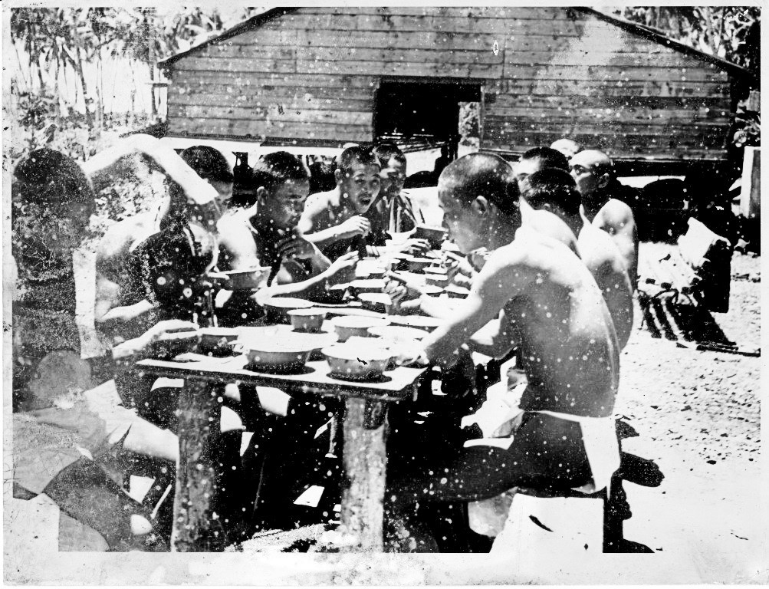
Figure 4. At what appears to be a Korean mess, men are wearing shorts or loincloths, probably supplied by the BPC as the Japanese troops had already been removed and the issue of shorts and calico by the BPC was due to the Koreans wearing “rags.”

Interestingly, while the BPC referred to the Koreans as Korean labourers, the army still seemed to regard them as POWs and pushed for their repatriation. Both parties did agree however on the need to recruit new labourers in order to permit a return to a less-ambiguous situation, while still ensuring the continued supply of superphosphate, a position further highlighted by the DET. Although the DET had been involved from the outset it seemed to have shifted its position more towards that of the army. Even the BPC seemed to have softened its stance. While it was still concerned with national priorities, and also its own profits, it acknowledged that the situation might be difficult to justify and could not continue indefinitely. Whether the softening of the BPC’s position was a morally-based decision or simply an acknowledgement of economic realities is difficult to determine. The reality was that disruptive tactics by

were recruited, however, the use of “slave” becomes problematic, despite Dr. Keke’s observations.

the Korean workers were having an impact. Disruptions by the Koreans were one of the few ways they could express their anger at the apparent lack of progress in relation to their repatriation. Both influences had an impact but it is only possible to guess which was more dominant. The growing inefficiencies of what was supposedly a temporary solution were becoming obvious, as was the potential for disruption. For the Koreans, disruption was a means, perhaps the only means, of pressuring the authorities for repatriation.
Interruptions at the work site by the Koreans during January and February were considered so disruptive that on March 6, 1946, the Department of External Territories stated to the Department of the Army that they “should be glad to learn whether you are yet able to furnish any indication as to when the repatriation of these Koreans is likely to be undertaken.”³⁵ Further disruptions were to occur over the next three weeks, forcing the BPC to contact the army again. On March 22, 1946, it advised the army of a series of cables between itself and the manager on Nauru,³⁶ which summarised the general feeling that the Koreans should be removed to Rabaul by the BPC steamer Trienza, as further trouble seemed probable if they were detained indefinitely.³⁷ To emphasise the point, the department further stated, “Unless definite date removal in the near future given Koreans, agree continuous trouble.” “Consider Koreans would be content if Army informs Administration some definite month their removal Nauru—Rabaul say May or June.”³⁸ The manager on Nauru was then advised that the army had agreed to receive the Koreans when convenient to the administration on Nauru. The BPC, while organising the transfer to Rabaul for June on board the Trienza, authorised the manager on Nauru to assure the Koreans that arrangements were being made for their transfer to Rabaul, where they would await repatriation.³⁹ There, the army would assume responsibility for them once again.
The BPC further advised the manager that the information should be given with the proviso that everything would be subject to the Koreans’ promise of satisfactory work in the meantime.⁴⁰ In a further rider, the

³⁵ Department of External Territories to Dept Army, March 6, 1946, AWM 742/1/0 (255/13/944).
³⁶ BPC to Department of the Army, March 22, 1946, AWM 742/1/0 (255/13/944).
³⁷ Ibid.
³⁸ Ibid.
³⁹ Ibid.
⁴⁰ Ibid.

manager was advised that if he saw a possibility of further trouble, he was to telegraph the Trienza to divert to Rabaul to pick up military guards.⁴¹
Little information is available after the directive regarding Trienza’s diversion, but given subsequent events, it is reasonable to assume the Koreans were moved from Nauru shortly thereafter. On April 12, 1946, the Directorate of Research and Civil Affairs (DORCA) of the Australian Army in Melbourne was advised by the DET that further to its April 8, 1946, message, five or six Europeans would be included as part of the guard for the Koreans.⁴² Then, on April 25, 1946, the army in Rabaul informed Melbourne about the amount of currency held by some of the Koreans there, making it clear that they had been transferred to Rabaul by that point.⁴³ The plan was for the Koreans from Nauru to be held on Rabaul until a general repatriation of Koreans took place in accordance with instructions the army was to receive from SCAP.⁴⁴ The Koreans were to remain in Rabaul until the army was able to arrange repatriation. Given the general lack of shipping and the relatively low priority attached to such a group, it was obvious there could be a considerable time delay. Surprisingly, the Koreans did not remain long in No. 11 GP Camp Rabaul, and were embarked on May 7, 1946, for repatriation.
It has not been possible to find any formal list of the Koreans who were repatriated from Nauru. Up until their repatriation from Rabaul, any information regarding the Koreans was of a general nature, describing the situation in group terms only, but before their repatriation, information regarding some of the individuals was recorded in an unexpected set of documents. The army developed a series of nominal rolls with lists of names and addresses, as well as amounts of Australian currency held by particular individuals that was to be returned to them at a later date. It is only from these and the subsequent corrections that individual information, limited though it may be, can be gleaned.
It is important to note that these rolls were produced as a result of searching those being repatriated prior to boarding the ship. ⁴⁵ As

⁴¹ Ibid.
⁴² Inwards Teleprinter message DRCA Department of the Army Melbourne 3639.28, April 12, 1946, AWM 742/1/0 (255/13/944), Box 78.
⁴³ A Message Mil. Dist. Rabaul to Army Melbourne XB/4871, April 25, 1946, AWM MP 742/1/1 255/3/31.
⁴⁴ SCAP refers to Supreme Commander for the Allied Powers, which was Douglas MacArthur. Army Melbourne to Mil. Dist. Rabaul, April 11, 1946, AWM 742/1/0 (255/13/944), Box 478.
⁴⁵ AWM 742/1 255/3/317. Nominal Rolls 8 pages, 3 Copies. Various Corrections,

repatriation grew slowly closer, the problem of currency in the hands of the Koreans and the limit they were allowed to retain became important to decide. This is somewhat surprising as the amounts held by individuals were small, as was the grand total of all currency held by the Koreans.
Although there were 536 Koreans on Nauru, only 259 of them were listed as having any Australian currency as a result of the search. The largest amounts held by any individual Korean was A£11/-/- and the grand total for the whole group was only A£268/14/-.⁴⁶ The monies represent savings from the wages paid by the BPC in return for the work the Koreans had performed on Nauru. The amounts give no indication of actual wages paid, only the amounts they had been able to save while at Nauru and Rabaul. Since the names cover 48 percent of those on Nauru, one can only assume that those not named had no savings, were more adept at hiding their money, or a combination of both. It is most unlikely they did not work on Nauru. The monies saved, it must be assumed, were what remained after expenditure at the “Store,” the only one on the island, owned and operated by the BPC. The Koreans finally departed Rabaul on May 7, 1946, but without their money, which was left behind in envelopes that were then transferred to Melbourne and recorded in the nominal rolls.
It must be stressed that the information gleaned only covers those named on the rolls. Importantly, it should be noted that in the preparation of the rolls, those collecting information and preparing the data may have been military interpreters, but this is not clear. Given the limited numbers of such personnel in the army, there would only have been few interpreters available to do this work, if any. These were supplemented with Nauruan “interpreters” who had learned some Japanese and who had been returned from Truk and the surrounding islands.⁴⁷ As a result, it is difficult to determine their level of expertise. That the rolls were retyped, on at least four occasions, creates additional problems in that it is often difficult to determine whether what is transcribed shows the actual names, or if what was “initially” recorded is a typographic or romanisation- related error, and if it was changed to a Korean format, on whose decision

May 7, 1946, actual date each roll typed not indicated, all rolls and corrections dated May 7, 1946.
⁴⁶ Ibid.
⁴⁷ Although not mentioned by name in Cude’s diary, Edward Tsitsi would probably have been included, as he was fluent in Japanese and Korean. He learnt his Korean from his overseer while working on vegetable gardens. He was later to become a leader in the movement for Nauruan independence, the drafting of the Constitution, as well as participating in the first government.

this was based. Of the addresses of those listed on the roll, four administrative areas account for 93% of the personnel.⁴⁸ Three areas are statistically significant.

Japanese administrative area as listed on the roll, by percentage
Kogendo 48.5%
Chuseinan 10.8%
Kankyonan 23.2%⁴⁹

Other areas have extremely small numbers of ex-residents, often a single representative, and are not statistically significant. The administrative areas are romanised from the Japanese as it appeared on the roll. Unfortunately, it may not be possible to convert them to modern Korean equivalents with absolute certainty due to the romanisation used by the Australians. Consequently, it is difficult to determine the significance of the fact that the majority came from only three areas.
As the initial roll contained both typing and arithmetical errors, it was decided to have them retyped. The retyped schedules, all under the original date of May 7, 1946, appear as an attempt to correct such errors. When compared with the originals, however, the modified rolls might seem to make the romanisation of the Korean names clearer, but there is still a hint of Japanese influence. This may reflect Japanese officials having adopted “simple” Japanese for the Koreans.

“Original” roll names changed to “Korean”
Cho Kaen Jang ha (?)on
Rhee Hoshoku Rhee Vosik
Rhee Ryuyu Rhee Ryong Woo
Sai Gin Sik Cho(?e) Un Sik
Go Kanru O WhanRyon
Kim Shinkyo Kim JinWook
Go Jido O Shi Hyung
Ken hokum Yum Bong Hun
TeiKeidai Tung Kyu Tai

The above names are rendered as they appear on the rolls, with no attempt made to correct the romanisation; (?) indicates difficulty

⁴⁸ Ibid.
⁴⁹ Ibid. No modern Korean administrative area was given.

deciphering a letter.⁵⁰ Perhaps a glaring omission is that no date of birth is recorded. Such information would have proven invaluable, as would specific birthplaces rather than administrative areas. Although it cannot be proven, the inclusion of Korean names was probably a Korean initiative since it clearly involved additional work for the Australians.
Even though the army in Melbourne knew on April 25 that the Koreans had some currency, probably due to the smallness of individual amounts as well as the meager grand total, they allowed repatriation on May 7, 1946, receiving the nominal rolls, envelopes and other paperwork on May 11, 1946. With the Koreans on the high seas it would be impossible to return any funds and thus the actual currency was forwarded to Melbourne where it was represented by a military voucher, WF 89No2.⁵¹ None of the retyped rolls indicates the date it was retyped, but the change in the exchange rate used in calculations indicates that it was done over a period of time. The rate changed from A£ 1=Y 48 to A£ 1=Y160. There were also a few changes to the spelling of various names, though in some cases the name was totally changed.
With the Koreans in the process of being repatriated and the money in Melbourne converted to military vouchers, the only thing that needed to be decided was how to organise the return of the money to the rightful owners. That the money belonged to the Koreans as part of the payments by the BPC for their work on Nauru was clear,⁵² it having previously been determined that the Koreans were not entitled to the repatriation allowance payable by the Japanese government (suggesting the Japanese didn’t consider them military personnel, or at least had other reasons for non-payment) and the earnings were for work performed after the cessation of hostilities. These facts seem to confirm the status of the Koreans as having been changed from Japanese POWs to that of disarmed personnel, although the army seemed to still hold itself responsible for their repatriation. The army had, it seems, hoped to return the funds through the offices of the British Commonwealth Occupation Forces (BCOF) in Japan.⁵³ If this option was pursued, it would mean retyping the rolls to include the new exchange rate.
Although the retyping was completed, there is no record of the Koreans actually receiving the funds. The army attempted to arrange payment through the fiscal offices of the American military authorities in

⁵⁰ Ibid.
⁵¹ AWM MP 742 255/3/31 EB 4971.
⁵² Ibid.
⁵³ Ibid.

Korea, which required that they be retyped yet again. It was hoped to arrange payment through SCAP channels in Korea. ⁵⁴ A request to implement the proposed plan was submitted to GHQ SCAP on March 17, 1947, by the BCOF in Japan to await a decision.
Once the decision had been made, the result would have been forwarded to Melbourne for action. Unfortunately, it has not been possible to find evidence of any decision. It is possible that SCAP was unable to acquiesce to the request. Therefore, it is not known at this stage if the A£264/7/7 or A$525.75 was returned to the 249 Koreans recorded as possessing currency.
The treatment of the Koreans at Nauru might represent the first real Australian contact with Koreans since the Australian missionaries in Korea had been imprisoned and deported at the outbreak of the Pacific War. It also indicates that, like most other nations, Australia was perhaps willing to bend the rules when acting in its national interest, even while implementing international covenants, although this clearly depends on one’s interpretation. Just how important this contact was is debatable, however, as an overall policy toward a newly independent Korea was being developed, often on the other side of the world. It was a policy in which Australia was to become deeply involved, though its role has been overlooked or dismissed.
This paper set out to highlight the largely unknown fact of the existence of a relatively large number of Koreans on a small island in the Pacific at the end of the Pacific War. Many questions remain, however. The formal status of the Koreans working on Nauru during the Japanese occupation is unclear. Were they a slave-labour force, as believed by Dr. Keke, based on his observations about their treatment, or were they some form of conscripted, indentured, or volunteer force? Their treatment and the work to which they were assigned, particularly in relation to their collecting of night soil, might support Dr. Keke’s belief. Whether they were “slaves” in a formal sense, however, is more difficult to determine, although they were clearly subjected to some form of forced labour. The status of the Koreans becomes more ambiguous when it is noted that they did not receive the one-off payment from the Japanese government to imperial troops at the end of the war. This non-payment might go some way toward clarifying whether they were in any way part of the military, although it might be claimed that it was merely a tactic of the Japanese government to distance itself from the episode. It still fails to determine

⁵⁴ HQ Chief Payments Office BCOF Eta Jima to Army HQ Melbourne, Aug. 26, 1946, AWM 742/1 255/3/317.

definitively if they were slave labour or some conscripted or coerced labour force that was badly treated or even volunteers who received discriminatory treatment.
The main focus of this paper, the recruitment of Koreans as labourers by the BPC and their delayed repatriation, makes clear that the Koreans’ ambiguous status continued after the end of the war. The Australian army often acted as if they were POWs, but relinquished control of them to the BPC for use as “civilian” labourers. Complicating things further, it is not even clear if the Koreans were compensated for their work, and it may not be possible to determine if the Koreans received the monies they were owed. They did, however, leave a legacy on the island. It is known that Koreans fathered at least two children and that their descendants are among the present Nauruan population. At least one mother was punished on her return to Nauru by being imprisoned and by having her hair cut.
Ultimately, rather than clarifying the actual status of the Koreans on Nauru, this paper has suggested a series of possible answers which require further investigation, and has opened up the possibility of an additional area of study.

Dr. Ron Munro, PhD (A.N.U.), is founding treasurer and member of the Korean Studies Association Australasia (KSAA). Alamanda Roland Lauti is director of the University of the South Pacific, Nauru Campus, Republic of Nauru.
The writers acknowledge the encouragement, assistance and suggestions provided by Dr. L. Keke during the writing of this paper, the support of staff at the Nauru Campus of the University of the South Pacific, the Nauru Consulate-General in Brisbane who greatly assisted the research, and last, but not least, Ms. Briar-Rose Alona, a doyen of Nauruan historians and a true living treasure.

