School Records Under Japanese Rule:

A Fragment from Gilsang Elementary School, Onsuri, Ganghwa Island, 1920-45

Russell Kelly

I began teaching English language at Gilsang Elementary School in April 2017. As a historian, I became interested in learning about the school’s past, particularly after finding some old photographs hanging in one of the stairwells and a brief history timeline displayed in the school foyer. From this I learned that the school had been established in 1920, and I wondered if there were written records stored away somewhere. Firstly, I enquired at the Ganghwa County Office as to whether they held education archives, to which the answer was no; the school would have old records if they existed. I then enquired at the school office and a senior teacher unlocked a cupboard and produced an old record book written in Hanja.
The book contains 27 pages with 12 columns of about 19 characters. The first record was written in 1920 and the last in 1945, a period of 25 years. Records of staff changes run through the whole period from 1920 to 1945, but student records run only from 1920 to 1934. There is no explanation for this cessation.¹
In 2018, Kim Hai-yin, a doctoral student at the Academy of Korean Studies, translated the contents from Chinese characters (Hanja) to both Hangeul and English. Without her considerable efforts, carried out during her own studies, this record book would have remained an unread artefact in a dark cupboard.
As a record of a rural Korean school under Japanese educational administration, this record book is an important piece of tangible heritage containing revealing information on school management during that period.

¹ The book is divided into 13 sections: General Information; Facilities; Expense Balance Budget; Basic Property; Donations; Class Organization; Class Subject Changes; Staff changes; Student numbers; Activities; Committees; Inspectors; Inspections

Using these primary records to slot into the historic events of the time I have sorted the records chronologically to produce a clearer picture of the school year cycle.
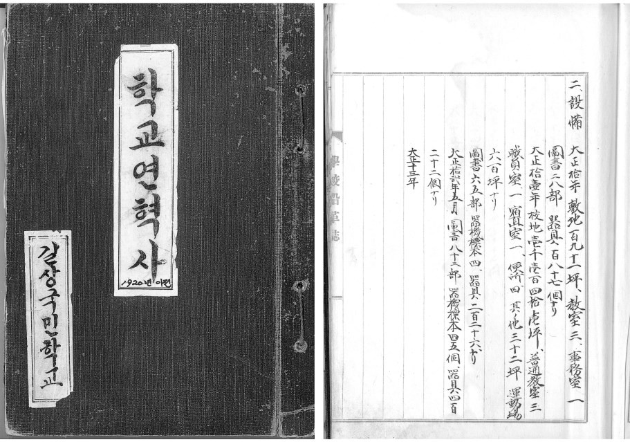
Figure 1. The cover of the record book with the title written in hangeul (left), and a typical page of the record book written in hanja.

First Christian school at Onsuri

Onsuri is a small rural town in the south of Ganghwa Island in the township of Gilsang. It sits at the crossroads below, and just northeast of, Mount Jeongjok, site of the ancient hill fortress Samnang Fortress, an ancient mountain fortress which contains the temple complex of Jeondeung Temple. British Anglican missionaries arrived in Onsuri in 1898, and in 1906 a hanok-style Anglican church was constructed by Bishop Mark N. Trollope and a rectory by Reverend Frederick Richard Hilary.² Soon after the construction of the church, in the same year, the Anglicans established a school which was named Jinmyeong. Reverend Hillary was at the school during his term at Onsuri from 1904 to 1909 and was instrumental in founding the school and establishing the curriculum.

² Anglican Bishop Charles John Corfe had built the first hanok-style church in Ganghwa town in 1900 with the help of a royal architect.

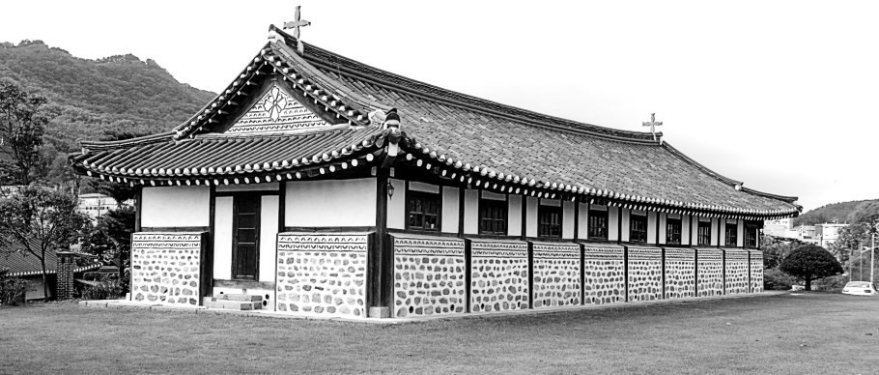
Figure 2. The Anglican church at Onsuri, built in 1906. Jeongjoksan and the ancient Samrangseong in the background.

Chronological sequence of events³

1920: In early 1920, 14 years after its foundation, the Anglican-run Jinmyeong school was transferred to Japanese administration. On May 1, 1920, the school was officially approved to be managed by the Japanese colonial administration and renamed Gilsang Public Elementary School.⁴ On June 19 the first Japanese school principal, Shoda Minokichi, was appointed. He was followed four days later by the appointment of a Korean teacher, Go Seong-rok, who would become the longest-serving teacher, retiring in 1937 after 17 years’ service.
On 10 July, the school was founded on the site of Jinmyeong private school in the shadow of Mount Jeongjok and Samnang Fortress. At this time there were 83 students, all boys, in first and second grades. The school was established with a four-grade system—there were no third- or fourth-grade students at the time of foundation. The last event of note for this school year was the appointment of Korean teacher Hwang Jong-seok on Dec. 1.
A general note explained some routine school activity. Every Monday after class there was a staff meeting and on Wednesdays there

³ Note that I have arranged the sequence by calendar years, but the school year ended and started around March 31 each year and hence graduations and staff replacements took place at that time.
⁴ Its name in Korean was 길상공립보통학교.

was a meeting for researching teaching material. Research results were presented once a semester. There was also a school excursion on an appropriate day every May. The end and start of the school year was on or around March 31, as on this date teachers and staff usually moved in or out.

1921: It was noted that the school site measured 191 pyeong,⁵ a little over 630 square meters. On it sat three classrooms and an office. Resources included 28 books and 187 “instruments” or “tools.”⁶ The expense budget balance was 4,903 yen. Korean teacher Yu Tae-ok was appointed on March 31.
The school year started with three classes—first, second and third grades. There were now three Korean teachers and the Japanese principal with 195 registered students (see Table 1)—it would seem that class sizes were enormous; 11 students were “expelled.”⁷
During this year, a new building with four classrooms was built, at a cost of 7,900 yen. In April the girls’ department was established with first-grade students and on April 24 the boys’ department was moved to the new building. It was noted on June 3 that the school committee consisted of five Koreans, probably members of the local community: Kim Yeong-baek, Kim Yeong-ji, Shim Hoon-taek, Hwang Myeong-yeong, and Hwang Yeong-jo.

1922: On Feb. 1, another Korean teacher, Gang Geon-heum, was appointed. The school site was increased to 1,141 pyeong, about 3,772 square meters, a sixfold increase in area. The playground was 600 pyeong (1,984 square meters). Facilities noted were three general classrooms, one office, a night duty room and four toilets—no mention was made of the new building of four classrooms, although an enigmatic note under the facilities section stated, “the rest was 32 pyeong” (106m²), and could be referring to the new building. Resources consisted of 65 books, four

⁵ A pyeong is a Korean form of measuring land or floor area; 1 pyeong = 3.3m².
⁶ The translator notes: ‘I’m not sure what this ‘instrument’ (기구; 器具) means, because 器具 (기구) can be tools, plates, facilities, etc.’
⁷ The term ‘expelled’ is translated from 퇴학아동, which is the Korean term used
these days for ‘expelled child’. The large numbers of students recorded as ‘expelled’ in the school records suggests that at that time the term meant ‘left the school’ or were ‘de-enrolled’ for whatever reason. The original Chinese term in the records,退學兒童, translates more clearly as ‘withdrawal from school’.

equipment samples⁸ and 226 instruments. In May the resources were increased to 82 books, 45 equipment samples and 422 instruments. The expense budget balance for 1922 was 6,105 yen.
There was another leap in the student cohort with an intake of 124, bringing to 297 the number registered; 44 students were expelled. With four teachers plus the principal, this was still a considerable class size to cope with. To alleviate this, the first- and second-grade boys started a double-shift school system and subjects were changed; the other classes followed the normal system. The school year had started with five classes, although which grades these were was not recorded—there were now first through to fourth grades. On Saturday, March 25, a ceremony was held for the award of “study certificates,” for which an amount of 22 yen was donated. A sports day was held on Sunday, Oct. 29, for which an amount of 39 yen was donated.

1923: March saw the school’s first graduation ceremony, for which an amount of 40 yen was donated. Thirty-one fourth-grade boys graduated from the school. There would not be another graduation until 1926 due to the implementation of a six-grade system.
The school expense balance budget was 5,791 yen. In April two more central classrooms and employee housing were added at a cost of 5,490 yen.
The number of students registered for this school year was 335, with an influx of 103 students entering and 44 students expelled. There were now six classes and the subject of “agriculture” was added to the fourth-grade curriculum. At this point there were no fifth or sixth grades. On March 31 part-time teacher Park Yeong-taek was appointed, followed on April 30 by part-time teacher Yu Byeong-gyu who “moved in”, and on May 1 teacher Kim Geon-hee was appointed. Apart from the Japanese principal, the school now had seven Korean teachers: five full-time and two part-time.

1924: On March 23, the ceremony for awarding study certificates was held for which an amount of 28.52 yen from parents or community leaders was donated. On March 31 the first Japanese teacher was appointed, Sudo

⁸ The translator notes: Í’m also not sure. 기기 (器機) means machine or equipment and 표본 (標本) means sample or specimen. So I translated 기기표본 (器機標本) to ‘equipment sample’, but I don’t know what it exactly means.

Kingo. A further 108 new students entered the school.
The expense budget was 8,427 yen for the new school year. This year saw some big changes to the class structure and curriculum. From April, the grade system was changed from four grades to six grades, class times were extended and the subjects of history and geography were added.
A clearer picture of class distribution was recorded for this year: Class 1 consisted of first-grade boys; Class 2, second-grade boys; Class 3, third-grade boys; Class 4, fourth-grade boys; Class 5, fifth-grade boys; Class 6 comprised first- and second- grade girls; Class 7, third- and fourth-grade girls—a total of seven classes for 417 registered students. During this year, 45 students left the school. Note that at this point there was no sixth grade due to the increase in the grade system. Consequently, there would be no graduations until 1926.
In June, school committee member Seo Byeong-seung was appointed. On Nov. 1, teacher Yu Tae-ok moved out, to be replaced by a Japanese teacher, Kenno Chiyo, appointed on the same day. During November, three classrooms were added to the southern part of the school, the cost not recorded. All of the girls’ department then moved to this new school building.

1925: On March 31, teacher Shin Yeong-su was appointed. The student ranks swelled to 457 with the intake of a further 144 children. During this year 88 students would leave the school for reasons not stated. The school expense balance budget was 10,336 yen.
On Aug. 31, teacher Yu Gap-jun was appointed, replacing Gang Geon-heum who left soon after, on Sept. 9.

1926: In March 1926, the second graduation was held, with 30 boys graduating from sixth grade. This was a significant milestone for the school, as it was the first graduation since 1923 and the first for sixth-grade students. Also, the number of students enrolled reached its peak at 512 children with 152 new enrolments, and during the year withdrawals also peaked, with 96 students leaving school. The school expense balance budget was 10,241 yen.
The year 1926 was also a busy one for staff changes. On March 31, teachers Hwang Jong-seok, Kim Geon-hui, and Yu Gap-jun (who had served only seven months) moved out. They were replaced by teachers Yu Ik-su on March 31 and Gu Bok-seo and Seo Ae-hui on April 15. On June 15, Yu Byeong-gu moved out, to be replaced on June 28 by teacher Park

Heon-byeong.
On Nov. 8, Japanese teacher Sudo Kingo died in service. On Dec. 26, part-time employee Kim Byeong-ryong was appointed, presumably as a replacement for Sudo.

1927: Another milestone saw the first girls graduating in March—21 of the 62 sixth-grade graduates were girls (see Graph 2). There were 499 students registered this year, with an intake of 152 and a withdrawal of 56 students. The school expense balance budget was 8,944 yen.
Staff changes for 1927 saw three teachers moving out and three moving in. Shin Yeong-su left on Feb. 28, followed on March 31 by Kenno Chiyo. Teacher Lim Su-bok was appointed on April 1 and on 10 July, the school’s seventh anniversary, part-time employee Kim Byeong- ryong moved out, having served just seven months. The school was now two teachers under-staffed, which was not remedied until Sept. 1 with the arrivals of Seo Jung-seol and Lee Hyeon-suk.

1928: The fourth graduation ceremony saw 75 graduates—61 boys and 16 girls. The number of students registered for the new school year was 453, with an intake of 115 and those withdrawing, 76. The expense balance budget for the year was 8,763 yen.
Staff changes for 1928 saw teacher Yu Ik-su move out on March 31 after serving two years, and also on that day, teacher Lee Hyeon-suk retired. The next day, April 1, teachers Heo Sun-gyeong and Sugiwara Yasuo were appointed. Teacher Seo Ae-hui moved out on Aug. 31.

1929: Seventy-nine sixth-grade students graduated—68 boys and 10 girls. The new school year saw 421 registered students after an intake of 101 and 50 having withdrawn.
There were no staff changes during 1929. Including the principal, there were eight teachers, two of whom were Japanese. There was, however, a change in the school committee with the appointments of Namgung Seol, Jo Nam-gyu, and Kim Yeong-sik. The school expense balance budget was 8,452 yen.

1930: Seventy-two sixth-grade students graduated—62 boys and 10 girls. The new school year saw 426 registered students after an intake of 105 and 50 having withdrawn. Teacher Heo Sun-gyeong moved out on Oct. 20, to be replaced by Oh Bong-sun on Nov. 1. The school expense balance budget was 8,909 yen.

1931: Eighty-one sixth-grade students graduated—62 boys and 19 girls. This graduation ceremony, the fifth, was the largest in total number graduating. The new school year saw 382 registered students after an intake of 106 and 51 having withdrawn. The school expense balance budget was 9,490 yen. On March 28, teacher Seo Jung-seol moved out and on the 31st, teacher Sugiwara Yasuo took a “leave of absence,” the same day that teacher Kim Sang-bong was appointed. Another replacement teacher, Yamamoto Iwaoki, moved in.
On Sept. 18, the Japanese Kwantung Army staged the Manchurian Incident, which prompted the invasion of Manchuria by Japan. This set the stage for a war with China six years later that would ultimately engulf the entire Asia-Pacific region.

1932: Seventy sixth-grade students graduated—57 boys and 13 girls. The new school year saw 366 registered students after an intake of 106 and 65 having withdrawn. Teacher Kim Sang-bong moved out on March 31, replaced by teacher Jin Gi-beom, who moved in on April 12. Teacher Park Heon-byeong moved out on Nov. 15, replaced on Nov. 27 by teacher Jo Byeong-cheol. Kim Geon-cheol was appointed to the school committee. The school expense balance budget was 8,022 yen. This was the last such record concerning the school budget.

1933: Seventy-two sixth-grade students graduated—63 boys and just nine girls. The new school year saw 382 registered students after an intake of 92 and 48 having withdrawn. This was the last record of student numbers. Teacher Yamamoto Iwaoki took a “leave of absence” on March 31, the same day that teacher Oh Bong-soon moved out. Both teachers were replaced in May by teachers Momosou Kenji and Ham Eun-seok on May 2 and 16, respectively.

1934: Fifty-three sixth-grade students graduated—42 boys and 11 girls. This was the last record of graduations entered in the book. On Aug. 31, teacher Jeon Jeon-ryeol moved in to replace teacher Momosou Kenji who moved out on Sept. 7.

1935: Teachers Jeon Jeon-ryeol moved out on March 31 and Lim Su-bok on April 8. They were replaced on March 31 by teachers So Jin-chan and Kunijiki Kutarou. So Jin-chan served only until July 16, being replaced by teacher Yang Dae-jong on Aug. 28.

1936: After 16 years of service, school principal Shoda Minokichi retired on March 27, followed by teachers Jin Gi-beom and Ham Eun-seok, who moved out on March 31. The new head teacher, or principal, was Echi Michio who moved in on March 31 along with part-time employee Seo Won-ja and teacher Lee Hyeon-gi.
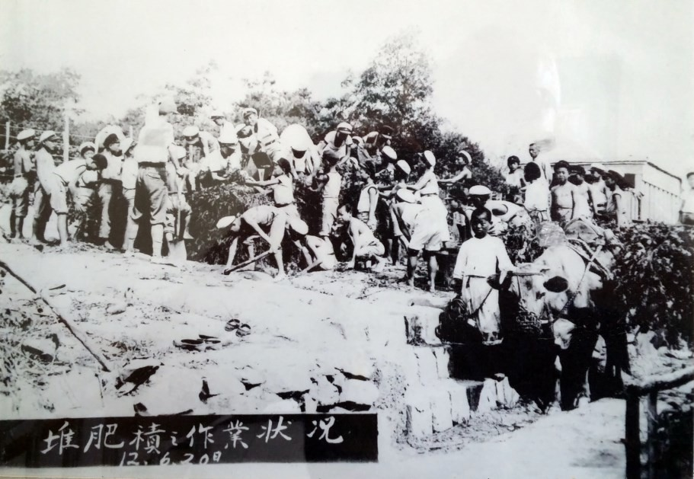
Figure 3. The earliest photo on display at Gilsang Elementary School. Taken on June 20, 1937 (‘Showa 12’), the caption translates as ‘Making a compost pile, yo heave ho, yo heave ho! Making fertiliser.’ Of note are the two types of military-style school caps worn by the boys. Two teachers are evident; one in the left foreground wears obvious Japanese clothing and is likely teacher Kunijiki Kutarou. The other teacher stands in the background on the right and may be the principal, Echi Michio. Including the boy with the bullock, 38 boys are visible. Presumably the students are generating this fertiliser for the school farm—the subject of agriculture had been on the school curriculum since 1923. To this day, Gilsang Elementary School still has a small farm tended by all grades, from 1st to 6th, growing all kinds of vegetables, such as corn, lettuce, sweet potatoes and tomatoes.

1937: After 11 years of service, on April 4, teacher Gu Bok-seo died. On April 30, after 17 years of service, teacher Go Seong-rok, the last remaining of the founding staff of 1920, retired. On June 22, Kim Yong- hyeon moved in, initially as a part-time employee, but served as a teacher

from June 30, 1938. On July 7, fighting broke out between Japanese and Chinese troops in China, setting off the Second Sino-Japanese War.

1938: Teacher Kunijiki Kutarou and part-time employee Seo Won-ja moved out on March 31, the same day that teacher Kubota Shinji moved in. On May 25, Eom Gyu-jeong was appointed, initially as a part-time employee, but served as a teacher from Dec. 28, 1939.

1939: Teacher Kim Yong-hyeon retired on March 15. Teachers Lee Hyeon-gi and Kubota Shinji moved out on March 31, replaced by Lee Hyeon-suk and Ishi Tsunehiko. Teacher Yang Dae-jong moved out on May 2. On Sept. 1 teacher Ishi Yoshio was appointed, followed on Sept. 16 by part-time employee Kidoyo Shiko.
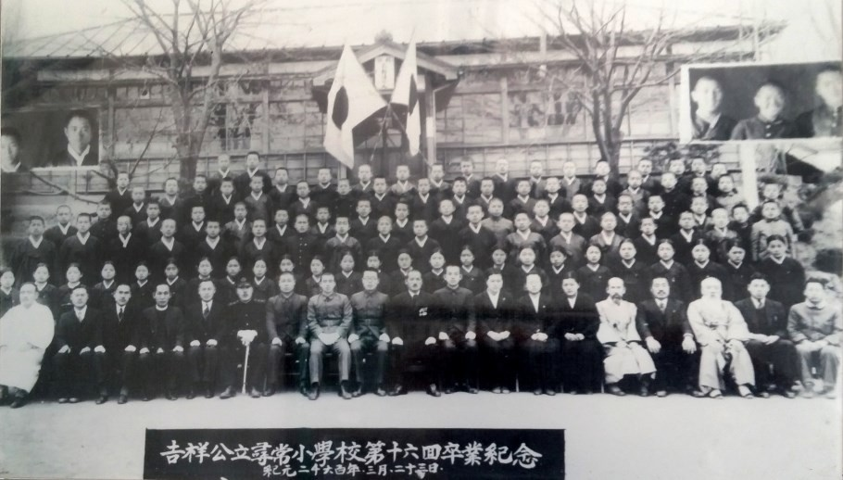
Figure 4. The 16th graduation of Gilsang Public School students on March 23, 1940. There are seventy-six boys and twenty-five girls appearing as graduates behind nineteen adults – sixteen men and three women – of whom seven were staff members. The head teacher, or principal, at this time was Echi Michio, likely the man in the center (with medals). Other teachers at this time, and also likely in the photo, were Jo Byeong-cheol, Lee Hyeon-suk, Eom Gyu-jeong, Ishi Tsunehiko, Ishi Yoshio, and part-time employee Kidoyo Shiko. Others identifiable are a priest (front row fourth from left); possibly a school inspector or local policeman (front row sixth from left); and perhaps other senior members of the local community (front row left and right).

1940: On March 31, teachers Eom Gyu-jeong and Lee Hyeon-suk moved out, replaced by newly appointed part-time employees Shiroyama

Shoomori and Nishihara Keiai who would become full teachers on July 1, 1941, and March 31, 1942, respectively. On May 6, principal Echi Michio moved out, replaced by principal Ishiwara Shigeyoshi on May 9. On June 6, teacher Ok Jeon-seong was newly appointed. On July 20, teacher Jo Byeong-cheol moved out. On Sept. 13, teacher Iwada Junichi moved in.
On June 27, a Youth Special Training Centre was established at the school. Later, an Oct. 26, 1942, ordinance (Joseon cheongnyeon teukbyeol yeonseong) from the Japanese Government General would mandate the establishment of Joseon Youth Special Training Centres in “every municipality, village district, and township” for the training of male youth for future possible military induction. However, such centres had existed in smaller numbers since 1929, and this one at Onsuri was one of them, opened two years before the 1942 ordinance. Even though the Centre was located at the school, male primary school students attended only after graduation.⁹

1941: On Jan. 25, teacher Iwaoka Chiaki moved in. On March 1, teacher Ishi Tsunehiko left to join the army. On March 31, teacher Ok Jeon-seong was “despatched to Hamgyeongnam-do.” The same day two teachers moved in and one was newly appointed: Matsumoto Shigeo, Miyamura Shigenori, and Ooyama Sumiko. On April 22 part-time employee Shiroyama Sadako was newly appointed, becoming a full teacher on Aug. 31, 1942. On Oct. 30 teacher Shiroyama Shoomori retired, as did Iwada Junichi on Dec. 30.
On Dec. 8, the Japanese declared war on the U.S., the British Empire, and the Netherlands by launching military assaults on Hawaii and the European colonial possessions Hong Kong, the Philippines, Malaya, Burma, the Dutch East Indies, and New Guinea.

1942: The year 1942 saw numerous staff movements. Part-time employee Kidoyo Shiko retired on Feb. 28. Teacher Ishi Yoshio took a “leave of absence” on March 31, the same day that Iwaoka Chiaki moved out and teachers Nishihara Keiai and Miyamura Shigenori retired. That day also saw teachers Matsumara Kosuke and Arai Junman newly appointed as replacements. The next day part-time teacher Ishimura Ben was newly appointed. On April 15, part-time employee Kaneko Zaihan was newly appointed and on April 23 part-time teacher Shozo Uematsu was newly

⁹ Takashi Fujitani, Race for Empire: Koreans as Japanese and Japanese as Americans During World War II (Berkeley: University of California Press, 2011), 273-76.

appointed. On May 11 part-time teacher Hirayama Eiichi was newly appointed as was teacher Nakanishi Ichiro on May 31. On Oct. 30 part- time employee Kaneko Zaihan retired after only six months of service. On Nov. 24 part-time employee Ooshiro Shookai moved in as a replacement. Staffing, as a result of all these comings and goings, reached a peak of 11, which would be retained until the last year of these records in 1945.

1943: On Jan. 18, part-time teacher Tsukishiro Junichi moved in. On March 31, teachers Matsumoto Shigeo and Ooyama Sumiko, who had started together in 1941, and also teacher Nakanishi Ichiro, moved out. Also that day, teacher Matsuoka Masaomi moved in. On June 5 part-time teacher Yu Tae-hyeon moved in. On Sept. 30 part-time teacher Shozo Uematsu retired. On Nov. 30 part-time employee Mine Fumiko was newly appointed.
A donation of 200 yen for a new school flag was received from Jinno Motoikin of Busan. Something more telling of the times was a donation of 350 yen from a financial institution in Onsu village for Youth Training Centre firearms.¹⁰

1944: On March 7 a Young Women’s Training Centre was set up at the school. This was for the training of girls of marriageable age, which at this time was from about 15 years of age.¹¹
On March 31, part-time teacher Hirayama Eiichi moved out. On that day teacher Kanemoto Sheiko moved in and teachers Nagakawa Narako and Oohara Yoshimune were newly appointed. On May 15 teacher Arai Junman moved out. Teacher Kanemoto Sheiko retired on Nov. 30.
With the U.S. capture of the Marianas in July and August, the Japanese home islands came under threat. The Japanese prime minister and cabinet resigned. In November, U.S. bombers flew from Saipan to bomb Tokyo.¹².

¹⁰ A search of the Governor General Gazette at the National Library of Korea website found the term 溫水金融組合 金星學濟 twice in articles dated July 2, 1942, which were indexes of various financial institutions; the term translates rather vaguely as “Onsu Village financial combination.” Accessed July 13, 2019, https://www.nl.go.kr/NL/contents/N20302010000.do.
¹¹ Fujitani, Race for Empire, 273-76.
¹² “Pacific War: The Central Pacific Islands.” Brittanica. Accessed Aug. 9, 2019. https://www.britannica.com/topic/Pacific-War/The-Central-Pacific-Islands

1945: On Jan. 25, part-time employee Mine Fumiko retired, replaced the next day by part-time teacher Shozo Uematsu. On March 31 teachers Matsumura Kosuke and Matsuoka Masaomi moved out. That day also saw teachers Yu Jung-seon and Tokuyama Zunwa move in, teacher Tanaka Heikyu newly appointed, and part-time employee Eshima Harumoto move in. On April 18 teacher Takayama Fumimoto moved in and on April 26 another teacher moved in.¹³ On May 1, part-time teacher Tsukishiro Junichi “took a leave of absence to join the group.”¹⁴ On May 12 a part- time employee was newly appointed.¹⁵ On June 30 teacher Nagakawa Narako retired—this was the last record of staff movements.
On Sept. 24, three weeks after the formal Japanese surrender on Sept. 2, Gilsang national school was established, coming under complete Korean control and management for the first time.

1946: The last record in the book simply stated that the Dong-geom branch school of Gilsang Public Elementary School was established. The occupation was over and a new national era had begun.

Conclusion

The first thing of interest is the student enrolments (Graph 1). There was a steady yearly increase in student registrations from 83 students in 1920, peaking in 1926 at 512 students. As a comparison, the modern yearly registrations from 2017 to 2019 were about 240 students. This suggests a much greater young rural population then than now and indeed, figures from 1960, admittedly a much later date, put the rural Korean population at around 14 million, compared to 3.4 million in 2008.¹⁶
Looking at the figures for “Entered,” “Registered,” and “Expelled,” it can be seen that they do not add up. Firstly, the number expelled could only have been recorded at the end of the school year, so for instance, taking 1920 and 1921 as an example, this is how it adds up:

¹³ The teacher’s name, 趙漢梅理, was not romanised.
¹⁴ Translator’s note: 입단 (入團): 입 means ‘join’, 단 means ‘group’; such as, 극단 (theatre troupe) and 사단 (army group). So 입단 means ‘join the specific group,’ but there’s no information about which group it was so I guess it means ‘joining the army’ in this context.”
¹⁵ The part-time employee’s name, 日朴容字, was not romanised.
¹⁶ Chul-Kyoo Kim, “Changing Rural Communities,” in Social Change in Korea
(Seoul: Jimoondang, 2008), 62.

83 students were registered in 1920; 11 left the school (expelled) as recorded in 1921, leaving 72; then 67 students entered, which should total 139 registered students; however, the number of students registered in 1921 was 195, a difference of 56 additional students. It is not clear how to reconcile these figures. The answer may lie in the number of students entering and registered and what those terms mean. “Entered” may refer to new starters in first grade and “Registered” may refer to not only students continuing from the previous year and the new starters, but also older students entering who had previously not been in the school system.
How many girls attended school? The school, as handed over by the Church of England, started with 83 boys, enrolled in 1920. The following year the girls’ department opened and girls were enrolled. Unfortunately, there is no record of separate numbers of boys and girls. However, from later graduation numbers it could be assumed that girls represented anywhere from 13 percent to 34 per cent of the student body. For instance, in the first graduation containing girls in 1927, 41 boys and
21 girls graduated, representing 34 percent of the total 62 graduates (Graph 2). These were the girls who had likely started school in 1921 when the girls’ department opened. This number would remain the highest number of female graduates in the record book.
During this period, Gilsang was a segregated school, with the girls taught different subjects than the boys. Regardless, this was an indication of the changes that had occurred in Korean education which, for the first time, presented country girls with opportunities for higher education. With a base in formal education these young women, upon graduation, could conceivably enter high school in the larger cities. In any case, the fact that rural Korean children at this time were receiving a structured education and graduating from the system was a very positive development in Korean education, despite it being under the auspices of a colonial administration.
Staffing is of interest. Firstly, the school always had a Japanese principal—three during this period 1920-45. Beginning in 1924 there was usually an additional Japanese teacher permanently on staff with the odd short gap—the 1927 school year, for instance, did not have a Japanese teacher on staff and again briefly in 1934. Staff numbers increased gradually over the years from three in 1920 to eleven in 1944 (Graph 3). Note also that the staff turnover rate increased dramatically from 1939 to the end of records, with 37 staff coming in and at least 30 leaving, in a space of seven years. This was about equal to the staff turnover from 1920 to 1938, a space of 18 years, which saw 39 staff arrive and 32 leave.

From 1939 there was, apparently, an explosion of Japanese teachers on staff. Of the 37 teachers recorded moving in, 33 had Japanese names. However, almost all of them were Koreans. In 1939, the Government-General had issued Ordinance 19 followed by Ordinance 20 in 1940, known as Sōshi-kaimei, implementing a name change policy by the Japanese for Koreans.
Although not a mandatory requirement, “… without a Japanese name citizens could not enter schools, get jobs, or obtain ration cards. The government stopped issuing permits and postmen stopped delivering packages to those with Korean names. However, many Koreans built into their new names ingenious reflections of their Korean name, hometown, or a significant family attribute.”¹⁷ Certainly any Korean employed by the colonial authority was obliged to comply, albeit with creativity. Common patterns adapting Korean names to Japanese can be detected in the many teachers’ Japanese names, such as Kanemoto Sheiko, Matsumara Kosuke and Takayama Fumimoto.
Finally, the details this school history book affords for the Japanese colonial period of education are an invaluable historical asset not just for Gilsang Elementary School, but for Korean education and academia. But questions arise; how many other Korean schools have old record books or old photographs? In Korea, schools retain their own records which are not held in central archives. Moreover, with routine staff turnover every five years, historical knowledge about individual schools is not retained, other than by the memories of older members of the local communities. A government-funded project to conduct a nationwide audit of school historical records could provide a new window into the educational history of Korea.

¹⁷ Kang, Hildi. Under the Black Umbrella: Voices from Colonial Korea, 1910- 1945. Ithaca, N.Y.: Cornell University Press, 2001, 117-122. Quoted in “How Koreans Chose Japanese Names,” Far Outliers (blog), Dec. 20, 2005. http://faroutliers.blogspot.com/2005/12/how-koreans-chose-japanese-names.html.

Table 1. Student numbers, 1920-34, Gilsang Elementary School

Year | Entered | Registered | Withdrew | Graduated
 |  |  |  | Boys | Girls | Total
1920 |  | 83 |  | 0 | 0 | 0
1921 | 67 | 195 | 11 | 0 | 0 | 0
1922 | 124 | 297 | 44 | 0 | 0 | 0
1923 | 103 | 335 | 44 | 31 | 0 | 31
1924 | 108 | 417 | 45 | 0* | 0 | 0
1925 | 144 | 457 | 88 | 0* | 0 | 0
1926 | 152 | 512 | 96 | 30 | 0 | 30
1927 | 153 | 499 | 56 | 41 | 21 | 62
1928 | 115 | 453 | 76 | 61 | 14 | 75
1929 | 101 | 421 | 50 | 68 | 10 | 78
1930 | 105 | 426 | 50 | 62 | 10 | 72
1931 | 106 | 382 | 51 | 62 | 19 | 81
1932 | 106 | 366 | 65 | 57 | 13 | 70
1933 | 92 | 382 | 48 | 63 | 9 | 72
1934 | No record | No record | No record | 42 | 11 | 53
*The four-class system changed to a six-class system, therefore there were no graduates in 1924 or 1925. Records of student numbers inexplicably ceased from 1934, despite other records continuing to 1945.

Graph 1: Student enrolments, 1920-34, Gilsang Elementary School. There were 101 graduates in 1940 (see Graph 2).
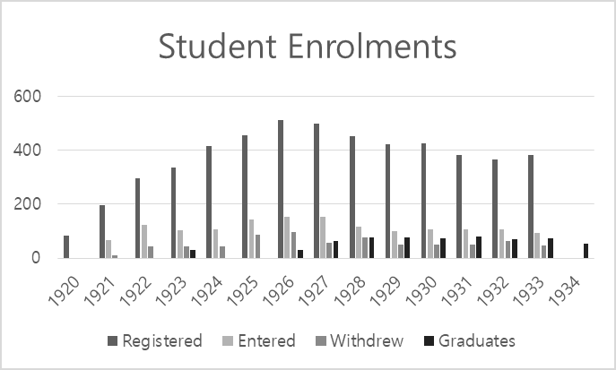

Graph 2: Graduates, 1920-34, Gilsang Elementary School. Percentage on the right is for girls as a percentage of total graduates. Figures for 1940 can be taken from the graduation photo comprising 76 boys and 25 girls.
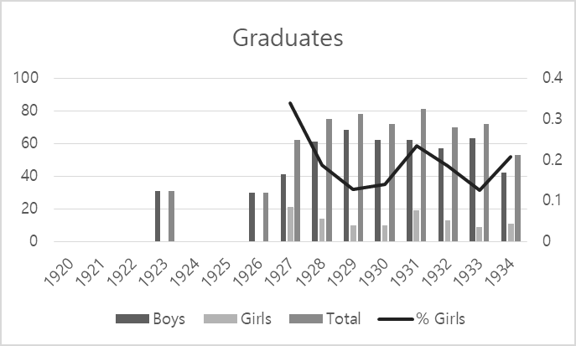

Graph 3: Staff Movements. This does not include 1945 due to the uncertainty of the figures, although there were definitely recorded five staff who moved out and eight who moved in. There are six staff members, including the principal, who do not have a ‘moved out’ record for 1945.
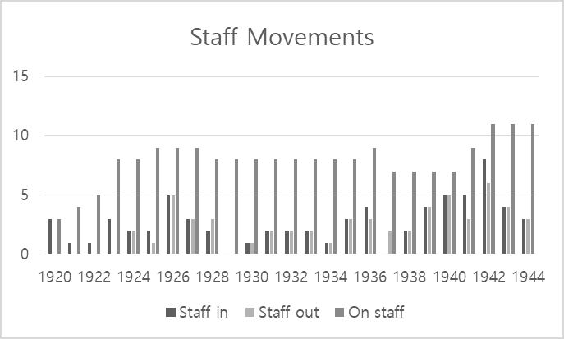

Russell Kelly is an Australian historian, and author of the history book In the Wake of the Lord Melville, a benchmark historical study on the convict transport Lord Melville and her passengers arriving in the colony of New South Wales in 1817. He was production manager and editor of the authoritative four-volume military history Allied Air Transport Operations South West Pacific Area in WWII by his father Robert H Kelly AFC, OAM. In 2010, after a career in publishing, Russell moved his interest and focus to Korean historical studies. He entered Griffith University in Brisbane in 2012 and after a year on exchange with Korea University in 2013, he graduated in 2014, majoring in two areas, History and Cultural Heritage, and Languages and Culture—Korean. In 2017 he graduated with a Master’s degree from The Academy of Korean Studies (Seongnam), majoring in Korean Culture and History. Russell moved to Ganghwa Island to teach English at a rural school for three years, during which time he immersed himself in historical research and exploration, discovering an archaeological site in the process.

Bibliography

Gilsang hakgyo yeonhyeoksa [Gilsang School History]. Translated by Haiyin Kim. Unpublished manuscript, 2018.
Cheong, Do-in. “Ganghwa Onsuri Gyohoe” [Ganghwa Onsuri Church]. Hanguk Gyohoesa [Korean Church History] (blog), June 8, 2009. http://blog.naver.com/kjyoun24/60068865821.
Ewha Womans University Archives, ed. EWHA Old and New 110 Years of History 1886-1996. Seoul: Ewha Womans University Press, 2005.
Fujitani, Takashi. Race for Empire: Koreans as Japanese and Japanese as Americans During World War II. Berkeley: University of California Press, 2011.
Kang, Hildi. Under the Black Umbrella: Voices from Colonial Korea, 1910-1945. Ithaca, N.Y.: Cornell University Press, 2001, 117-122. Quoted in “How Koreans Chose Japanese Names.” Far Outliers (blog), Dec. 20, 2005. http://faroutliers.blogspot.com/2005/12/ how- koreans-chose-japanese-names.html.
Kim, Chul-Kyoo. “Changing Rural Communities.” In Social Change in Korea, 62-71. Seoul: Jimoondang, 2008.
Yuh, Leighanne. “Contradictions in Korean Colonial Education.” International Journal of Korean History 15, no. 1 (February 2010): 121-150.
“Ganghwa Onsuri Gyohoe” [Ganghwa Onsuri Church]. Hanguk Gidok Gyohoesa [Korean Christian Church History] (blog), Oct. 9, 2012. https://web.archive.org/web/20200213114546/photohs.co.kr/xe/ kyungki_kyodong/7244.

List of Japanese Names

Shoda Minokichi (生田巳之吉) Sudo Kingo (須藤金五)
Kenno Chiyo (玄野千代) Sugiwara Yasuo (杉原安男) Yamamoto Iwaoki (山本岩樹) Momosou Kenji (百副健兒) Kunijiki Kutarou (國字菊太郞) Echi Michio (越智通雄) Kubota Shinji (窪田進治)
Ishi Tsunehiko (石井久彦)
Matsumara Kosuke (松村孝助) Arai Junman (新井順萬) Ishimura Ben (石村勉)
Kaneko Zaihan (金子在範) Shozo Uematsu (靑松相淑) Hirayama Eiichi (平山英一) Nakanishi Ichiro (中西一郞) Ooshiro Shookai (大城承海) Tsukishiro Junichi (月城純一) Matsuoka Masaomi (松岡正臣)

Ishi Yoshio (石井義雄) Kidoyo Shiko (木戶淑子)
Shiroyama Shoomori (城山瑽守) Nishihara Keiai (西原敬愛) Ishiwara Shigeyoshi (石原重義) Iwada Junichi (岩田純一) Iwaoka Chiaki (岩岡千秋) Matsumoto Shigeo (松本重雄) Miyamura Shigenori (宮村重德) Ooyama Sumiko (大山澄子) Shiroyama Sadako (城山貞子)
Mine Fumiko (嶺フミコ) Jinno Motoikin (神農基欽) Kanemoto Sheiko (金本淸í¬) Nagakawa Narako (永川麗í¬) Oohara Yoshimune (大原吉宗) Shozo Uematsu (靑松相淑) Tokuyama Zunwa (德山淳和) Tanaka Heikyu (田中炳九) Eshima Harumoto (江島春元)
Takayama Fumimoto (高宮文元)

