The Bairds’ Contributions to Building Design in 1910s Pyongyang

Nate Kornegay

One of the first challenges for William Martyn Baird (1862-1931) in establishing the Presbyterian mission at Fusan [Busan] was construction. As a U.S. missionary who would become best known for his role in founding Union Christian College (Soongsil) at Pyongyang, Baird arrived in early 1891 to a port with no available accommodations. It wasn’t until September that he, by way of the U.S. consul in Seoul, was able to secure a property for the mission station the Northern Presbyterians wanted to establish in Fusan. He then had to find building materials and a contractor to handle construction work for the mission’s first small house there, his account of the situation seeming to indicate he oversaw and organized the affair rather than being physically involved in its construction.¹
There is little evidence to suggest that Baird was much of a practical builder, and most of his work remained focused on religious and educational matters throughout his time in Korea. However, about two decades after his first experience in Fusan, he became involved in another construction project. Around 1909-10, as Union Christian College was continuing to develop in Pyongyang, a Midwestern architect was courted by the Presbyterian mission. This appears to have been Cyrus D. McLane (1866-1945), an Iowa native based in Rock Island, Illinois, at the time.² He was a successful designer who worked for years as an instructor at his alma mater, the University of Illinois, where he became associated with

¹ William M. Baird, “The Opening and Early History of Fusan Station,” 3. Undated manuscript located in “William M. Baird clippings and miscellaneous items, 1885-1888, 1903, 1913-1932, 1951, n.d.,” in William M. Baird Papers, RG 173, Box 1, Folder 16; Presbyterian Historical Society, Philadelphia, PA. All Presbyterian Historical Society sources were accessed at Pearl Digital Collections, https://digital.history.pcusa.org.
² The Rock Island Argus, Nov. 27, 1912, Library of Congress.

the construction of some of the buildings on campus.³
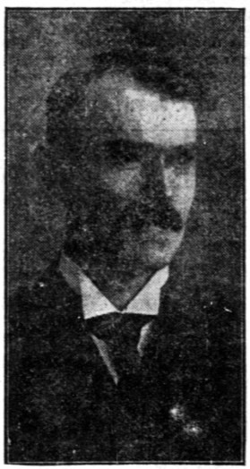
Figure 1. A published photograph depicts Cyrus D. McLane. (The Rock Island Argus, Nov. 27, 1912. Library of Congress)

Little is known of what transpired between the Presbyterian community at Pyongyang and McLane, but a report written by Baird sheds some light on the matter. Baird, who also served as the president of the Pyeng Yang Academy, indicated they had given a lot of thought to building plans as more funds had become available for a new college building. ⁴ Not only did Baird claim the property committee of the Presbyterian mission had approved the new building project, but an outline plan was reportedly passed on to McLane. Not long after this, however, their deal fell through. After months of waiting for detailed plans from the architect, too much time had passed and the mission lost what they estimated was an entire year on the project, making it clear to those in Pyongyang that McLane would not be able to do the work for them.⁵
This appears to have been a period of change in McLane’s life,

³ Nineteenth Report of the Board of Trustees of the University of Illinois
(Springfield: Phillips Bros., 1898). University of Illinois at Urbana-Champaign.
⁴ William M. Baird, “Personal Report of W. M. Baird for the year 1910-1911,” 4. Typewritten script located in “William M. Baird station, institutional, and personal reports, 1891-1931,” in William M. Baird Papers, RG 173, Box 1, Folder 9; Presbyterian Historical Society.
⁵ Ibid.

which may help to explain the incomplete Union Christian College building plan. In 1910, after having worked for fifteen years at Temple, Burrows, and McLane, he left the firm to become superintendent of construction for Moline Plow Company.⁶ He was involved in the YMCA, which provided a link to the missionary community as well as to Moline, and perhaps suggests how he was connected to the mission at Pyongyang.⁷ Cases such as this one resulted in the Presbyterian community
taking building matters into their own hands. This was even more pronounced in the peninsula’s rural interior where there was little hope of securing funding for an expensive stateside architect. While Protestant missions were sometimes able to fund and complete major projects with professional American architects (like Henry Bauld Gordon’s Severance Hospital and Henry Killam Murphy's Chosen Christian College), these proved to be exceptions. Instead, it was missionaries on the ground who often designed or supervised construction of such structures.
After the deal fell through with McLane, William Baird took to designing and overseeing the construction of the college himself, and his wife Annie Laurie Adams Baird (1864-1916) went so far as to become involved in “repeatedly drawing up floor plans, elevations and other necessary drafting.”⁸ Preparing for the new building at Union Christian College was such a challenging task that William Baird developed a newfound appreciation for architectural planning, going so far as to say that McLane’s standard design costs were actually inexpensive. William Baird explained that McLane “would ordinarily charge $900 to $1000 for such a job. Before making the attempt, I might have considered that a large sum but since then I have many times had reason to think that it would not be half enough to pay for the amount of work included.”⁹
The frustration of overseeing such a large task is perhaps detectable in Baird’s words here, and in retrospect he probably would have balked at the Presbyterian mission board’s suggestion that a single architect take charge of all building matters in Korea.¹⁰ The Presbyterian

⁶ “Rock Island Preservation Commission: Preliminary Determination Committee Agenda,” City of Rock Island, July 22, 2020, https://www.rigov.org/ AgendaCenter/ViewFile/Agenda/_07222020-599.
⁷ The Rock Island Argus, March 18, 1910, Library of Congress.
⁸ Baird, “Personal Report of W. M. Baird for the year 1910-1911,” 5.
⁹ Ibid.
¹⁰ Minutes and Reports of the Twenty-Fifth Annual Meeting of the Korea Mission of the Presbyterian Church in the U.S.A. (Seoul: The Seoul Press Office, 1909), 100; Samuel H. Moffett Manuscript Collection, Princeton Theological Seminary

community in Korea well understood that “with buildings going up all over Korea, an architect in charge of them all could do little more than travel back and forth between them and there would be practically no saving of missionary time and strength for in each place as in the past, some one must give the greater part of his time to the continual supervision absolutely essential where Oriental workmen are used.”¹¹
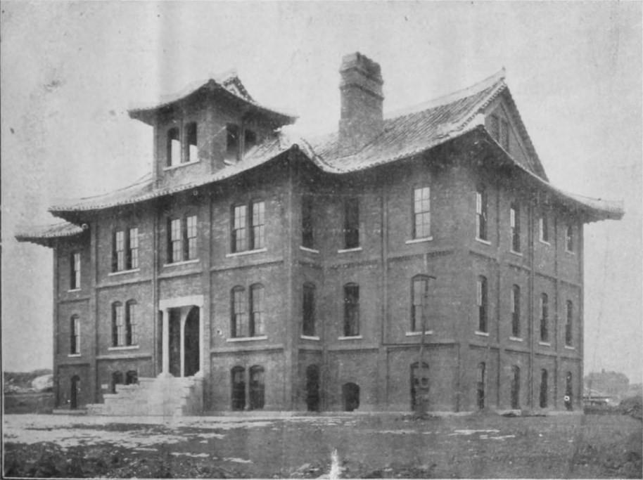
Figure 2. A published photograph depicts the Union Christian College building that the Bairds designed. (The Korea Mission Field, Vol. 9 No. 2, February 1913. Samuel H. Moffett Manuscript Collection, Princeton Theological Seminary Library.)

Baird was cautious in preparing for the Union Christian College building, thus leading him to seek the advice of the entire Christian community. He specifically called upon seven different missionaries in Korea, each with building experiences that proved helpful to Baird. ¹²

Library.
¹¹ Ibid.
¹² Baird’s report indicates he either consulted with or was helped by O. R. Avison,
A. M. Sharrocks, C. A. Clark, R. McMurtie, J. E. Adams, A. B. Turner, and J. A. Thompson. All of these missionaries had been involved in construction matters at

With little construction knowledge, Baird became somewhat of a self- taught builder, drawing from published construction guides and from the experiences of other missionaries. One of these construction guides specifically mentioned by Baird was a Frank E. Kidder handbook. Kidder’s books featured guides in everything from physics and trigonometry to practical matters like load-bearing tests for foundations.¹³
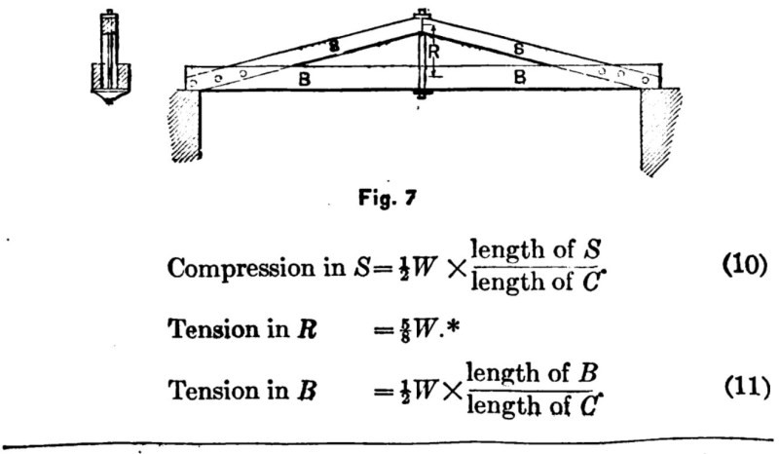
Figure 3. An illustration showing formulas for calculating compression and tension in trussed beams serves as an example of the kind of information in a Kidder handbook. (Frank E. Kidder, The Architect’s and Builder’s Pocket- book [New York: Wiley & Sons; London: Chapman & Hall, 1904], 587. Hathi Trust Digital Library)

After making “twenty six pages of typewritten specifications in English” for the aforementioned Union Christian College building, William Baird and several Korean secretaries worked for weeks on translating them into a “small volume” that local builders could read and bid on.¹⁴ “Chinese contractors could have been found who could read English,” Baird wrote, “but I desired to let the Koreans have an

some point during their time in Korea. Baird, “Personal Report of W. M. Baird for the year 1910-1911,” 5.
¹³ Kidder’s book had many editions published with additional authors over the years. See for example Frank E. Kidder, The Architects’ and Builders’ Pocket- Book, 3rd ed. (New York: Wiley, 1886), https://catalog.hathitrust.org
/Record/008631666.
¹⁴ Baird, “Personal Report of W. M. Baird for the year 1910-1911,” 5-6.

opportunity of bidding on the college building.” ¹⁵ Four Korean contractors bid on the work, with the project going to the lowest bidder, a man named Kim Chyung Heung who had previously been involved in building missionary residences at Kangkei.¹⁶ According to Baird, he and Kim talked over all the construction details and he was satisfied with Kim’s work on the building.¹⁷ Baird’s frustration with the project was then tempered by the consolation of his translated text possibly “making it easier for some future builder who might wish to employ Korean contractors, and also for Koreans to secure contracts and build difficult buildings.”¹⁸ The building, completed sometime between 1912 and 1913, was of good quality and followed American ideas regarding learning spaces better than earlier modified Joseon-style buildings.¹⁹
It is interesting to note the potential significance of a claim made in 1968 that the “small volume” William Baird and the secretaries created would go on to become a so-called “builder’s bible” for every mission station in Korea. If true, this claim would do something to explain the many Western-Korean hybrid structures that continued to be built in mission stations throughout the colonial period.²⁰

¹⁵ Ibid.
¹⁶ Ibid. Kangkei is present-day Kanggye, Chagang Province, North Korea.
¹⁷ Ibid.
¹⁸ Ibid.
¹⁹ The earliest known and clearly dated image of the building was published in The Korea Mission Field 9 No. 2, February 1913. There is also a biographical document in the William M. Baird Papers indicating Baird was building supervisor from 1911-12, placing the building’s completion sometime around 1912-13. See point no. 30 in undated biographical record located in Baird, “William M. Baird clippings and miscellaneous items, 1885-1888, 1903, 1913- 1932, 1951, n.d.” The term “modified Joseon-style” specifically refers to buildings used by Western diplomatic and religious missions whose designs were modified to include both Korean and Western features at the turn of the twentieth century. Some were new constructions and others were renovations of extant Joseon buildings. For more on this topic, see Nate Kornegay, “Modifying Joseon Architecture (1884-1905),” Colonial Korea, June 18, 2019, https://colonialkorea. com/2019/06/18/modifying-joseon-architecture-1884-1905.
²⁰ This claim was made in a 1968 text on W. M. Baird that offered few clear citations, making it challenging to verify thus far. However, it could have been based on, for example, personal letters that were not discovered in time for this article, or anecdotes passed down through the Baird family. This 1968 text also makes the claim that Baird chose not to hire McLane because of the architect’s high cost, which conflicts with Baird’s report that McLane took too long to send building plans to Pyongyang, mentioned above in footnote 4. As such, more

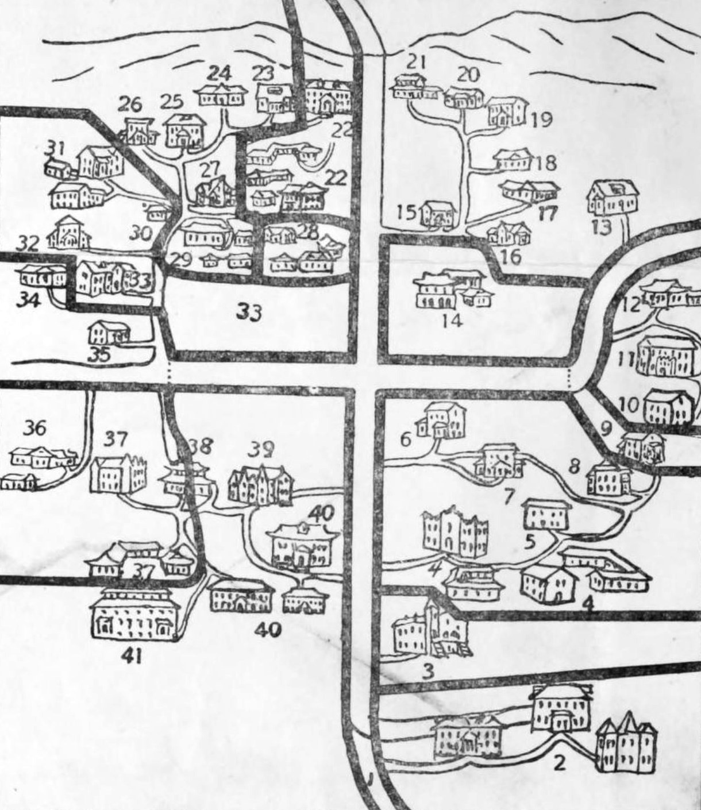
Figure 4. A sketch depicts the Presbyterian mission station compound at Pyongyang. The structures labeled as no. 40 indicate the location of the Union Christian College building and its dormitories. (Letter from Samuel A. Moffett to Howard, July 7, 1935. Samuel H. Moffett Manuscript Collection, Princeton Theological Seminary Library)

As contemporary American school design became more achievable on the peninsula, the Bairds found inspiration for Pyongyang’s boys’ academy building in the architecture of their home country. In 1914,

research is needed. Richard H. Baird, William M. Baird of Korea: A Profile (self- pub., 1968), 140, https://archive.org/details/williammbairdofk0000bair.

when Annie Baird visited her hometown of Topeka, Kansas, she was impressed by the new Central Park School. Built in 1909, a local newspaper called it “the most modern structure of its kind” and its plan the “latest and best in school building architecture.”²¹ The amount of light allowed in by a building had become an important factor in then- contemporary school design, a factor that would even affect Western missionaries involved in construction in Korea.
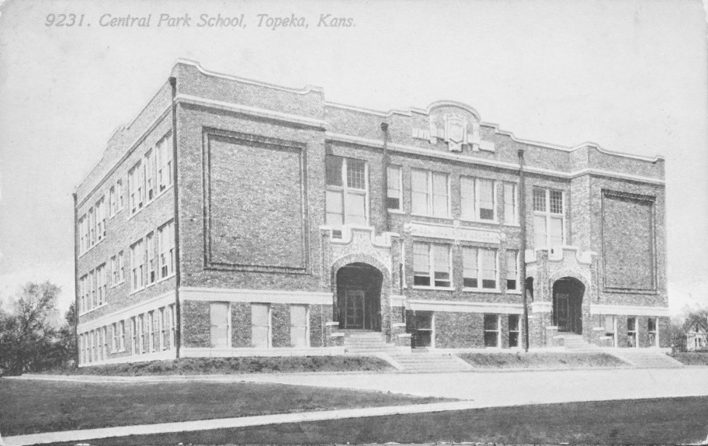
Figure 5. A postcard depicts Topeka’s Central Park School, formerly located on Lincoln Street between 15th and 16th streets. (Nate Kornegay Collection)

As such, Central Park School made use of walls of large windows. The school’s general grounds were also held as a prime example of proper grading (earthwork) in an American text on improving schools.²² Though there were reportedly several architects and school board members who informed the building’s design, the plan was initially penned by an architect named L. M. Wood.²³ His plan was then reportedly somewhat modified by these other unnamed architects and school board members.²⁴
In a letter to her husband, Annie Baird wrote that she would

²¹ The Topeka State Journal, Feb. 4, 1908, Library of Congress.
²² School Buildings, School Grounds, and Their Improvement (Topeka: State Printing Office, 1911), 5, https://catalog.hathitrust.org/Record/009562089.
²³ The Topeka State Journal, March 3, 1908, Library of Congress.
²⁴ The Topeka State Journal, April 7, 1908, Library of Congress.

immediately send him the building plan—and it seems she did.²⁵ When the new academy building was completed in Pyongyang, it resembled Topeka’s Central Park School.²⁶ It became known as the Helen Marquis Memorial Academy, used for boys’ education. It remains unknown whether Wood knew his school design was also used in Pyongyang.
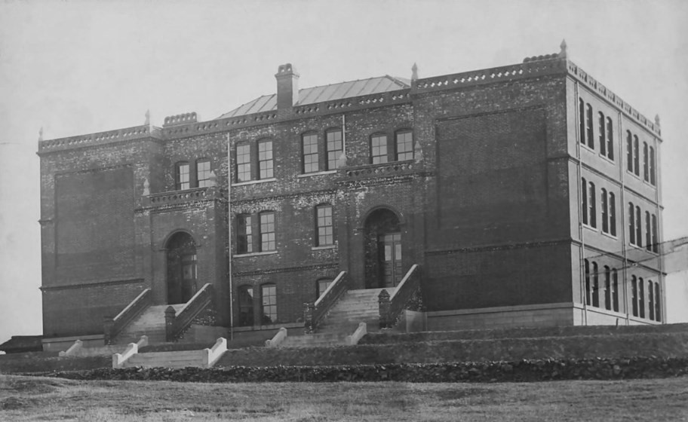
Figure 6. A photograph depicts the Helen Marquis Memorial Academy at Pyongyang. This school building was very similar to the Central Park School building in Topeka. (Labeled as “1910-1919 – Helen Marquis Memorial Academy Building – Boy’s Academy, Pyeng Yang, Korea” in Moffett Korea Collection. Princeton Theological Seminary Library).

The Bairds clearly became involved in building design and planning, yet it remains unclear just how many projects their hands touched. And while the evidence presented here seems to suggest they handled only a few buildings, the buildings were significant enough in scale and scope to be worthy of study and commentary today. That the histories of these buildings have links to architects in the United States is

²⁵ Letter from Annie L. Baird to William M. Baird, May 15, 1914. Located in “Correspondence from Annie Baird, 1914-1916” in Annie Laurie Adams Baird Papers, RG 172, Box 1, Folder 3; Presbyterian Historical Society.
²⁶ The author is unfortunately still searching for evidence of a more precise completion date for the Helen Marquis academy building, but a photograph of the building (see Figure 6) with a handwritten date of Jan. 12, 1917, could suggest it was built sometime by then, if not the late 1910s in general.

also noteworthy in partially answering the questions of how they came to be and why they looked the way they did. In the case of the Union Christian College building, the failure of the deal with McLane appears to have resulted in Baird defaulting to a Western-Korean hybrid plan akin to other mission structures of the time in Pyongyang. In the case of the boys’ academy, it was copied and modified from an American school plan, resulting in a more American-style structure that brought a little piece of Kansas architecture all the way to Pyongyang. Furthermore, in addition to the help received from other missionary-builders, Baird’s description of how he relied on guides such as Kidder’s handbook is suggestive of how some missionaries without an engineering or building background may have been able to make the necessary calculations and technical plans for a given structure.
Both buildings stand as good examples of how the Presbyterian community, and many missionaries in general, adapted to their situation in Korea and took on new roles to achieve their goals and build up their mission stations. Though the Bairds do not appear to have become prolific “missionary-architects” in the way others did, their name joins the ranks of several other missionaries who took up the role of builder or designer in early modern Korea.

Nate Kornegay photographs and writes about early modern architecture in Korea. He is currently working on a number of projects, including the study of a particular ceramic tile trend found throughout the former Japanese Empire. Research articles and architectural photo essays can be found at his website, Colonial Korea. Visit www.colonialkorea.com.

