The Boats of the Han River

Robert Neff

In the late 19th century, traveling between Chemulpo (modern Inchon) and Seoul was not an easy task. Depending on the season, one could go overland or by river. Options for 26-mile overland trip were appalling: walk, ride in a rickshaw, in a chair or palanquin (borne by 2-4 bearers), on a bicycle (popular with foreigners residing in Korea in the mid 1890s) or on a Korean pony which was famed for its strength and surefootedness but was equally notorious for its ferocious attacks upon its companions, handlers and riders. Many people chose the perceived easier course – traveling by river.

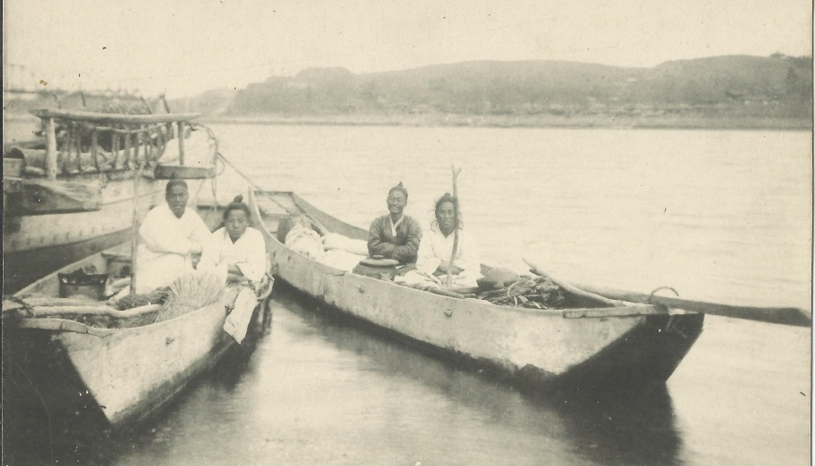

Junks and Riverboats
There were many types of vessels that traveled up and down the Han River. Some of these vessels were Korean coastal junks that occasionally ventured away from, but more often hugged, the relative shelter of Korea's coastline. Others were seafaring junks including Chinese and Japanese that traveled from their own shores bringing goods to Seoul. And to a greater extent, the smaller Korean river vessels that remained within the confines of the Han River. Captain Fritz W. Schulze, a German employed by the Korean Customs Department, wrote in August 1884: “Native junks from about 10 to upwards of 100 tons constantly navigate the river in perfect safety; also several foreign-built vessels under the Korean flag, officered and manned by natives. The Chinese and Japanese junks, as well as other sailing ships trading to this port, almost invariably obtain permission to proceed up river, as far as Song Gai, or Yong San (Mapo)...”

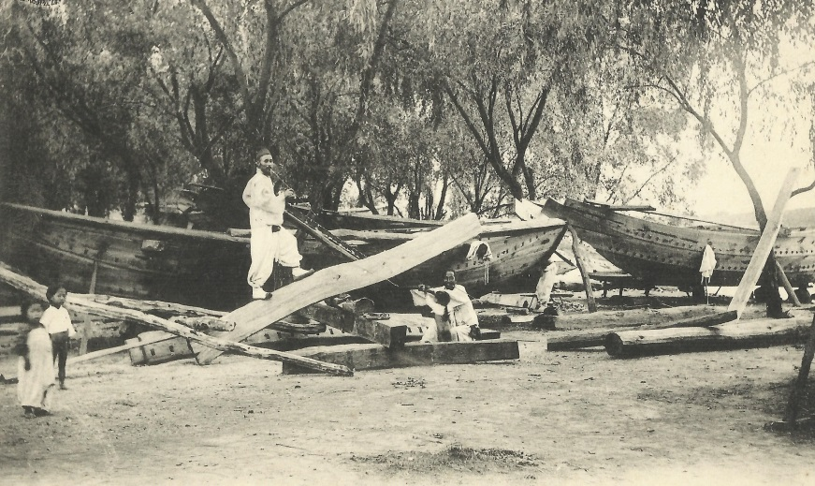

The Korean riverboats, depending on their purpose, were often altered to optimize their cargo capacity. Horace Underwood wrote: “An immense amount of brushwood is consumed as fuel in the city of Seoul and boats bringing this up the river in the fall have on either side a built out framework approximately equal to the beam of the boat, thus enabling them to carry three times the normal deckload of this light but bulky freight.”
The boats were not built for comfort: “None of these river boats are decked or have enclosed cabins. A small section is used for galley where the crew cook the rice. This contains a place for a jar of the Korean pickle or ‘kimchi’; a moderate sized water jar; a small supply of fuel, and space for the few dishes required ... Rolls of a kind of thatched-matting called ‘dheum’ are spread as a shelter against the weather and when loaded the cargo is often stacked to provide a sort of cabin.” There was really no need for cabins because, for the most part, the ships did not travel at night, except in safer sections of the river and only when the moon was very bright. Most of the time the boats were brought close to a riverbank at dusk and tied to trees or large rocks until morning. The small crews were forced to find whatever shelter was available or slept amongst the cargo.
A sailor's life is inherently dangerous so it is with little wonder that many sailors find solace in religious beliefs, even today. The Korean sailors of the past were no exception but unfortunately many of their beliefs have been lost through the passage of time, or through people's unwillingness to divulge them. Horace Underwood, who wrote a book about Korean boats and ships, expressed his frustration in obtaining information when he wrote:
“Nor is it easy to get information from Korean sailors. Some have a superstitious objection to talking to a Christian about such things and others are half-ashamed of these old beliefs and fear that what they say will be used to ridicule the Korean people.”
While there is a little information concerning the superstitions of sea-going vessels, there is less concerning the riverboats. It is very likely that river sailors made sacrifices of food and alcohol to local deities at sections of the river that were considered the abodes of dragons and spirits. Sacrifices were also made at places thought to be haunted by ghosts. One such place on the Han River was Son Dol Mok where lurked “the spirit of the boatman Sondol who was unjustly beheaded by the King.”
Dogs were considered bad luck aboard ships. If a dog jumped aboard a ship it had to be captured and sacrificed as an appeasement to the gods, even if the sailors were required to pay an exorbitant amount of money to the dog's owner. Women passengers, at least on sea-faring vessels, were considered bad luck and were not transported during the first month of the year.
Despite the precautions taken by the superstitious sailors and Captain Schulze’s insistence that during his survey of the Han River not a single accident occurred to any of the junks, accidents did happen. The swift currents, fogs and shifting sandbanks of the river often claimed vessels, stranding them upon the sandbanks. In 1886, a young American woman and group of westerners departed Chemulpo on rickshaws and ponies carrying their light luggage, and had their heavy luggage shipped to Seoul aboard a junk. She recalled, “We did not see these heavy boxes for three months, as they were stuck on a sand bank during the rainy season!”

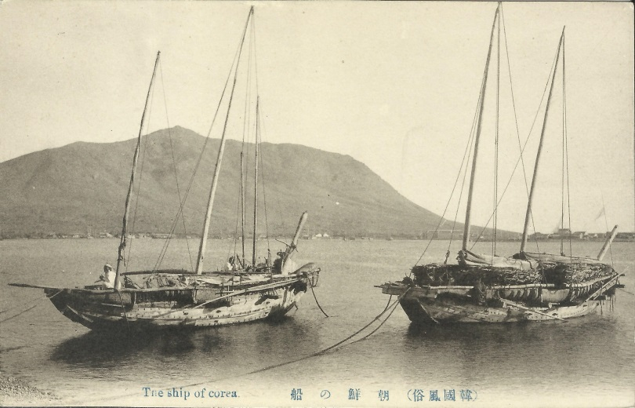

Ferryboats
Because the Han River was often too deep to ford and possessed no bridges, ferryboats were an essential part of transportation. There were eleven ferry crossings, but the most important were Gwang, Hangang, Yanghwa, Mapo and Yongsan. The ferryboats were “of very heavy construction, very broad in the beam, low in the bow to allow loaded ponies or oxen to come on and off; with relatively high poop to allow the use of the huge sweep required to handle so heavy a load.”
One early western visitor to Seoul in 1885 wrote: “Arrived at the river, we found a large ferry-boat all ready to receive us. It already contained some two dozen Coreans, mostly with heavy packs on their backs, and a fine large bull; but we managed to find space for our three ponies, our mafoos [horse handlers], and ourselves, and the whole miscellaneous cargo was soon yulched across a somewhat novel sight.” And while this all impressed the visitor, it was the Korean passenger with a pig on his back that seems to have dominated his attention.
Isabella Bird Bishop in her travels in Korea in 1894 and 1897 wrote: “Ferries are free. The government provides the broad, strong boats which are used for ferrying cattle as well as people, and the villages provide the ferrymen with food. Passengers who are not poor usually give a small douceur.” Evidently westerners were exempt from the free passage. Richard Wolfe, an English missionary visiting from China in the fall of 1884, noted in his travelogue: “About six o'clock I arrived at the river, which I crossed, pony and all, in a boat; fare, two cents.”
“A man named Hong Chong-sun secured the right to manage all the ferries across the Han in the vicinity of Seoul. He immediately raised the tariff a hundred percent and made the ferry-men do the work at bottom prices. Therefore the ferrymen made a violent demonstration with clubs and stones with the result that the obnoxious Hong was driven out and things resumed their former status.”
“The Department of Agriculture Commerce and Industry sent an order to the Governor of Seoul stating that the city authority must warn the ferry men at the river towns not to delay the progress of the mail carriers who are going South every day. These boatmen will not take over the carriers immediately when they arrive at the ferry, because they do not pay handsome toll like other passengers. This causes great delay in delivering mail, and the Governor must order the boatmen to take the carriers over as soon as they get to the ferry.”
Despite the ferryboats' strength, they were weakened by the inadequate ribbing and crossbeam support in an effort to make loading ponies and bulls easier. According to Horace H. Underwood, “after some years of use these boats loosen up in an alarming fashion.” There were other problems as well. During the monsoon season in 1897, The Independent reported: “One of the ferryboats at King’s Ferry capsized two days ago with thirty passengers and two oxen, including two boatmen and they were all drowned. The police Dep't ordered the ferrymen not to carry such a large number of passengers in their boats during the rainy season.”

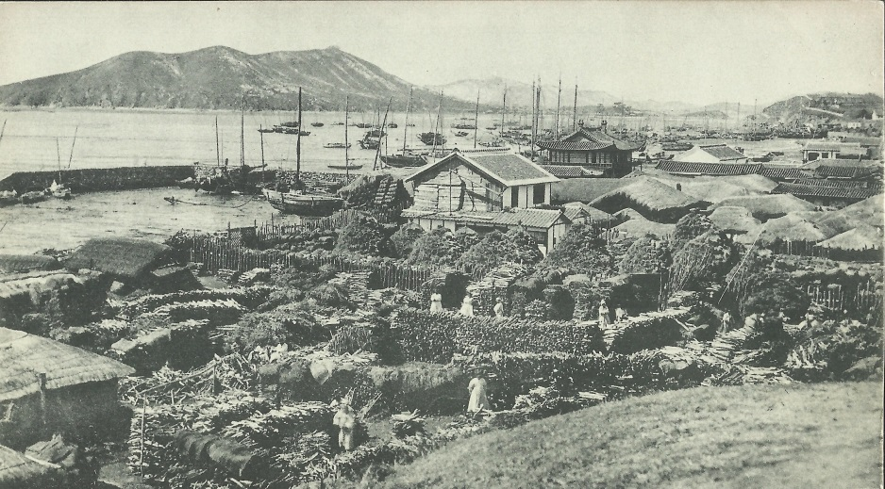
Chemulpo

Steamships
In September 1884, Captain Fritz W. Shulze presented his opinion on the feasibility of steamboat navigation on the Han River to his superior, P. G. von Mollendorff. In it he wrote, “I am glad to report that of the many Chinese and Japanese junks which obtained permission to proceed up river, none have met with any accidents, which favorable results naturally lead to the inference that steam navigation can be carried on still more successfully.” It was his opinion that as long as “foreign navigators with foreign-built vessels, especially with steamers” used “common nautical skill and ordinary caution” they had “no reason to hesitate to participate in the navigation of this river, where the natives with their clumsy and frail boats have hitherto carried on the trade quite successfully.” His smug comments probably haunted him in later years but there were many who shared his opinions.

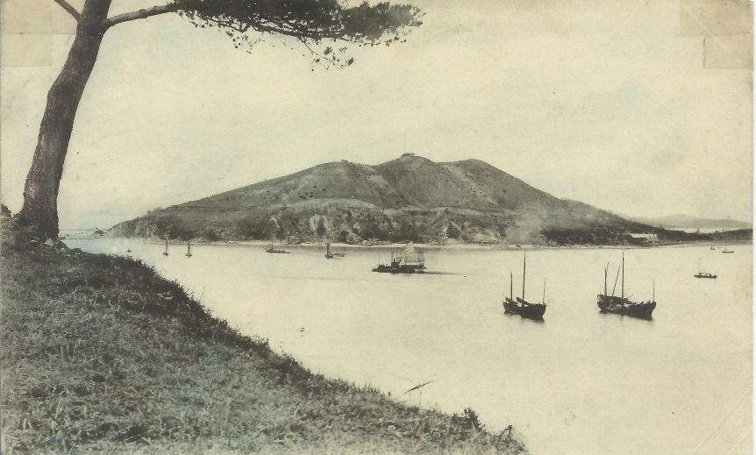
Chemulpo

In October 1886 a group of Korean merchants pooled their money together and formed the Corean Merchants’ Steamship Company [CMSC] with the intent of establishing steamship transportation along Korea's coast and on the Han River. The company’s first effort to obtain a steamship ended in failure after its Korean agent lost 1,200 dollars in Nagasaki to a Japanese swindler who sold him a ship that he did not own. The company did, eventually, manage to buy at least two steamers – and a photograph of the larger one was shown to King Gojong who allegedly “expressed himself highly pleased with it.”
The company had great expectations for these steamers. A coal field near Pyongyang had been recently investigated by Alfred B. Stripling – a former member of the Korean Customs Department – and it was the intention of the company to use this coal to cheaply convey the “tribute rice” from the coast to the capital.
The establishment of this company angered many Chinese and Japanese junk owners because prior to the company’s establishment, they had been allowed to freely proceed up the river to Mapo. Now they were denied access.
Despite the promise of success, the company soon found itself in financial trouble. In October, a Chinese newspaper reported that the company’s two vessels were running regularly but noted: “It appears that the vendors of these steamers are experiencing a difficulty in obtaining the balance of the purchase money, which, so far as at least one of them is concerned, is not to be wondered at!”
It was generally believed that the company had overpaid for the ships and many felt the Americans were to blame. In June 1886, Horace N. Allen wrote to the American Trading Company in Japan informing the company that the Korean company wished to purchase a small steamer to operate between Seoul and Chemulpo. Allen stated that the Korean company had a capital of about $7,500 and did not care to exceed $15,000 in the purchase of the vessel. He hoped that the American Trading could send the particulars of two or three vessels within the price range of $5,000-10,000. Allen was convinced that the Korean company would buy whatever ship the American firm suggested as long as they were able to afford it. But in November, after the ship had been purchased, rumors circulated (allegedly started by a Japanese man) that the American Trading Company and its representative in Chemulpo and George C. Foulk, the acting American Charge d’affairs, had conspired together and purchased a ship for $10,000 and then resold it to the Korean company for $28,000. It seems to have been a misunderstanding as the ship was purchased for $10,000 or roughly 28,000 yen.
Another American firm, this one in Nagasaki, George Lake & Co., also sold a ship (Taehan) to the Korean company. However, the Korean company was unable to make their promissory note’s payment of $1,132 on December 15, 1886. Within days, Edward Lake (who was running the company in his brother’s absence) immediately contacted Foulk at the American Legation in Seoul and demanded foreclosure on the ship.
Troubles continued to plague the company. In February 1887 the Taehan was reported to be missing. It was bound for Mokpo and had left the previous month; fortunately it soon made it to its destination but it was not long before it had a new owner.
In October 1887, the steamer the Taehan was sold at an auction in Chemulpo in order to pay off its debt. The buyer was, unsurprisingly, Edward Lake who soon afterwards had the ship steam back to Nagasaki flying the American flag. Lake had managed to purchase it back for only an eighth of the $9,000 dollars the Koreans had paid for it. The American minister to Korea, Dinsmore, reported to the Secretary of State on October 10, 1887 that Lake “sold the ship for an enormous price” then “bought her at a forced sale at far less than her value. The Koreans are sore naturally.”
The CMCS continued to operate for several years – mainly along the coast – and suffered a couple of shipwrecks and financial difficulty. According to one writer, “these steamers were managed by government officers, but the shipping business was not successful due to [the] lack of efficient shipping management.” In 1892, the Korean government established a national shipping company and transferred the CMCS’s ships into it.

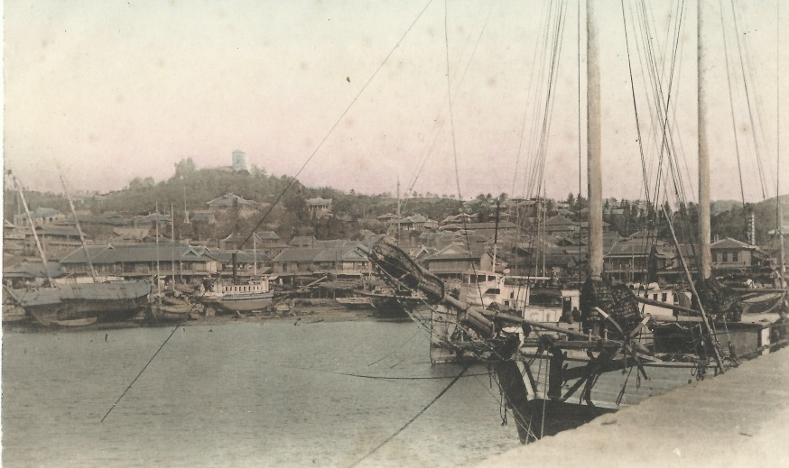
Chemulpo 1910-1920

While the lack of efficient shipping management may have crippled the CMCS, it did not deter other entrepreneurs from establishing their own companies. In 1888, Friedrich Gorschalki, a German businessman with properties in Chemulpo and Seoul, began operating a small steamer that charged foreigners $1.00 and was said to “answer its purpose exceedingly well”. What became of this little steamer is unknown for it is only mentioned once in a newspaper and does not appear in any of the trade reports.
In June 1888, another Korean company, Samho Hwaesa, was established and purchased two small wooden steam launches from Osaka and renamed them Yongsan (16 tons) and Samho (13 tons). It isn’t clear when the Samho arrived in Korea but we know that the Yongsan sailed from Osaka and arrived in Nagasaki on August 3, 1888 with the Korean flag at its mast. By the end of August, the two ships were in Korea and began passenger service between Chemulpo and the river ports: Hangang, Yongsan, Seogang, Yanghwa and Mapo (Samho). But like its predecessors, the Samho Hwaesa soon experienced the wrath of the river. Within days of operation, one of the steamers ended up stranded halfway between Seoul and Chemulpo “putting her passengers to great inconvenience.” The company was lucky for the steamer apparently did not suffer much damage but a couple of months later a newspaper reported that one of the small steamers had been sunk in the river.
Despite these early difficulties, the company purchased another steamboat in December – an iron river steamer imported from Germany and put together in Japan. It was declared “a good sea boat” and named the Chai-kang. While it may have been a “good sea boat” it was not a match for the Han River. In April 1889, Captain Fritz W. Schultz, took command of the Chai-kang. It is ironic that he was considered to be the leading foreign expert of the Han River because after making only a few trips on the river he struck a submerged rock, breaking both her screws and doing damage to the bottom of the ship. A correspondent in Seoul reported that “two spare screws had been sent with the vessel, so the detention will not be very long. It is understood that no blame is attached to the captain.”
Then on September 15, at 4 a.m., the steamer ran onto another rock in the river and “the whole of the passengers (including two ladies) and the crew were rescued by a native junk. Hope of getting her afloat again at an early date were entertained.” Apparently the ship was refloated, but not for long. On the night of September 30, the ship again struck a rock. Once again, fortune was with the captain and the company and no lives were lost. However, the company was unable to refloat the ship on its own so in November, an Englishman named Walters, who worked for the Korean government, approached Captain Dryer, commander of the American warship USS Marion, and asked if he could obtain some chains and cables to help raise the Chai-kang. Unfortunately the USS Marion had no chains and cables to loan the Korean government and the steamer was declared a complete loss.
It is unclear how long the Samho Hwaesa remained in operation but apparently it did so up until at least 1893. In May of that year, a Japanese newspaper reported that the small 30-40 ton side-wheeled steamer Toki Maru had been purchased by the Korean government and rechristened the Kei-lee. It was to be “used for river service in the neighbourhood of Seoul.”
The Chinese were also involved in steamboat operations on the river. Through the efforts of Yuan Shih Kai, the Chinese Resident Minister to Korea, a Chinese Shipping Company was established in 1892. But it wasn’t until August 1893 that The North China Herald announced the “trial trip of the Hanyang, a vessel which has been constructed by the Fauchong and Co. for a Chinese syndicate, to ply between Chemulpo and Mapo, Corea, a distance of about sixty miles on the river Han. The boat, which is commanded by Capt. Morsel, indicates a very creditable spirit of enterprise on the part of some Chinese capitalists, who if the present venture is successful – and the prospects are unusually promising – will soon put other vessels on the line. Being only intended for river service the Hanyang is a small and handy craft. She is capable of carrying some 60 tons of cargo, and about 140 passengers … She has been built to steam 10 knots an hour … The fare for Asiatic passengers from Chemulpo to Mapo will be 75 cents and for foreigners $1.50. The main source of cargo receipts is expected to be from rice, the syndicate having also acquired a monopoly of the tribute rice carrying along the district they serve.”
As the Chinese newspaper noted, the prospects were very promising but unfortunately those expectations fell through. The company enjoyed a subsidy of 5,000 dollars from the Chinese government and had a contract with the Korean government to transport 100,000 bales of rice from Chemulpo to Seoul. But the steamer – the only one the company possessed – cost nearly $120,000 and was huge – especially compared to its Japanese competitors who had only six small boats and that it “could have taken all the little Japanese craft into its hold without difficulty.” A Japanese newspaper smugly remarked that because of its huge size many believed that it would monopolize the river trade “but in point of fact its size proved its ruin, for in the first place it required a large crew and in the second it drew too much water when filled with cargo to navigate the river conveniently.”
After only six months of operations, the company lost $5,000 and, according to the Japanese paper, “the company was ignominiously wound-up and the steamer sold for 30,000 yen. Henceforth she is to have a Japanese crew and will carry tribute rice on the Chinese coast.” Perhaps it was fortunate for the company. During the summer of 1894, war broke out between China and Japan (Sino-Japanese War, 1894-95) and undoubtedly the ship would have been seized by the Japanese military.

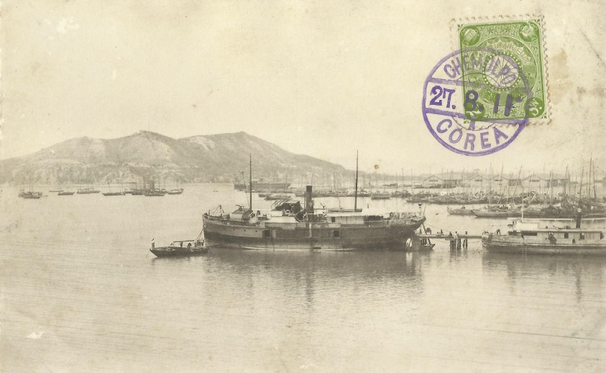
Chemulpo c. 1911

Following the defeat of the Chinese by the Japanese, the lucrative steamboat operation remained firmly and uncontested in the hands of the Japanese, specifically the Shoji River Steamer Company. By 1898, the company operated at least four steamships (Sebi Maru, Yaski Maru, Amakusa Maru, and Suminoye Maru) and were frequently mentioned in the English-language newspaper printed in Seoul, The Independent.
The Japanese steamship company experienced the same problems its predecessors and competitors faced – frequent groundings due to shifting sandbanks. The frustration this caused amongst the passengers was frequently described in contemporary books and newspapers.
Isabella Bird Bishop caustically described steamship travel on the Han River in 1894: “Nearly every passenger who has entrusted himself to the river has a tale to tell of the boat being deposited on a sandbank, and of futile endeavors to get off, of fretting and fuming, usually ending in hailing a passing sampan and getting up to Mapo many hours behind time, tired, hungry, and disgusted. For the steam launches are only half powered for their work, the tides are strong, the river shallows often, and its sandbanks shift almost from tide to tide. Hence this natural highway is not much patronized by people who respect themselves …”
Dr. Clarence F. Reid described his and Bishop Eugene R. Hendrix's 1895 Han River trip as being unforgettable. He wrote that “after puffing away for about seven hours our little craft ran on a mud-bank and our captain informed us that there was no hope proceeding further for at least eight hours (until the next high tide). As we were looking about for some protection from the piercing wind which swept the deck a fellow passenger told us of a good road to Seoul only six miles away.’ Determined to ‘show how Occidental pluck and energy could overcome Oriental inertia’ the party left the boat about 5 p.m. Soon they learned that the good road was a myth and that it was twenty miles to Seoul instead of six! But they had started out to demonstrate and they did, reaching Seoul at half past one the following morning …”
Yun Chi-ho, who went out to meet Dr. Reid and Bishop Hendrix, wrote in his diary: “At 1 p.m. went to Riongsan with Mr. Appenzeller to meet Bishop Hendrix and Dr. Reid. The river steamer did not come in until 5 a.m. but the parties we waited for were not on board. Learned that the Bishop's party, on the boat's being stuck on the sand bar down the river, took to their feet and made for Seoul overland. Felt very sorry for them.”
Travel on the river was considered so haphazard that many – including Koreans – were wary of using it to transport expensive property. When Muriel Armstrong Jaisohn had her Steck piano transported from Chemulpo to Seoul, she requested that the movers use a steamboat but her request was ignored by the forwarding agent and instead it was sent overland. “[T]wenty-one coolies brought the Piano to my house by oxcart, ropes and poles, making short cuts over frozen rice fields to save time and expenditure of energy.” She gushed to the manufacture that even after receiving “such rough treatment” her piano remained in perfect tune and was “possible proof of its magnificent construction.”
But in August 1897, The Independent, acknowledged that in the early days of steamship travel on the Han River “it was very much of a lottery if you caught the steamer at all, and then the odds were even as to reaching your destination. The steamers generally walked the distance, feeling their way along with poles on each side and making it in anywhere from twelve to thirty-six hours . The channel was a mystery and you always counted on resting on a mudbank to eat your lunch. There is not a mud bank between Chemulpo and Seoul I have not eaten a lunch on, at some time or other. Those days are no more. A race of pilots have sprung up who know the old river like a book, and the trip on the Han has become a pleasure trip through Aradian scenery instead of a plunge into the unknown.”
Despite the newspaper’s assurances, misfortune continued to plague the Han River steamers. A couple of months later, the Shoji River Steamer Company's vessel, the Yasuki, had a near-explosion when some of the plate on the boiler dangerously bulged out and would have burst, possibly destroying the ship, but fortunately the engineer shut it down before this could happen. And a year later, the Independent reported another incident involving the Shoji River Steamer Company: “The new river steamer ‘Sebi Maru’ recently put on the run between Chemulpo and Seoul foundered on the evening of the 14th at a place some 15 miles below Yongsan, and is now quite covered up by sand. Out of some 23 people on board 17 were lost. The cargo is a total loss.”

Pirates
Dangers to river navigation were not confined only to natural events – there were also incidences of piracy and armed robberies. Although steamships were exempt from the ravages of the pirates, native and foreign junks were not. The Korean Repository noted that on May 19, 1892, a number of Chinese merchants left Chemulpo “on a junk for Seoul with a ‘general’ Chinese cargo. The following day at 4 p.m. about two miles below Mapo a Korean junk hove in sight and hailed the Chinese to stop. The latter refusing to lower their sails the Koreans fired on them wounding three. Matters were beginning to look serious for the Chinese when another Korean junk came in sight and the would-be pirate made his escape. The Chinese then returned to Chemulpo and were placed under the doctor's care. The slugs having been extracted, all are doing well.”
The writer went on to note that “piracy on the rivers and high seas had not been heard of for centuries,” but observed that “this kind of work seems to be reviving as of old.” Indeed it had. Over the next decade or two, piracy sporadically posed a threat to small-vessel shipping in the Chemulpo and Han River region. According to the author of an article published in The Independent in 1898, “piracy is rife in the waters adjacent to the port [Chemulpo] and several cases have been called to my attention.”
But piracy was not only limited to Koreans. Even though the foreigners did not rob from the Korean junks, they did illegally commandeer them. In August 1891, a small number of foreigners, including a couple of English officers, took a steam launch operated by Japanese from Chemulpo to Seoul. After several hours of travel the steam launch became lodged upon a sandbar and the Japanese decided to take measures to lighten the load:
“The Japanese in charge of the launch, seeing some Koreans in a small boat towing a junk down-stream, put off in their skiff and seized the boat, not without a lengthy altercation with the owners and some blows with a bamboo. Returning in triumph, they made some of our Korean passengers get into the boat, with the object of lightening the launch, but she had so much cargo on board that this was in vain.”
When it became apparent that they would be stranded for the night, the western passengers followed the example given to them by the Japanese “… as there was no accommodation of any kind and we wanted our dinner, we prevailed on a Korean junk, which was gaily sailing up the river, to take us on board; but no sooner had we boarded her, than the owners said the current was too strong and they must anchor. We would not allow this, and took charge of the junk; but we were not enough to hoist and work the huge unwieldy sail and likewise steer, so we put the master of the junk to do the latter while we did the former.” Eventually they were forced to spend the night along the river and did not arrive in Seoul until the following day.
Other dangers lay upon the banks themselves. In November 1892, a Chinese merchant from Chefoo, China, was attacked and killed by a gang of Korean thieves on the sand near the ferry crossing on the road to Chemulpo. The Chinese Minister to Korea, Yuan Shi-Kai, offered a reward of 500,000 cash [about 155 yen] for the apprehension of the gang. In December 1897, another incident took place after two Chinese merchants stopped their boat at ferry station to spend the night. “One of the Chinamen went on shore for refreshments while the other was sleeping in the boat with a Korean ferryman. A number of robbers boarded the junk and carried away the goods and threw the sleeping Chinaman overboard after inflicting fatal injuries upon him. The Korean ferryman gave an alarm and the men from other junks came to the rescue, but it was too late to capture the robbers.”
But not all crimes committed were against foreigners. In 1898, according to the Korea Repository, “‘Sweatless gangs’ otherwise known as land pirates” had moved from the districts beyond the capital and had “begun their deeds of blood and violence in and about the capital.” One of their victims was a young widow who ran a pawn shop at one of the river ports. She was brutally murdered and everything stolen from her shop. In May of the same year, The Independent reported:
“In the three villages of Tongmak, Mapo and of Riongsan along the river there are four or five thousand house. Of late, thieves and robbers, armed with swords and guns, break into the buildings and, after tying and beating the inmates, help themselves to whatever they may find. Sometimes, they write notes to well-to-do folks telling them to bring so much money to a certain out-of-the-way place or take the consequences. Thus the people of these villages are disturbed and worried. For their protection there are only two chief constables and eight policemen. The chief of the Western Station, within whose district the villages are located, has asked the Central Department to increase the police force for these places and for ten firearms with 300 cartridges.”
Even though the police force was increased, it wasn’t able to completely squash the rampant crime wave. In 1902, robbers entered a home near the river and murdered the occupants and then calmly loaded up all their goods. The Korean government threatened the local police authorities with severe punishment if the thieves were not quickly apprehended. The following year a “band of robbers looted a village in No-yang and another in Kimpo and loaded their booty on twelve boats on the river and sailed away with it.”
Apparently Mapo Ferry landing was a bed of woe for many traveling merchants. According to City History Compilation Committee of Seoul: “brokers, peddlers and hustlers, and the crowds of 'shrewd people' (gangsters), would take by force the goods of naive traders coming up from the countryside or take advantage of them, buying their goods at dirt cheap prices.”

The Railroad and Modernization
In late 1896 negotiations between American businessmen and the Korean government for the construction of a railroad from Seoul to Chemulpo were completed. The news was received with great pleasure and anticipation by travelers between the two cities.
“Some gentlemen started last Saturday at 12 o'clock, noon, from Chemulpo and came up the river on a Japanese steamer arriving in Seoul at seven o'clock Sunday morning. It will be a glad day when a man can go by rail between these points instead of being at the mercy of these poor crafts,” wrote The Independent.
Construction of the railroad began on March 22, 1897, just outside of Chemulpo. A ceremony was held to honor the beginnings of the railroad's construction and was attended by a great number of Korean officials, western diplomats and leading businessmen, along with the western employees of the railroad. The atmosphere was exuberant in anticipation that the capital would soon be linked to the crucial port of Chemulpo, and no longer would travelers be at the fickle mercy of the river steamers, or forced to endure the thirteen or fourteen hour journey on foot.
Some feared that the railroad's introduction would destroy traffic along the river, but a report by the British legation in Korea expressed the opinion that the profitable river trade would continue: “The opening of the railway may possibly interfere with this traffic, but the number of passengers who travel between Soul and different points on the river will probably be sufficient to justify its continuance even should it lose the carriage of cargo from Chemulpo.”
His assessment was correct. After the completion of the Seoul-Chemulpo Railroad and the subsequent lines that linked not only distant parts of Korea with the capital, but with Russia and China as well, transport on the Han River was admittedly affected, but not eliminated. When the Hangang Railroad Bridge was built in 1900 it seriously affected the ferry service in that immediate area. In 1910, a boat bridge was built at Mapo ferry crossing by Ueda, a Japanese businessman. This threatened the livelihood of the ferrymen in the area and more than 10,000 people were said to have taken part in the riot.
Despite the damage done to the river ferry industry, vessels continued to ply the river and, as evidenced by Horace H. Underwood's claim of having “counted [along the Han River] 200 boats aground till the spring tides should float them,” fall victims to its treacherously shifting sandbanks.

The Han River Today
A lot has changed on the Han River since the 19th century. The river no longer plays a key role in transporting goods from Chemulpo (Incheon) to Seoul – that role is firmly held by the railroad and trucking industries. But it has taken on a new role – one of entertainment and leisure. Yachts of all descriptions sail lazily up and down the river flaunting their owners’ wealth and status while speedboats, jet skis, and water-skiers race by, symbols of youth and daring. But not all the thrills take place on the river – sometimes over the river! In 2007 and 2008, there were tight-wire walking competitions across the Han River.
Along the banks of the river are myriads of people fishing. No longer is this the sport of elderly men for the banks are lined with the young – males and females – all trying their luck at catching a fish. Few, if any, of the younger generation probably eat their catch.
There have been elaborate plans in the recent past to make the Han River and Seoul the “maritime tourism hub of Northeast Asia.”
In November 2009, Oh Se-hoon, the mayor of Seoul, announced that a river passenger terminal would be built in Yeouido by 2011 and the following year a 5,000-ton international cruise ship carrying 160 passengers complete with duty-free shops, theater, gym and swimming pool would begin operation cruising between Seoul and Chinese coastal cities. In addition, there would be at least one 2-3,000 ton domestic passenger ship operating from the Yeouido terminal. While these plans have apparently stalled or have been forgotten there is a relatively vibrant riverboat tourism industry. Several riverboats offer tours along the river and appear to be fairly popular with Chinese tourists. There are also several restaurants on old ships anchored or grounded near the banks of the river. There are even water taxis but I have rarely seen anyone use them.
The Han River is the heart of Seoul.

Robert Neff is a writer and researcher of the late Joseon era. He has written or co-written several books including Letters from Joseon, Korea Through Western Eyes and Westerner’s Life in Korea. He also writes a weekly column for Korea Times.

Earlier versions of this article were published in: Robert Neff, “Navigating the Heart of Seoul”, Oh My News, March 25, 2008; Sung-hwa Cheong and Robert D. Neff, 서양인의 조선살이(Seoul, South Korea: Purun Yoksa, 2008), 320-332.
Fritz W. Schulze to A. B. Stripling, August 21, 1884, cited in Fritz W. Schulze, The Navigation of the Soul River, a series of dispatches from Captain Fritz W. Schulze to von Mollendorff and given as a lecture to the Royal Asiatic Society, China Branch, December 15, 1884.
Horace H. Underwood, Korean Boats and Ships (Seoul, Korea: Chosen Christian College, 1934 – reprint Yonsei University Press, 2000), p. 17.
Ibid. pp. 11-12.
Ibid. p. 29.
Ibid, p. 37; “Where the Han Bends”, The Korean Repository, Vol. II (1895), pp. 241-243.
Annie Eller Bunker, “Person Recollections of Early Days,” Charles A. Sauer, ed. Within the Gate, (Seoul, Korea: Y.M.C.A. Press, 1934) p. 60.
The City History Compilation Committee of Seoul, The Modernization of Seoul and its Trials, (Seoul, South Korea: Seoul Metropolitan Government, 2002), p. 20 and 184
Horace H. Underwood, Korean Boats and Ships, pp. 9-10.
The North China Herald, November 4, 1885; The Illustrated London News, April 3, 1886.
Isabella Bird Bishop, Korea and Her Neighbours, (1898 – Reprints of Western Books, Seoul, Korea: Yonsei University Press, 1970), p. 104.
Archdeacon John Richard Wolfe’s papers and diary, pp. 418-430 dated June 1885, C.M.S. [Church Missionary Society] Archives located at Birmingham University Library, England.
The Korea Review, Vol. II (1902), p. 123.
The Independent, January 19, 1897.
Horace H. Underwood, Korean Boats and Ships, pp. 9-10.
The Independent, July 22, 1897.
Fritz W. Schulze to P.G. von Mollendorff, September 29, 1884, cited in Fritz W. Schulze, The Navigation of the Soul River, a series of dispatches from Captain Fritz W. Schulze to von Mollendorff and given as a lecture to the Royal Asiatic Society, China Branch, December 15, 1884.
Fritz W. Schulze to A. B. Stripling, August 21, 1884, cited in Fritz W. Schulze, The Navigation of the Soul River, a series of dispatches from Captain Fritz W. Schulze to von Mollendorff and given as a lecture to the Royal Asiatic Society, China Branch, December 15, 1884.
This company has also been referred to as the Daeheung Trading Company. According to a regional directory for 1887: E. Pyung Sun (Yi Byeong-seon) was the manager, Kim Tong Hun (Kim Dong-heon) the accountant, Yi Hak Kiun was the secretary, Cheseney Duncan was the foreign secretary, and Captain J. A. Koch commanded the coastal steamer. Captain Ferdinand Meyers may have commanded the river boat. Choi Wan Gee, The Traditional Ships of Korea (Seoul, South Korea: Ehwa Womans University Press, 2006), p. 34; Jae-Seung Kim, The Facts of Korean Classic Stamps (Kimhae, South Korea: Inje University Press, 1998), pp. 178-186.
Horace N. Allen, Korea the Fact and Fancy, (Seoul, Korea: Methodist Publishing House, 1904 – Reprinted 1984) pp. 28-30.
The North China Herald, August 27, 1886.
Ibid.
The Japanese Gazette, August 26, 1886.
The North China Herald, October 27, 1886.
Allen wasn’t the only one trying to find a ship for the CMCS. Chesney Duncan, a former employee of the Korean Customs Department, was hired as the foreign secretary and tried to not only find a steamship but also to raise capital for the company. Horace N. Allen to J. R. Morse, June 11, 1886, Allen Archives; Wayne Patterson, In the Service of His Korean Majesty (Berkeley, CA: Institute of Asian Studies, University of California, 2012), p. 124; The North China Herald, August 27, 1886.
Sam Hawley, America’s Man in Korea (Lanham,MD: Lexington Books, 2008), pp. 247-248.
Jae-Seung Kim, The Facts of Korean Classic Stamps, p. 181.
For George Lake’s sordid affairs see Robert D. Neff and Sunghwa Cheong, Korea Through Western Eyes (Seoul, South Korea: SNU Press, 2009), pp. 321-350.
Edward Lake to George C. Foulk, December ?, 1886, enclosed in John M. B. Sill to Secretary of State, No. 228, Diplomatic Series, July 22, 1896, American Diplomatic Despatches.
The Rising Sun & Nagasaki Express, October 26, 1887.
Fred Harvey Harrington, God Mammon and the Japanese (Madison, WI: The University of Wisconsin Press, 1944), p. 195.
London and China Telegraph, December 1, 1888.
The Rising Sun & Nagasaki Express, August 15, 1888.
The North China Herald, September 7, 1888; “Chemulpo”, The Korean Repository, Vol. IV (1897), p. 377; The City History Compilation Committee of Seoul, The Modernization of Seoul and its Trials, p. 190.
The Rising Sun & Nagasaki Express, December 25, 1888.
The ship is often claimed to be owned and operated by E. Meyer & Co. a German firm in Chemulpo. This may be because the company ordered and purchased the ship for the Korean government.
The Rising Sun & Nagasaki Express, December 5 and 25, 1888.
Ibid. June 19, 1889.
Ibid. September 25, 1889.
The Korean Repository incorrectly notes the incident as taking place in 1888. “Chemulpo”, The Korean Repository, Vol. IV (1897), p. 377.
Ibid. p. 377; Commander N. M. Dyer to Mr. Dinsmore, November 27, 1889, American Naval Dispatches.
The Rising Sun & Nagasaki Express, May 3, 1893.
One of the partners in this Chinese Company was Tan Jiecheng. He was the owner of the Tong Xun Tai Company – one of the earliest Chinese firms operating in Seoul (1874) and Chemulpo (1882). Takeshi Hamashita, China, East Asia and the Global Economy (Oxon, UK: Routledge, 2008), pp. 169 and 172-173; Hamashita Takeshi, “Overseas Chinese Financial Networks and Korea”, S. Sugiyama and Linda Grove, eds. Commercial Networks in Modern Asia (Oxon, UK: Routledge, 2013), pp. 57 and 61-62; George Nathaniel Curzon, Problems of the Far East (London, UK: Longmans, Green and Co., 1894), pp. 182-183.
Ferdinand H. Morsel came to Korea in 1883 as an employee of the Korean Customs Department as Harbor Master up until 1891 when he established his own company. The Japan Weekly Mail reported him working as a Han River steamship captain in 1891 but on what ship and for which company is unclear. Japan Weekly Mail, September 16, 1899.
The North China Herald, August 18, 1893; The Rising Sun & Nagasaki Express, August 23, 1893.
The Japan Weekly Mail claimed that it was the only steamship the company owned but George Curzon claimed the company had two ships – one of which Sir Nicholas O’Conor used to travel to Seoul in May 1893. Curzon’s accounts are suspect as he mistakenly claimed that the Korean government began operating two steamships running between Seoul and Chemulpo in 1880. “Failure of a Chinese Steamship Company in Korea”, The Japan Weekly Mail, February 3, 1894; George Nathaniel Curzon, Problems of the Far East (London, UK: Longmans, Green and Co., 1894 ), pp. 182-183.
“Failure of a Chinese Steamship Company in Korea”, The Japan Weekly Mail, February 3, 1894.
Ibid.
This seems like a remarkably low price – around $15,000.
“Failure of a Chinese Steamship Company in Korea”, The Japan Weekly Mail, February 3, 1894.
The Independent, 1897-1898.
Isabella Bird Bishop, Korea and Her Neighbours, p. 35.
W. A Noble, “Pioneers of Korea,” Charles A. Sauer, ed. Within the Gate, (Seoul, Korea: Y.M.C.A. Press, 1934) pp. 32-33.
October 13, 1895, Yun Chi-ho’s Diary, Vol. 4, p. 73.
“The ‘Steck’ a Winner”, The Music Trade Review, April 22, 1899, p. 17.
Ibid. p. 17.
The Independent, August 3, 1897.
The Independent, October 26, 1897.
Ibid. December 20, 1898.
“Piracy on the Han Kang”, The Korean Repository Vol. I (1892), pp. 131-132.
Ibid.
It wasn’t just along the Han River. Kim Chua-pil, a merchant, lost $260 worth of merchandise to pirates off the coast of Hongju in late 1896. Later that year, a pirate ship with 40 pirates armed with guns and swords, plundered a Korean junk and severely wounded crewmember and injuring several others. In 1902, the Korea Review reported: “The districts of Nam-yang, Su-won, Chin-wi and Inchun are infested with bands of robbers many of whom seem to have a rendezvous or a retreat on the island Ta-bu-do about thirty miles south of Chemulpo. They have a black boat in which they ply between the mainland and their island. The government has placed officers with boats to intercept and capture them.” The Independent, January 16, April 8, 1897, May 3, 1898; The Korea Review Vol. II (1902), p. 75. Even under the iron-fist of the Japanese there was piracy. In June 1907, Police Inspector Iwai and a sergeant and constable aboard the Sakurai Maru patrolled the waters off Chemulpo in an effort to suppress the rampant pirate attacks. There efforts seem to have failed for in January 1910, a Korean merchant named Kim Kwang-syun and his vessel were attacked by pirates off Namyang Island near Chemulpo. Half of merchant ship’s rice cargo was taken. Three months later, another merchant was robbed by pirates – this time near Pilyok Island, South Cholla Province. The authorities immediately dispatched two coastguard vessels in an attempt to apprehend them. The Seoul Press, June 13, 1907, January 14 and April 14, 1910.
A.E.J. Cavendish and H.E. Goold-Adams, Korea and the Sacred White Mountain (London, England: George Philip & Sons, 1894), pp. 23-26
Ibid.
There was so much banditry in Seoul and its vicinity that King Gojong threatened “to punish the respective officers severely unless they [succeeded] in capturing the miscreants at once.” The Korean Repository Vol. I (1892), pp. 348-349.
The Independent, December 23, 1897.
The Korean Repository, Vol. V. (1898), pp. 198-199.
The Independent, May 31, 1898
The Korea Review, Vol. II. (1902), p. 77.
The Korea Review, Vol. III. (1903), p. 506
The City History Compilation Committee of Seoul, The Modernization of Seoul and its Trials, p. 20.
The Independent, May 14, 1896.
Diplomatic and Consular Reports on Trade of Corea for the Year 1897, (London, England: Foreign Office, 1898) p. 12.
The City History Compilation Committee of Seoul, The Modernization of Seoul and its Trials, p. 184.
The City History Compilation Committee of Seoul, The Modernization of Seoul and its Trials, p. 188.
Horace H. Underwood, Korean Boats and Ships, p. 8.
“Seoul ‘to become Maritime Tourism Hub’”, Chosun Ilbo, November 17, 2009.
Ibid.

