A Korean Counterblaste to Tobacco
Accompanied by a few notes on the history of smoking in Korea

Boudewijn Walraven

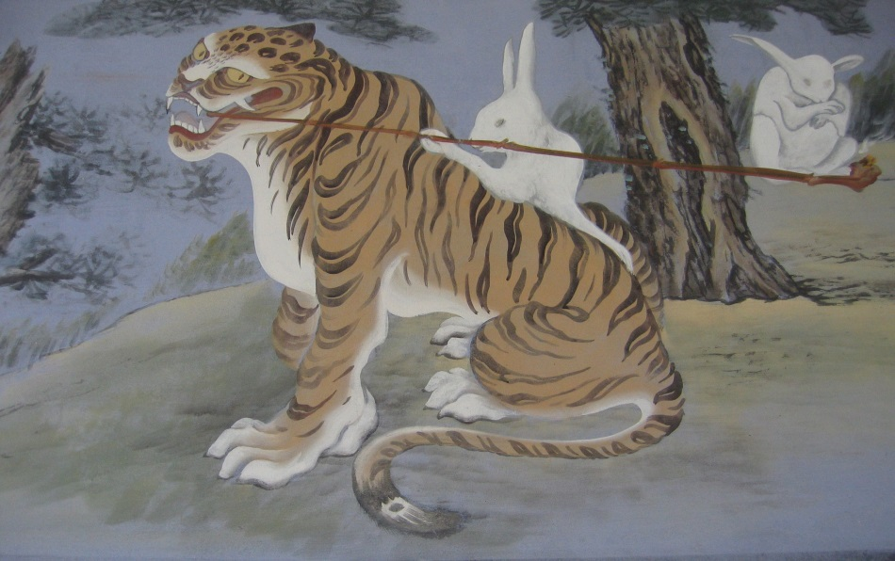

Painting on the wall of a temple in Seoul.

“Long, long ago when tigers smoked,” is a well-known expression, familiar to most people who have spent some time in Korea. Long ago it may have been, but not more than four centuries. The early seventeenth century was the time when tobacco reached Korea, as one part of what might be called the American Revolution in global food culture, which after the discovery of the Americas by Columbus in 1492 introduced South- and Meso-American products to almost all parts of the world. This included food items that would become essential to local cuisines, like tomatoes in Italy, potatoes in Ireland, red peppers in Asia, and cassava in Africa, as well as things that made the lives of people in many regions of the earth more pleasurable, such as chocolate and vanilla. Tobacco might be included in the latter category, but it is exceptional for the diametrically opposed reactions it evoked in different parts of the globe. Some praised it as a panacea for all kinds of complaints or as a supreme pleasure, others judged smoking to be an execrable and dangerous abomination. In England, no less a person than the King, James I, joined the fray in 1604 with the publication of his Counterblaste to Tobacco. (Not entirely coincidentally he was also the first one to put a tax on tobacco.) Tobacco was, he wrote, placing it in as unfavourable context as he could, “first found out by some of the barbarous Indians to be a Preservative, or Antidot against the Pockes [syphilis], a filthy disease whereunto these barbarous people are (as all men know) very much subject… so that from them was first brought into Christendom that most detestable disease, so from them likewise was brought this use of Tobacco, as a stinking and unsavorie Antidot… making so one canker or venime to eate out another.” In other words, tobacco was tainted with barbarism, disease, and paganism. The seventeenth-century Islamic scholar Muhammad-al-Wali warned that no proper Muslim should smoke as tobacco grew where the Devil had pissed. Whether one liked it or not, because of the cultural connotations tobacco almost instantly acquired wherever it was taken, it has always been much more than just a consumer product. Everywhere it has had additional meanings attached to it that go far beyond that of a simple commodity, not least with its original users, the American Indians, who used it primarily in ritual contexts. In this respect, it is similar to alcohol, which carries a multiplicity of socially determined symbolic meanings, both positive and negative.
According to both private writings and the official histories of Chosŏn, the Veritable Records (Chosŏn wangjo shillok), tobacco came to Korea from Japan. The Japanese may have learned the habit of smoking from the Portuguese or Spanish, but in view of the fact that the Japanese word for pipe, kiseru, is derived from the Khmer (Cambodian) ksher, it is not impossible that the Japanese, who in the sixteenth century still used to trade with South-East Asia, were (also) introduced to tobacco in those regions. The literatus Yu Mongin (1559-1623) wrote around 1612 that when relations were restored in 1609 after the Japanese invasions of the late sixteenth century, the Japanese brought tobacco to their trading post in Pusan as a remedy against phlegm. The taste of the smoke was bitter, he added, the smell awful, and it made one’s mouth feel as if it had sprouted thorns. Women who smoked would not be able to conceive and if they were already pregnant they might suffer a miscarriage. In spite of all this, Yu Mongin lamented, tobacco was accepted by the Koreans as a remedy against all kinds of ailments, and soon men and women of all ages in Seoul were smoking, whether they were ill or not, filling the streets with evil odours, while young louts were singing a song declaring that they could live without beautiful women and fine wine, but not without tobacco.
The Koreans called tobacco most commonly namch’o, the “southern herb,” or namnyŏngch’o, the “southern miraculous herb.” In these compounds “southern” should be understood as referring to the westerners, such as Spaniards or Dutchmen, who had brought tobacco to Japan (because they were thought to have come from the south, the Dutch sailors who were shipwrecked in 1653 all were given the surname Nam). An alternative name was tamp’ago or tambago, in which it is not too difficult to recognize the word “tobacco”. The insertion of a nasal sound, m in this case, is a phenomenon that may be observed in many languages from very different linguistic groups. It is also seen, for instance, in the Indonesian word for tobacco, tembako. There is no reason, therefore, to doubt that the current Korean term for tobacco, tambae, is derived from the same root.
Once tobacco was taken to other continents, its acceptance there was amazingly fast, as already hinted by Yu Mongin. During his thirteen-year stay in Korea from 1653 to 1666 the Dutch sailor Hendrik Hamel noted the prevalence of smoking:

The Japanese taught them to grow tobacco and how to smoke it. The seeds, according to the Japanese, came from Nampancoeck [Namban’guk] and so tobacco is still often called nampancoij [nambanch’o]. It is now in wide use, even by children of 4 or 5 years old, and by men as well as among women. One finds few people who do not smoke at all. When tobacco was first introduced they gave for each pipe a measure of silver [about 4 grams] or its equivalent.

Considering that even toddlers smoked, the price of tobacco quickly must have gone down.

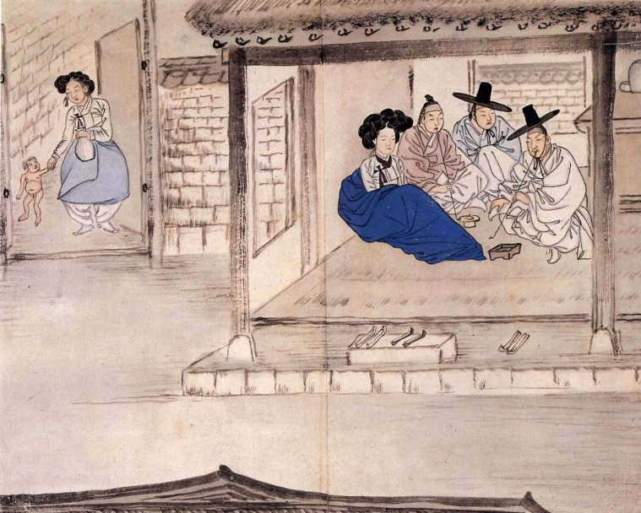

Smokers in a kisaeng house depicted by Shin Yunbok

Since its introduction, only a few decades earlier, the cultivation of tobacco had developed to such an extent in 1638 that that the government had to control its smuggling to China. Moreover, people grew so attached to their smoke that they tended to light up in places where this was deemed unseemly, such as royal tombs, or considered to be dangerous because of the risk of fire at the royal palaces. Additional evidence for the degree to which Koreans of the Chosŏn period indulged in smoking is available in various forms. Tobacco pipes appear in almost all the paintings that depict scenes from daily life. These genre paintings also confirm that women smoked. In one painting by Shin Yunbok, kisaeng on horseback smoke their long pipes, and in another of his paintings a kisaeng with her pipe sits in dreamy contemplation at the edge of a lotus pond.
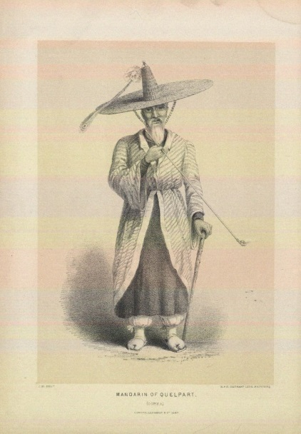

An official on Cheju, after a sketch made in 1845 when Edward Belcher visited the island.

Yet another picture shows a mother smoking a pipe while she is riding an ox with a child in her lap. A line from the p’ansori libretto Pyŏn Kangsoe ka (The Song of Pyŏn Kangsoe, also known as Karujigi t’aryŏng) describes how the sadang, itinerant female artists, while travelling from one place to another smoke their pipes while they are carried piggyback by their male companions, the kŏsa. Tobacco relieved the tedium and hardship of travel and was a consolation in solitude (Chŏng Tasan in a poem called it an exile’s best friend), but also became an important part of social life which might be presented as a courtesy gift. The account books of nineteenth-century Seoul merchants show that consistently substantial sums were spent on tobacco to be presented to third parties.
A particularly rich source for our knowledge of smoking in Chosŏn is the Classic of Smoking (Yŏn’gyŏng) by Yi Ok (1760-1850), one of the most original and interesting writers of that age. It was written in 1810 and in spite of its title, which irreverently mimics that of the great Confucian classics, deliberately deals with the very mundane details of everything that has to do with the consumption of tobacco. From, obviously, tobacco and pipes to special knives for cutting tobacco, tobacco pouches and boxes, pipe cleaning gadgets, braziers and flint stone, nothing was beyond his attention. Yi clearly comes out in favour of smoking, as the section “The uses of smoking,” here translated in full, illustrates.

- When after you have eaten your fill, a sharp taste or a fishy taste remains in your mouth, a single pipe of tobacco eases the stomach and refreshes the spleen.
- If, when you wake up early in the morning, before brushing your teeth, you are bothered by phlegm or slime, you smoke a single pipe of tobacco, it feels fresh as if it all has been washed away.
- If, when worries and anguish accumulate or you have nothing to do and are bored, you slowly smoke a single pipe, it is as if you wash it all away with alcohol.
- If, when your liver is inflamed and your breathing is hard because you have drunk too much, you relax smoking a single pipe, the feeling of oppression flows away with your exhalations.
- If, when the rivers have frozen over because of the severe cold, when it snows and icicles form in your beard and your lips are numb, you smoke several pipes in succession, it is better than drinking hot water.
- If, when the waters have swollen and mould has formed on your bedding and clothes because of heavy rainfall, you continue to smoke, you feel comfortable and all right.
- If, when composing poetry you are stuck, rubbing your moustache and gnawing the end of your brush, you smoke a single pipe with special care, poetic ideas will follow in the wake of the wisps of smoke.

In another passage, Yi Ok lists the occasions when the taste of tobacco is particularly good. For instance, when you have been reading intently for a long time without eating or drinking anything, or on a cold winter morning when you smoke in bed under the bedcovers, which gives you the feeling that spring has come. A pipe is also a great comfort in Seoul in the heat of summer when the fish shops and latrines stink to high heaven. The taste of tobacco is particularly good to people at court, who silently have to wait on the king for hours and hours, solemnly maintaining decorum. As soon as they leave the palace, they quickly reach for their tobacco pouches and smoke, “a sweet fragrance filling their innards.”
Yi Ok devotes some attention to undesirable ways of smoking, which include smoking in front of one’s social superiors or when making sacrifices to the ancestors, and smoking during a storm or near a gunpowder magazine. He is also disgusted by a young female servant who sits smoking on the fireplace in the kitchen, bellowing smoke, and afraid of the ragged beggars in Seoul who block the way of people and demand some tobacco. Smoking itself, however, never becomes the target of his criticisms.

The anti-tobacco lobby
In spite of the popularity of tobacco, voices could be heard that decried the addiction to tobacco right from its introduction to the end of the nineteenth century, some of them merely protesting against certain forms of smoking, as Yi Ok did, others condemning smoking outright. King Chŏngjo, although a fond smoker himself, at one moment ordered that the cultivation of tobacco should be forbidden, so that the land could be used for crops that could feed the people. There will be no need to add that this plan was doomed to fail. Another objection against smoking was that the habit might upset the social hierarchy. It was demeaning, for instance, for someone of higher status if his addiction forced him to beg tobacco from inferiors. Generally it was also thought improper if someone of inferior status smoked in the presence of a superior (a custom that has survived into modern times). In 1790, a student of the Sŏnggyun’gwan was thrown into prison after he had loudly protested when he was rebuked for continuing to smoke when the Minister of State passed by. The high price of tobacco was another reason to reject smoking (particularly for the less fortunate). It was repeatedly observed that the poor would not forego the pleasure of tobacco, no matter how destitute they were.
It is not known if Buddhist monks had such practical considerations in mind when they objected to smoking, but we have some evidence (as far as I know not noticed by earlier authors writing on the use of tobacco in Chosŏn) that they were among the fiercest critics of the “southern miraculous herb.” The main piece of evidence is a single page in a version of Yŏmbul pogwŏnmun, a Buddhist text published in the second half of the eighteenth century to promote the practice of yŏmbul, the mindful invocation of the Buddha Amitābha in order to be reborn in Amitābha’s Pure Land and avoid the torments of the many Buddhist hells. The heading of the page is Yuma-gyŏng, which is the Korean title of the Vimalakirti sutra, a celebrated sutra that records a debate between the learned lay devotee Vimalikirti and (among others) the Bodhisattva of Wisdom Manjuśri. The text has nothing to do with that sutra, however, and is an obvious apocryphon. It is the Korean “Counterblaste to Tobacco” mentioned in the title of this piece, and adds threats of infinite suffering to serious health warnings. Its full text runs as follows:

Yuma-gyŏng

The Yuma-gyŏng says: When the Buddha went to the country of Pallae en expounded the Law there, the king of that country with his family and his officials attended and asked the Buddha: “Why is it that the people of this kingdom, whether they are men or women, suffer from so many illnesses and die early?” The Buddha answered: “Why is it so in this country? It is because there is the evil herb of illness and people like to smoke it, and they don’t take the words of the Buddha seriously. That is why there are severe plagues in this country and why they die early and go to the hells to suffer countless sufferings. It is sad to see it.” Hearing this, the king was shocked and he issued an order to all the people to forbid smoking: “The evil herb of illness is not to be smoked. Why is that? The evil herb of illness has five names. The first is chilmyŏngch’o, the second the herb of darkness, the third the evil and lascivious herb, the fourth the herb of bad rebirth, the fifth the herb of great greediness. The sin of those who smoke this herb is great and serious, and therefore even if you have practiced self-cultivation and yŏmbul you will garner no merit, and so when you die and then the messengers of the Ten Kings [of the underworld] appear and take you away, after they have interrogated you under torture, you will enter Burning-Snakes-Hell and suffer there for 3,000 kalpas [eons], and then you will enter Boiling-Cauldron-Hell and suffer there for 3,000 kalpas, and then again you will enter the Avici Hell, suffering birth and death over and over again, and for one existence after another you will not be able to be reborn in the world of man, and so you will not be able to hear the words of the Buddhist Law.”

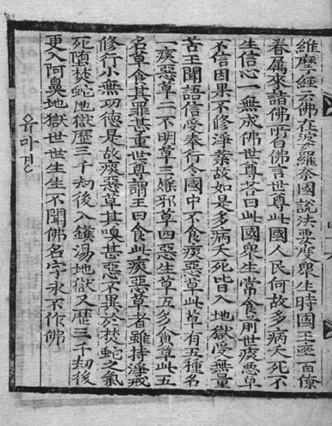

The anti-smoking sutra

There are indications that this was not a unique, one-off Buddhist condemnation of smoking. The reference to the practice of yŏmbul is not found in the hanmun text. It is not unlikely therefore that that is an addition to make the text fit better in the context of Yŏmbul pogwŏnmun and that the apocryphal sutra also was printed separately or in juxtaposition with other texts (although I have not yet found evidence of that). In a nineteenth-century Buddhist kasa by the monk Namho Yŏnggi (1820-1872), moreover, a monk who is begging in the streets of the capital addresses people from all walks of life, urging them to mend their ways, and near the end asks a smoker why he insists on consuming the “herb of five evils” (oakch’o). Perhaps the absence of smoking monks in genre paintings (which occasionally do depict monks having sex or spying on half-naked women) also may be taken as indirect evidence that there were strong religious objections against smoking.
In a sense, however, it may be wrong to speak of “religious” objections in this context. The rejection of smoking certainly was given a religious charge in this supposed excerpt from the Yumagyŏng. But the person who composed this apocryphon may very well have been motivated primarily by the practical considerations also entertained by certain members of the literate elite: that smoking was not healthy, that the land used to grow tobacco could better be used for the cultivation of food crops to avoid famine (a recurring phenomenon in Chosŏn that was so serious that it sometimes led to cannibalism), and that the poor should not squander their meagre resources on smoking. Seen in this way forging the sutra may be considered as an example of the Buddhist concept of upaya, “skilful means,” which refers to something which ultimately may not be true, but is acceptable as long as it benefits someone. Whether as such it was successful one may doubt.

References
An, Taehoe. Tambago munhwasa. P’aju: Munhak tongne, 2015.
Evon, Gregory N. “Tobacco, God, and Books: The Perils of Barbarism in Eighteenth-Century Korea,” Journal of Asian Studies 73, 3 (2014), pp. 641-659.
Injo Shillok. Available online: sillok.history.go.kr.
James I, A Counterblaste to Tobacco. London: 1604 (available in Project Gutenberg)
Kang, Chunman. Tambae ŭi sahoe-munhwasa, Seoul: Inmul kwa sasangsa, 2011.
Lee, Younghee. “A Buddhist Reconquest of Korea? Namho Yŏnggi and ‘Changan kŏlsikka’,” Journal of Korean Religions 3,1 (2012), pp. 85-103.
Myŏngyŏn. Yŏmbul pogwŏnmun, translated by Chŏng Uyŏng and Kim Chongjin. Seoul: Tongguk taehakkyo ch’ulp’anbu, 2012.
Roeper, Vibeke & Boudewijn Walraven. 2003. Hamel’s World: A Dutch-Korean Encounter in the Seventeenth Century. Amsterdam: SUN, 2003.
Shin Kyuhwan and Sŏ Honggwan. “Chosŏn hugi ŭi hwaktae kwajŏng kwa hŭbyŏn munhwa ŭi hyŏngsang,” Ŭihaksa Vol. 10, No. 1 (2001), pp. 23-59.
Sŭngjŏngwŏn ilgi. Available online: db.itck.or.kr.
Walraven, Boudewijn, “The Otherworldly Counter-Discourse of Yŏmbul pogwŏnmun: An Eighteenth-century Pure Land Text,” Journal of Korean Religions 16, 1 (2015), pp. 159-187.

Boudewijn Walraven is a retired Professor of Korean Studies of Leiden University and presently attached to the Academy of East Asian Studies of Sungkyunkwan University, Seoul.

All squashes hail from South America, too, which means that the pumpkins in the story of the brothers Hŭngbu and Nolbu, or the pumpkin that is changed into a carriage in the tale of Cinderella are products of the post-Columbian era, a good reminder that oral literature is not static.
According to the Leiden University Arabist Dorrit van Dalen.
Injo shillok, kwŏn 37, 16th year of Injo’s reign, 8th lunar month, 4th day. A Franciscan friar is on record as having presented seeds of the tobacco plant to the Japanese.
An Taehoe. Tambago munhwasa (Seoul: Munhak tongne, 2015), pp. 32-33. This is by far the richest source for the history of tobacco in the Chosŏn period. For an overview of the growth in the number of smokers, see Shin Kyuhwan and Sŏ Honggwan, “Chosŏn hugi ŭi hwaktae kwajŏng kwa hŭbyŏn munhwa ŭi hyŏngsang,” Ŭihaksa Vol. 10, No. 1 (2001). Kang Chunman, Tambae ŭi sahoe-munhwasa (Seoul: Inmul kwa sasangsa, 2011) provides some historical background but is focused on the twentieth century.
It may be noted that Sir Walter Raleigh in 1578 also used a bisyllabic variant of the word: tobah, which in turn is similar to the seventeenth-century Dutch toeback (in which oe is pronounced as Italian u). Also cf. tombac, the variety of tobacco used to smoke in Middle-Eastern waterpipes.
Vibeke Roeper and Boudewijn Walraven (eds.), Hamel’s World (Amsterdam: SUN, 2003), p. 151.
Injo shillok, vol 37, 16th year of Injo’s reign (1638), 8th lunar month, 4th day. It is possible, however, that some of the tobacco smuggled to China had in turn been imported from Japan through the Waegwan, the Japanese trading post in Pusan.
Sŭngjŏngwŏn ilgi (Daily Records of the Royal Secretariat), vol. 31, 8th year of the reign of King Injo (1630), 11th lunar month,18th and 19th day and 10th month, 12th day.
An Taehoe, Tambago munhwasa, p. 79.
Owen Miller, “Tobacco and the Gift Economy of Seoul Merchants in the Late Nineteenth Century,” in Key Papers on Korea: Essays Celebrating 25 Years of the Centre for Korean Studies, SOAS, University of London, edited by Andrew David Jackson (Leiden/Boston: Global Oriental, 2014), pp. 27-40.
Yi Ok, Yi Ok chŏnjip 4 vols., compiled with translations into Korean by the Shilshihaksa kojŏn munhak yŏn’guhoe. Seoul: Hyumŏnisŭtŭ, 2009, vol. 3, pp. 393-452 (Korean translation) and vol. 4, pp. 408-430 (hanmun original).
Yi Ok, Yi Ok chŏnjip, vol. 3, pp. 441-443, vol. 4, pp. 426-427.
Yi Ok, Yi Ok chŏnjip, vol. 3, pp. 443-444, vol. 4, p. 427.
Gregory N. Evon, “Tobacco, God, and Books: The Perils of Barbarism in Eighteenth-Century Korea,” Journal of Asian Studies, Vol. 73, No. 3 (2014), pp. 41-42.
An Taehoe, Tambago munhwasa, p. 96
An Taehoe, Tambago munhwasa, pp. 233-236. The –juk in this compound stands for changjuk, literally “long bamboo,” the most common word used at the time for “pipe.”
An Taehoe, Tambago munhwasa, pp. 236-237.
An Taehoe, Tambago munhwasa, pp. 100-101.
Boudewijn Walraven, “The Otherworldly Counter-Discourse of Yŏmbul pogwŏnmun: An Eighteenth-century Pure Land Text,” Journal of Korean Religions 16, 1 (2015), pp. 159-187. The hanmun is only a single page, the Korean translation extends to two pages.
In theory, all sutras are the words of the Buddha. In practice, new sutras could be added to the canon when the need arose. Being a later creation (or as it often was phrased “a newly rediscovered sutra”) did therefore not necessarily disqualify a sutra as uncanonical, even if the version of the Yumagyŏng presented here never achieved such canonical status.
Yŏmbul pogwŏnmun is a bilingual text, but the hanmun and han’gŭl are not always exactly the same. This translation is based on the han’gŭl text in Myŏngyŏn, Yŏmbul pogwŏnmun, with translations by Chŏng Uyŏng and Kim Chongjin (Seoul: Tongguk taehakkyo ch’ulp’anbu, 2012), pp. 144-146.
The meaning is unclear. The hanmun text has tam-akch’o, bad phlegm herb.
The invocation of the Buddha Amitābha.
The worst of all the hells, for those who have committed the most heinous crimes such as killing one’s father or mother, or an enlightened one.
In the hanmun text, the last part, with the specification of all the torments that await the smoker, is again spoken by the Buddha.
Younghee Lee, “A Buddhist Reconquest of Korea? Namho Yŏn’gi and Changan kŏlsikka,” Journal of Korean Religions 3,1 (2012), p. 94.

