Jean Perry: Twenty Years a Korea Missionary

Gigi Santow

After my mother died I embarked on a little project to try to flesh out the family stories she had absorbed from her paternal grandmother and then transmitted to me. I was hunting not for rich or illustrious forebears but for the truth: the more ordinary, the more credible. I was hampered in my quest both by my mother’s lack of respect for the mundane and by the delight she took in being entertaining.
The results of my investigations were often disconcerting, but one story in particular caught my attention because the essential details could be corroborated. The account concerned my mother’s great-aunt, her grandfather’s youngest sister, Jean Perry. According to family lore, she had been a missionary in China. I discovered that in fact she had been in Korea, but details of geography seem to have trumped those of governance, at least in Australia: contemporary journalists might describe Korea as ‘a large tract of Northern China’; and ‘Corea, China’ served as a postal address. When some foreign missionaries were savagely murdered in China in 1895, the Queensland press excitedly inferred that Miss Perry (‘formerly of Blackall and Gladstone’) had been a victim, which prompted her sister Lottie to write to Rockhampton’s Morning Bulletin to explain, in contradiction of the paper’s account, that her sister was alive, and working hard, but in Corea.
Maternal lore asserted, secondly, that when Jeannie returned to England she married a rich man. All true: the return, the marriage and the wealth. Her husband’s net estate was valued in 1928 at just under half a million pounds. I cannot substantiate my mother’s claim that there was a revolving summerhouse in his garden but it hardly seems necessary to try to do so.
English census returns furthered my general quest—not just the search for Jean Perry—as did vital registration records in England and Australia. The ongoing programme to scan Australian newspapers and make them freely available on the internet has been invaluable (http://trove.nla.gov.au/newspaper). What a treasure it is, and how aptly named.

* * *

One of Jean Perry’s grandfathers was a carpenter and the other a baker, but her parents were schoolteachers. Marrying in 1850, and all the while adding to the family, they moved from school to school in southern England, from Walthamstow, Essex, down to Blandford, Dorset, and then back east to St Mary Cray, Kent. This is where Jean was born, in 1863, the youngest of seven surviving children, first two boys, then five girls. The final move in England was back to Loudwater, Buckinghamshire, close to the birthplaces of her parents.
The first dramatic dislocation in Jean Perry’s life came in 1882 when she travelled, with her parents and sisters, to Australia. Ranging in age from twenty-eight down to Jeannie’s nineteen, the daughters of the family were unmarried schoolteachers. Queensland’s Department of Public Instruction was advertising for teachers. Jean’s father, Henry Thomas Perry, was an atypical applicant, being a family man approaching sixty rather than a bachelor in his twenties who was all too likely to reveal a weakness for drink, gambling, or fiddling the books. But potential husbands for the Perry girls—my mother’s term for the sisters—would be more numerous than in England, and if they did stay single they’d be better paid. Accordingly, the family emigrated to Queensland, and after a brief stay in Mackay, their point of disembarkation, Mr Perry was posted inland to Blackall, along with Sarah, his oldest daughter. And indeed there were marriages, one a year for three years, until only Jean and her eldest sister Sarah, remained. With their parents’ health failing, the reduced family of four moved back to the coast, to Gladstone, and the sisters ran a little school (‘The Academy’) and cared for their parents until, in quick succession, they died.
The second dislocation came a decade after the first. After Jean and Sarah had persevered for a few years with their school, the local minister encouraged Jean to answer the Presbyterian Women’s Missionary Union’s advertisement for ‘a lady missionary’ to join a group bound for Korea. She applied and, to Sarah’s sorrow, was selected.
Thus, towards the end of 1891, Miss Perry travelled with the Reverend and Mrs Mackay, Miss Menzies and Miss Fawcett to the port of Pusan or Fusan (now transliterated Busan), on the south-eastern tip of the Korean peninsula. They arrived in winter, unheralded, with no accommodation prepared. Mrs Mackay died some months after their arrival, and her widower, himself unwell, returned to Melbourne. In the following year he brought a Miss Moore back to Korea to replace his late wife, but then he married Miss Fawcett and the newly-weds departed for home. This is a confusing story—I find it confusing myself. The essential point is that for a number of years a small group of women was in charge of the Pusan mission. Another male missionary, the Reverend Adamson, did not arrive until 1894. (In the following year Mrs Adamson’s death brought to three the number of deaths at the P.W.M.U. mission out of only nine arrivals.)

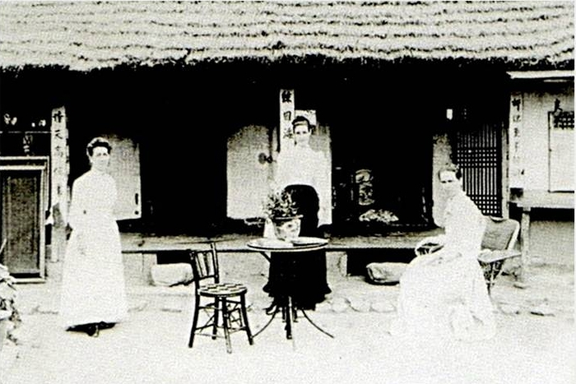

Korean House where the missionaries lived in 1893. Jean Perry is on the right.

Mrs Isabella Bird Bishop provides a glimpse of the depleted group near the start of her Korea and Her Neighbours. ‘I was accompanied to old Fusan by a charming English “Una”’, she writes—the reference is to the representative of Truth and the True Church in Spenser’s Faerie Queene; her temporal guide was Miss Perry—‘who, speaking Korean almost like a native, moved serenely through the market-day crowds, welcomed by all.’ Mrs Bishop found the ‘Australian ladies … well and happy’, despite living in ‘detestable circumstances’. Some miles away from the tiny foreign community, their compound surrounded by ‘mud hovels’, the ladies were busy in the town and the surrounding countryside providing medical assistance, conducting religious services, and classes for adults and children. By the time of Mrs Bishop’s second visit a year later the ladies, still ‘well and happy’, had converted their original dwelling into ‘a very primitive orphanage’.
Five years after her arrival in Korea, Miss Perry set off for Australia to raise funds for the home that she wanted to set up in Seoul for destitute little girls. The usual steamship route took her first to Japan and there, at a missionary house of rest, she met Miss Ellen Pash. An Englishwoman fourteen years Miss Perry’s senior, and a very early graduate of Girton, Cambridge, England’s first residential college for women, Miss Pash had worked with the Salvation Army in England, France, and India, until her health ‘broke down’. She was planning to visit relatives in Victoria, and the women decided to travel together. They were to become not just colleagues but lifelong friends.
So then it was a party of two. Australian newspapers describe the ladies’ appearances in church halls and meeting rooms, town halls and drawing rooms, as far north as Rockhampton, as far south as Hobart, and as far west as Adelaide, and in many places in between. Their fund-raising took various forms. Some meetings did not charge an entry fee, but there would be a collection afterwards and helpful information provided about where to direct further donations. Sometimes there was a bazaar. The entertainment typically consisted of the Misses Perry and Pash, in native costume, singing hymns ‘in the Corean and Indian languages’; sometimes there were small children in quaint dress. One or both would speak, referring variously to their work in Corea or India. I quote from one of the brisker press reports—it makes no mention of costumes, singing or children—that of The Western Champion and General Advertiser for the Central-Western Districts (Barcaldine, Qld) of Tuesday 17 August 1897:

Two adventurous ladies, Miss Perry and Miss Pash, B.A., Cambridge, visited Rockhampton recently with the view to create an interest in the Corean mission, says the Record, in which the first-named lady has been engaged for nearly six years past, having, in fact, been in that ill-fated country during the whole of the late Japan-China war. Miss Perry’s efforts have been directed to the rescue of Corean girls from the degradation in which they are kept under native custom, and she is enthusiastically devoted to her work. … It is impossible not to admire the missionary zeal of ladies who thus leave friends and kindred …

Shortly thereafter, the ladies were off back to Seoul. They built their new inter-denominational home for little girls, teaching them to read and write in Korean and to do arithmetic, and instructing them also in hygiene, needlework, housekeeping, and the Scriptures. Subsequently they set up a separate home for boys. And Miss Pash learnt Korean.
In 1903 came a second trip to Australia. It was a longer visit than the first because Miss Perry was being slow to recover from a second bout of typhoid. Once she was in better health, however, the trip resembled the earlier one—the thousands of miles travelled, the gruelling round of cheerful fund-raising meetings, the native dress, the singing in Korean (the Australian press finally having abandoned the ‘C’ in favour of a ‘K’)—except that the lectures were now enhanced by the additional attraction of Mirlin’s [sic] Limelight Lantern. Advertisements for the ladies’ meetings, and subsequent accounts of them, made much of their sophisticated recourse to the magic lantern, and this, along with considerable public interest in the ongoing turbulence in Korea, must have boosted their audiences. As the Brisbane Courier reported on Tuesday 30 August 1904:

In the Albert Hall last evening, an interesting illustrated lecture on Korea was given by Miss Pash and Miss Perry, who for several years were engaged as missionaries in Korea. They gave graphic details of the commercial, social, domestic, and religious life of rich and poor … Both ladies were attired in the costume commonly worn by Korean women, and on the stage with them were several children also wearing the native costume. The views, which were both meritorious and artistic, included various scenes in and around Seoul, the capital of Korea, a Japanese military camp, Japanese troops on the march, glimpses of Chemulpho, the sinking of a Russian man-of-war, &c. The lecture throughout was listened to with keen attention by a thoroughly appreciative audience. It is both interesting and instructive, and is specially valuable at the present time, in making us better acquainted with a country and people but little understood.

* * *

Early on in my project, I had the great good fortune to to manage to establish contact with a grandson of Jeannie’s sister Lottie. Not only was Gerald a congenial soul but he was interested in family. After we’d been corresponding for a while—he in Toowoomba, Queensland and I in Stockholm—he mentioned that he owned a book inscribed to his grandmother by the author, Jean Perry. There were some missing pages and he wondered whether I knew what was in them; but I had not known that any such book might exist.
What a revelation that was, and then to discover that there were four books. And how moving it was finally to hold in my hands Miss Perry’s books, and in such a place—the beautiful new British Library—and finally to hear Jean Perry’s own voice.

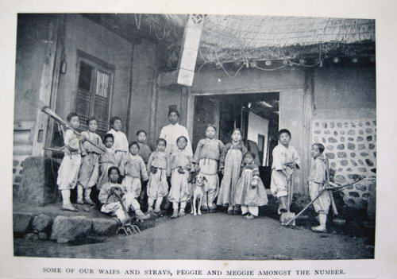

From Chilgoopie the Glad

After her second fund-raising trip to Australia, Jean Perry began to publish books about her Korean experiences. I do not know when she began to write, that is, to do more than draft lectures and write letters and reports, but to write. I can only guess at her reasons. She may have thought that the revenue from the sales of books, and from donations inspired by their contents, would be necessary if, as seemed possible, her increasingly poor health prevented her from undertaking further fund-raising journeys; indeed, she may have anticipated that she would soon be retiring from Korea. Perhaps intimations of mortality made her want to leave behind a record of her work and her beliefs and opinions, and it would certainly be easier to sit and write than to carry out more strenuous tasks. Each of these conjectures has merit, I think, but there is an additional factor, that she enjoyed writing. I think she was good at it.

It was a pouring wet day, at the height of the rainy season in Korea, when everything—including food, furniture, and clothing—was damp, moist, and unpleasant; when you breathed into your lungs from the steaming atmosphere microbes of every class and quality, which rose in invisible swarms from the reeking gutters beside the straggling, narrow roadways, and from the cesspools which flanked the entrance of every dwelling-place of the little Korean town.
Yellow-stained water poured from the low-hanging thatched eaves of the cottages, and small boys in vari-coloured garments, which hung in drenched and uncleanly folds round their ankles, splashed through every available pool in thick wooden clogs …
It was on such a day as this, in July, that I was introduced to our hero.…
I was sitting writing in my eight-feet square room, writing an account of “missionary labour” to the friends at home, whose pence and halfpence, with a sprinkling of the mighty silver … supplied me with sustenance for the body …
I had just written, “Am snatching time on a rainy day, when there is a lack of callers, to tell you how—”. My flow of eloquence came to a standstill, for there was an ominous sound just outside the door.…

Thus begins Chilgoopie the Glad, the first of Jean Perry’s four books. Enhanced by splendid photographs that surely derive from those magic-lantern slides, Chilgoopie appeared in 1906. So did The Man in Grey, which was illustrated by Sid Paget, the popular illustrator whose depictions of Holmes, Watson and their adversaries fixed for all time their physical appearances in the popular imagination. In 1908 came Uncle Mac the Missionary, which was illustrated, Sid Paget having died, by his brother Wal. Finally, in 1912 came Twenty Years a Korea Missionary. Only this last book is declaredly autobiographical, but the fictional element, especially in the first two books, is slight.
The books reveal so much: Jean Perry’s visceral sense of justice, for instance. Although fond of the ‘quiet and thoughtful’ Korean, whom she distinguished from the ‘warrior’ Japanese and the ‘keen businessman’ Chinese, she was affronted by the general east-Asian privileging of the male sex. Consequently, one strand of The Man in Grey concerns the Korean preference for little boys: she contrasts the rejoicing of the foreign missionary’s wife when she bears a daughter with the abuse a local woman receives from her mother-in-law when she does the same, but then the child’s father—a convert—defies his mother for the first time in his married life, and comes to the aid of his wife.
Likewise, not herself an ancestral Presbyterian, she was impatient with that denomination’s comparable prejudice in favour of the male. She had a strong bond with her father, and perhaps had been influenced also by her experience at Blackall, the rough Queensland town where although her ailing father had nominally been head teacher it had been her sister Sarah who was effectively in charge: ‘the mainstay of the school’ is what one school inspector called her. In Chilgoopie, Jean defends herself when she is criticized for baptising a man who requested the rite on his deathbed.

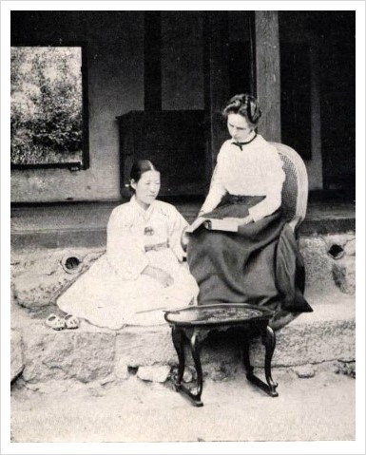

Miss Jean Perry, and Mareeya the Matron of the Home for Destitute Children, Seoul (from Chilgoopie the Glad)

In The Man in Grey, ‘little Miss Smart’, gets into trouble:

She had started a meeting for women, and many had attended regularly, and they had asked her if their husbands and brothers and cousins might come also, with the result that as many men were attending the meetings as women. … Then a missionary brother … told her it was not her work; she ought not to address a mixed meeting. She had not remembered it was a mixed meeting till the brother told her so.…

The matter is thrashed out at an annual missionaries’ assembly: “…One brother rose, and said a woman should not usurp authority over a man: he had Scripture for it.” Someone in the audience declares that women should defer to their husbands, and someone else asks, “But suppose they have no husband, sir?” to which is given the testy response, “Then they ought to have.” Finally comes an intervention from the chairman: “We have not yet replied to Miss Smart’s question. What shall we do? Break up her meeting or keep on?” A new interlocutor speaks from the floor, and all ends well: Miss Smart’s meeting will continue.
Then there is the matter of language. Jean Perry was quietly but understandably proud of her fluency and literacy in Korean, and is both amusing and convincing on language acquisition. In Chilgoopie, in response to questions about how she had learnt the language, she describes how she studied for the first year or two for six or seven hours a day with a Korean scholar who knew no English. Mr So initially puzzles over how to proceed, and the author digresses:

I have noticed this peculiar difference between the Eastern and Western nations, that whereas a European in any straits invariably scratches his head, an Easterner in like straits attacks his chin. Perhaps this is why the Westerner so frequently goes bald, and the Easterner very seldom succeeds in growing a beard.

As she watches, Mr So prepares some ink, wets his brush, starts to write, and the lesson begins:

I was, of course, a humble spectator of all this, and watched carefully, till at length the teacher looked up and said, pointing to the water, ‘Mool’, writing the character down, and signing me to do the same. Then I got the word for ‘table’, and the prepositions for ‘on the table’, ‘under’, ‘over’, etc., till I had quite a list of words. But how to write them down in those strange characters was a puzzle.…
There are three stages at which you arrive when studying an Eastern language:-
First: You feel you will never get it, because of its extreme difficulty.
Second: In a few months you think you have nearly got it, and really must have a natural gift for languages.
Third: Later on you think you may perhaps see light on the subject in a few years—say ten or twelve; but a real student will never feel he has ‘got it’.

If I had more space, I would say more about Ellen Pash, who was interesting in her own right. I would say more about such aspects of Jean Perry’s personality as her lack of sectarianism, her pragmatism, her scorn for pomposity, and her fondness for children—boys as well as girls—and for animals. I might try to address the apparent contradiction in her books between her avowals of ecstatic evangelicalism and her sense of humour. Her ironic use of ‘heathen’, for example, is startling both for the time and for her occupation:

After weeks of careful application I succeeded in mastering a whole text, and so, armed with a part of the Gospel, I went out to encounter the real live heathen, and deliver my message.… Soon my patience was rewarded by the appearance of a woman … With what loving glances I regarded her as she silently approached, as I recognised in her my first audience, and the representative of all the women in Korea in heathen darkness! … stepping towards her, with my most winning smile, I began, in a clear and rather authoritative voice, I am afraid:- ‘Noo-goo-tun-gee, cu-a-talmit-nan-sa-ram-miel-mang … ’ (John iii. 16). [For God so loved the world that he gave his only begotten son…’]
So intent was I on getting out the right words that I had not paid much heed to the woman’s countenance; but she waited for no further explanation. With a yell of despair she sprang down the path, clutching with both hands her precious basket, and crying out, “Such eyes, oh! fearful! and such a nose! oh, I die, I die!”

I am unqualified to attempt to interpret the fact that Korea today—South Korea, I mean, God help the North—stands out from its east-Asian neighbours in being a very Christian country. In 2005, 52 per cent of the population reported a religious affiliation: 23 per cent identified as Buddhist, but 29 per cent as Christian. In comparison, the proportion of Japanese who identify as Christian is one per cent.

* * *

In 1911, nearing fifty, Jean Perry returned to England. Several years later she married a twice-widowed man, twenty-five years her senior, who had made a fortune in South Africa. Mr Newberry had strong connections with the Salvation Army, with which Ellen Pash, who was a witness at the wedding, had previously been associated. I think it likely that this is how they met.
So far as I have discovered, Jean Perry neither published more books nor was noticed subsequently by either the Australian or British press. Undoubtedly she did good works in her immediate neighbourhood in Surrey. She corresponded with members of her Queensland family, and she sent presents to her Australian great-nieces and great-nephews: The Girls’ Own Annual to my mother and her younger sister, and The Boys’ Own Annual to their male cousins. She died, a seventy-one-year-old widow, in Bournemouth, in 1935.

Acknowledgements

I dedicate this piece to the memory of my cousin and kind informant Gerald Pennycuick, who I think would have enjoyed reading this brief account of the life and achievements of his grandmother’s youngest sister.

Select Bibliography

Bishop, Isabella L. Bird. 1898. Korea and Her Neighbours: A narrative of travel, with an account of the recent vicissitudes and present position of the country. London: John Murray.
Kerr, Edith A. and George Anderson. 1970. The Australian Presbyterian Mission in Korea, 1889-1941. Sydney: Australian Presbyterian Board of Missions.
Perry, Jean. 1906. Chilgoopie the Glad: A story of Korea and her children. London: S. W Partridge and Co.
Perry, Jean. 1906. The Man in Grey: or more about Korea. London: S. W Partridge and Co.
Perry, Jean. 1908 Uncle Mac the Missionary: or more news from Korea. London: S. W Partridge and Co.
Perry, Jean. 1912. Twenty Years a Korea Missionary. London: S. W Partridge and Co.

Online references

Information on Australian teachers, including Jean Perry’s father, as well as Sarah and Jean:
http://www.archives.qld.gov.au/Researchers/Indexes/Professions/Pages/Teachers.aspx

Gigi Santow is an academic demographer. After some decades working in tertiary institutions, in Australia and elsewhere, she now lives in her home town of Sydney, and works downstairs.

