Royal Asiatic Society Publications

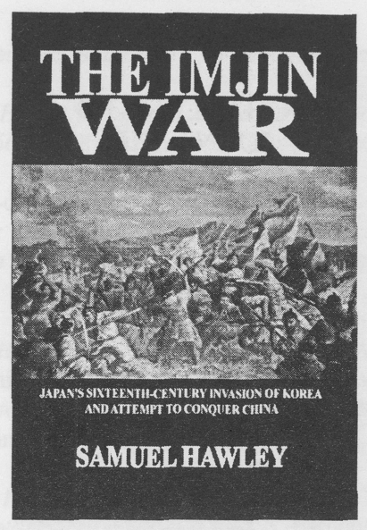
THE IMJIN WAR: JAPAN'S SIXTEENTH-CENTURY INVASION OF KOREA
AND ATTEMPT TO CONQUER CHINA
BY SAMUEL HAWLEY
Co-published by the Royal Asiatic Society, Korea Branch and the Institute of East Asian Studies, UC Berkeley Hardbound, xvi pp. + 664 pp. + 20 pp. illustrations
List price: $45.00; KW45,000
Members' Price: $40.00; KW40,000
In May 1592 a l58, 800-man army aboard a thousand ships sailed from Kyushu to Pusan on Korea's southern tip. Its objective: to conquer Korea, then China, and then the whole of Asia. The resulting seven years of fight- ing, known in Korea as the Imjin War after the year of the water dragon in which it began, involved 300,000 combatants and claimed more than two million lives. It dwarfed any contemporary conflict in Europe, and was one of the most devastating wars to grip East Asia in the past thousand years.
Royal Asiatic Society Publications

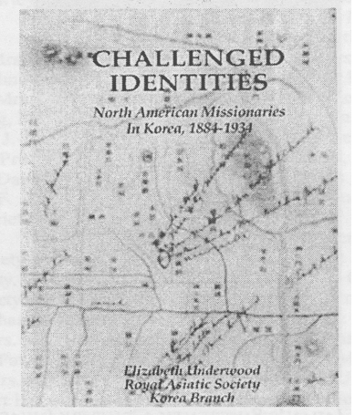

CHALLENGED IDENTITIES： NORTH AMERICAN MISSIONARIES IN KOREA, 1884-1934
BY ELIZABETH UNDERWOOD
Hardbound, 326 pp. + 16 illustrations
List Price $33.00; KW33.000
Member's Price: $27.00; KW27,000
A fascinating look into the lives of the first Protestant missionaries to Korea: the challenges they faced in their lives, from overcoming culture shock and learning the language to raising a family and building a house; and the challenges they faced in the Christian work that they did, challenges that shaped their identities, their policies, and indeed their beliefs in the land of Korea more than a century ago.
Royal Asiatic Society Publications
(RAS members subtract 10 percent from the list price)
HENDRIK HAMEL, HAMEL'S JOURNAL AND A DESCRIPTION OF THE KINGDOM OF KOREA, 1653-1666, trans. Dr. Jean-Paul Buys (softcover, 107 pp., $12) The extraordinary firsthand account of a group of Dutch sailors ship¬wrecked on Cheju-do in the middle of the seventeenth century. More than thirteen years later eight of the men were able to escape to Japan, giving the outside world a first-hand description of the entirely unknown country of Korea.
GARI LEDYARD, THE DUTCH COME TO KOREA (SOFTCOVER, 231 PP., $25)
The story of the shipwreck of a Dutch vessel in the mid-seventeenth cen¬tury and of the adventures of the crew during thirteen years of captivity in the Hermit Kingdom./
KU DAE-YEOL, KOREA UNDER COLONIALISM： THE MARCH FIRST MOVEMENT AND ANGLO-JAPANESE RELATIONS (HARDCOVER, 350 PP., $25)
A thorough study on March First Movement, a Korean uprising against Japanese colonial rule in 1919, with special emphasis on its international implications and Britain's role in the uprising.
WILLIAM F. SANDS, UNDIPLOMATIC MEMORIES (softcover, 238 pp., $16)
Reprint of a delightfully informal account of Korean affairs and foreign policy at the turn of the 20th century as seen by a young American foreign service officer.
KEITH HOWARD, ED., KOREAN SHAMANISM： REVIVALS, SURVIVALS AND CHANGE (SOFTCOVER, 258 PP.)
A collection of critical research on Korean shamanism from prominent scholars in the fields of anthropology, religion, history, and the arts.
BASIL HALL, VOYAGE OF DISCOVERY TO THE WEST COAST OF KOREA AND THE GREAT LOO CHOO ISLAND (SOFTCOVER, 222 PP., $16)
Hall's 1816 account of his voyage to Korea is a classic of Far Eastern travel literature, containing vivid descriptions of the Hermit Kingdom.
PAUL S. CRANE, KOREAN PATTERNS (softcover, 188 pp., $15)
Classic observation of Korean culture and daily life, written by a country doctor and missionary who worked and lived in Korea in the 1950s and ‘60s.
J. S. GALE, KOREAN SKETCHES (hardcover, 256 pp., $25) A reprint of the 1898 account of the "Hermit People" by James Gale, one of Korea's most famous scholar-missionaries. Of interest both as a picture of what Korea used to be and for its frequent relevance to attitudes today.
HAROLD F. COOK, PIONEER AMERICAN BUSINESSMAN IN KOREA: THE LIFE
AND TIMES OF WALTER DAVID TOWNSEND (softcover, 100 pp., $5) This biography of one of the first foreign businessmen in Korea becomes the framework for a unique view of early trade issues and difficulties, with a description of life for foreign traders in Korea a century ago.
ALLEYNE IRELAND, THE NEW KOREA (hardcover, 352 pp., $25) Reprint of Ireland's 1926 study gives a positive view of Japanese colonial rule in the mid 1920s. Detailed information on the bureaucratic and judicial systems. Stress on Japanese contribution to economic development.
RICTIARD RUTT, TRANS. THE SONG OF A FAITHFUL WIFE (SOFTCOVER, 97 PP., $7)
The story of Ch'unhyang, the timeless love story of Korea. An official's son and a girl of low birth fall in love and are secretly married. The offi¬cial and his family are sent away, and the girl becomes the property of a local official who abuses her. Her lover attains the rank of government inspector and returns to punish the local official and rescue his beloved.
HORACE N. ALLEN, THINGS KOREAN (HARDCOVER, 256 PP., $25)
Reprint of Allen's 1908 collection of observations on a Korea newly opened after 500 years as the "Hermit Kingdom." The author served in Korea from 1884 to 1903, first as a missionary doctor, then as an Ameri¬can diplomat.
HAROLD F. COOK, KOREA'S 1884 INCIDENT: ITS BACKGROUND AND KIM OK-KYUN'S DREAM (SOFTCOVER, 264 PP., $15)
The story of the attempted coup aimed at bringing more rapid reform and modernization to Korea in the early years after her opening to the rest of the world. The work includes an analysis of the situation in 1884 and evaluates the motives of the plotters and the results of the attempt both on the nation and for the individuals.
LILLIAS H. UNDERWOOD, FIFTEEN YEARS AMONG THE TOPKNOTS (SOFT-
cover, 403 pp., $18)
A delightfully written personal, perceptive account of a long-gone Korea, shedding new light on a period of incredibly rapid change. This reprint of the 1908 edition contains three new chapters and this edition includes a personal sketch of the author by her younger sister.
JAMES HOYT, SONGS OF THE DRAGONS FLYING TO HEAVEN： A KOREAN
EPIC (softcover, 187 pp., $6)
A translation of the first book written entirely in hangul, the Korean alphabet promulgated by King Sejong in 1446.
JUAN RUIZ DE MEDINA, S.J, THE CATHOLIC CHURCH IN KOREA (hardcover, 380 pp., $25)
Rich in new information about the history of the Korean Catholic church before the time of its recognized foundation in 1784. The author has col-lected information about Korea and the Koreans from documents in five European libraries.
RICHARD RUTT, ED., JAMES SCARTH GALE'S HISTORY OF THE KOREAN
PEOPLE (hardcover, 174 pp., $30)
A reprint of Gale's classic English-language history of Korea, first pub¬lished in 1927, extensively annotated by Rutt with reference to sources ana including commentary.

RICHARD RUTT, KOREAN WORKS AND DAYS (SOFTCOVER, 205 PP., $5)
A fascinating account of rural Korea in the 1950s from the perspective of a sensitive and inquisitive foreign village priest; a record of the seasons, the harvest, the customs of the people, and conversations with local Confucian scholars.
RICHARD RUTT AND KIM CHONG-UN, TRANS., VIRTUOUS WOMEN (HARD-COVER, 399 PP., $25)
The three most significant works of traditional Korean fiction: "A Nine Cloud Dream," "The True History of Queen Inhyon," and "The Song of a Faithful Wife, Chunhyang."
MARTINA DEUCHLER, CONFUCIAN GENTLEMEN AND BARBARIAN ENVOYS
(hardcover, 310 pp., co-published with University of Washington Press, $25) The only thoroughgoing study of the opening of Korea after centuries as
the "Hermit Kingdom"; discusses the rivalries among China, Japan, and Russia and the problems of the traditional Confucian scholar-bureaucrats trying to cope with their rapidly changing world.
AGNES DAVIS KIM, I MARRIED A KOREAN (SOFTCOVER, 260 PP., $18)
The author's personal account of an early international marriage, its almost insurmountable difficulties and unexpected joys. A postscript in this edition describes the Kims' lives in Korea and America during the 25 years since the book's first publication.
ROBERT F. SPENCER, YOGONG： FACTORY GIRL (SOFTCOVER 185 PP., $6)
The author's work is based on a field study done on one of the reasons for Korea's economic miracle, the workers, focusing on the young women who work behind the scenes producing the goods that have pushed Korea into another classification.
These books are available to the general public at the list price, and to RAS members at a ten percent discount. To order, send check or money order to the RAS at:
Royal Asiatic Society
CPO Box 255
Seoul 100-602 Republic of Korea
For international orders, add 25 percent to the total list price (before member discount) for shipping (sea mail) and handling. For orders within Korea, add 10 percent.

