[page 35]
Study of the Archaeological and Historical Sites of Kaesong1

ELISABETH CHABANOL

Introduction

The present-day city of Kaesong (開城) is located to the north of the DMZ that separates the two Koreas, eight kilometers west of Panmunjom village and one hundred sixty kilometers south of the capital of the Democratic People’s Republic of Korea. The site has the rivers Yesong and Imjin to the south and southwest and the Yellow or Western Sea to the west.
Kaesong was built on the site of the former capital of the Koryo kingdom (918-1392). It became the capital in 919 and remained so until 1392, except for a short period from 1232 to 1270 when the court fled to the isle of Kanghwa, in the Han River estuary, during the Mongol occupation.
Generally speaking, there has been little interest in the study of the history of ancient Korean cities such as Kaesong. Even though, like Kyongju and Seoul, Kaesong was one of the most important capital cities in the history of Korea (taking into account the length of time for which it was the capital, its importance as a political, cultural and commercial center, and its size and monuments), few studies of its site have been made, and fewer still published in Western languages. However, it should be noted that several papers have recently been published in Korean. The main reason for this is undoubtedly the improvement in relations between the two Koreas which has meant that South Korean researchers have been allowed freer access to sources and sites which had been inaccessible to them since the Korean War. This craze, albeit relative, shows itself in the popularity among the Korean general public for soaps about the most popular kings of the dynasty: the founder Wang Kon (王建) and Kongmin (恭愍王). [page 36]
In short, a systematic study has yet to be made of the capital Kaesong. That being said, it should be emphasised that access to the site is still limited, which makes it difficult to study the layout of the city or to interpret its organization in terms of social, political or economic factors.
In the course of this presentation we will examine the current state of research into the site and list the various sources that will be used to further our research: archaeological institutions, museums, manuscripts and published research. Finally, we will describe the principal sites.

Archaeological Institutions

1. Kaesong during the Japanese Occupation (1910-45)

The office of the Governor General of Korea, Chosen sotokufu (朝鮮總督府), set up an administrative structure in charge of finding, carrying out archaeological digs, conserving and restoring monuments according to the Japanese method. In 1910 an archaeological research committee was set up, and in 1915 a small museum was inaugurated in Seoul to present material discovered during excavations.
It was not until November 1, 1931 that Kaesong’s own museum, the Kaesong purip pangmulgwan (開城府立博物館) or “Kaesong District Museum” was inaugurated. Prior to this, there may have been, for a short time, a small exhibition of objects from the Koryo period in the area in front of the Manwoltae palace. The Kaesong purip pangmulgwan was situated on Janamsan, behind the Confucian school Sungyang sowon.3 In fact, when Kaesong changed in status,4 Korean businessmen raised funds to erect an 87 p’yong (287.1 m2) museum whose very precise rules and regulations for visitors, written in Japanese, are in our possession. From the opening of the museum up until the Second World War the museum’s curators were all Korean.5 Thus, unlike the other provincial museums such as Puyo, Kyongju and Kongju, the museum was not directly controlled by the Governor General of Korea. It was a true regional museum. The museum’s collections consisted of objects gathered by Japanese collectors and material found during digs. From 1933 onwards stone pagodas rescued from destroyed temples in the region were placed in front of the museum.
[page 37]
2. Kaesong in South Korea (1945-50)

In 1945 Korea regained its independence but the country was split at the 38th parallel. Kaesong was now south of the military demarcation line, in the Republic of Korea. In April 1946 its heritage and its museum became the responsibility of the National Museum of Korea which began field-work on the Republic’s territory.
In May 1947 Kaesong museum started to excavate the tomb of Pop-tang-dong (法堂洞). In 1949, just before the start of the Korean War, the last curator, Chin Hong-sop, appointed in 1946, transported most of the collections to Seoul. They were stored in the Toksu museum and then in the National Museum of Korea in Seoul.6 In 1950, when war broke out, museum employees buried the hundred or so objects that remained in the museum’s collections and fled. It is said that these items remain buried. The war ended in 1953, but the DMZ separating the two Koreas was drawn south of Kaesong and so the city became part of North Korean territory.

3. Kaesong in North Korea (1953-present)

From 1948 to 1955 there was little archaeological activity in the Democratic People’s Republic of Korea due to social instability followed by the Korean War. That being said, the roots of North Korean archaeology were established during this period. Several laws on the conservation of heritage were passed, the “Law for the Preservation of National Heritage and the Natural Environment” in 1946, and ‘‘Guidelines for the Preservation of Cultural Heritage” in 1948, which forbade the looting and sale of art. Provincial history museums were established in Pyongyang and in the principal regional capitals of the country. These institutions carried out archaeological campaigns.
Research was concentrated in the area surrounding P’yongyang, in the Yalu river basin and along the northwest coast: Bronze Age remains, from the 1950s onwards; and from the 1960s, the Han tombs to the south of Pyongyang, the Koguryo tombs, and the kingdom of Parhae. This latter research was undertaken with the help of Chinese archaeologists. No excavations of any note were carried out in Kaesong.
From the ‘80s onwards the country’s economic situation necessitated a reduction in archaeological activity and the number of excavations and published research diminished. [page 38]
Recently Japanese archaeologists have conducted excavations with the Academy of Social Science in the Temple of Ryongdong.
At present, institutions active in the field are: the Institute for the Study of Material Culture or the Archaeological Institute, established in 1953, and the Institute of History, both part of the Academy of Social Science; the Archaeology Department of Kim Il-song University; the Central Museum of Korean History (the forgoing institutions, which are all based in P’yongyang, are carrying out a number of small excavations); and the Koryo Museum in Kaesong, which only carries out small-scale research. The DPRK signed the UNESCO World Heritage Convention in 1998.
The Kaesong Museum was closed at the end of the Korean War and in 1955 the South Korean government withdrew the articles of association. Kaesong Museum ceased to exist. According to some witnesses the building was destroyed during the ‘60s whilst others maintain that it was during the ‘80s. Kaesong city council is not sure what the museum’s precise location was. It was replaced by the Koryo pangmulgwan (고려박물관) or Koryo Museum, established in 1952, which has been relocated several times and is currently housed in the buildings of Songgyungwan (成均館), two kilometers to the northeast of the center of the city. Songgyungwan, originally known as the palace outbuilding “Taemyon”, was built by the eleventh Koryo king Munjong (1046-83) and was designated as the principal teaching institute in 1089. It was given the name Songgyungwan in 1308 and was destroyed by fire during the Imjin War (Japanese Invasion) in 1592. Its twenty buildings date from its reconstruction, which started in 1602, and comply with the characteristics required of a Confu-cian educational establishment of the period. These are the oldest wooden buildings in North Korea.7 Since August 1987 they have housed the Koryo Museum which may conserve more than a thousand items. Its grounds contain pagodas from temples and monasteries in the region as well as steles and stone lanterns. These historic buildings are not at all suited for use as a museum, neither in terms of conservation of works of art, nor in terms of presentation and reception of visitors. Building 1 is devoted to the foundation and development of the Koryo kingdom, Building 2, the main hall, houses objects and documents explaining the development of printing and astrology in Korea as well as a collection of celadons. Buildings 3 and 4 are devoted to metallic and other objects.
[page 39]
Written Sources and Published Papers

The city has a tradition of scholarship and ever since the Choson period numerous papers (sack’an upchi or private gazetteers) have been written about the city of Kaesong by local magistrates and townspeople. In this way Kim T’aeg-yong (金澤垄, 1850-1927), historian at the end of the Choson dynasty and native of Kaesong, attempted to revise the historiography of the former capital, generally seen from Seoul’s point of view.
Other texts available for study are the Koryosa (高麗史), published in 1451, and various Chinese sources such as the Songshi (宋史), the official history of the Song dynasty,8 and the Chinese envoy Xu Jing’s description of his visit to Kaesong in 1123 .
During the period of Japanese colonial administration9 the first field studies of the city’s monuments were carried out, mainly on the royal tombs. Some of the results were published in research and archaeological reports drawn up under the auspices of the Japanese government, Chosen sotokufu. Despite the fact some digs were undoubtedly carried out, the published research is mainly about the exterior of the monuments and their history. Even though the Japanese carried out meticulous research into the Kyongju site and the Silla tombs, the archaeology of Koryo has been neglected until recently. During the final years of the colonial period Ko Yu-sop,10 curator of the Kaesong museum from 1933 until his death in 1944 and the pioneer of studies into the history of art in Korea, produced the first detailed history of a selection of monuments in Kaesong. His knowledge of the sources together with his familiarity with the city means that his work, published in 1946, is the most authoritative study currently available.11
It wasn’t until 1996 that a publication marked a renewal of interest in Kaesong by researchers in the Republic of Korea. Pak Yong-un published a detailed history of the ancient capital of the Koryo kingdom, concentrating on the historical organization. But the most concerted study on the subject to date has been carried out by a team from the Korean Association for Historical Studies, “Harfguk yoksa yon’gu hoe.” Under their auspices several papers have been published on subjects such as the walls of Kaesong, its markets, temples and economy. Another source worthy of note is the work of Kim Ch’ang-hyon, whose field of interest is the spatial organization of the city, identifying the location of principal state buildings, [page 40] discussing their names and their many modifications. Finally at the end of 2004 came proof of the renewed interest in the former capital of a unified Korea with the publication by the Korean National Committee of the International Council on Monuments and Sites of a thick volume entitled Historical Relics in Kaesong and of several pamphlets regrouping information given during their workshops on the subject.
In North Korea, in addition to short articles published in specialist North Korean reviews,12 a book was published in 2002, in Korean, 160 page s long with neither illustrations nor plans, a compilation of raw data whose introduction claims that it aims to present to the world for the first time the culture of the Koryo kingdom,13 Among the research on the city carried out by Westerners, the workshop organized by Sem Vermeersch in 2003 at the Korea Institute of Harvard University14 and the collaboration between the Ecole Francaise d’Extreme-Orient (French Institute of East Asian Studies) and the National Bureau of Cultural Properties Conservation15 are worthy of note. All these studies are based almost exclusively on written sources. The scant data which comes directly from the field has been published in a small number of sporadic articles by North Korean experts.

The Sites

The site of Kaesong became a capital city in 919. Wang Kon (877-943) founded his dynasty in 918 and in January 919 designated the site, to the south of Song’ak(松嶽), as his capital, naming it Kaeju(開州).16 The city, a prefecture during the Silla period, was known as Song’ak. During the Koryo period it was often called Kaegyong (開京), “Capital”, or Hwangdo, “Imperial Capital”. The city comprised several districts of which the most important were Song’ak in the north and Kaesong in the south. Kaeju or Kaegyong refer to the entire city, whereas Kaesong-pu was used to designate the administrative unit governing the capital and the dependant districts. It eventually came to be the name for the capital.17
In 1392, after the fall of the Koryo kingdom, Kaesong, a city of 500,000 to one million inhabitants, depending on the researcher, was abandoned by the new Yi dynasty. At this period it became known as Songdo (松都). From the beginning of this new dynasty local scholars loyal to the old regime started to write melancholic poems inspired by the state of the [page 41] former capital with its temples and palaces in ruins.
The surviving ruins comprise structures that formed the city’s defences, royal or aristocratic tombs, sites of palaces, sites of habitations.

1.Walls

Kaesong was surrounded by a wall twenty-three kilometers long, unique not only because of its size but also because of the way it blends into the topography of the site. According to the rules of geomancy and for strategic reasons, Korean city walls were generally constructed on the crests of hills, thus integrating the landscape into the defensive structure. Small walls have probably been present on the site ever since the Silla period. In the Koryo dynasty the walls were made from beaten earth. However during the 14th century certain parts were rebuilt in stone. Large sections of the stone construction survive and parts of the earth walls are still visible. The walls had around twenty gates, some of which are still in place.
According to Chong Ryong-ch’ol, professor of history at Songdo University in Kaesong,18 who has written a thesis on the walls of Kaesong,19 the exterior wall dates from the 11th century and the interior wall from the 14th century.20 The most famous gate is Namdaemun (南大門), the south gate of the interior wall, which was built at the end of the Koryo dynasty, between 1391 and 1393. The original wooden structure, destroyed during the Korean War, was replaced by an “identical” structure in 1954. It has housed the bell of the Yonbok monastery since the monastery’s destruction in 1563. This gate, in the heart of the city, gave access to the largest market. According to texts, prior to its construction, during the Koryo dynasty, this zone was the junction of the major north-south route with the major east-west route. It would be prudent to investigate this. Historians do not agree either on whether or not there was an earth wall already in existence prior to the construction of the stone wall. It could be interesting to verify this point with excavations.

2. Tombs

Koryo-dynasty tombs are usually north-south orientated and placed on the south-facing slope of a hill so that the back of the tomb is protected. The ideal site is protected by mountains to the east and west and has water [page 42]running between the tomb and the mountains. To the south there should be a valley. Given the importance of the geomancy and the political importance of the Koryo capital, the tombs of most of the kings, queens and aristocrats of the Koryo kingdom are situated in the area around Kaesong, in the Kaep’ung-gun and P’anmun-gun zones outside the city walls. More than twenty tombs are to be found to the north and west of mount Song’ak (松嶽山) on the south slopes of the Mansu mountain range, and on mount Yongsu.
According to epigraphic inscriptions, it was common practice even for aristocrats born in the countryside to be buriea in Kaesong. This custom continued until 1170.21 Subsequently, because of the increasing powers given to regional governors, it became custom and practice to be buried in one’s birthplace.
Of the thirty-four royal tombs, two are situated in Kanghwa and the precise locations of three others are uncertain. Of the remaining twenty- nine tombs, seventeen are known to lie in the Kaesong region.
In 1916, while making an inventory of the site, Japanese archaeologists counted fifty-three royal or aristocratic tombs of which ten were identified.22 The most imposing tombs are those of the founder of the dynasty, Taejo (太租), Wang Kon’s posthumous title, and of King Kongmin. These are the best known. However many tomb sites are inaccessible today as they are in the area strictly controlled by the army.

The Tomb of Wang kon (T’aejo)

Site: Kaep’ung-gun, Haeson-ri, 3.5 kilometers from Namdaemun; burial place of Wan Kon (877-943) and his queen; built in 943 .
In front of the tomb stand two statues of officials, a lantern, an offertory table, a statue of an animal and twelve guardian gods who served as buttresses to the base of the tumulus. The guardian gods are now fixed along the walls of an artificial underground corridor which leads to the burial chamber.
According to an inscription, the tomb was restored in 186/ by the governor on the king’s orders. Studied by Japanese archaeologists then looted by the Japanese occupiers, the burial mound was excavated by North Korean archaeologists following a visit by Kim Il-song on May 5， 1992. Its reconstruction started in 1993, at the request of the head of state. [page 43]
On this occasion the Wang family, who still live in Kaesong, donated the family chokpo to the national museums.23
During excavations in 1993-4 a bronze statue of King Wang Kon, seated, was discovered behind the tomb, together with goblets for spirits, a bronze buckle and a bronze ewer. According to Choson period records, there were numerous statues and paintings of T’aejo. We know that T’aejo’s statue and coffin were moved from Kanghwa to Kaesong in 1270 after the return of the capital from the island of Kanghwa. In 1428 the Yi dynasty King Sejong (世宗王) authorised the burial of several paintings and cast statues of T’aejo and other Koryo kings near their respective tombs.25 The statue of T’aejo was worshipped. The high standard of the statue discovered suggests that it was revered by the Koryo kings.
Since the reconstruction of the tomb the number of statues has significantly increased: four officials, four soldiers, and four tigers mark out the burial area.

The Tomb of King Kongmin and his Queen

The necropolis is situated approximately five kilometers northeast of the Kaesong city walls, in Kaep’ung-gun, Haeson-ri.
King Kongmin, who reigned from 1351 to 1374, was the last significant monarch of the dynasty. He tried to restore the authority of the royal house following a century of Mongol interference in the government. The construction of his tomb, the most impressive of all the Koryo period royal tombs, was undoubtedly part of his strategy to revive the monarchy, and should be considered as the symbol of his power. Following the death of his wife, Princess Noguk, in 1365 he built a tomb for her on a site that had been meticulously chosen. Then, several years before his own death, he built his own burial place next to the queen’s tomb. It is the only example of twin tombs in the Koryo period as queens were generally buried in the same tomb as the king.
The tomb of King Kongmin, to the west, is known as Hyonnung (玄 陵) and that of his wife, to the east, Chongnung (正陵). The tombs are half way up the slope of a hill and can be reached by a series of stairs. Granite paving stones carved with clouds and the twelve guardian gods form buttresses at the base of each tumulus, and the two tumuli are encircled by a single balustrade. Statues of sheep and tigers are placed in an alternating[page 44] ring around the two tumuli and link them. The burial zone is marked to the left and the right by 3.3-meter-high statues of two soldiers and two officials. Restorations have been carried out over the years and it is difficult to distinguish the original parts from those that have been restored
Japanese archaeologists made the first excavations26 from 1905 onwards and started to restore the site in 1920. The king’s tomb was reputedly subsequently looted by the Japanese occupiers. In 1956, the Committee for the conservation of cultural assets in Kaesong carried out further restoration and at the same time proceeded to investigate the interior of the stone room in the king’s tomb. The mural paintings of the twelve signs of the zodiac were copied and a model built. On the east wall of the stone room a door is painted, below which there should be a small rectangular opening, roughly ten by five centimeters, leading to the stone room in the queen’s tomb. It may be blocked. The queen’s burial chamber has not yet been properly excavated. Ever since the reign of King Songjong (成宗王, 1469-94), there have been reports that it contains treasures. The National Bureau of Cultural Properties Conservation would like to study the structure of the interior but has not yet been able to locate the entrance. Passing a radio-controlled camera through the orifice which links the two rooms could give an idea of the state of the interior of the room and the location of the door. The contents of the king’s tomb have been dispersed in Japan and the USA but the funeral artefacts in the queen’s tomb remain unknown. The king’s chamber was subsequently re-opened in 1988.
To the east and west of the base of the tomb there are temples. The site of the eastern temple is indicated by a stele.27 The column plinths have disappeared but it is possible to read the site. Japanese archaeologists started excavations which were later abandoned due to lack of funds. Shrines were built in memory of all the kings, queens and non-reigning fathers of dead Kings in specially constructed or existing temples, which thus became commemorative shrines as in this example.
The three successive terraces of the western temple are still clearly visible, as are numerous stone column plinths. Antefixes (roof end tiles) decorated with Sanskrit characters protrude from the ground. A survey has yet to be done and there is no documentation in ancient or more recent sources about the site. However these temple shrines, used to pay homage to the ancestors, were not at the start of the period linked to a necropolis. It [page 45] wasn’t until the end of the period, when Kwangt’ong Poje sonsa was built in memory of King Kongmin and his wife, that they were constructed near tombs.

3. Palaces

The sites of the palaces are undoubtedly what give us the best impression of what was the splendor of the Koryo dynasty.
Manwoltae Palace (滿月臺)
The main palace, known as the “Palace of the Full Moon” because the site is encircled by mountains, is situated north northeast of the city two kilometers from the center. To its north it leans against Mount Song’ak, 489 meters high. The palace had its own defensive walls to protect it. Staircases lead to the main hall (Hoegyong chon, 會慶殿) which is the most important structure still in existence. Its foundations, terrace supports and some columns are still in situ. It was built in 919, completed in 1029 and burnt down in 1361 during the invasion by the red turban rebel army.28 The royal palace and its compound housing members of the royal family occupied around 1,260,000 m2. The royal palace itself, including the government offices, covered some 390,000 m2. Several surveys of the site were carried out during the Japanese occupation. Later North Korean archaeologists dug trenches in the north zone of the site which show that the site was rebuilt on three separate occasions. However the western part of the site, which contained the library of Wang Kon and the royal bedrooms, has never been excavated.
The National Bureau of Cultural Properties Conservation wishes to restore the site of Manwoltae rapidly—it is a major tourist site—and even reconstruct it, or at least the main entrance, once they have completed excavation around the site of the palace. Recent finds include a metal helmet, a metal printing block, various tiles, and a ceramic plaque that covered a column plinth.

Kyongdok Palace (敬德宮)

Situated south of Namdaemun, in the district of Namsan-dong, this site is well off the tourist trail. To a great extent it has been abandoned to agricul- ture. Former residence of Yi Song-gye (李成桂), founder of the Choson[page 46] dynasty, otherwise known as King T’aejo (1392-98), it was transformed into a palace in 1401 and given the name of Kyongdok-kung. It was used as a palace until 1405, when the Yi capital was transferred to Hanyang. Even though the site has been greatly disturbed, two terraces and a well still exist. Large quantities of roof tiles from different epochs protrude around the site. The stele erected by King Sukchong (肅宗王) in 1693 has survived. No excavations have been made to date.

4. Temples and Monasteries

Buddhism was the official religion during the Koryo period. There were about one hundred thirty temples within and around Kaesong.29 It is likely that there were around seventy important monasteries. All that remains are the stone pagodas, some of which are conserved in the Koryo Museum. However, a rigorous inventory has never been made.
We know most about Hungwang-sa monastery (興王寺), which is situated southeast of the city walls. The site is to the south of the economic development zone. To date, only one inventory with cursory summaries has been made. The site should soon be excavated Known because of its stele, it is frequently cited in the Koryosa. It was built in 1056 by King Munjong (1046-75) and completed in 1067. The site is around 10,000 m2 in area and contains 2,800 intercolumniations.30
Anhwa-sa (安和寺)
This monastery,31 four kilometers from the south gate, was destroyed at the end of the Koryo period, restored in 1931 by the Japanese, destroyed once again by bombs during the Korean War, and rebuilt in 1987 on Kim Il-song’s orders. The second lateral building has not been rebuilt.

5. Habitations

Kaesong is unique in having large numbers of traditional Korean houses, known as han’ok in South Korea and chosdn-sik sallim chip (조선식 살림집) or choson-sik kiwa chip (조선식 기와집) in North Korea, many of which date from the end of the Choson period. These houses are an important element for understanding the evolution of the city since the Koryo period. Certain archaeologists put forward the theory that these houses date from the end of the Koryo dynasty. However, according to [page 47] Professor Byun Ryong Mun32 of the North Korean Academy of Science, it is not possible to accurately date the structures as they have not been sufficiently examined.
The Choson dynasty heralded many changes in architecture, but the brick walls of these houses are built in a similar fashion to those of the Koryo tombs. Many bricks have been replaced over the years and the foundations need to be analyzed. Eighteen hundred houses are protected, of which one thousand lie in the center of the city. During his visit to the site ten years ago Kim Il-song ordered the preservation of these han’ok.

Conclusion: Conserving Kaesong

Though Kaesong miraculously escaped devastation during the Korean War, its heritage has suffered from neglect. Numerous restorations are necessary. However the most urgent need is without a doubt to understand the material culture of ancient Kaesong. To date no systematic archaeological survey has been carried out. Some excavations were undertaken during the Japanese colonial period and, more recently, by archaeologists from the DPRK, but we have no idea how they were carried out.
Widespread, systematic excavations should be made of the undisturbed sites in order to understand the construction techniques, materials and structural aspects of both the monuments from the Koryo dynasty and later monuments. This would enable us to date the structures and gain a better understanding of the social and economic life of these people, of whom historical sources tell us almost nothing.
There have been thefts, particularly from the tombs, which show no sign of abating, given the increasing number of celadons of this epoch being sold on the South Korean antiques market. This reinforces the necessity to study the tombs before the sites are irretrievably disturbed and the funereal artefacts moved out of context. In particular a topological survey should be made to help us to understand the physical relationships between the tombs.33
It is also imperative to catalogue the ancient buildings in Kaesong and carry out a detailed study of the han’ok houses so as to be able to restore this precious cultural heritage to the highest possible standards.
The National Bureau of Cultural Properties Conservation appears to have a different set of priorities which focus on the intramural part of [page 48]Kaesong, restoring and promoting the principal sites which are of interest to tourists: the site of the tomb of King Kongmin, including excavation of the queen’s tomb; the eastern and western parts of the Manwoltae site including restoration of part of the palace; restoring Songgyungwan and transferring the Koryo Museum into new buildings. They also wish to have Kaesong designated as a UNESCO World Heritage site.
Given that Kaesong is the only remaining Asian capital city to have escaped urban redevelopment and whose archaeological strata remain intact and undisturbed, it would be highly advisable to protect the entire intramural area by designating it a site of historical interest rather than protecting a selection of sites that have been arbitrarily designated as important. It should also be born in mind that a controlled development of the entire site should, in the long term, lead to more sustainable tourism resources. The need to preserve Kaesong has become all the more urgent ever since the decision was announced to create the Economic Development zone, a large industrial park built by South Korean enterprises, right next to the intramural city.34
In June 2004 a law was passed integrating within the “Kaes6ng zone’， (Kaesong chigu, 개성지구) the “industrial zone” and the intramural area, which has been designated a “tourist area”. The Kaesong zone falls under a government department (Min’gyonghyo 민경협, or CPEEC35), which is also responsible for the archaeological digs, reporting directly to the executive committee. The priority is therefore to convince this entity of the necessity of conserving the treasures of the sleeping beauty that is Kaesong, while enhancing their value in the medium to long term.

NOTES

1. This article is a summary of several field trips to Kaesong made up to December 2004 at the invitation and with the aid of the National Bureau of Cultural Properties Conservation.
2. See the bibliography which follows.
3. We were able to visit the site of this museum thanks to the precise directions given by Professor Chin Hong-sop, who lives in South Korea and who was curator of the museum from 1946 to 1949. (Take the path that rises to the right of the buildings of the Confucian School 校陽書院). Curiousfy, the existence of the museum has been erased from the collective memory of the[page 49] citizens of Kaesdng. Only a few aging residents of the district remember the old museum. Destroyed some fifteen or thirty years ago, depending on the source, it was replaced by the symbolic Museum of the Revolution, built on the hill dominating the south of the city, to highlight the statue of Kim Il-song.
4. It became a district or “pu” 府.
5. The first curator of the museum was Yi Yong-sun. He was succeeded by Ko Yu-sop from March 1933 to June 1944，then Min Pae-sik, and after the liberation by Chin Hong-sop.
6. The National Museum of Korea moved from Namsan to three successive buildings within the Kyongbok palace complex and finally, in October 2005, to Yongsan.
7. They escaped bomoing during the Korean War.
8. Gaoli 高麗, Songshi 487 Beijing: Zhonghua shuju, 1962-75, p. 14 054.
9. See the various maps of the city drawn up by the Japanese administration in: Kim Ki-ho, Kaesong kugyong (Seoul: Taehan kongnonsa, 1972).
10. Born in 1905.
11. Ko Yu-sop concentrated his research on the Buddhist monasteries and temples and other historical sites in and around Kaes6ng.
12. North Korean archaeological periodicals, some of which have ceased to exist,
are: Munhwa yumul 문화유물 (1949-50), Munhwa yusan 문화유산 (1957-62), Kogo minsok 고고민속 (1963-67), Choson kogoyon’gu 조선고고연구 (1986-present). Two collections: Kogohak charyo chip 고고학자료집, and Kogo minsok nonmun cnip 고고민속논문집.
13. Sahoe kwahak ch’ulp’ansa, ed., Koryo yujok yon’gu (P’yongyang: Sahoe kwahak ch’ulp’ansa, 2002 [Chuch’e 91]), 160.
14. Acta Koreana, July 2004.
15. Munhwajae pojon chido kuk 문화재보전지도국.
16. In 919 Wang Kon moved his capital from Ch’orwon to Kaesong.
17. cf. Pak Yong-un (1997).
18. The history faculty of Songdo Taehakkyo (2000 students) also includes the Archaeology and History of Art Department (200 students).
19. Ch6n Ryong-ch’o1, “Study of the Walls of Kaes6ng, Capital of the Koryo Kingdom (1),” Ryoksa kwahak 2 (1980).
20. There was an earlier earth wall.
21. There was an army revolt due to poor conditions.
22. It is not known who is buried in Ch’il nung (Seven tombs), a necropolis situated behind the tomb of Wang Kon.
23. Kaesong Wangssi chokpo, which dates from 1918, 13th generation.
24. The tumulus measures nine meters in diameter, with murals in the stone burial room, with a south-facing entrance.
25. Sejong sillok 60.
26. The tomb to the west has a stone room with an access corridor, mural paintings of the sun, the great bear, and Orion’s belt on the ceiling and the twelve[page 50] guardian gods on the walls.
27. Kwangt,’ong poje sonsa 廣通普濟禪史.
28. Red Turbans: powerful brigand force.
29. According to Han Ki-mun, Koryo sawon-ui kujo-wa kinung (Seoul: Minjoksa, 1998), 470-79.
30. Hwang Su-ydng, “Koryo Hungwang-sa chi-ui chosa,” in Pulgyohak nonjip: Paek Song-uk paksa songsu kinyom, 1109-33 (Seoul: Tongguk munhwasa, 1957).
31. Capital monastery founded by T’aejo, 930.
32. Pyon Ryong-mun
33 . For example, the tomb of King Kongmin and Ch’illung (七陵).
34. From June 24 to August 11, 2004 a brief survey and some excavations were carried out in the zone that is due to become an industrial park, financed by the Har’guk t’oji kongsa (한국토지공사),a South Korean public finance company. A group composed of around twenty South Korean and forty North Korean archaeologists worked together for almost two months on the site.
35. Korea Committee for the Promotion of External Economic Cooperation
(조선대외경제협력추진위원회 Choson tae’oe kyongje hyomnyok ch’ujin wiwon hoe).

BIBLIOGRAPHY
Breuker, Remco E. “History with a Capital H: Kaesong’s Forgotten Claim of Capital History.” Acta Koreana 7, no. 2 (2004): 65-102.
Ch5n Ryong-ch’ol. Kaesong ui yet chach ui-rul todumo. P’yongyang: Munhwa yesul ch’ulp’ansa, 2002 (Chuch’e 91).
Chosen sotokufu, ed. Chosen koseki zufu. Volumes 6, 10, and 11. Keijo (Seoul): Chosen sotokufu, Taisho 4-Showa 10 (1915-1935).
，ed. Taisho 5 nendo koseki chosa hdkoku. Keijo: Chosen sotokufu, 1916.
Han Ki-mun. Koryo sawdn-ui kujo-wa kinung. Seoul: Minjoksa, 1998.
Han’guk yoksa yon’gu hoe. Koryo-ui hwangdo Kaegyong. Seoul: Ch’angjak-kwa pip’yongsa, 2002.
Haulsser, Sonja. “Kaesong from the Perspective of Chos6n Dynasty Intellectuals.” Acta Koreana 7, no. 2 (2004): 35-64.
Hwang Su-yong. “Koryo Hungwang-sa chi-ui chosa.” In Pulgyohak nonjip: Paek Song-uk paksa songsu kinyom, 1109-33. Seoul: Tongguk munhwasa, 1957.
Kaesong purip pangmulgwan. Kaesong purip pangmulgwan annae. Kaesong: Kaesong purip pangmulgwan, 1936. [page 51] Kang Hoson. “Kaegy6ng-ui chol.” In Koryo-ui hwangdo Kaegyong, edited by Han，guk yoksa yon’gu hoe, 223-43. Seoul: Ch，angjak-kwa pip’yongsa, 2002.
KBS, Yoksa sup’esyol: 4 Pukhan-ui munhwa yusan. Seoul: Hyohyong ch’ulp’an, 2002.
Kim Ch，ang-hyon. Koryo Kaegyong-ui kujo-wa ku inyom. Seoul: Sinsowon, 2002.
Kim Ki-dok. “Koryo sidae Kaegy6ng-ui p’ungsu chirijok koch’al.” Han’guk sasang sahak 40(2001): 63-119.
Kim Ki-ho. Kaesong kugyong. Seoul: Taehan kongnonsa, 1972.
Ko Yu-sop. Songdo-ui kojok. Seoul: Yorhwadang, 1977. (Originally published in 1946).
Munhwajae kwalliguk Munhwajae yon, guso, ed. Pukhan munhwa yujok palgul kaebo. Seoul: Munhwajae kwalliguk Munhwajae yon’guso, 1991.
Pak Chong-jin. “Koryo sigi Kaegyong-ui wich’i-wa kinung.” Yoksa-wa hyonsil 38 (2000): 78-80.
Pak Chong-jin. “Kaesong munhwajae mat pogi.” In Koryo-ui hwangdo Kaegyong, edited by Han’guk yoksa yon’gu hoe, 253-71. Seoul: Ch’angjak-kwa pip’yongsa, 2002,
Pak Yong-un. Koryo sidae Kaegydngyon’gu. Seoul: Ilchisa, 1996.
Pak Yun-jin. “Koryo sidae-ui Kaegy6ng iltae sawon-ui kunsajok—chongch’ijok songgyok.” Han’guksa hakpo 3-4 (1998): 78-120.
Pukhan munhwajae segye yusan tungjae cniwon saop. Kaesong: Historical Relics in Kaesong. Seoul: Icomos, 2004.
Sahoe kwahak ch’ulp’ansa, ed. Koryo yujok yon’gu. P’yongyang: Sahoe kwahak ch’ulp’ansa, 2002 (Chuch’e 91).
Song Ky6ng-nok. Pukhan hyangt’o sahakchaga ssun Kaegyong iyagi. Seoul: P’urunsup, 2000.
Vermeersch Sem. “Buddhism at the Center: The Temples of Kaesong and their Socio-Political Role.” Acta Koreana 7，no. 2 (2004): 7-34.
Yoksa-wa hyonsil. Koryo sigi Kaegyong ui kujo-wa kinung 38 (Dec. 2000): 1-222. [page 52]
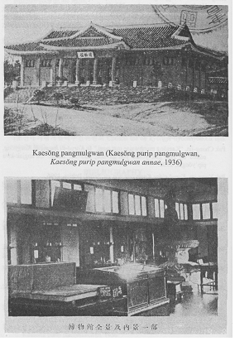
[page 53]
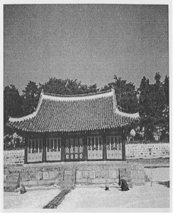
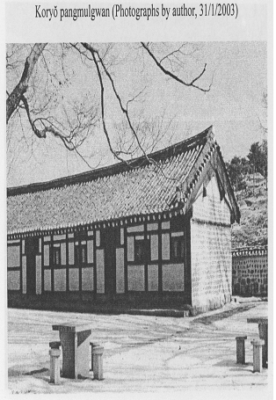
[page 54]
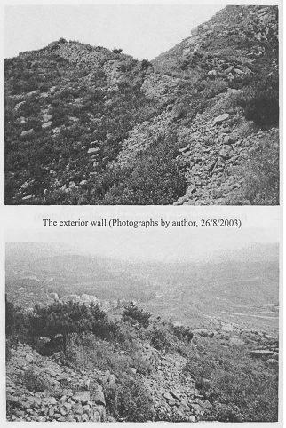

[page 55]
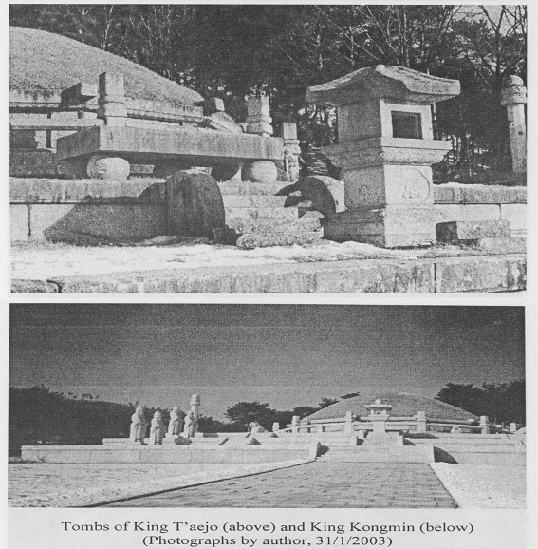
[page 56]
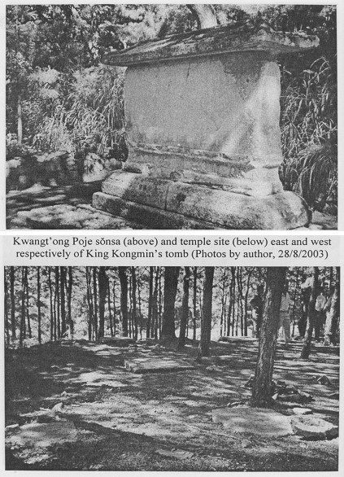
[page 57]
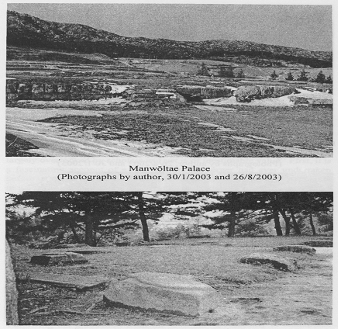
[page 58]
