[page 9]
For Men or Women? The Case of Chinju kommu, a Sword Dance from South Korea

Judy VanZile, Ph.D.

[JUDY VANZILE is professor of dance at the University of Hawai’i at Manoa.]

In 1967 Chinju kommu, or the Sword Dance of the City of Chinju, was designated an Intangible Cultural Asset by the government of South Korea. At that time its choreography was fixed and it was established as a dance for eight women, although the dance is said to have been originated by men. The article examines the historical development of Chinju kommu from the perspective of the gender of its performers and the functions the dance has served at different times. This is followed by a discussion of movement characteristics. The author proposes that although the dance, as performed today, retains clear suggestions of both male-female and masculine-feminine characteristics, and while features of these dichotomous categories have contributed to the development of the dance and, indeed, to its very survival, ultimately gender is not what the dance is about.
Eight female dancers walk casually into the performing space . They wear long blue skirts and long-sleeved blouses. Atop this traditional clothing of Korean women, they wear long dark blue jackets styled after those of male military officials of former times. Each dancers hair is pulled back tightly at the nape of the neck into a chignon, through which is thrust a long hair pin―both typical of older Korean women. On top of their heads they sport round, flat, black hats, each with a peacock feather and red tassel dropping lazily over the side and a chain of large red and yellow beads draped loosely beneath the chin—again reminiscent of former male military attire. The dancers long, multicolored sleeves, typical of female court dancers of an earlier era, hang almost to the ground, and each hand grasps a specially-made sword not [page 10] much longer than a dagger. Small metal ornaments dangle loosely from the blade and a red tassel is suspended from the handle, a design that contributes to the swords aesthetic rather than realistic function.
The dancers position themselves in two lines facing each other, both lines perpendicular to the audience. They slowly lower themselves to a kneeling position, quietly place their swords on the ground beside them, and rise to begin the dance.
They continually bend and extend their knees as they walk slowly through a series of formations in which the lines merge, open into two lines parallel to the audience, and merge and open several more times. They then remove the long sleeves fastened at their wrists and drop them to the floor at the sides of the performing area. Again the dancers change their group formation, this time moving their hands and wrists as if holding and manipulating the swords.
Upon re-forming their original two parallel lines they sit, grasp the long “tails” of their jackets, and move them to reveal the red inner lining. The dancers then tie the ends of their jacket tails behind their backs, and, while still seated, move their hands and wrists once more as if holding and manipulating the swords. They pick up one sword and then the other, and flick their wrists while bending and extending their elbows and turning their forearms. The metal ornaments on the swords clang gently and the tassels spin as the blades trace arcs in space, movements that are ornamental rather than realistic representations of combat actions. The dancers stand and change formations, continuing to manipulate the swords as they advance and retreat, and then form a circle.
By this time the tempo has increased, and the dancers do a series of individual turns at the same time as they progress around the circle, all the while continuing the complex arm movements and wrist flicking. The turns are reminiscent of movements most often seen in dances performed by men and the concurrent sword manipulation ornaments the movement rather than replicating fighting actions. The tempo then slows, the dancers walk around the circle, still manipulating their swords, form a single straight line parallel to the audience, bow, and quietly exit by backing away from the performing area. No story has been told. Only a hint of military action has been offered. The strongest impression is that of a kaleidoscopic ensemble of women who perform in unison, gently grouping and regrouping amidst a calm swishing of sword blades―all with a serious and slightly weighty quality.
This twenty-minute dance is most frequently identified as Chinju kommu. Kom is the Korean word for sword and mu the Sino-Korean word for dance. [page 11]
Throughout history there have been many sword dances in Korea, all of which are known generically as kommu. Although historical documentation has clouded the precise origin of these dances, today the small city of Chinju, near the southern tip of the South Korean peninsula, is considered the home of a sword dance given special recognition by the Korean government, and referred to as Chinju kommu.
An outline of the history of Chinju kdmmu and an examination of the dance in relation to gender follows. A conclusion is drawn that although the dance, as performed today, retains clear suggestions of both male-female and masculine-feminine characteristics4, and while features of these dichotomous categories have contributed to the development of the dance, indeed, to its very survival, gender is not what the dance is ultimately about.
The early history of Korean sword dances liberally intertwines fact and fiction. An historical text compiled in the late 1600s (Tongyong chapki) documents two stories dating from as early as 660 A.D. There are differences in the stories, but they both relate to a young boy from the Silla Kingdom. In one story he was sent to the enemy kingdom of Paekchae to dance in the streets. The king of Paekchae heard of the beauty of the young boy’s dancing and invited him to perform in the court. While performing a sword dance before the king, the young boy seized the opportunity to help his homeland by killing the enemy king with his dance weapons. He was then captured and executed. According to this story, the people in his homeland of Silla created a mask with his features and performed a sword dance to commemorate their young dancer-hero’s courageous act.
The second story simply indicates that a young boy soldier was killed in battle. In sorrow, his father made a mask of the boy’s face, and during funeral rituals the boys fellow soldiers performed a sword dance. It is not clear if the dancers in either story actually wore masks during the dance.
The most significant commonalities in these stories in relation to Chinju kommu are the tie to military personnel and battle, the use of a sword, and the indication that the earliest sword dance performers were boys or men. The original dance in the first story was performed by a young boy; it is not clear, in that story, whether the people who danced to commemorate the death of the young boy dancer were male or female. The fellow soldiers who danced in the second story were undoubtedly men. Historical records are not adequate to trace completely the development of sword dances, but we do know that changes occurred in the number and gender of the performers.
For more than a century following the written documentation of their origin, references to sword dances are minimal, with significant ones not [page 12] appearing until the 19th century. At that time official records documented formal court activities and included information comparable to elaborate program notes. These and other records mention sword dances and/or include line drawings of them5. Some of the drawings show four female dancers and others two male dancers.
One of the richest descriptions of sword dance movements is contained in an 1896 publication by a foreigner that briefly describes a dance performed at the royal court in Seoul.
The dancers are as usual clothed in voluminous garments of striking colors. Long and brilliantly colored sleeves reach down to and beyond the hand. False hair is added to make an elaborate headdress in which many gay ornaments are fastened. The dance is done in stockinged feet, and as the sword dance is the most lively of all, robes are caught up and the sleeves turned back out of the way. The girls pirouette between swords laid on the floor and as the music becomes more lively they bend to one side and the other near the swords until at last they have them in their hands, then the music quickens and the swords flash this way and that as the dancer wheels and glides about in graceful motion. A good dancer will work so fast and twirl her swords so dexterously as to give one the impression that the blade must have passed through her neck. This dance is also done in men’s clothes at times, but the cut of the garments of the sexes is so much alike as to present little external difference except that the colors of the men’s are either white or of one shade, and the mass of hair worn by the dancer ordinarily is replaced by a simple hat. (Allen 1896:384)
This passage is particularly interesting because of its comments regarding the male or female attire worn by female dancers. Today’s costume includes components of attire worn by women as well as those worn by men. The movement dynamics described by Allen, however, are in direct contrast to the version of Chinju kommu performed today and described at the beginning of this article.
Despite the probability that men or boys were the earliest performers of sword dances, today the primary performers and teachers of Chinju kommu are women in the city of Chinju who have been designated by the Korean government to perpetuate the dance. Although perhaps originally performed for ritual or celebratory purposes, Chinju kommu is performed today primarily for entertainment or to display cultural manifestations of Koreas past. It is done in [page 13] the capital of Seoul as part of special performances of dance and music that have been designated Intangible Cultural Assets, occasionally in concert performances of traditional dance and music throughout South Korea, and, most importantly, in Chinju at an annual festival to honor a woman known as Nongae.
Nongae became a heroine in Chinju in the late sixteenth century. The city played a pivotal role in Korean battles with the Japanese, and despite attempts to maintain its stand, ultimately succumbed, on several occasions, to the powerful blows of its island neighbor. Because of her reputation as an entertainer (a kisaeng6), in October of 1592 Nongae’s presence was requested at a Japanese victory celebration held inside the Chinju castle. Although she graciously met her obligation to fill the leisure time of the Japanese officials, she maintained her loyalty to Korea and privately lamented the death of her Korean sponsor. She lured the Japanese general she was entertaining to a precipice overlooking the Nam River, which runs through the city of Chinju. To show her support for her homeland, while embracing him in an assumed air of affection she pulled him over the brink to both their deaths in the water below. In time a shrine was erected along the river at the site where the incident took place, and an annual festival is now held to honor Nongae. What is particularly intriguing in relation to gender is that at this festival to honor a woman, eight women clad in costumes based on male military attire perform a dance with roots that apparently lie in a dance of men, with movement qualities that although suggestive, have been transformed to a quality more appropriate to women.
The quality of the movements used in todays Chinju kommu is predominantly soft and gentle, characteristics that epitomized femininity in the Confucian-dominated Choson courts (1392-1910)7. This quality is sometimes layered on top of less feminine movements, such as exposing the palms of the hands. Korean court women did not expose this part of their bodies. It is likely this contributed to dance movements in which arm gestures are seldom complete until the forearm turns inward and the wrist relaxes so the fingertips point gently downward, concealing the palm. Hence, if the palms are shown, it is only in passing. Some Korean scholars also believe the desire to conceal the palms contributed to female court dancers covering their hands with long sleeves. Movements concealing the palm are present in Chinju kommu, as are the use of long sleeves to hide the hands, but early in the dance the sleeves are removed and in one section of the dance a gentle, but nonetheless blatant, display of the palms is performed—a movement not found in any other Korean dance8. [page 14]
The palm display movement of Chinju kommu begins with one arm extended forward at shoulder height and the other overhead, both turned so the palms face upward. (Figure 1)

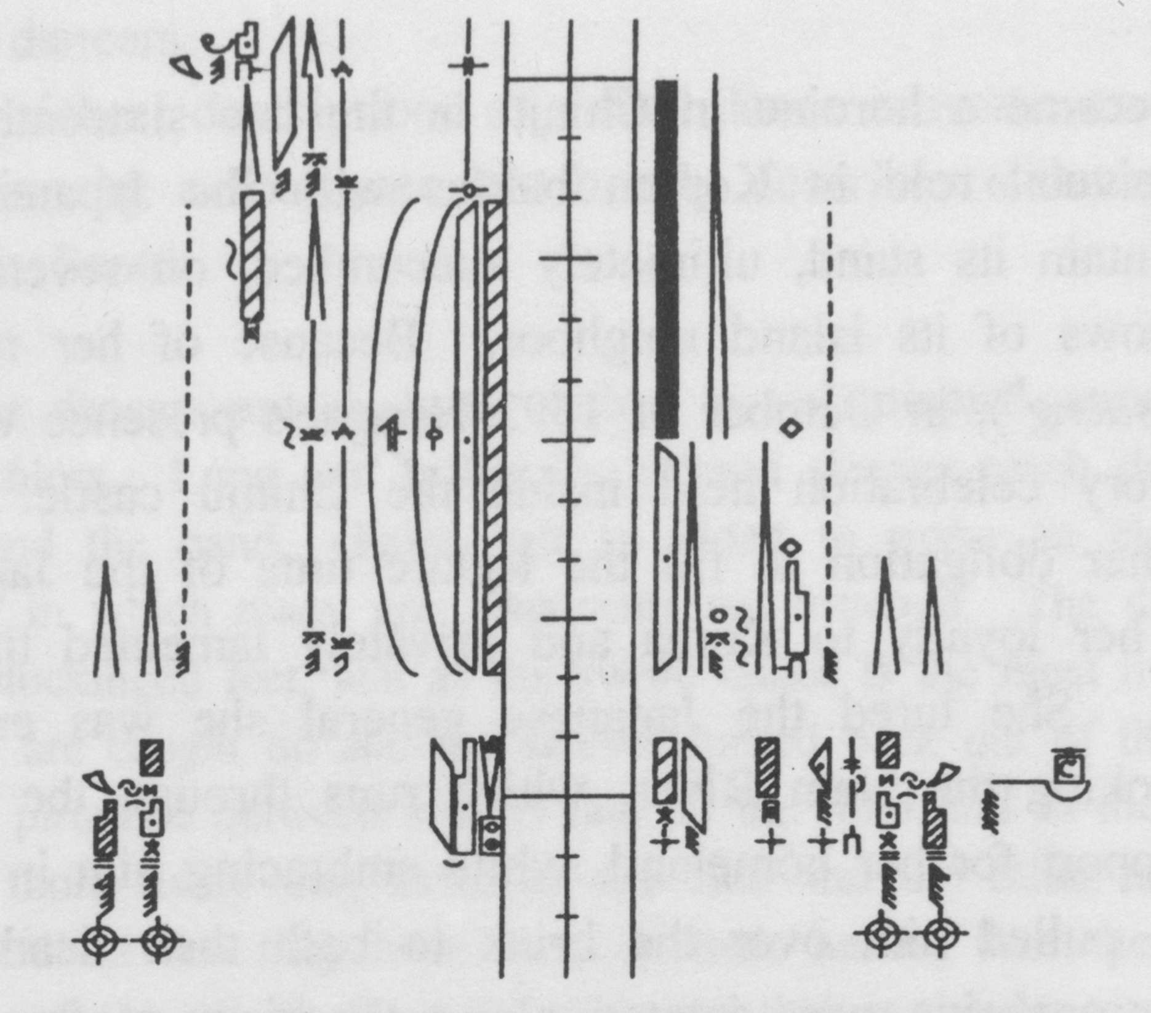
Figure 1. Palm Display Movement
The fingers are laterally closed and rounded so that the palm surfaces of the fingers lightly touch the palm surface of the thumb. The fingers then open and straighten quickly, exposing the palms, before the arms begin excursions through the horizontal and vertical planes, as the forward arm opens sideward at shoulder height, the high arm lowers to the side of the body.
A Chinju kommu movement that is particularly unusual among traditional Korean dances and that is also counter to stereotypic Confucian female decorum is one that might be called the torso display. (Figure 2)
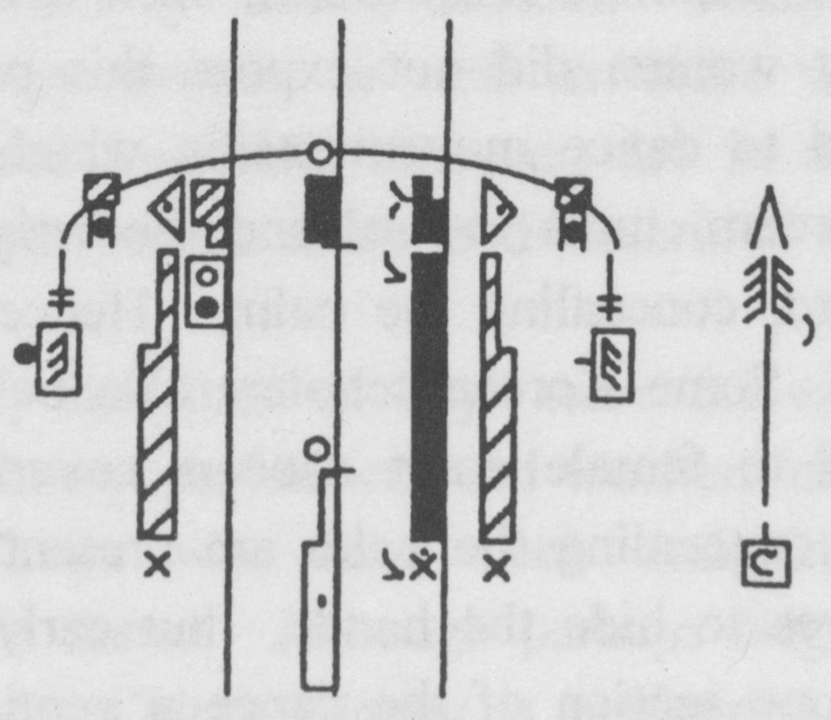
Figure 2. Torso Display Movement [page 15]
Although the arms are often extended sideward at shoulder height in Korean dances performed by women, there is a tendency to move them forward a bit so they point slightly to the diagonal rather than sideward, and to round the shoulders a little to make the front surface of the chest slightly concave, de-emphasizing the female anatomy. In Chinju kommu, however, there is a movement that opens out the chest area. In one sequence the dancers rather abruptly assume a fourth position and tilt their torsos backward with their arms opened sideward at shoulder height, the palms again facing upward. This movement, which blatantly opens out the front surface of the dancers bodies, is the direct antithesis of traditional humble and gentle female deportment.
No one knows for sure the reason for these movements, unusual for Korean women as well as for Korean dance in general, nor any meaning that may have been derived from them. Nor does anyone know when such unusual movements became a part of Chinju kommu. While there are several possible answers, all of them are speculative. One native Korean dance researcher believes that the palm displaying movement was present in dances performed in the court during the Choson dynasty, and that this movement has been preserved only in Chinju kommu. In former times court dances were sometimes performed by men, and, as previously mentioned, several illustrations substantiate this. Therefore, it is possible this type of movement was originally appropriately performed by male court dancers, and was not transformed when women began to perform the dance. Thus, it is possible that Chinju kommu, as performed today, retains movements originally performed in the court by male dancers, and that the dance was originally a court dance.
A second possibility, expressed by a Chinju dance teacher, relates to the story of the origin of the dance. She feels the displaying of the palms and chest area are very strong, courageous movements and are an attempt to incorporate into the dance a sense of the strength and courage of the young boy dancer who killed the enemy king. If this is accurate, the origin and meaning of the dance may have provided acceptable reasons for women to perform movements that otherwise would have been unacceptable.
A third possibility lies in the Chinju environment in which the dance performed today is said to have evolved or to have been preserved. Because the dance was originally perpetuated in this region by kisaeng, the dancers, either because of their artistic or their social functions, may have been allowed to take liberties with movement and the display of their bodies inappropriate for other women. This explanation is tenuous, however, in light of the notion that the use of long sleeves by court dancers who were kisaeng may have originated in the inappropriateness of women showing their hands before the king. Would [page 16] not a kisaeng show a similar respect to patrons outside the court?
A fourth possibility is that standards of female propriety inhibiting the display of the palms and chest area were imposed during the Choson dynasty, with its strong Confucian ideals. If this is the case, movements displaying these body parts may be indicative of a considerably older dance style, a style preserved today only in Chinju kommu.
The notion of Chinju kommu pre-dating the Choson period is supported in a governmental report submitted in 1966. This document justifies the governments designating Chinju kommu as an Intangible Cultural Asset by asserting that although there were many versions of sword dances performed at the time the report was written, and although the Chinju version had changed the overall movements from harsh to soft and graceful9, the Chinju version was the most authentic 10. The report goes on to state that during the Choson period two versions of a sword dance were performed in the royal court: one by male dancers for a male audience, the other by female dancers for a female audience11. Furthermore, the 1966 report, together with subsequent documentation and the memories of older dancers alive in the 1980s, clearly establishes women as the performers, since the early 1900s, of what is now known as Chinju kommu. The earliest of these female performers were kisaeng.
By the time of the Koryo period (918-1392), Korea had established a tradition believed by many to have been patterned after a practice in Tang China of female court entertainers. This institution of female entertainers involved a hierarchy of women who served in unofficial and official capacities with the local and/or central government. Various titles indicated the status of these women, based on their abilities and government affiliation, with kisaeng being the general term for female entertainer. The highest ranking kisaeng were those affiliated with the highest level of government.
During the Choson Dynasty there were twelve official kisaeng unions established in major provincial government areas to train young women entertainers for government officials in the provinces as well as for large, important banquets of the central government. One union was located in the city of Chinju. Although administrative authority for the training of kisaeng originally belonged to the royal court, this function was taken over by regional private schools in the early 1900s. These schools taught their own specialties, such as literature, music, or dance (Lee Byong-won 1979:80), and the sword dance known today as Chinju kommu became the specialty of the kisaeng school in Chinju.
According to former kisaeng alive in the early 1980s, and in reference to a time period probably in the mid-1930s, the Chinju Female Entertainers Union [page 17] (Chinju Kisaeng Chohap) held a kind of workshop (sasup) for seven days every March. At one of these workshops dancers were specifically recruited to learn a sword dance. Thirty to forty women applied and began the seven-day session, but many dropped out because of the difficulty of some portions of the dance.
The portion considered to be most difficult was the flying part near the end of the dance. This movement done by male dancers in some Korean dances is essentially a barrel turn in which the dancer jumps high off the ground while turning. This same movement has been modified in Chinju kommu so that the dancers do not leave the ground. The modification better suits models of stereotypic Confucian Korean feminine decorum, but retains the essence of the more vigorous movement, more usually associated with male dancers, from which it derives12. At the conclusion of the seven-day training period, four of the remaining women were chosen to perform.
From some time after this workshop until the end of the Korean War (1950-1953), Chinju kommu was not performed; it was, however, revived in the late 1950s. Two major changes are known to have occurred in the sword dance performed by kisaeng in Chinju before the 1930s and after the Korean War: eight women began to perform the dance instead of four, and the dance was considerably shortened. Older dancers state that the dance originally took one hour to perform; the full version performed today lasts approximately 20 minutes.
These two changes came about largely through the efforts of Pak Hon-bong (1907-1977), also known as Ki San, an avid supporter of the performing arts. Although not an artist himself, Pak was a strong advocate of folk traditions and strove to preserve Korean folk culture. In the late 1950s Pak requested that eight women reconstruct the Chinju sword dance. There is, however, no indication of why he requested eight performers. According to one of the female dancers involved in the reconstruction, it was not difficult to bring the dance to life again. In spite of the fact that it had not been performed since the mid-1930s, it was still very much alive in the womens memories, because they had performed it so many times. Pak was then instrumental in having Chinju pal kommu designated an Intangible Cultural Asset in 1967.
In preparation for bestowing the governmental honor and because of the advancing age of the early Chinju kommu performers, a cultural institute in Chinju recruited women for a special workshop in 1966. These women were specifically to learn and carry on the tradition of Chinju kommu. In 1967 eight women were designated National Living Treasures whose responsibility was to [page 18] perpetuate the dance. Four of the women were those originally selected from the entertainers union to perform in the mid-1930s and four were second generation dancers selected from the 1966 workshop. A third generation of dancers was subsequently selected from individuals who responded to a recruiting scheme that focused on middle-aged housewives. This group was specifically targeted rather than younger women because of the fear that younger women would leave Chinju to marry or attend college, and hence would not contribute to the preservation of the dance. These training sessions, financed by the city and offered free to participants, were initially attended by 50 women, but attrition was high. As in the mid-1930s kisaeng workshop, drop-outs cited the difficulty of the dance as a major reason; some also believed it was inappropriate for women to spend as much time away from home as was necessary to learn the dance. Confucian notions of the place of women and the low stature of kisaeng had left indelible marks15.
The focus on middle-aged housewives points to a significant difference between the first generation of clearly identifiable female dancers and those of later generations: the first generation were all professional entertainers who had learned a number of arts skills; from at least the third generation on, the dancers were housewives who were not professionals and whose arts skills focused specifically on Chinju kommu. The third generation maintained their positions as housewives while simultaneously assuming their roles as perpetuators of Chinju kommu. Hence, at the same time they continued the stereotypic role of the woman belonging to the house, they were entrusted with the perpetuation of one of Koreas officially-designated cultural artifacts and were in positions of significant recognition.
The primary administrative force behind the perpetuation of Chinju kommu in the 1990s was Song Kae-ok, one of the second generation of dancers who was eventually designated by the Korean government as one of the eight highest ranking perpetuators of the dance. Her involvement with the dance reflects a number of things relating to gender and societal attitudes. Because of a strict Confucian upbringing, Song spent her early days studying Chinese literature. Her parents maintained the commonly held belief that dance was performed by female entertainers, whose status was quite low despite their importance in government functions. It is interesting to note that during the Choson period, which ended shortly before Song was born, Confucianism barred women from most forms of education, and many women were illiterate. It was the kisaeng who were the primary female readers and writers. Although she had a keen interest in dance, it was not until her husband died that Song began to study it. She was then torn between her freedom to learn dance and her [page 19] family obligation to support her five children. The latter necessity led to developing a strong business sense, and it was not until the mid-1970s that she became actively involved with the Chinju kommu dancers. Because of her sophisticated educational background and her business acumen, she has served as coordinator for the activities of the Chinju kommu dancers since the 1980s.
What can we make of this rather complex and not-always-known historical background in relation to gender issues and the way Chinju kommu is performed today? Chinju kommu’s development has led to a dance that includes many movements stereotypically characteristic of other older Korean dances, some of which are performed primarily by women and some primarily by men. Additionally, some of the costume components are or were typically worn by women and some by men. All of these features are distinctively present rather than being combined in any androgynous manner. The intent of the dance is not primarily to represent literally its likely military origins nor to represent women or men. The 1967 designation of Chinju kommu as an Intangible Cultural Asset was, like many other such designations, recognition of something that displayed a distinctively Korean identity without particular regard for gender representation. It was an acknowledgment of something considered important from Koreas past selected to create a Korean identity in the present, regardless of gender issues16.
It is intriguing that a dance attributed to male military roots is now performed to celebrate the heroic deed of a woman (Nongae) important in the history of the city of Chinju. It is also intriguing that a dance with such roots became the purview first of young female entertainers and eventually of middle-aged housewives. What is particularly fascinating from a movement perspective is why a movement associated with stronger dances most usually performed by men, the flying movement, and several movements that directly contradict notions of femininity prevalent in Korea at least at one time in history the palm display and torso display movements, have been choreographed together with movements that are more stereotypically feminine. Information available today does not allow us to assign meaning to these features nor to establish a clear rationale for their existence; they remain a puzzle17.
Chinju kommu may be on the brink of another change, however In 1990，young professional women dancers of the Korean Traditional Performing Arts Center (Kungnip kugagwon), a government-sponsored institute in Seoul, began to perform Chinju kommu. They modified the usually full, loose-fitting costume by wrapping the skirt tightly in a style that is traditional when women are working and want to keep their full skirts out of the way. This style [page 20] reveals the contours of the female body. While for working women such a display of the female form was undoubtedly inadvertent, for the viewer of Chinju kommu it specifically calls attention to the fact that the performers are women, and the dance these women perform has a very light, uplifting, and almost joyous quality. All of these features constitute a sharp contrast to the full-figured image of Chinju’s housewife-dancers and their weighty performance quality. It is easy to envision this as the beginning of another significant change in one of Koreas officially designated dance treasures.
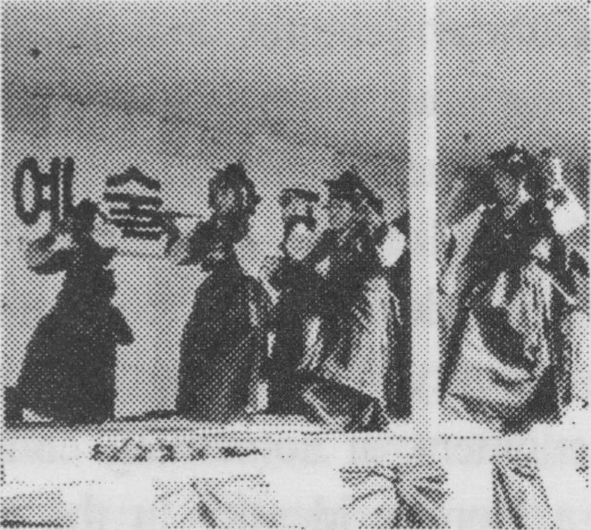
Photo 1
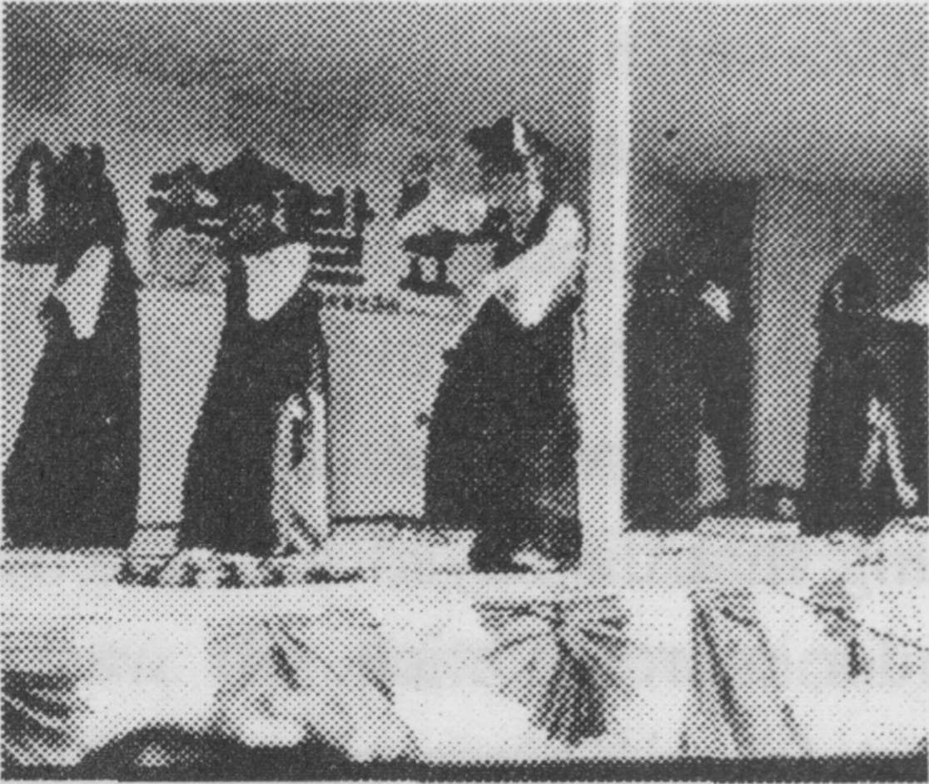
Photo 1A
▲ Chinju dancers perform Chinju Kommu. Photo: Judy

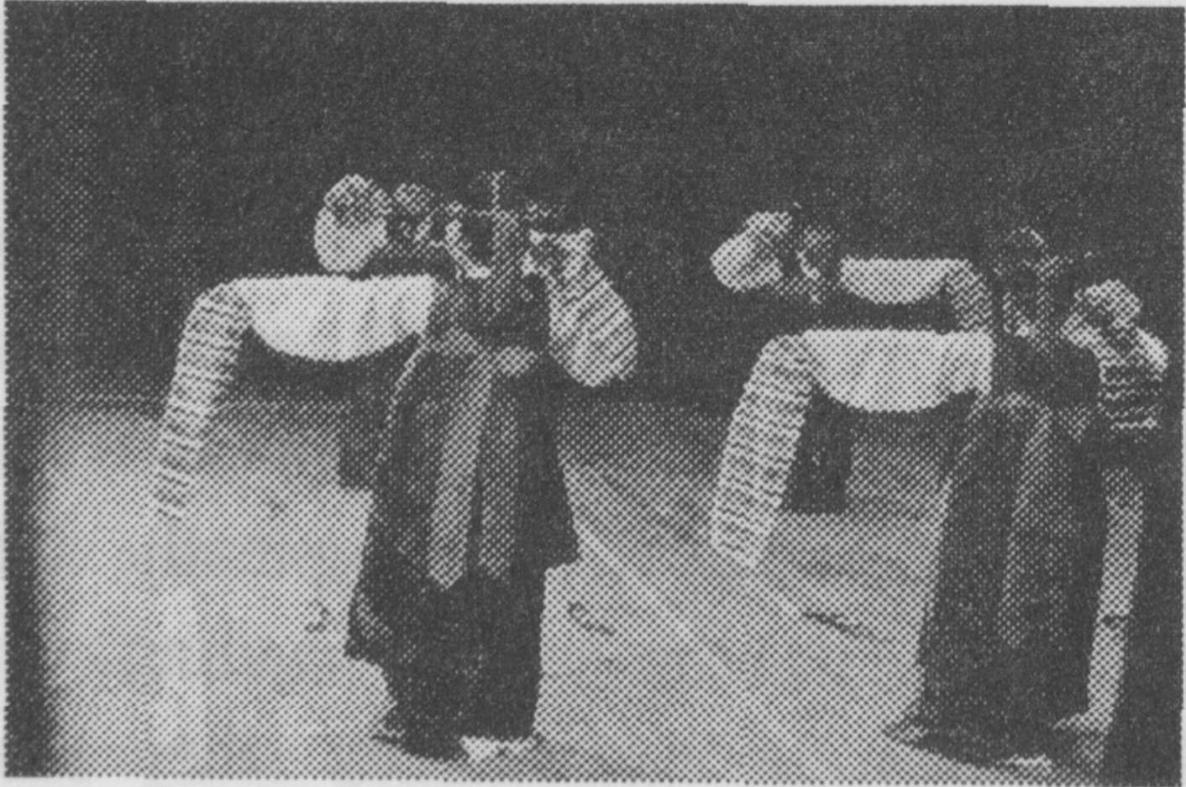
◀ Photo 2
Dancers of the Halla Huhm Dance Studio in Hawaii perform Chinju kommu. Photo: Judy Van Zile [page 21]
NOTES
1. Portions of this paper are based on Van Zile 1991a and 1991b.
2. The complete name of the dance is Chinju pal kommu. P’al is the Korean word for the number eight, and it is the version of the dance performed by eight women that was designated an Intangible Cultural Asset by the Korean government in 1967. (For an explanation of Koreas Intangible Cultural Asset system see Van Zile 1987.) Although kom is the Korean word for sword, the dance is frequently referred to in both Korean and English as a “knife” dance (kal chum in Korean) because of the relatively small size of the implement used today. Hence, the title of the dance indicates the city with which it is associated, the number of dancers, and the implement used in the dance. Today the dance is sometimes performed by fewer than eight dancers in an abbreviated format, so it is generally referred to simply as Chinju kommu.
3. For a fuller historical treatment of the dance see Van Zile 1991a.
4. The category male-female or man-woman are used here in relation to aspects identified on the basis of physiological traits; masculine-feminine is used in reference to characteristics associated with non-physiological traits. For example, some dances are performed only by men and some only by women, the labels referring to physiological traits of the performers. Movements identified as masculine may be those most usually performed by men and hence given the appellation masculine, but they may also be performed by women.
5. See, for example, the 1893 Kungjung chongjae mudo holgi (Written Material on Court Entertainment Dances).
6. Kisaeng is a Chinese compound than can be loosely translated as students of the arts performed by females. Kisaeng participated in the full panoply of social events that comprised the cultural lives of Koreas governing elite. In the capital, as members of the Court Entertainment Bureau, Kisaeng presented elaborately choreographed music and dance pieces on festival days and occasions of state, twirling long crimson sashes and carrying a dazzling array of banners emblazoned with pairs of phoenixes and peacocks; when court officials required “willow waists and mouth organs to foster a party mood at private banquets they were summoned out as well”. At government offices throughout the provinces rosters of kisaeng were kept so that “glistening eyebrows” and “crimson skirts” would be on hand to greet visiting dignitaries and newly appointed administrators. At the end of a long night of banqueting, they might also be called upon to “provide a pillow and ease the loneliness of the hours remaining until dawn”(McCarthy 1994:6) [page 22]
7. Unfortunately documentation does not allow us to know precisely how appropriate feminine decorum of the period was translated into movement. Descriptions do, however, suggest softness, gentility, and humbleness: women were considered inferior to men; an unmarried woman followed the dictums of her father, a married woman those of her husband, and a widowed woman those of her son; a woman was responsible for maintaining purity in customs; women were to be strong and responsible but modest and submissive; and, above all, a woman had to be virtuous (Deuchler 1977:3-4). A wife was to be “loyal and pure, self-controlled, flexible and obedient, and serving others. She minds exclusively the domestic realm and does not concern herself with public affairs” (Deuchler 1993:574). For further comments on desirable characteristics of women during the Choson period see, for example, Deuchler 1977 and 1993, Koh 1987, and Young Hee Lee 1994.
8. That this movement, known as ip ch’um, appears in no other Korean dance performed today and is so unlike any movement found in other Korean dances makes one wonder about its origin. Unfortunately the name given to the movement does not provide a clue. “Ch’um” is simply the Korean word for ‘dance.’ Dictionary translations and those provided by Chinju kommu dancers indicate that “ip” means ‘mouth,’ ‘tongue,’ ‘speech,’ ‘words,’ ‘a beak,’ and ‘one’s taste.’ While it is possible to imagine the opening of the curled fingers that displays the palm to symbolize speech, the opening of one’s mouth, or the opening of a beak, this does not bear any relationship to the nature of the dance or its origin. Some senior dancers say the movement symbolizes the shooting of a bow and arrow. This is logical in relation to the military nature of the supposed origin of the dance, but is not logical when considering that the early stories all specifically describe a sword dance. Although not attempting to translate the words “ip ch’um,” one important Chinju kommu dancer describes the movement as resembling the opening of the petals of a flower (Ch’ae Yae-bun: personal communication 3/18/91).
9. Kim Chun-heung et al, p. 27.
10. Ibid, p. 10. The report describes a number of specific movement differences between the version of the dance performed in Chinju and those performed elsewhere. It is unclear, however, in describing the specific rationale for considering the Chinju version the most authentic, authenticity being an important criteria for designating dances as Intangible Cultural Assets. The report refers to documentation contained in several important historical works at the same time it comments on difficulties in knowing precisely how the Chinju movements relate to those described in only general ways in some of the sources. The age and memories of dancers alive at the time the report was written seem to be the primary rationale for establishing authenticity, which is apparently equated with closeness to some original performance.
11. In both cases the dance was done by two performers (ibid, p. 21). [page 23]
12. According to Deuchler (1977:4), The Confucian image of woman was ••• a double one: she had to be modest and submissive, but also strong and responsible. On the level of Confucian idealism, the image was considered virtuous; on the level of daily life, it often meant bondage. This notion of women having a dual image could provide an interesting explanation for taking an essentially masculine movement and modifying it for a more feminine execution.
13. I Yun-rae (6/14/83).
14. This is the full title of the dance, as described in Note 2.
15. Views of kisaeng seemed to vary. While some looked down on them with great scorn and considered them a threat to Confucian propriety (see, for example, McCarthy 1994:6), the nature of the dances they performed in the court appears to have epitomized the stereotypic notion of female Confucian propriety. They symbolically depicted the ideal while, in reality, were often accorded a far-from-ideal status.
16. For a discussion of Korea’s Intangible Culture Asset system and issues of identity see Van Zile 1995.
17. It would be tempting, for example, to attribute in a Confucian framework the less feminine movements to womens movements of the 1920s that were liberating women from some of the strictures of Confucianism (see, for example, Kim 1994). But there is insufficient evidence to establish a cause-effect relationship. (For an indication of gender issues in relation to music see Howard: 1995.)

REFERENCES CITED

Allen, Horace N. (1896) Some Korean Customs. Dancing Girls, The Korean
Repository. Vol. III，No. 10 (October), pp. 383-386.
Deuchler, Martina (1993) Sin Sukchu: OHouse Rules, in Peter H. Lee, editor.
Sourcebook of Korean Civilization. Vol. I. From Early Times to the Sixteenth Century. New York: Columbia University Press, pp. 571-574.
(1977) The Tradition: Women during the Yi Dynasty, in Virtues in Conflict.
Tradition and the Korean Woman Today, Sandra Mattieli, editor. Korea: Royal
Asiatic Society, Korea Branch, pp. 1-48.
Howard, Keith (1995) Gender Issues in the Conservation of Korean Music: Some
Presumptive Assumptions, in Lux Oriente: Festschrift for Robert Gunther. Koln.
Kim, Chun-hung, Pak Hon-bong, and Yi Ki-yong (1966) Chinju kommu. Muhyong
munhwajae chosa pogoso [Chinju kommu. Intangible Cultural Asset Research Report]. Seoul: Munhwajae kwalliguk. [page 24]
Kim, Yung-Hee (1994) “Women’s Issues in 1920s Korea”, Korean Culture. Vol. 15,
No. 2, pp. 26-33.
Koh, Hesung Chun (1987) “Women’s Roles and Achievements in the Yi Dynasty”, in
Korean Women in Transition. At Home and Abroad. Eui-Young Yu and Earl H. Phillips, editors. California: Center for Korean-American and Korean Studies, California State University, Los Angeles, pp. 29-45.
Lee, Byong-won (1979) “Evolution of the Role and Status of Korean Professional
Female Entertainers (Kisaeng),” World of Music. Vol. XVI, No. 2, pp. 75-81.
Lee, Young Hee (1994) “Women’s Literature in the Traditional and Early Modern
Periods”, Korean Culture. Vol. 15, No. 2, pp. 14-25.
McCarthy, Kathleen (1994) “Kisaeng and Poetry in the Koryo Period”, Korean
Culture. Vol. 15, No. 2, pp. 4-13.
VanZile, Judy (1995) “From Ritual to Entertainment and Back Again: The Case of
Choyongmu, a Korean Dance”, Dance, Ritual and Music. Proceedings of the 18th Symposium of the Study Group on Ethnockoreology, The International Council for Traditional Music. Warsaw, Poland: Polish Society for Ethnochoreology Institute of Art-Polish Academy of Sciences, pp. 133-140.
(1991a) “Chinju’s Dance Treasure”, Asiana. Vol. 3, No. 10 (October), pp.
8-14, 16-17.
(1991b) “Chinju kommu: An Implement Dance of Korea”, Studia
Musicologica Academiae Scientiarum Hungaricae, Vol..33, Nos. 1-4, pp. 359-366.
(1987) “How the Korean Government Preserves Its Cultural Heritage”, Korean
Culture, Vol. 8, No. 2 (Summer), pp. 18-19.

