[page 59]
Yi I, Yulgok(1536-1584), A Path to Maturation and Fulfillment:
—Poetry, Philosophy, and Wisdom—

Philippe Thiebault

[PHILIPPE THIEBAULT has lived in Korea for many years, taking a Master’s degree in East Asian philosophy and language in 1984 at Sungkyungwan University, followed by a doctorate in 1994. He has taught at Sungkyungwan University, Kangwon University, and Konkuk University. The academic year of 1995 was spent as a visiting professor at the University of Southern California.]

In this essay I would like to deal with the philosophical reflection of Yi I, Yulgok (1536-1584) (a) in its vivid dimension. With Yulgok, I intend to better grasp the functioning of the East Asian mind, and of the Korean mind in particular. Neo-Confucianism is often introduced with its technical concepts, but not always with a sufficient reinterpretation allowing appreciation of the meanings of this way of thinking and allowing one to connect this new understanding to the intelligence of the present.
Everything depends on how the act of philosophizing is perceived. Philosophers in the Far East and in the West went through numerous historical stages of creation within diverse contexts. In Europe, the rise of reason made the philosopher partly a scientist, the technician of a field, but Rousseau and Nietzsche rejected such a view.
The approach to understanding a philosopher such as Yulgok is something quite complex. I do it as a Westerner, recognizing my prejudices and weak points. Only some rare English translations exist and it is difficult to interpret the original in Chinese characters. Also, a Neo-Confucian looks unfamiliar, because he is not just a technician of ideas, he is at the same time a practical man, a statesman, a poet and a thinker who finds the time for standing aside and meditating.
I will introduce Yulgok’s thought as a research of “maturation and fulfill- [page 60] ment of the mind-and-heart.” However, I will not emphasize the technical aspect of his thought, but will first tune in to his philosophical concern and walk with him, testing how far he can be understood. There is no philosophical work of Yulgok comparable to The Ethics of Spinoza or The Phenomenology of the Mind of Hegel, although one can mention the Songhak chipyo (b), 丁he Compendium of Learning to Become a Sage (1575), his major work and some philosophical letters (1-572). That is why, retrieving Yulgok’s philosophical thought is much more arduous than in the case of a Western thinker.
Yulgok dealt with history, politics and economy. He held important positions in conformity with the Confucian spirit of serving one’s nation, but very early, he attempted, within the limits of the Neo-Confucianism OT his time and on the foundation of Yi Hwang, Toegye (c), to solve difficult questions about man. I chose to appreciate his research from different angles, knowing that I cannot fully present his thought satisfactorily.
First, I will start with Yulgok’s poetical creation in order to enter his universe. Poetry, in my view, is a short but intense moment, at a given stage of life, when the mind grasps itself in its depth in the flesh of existence. A poem is a privileged locus of emergence of an author’s mind, providing the direction of the author’s research.
Second, my attempt is to go further than a presentation of Yulgok’s fixed ideas, for example, those of I/Li-Ki/Qi (d), Sadan-Ch’il Chong (e), and to bring to light the foundation on which he laid his reflection, to clarify how he made his own hermeneutics of the Classics and how he came, with nuances and clarity, to his comprehension of the human condition. Therefore, the second point I will present reflects the genesis of his thought, starting from the I Ching (f) or from Zhu Xi/Chu Hsi but also introducing the original points of his thought.
Third, I will deal with the subject of wisdom, that is to say with the becoming and accomplishing of humanity, which were Yulgok’s whole objective. It is a theme again spoken of in Europe today. I mention for example, Pope John-Paul II’s 1998 encyclical letter Fides et Ratio, Faith and Reason and the book by French philosophers Andre Comte-Sponville and Luc Ferry, The Wisdom of the Moderns.1
The evaluation of Chinese and Korean wisdom may have a significant meaning. Such a form of wisdom is neither Stoic nor Christian, although it offers some similarities. It is not the wisdom of a Montaigne, but, nevertheless, it contributes to the project of acting well as a man. One historical fact: Yulgok wrote his mature work Compendium of Learning to become a Sage in 1575; that same year Montaigne was working on his Essays, writing, “There is nothing more beautiful nor legitimate, than to act well and duly as a man; there is no more [page 61] arduous science than knowing how to live this life well and naturally.”2 Yulgok, also, gave his full attention to finding the key to becoming more humane, to fulfilling oneself, aware that man walks on a ridge which on one side opens onto the highs of wisdom and on the other side plunges into animality.

AWAKENING OF THE MIND-AND-HEART IN YULGOK’S POETRY

Poetry can be seen as a starting point and as an outcome. For Confucius, it was a means to awaken the mind.3 Heidegger, among others, after arduous philosophical research, came back to ancient Greek poetry as a key to decipher the real. In starting with the relation between philosophy and poetry, I face the question of the status of philosophy which is both one and many, multiple in its approaches and contexts. Instead of dealing with philosophy separately, one may consider it in relation to poetry as an inspiration and a fulfillment, beyond words and silence.4
In order to reach the East Asian poetical mind, I will make a detour through German poetry. I pause a moment to reflect on Holderlin who lived at the time of Hegel:
What has philosophy, the cold “sublimeness” of such a science, to do with poetry?.../... Poetry is the starting point and the term of this science.../... Pure intellect never produced something intelligent nor pure reason something reasonable.../... Without the beauty of the mind and of the heart, reason is like the foreman whom the master of a house imposed on his servants.5
The poet reminds the philosopher that existence is decided, to a great extent, at the level of the heart, of sensitiveness to beauty and purity. Such a poetical sen-sitiveness escapes pure conceptual demonstration. It is connected to the mind and at the same time remains close to what is concrete. The notion of mind in contrast to reason, Vernunft, should be explored further in order to find an articulation between the philosophical spirit and the poetic spirit. The second lesson Holderlin teaches is the importance of nature in the development of the human mind. Fascinated by Greek civilization, he longed for the encounter between man, nature, and divinity.6 Therefore, it is in contact with nature that man awakens himself to feelings and to moral life, as Rousseau, whom Holderlin praised, expressed it.
Far Eastern thinkers never moved away from nature and from the enthusiasm in relating to it. Taoism comes to mind, particularly Zhuangzi/Chuang-tzu, who is a model of harmony between philosophical and poetic expressions. The Confucians did not forget Zhuangzi/Chuang-tzu. Nature played an important role in their philosophical creation. I take the example of Yi Hwang, T’oegye, the [page 62] forerunner of Yulgok, for example in his Anthology of Deep Reflections, Chasong nok (g) (1558).
Emptying the mind and calming it, time is spent appreciating diagrams and books, admiring flowers and plants, rejoicing in the rivers and the mountains.../... It is better not to read books to the point of exhausting the mind. Only in following the passion of the heart, can meaning and joy be found.../...7
Among other Chinese and Korean philosophers, Yulgok is no exception. He wrote many poems, while this was rare for a Western thinker. Yulgok’s poems were inspired, not only by Confucianism but by Buddhism and Taoism from different periods. Yulgok mentioned different classics like the I Ching, the Book of Odes, historical books, but also Zhuangzi/Chuang-tzu (h), Liezi/Lie-tzu (i) and great poets such as Li Bai (j), Du Fu (k), Han Yu (l) and Su Shi (Dong-Po) (m).
I will first present a poem by Yulgok which evokes the climbing of a mountain and waiting for the sunrise. Beyond this evocation of nature, one perceives a reflection on man looking for his origin, reflection which is expressed more technically in other philosophical writings.
Watching the Sun Rise from the Top of a Mountain
A snow-covered peak in the very high mountains.
Following the dangerous path, I walk away from white clouds.
Leaning on a stick, groping, I climb steep mountains.../...
At first cockcrow, I get up to climb to the summit.
At the far limits, hardly to be seen, the sky is still dark.
A while later, the sun beams spread over the world.
It is impossible to distinguish between sea waves and morning fog.
Finally, the sun, like a sphere, emerges at the top of the road.
Tinted clouds taper, forming a canopy.
Bluish water and reddening sky are parting.
Look afar, see the Eastern Sea like a long line.
How distant it is! In the Eastern Sea,
the place where the sun rises, where is it?8
In the light beautiful colors which progressively take over the snowy and foggy landscape of a winter morning, man confronts the inaccessible origin of the earth and of the sun. This poem reminds us of some Chinese or Korean landscapes where people are hardly seen, but where the presence of the mind is very strong in contrast with the emptiness and the silence of nature. Yulgok’s poem echos these lines of Holderlin: [page 63]
Lost in the immense blue, I often raise my eyes toward the sky or lower them down upon the sacred sea. It seems that a fraternal spirit opens its arms, that the suffering of the solitude dissolves itself within the divine life.
But, what is the divine life, man’s heaven, if not becoming one with every-thing? Becoming one with living things, returning, through a radiant self-forgetting, to the Wholeness of nature, such is the highest degree of thought and joy, the sacred peak, the place of eternal calm....9
With Yulgok, man not only enthusiastically unites with nature, but he looks to find the secrets of the universe and of man, as expressed in the following poem.
Writing One’s Inmost Thoughts on a Winter Solstice Evening
During a winter solstice evening at midnight, the Yang starts moving.
It is difficult to express the mysterious dimension of Heaven’s heart.
Knowing the being which is hiding within the non-being,
When the earth shakes at the sound of thunder,
kindle a new fire in the middle of the night
and stay without falling asleep,
Silently thinking of the mysterious basis.
As the pure Yin comes near, all things still sleep without life.
Spring comes back to earth,
buds nourish the resurrecting will.../...
I am part of the three Ultimates.10
Such energy prevails for all beings.
Bright virtue shines,
Brilliant as sun and moon,
As what was conferred by Heaven.
A corrupted thought erodes original brightness,
At the beginning faintly and at the end violently.
Mountain trees suffer from ax and sickle.
Heaven’s truth gets lost in selfishness and falseness.../...
With determination, I solemnly make a promise
And Heaven, in accord, listens to me and looks at me.
The world is an ax attacking original nature.../...
If the mind is not one in concentration. [page 64]
Corrupted thought grasps the occasion;
It confusedly rushes in and disappears,
With the violence of a flame and the swiftness of a horse.../...
If the purified mind is as vast as Heaven,
one fears no shame in the remotest place.
The burden is heavy, the road very long.
In a word, we must recognize a master in the will.../...
Only when dust piles up, is it wiped away;
Originally, the water and the mirror show no stain.11
Through numerous poems, Yulgok let filter solitude, and sometimes sadness. Through the allusions, one understands that he moved away from political games and intellectual narrowness. He evaluated without compromise the great thoughts of his time. Above all, he challenged and dealt with the problems of death, the mystery of the universe, and the conflicts within man’s heart. One also sees in the second poem the determination of Yulgok to take a road out of the duplicities, to escape what leads man away from the fulfillment of his original potential. T’oegye, repelled by man’s evils, loved to contemplate trees, sources and birds and appreciated an hermit’s life. Yulgok was sensitive to symbolic events happening in nature: the thunder, the return of spring, the sunrise. He was not just looking for the beauty of nature or union with it, but, within the symbolism of nature, for the truth to which one must open oneself. Within nature, he responded to a call to become more humane, impatient to give his share in straightening and improving society.

GENESIS OF YULGOK’S THOUGHT

A more challenging part of my purpose is to study Yi I, Yulgok’s thought with its roots ana its dynamism, and to introduce his original ideas. I drew three charts to help visualize the different layers of Yulgok’s thought, its vital articulations and its conceptual structure.12 No thinker starts completely anew; that’s why what he meditated on before and during the creative process is of importance. Opposed to Descartes, who made a clean sweep in order to start thinking by himself, Yulgok, related to a strong tradition following Confucius, who considered himself more as a transmitter than a creator.13 A difficult point is that, in order to introduce Yulgok’s original ideas, one must grasp what defines the structure and the inspiration of his thought.
Yulgok is a thinker who considered different forms of thought in their whole and who connected them. He studied Buddhism, Taoism and diverse Confucian [page 65] schools intensely, but he came back to several different sources of inspiration such as the I Ching, Kong Fuzi/Confucius (o), Mengzi/Mencius (p) and the founders of the Confucian renewal like Zhou Dounyi/Master Chu (q), the Ch’eng brothers, Ch’eng I (r) and Ch’eng Hao (s), and Zhu Xi/Chu Hsi (t). In creating his concepts, Yulgok used particularly the Great Commentary of the I Ching (u), Mengzi/Mencius, the Doctrine of the Mean (v) and Zhu Xi/Chu Hsi. He mastered the classics and often articulated them one to the other, because he kept a running thread which brought to light certain strong points of the classics.
First, I will cover Yulgok’s reflection on the Book of Changes. Next, using the second and third columns on the first chart progressively, I will discuss his reflection on the Neo-Confucian system. Yulgok’s own views will then emerge, as we see in the third column of the same chart. If we separate these factors for the sake of analysis, we must remember that the different aspects of Yulgok’s thought are interlocked.
Let us see first Yulgok’s meditation on the Changes called Yoksu ch’aek
(w):
The fundamental meaning of the great Changes is nothing else than the real principles. The latter are principles of truth which never rest.../... Thanks to them, one follows the principles of human nature and destiny. Thanks to them, man penetrates the reason of what is obscure and what is clear. Thanks to them, man realizes fully the concrete situations. Their essence is great and contains everything. Their application is spiritual, divine, and everything exists due to them.14
While analyzing the Book of Changes, Yulgok showed first his insight into ancient classics and, second, his audacity in reinterpreting them. In his vision, the highest principles, man’s original nature and concrete situations of life relate to each other There is a rooting of man in an essential dimension, which Yulgok expressed through the concepts of basis, bon (x), Great Basis, taebon (y), and which is manifest in concrete life. There is a correspondence between the world of essence and the world of phenomena. Yulgok’s onto-metaphysical research was not foreign to an ethical quest. It reminds us of Levinas’ saying: “Metaphysics is not disconnected from ethical relationships.”15 Discovering the universe is, at the same time, finding out about man’s possible path of action. While Ontology or Metaphysics may be abstract and above existence, they are, according to Yulgok, closely connected to life and enlighten it. To Yulgok, Ontology is Ethics.
Scholars carefully studied the Changes; they deeply explained their pure and hidden meaning. They clearly demonstrated and largely introduced the To/Dao of opening things and accomplishing tasks.../... To understand the To/Dao of [page 66] Changes, one must consider as a unique source the essence and the applications, and grasp the fact that there is no space between what is manifest and what is hidden. If one does not reach sincerely the highest knowledge, one cannot discover the principles of changes; if one does not purify one’s thoughts and rectify one’s mind-and-heart, one cannot put the truth into practice. Therefore, knowledge and purification are one and same action at the heart of the Changes.16
Yulgok was for a practical knowledge of the universe, and the principles which he discovered guided him toward action of fulfillment. The highest knowledge is not pure knowledge in itself, it remains humane, connected to the transformation of the universe and of man. The world is not created ex nihilo and man is not created from an external origin. Man awakens to this present and infinite life, he takes part in the life of which he progressively discovers the meaning and the greatness. Some key texts of the Great Commentary of the I Ching are present behind Yulgok’s reflection and enlighten his concepts.17
On the basis of all his knowledge, Yulgok carries out his own hermeneutics of the I Ching.
All things are the unique Five Elements; the Five Elements are the unique Yin and Yang; the Yin and Yang are the unique Great Ultimate. The Great Ultimate is the name one was forced to put. The essence of the Great Ultimate is called the changes; its principles are called the To/Dao; its applications are called the spiritual/divine(numinous) sin/shen (z).18

One observes here the return, through reflection, toward the unity of principles and the relation between what is the most concrete and the most high/spiritual. In the spirit of the I Ching, Yulgok thinks that the highest expression of the To/Dao, of the T’aeguk/Taiji (aa) is the original life in its goodness which man aspires to retrieve. One of the keys of the understanding of Yulgok lies in the third point of the statement, “The applications of the T’aeguk/Taiji is the spiritual/divine/spirit.” It is not enough to know the universe, one has to enter into and to live within the dimensions of the spiritual/divine and of the mystery. Man is making his way toward the spiritual, not in a beyond, not in a tomorrow, but in action here and now, in the most humble situation. What astounds man in the discovery of the absolute is the fact that the absolute is at the same time high and humble, far and near, understandable and incomprehensible, as The Doctrine of the Mean also reminds us.19
To continue a little more with the concept of transcendence, although Yulgok was a NeoConfucian, he was able to maintain a relationship with Early Chinese Thought. During the Shang dynasty, there was a belief in the transcendent as a personal ruler expressed through the Lord on High, Shangdi/Sangche (ab). [page 67]
During the Zhou/Chou dynasty, in Confucius’ time, there was a shift to Heaven, Ch’on (ac), although the Confucian Analects mention several times a personal dimension of Heaven. During the Song dynasty, the transcendent was identified with Principle, but Chu Hsi was not always clear. Let us add that the Far Eastern concepts are more flexible than in Western philosophy and that the different layers of thought are connected between them, allowing a reflection which may be less precise but very rich. Concerning Yulgok, he articulated the different concepts of Heaven Ch’on, To/Tao and T’aeguk/Tai-chi. At certain times, he expressed some doubts about the source of the universe and, at other times, as I searched in a number of his essays, he had several important affirmations of a personal dimension of Heaven.
Heaven cannot but make emerge the sage and give the meaning.../... Such is the natural correspondence which constitutes the mystery of exchange between Heaven and man20 and also:
When one understands that there is nothing that Heaven does not do not for man and nothing that man does not do not for Heaven, one can speak about Heaven’s Will.21
Man discovers himself in a relation with Heaven, although he understands only progressively what is at stake in this relationship. The latter offers itself as a task to fulfill in order to contribute to the transformation of the universe.
Next, let us come to the more specific Neo-Confucian dimension of Yul- gok’s reflection. In fact, a shift to new concepts, particularly those of I/Li (ad) and Ki/Qi (ae), happened during the Song dynasty in China and the Chos(n dynasty in Korea. The reassessment of these concepts in relation with Western Philosophy is only recent and leaves many problems unsolved. The concept of I/Li became central, a tool to organize the different dimensions of reality. I/Li must not be seen as a Western scientific principle, but as the way according to which a being develops and fulfills itself in the cosmos. It is more like a flow of existence manifesting patterns, the ability of self-creativity, according to modem commentators. It is not just an ordering principle, but an articulation of the way the world ought to be.
Yulgok used the Neo-Confucian philosophical frame in a new and powerful way. I will introduce briefly some aspects of his approach. Yulgok was fascinated both by the unity of the universe and by its rich diversity. The origin of the universe is one, even if its manifestations are many. Man is the heart of the universe and man’s heart is one. To understand man’s unity, says Yulgok, one must understand the unity of the universal principles, hence his key concept of the ‘mysteriousness’ of the relationship between principle and vital force/energy. [page 68]
Principles are one, but a greater mystery is the life of unity which is present between principle and vital force/energy. The universe is neither unity nor diversity, it exists within a relation of unity and diversity; reality is neither what is ideal nor what is concrete, it is a relation of what is ideal and concrete. Yulgok was looking to overcome the limited views of different schools and to penetrate deeper into the metaphysical dimension of reality.
Western philosophy distanced itself from cosmology and ontology and wanted to understand man through pure reason, but with only pure reason it is difficult to follow Yulgok who attempted to grasp reality as it emerges, of unity within multiplicity.
There is a single thread running through the explanations of both principle and material force and the human mind and the Tao mind (af). If one has not comprehended the meaning of the human mind and the Tao mind, it amounts to not comprehending principle and material force. If one has already clearly understood the inseparability of principle and material force, then one can extend that to an understanding of the fact that the human mind and Tao mind do not have a twofold origin.22
Therefore, time is needed to clarify the relation between the I/Li and the Ki/Qi. Different from T’oegye, Yulgok emphasized that it is necessary to ponder the mystery of the I/Li and Ki/Qi which cannot be separate.23 The difficulty, says Yulgok, is to grasp how the I/Li and Ki/Qi are at the same time one and two, two and one. At the deepest of their unity, they keep their own identity and in their independence, they remain one.
Generally speaking, principle is the master of material (vital) force, and material (vital) force is what principle mounts upon (where principle is present). Without principle, material force has no grounding; without material force, principle has nothing on which to depend. They are not two(separate) things, but again they are not a single thing. They are not a single thing, therefore, they are one and yet two; they are not two things, therefore they are two and yet one.../... In the midst of their marvelous unity principle is principle and material force is material force.../.,. They are “interfused” with no interstice.../.... Principle has no beginning, and therefore material force likewise has no beginning.24
Yulgok accurately expressed the mystery of relationships within and between beings. He showed how the possibility of such relationships comes from rooting in something which sublimates these relations and still is at the heart of them. He put great emphasis on the incarnate dimension of man, but what appeared to him even a more crucial philosophical issue was the relationship between the different dimensions of reality. [page 69]
I will turn for a moment to the second chart which may help us to perceive the creative dimensions of Yulgok’s thought. Let us notice Yulgok’s sense of unity within the complementary relationship of Yin and Yang. Mind-and-heart is central. It must become real, substantial. As Mencius said, “He who has exhausted all his mental constitution (mind-and-heart), knows his nature. Knowing his nature, he knows Heaven.”25 Also Mind-and-heart comprehends both original nature and feelings, and for Yulgok, feelings comprehend human nature. One’s task is to go to the depths of the Self until one reaches the Four Beginnings and the original sincerity. In developing a substantial heart, man comes into harmony with Heaven which moves the whole universe through real principles, and in this mysterious relation of creativity, emerges a world of real accomplishment. This world is nothing else than a world of wisdom, of sanctity, and sincerity. In order to contribute to such a world, man has to start from enlightenment, from the “getting/finding oneself,” to develop his knowledge and straighten his heart, to set his will to cultivate himself in order that not only the individual, but also family and society emerge within the context of wisdom.
Yulgok kept looking for truth, beyond pure ideas and his research is expressed through concepts which come back like leitmotiv: the spiritual, the mysterious, the oneness, the substantial/real, the authentic/sincere. He was fascinated by the dynamic relation between dimensions of reality, Heaven and man, spiritual and material, invisible and visible, but what was essential for him was the substantial creativity of the mind-and-heart. Yulgok said:
Heaven works through real principles and all things are fruitful. Man,
through a real mind-and-heart, moves all things. This real principle and this true
mind-and heart are nothing else than Sincerity, Song/Sheng (ag).26
On this basis a real efficiency is reached in action. A bridge is dearly made when Yulgok develops his view of Sincerity. What is reality or substantiality? It is not a material or external accomplishment but an internal one.27 A careful interpretation of sincerity has to be done, especially due to the analyses of Heidegger and Sartre on authenticity. Yulgok emphasized that sincerity is the way of Heaven and that man works at becoming like Heaven, therefore, man’s mind-and-heart is the heart of the universe28; it expresses the essence of the universe; it has to balance and mature the essential nature given by Heaven and the physical inheritance.
I will end this second part by dealing some more with the complexity and depth of the mind-and-heart. As he first meditated on the mystery of the universe, Yulgok meditated on the role of man’s feelings, because we grow and develop within emotions, but without always knowing their roots and their impact. Differ- [page 70] ently from other Neo-Confucians, Yulgok presented the feelings as containing human nature.29 Again he insisted first on the unity of the mind, which is related to his ontological research.30 Before the arousing of feelings, there is the original purity of human nature. The mind and human nature are one, the feelings are one, feelings and human nature are one. Yulgok clearly wanted to avoid dualism within man. It is easy to see that feelings or body are related to evil and original nature to goodness. Therefore as the relation I/Li-Ki/Qi is mysterious, the relation between human nature and feelings is mysterious.
Furthermore, if Yulgok wanted to affirm his belief in man’s original goodness, he wanted, at the same time, to express his awareness of the danger of evil. In not keeping core goodness, man could allow his original nature to be hurt and damaged, as he explained in his remarkable Essay on the Human Mind and the Tao/Dao Mind31 and some letters. He said in one of his letters:
Both good and evil feelings are stimulated by things and start moving, but that whereby they are stimulated may be correct or wicked and their movement may be perfectly moderated or excessive or deficient, and so there is a differentia-tion between good and evil.../... This represents the starting point of the feelings when they are disrupted by the physical and lose the original condition of human nature. They are evil, therefore, and are not perfectly moderated. One does not see how they are the beginnings of humanity, rightness, propriety and wisdom. They emerge divided.32
There is only one mind, but a split comes into it, not because the physical dimension is evil, but because the mind is not able to guide emotions and thoughts clearly, right from the start. The original purity and sincerity, instead of being nourished, are, therefore, veiled like the sun disappearing behind clouds. For Yulgok, the role of will is crucial:
When one is not able to exercise careful discernment and consider one’s direction, then feelings overcome, the passions are inflamed, and the human mind is all the more in peril, and the Tao mind all the more subtle [and hard to realize]. The exercise of careful discernment, the yea or the nay, are entirely a matter of the will; therefore, in cultivating oneself nothing has priority over making the will sincere.33
If Western philosophy in relation to Christianity has explored evil in man more, the Far East, as we see in Yulgok’s works, has given more attention to how to avoid evil by constantly working at the understanding of the deep self and at the understanding and transforming of man, particularly his actions. [page 71]
PHILOSOPHY OF THE FULFILLMENT OF THE MIND-AND-HEART OR THE RESEARCH OF WISDOM

Yulgok spoke of Songhak (ah), which means study to become a sage/saint. This seems, at first, outdated or obsolete for the modern mind, but, if science has conquered numerous philosophical domains, the questions of evil, injustice, immorality, and death remain enigmas. Some contemporary French philosophers clearly say that philosophy, in its depth, beyond disenchantment and deconstruction, is a research of maturation.34 Despite all theories and imperatives, many people have difficulty to become and remain humane, with sound emotions. Pascal, as a Christian, spoke about man’s misery. Yulgok, as a Confucian, was aware of man’s degeneration. He quoted Chu Hsi: “Man’s original mind-and-heart has long since been corrupted”35 and Mencius: “We must look for the mind-and-heart that we lost.”36 This, in fact, corresponds to Yulgok’s center of attention. In accord with T’oegye, he wanted to contribute to a rebirth of the mind-and-heart and to a fulfillment of man’s nature.
In his philosophical letters, Yulgok meditated the springing up of the mind-and-heart in man, the springing which, to him, seemed even more astonishing than the springing up of life in the universe.37 What amazed Yulgok was not only, like Hegel, the rising of the pure reason, but even more the maturation of the mind-and-heart which finds a balanced relationship between the original nature and the incarnate nature. Reason alone cannot bring about such a relationship, but rather the mind-and-heart. “The mind/reason is absolute” says Hegel. “The mind-and-heart realizes the authentic goodness in harmony with the absolute goodness,” would state Yulgok.38
Far Eastern thinkers do not allow a separation between reason and heart, which can give rise to certain weaknesses, but its strong point is to integrate the spiritual dimension into reality, morals into action. Koreans and Chinese may have progressed less toward freedom, in the European sense of the term, but they remained closer to the moral source and seem to have reached a great internal freedom, a spontaneity in life beyond rules, in the spirit of what Confucius once said: “At seventy, I could follow what my heart desired, without transgressing what was right,”39 which seems to go beyond Kant’s categorical imperative, a true freedom being its own imperative, asceticism and happiness being harmonized.
What is this wisdom by which Yulgok felt attracted and which he invites us to discover? I emphasize that Yulgok’s wisdom is both realist and visionary, if not mystic and prophetic, in the sense that it goes beyond the transmitted tradition. Yulgok evoked the model of some great figures; he, also, acknowledged the [page 72] limits of people within their ordinary life. Coherently with his ontological reilection, he saw man’s path in relation, at the same time, to sainthood and commonality, to sacred and secular, to self and society. The question struck him: “Is it possible to become a sage in this life?” In his mature work, the Compendium of Learning to Become a Sage, Yulgok dealt, not only with the Self, but with family and society, for becoming human includes, beyond individual fulfillment, the complex aspects of otherness and action.
Yulgok’s philosophy is a philosophy of the transformation and of the fulfillment of man, but it is, at the same time, rooted in meditation. For him, it is only from the depths of the mind that the correct action can spring.40 Yulgok spent much time in reflection and in organizing his thinking, but all this self-cultivation finds its meaning in the action which succeeds. Yulgok, therefore, ended the three main parts of the Songhak chipyo with “efficiency in accomplishment,” konghyo (ai). Complete fulfillment may never be reached, but the important thing is not to give up along the way.
There was a modern reaction against Kant’s rigid form of morals. Modern man insists on respect of his freedom, of his rights and of the fulfillment of his legitimate desires. It is, therefore, today, instead of morals, we speak of ethics, which means a good life, smoother and more human.41 Europeans, since the Greeks, were often concerned with happiness. The concern of a Confucian, like Yulgok, was not first happiness nor pure obedience to a law, but an internal joy in accomplishing what was right, virtuous, good.42
Yulgok wondered: “What does it mean to be a sage? Why am I not a Yao or a Shun?”, focusing, not on what I can know or do, but on what I can become.
People have an originally good nature, in which there are no distinctions of past and present, wisdom and foolishness. Why is it that only the sage reaches wisdom and that I remain an ordinary person? It is truly because the will was not established, the intelligence was not enlightened, and the action was not upright. (author’s underlining)43
Man, in order to take the path of wisdom, must decide for himself the way to take and give his utmost to all aspects of life, within the unity of knowledge and action. Reaching wisdom, for Yulgok, depends on this complete dedication.
A sage is someone who perfects his research, who fully develops knowledge, who makes his thought/will fully sincere and who completely rectifies his mind- and-heart.44
True wisdom is when man himself lives naturally, with others, in society, in [page 73] his studies and in his work. Wisdom is not something that you can force. It has to be worked at and it is also given to you.
The sage does not wait to think and to make efforts and still spontaneously, he reaches the highest knowledge. He makes his will sincere and rectifies his mind-and heart.45
Wisdom may be when one does not pretend to achieve wisdom which makes us think of Hannah Arendt in her Thinking and Moral Considerations.46 Yulgok used this expression of “getting naturally” chaduk (aj) as a symbol of fulfillment, like for the butcher who, in the story of Zhuangzi/Chuang-tzu is one with his knife to cut the meat or like the painter who, in his creation, is one at the same time with the nature he wants to represent and with his techniques. Wisdom is a natural knowledge47 and a natural life because it is in total conformity with the original nature which is also a nature of principle,48 hence Yulgok’s remark:
It is only after having reached the enlightenment in the study of principles that one can truly fulfill one’s action. One must first have a real mind-and-heart for realizing a substantial study. That is why sincerity is the foundation of the fulfillment of all actions.49
By sincerity, Yulgok did not mean a subjective sincerity but the straightfor-wardness of principles according to which life can reach its fulfillment. It is a matter of sincerity benefiting the fulfillment of all beings in creating a world of goodness.
For the majority of people, for whom self-fulfillment is not something directly spontaneous, but requires first efforts, Yulgok suggested a path related to self-cultivation. What has value, to Yulgok’s eyes, is the “real change,” “the efficiency to become different.” The highest ideal is nothing if it is not translated into practice. Kant’s morals, although pure, may paralyze us. Yulgok looked for a path to liberate man’s heart.
If a man studies with sincerity, he can straighten his partial physical disposition and, therefore, restore his original nature.50
What did Yulgok mean by “straightening one’s physical disposition” kyo kijil (ak)? The etymology of staightening, kyo, means to straighten a twisted arrow, that is to say to give back to an instrument its original function.51
Yulgok relied on the Confucian optimistic belief in the goodness of human nature, on the confidence of holding evil in check,52 The way to straighten one’s physical disposition, said Yulgok, is to vanquish the deviating self.53 When man controls his personal desires which are not correct, he brings a true relationship [page 74] between his physical disposition and his mind-and-heart Rites play an important role in this search for balance. They are one factor which has virtually disappeared from modern society, but which can still be seen in the East, where they remain deeply rooted despite modernization. For Yulgok, discipline and maturation, through the rites, help to keep the mind-and-heart from being hurt and also help nourish it. The day by day deepening of the Self and practice of good are the keys to self-transformation as can be seen, by comparison, in the case of music.
For all techniques and arts, is there someone who has, since his birth, all knowledge? I will tentatively speak of the practice of music. A young boy or a young girl, when first learning the Korean harp and mandolin, move their fingers and start to sing; those who listen cover their ears and try not to hear, but if the students keep trying and concentrate their minds on the music, they create beautiful music and reach a high sphere. The sound is pure and harmonious and forms a smooth flow. It is even difficult to express in words the fineness of such music. This boy or this girl, how could he or she play such music from the beginning? It was in really doing their utmost, studying and practicing a lot. It is the same in all arts. How could it be different in the study whose goal is to straighten one’s physical disposition? There are, however, many people who are excellent in different forms of techniques and arts but, among those who study, rare are those who work at straightening their physical disposition. They work at making their research broad and erudite and their views numerous.54
This path of returning to the original heart implies at the same time a struggle against and an absence of action; it is to block the way of evil, and also to protect, to take care, grow, develop human nature, according to the agricultural images which Mencius used in his works. It is to ceaselessly work at one’s art, as in the example of music given by Yulgok. It is to take seriously all aspects of concrete life and still not being attached to, but being free of them. It is action and non-action, individual action and common action.

CONCLUSION

In conclusion, today, more than complex philosophical systems, we need new forms of wisdom for our time, and here Yulgok, among other Asian thinkers, can play a positive role. A way out of the loss of meaning that we experience is to meditate once again Eastern and Western philosophies, and the background of their traditions, go back to the great figures of the past who have not ceased to be our own teachers.
I pause briefly to cite the encyclical letter Fides et Ratio mentioned at the [page 75] beginning, which well expresses the challenge of our time,55 and the importance of the East.56
One of the most significant aspects of our situation.../...is the “crisis of meaning”.../...Philosophy needs first of all to recover its sapiential dimension as a search for the ultimate and overarching meaning of life.../...57
We face a great challenge at the end of this millennium to move from phe-nomenon to foundation, a step as necessary as it is urgent.../... Speculative thinking must penetrate to the spiritual core and the ground from which it rises.58
I appeal to philosophers, and to all teachers of philosophy, asking them to have the courage to recover, in the flow of enduringly valid philosophical tradition, the range of an authentic wisdom and truth -metaphysical truth included- which is proper to philosophical inquiry.59
In our perception of values, we seem to be inhabited by profound contradictions, which are caused by the wounds of evil in our mind-and-heart. On one hand we can reach a sophisticated understanding of reality and on the other hand, we become the playthings of superficial views, which is the source of confusion and pain in society. A philosopher cannot just take pride in his books; his ideas involve his own life and affect the lives of others, as Rousseau well expressed it.
I witnessed many who were doing philosophy in a more learned way than I, but their philosophy was, so to speak, foreign to them.../... They studied human nature in order to speak cleverly about it, and not in order to know themselves.60
In going deeper into Yulgok’s philosophy, we realize that the core issue of philosophy is not just to be knowledgeable about Self, but to deal with the different aspects of Self, particularly those which have a tendency to be twisted and injured by evil. Every philosopher, when truthful, finds himself shallow, powerless, humbled by the failures of not reaping goodness and not reaching fulfillment. Confucius said: “To have faults and not to reform them, this, indeed, should be pronounced having faults.”61 And Yulgok: “There are many people who exhibit excellence in different forms of techniques and arts but, among those who study, rare are they who work at straightening their physical disposition, that is to say, at becoming sages or adults as Ricoeur would express it. To come back to the title, Yulgok truly opened a way to maturation and fulfillment anu, in harmony with Zhuangzi/Chuang-tzu, he is saying to us: “A path becomes a path by walking it.”63 [page 76]
Glossary of Chinese Characters
a. Yi I, Yulgok 李珥 栗谷
b. Songhak chipyo 聖學輯要
c. Yi Hwang, T’oegye 李滉 退溪
d. I/Li-Ki/Qi 理氣
e. Sadan-Ch’il Chong 四端七情
f. I Ching 易經
g. Chasong nok 自省錄
h. Zhuangzi (Chuang-tzu) 莊子
i. Liezi (Lie-tzu) 列子
j. Li Bai 李白
k. Du Fu 杜甫
1. Han Yu 韓愈
m. Su Shi (DongPo) 蘇軾 (東坡)
n. Tot’ong 道統
o. Kong Fuzi/Confucius 孔子
p. Mengzi/Mencius 孟子
q. Zhou Dounyi 周敦頣
r. Ch’eng I 程頣
s. Ch’eng Hao 程顥
t. Zhu Xi (Chu Hsi) 朱熹
u. Great Commentary 繁辭
v. Doctrine of the Mean 中庸
w. Yoksu ch’aek 易數策
x. bon 本
y. Taebon 大本
z. sin/shen 神
aa. T’aeguk/Taiji 太極
ab. Shangdi/Sangche 上帝
ac. Ch’on 天
ad. I/Li 理
ae. Ki/Qi 氣
af. human mind and Tao mind 人心道心
ag. Song/sheng 誠
ah. Songhak/Chengxue 聖學
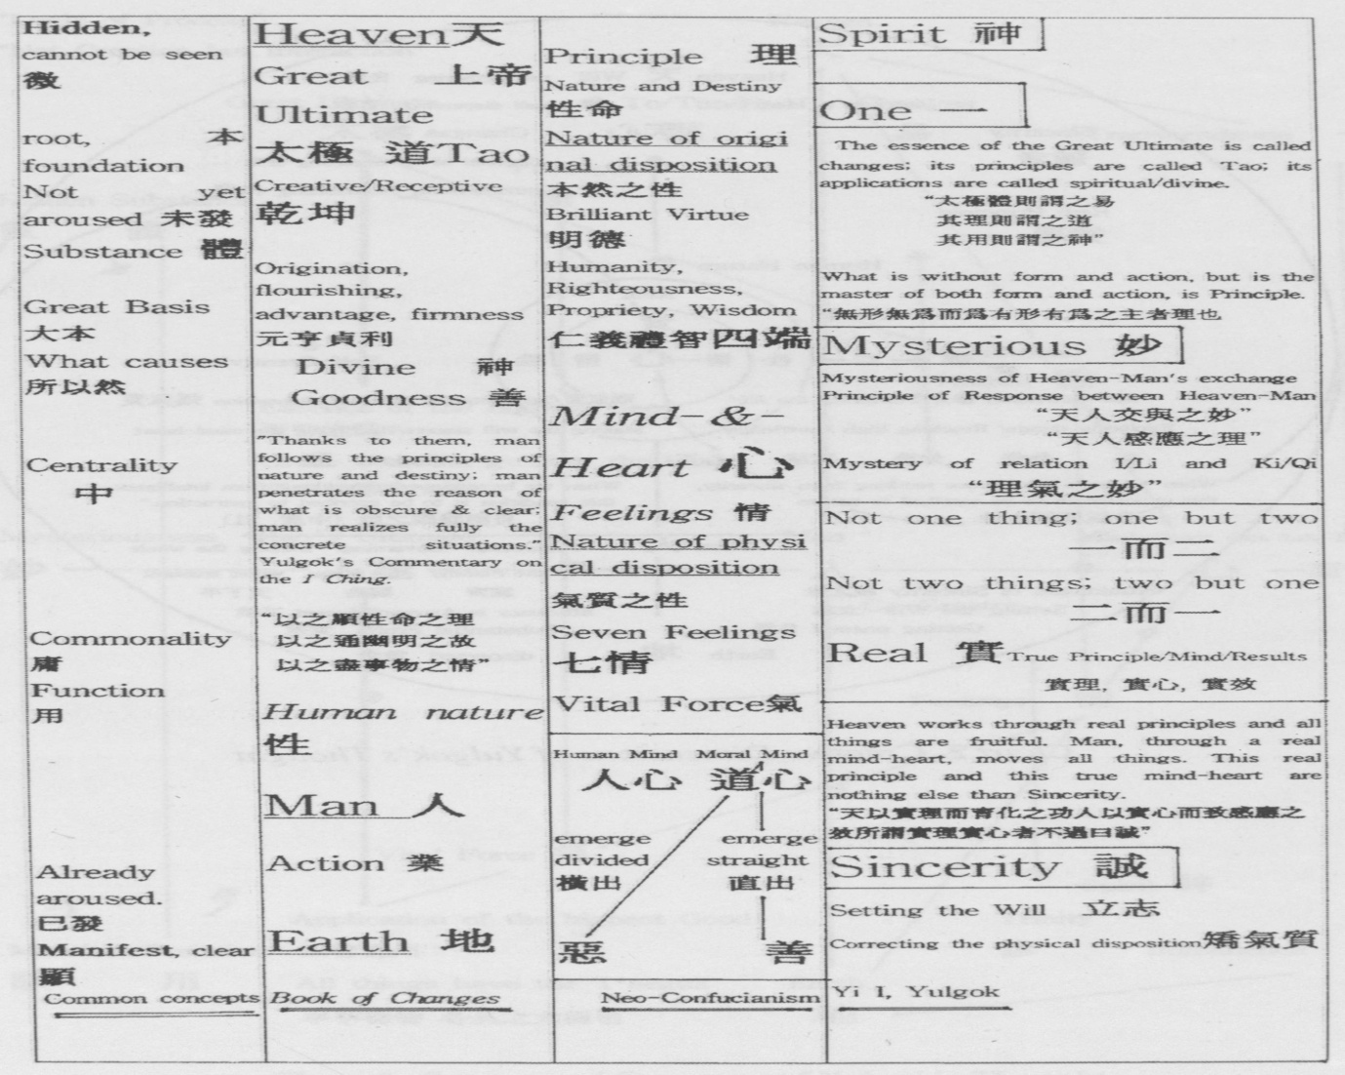
ai. Konghyo 功效 [page 77]

Chart 1. Layers of Yulgok’s Thought [page 78]
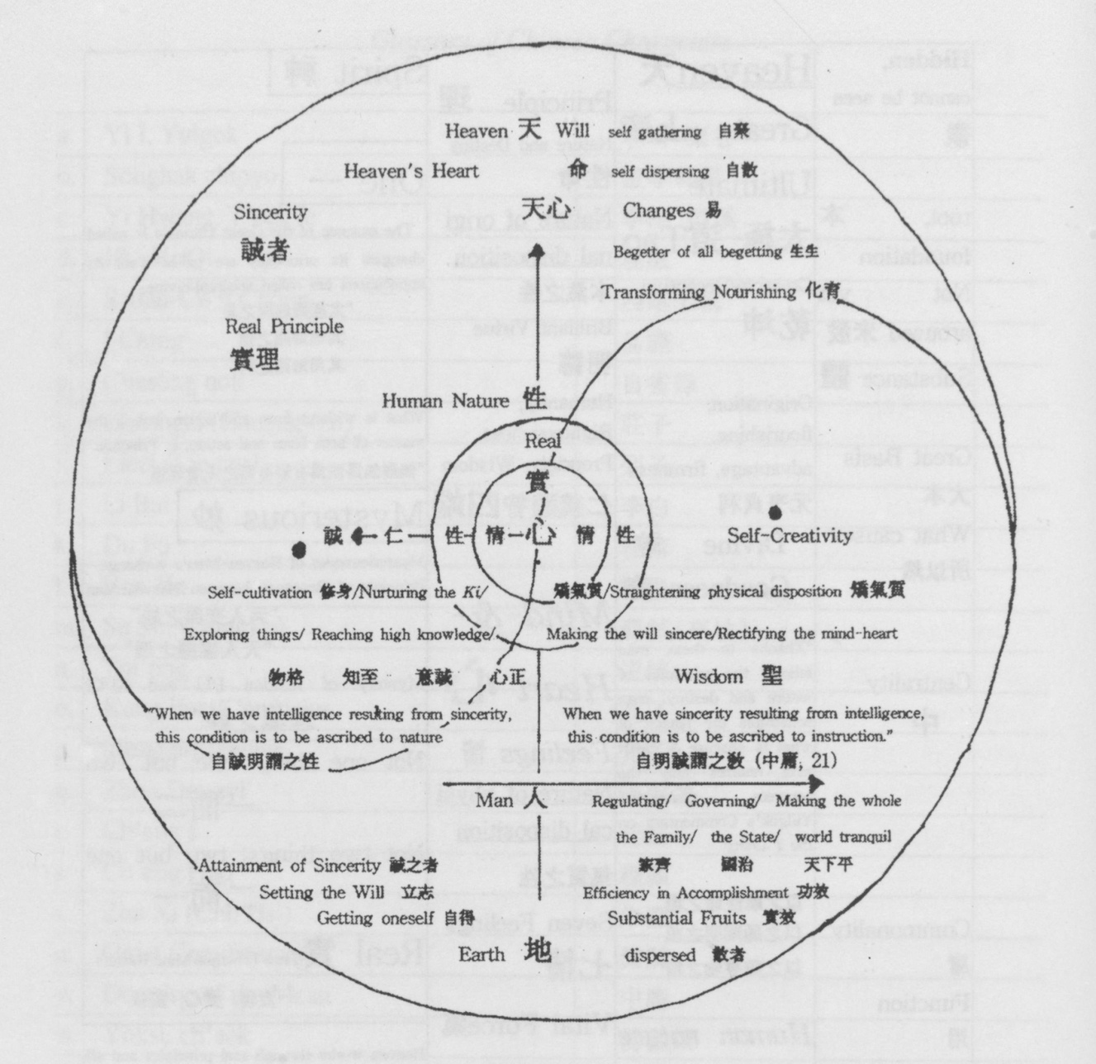
Chart 2. Creative Dimensions of Yulgok’s Thought [page 79]

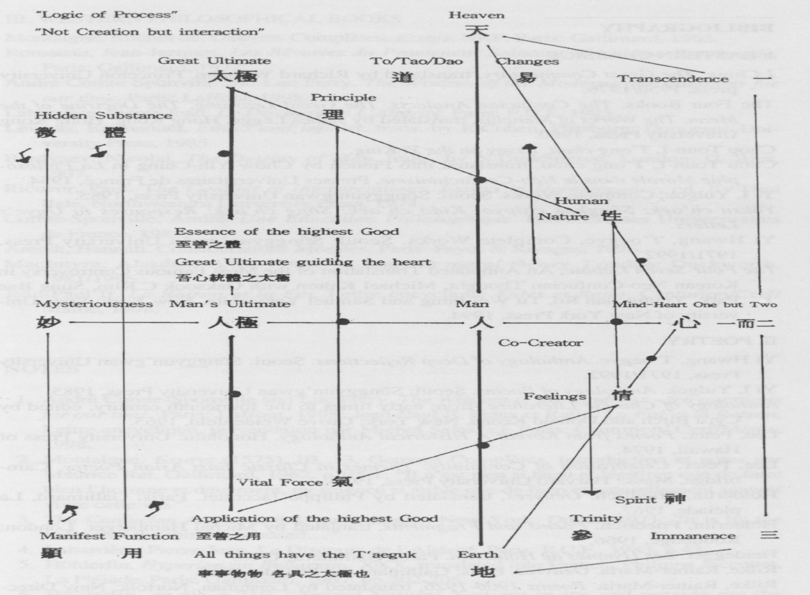
Chart 3. Conceptual Structure of Yulgok’s Thought

[page 80]
BIBLIOGRAPHY

- EASTERN CLASSICS
I Ching, The Great Commentary, translated by Richard Wilhelm, Princeton University press, 1950/1976.
The Four Books, The Confucian Analects, The Great Learning, The Doctrine of the Mean, The Works of Mencius, translated by James Legge. Hong Kong: Hong Kong University Press, 1960.
Chou Toun-I, T’ong chou, Essay on the Yi King.
Chou Toun-I, T’ong chou, translated into French by Chow Yih-Ching in La Philoso- phie Morale dans le Neo-Confucianisme, Presses Universitaires de France, 1954
Yi I, Yulgok, Complete Works. Seoul: Songgyun’gwan University Press, 1985.
Yoksu ch’aek; Songhak chipyo; Kido ch’aek; Song ch’aek; Responses to Ugye’s Letters.
Yi Hwang, T’oegye, Complete Works. Seoul: Songgyun’gwan University Press, 1971/1992.
The Four-Seven Debate, An Annotated Translation of the Most Famous Controversy in Korean Neo-Confucian Thought, Michael Kalton with Oaksook C.Kim, Sung Bae Park, Youngchan Ro, Tu Wei-ming and Samuel Yamashita. New York: State Uni-versity of New York Press, 1994.

- POETRY.
Yi Hwang, T’oegye. Anthology of Deep Reflections. Seoul: Songgyun’gwan University Press, 1971/1992.
Yi I, Yulgok. Anthology of Poems. Seoul: Songgyun’gwan University Press, 1985.
Anthology of Chinese Literature -from early times to the fourteenth century, edited by Cyril Birch and Donald Keene. New York: Grove Weidenfeld, 1965.
Lee, Peter. Poems from Korea: A Historical Anthology. Honolulu: University Press of Hawaii, 1974.
Lee, Peter. Celebration of Continuity: Themes in Classic East Asian Poetry. Cam-bridge, Mass.: Harvard University Press, 1979.
Holderlin, Friedrich. Oeuvres, translated by Philippe Jaccottet. Paris: Gallimard, La pleiade, 1967.
Holderlin, Friedrich. Poems and Fragments, tranlated by Michal Hamberger. London: Routledge, 1966.
Heidegger. Les Hymnes de Holderlin. Paris: Gallimard, 1988.
Rilke, Rainer-Maria. Oeuvres. Paris: Gallimard, La Pleiade, 1967.
Rilke, Rainer-Maria. Poems 1906-1926, translated by Leishman. Norfolk: New Directions, 1957.
Hugo, Victor. Oeuvres Poetiques. Paris: Gallimard, La Pleiade, 1974.
Hugo, Victor. The Poet is a Rich Man, Wisdom, Paris: Gallimard, 1974.
[page 81]
III. WESTERN PHILOSOPHICAL BOOKS

Montaigne, Michel de. Oeuvres Completes, Essais, NRF. Paris: Gallimard, 1962.
Rousseau, Jean-Jacques. Les Reveries chi Promeneur Solitaire, Troisieme Promenade. Paris: Gallimard, 1972.
Andre Comte Sponville and Luc Ferry. The Wisdom of the Modems -ten questions for our time. Paris: Laffont, 1998.
Labarriere, Pierre-Jean. Le Discours de L’Alterite. Paris: P.U.F, 1983.
Levinas, Emmanuel. Ethics and Infinity, trans, by R.Cohen, Pittsburg: Duquesne University Press, 1985.
Berdyaev, Nicolai. The Destiny of Man, trans, by N.Duddington. London: G. Bles, 1937.
Ricoeur, Paul. The Conflict of Interpretations, Essays in Hermeneutics, ed. By Don Ihde, Northwestern University Press, 1974.
Comte-Sponville, Andre, Une Education Philosophique. Paris: Presses Universitaires de France, 1989.
Arendt, Hannah. Considerations Morales. Paris: Payot & Rivages, 1996.
Maclntyre, Alasdair. After Virtue -a study in moral theory. London: Duckworth, 1981/1996.
Jean-Paul II. La Raison et la Foi, Lettre encyclique Fides et Ratio, Centurion/Cerf/ Mame, 1998.

NOTES
1. Anare Comte-Sponville and Luc Ferry. The Wisdom of the Moderns - ten questions for our time. Paris: Laffont, 1998; Jean-Paul II. Fides et Ratio. La Foi et la Raison, Lettre encyclique, presentation par Michel Sales, s.j. Paris: Centurion/ Cerf/Mame, 1998.
2. Montaigne. Essays (1575), III, 13, Oeuvres Completes, introduction et notes par Maurice Rat, Gallimard, 1962, p. 1091: “Il n’est rien si beau et legitime que de faire bien l’homme et deuement, ny science si ardue que de bien et naturellement scavoir vivre cette vie.”
3. The Confucian Analects, 8.8, trans. Legge. New York: Dover, 1971: “It is by the Odes that the mind is aroused...”
4. Labarriere, Pierre-Jean. Le Discours de r Alterite. Paris: P.U.F., 1983, p.43.
5. Holderlin, Hyperion an Bellarmin, XXX, translated into French, Philippe Jaccottet, La Pleiade. Paris: Gallimard, 1967, pp.202-205.
6. Holderlin, op.cit, p.210: “Sacred Nature! You are in me and outside me the same.../... There will be a unique beauty: Man and nature will unite within the unique divinity in which all things are embraced.” [page 82]
7. Complete Works of Toegye hereafter, TC, 1.2-3 (vol.3, pp.153-154, Songgyun’ gwan University) Chasong nok.
It could be compared to Victor Hugo. The Poet is a Rich Man, Wisdom. Paris: Gal-limard, 1974, p. 191:
We would not produce anything valuable The poet is the owner
Without the ormer,the ash and the holly; Of the beams, the perfumes, the voices;
The air helps us; and the bird contributes It is to this lonely dreamer
To our poems.
That belongs the echo in the woods.
8. Complete Works of Yulgok, hereafter, YC, 1.22b-23a (vol.1, p. 13, Songgyun’gwan University), P’ungak saneso kujonge olla Haetoti kwanggyongul poda.
9. Holderlin, op.cit, p. 137.
10. Heaven, Earth and Mankind.
11. YC 1.28b-29a (vol. 1, p. 16) Anthology of Poems.
12. See appendix Charts 1, 2, and 3.
13. YC 26.2a (vol.2, p.73, Songgyun’gwan University Press) Songhak chipyo, Com-pendium of Learning to Become a Sage: “The sages in the ancient times, in relation to Heaven, established a direction for people and, starting from there, began to transmit the tradition of the Tao/Dao, Tot’ong (n).”
14. YC 14.50b (vol.1, p.305) Yoksu ch’aek.
15. Levinas, Emmanuel. Ethics and Infinity, trans. R.Cohen, Pittbsburg: Duquesne University Press, 1985, p.60.
16. YC 14.53b (vol.1, p.307) Yoksu ch’aek.
17. The Great Commentary, op.cit, I. IX. 9.
18. YC 14.48b (vol.l, P.304) Yoksu ch’aek.
19. Doctrine of the Mean, trans. by James Legge, 12. 1-2: “The way which the superior man pursues reaches wide and far, and yet it is secret. Common men and women, however ignorant, may intermeddle with the knowledge of it; yet in its utmost reaches, there is that which even the sage does not know. Common men and women, however much below the ordinary standard of character, can carry it into practice; yet in its utmost reaches, there is that which event the sage is not able to carry into practice.”
20. YC 14.49a (vol.1. p.305) Yoksu ch’aek.
21. YC 5.7b (vol.2, p550) Kido ch’aek, Essay on Prayer.
22. YC 10.11a (vol.1, p.201)
23. YC 10.11a (vol.1, p.201)
24. YC 10.2a-b (vol.1, p. 197)
25. The Works of Mencius, trans. by James Legge, Bk VII, Pt.I, Ch.I.
26. YC 6.15a (vol.2, p.570) Subu, Song ch’aek, Book on Sincerity.
27. Berdyaev, DM 135: “Creativity is the supreme mystery of life.”
28. YC 10.21b (vol.1, p.206) Yulgok’s Response to Ugye,s Fifth Letter, op.cit, p. 163
29. YC 9.34b (vol.1, p. 192) Yulgok’s Response to Ugye’s First Letter, op.cit, p. 113: “The Four Beginnings do not have the comprehensiveness of the Seven Feelings, [page 83]
while the Seven Feelings do not have the genuineness of the Four Beginnings.”
30. YC 9.39b (vol.1, p. 194) Yulgok’s Response to Ugyes Second Letter, op.cit, p.119: “The not-yet aroused condition is the nature in its original state, the ‘wondrousness’ of the Supreme Ultimate, Equilibrium, the Great foundation.”
31. YC 14.4 (vol. 1, p.282) Essay on the Human Mind and the Dao Mind.
32. YC 9.38b (vol. 1, p. 194) Response to Ugye’s Second Letter, op.cit, p. 119.
33. YC 9.36a (vol. 1, p. 193) Response to Ugye’s First Letter, op.cit, p. 135.
34. Ricoeur explains this in relation to Hegel’s figures of mind, Comte-Sponville in relation to despair and Ferry in relation to the secularization of Christianity and to the process of man’s deification.
Ricoeur, Paul. The Conflict of Interpretations, Essays in Hermeneutics, ed. By Don Ihde, Northwestern University Press, 1974, French ed., p.320, “The problem of conscience seems, to me, to be connected with the question, ‘How a man leaves his childhood, how he becomes an adult?’ “; Ferry and Comte-Sponville. The Moderns’ Wisdom. Paris: Laffont, 1998, p.535, Luc Ferry considers that “The corner of the moderns’ wisdom: to become an adult -and this becoming ceases only with death- is the ultimate condition making possible an authentic individualiztion of our exis-tence.”
35. YC 20.23a (vol.1, p.438) Compendium of Learning to Become a Sage, songhak chipyo.
36. YC 20.12 (vol.1, p.433) Compendium of Learning to Become a Sage, Songkak chipyo.
37. The Doctrine of the Mean, Chap. 1, 4, trans. Legge. New York: Dover, 1971: “While there are no stirrings of pleasure, anger, sorrow or joy, the mind may be said to be in the state of equilibrium. When those feelings have been stirred and they act in their due degree, there ensues what may be called the state of harmony. This equilibrium is the great root from which grow all the human actings in the world and this harmony is the universal path which they all should pursue. Let the states of equilibrium and harmony exist in perfection and a happy order will prevail throughout heaven and earth, and all things will be nourished and flourish.”
38. YC 9.24b (vol.1, p. 187) Response to Ugye’s Letter: “The supreme goodness is another name for the T’aeguk/T’ai-chi, it is the essence of the ‘illustrious virtue’ (trans. Legge) or clear te/de. What constitutes the precise law of the original nature, which is given by Heaven, is the essence of the supreme goodness, that is to say the T’aeguk/Tai-chi, which guides my heart. What constitutes the precise law of the original nature, which is related to everyday life, is the application of the supreme goodness, that is to say the T’aeguk/T’ai-chi, which is contained in all things and all events.”
39. The Confucian Analects, 2.4, trans. Legge, New York: Dover, 1971.
40. I Ching, The Great Commentary, II, V, 11, trans. Richard Wilhelm, op.cit: “The superior man perceives the seeds and immediately takes action. He does not wait even for a whole day.” [page 84]
41. Maclntyre, Alasdair. After Virtue -a study in moral theory. London: Duckworth, 1981/1996; Ricoeur, Paul. Soi-meme comme un autre. Paris: Seuil, 1990.
42. I Ching, trans. Wilhelm, op.cit, p.295: “He is active everywhere but does not let himself be carried away. He rejoices in heaven and has knowledge of fate.”
43. YC 27.4 (vol.2, p.82) Secrets to straighten the Excesses of Youth.
44. YC 9.28b (vol. 1, p. 189) Yulgok’s Response to Ugye.
45. YC 9.28b (vol. 1, p. 189) Yulgok}s Response to Ugye.
46. Arendt, Hannah. Considerations morales. Paris: Rivages poche, 1996, p.41.
47. The Confucian Analects, 16.9, trans. Legge. New York: Dover: “Those who are born with the possession of knowledge are the highest class of men. Those who learn, and so, readily, get possession of knowledge, are the next. Those who study with difficulty, but learn are another class. Come last those who neither study nor learn.”
48. The Doctrine of the Mean, chap.20. 18, trans. Legge, op.cit: “Sincerity is the way of Heaven. The attainment of sincerity is the way of men. He who possesses sincerity, is he who, without an effort, hits what is right, and apprehends, without the exercise of thought; he is the sage who naturally and easily embodies the right way. He who attains to sincerity, is he who chooses what is good, and firmly holds it fast.”
49. YC 21.2 (vol. 1, p.463) Compendium of Learning to Become a Sage, Songhak chipyo.
50. YC 21.6b (vol. 1, p.465) compendium of Learning to Become a Sage, Songhak chipyo.
51. Chou Toun-I, T’ong chou, Essay on the Yi King, 7.2: “The sage teaches, helping people to change evil in themselves, to reach the Mean by themselves.”
52. The Confucian Analects, 4. 4, trans. Legge, op,cit: “If the will be set on virtue, there will be no practice of wickedness.”
53. The Confucian Analects, 12. 1, trans. Legge, op.cit: “To subdue oneself and return to propriety (rites), is perfect virtue.”
54. YC zl.l3b-14a (vol. 1, pp.468-469) Compendium of Learning to Become a Sage, Songhak chipyo.
55. La Croix, “L’encyclique satisfait les philosophes”, Recueilli par Robert Migliorini, 17 octobre 1998. (The encyclical letter satisfies the philosophers).
56. Fides et Ratio, paragaph 72: “My thoughts turn immediately to the lands of the East, so rich in religious and philosophical traditions of great antiquity. Among these lands, India has a special place.../... What has been said here of India is no less true for the heritage of the great cultures of China, Japan and the other countries of Asia…”
57. Fides et Ratio, Paragraph 81.
58. ides et Ratio, Paragraph 83.
59. Fides et Ratio, Paragraph 106.
60. Rousseau, Jean-Jacques. Les Reveries du Promeneur Solitaire, Troisieme Prome-nade. Paris: Gallimard, 1972, p.58: “J’en ai beaucoup vu qui philosophaient bien [page 85] plus doctement que moi, mais leur philosophie leur etait pour ainsi dire etrangere.../... lis etudiaient la nature humaine pour en pouvoir parler savamment, mais non pas pour se connaTtre.”
61. Confucian Analects, 15. 28.
62. YC 21.13b-14a (vol.1, pp.468-469) Compendium of Learning to Become a Sage, Songhak chipyo.
63. Quoted by Hall and Ames in Anticipating China, State University of New York Press, 1995, p. 181.

