[page 35]
The Great Tumulus of Whangnam

Kim, Young-Duk

The sight of grand tumuli or old tombs in Kyungju City produces strong impressions on viewers. Some are struck by the enormity of the tombs, some by the gentle round shape, and some by the mysteries related to the indentity of buried kings or queens and the origins of the so called stone-pile, wooden- chamber structure of the tombs. It was exciting, therefore, that excavation began of the biggest twin tumului, the great tumulus of Whangnam, on July 6, 1973 in the hope of unravelling the secrets of the tumuli. KBS, the Korean Broadcasting Station, produced a video telling about the excavation as one of its ten projects on the traditional cultural heritage of Korea. In the following I will try to recapture and summarize the story as depicted in the video.
Three questions come up: 1) Why is it that the famous golden crown of Silla with its decorative motif of trees and deer horns was found only in the early royal tombs of Silla? 2) Where did the peculiarly Silla style tombs of a wooden chamber covered with stones and soil come from? A possible relation between the ruling clan of the Kims of Silla and the Scythean people of the sixth century B.C. Eurasian steppe was suggested. 3) Who was buried in this great tomb?

THE ORIGIN OF SILLA TUMULI

There is a great tumulus park with about ten tumuli in the middle of Kyungju city, the capital of the Silla kingdom for a thousand years. Nothing is known about the buried kings or the dates of burial. One of the ten tumuli in the park is called the great Whangnam tumulus and is the biggest there. It is topped by a double mound.
In around the fourth or fifth century when the great tumulus of Whang-[page 36] nam was built, the typical Paekche royal tomb style was a stone pyramid. Paekche tombs along the Han River in the Seoul area were built in a pyramid style, a style similar to Koguryo tombs with three layers of stacked cut stone.
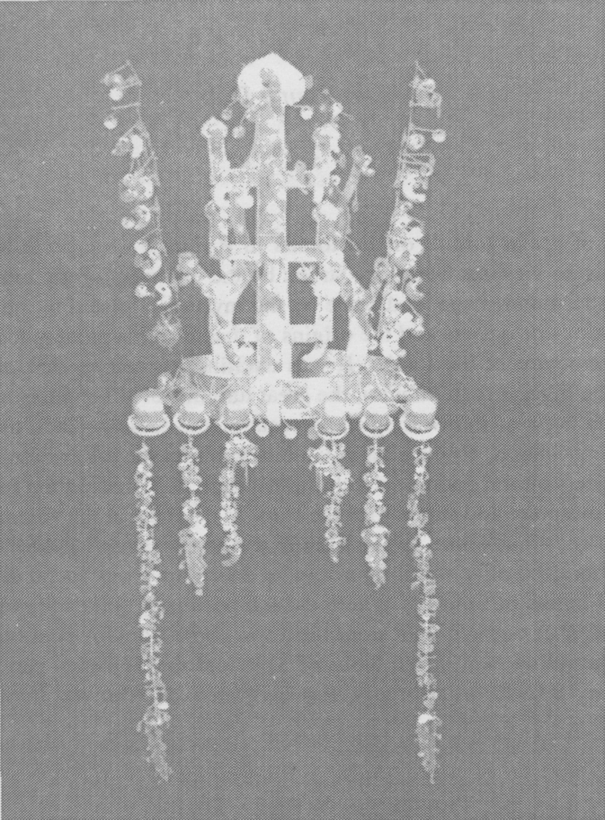
Silla Gold Crown

The structure of Silla tumuli was quite different. Silla tombs had a wooden chamber in the center of each in which there was a wooden coffin, while the floor was covered with stones. Stones were piled on and around the chamber, and finally it was covered with soil to make a rounded mound. The Whangnam great tumulus was formed by a pair of such tombs joined together.
[page 37]
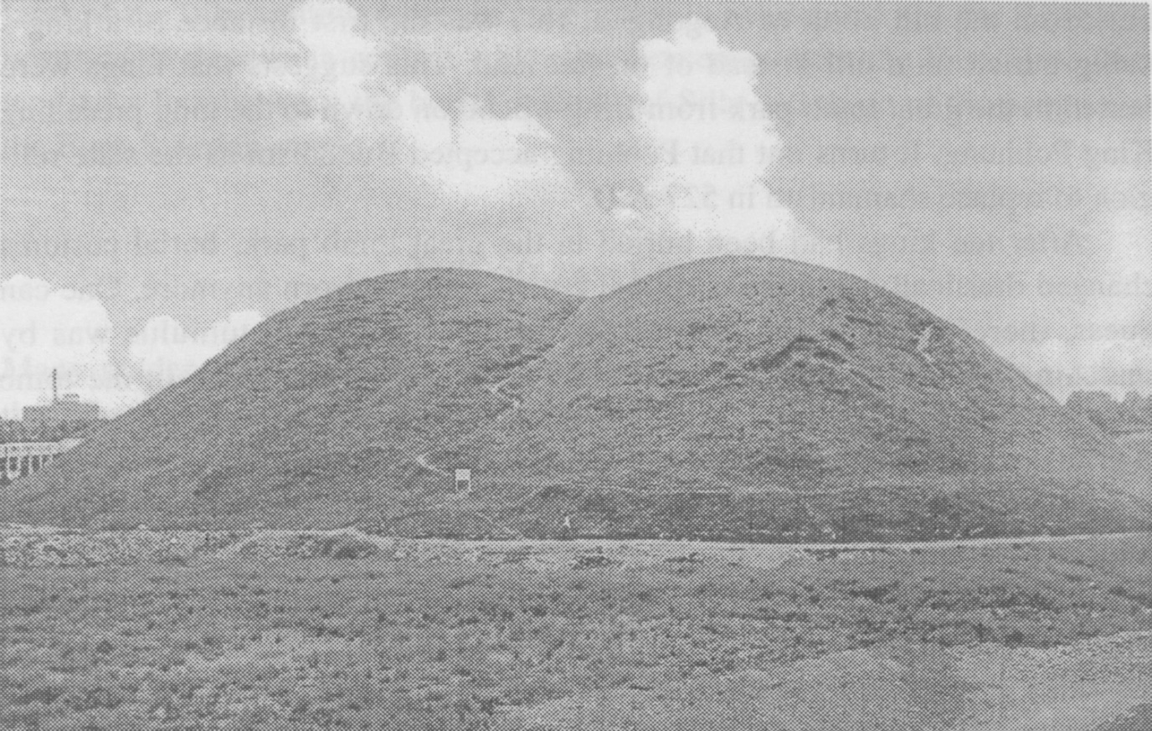
Ancient royal tomb in Kyungju

The central burial chamber in the southern tomb had a wooden chamber holding accessories for after-life necessities.
The differences in tomb styles among the three kingdoms suggests the rulers of these kingdoms had distinct cultural traditions. The excavation at the Whangnam tumulus confirmed this. The northern part of the tumulus turned out to be a queen’s as indicated by retrieved artifacts such as a belt with an inscription “lady’s belt”, rings, and numerous other ornamental artifacts. The southern part of the tumulus belonged to a king, and contained relics of weapons, a sword with a ring fitting, and silver and gold crowns. Even bone fragments were found indicating the age of the king to have been about sixty. More surprising was the finding of bone fragments belonging to a fifteen year old girl, who was buried to serve as an after-life attendant. This confirmed the writings in the Three Kingdoms Chronicles about the custom of sacrificial burial.
Who could the king, buried in the Whangnam tumulus with so many splendid golden artifacts, be? To find out who the king buried in that great tomb was, we checked the Samguk-sagi or Three Kingdoms Chronicles. It recorded that in October of the twenty-third year of his reign, King Michu passed away and was buried in the great tomb park area. He is known to have been the first king to be buried there. According to the Chronicles, King Pob-hung passed away in July of the twenty-seventh year of his reign and was [page 38] buried on the hill north of Aegongsa. This was the first instance of a king’s being buried on a hill instead of on flat land. This suggests that kings were buried in the great tomb park from King Michu on down to the king preceding King Pobhung. It turns out that Pobhung accepted Buddhism as the state religion to replace shamanism in 527 A.D.
After ten kings had been buried in the great tomb park, burial customs changed drastically, and the traditinal crown was not worn anymore. One can guess, therefore, who the king buried in the Whangnam tumulus was by searching for a king who had reason to build the biggest tomb in the tomb park. Around the beginning of the Christian era, the Park clan settled in Sora- bul, or the land of Silla, to rule, but soon another clan, the Suk clan, moved in from the sea to overpower the Park clan. Next the Kim clan emerged as the rulers in the middle of the third century, and King Michu was the first ruler from the Kim clan. The Suk clan reclaimed power for a while after King Michu’s reign only to yield to the Kims once more. Where did the Kim clan, as the victor among the three clans, come from? A legend says that the founder of the Kim clan originated in the Kyerim forest in Kyungju, where a golden box came down from heaven to a tree in the forest. It contained a baby who grew to become the founder, Kim Alchi, of the Kim or golded clan of Silla.
Now we look for archeological findings in another area to trace the origin of the Kim clan as well as the origin of the tomb culture. On Ukok Plateau, (7,500 feet alt.) in the Altai region of Russia close to the Chinese border between Mongolia in the east and Kazakstan in the west, an excavation team dug up a kurgan or burial mound which was 2,400 years old and unlooted. There they found the mummified body of a lady in a log coffin. She had tatoos of deer on her wrist and shoulder and her head faced east. What interests us most is the structure of the kurgan. Inside it a log funerary chamber was buried under a stone pile, and a log coffin was found in the chamber with food and other artifacts in vessels while horses in splendid trappings were found against the north wall of the chamber. This appeared quite similar to the structure of the early Silla tomb. In this and other kurgans there were abundant artifacts made of gold and with animal motifs.
Many tribes arose on the Eurasian steppe in ancient times. They created a Scytho-Siberian culture throughout the steppes. Scytheans were depicted by the Greek historian Herodotus as a powerful semi-nomadic people who lived north of the Black Sea between 800 and 100 B.C. and shared with people in other parts of the steppe a uniform artistic style dominated by animal motifs, a love of horses, and burial customs. The steppes are, however, so vast, more than 3,000 miles from the Black Sea to the Great Wall of China, that the cul-[page 39] tures of the tribes within a certain area probably overlapped and the Scythians never came directly in contact with other horsemen from the East. Here then we find a link between the burial customs of Silla and those of the peoples of the Euro-Siberian steppe.

THE GOLDEN CROWN

Many golden artifacts were found in both the northern and southern parts of the Whangnam tomb. In the northern coffin alone more than 3.75 kilograms of golden artifacts were found. These artifacts display the highest level of aesthetic achievement. The excavation was initially made on the northern part of the tomb. It yielded the most splendid gold crown, in fact not only a gold crown but also a large quantity of gold and silver artifacts. These included eleven bracelets, twelve rings, earrings, a belt, silver vessels, and silver cups with various animal motifs. The gold bracelets were made of two layers of gold plate with jewels embedded in them. Several pieces of glassware in various colors and designs were also found.
The excavation of the southern part of the tumulus took two years beginning in 1973, and many gold artifacts were found there also, including weapons, especially a sword with a ring fitting on the handle. A gold crown was also found there. These gold crowns were adorned with three or four trees and several deer horns, which were in turn adorned with comma shaped jade pendants and gold flakes.
What could these adornments symbolize? Why did the royal Kim clan adopt these symbols? The symbol of tree and deer horn, surprisingly, is linked with the shamanism practiced throughout Siberia. In their rituals Siberian shamans made use of sacred trees. It was believed that the soul of a shaman could reach heaven by climbing a tree and then reach back to earth through a tree, and thus serve as an intermediary for men between heaven and earth. Thus a shaman can heal a sick man, prophesy his future, and perform rituals such as rain making. Their songs, dances, drums, and costumes all reflected these roles in a symbolic manner. Many of these shamans on the Eurasian steppe wore headgear adorned with deer horns.
What is the symbolic significance of a deer horn? On the Eurasian steppe deer were considered very precious and even holy from time immemorial since deer were important sources of food and had many other uses, so deer were not only hunted but also revered. These beliefs were reflected in the dress of shamans who wore headgear adorned with deer horn symbols as seen[page 40] in some on display at the Krisnoyask Museum or others in documentary films of Siberian shamans. Deer horn tatoos were also found on the shoulder of a shaman mummy of the fifth or sixth century B.C. A tree represented a holy symbol of communion with heaven for a shaman. Sometimes a shaman’s ritual mask had three trees decorating it instead of a deer horn.
When trees are placed together with deer horn headgear, the design matches that of a Silla king’s crown, but this sort of combination of ritual symbols was not found among the Siberian shamans. A golden crown with a design of tree and deer horns was, however, found in the Hermitage Museum in St. Petersburg in Russia. This crown was excavated in the Sarmach area near the Black Sea and was dated in the first century A.D. This area is thousands of kilometers away from Silla, so what could the connection be?
The area to the north of the Black Sea was occupied by the Scytheans, a nomadic people who came to the area from the east and held sway over the area from the eighth to the second century B.C. They were aggressive horse riders who loved decorating themselves and their horses with golden ornaments with animal motifs. The Eurasian steppe served as a passageway linking and spreading the shaman culture as well as a culture of gold and horses throughout the Eurasian steppe from the Black Sea to the Great Wall of China, a distance of over eight thousand kilometers. The steppe was dominated after the Scytheans by many different tribes at different times. These included the Huns, Turks, and Mongols. In spite of the changes in dominant people, the horse culture remained. Silla’s rulers were also horse riders and horse lovers, which is evident from the finds of numerous equestrian trappings and accessories as well as horse bones in the tombs.
One of the unusual artifacts found in one of the tombs was a saddle bow which was gold-plated and decorated with irridescent beetle wings. There are many relics related to horses from the great tomb park. One tumulus yielded a horse painting on a piece of birch bark. It depicted a white horse with flying mane galloping above a cloud. These remains demonstrate that the royal members of the Kim clan of early Silla buried in the tumulus park were horse riders. This custom of burying horse equipment and horses as a sacrifice was shared by the Scytheans and other nomadic peoples of the steppe.
Inevitably the conclusion is that the royal Kim clan came from among these horse riding nomadic people of the Eurasian steppe. At the time Silla built their tombs with wooden chambers and stone piles, the steppe was dominated by the Huns. The Hun tribe had features like those of the Mongols and had occupied the Altai area in Russia since the first century A.D. They were called Hyungnu by the Chinese. The Hun culture was similar to that of the [page 41] Scytheans. They had totem poles and possessed comma shaped jewels and kurgans. The Huns dominated the steppe around the beginning of the Christian era, and fought against many peoples living on the borders of the steppe to maintain their control over it.
A group of Huns advanced westward to the Black Sea area and further west to establish the Atilla Kingdom in Hungary around the fifth century. At this time of movement and confusion a group of Huns in the Altai area chose to move to the east, and perhaps they eventually reached the Korean peninsula. It was around the fourth or fifth century that the tombs of wood and stone appeared in Kyungju. The kurgans of the Huns before the Christian era were also wooden chambers and rock piles. The Huns buried a mummified body with a death mask and equestrian trappings and weapons in the wooden chamber. Numerous tombs or kurgans remain in the Altai area waiting to be explored. When this is done, we may find further evidence of a link between the Huns and the Silla people.

THE OCCUPANT OF THE GREAT TOMB

Mich’u was the first king of Silla from the Kim royal family. The Kims were succeeded by the Suk clan, and they in turn were replaced by the Kim clan again. It is known that King Pophung accepted Buddhism as the state religion in 527 A.D. and adopted Tang Chinese institutions in the judicial and other organisations of the state. During the reign of King Pophung traditional shamanism was dismissed and the golden crown gave way to silk headgear, and royal burials took place on a hill with a stone chamber with a side opening instead of a kurgan-like tomb with a wooden chamber under a stone pile, so it is believed that the king and queen in the Whangnam tomb must precede King Pophung.
There is, however, scant indication of which particular king is the occupant. The retrieved burial goods include 34,550 ornamental artifacts, 175 pieces of weaponry, 758 items of horse trappings, and 192 vessels in the northern tomb alone, and yet no direct evidence exists of the identity of the occupant. A small ceramic bottle with a dark brown glaze suggests a date later than the early fifth century, while carbon dating suggests fifth or sixth century as the possible date of the tomb. It was tentatively suggested, therefore, that one of two kings was a possible candidate as the occupant of the tomb: the seventeenth king, Naemul (351 to 402 A.D.), or the twentieth king, Chabi (458 to 479 A.D.). According to the report on the excavation, however, it has [page 42] been suggested by historians that perhaps King Naemul and his consort are the occupants of the tumuli, since he was responsible for the continued rule over Silla by the Kim royal family.
We still do not know exactly who is buried in the great tomb of Whangnam.

REFERENCES
K.B.S. Video, The Whangnam Great Tomb.
Bureau of National Cultural Treasures. (1985). Report on the Excavation of the Whangnam Great Tomb.
National Geography, Vol. 186,No. 4 9; (Oct. 1994).

