[page 1]
A Short History of Tea

Brother Anthony of Taize

People do not always realize that all the tea drunk in the world, no matter whether it is called white, green, red, brown, or black, and no matter where it comes from, is made of the leaves of one small evergreen tree or bush. For several centuries Europeans drank tea without ever having seen a tea plant, because their traders were not allowed to travel inside China, the unique source of tea at that time.
The first detailed study of tea published in Europe was written by Dr. Wilhelm ten Rhyne (1649-1700), a celebrated Dutch physician and botanist who also wrote the first account of acupuncture. He lived in the Dutch ‘factory’ (trading post) on the artificial island of Deshima in the harbor at Nagasaki from 1674 to 1676. His text on tea, written in Latin, was published in Danzig in 1678,as an appendix to Jacob Breyn’s Exoticarum plantarum centuria prima (First Century of Exotic Plants). It seems never to have been translated into English.
Some years later, in 1683, the German scholar Engelbert Kaempfer set out on a journey through Russia, Persia, Arabia, and India. From there he took ship to Java, Siam, and finally Japan, where he too lived for a time on Deshima before returning to Europe in 1693. Kaempfer wrote his own account of Japanese tea to complement that of ‘my much honored friend’ ten Rhyne. It was published in the third fascicle of his Amoenitates Exoticae (Exotic Pleasures; 1712). An English version of this has recently been published.
Kaempfer’s work in making Japan known in Europe was hailed by the great botanist Linnaeus. The first edition of Linnaeus’s Species Plantarum published in the first half of the 18th century suggested calling the unseen plant Thea sinensis, taking the Latin name for tea from Kaempfer’s work.
It was only in the early 19th century that tea plants and seeds were obtained, after the English decided to challenge China’s monopoly by trying[page 2] to grow tea in India. Then it was found that in fact tea trees already grew wild, unrecognized, in the hills of Assam. A fierce debate raged as to whether these were identical with the Chinese variety, and whether Thea was a separate genus or part of the genus Camellia. It was finally settled by the International Code of Botanical Nomenclature in 1905 that the tea tree’s correct name, no matter where it grows, is Camellia sinensis (L.) O. Kuntze.
The tea tree is native to the whole monsoon area of southeast Asia: Thailand, Burma, southwest China, Assam. The raw leaves were surely used as food from very early times by the native populations. In Chinese legend, or myth, the qualities of tea are said to have been discovered by the Second Emperor, Shen Nung (Divine Healer, reputed to have reigned 2737-2697 B.C., who also discovered millet, medicinal herbs, and invented the plough. His predecessor, Fu-hsi, the First Emperor, had given humanity knowledge of fire, cooking, and music, while the Third Emperor completed the Promethean task of human happiness by revealing the secrets of the vine and astronomy.
There is an early mention of tea being prepared by servants in a Chinese text of 50 B.C.. Certainly tea was being cultivated in Szechwan by the third century A.D.. The first detailed description of tea-drinking is found in an ancient Chinese dictionary, noted by Kuo P’o in A.D. 350. At this time the fresh green leaves were picked, then pressed into cakes, that were roasted to a reddish hue. These were crumbled into water and boiled with the addition of onion, ginger, and orange to give a kind of herbal soup that must have been very bitter but was considered to be good as a remedy for stomach problems, bad eyesight, and many other diseases.
In A.D. 519 the great Indian master Bodhidharma, the traditional founder of the Zen school of Buddhism, came to China. The Japanese sometimes claim that he brought tea with him from India, which seems unlikely; another story says that when he found himself growing weary after staying awake for seven years, he plucked off his eyelids. When he threw them to the ground two tea trees sprang up that had the power to keep him awake and alert. There is certainly an ancient Buddhist tradition of drinking tea before an image of Bodhidharma.
A major turning-point in the history of tea came in the 8th century, with the composition of the Cha Ching, the “Tea Classic” by Lu Yu in 780,which summarizes everything known at that time about every aspect of tea growing and preparation. This seems to have been commissioned by the tea merchants of the time to give a new impetus to the consumption of tea in the upper classes. It certainly succeeded. The crumbled cakes or bricks of tea were now boiled with nothing but a little salt and this was the form of tea that became the national drink of the elite in China’s Tang dynasty (618-907). Moreover, [page 3] since this kind of tea could be transported easily, a taste for it spread far beyond China, into Tibet, along the Silk Road to Turkey and India, and into Russia.
Lu Yu’s influence was enormous. He was the first to suggest that the ritual of preparing and drinking tea represented a code of symbolic harmony and order reflecting the ideals of cosmos and society. Lu Yu lists no less than twenty-four implements that are essentia! for the correct preparation of a cup of tea. These include the equipment needed for roasting and grinding the cakes of tea, as well as the stove for boiling the water, and the cups for drinking. Rich noblemen at once began to rival one another in acquiring beautifully crafted sets for making tea, while tea plantations spread across the southern part of China. By 850 people were also beginning to prepare tea in the form of detatched leaves, not compressed into bricks.
A great change came with the transition to the Sung dynasty (960-1279) when Chinese culture reached a new summit of refinement. Tea now began to be drunk in the form familiar to many from the Japanese tea ceremony, with dried blocks of green leaves ground to a fine powder and mixed with water by being whipped to a froth with a bamboo whisk in large, often dark-glazed bowls. In Korea today this is known as malch’a. Tea culture reached its height under the emperor Kiasung (1101-1126) who was untiring in his search for new varieties of tea and qualities of taste.
Then came the Mongols. Genghis Khan conquered Beijing in 1215,his grandson was Kublai Khan who overthrew the southern Sung in 1279. The Mongols liked to put cream in old-fashioned brick tea, which they treated as the soup in a meal. Kublai Khan founded the Yuan dynasty (1279-1368) and it was at this time that Marco Polo visited China, returned to Italy, and wrote Europe’s first report about China, without ever mentioning tea.
The Ming dynasty (1368-1643) that followed, in reaction to the Tartar invasion, tried to restore former Chinese ways in a cultural renaissance. It was only during the Ming dynasty that the method of making the tea that is mostly drunk in Korea today, green tea, was invented, as well as the method of allowing the tea leaves to soak (steep) in hot water for a time before drinking. In about 1500 the first teapots as we know them came into being, made at first of unglazed brown or red clay, the tiny Yixing teapots with their equally tiny cups that are still popular in southern China and Taiwan, and that are often used in Korea when Chinese tea is being drunk.
Finally, in 1644,the Manchus invaded China and took power as the Quing dynasty, that continued until 1912. It was only near the start of their rule that the tea makers discovered the secrets of controlled “fermentation” or [page 4] oxidation of the leaves before and during the drying process, which gave birth to the immense variety of tastes found in oolong (lightly oxidized) and red (black) teas (much more fully oxidized). The new methods of making tea demanded a cup that would emphasize the delicate colour of the brew. This is why so many more recent tea cups are white.
In 1516 the Portuguese landed in China, having discovered the sea route to the East. In 1557 they were allowed to establish a trading station at Macao in return for ridding the region of pirates, but the British and other nations had to wait until 1685 for permission to trade with China. So began the direct discovery of Chinese tea in the west, although the name had already been introduced through contact with the Turks, who enjoyed drinking brick tea brought along the Silk Road.
The first known reference to tea by an Englishman dates from 1615, when a certain Richard Wickham wrote to Macao asking for “a pot of the best sort of chaw”. The oldest name for tea recorded in China seems to have been ‘Kia’ and the prounciation ‘ch’a’ is only found after 725 A.D.. In certain regions a ‘t’ took the place of the initial ‘ch’ and we find the variant pronunciations ‘ta’ or ‘tail’ In Korea we find both pronunciations, Ch’a and Ta.
It is quite a mystery why England developed such an intense and widespread taste for tea, unparalleled in Europe. It was the Dutch merchants who first discovered the pleasures of tea, and began including a separate tearoom in their houses in the early 17th century, but after the Restoration in 1660 London began to fill with coffee shops, where tea was also served, and by 1683 there were reported to be over 2000 coffee shops in London.
Tea was at first a luxury, enjoyed only by the rich, and for a time the gov-ernment imposed a 200% tax on it. As a result, a thriving trade arose in tea smuggled from Europe. So much cheap smuggled tea entered every harbour in England that it soon became available to even the simplest homes. In the 18th century tea generally replaced the ale that had previously been the English people’s basic drink, and the Methodist campaigns against the Demon Drink were certainly helped by having tea to propose as a substitute. Finally the tax was abolished, smuggling ceased, but tea was in England to stay, with coffee only a pale second, at least until very recent decades.
By the early 19th century, China was exporting some 15,000 metric tonnes of tea to England every year. When the English government realized in the early 19th century that there was a very unfavorable trade balance with the Chinese buying very little from England in return, it decided to try to improve matters by introducing the Chinese to the expensive delights of Indian-grown opium; at the same time it set about establishing tea plantations in India. India [page 5] now produces something in excess of 200,000 metric tonnes of tea each year.
In Korea, the drinking of tea seems to have been introduced in the sixth or seventh centuries, probably by Buddhist monks returning from China, where the many schools of Buddhism attracted some of Korea’s finest scholars. There are reports in the Samkuk-yusa and Samkuk-sagi that Queen Sondok of Silla (ruled 632-47) drank tea and that King Munmu in 661 ordered tea to be used during ceremonial offerings. King Sinmun advocated the use of tea in order to purify the mind, while King Heundok is reported to have obtained tea seeds from Tang China for planting in 828, but these may not have been the first. In Japan the first record of brick tea being used dates from around 593,and the first planting of seeds is said to have occurred in 805.
During the Koryo Dynasty tea was made the subject of some of Korea’s oldest recorded poems. Tea was long offered in the ancestral ceremonies, which are still known as Ch ‘a-rye although tea has not been offered in them for centuries. Likewise there were regular ceremonies known as Hon-ta in which cups of green tea were offered before the statues of Buddha in the temples.
The culture of tea was so deeply identified with Buddhism that when the Yi Dynasty decided to replace Buddhism with Confucianism in the 14th century, the drinking of tea was repressed at the same time as most temples were destroyed. For centuries there are few signs of tea culture surviving in Korea; then in the early 19th century we find the great scholar Tasan, Chong Yak-yong (1762-1836), drinking tea in a formal way in a special tearoom during his exile in his mother’s home near Kangjin. He presumably learned the method of drinking tea from people in Kangjin. In the first years of the 19th century, a young Buddhist monk, Ch’o Ui (1786-1866), visited him there, stayed several months, and drank tea with him. The first great restorer of the Way of Tea in Korea, Ch’o Ui, later built the hermitage known as Ilchi-am above the temple now called Taehung- sa near Haenam, in the far south of Korea, and lived there for many years, cultivating the Way of Tea in his own tearoom. The hermitage and tearoom now to be seen at Ilchi-am are modern reconstructions. In 1836,the year of Tasan’s death, Ch’o Ui composed “Dongdasong”, a great poem in celebration of tea.
Yet despite the example of Ch’o Ui, the Way of Tea remained almost unknown in Korea, even among monks, until its restoration in the course of recent decades, a restoration due in large part to the efforts of the Venerable Hyo Dang, Ch’oi Pom-sul. He might be considered to be the Ch’o Ui of the 20th century, for he wrote the first full length study of tea to be published in modern Korea and taught many people about the various aspects of tea. He was active in the Independence Movement, and founded several schools and a [page 6] university after 1945, as well as being the teacher of virtually all the leading figures in the modern Korean tea revival.
We may now turn to the methods by which tea is prepared in Korea. After the loss of Korea’s tea culture in the 14th century, tea trees continued to grow wild in the southern regions, especially on the lower slopes of Chiri-san. These self- propagated bushes provided the leaves used by those few people still aware of their value. Tea does not grow north of Chonju and not on every kind of soil to the south. In recent years additional bushes have been planted on the slopes of Chiri-san, and other southern hills, but without the creation of artificial tea plantations. The finest tea is that grown in complete harmony with nature and with very little or no use of fertilisers. Tea plantations of a more intensive kind, with the bushes planted in neat rows and operated on an industrial scale, have recently been established in various areas, the most important being those found in Posong near Kangjin, on the slopes of Wolch’ul-san, and in Cheju-do.
Tea can only be made using the fresh tips, the scarcely opened buds that start to grow in early April. Once a leaf is fully developed, it is soon too coarse for use. After late May the bushes may continue to produce further shoots but these no longer have the intense flavour needed for good tea, so all the green tea needed for the year has to be plucked and made in less than two months.
The very earliest buds have the finest flavour, and are the most difficult to collect, especially if the winter frosts last late. The Korean calendar has twenty-four seasonal dates based on the movement of the sun; the day known as Kok-u normally falls on April 20. The tea gathered before this date is known as Ujon and commands the highest price. The next seasonal date Ipha falls on May 5-6, and tea gathered between those two dates is known as Sejak. Tea gathered after Ipha is known as Chungjak. These names often figure on the menus in tearooms to the mystification of the uninformed public. The earlier the tea, the more delicate the taste and the cooler the water should be in making it, with many authorities recommending that the water for Ujon be cooled down to 50 degrees.
The gathering of leaves requires skill and speed. It is done mostly by the women of the region, who can only collect a few pounds of leaves in the course of a day. The drying of the leaves into tea for drinking must be done within twenty-four hours of picking, before the juices in them start to oxidize. There are two main methods in use.
The tea known as Puch’o-ch’a is more common. The fresh leaves are dried by dry heat, in an iron cauldron over a wood fire or in a mechanical [page 7] drier, and are stirred constantly to prevent burning. From time to time the drying leaves are removed from the heat to be rubbed and rolled vigorously so that they curl tightly on themselves. They are then returned to the heat, and the process is repeated a number of times.
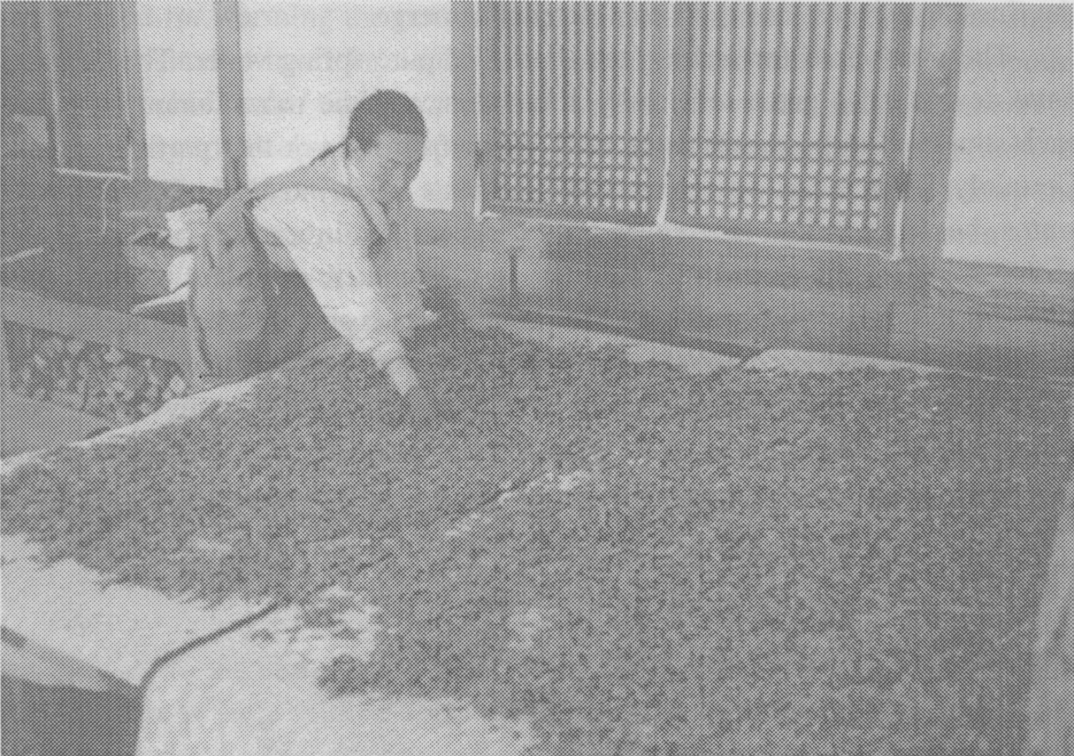
Tea leaves, Chung-ch’a, draining

With the tea known as Chung-ch’a, the fresh leaves are plunged for a moment into nearly boiling water, then allowed to drain for a couple of hours, before being placed over the fire. With Chung-ch’a the drying and rolling are done concurrently, the leaves are not removed from the heat until they are completely dried, after about two hours. This means that the people stirring and rubbing the leaves beween their gloved hands to roll them are obliged to sit directly over the cauldron on its fire. Not surprisingly, this tea, which has by far the finest fragrance, is very expensive.
The main difference between green tea and the kinds known as oolong or red, in English black, lies in the lack of oxidation. If the juices and enzymes within the leaves are allowed to oxidize, their surfaces having been bruised by initial cold rolling, and the final drying delayed by several hours, the result will be an immense variety of tastes quite unlike green tea.
When preparing tea for drinking, oolong teas are made using hot water, [page 8] that used for black tea (which is the only kind produced in India and Sri Lanka) should be almost boiling. The water used for green tea should be much cooler, never more than 70 degrees and for the first cup of a really good tea, such as Hyo Dang’s Panyaro, water as low as 30 degrees will produce the best results. If the water is too hot, or is allowed to remain too long on the leaves, the finest tase is lost and the bitter elements emerge.
The water used for making tea should be pure spring water. The Chinese have developed a great sensitivity about this, and the most famous teas are each supposed to be drunk using only water from this or that particular well. Certainly Seoul’s tap water can spoil the taste of any tea! Traditionally the water should be boiled in a kettle on a charcoal fire in a small brasero in the room; there are many poems about the various levels of sound as the water sings on the fire, slowly reaching the point where it sounds like wind rustling in bamboos or pines. Today most people use electric pots, which are less poetic but much simpler.
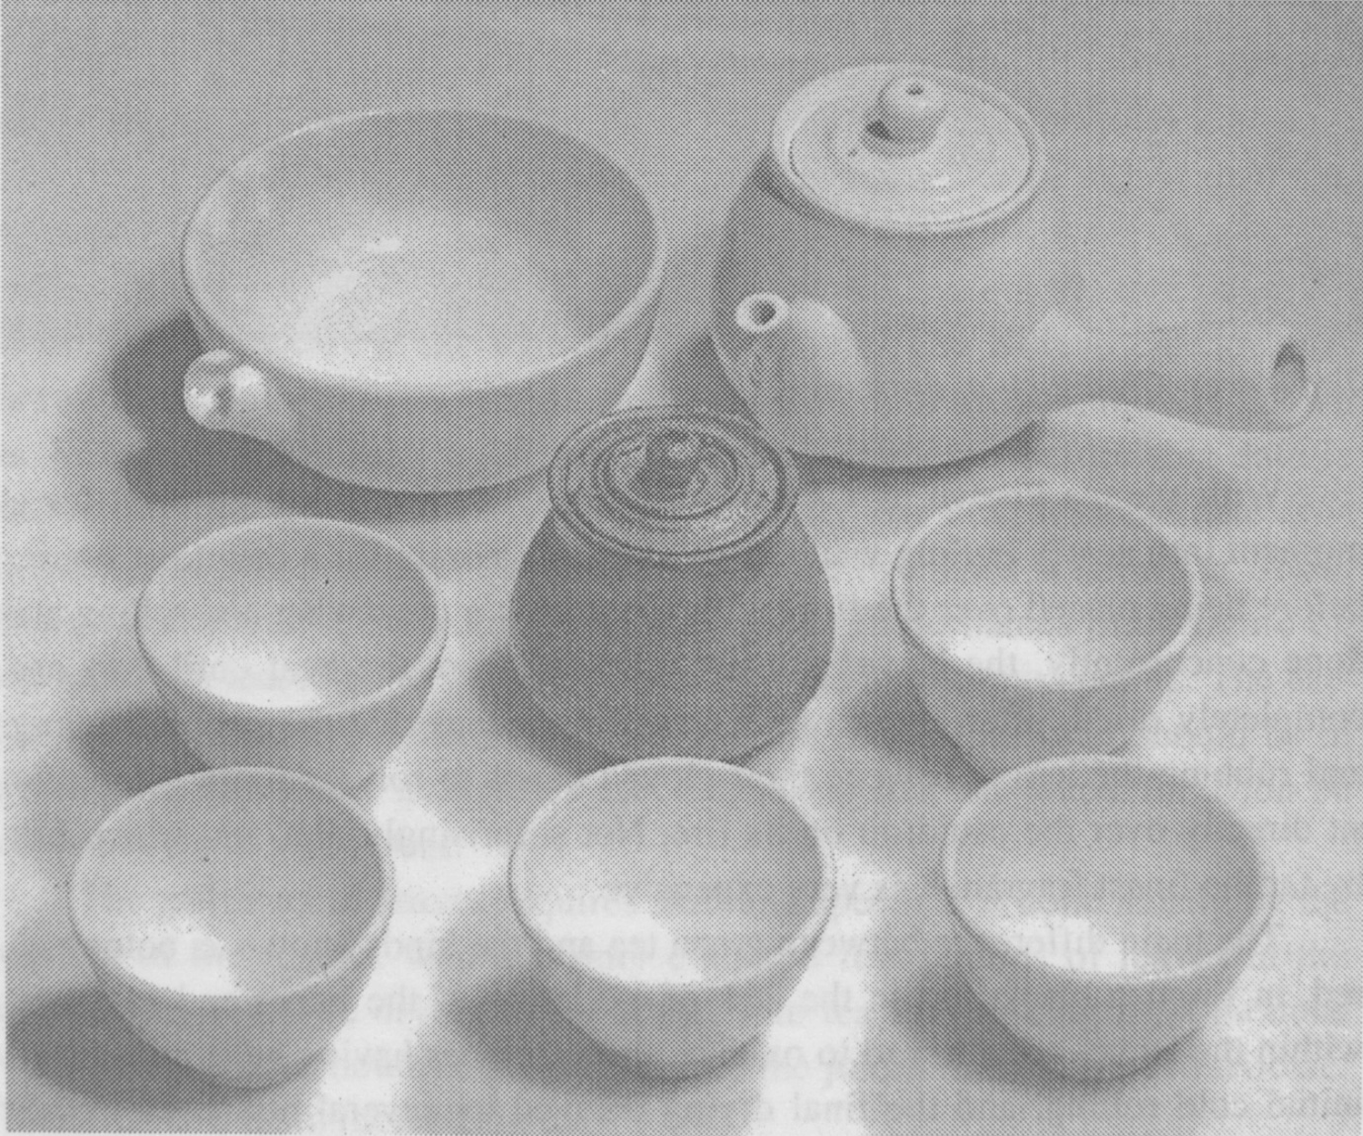
A traditional Korean tea set

[page 9]
In order to prepare green tea in the Korean way, we use a tea set, ta-gi, usually consisting of three or five cups, ch’at-chan, although the Venerable Hyo Dang used to say that drinking tea alone was the best of all. There is a tea pot, ch’akwan or ch’at-chonja, smaller than the English variety but larger than the little Chinese ones. In addition there is a large bowl into which the water used for warming the pot and cups can be discarded, kaesukurut, and a somewhat smaller bowl for cooling the water and the tea, with a lip for pouring, mulshikim sabal or kwittaekurut. A stack of wooden saucers, patch’im, stands ready to receive the cups after they have been filled. Today there is often a small stand on which the lid of the tea pot is placed while filling the pot, but this is not traditional. In theory, the tea should be in an ornamental tea caddy, ch’aho but in Korea it is usually taken directly from the packet in which it is sold, using a spoon or scoop, often made of bamboo, ch’asi.
When tea is being drunk, one person presides over the ceremony, preparing and serving. A first measure of hot water is placed into the lipped bowl, from which it is poured into the empty pot. This water warms the pot, and is then poured into the cups to warm them. A second measure of hot water is allowed to cool while a scoopful of tea is placed in the pot. The quantity used varies very much with the quality of the tea and the number of people drinking.
When the water is cool enough, it is gently poured into the pot. The water used to warm the cups is thrown away while the tea is allowed to draw in the pot for two or three minutes, and a new measure of hot water is placed in the lipped bowl to cool for the second serving.
The first serving of a new batch of tea is poured directly into the cups, a little at a time, back and forth, in order to spread equally the stronger tea that emerges from the bottom of the teapot. No water must remain in the pot, or it would develop the bitter taste that is so undesirable. The filled cups are put on the saucers and these are then placed in front of the drinkers. Cups should not be passed directly from hand to hand: only one person moving at a time is the rule.
Korean tea is usually drunk holding the cup in both hands. The first step is to view the colour of the tea, the second to inhale its fragrance, the third to taste it on the tongue, the fourth to follow its taste in the throat, and finally there is the lingering aftertaste in the mouth to be enjoyed. Tea is reckoned to contain five or six tastes: salt, sweet, bitter, tart, peppery, in varying proportions.
The water for the second and following cups can be a little hotter than that used for the first. The leaves having softened, the water needs to stand on them for only a very short moment, then the tea is poured into the lipped bowl, which is passed around, people serving themselves directly. This avoids pass- [page 10] ing cups back and forth.
Ordinary green tea will usually have lost most of its flavour after being served three times, but very good tea may be used to make four or five rounds. The used tea leaves can be employed in a variety of ways: in cooking, in bathwater, or as a hair-rinse, or to remove the smell from a reirigerator…
In Japan, the Way of Tea has become a very rigidly codified tea ceremony of immense complexity. Commercial institutes instruct housewives in each minute gesture at great expense, and the spontaneity of simple human companionship that the samurai valued in the ceremony is submerged under layers of ritualism. In Korea this has not happened. It is very important to remain natural while drinking tea together. At first the different steps may seem complicated, but it does not take long to master them and for the drinking of tea, alone or with others, to become a part of life.
There is no end to the list of benefits attaching to the drinking of green tea. It is good for you in almost every way, unless you drink too much of it on an empty stomach, when it can be irritating. Yet more than its health benefits, there is the dimension related to the Spirit of Tea, a quasi-religious dimension typified by the name of the tea made by Chae Won-hwa: Panya-ro, the Dew of Enlightening Wisdom.
In Korea, the tea revival initiated by the Venerable Hyo Dang has had a great impact. There are now tea rooms in most cities and even quite small towns; there are innumerable tea study groups and research centres; several reviews exist consecrated entirely to the various aspects of tea culture. There are a number of very famous tea masters, who give regular lectures. One of the most important of these is Chae Won-hwa.
She studied history at Yonsei University and soon became interested in the history of Korean thought. It was while she was preparing her final graduation thesis that she first met the Venerable Hyo Dang. In the ten years that followed she learned from him every detail of the Way of Tea as well as the method of making the tea he called Panya-ro (The Dew of Wisdom). After his death in 1979 she remained as his recognized successor. In 1981 she launched a study-association devoted to the “Panyaro Way of Tea” with a small number of like-minded associates. In 1983,the Panyaro Institute for the Promotion of the Way of Tea was launched in a room in Insa-dong and since then she has instructed hundreds of people in the Way, including all the leading Korean masters of tea.
Several years ago she went back to Yonsei University and did a Master’s degree, writing her dissertation about tea. She is recognized as a Great Tea Master and was honoured by being included among the six hundred exem-[page 11] plary and notable citizens of Seoul whose names were placed in a time capsule buried on Namsan on November 29,1994 to mark the 600th anniversary of the founding of the Choson Dynasty with Hanyang (now Seoul) as its capital. In another four hundred years, the capsule is destined to be opened and the citizens recalled, on the 1000th anniversary of the city. We cannot know what the standing of tea will be in the world of that time, but it is good that one of modern Korea’s greatest tea masters is among those whose names will be transmitted to distant posterity.

REFERENCES

Goodwin, Jason. A Time For Tea: Travels through China and India in Search of Tea. New York: Alfred A. Knopf. 1991.
Kaempfer, Engelbert. Exotic Pleasures: Fascicle III Curious Scientific and Medical Observations. Translated with an Interoduction and Commentary by Robert W. Carrubba. Library of Renaissance Humanism, Southern Illinois University Press. 1996.
Lee, Ki-yun. Tado. Seoul: Taewon-sa. 1989.
Manchester,Carole. Tea in the East. New York: Hearst Books. 1996.
Park Hee-joon. Ch’a han chan. Seoul: Shinorim. 1994.

