[page 1]
Wae Japan as a Tamno of Paekche

Kim Young-duk

I. INTRODUCTION

Japan was called Wae (pronounced “Wo” in Chinese, the character means ‘country of the small people’) until the early 8th century. Tamno was the title of a Paekche office or the word for an acquired territory, province, or colony ruled by a lesser king appointed to the post by the great king of Paekche. As stated in the Nihonshoki, a Japanese chronicle written in AD 720 [1] [2], a tamno was the origin of the state of Wae, or Yamato, of Japan. Nobody seems to have paid much attention to this statement until the discovery of King Muryong’s tomb at Kongju, Chollabuk-do, Korea, in 1971.
The discovery of artifacts and an epitaph of the king brought a big change in historians’ views on the international status of Paekche and on its relation- ships with other states. Thanks to this discovery, we now know that King Muryong’s real name in life was Sama and have been able to confirm the exact dates of his birth and death as well as his imperial status. [3]
Among the many relics found in the tomb were gold diadem ornaments and a pair of gilt bronze shoes with spikes on the soles. Such artifacts were symbols of a king’s status. These and other archeological findings provide strong evidence of the connection between King Muryong and the tamno kings of Wae Japan.
In addition to the archeological evidence, Chinese chronicles of the 5th and 6th centuries [7] give many references to the tamno of Paekche. Particularly noteworthy is the text of an epistle that appears in the chronicles of China’s Liu Song Dynasty. Dated 458, the text of the letter suggests that its sender, Wae King Mu, was a royal prince, son of King Kaero of Paekche, who reigned from 450 to 475. These and other pieces of evidence are dealt in detail in two remarkable videos produced by the Korean Broadcasting System and entitled, “The [page 2] Secrets of King Muryong’s Tomb” and “The Secrets of the Twenty-Two Tamno.” In this article we try to summarize the archeological and historical evidence that leads so convincingly to the conclusion that King Mu of Wae Japan in the late 5th century was none other than King Muryong in his youth.

II. TAMNO

Based on the book Piryu Paekche and the Origin of Japan, by Kim Sungho, [1] the videos produced by the KBS team probe the word tamno, which is somewhat similar to the modern Korean word tamuri, used in Chollado to mean a wall or boundary. [Editor’s note: It should be pointed out here that we have romanized the word as tamno in accordance with the modern pronunciation and the rules of the Mc Cune-Reischauer system. The word is spelt, however, with characters that separately are pronounced tam- and -ro.] Tamno is understood to mean an ‘expanse of land bounded by a stone wall’ or ‘territory’ or ‘province.’ Tamuri may be related to the word tamul, ‘a newly acquired piece of land.’ and to the word tamno, ‘an acquired territory or province.’ In fact, a long string of place-names containing tamul or words that bear a close resemblance to it stretches all along the west coast of Korea and around the southern end of the peninsula to Tsushima, which is written with Chinese characters pronounced taemal in Korean. [Editor’s note: Although the second character is read only as ma in modern Korean, in the idu style of reading and writing used in olden days, the character could also be read mal.] The word tamno is doubtless also related to an ancient name for Cheju Island, which was once called T’amna, and there exists an island near Osaka, the name of which is written with the same Chinese characters as the Korean tamno, but pronunced awaji, as attested by the author of the Nihonshoki. [2] This naming of new land using an old name is similar to what the Europeans did in the New World when they dubbed their new homes Nova Scotia, New England, New York, or even just Boston or Manchester, recalling the place-names of the “old country.”
It is of interest that the name of one god among the many who founded Wae was also Tamul. [6] In the mythology of the Nihonshoki, one god, called Susanoonomikado, came from Kumanari, or today’s Kongju, and then passed via Soshimori, or the present Chinhae, and eventually settled down in a middle eastern part of Kyushu near a peak which faces Korea and founded a state called Hiuga. It is surprising that, as evidence keeps mounting, more and more of these statements prove to be true or to contain elements of truth.
[page 3]
III. A GILT BRONZE CROWN AND A PAIR OF GILT BRONZE SHOES AS SYMBOLS OF A KING

As archeology in Korea and Japan makes advances and as the excavation of old tombs proceeds, we find many similarities between the artifacts retrieved in both countries, especially artifacts dating from the 5th and 6th centuries.
The KBS videos mention the similarity in pottery from numerous side-tunnel tombs of the Paekche style in the Asuka area of Japan to the pottery of Paekche. Even the flat irons from Asuka area tombs are found to be identical to those of King Muryong’s tomb. The Minegasuka tomb in Asuka yielded a sword and numerous pieces of jewelry, including necklaces, which are identical in material and design to the same kinds of objects found in King Muryong’s tomb.
Most surprising is the discovery of corresponding sets of regalia consisting of a gilt bronze crown and gilt bronze shoes of distinctive design in both Korea and Japan. One set was found at Ipchomni, Chollabuk-do, and one at Naju, Chollanam-do. On the other side of the sea, one set was found in the Funayama tomb on Kyushu, and another in the Fujinoki tomb in Nara. All of these gilt bronze shoes have a turtle-back design as well as about nine spikes on the soles. They are all identical to those found in the King Muryong’s tomb.
It is quite contrary to our common sense to think any person of lesser status than a king could wear such regal symbols. As we learn from Prof. Soh Jinchul’s book The World of King Muryong as Seen in Metal and Stone Relics [3], the status of King Muryong was that of emperor or great king ruling over feudal kings, or tamno kings, upon whom he bestowed such items as symbols of the entitlement he had granted them.

IV. TAMNO AS RECORDED IN CHINESE CHRONICLES [7]

It is most fortunate that diplomatic documents from Paekche and Wae Japan were recorded in the Chinese chronicles of 5th and 6th centuries. These Chinese chronicles state that Paekche ruled her territories, called tamno, by appointing kings as their rulers. The names of the twenty-two tamno are listed, and the names of eleven tamno kings are given.
It is noteworthy to find the name of King Konji, the brother of King Kaero, on the list of tamno kings. While he was on his way to the Asuka area of Japan in 461, accompanied by his pregnant sister-in-law, she gave birth to the future [page 4] King Muryong on an island near Kyushu. King Konji lived in the Asuka area until 477 and is memorialized in a shrine the dates of which coincide with the seventeen years of the reign of the Wae King Hung, or Ko in Japanese. Thus, he could have been the King Hung of Wae.
King Konji was the most powerful man in Paekche next to King Kaero. Konji’s son eventually became the 24th king, Tongsong, and his nephew Sama became the 25th king, Muryong.
One most surprising bit of evidence is an epistle [5] sent by a king of Wae in 478 to Liang China. According to Prof. Soh Jinchul [3], this king of Wae must have been King Muryong in his youth, entitled as King Mu, or Bu in Japanese, the tamno king of Wae. He lists many reasons for this conclusion.
This document begins with a statement that the King Mu’s ancestor Nyeh had conquered so many barbaric states in the west and so many hairy peoples to the east and so many states in the north. Then it goes on to state that the aggressive country of Koguryo is a threat to Paekche, which King Mu wants to support. However, he says he was unable to send his army immediately because of the sudden death of his father and brother. He goes on to say that now that the period of mourning is over, he is ready to send his army to fight Koguryo with the support of China. Prof. Soh points out that this document could have been written only by a son of King Kaero, who was killed along with one of his sons in a battle with the Koguryo army in 475 in the area of present-day Seoul. Thus King Mu must be King Muryong as a tamno king of Wae in his youth. Prof. Soh presents a very reasonable and convincing argument.
Soh [3] also points out correctly that the name Sama, which is inscribed on the bronze mirror [8] of Sumidahachimangu Shrine, was King Muryong’s real name in life. The inscription on the mirror says that Sama, as the great king or emperor, had it made as a gift to his successor, tamno king Ooto, in 503.
Another important point made by Soh is the correct interpretation of the inscription on the famous seven-branch sword of the late 4th century kept at Ishigami Shrine, which he reads as saying that the sword was given to a lesser king in Wae Japan by the Great King of Paekche.
There were five kings of Wae who sent state documents to China. Two of these kings have now been identified as King Konji and King Muryong while the other three are yet to be identified.
Also, who could the ancestor Nyeh mentioned in the 478 Wae epistle to China be? These are fascinating questions still to be answered.
[page 5]
V. CONCLUSION

We have examined and reviewed some of the evidence presented in the KBS videos relevant to the statements about tamno in the Japanese chronicle Nihon- shoki and about tamno as recorded in Chinese chroniclesas well as such archeological remains as the identical gilt bronze crowns and pairs of gilt bronze shoes found in various royal tombs. We have also looked at documents from 5th-Century Wae Japan as recorded in Chinese chronicles.
All this evidence leads one to conclude definitely that Wae Japan in the 5th and 6th centuries was a tamno, or feudal land, under Paekche.

NOTES
1. Kim, Sungho. Piryu Paekche and the Origin of Japan. Chimumsa Press, 1982.
2. Nihonshoki [AD 720], Vol. I,”Gods’ Era” Chapter, Section 4.
3. Soh, Jinchul. The World of King Muryong as Seen in Metal and Stone Relics. Wonkwang University Press, 1994. In Chapter 2, Soh points out that King Muryong’s epitaph describes his death using the Chinese character (pronounced pung in Korea) which is reserved for the deaths of emperors only.
4. Pictures of gilt bronze crown and shoes.
5. Epistle of Wae King Mu sent to Liu Song China in 478.
6. Nihonshoki, Vol I,”Gods’ Era” Chapter, Section 6. This god’s name, as written with Chinese characters, is read as Oomono in Japanese but as Taemul in Korean.
7. Liu Song Chronicles (458), Wei Chronicles (472), Southern Qi Chronicles (490, 495), Liang Chronicles (502)
8. The bronze mirror at Sumidahachimangu Shrine with its inscription, a Japanese national treasure
[page 6]
REFERENCE

Epistle of Wae King Mu sent to Liu Song China in 478

“Our land is located far away from your majesty’s land but guarding your bordering land in firmness. Our ancestor Nyeh was always on the alert, touring the land and ruling it directly, by himself, ever ready in armor.
He subjugated 55 states of the hairy people to the east, 66 states of barbaric people to the west, and 95 states in the north across the sea and extended our land and enhanced our authority.
We have always maintained our courtesy by sending our emissaries to the distant land of Your Majesty. With your grace we have governed our land in dignity, without disgracing our ancestors despite our humbleness. Although we have wanted to pay our homage by sailing to you, our way is often hampered by the ruthless country of Koguryo, which is bent on plundering and harassing its bordering peoples. For this reason our way is often blocked and our tributes are lost. Sometimes we can make it to your land, but often we cannot.
Lest Paekche fall, we were ready to dispatch an army of a million to strike Koguryo, encouraged by the cheering voice of justice. However, my father and brother were lost suddenly just before our campaign. We had to stay behind to offer our memorial services in a temporary shrine in honor of the deceased. However we cannot stay behind forever. We are now ready in armor and in spirit to carry out the revenge we wish for for our father and brother. Our loyal soldiers are ready to fight the enemy with courage and determination. With your grace and support we are ready to conquer this ruthless enemy, which we will do to the honor of Your Majesty.
We, your loyal subjects, have been dutifully governing our people and humbly request that you grant us the title of King, the Andong Martial, Ruler of Wae, Shilla, Imna, Kaya, Jinhan, and Mahan.

[page 7]
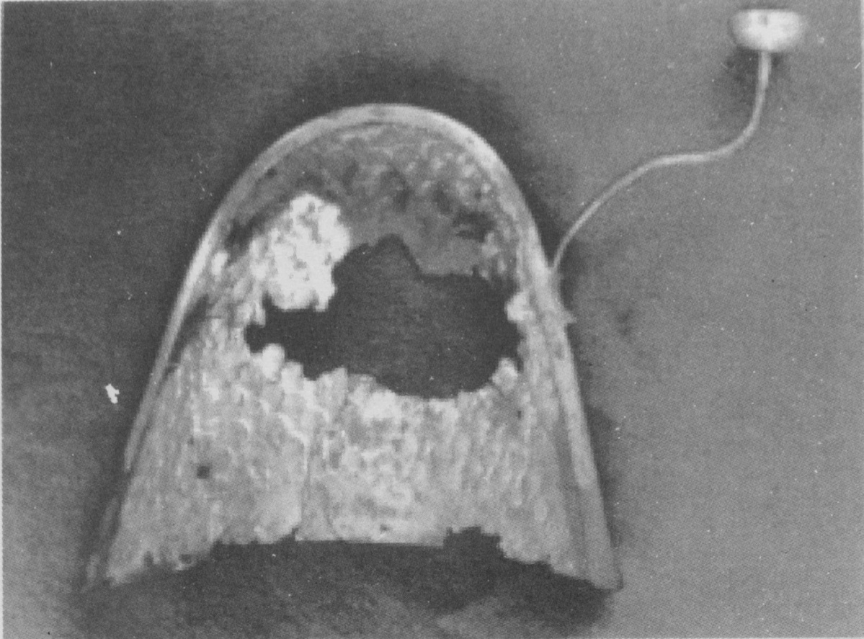
Gilt Bronze Crown from Ipchomni-Chollado

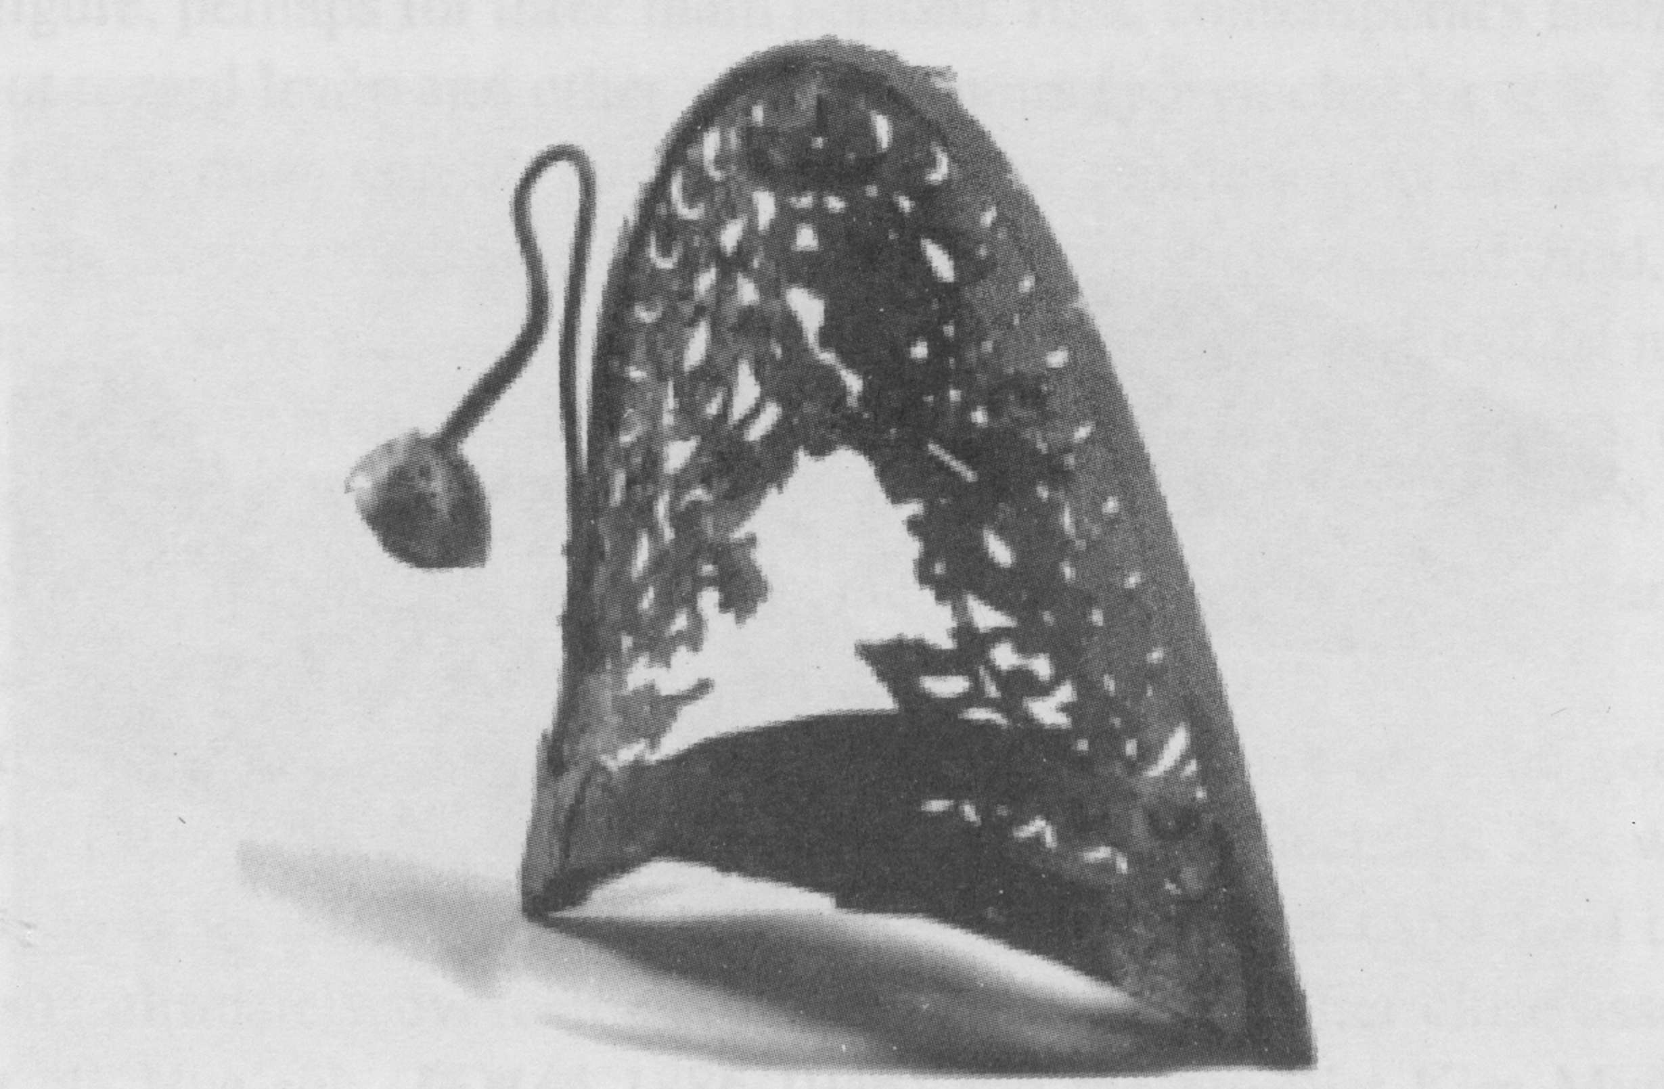
Bilt Bronze Crown from Funayame Tomb, Japan
[page 8]
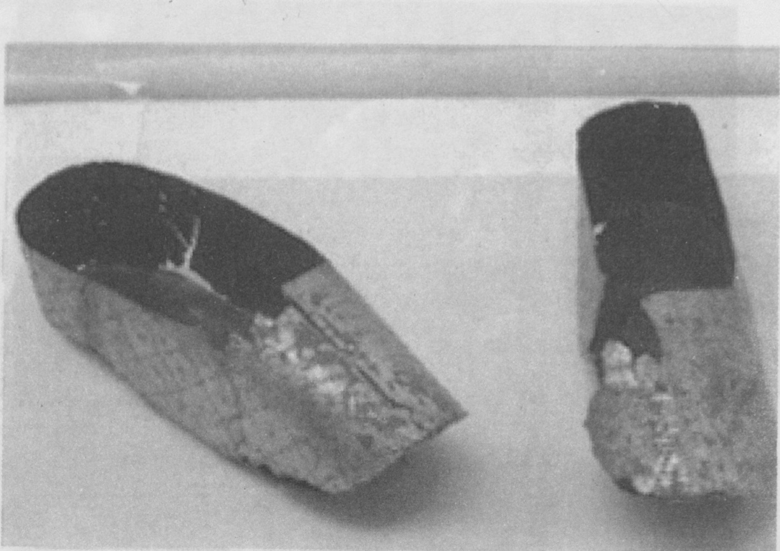
Gilt Bronze Shoes from Ipchomni-Chollapukdo

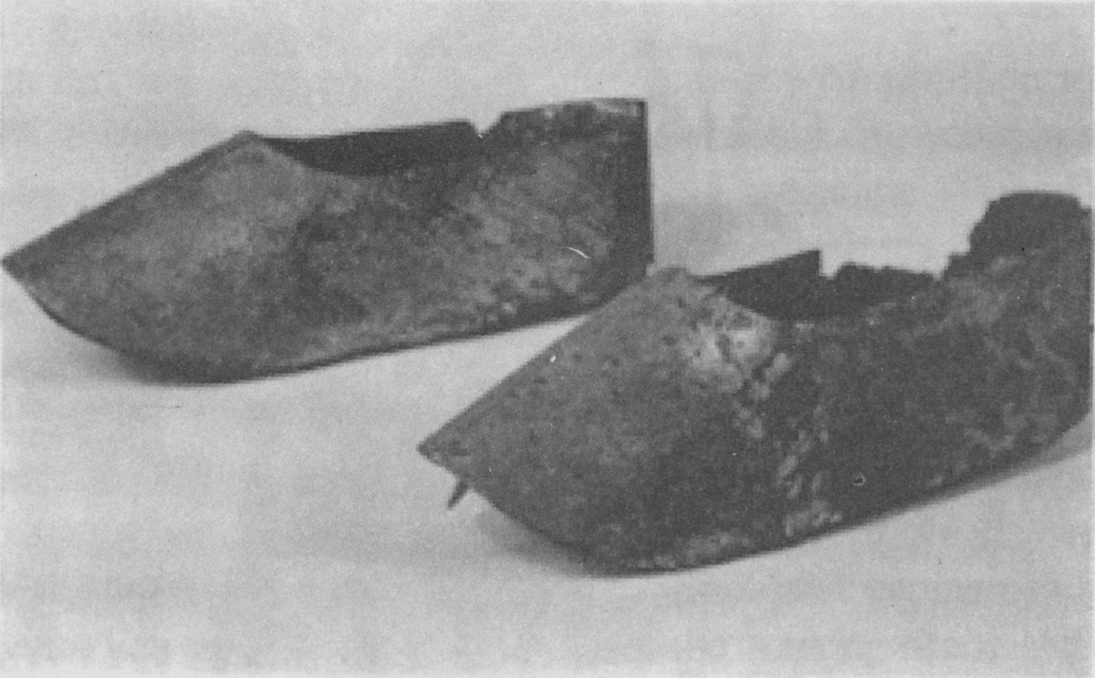
Gilt Bronze Shoes from Funayama Tomb, Japan

