[page 21]

O.N. Denny, Eki Hioki, and Syngman Rhee: Documents from the Papers of Henry Gehard Appenzeller

Daniel Davies

The letter from O.N. Denny, interview with Eki Hioki, and two letters from Syngman Rhee reprinted below come from the papers of Henry G. Appenzeller (1885-1902).1
Appenzeller received the letter from O.N. Denny and conducted the interview with Eki Hioki in his capacity as editor of the Korean Repository from 1895-1899. Neither Denny’s letter nor the interview with Hioki ever found their way into print. Appenzeller also founded a mission school for the Methodist mission, Paichai Hakdang in 1886 which he developed into a center for the Independence movement of 1896-1899. Syngman Rhee (Yi Seung-man), the president of the Republic of Korea from 1948 to 1960，studied in Appenzeller’s Paichai from 1895 to 1898, emerging as a leader in the Independence Club during that same period. Rhee wrote the two letters included in this series of documents out of their relationship as student/teacher at Paichai and out of their work together in the Independence Club.
We have reproduced the documents in chronological order—Denny’s reflections on the Kabo Reform movement (1894-1896), HGA, s interview with Japanese embassy official Eki Hioki concerning the assassination of Queen Min on 8 October 1895, and two letters from prison by Syngman Rhee after his arrest in December 1898 for leading Independence Club demonstrations in front of the Palace. Taken together, these documents offer insights into the 1885 to 1900 period of Korean histosry—the era of Chinese dominance prior to 1894, the Sino-Japanese War of 1894-95, the kabo Reforms of 1894-1896, the assassination of Queen Min, the Independencemovement of 1896-1898, and the prison life of Syngman Rhee.
[page 22]
O.N. Denny’s Letter to Henry G- Appenzeller1

INTRODUCTION

Denny, a United States citizen, served King Kojong as Vice President of the Korean Home Office and Director of Foreign Affairs from the spring of 1886 until the spring of 1890.2 Denny had served as the United States consul at Tientsin, China, from 1877 to 1880, and as consul general at Shanghai from 1880 to 1883 prior to serving as an advisor to the Korean government.
When the Dennys arrived in Korea in the spring of 1886, a small Protestant missionary and diplomatic community greeted them, among them Henry and Ella Appenzeller The Dennys and the Appenzellers developed a warm friendship during the time they resided in Seoul together.
Denny wrote the following letter in reply to a letter and a copy of the Korean Repository (January 1895) that he had received from Appenzeller. Although suitable for publication in the Korean Repository in the Letters-to-the Editor column, Appenzeller never published the letter. Possibly he planned to publish the letter, but the assassination of Queen Min in October 1895 swamped him with articles and he set Denny’s letter aside. In any event, Denny’s letter is an important primary source on Korean history during the period of 1877 to 1890.

Text
[envelope]
The Portland Savings Bank,
Portland, Oregon
O.N. Denny—Receiver
Rev. H.G. Appenzeller
Seoul, Korea
[letter]
Portland, Oregon
March 30,1895
H.G. Appenzeller, Esq.,
Seoul, Corea [page 23]

My Dear Mr Appenseller [sic];
Your short and welcome favor of January 25th [1895] is at hand, and right glad I was to hear from you. I received the Corean Repository [sic], and have read it through with much interest. I hope you will consider me a subscriber, and send it to me regularly.
I am very glad to note what you say about the reforms which are beginning to show themselves on the surface in Corea.3 Nobody knows better than you and other good friends we had in Seoul how hard I labored to bring about a better state of things internally and externally for the King and Corean people, but it was a hard job. I knew, though, my efforts would result in good in the future.4
Most of the reforms alluded to in Mr. Hulbert’s article I discussed frankly with the King and his advising officers, but the old custom was so deep seated there little can be done at any one time.5 It must be done gradually, and the changes brought so gently that the people will hardly realize themselves that changes are being made.
In one of my audiences just before I left Corea,6 the King7 asked me what would be necessary for him to do in order to make his country as prosperous as America and other western countries. I replied that the first step would be to wipe out all class distinctions and open up official life to competitors based upon energy, study, and efficiency; that it would be necessary also to make labor respectable and honorable, just as it is made honorable in western countries, that in western countries encouragement is given to every man to earn his own living; that it is laudable and honorable, and that Corea is the only country on the face of the earth that offers a premium on idleness.
I referred to the Yang Ban class.8 As you know, that class has been heretofore supported in absolute idleness, and the rule is so inexorable, that the laboring man must give to him out of his own earnings. If he is not able to pay his way he must be supported by the laboring people in absolute idleness.
I alluded to this state of things in two or three audiences which I had with the King. His majesty replied that this was a custom of so long standing that it would be very difficult to over throw it, as the Yang Ban were a powerful class in Corea. I then referred to the fact that in Japan at one time the Sameri [sic, Samurai], or the warriors of the short and long sword had become offensive in the use of these weapons that the Emperor wished to abolish the distinction. He did not wish to offend this strong and powerful class, and the way he got around it was by issuing a proclamation that it should be lawful for every man in Japan to wear the long and short sword[page 24] who chose to do so. That made the custom so common that it did away with the privilege, and hence this privileged class threw aside the use of these swords.
So I said to the King that all that would be necessary to be done was the issuance of a royal proclamation to the effect that labor in Corea from this time on should be honorable, and that it should be incumbent upon each subject to earn his own living in some way; that would dispose of the whole question，and I see in Mr Hulbert’s letter [article] a resolution pointing in that direction.
I recommended also, as you know, the development of the internal wealth of Corea, and the establishing diplomatic relations with the western world; a revisal of the laws, or abrogation of customs which Corea’s treaties rendered impracticable of execution, and that other rules which would support a prosperous course be adopted in their stead.
You know, too, as well as all others in the East, how accurate I was with reference to the independence of Corea. I pointed out to the Viceroy9 in my last audience just as clearly the present status of affairs between China and Japan as if I had the history of the last eight or nine months to have spoken from. The victorious march of the Japanese, both on land and water, therefore, has been no surprise to me.10 I knew from Japanese sources that there was a time coming when the various disturbances between the Japanese and Chinese would be leveled up, and to that end the Japs were always preparing, drilling and manouvering for the purpose of being masters of the situation when a critical time came.
I knew the vassal dogma set up by the Chinese was without merit or any-thing upon which to rest such a condition on the part of China; that after China had made treaties with Corea and Corea with the leading western countries, including Japan, they would never consent to give up the valuable concessions acquired, commercial and political, without a desperate struggle to maintain those treaties with Corea; that to admit vassalage between China and Corea would be to abrogate all of those treaties.
In that memorable interview lasting from eight o’clock in the evening until half past three in the morning, I told the Viceroy that what has happened would be sure to be the result, if China persisted in her then attitude towards Corea; that it would cost China millions of dollars and thousands of lives, and the destruction of a great deal of property, as well as lay waste to Corea herself, if China persisted in maintaining such a doctrine in Corea. A friend of mine the other day wrote me that the Viceroy expressed to him the opinion that if my advice had been listened to that China would have been saved the [page 25] greatest humiliation that had ever come to any nation, but now it is too late.
I feel very sorry for the poor Viceroy. He was willing enough to give up the idea of reducing Corea to the vassal state, but his government would not let him. Yuan11 was determined on this point, and having powerful support at the Court of Peking, was enabled to over rule the Viceroy in this matter
As a result of that mistaken policy China is disgraced and humiliated in the eyes of the world, and now the Viceroy lies a dagerously wounded man in the country of the enemy as a result of Yuan’s reckless and ill-advised course in Corea. While I was sure that the Japanese would be victorious, I did not dream that it would be so overwhelming and complete as it has been. Just to think of it, not a single reverse in this war has ever come to the arms of the Japanese, either on ships or on land. They have shown themselves to be possessed of a high order of military skill, courage, and patriotism necessary to win battles, and if a satisfactory adjustment is not made by Li at Simonosaki12 [sic] Japan will dictate terms of peace from Pekin as the English and French did in 1860.
I cannot say that I regret the controversy, because I believe it will be the means of thoroughly opening up the interior of China to Western inventions and the influences of western civilization. I do, though, from the bottom of my heart feel sorry for Li. He is a man of the highest order of patriotism, thoroughly loyal to his government and his people, and to be wounded nigh unto death in trying to extricate his government from a condition of things resulting from bad advice, and which was in opposition to his own judgment and advice, it is hard indeed. This war, too, will free Corea completely from the blighting influence of Chinese domination in that country. The next thing they will have to fear will be from the ever victorious Japs.
I look, however, to see various reforms introduced and a much more prosperous government in Corea from this time on than had existed heretofore.
I hope that everybody in Seoul of our old friends and acqusintances are in good health, and that they are getting along satisfactorily in their missionary and other work. You will have with you a young medical missionary by the name of Wells about the 1st of May [1895].13 The Dr. has been in to see me several times. He seems anxious to get into his new field of labor, and I think will be a conscientious worker with you in relieving the sufferings of the Corean people.
I have not been well for some time, having been attacked again by the grippe while in the Legislature;14 although I am much better than I have been, I am not free from the effects of it yet. Mrs. Denny15 is very well, ana joins[page 26] me in love and good will for you all.
Sincerely yours,
PS. Before Mr [Franklin] Ohlinger left [the Ohlingers departed Korea in the Fall of 1893] he wrote me concerning my subscription to the stock in the recreation grounds.16 I will be thankful to you if you will write me the present status of that subscription, and whether I will, with the others, receive any consideration for that interest.

Report of Conversation between Mr. E [ki] Hioke [sic，Hioki] and the Rev. Appenzeller (Methodist Episcopal Misson, Seoul) at the Japanese Legation, Seoul, 12th October 1895

INTRODUCTION

The Japanese embassy in Seoul plannned and instigated the assassination of Queen Min Myongsong (1851-1895) on 8 October 1895.1 Appenzeller—accompanied by Alexander Kenmure2 interviewed one of the Japanese embassy staff, Eki Hioki, on 12 October 1895, four days after the murder of the Queen. Hioki, who spoke and wrote in English, had served as Appenzeller’s source of information at least two times prior to this interview.3 At the time of Appenzeller’s interview with Hioki, Miura Goro (1846-1926), Lieutenant-General in the Japanese embassy in Seoul, attempted to cast all the blame for Queen Min’s assassination upon factions in the Korean government and military. Appenzeller, outraged by the assassination of Queen Min, wrote and published extensively upon the assassination, and upon the investigation following.4 But, he never published his interview with Eki Hioki, which follows:

Text

[Hioki]:—The recent troubles between [Seoul Korean] policemen and [Korean] soldiers [in Seoul, 3 October 1895 to 6 October 1895],5 it is said, comes partly from the jealousies between them, but the real cause is that there [page 27] has been intrigues between the factions, and you know that the newly drilled soldiers6 have not been liked by the faction.7 We have heard from time to time of this friction. The new soldiers wanted to be placed in the place of honor because they think they are better than the old soldiers, that they ought to be taken into the confidence of the King. But the party in the Court [Queen Min] did not like it; they wished to disband the new soldiers.8
Appenzeller:—The old soldiers [i.e., Palace guards under col Hyon] are those trained by General Dye?9
Answer [Hioki]:—Yes. The new soldiers wanted to take the place of these old soldiers. Some intrigues have gone on very actively, and the Conservative party in the Court10 wished to put an end to the new company. At least, such is my impression, and I think it is reasonable. Those factions in the Court wanted to find some pretext for disbanding the new soldiers and in order to create this pretext they gave some plan to the chief of the police (i.e., the son-in-law of the Tai Wan Kun).11 It seems to have given some opportunity for soldiers and the police to come into collision.
I happened to be at hand when the conflict took place. This man went into the court, with a highly exaggerated account of the troubles, and counselled the King to disband the newly drilled soldiers. What the representative of the police said to the King was known to the soldiers and the military people shortly afterwards. And he knew that he was in danger unless he can have his plan carried out in time to prevent anything happening. And so they say that he caused purposely the second trouble [6 October 1895] that happened some days after at night when the soldiers are said to have attacked the police headquarters. At the time of the second trouble the Minister of War (An)12 came to the place where the Japanese soldiers were and asked them to help him to suppress the secound trouble.
At first one of the Japanese officers went to the scene of trouble (he went alone, to the front of the police headquarters). He found nobody—the place perfectly quiet He went in and made enquiry. He asked what soldiers made the attack, and was told “the 2nd Company.” He went to its place, and found everything quiet There was no signs of trouble. He went inside, and asked the Captain of the Company, and the Captain said nothing of the kind had taken place. None of his soldiers had broken out.
The Japanese officer looked in and could not understand the matter. The men were in bed asleep. He was satisfied that all the soldiers were there. Now this is said of some people very strange. Early next morning, Mr. Takhisi,13 Adviser of Police Department, wrote to Viscount Miura14 that he received a report that 300 soldiers attacked the head-quarters of police last night (6th [page 28] [October 1895]) and he asked the Count to take the matter into serious con-sideration. The present state of matters could not be allowed to continue.
At the same time he reported that the Police Department had had all their forces gathered in the head-quarters and that upon the attack they opened the gates, met the soldiers with drawn swords, and that the soldiers immediately ran away. This is the strange part of the story. If the soldiers really pre-medi-tated an attack, why should they run away? And if they did run away, and the police were ready to fight, why did they not arrest some soldiers?
This is interpreted in various ways. Some people say that it was a mere pretext. The morning of the 7th [October 1895], the King sent the Minister of War15 to Viscount Miursa, and he told the Count that the King wanted the opinion of the Count for disbanding the new soldiers. The Viscount told Mr An: “Well, they are the Kings subjects and the King’s soldiers and the King can do as he likes,” that is a matter of course, but he said that it would not be advisable to do so at first without establishing some investigations, without have found out the facts, and besides that, these soldiers had been trained by Japanese soldiers by request of the King himself, and and in my opinion are better drilled than any in the country. If the King decided to disband these soldiers under these circumstances and without investigation he thought the King’s action would not be considered friendly to the Japanese, he must take steps to prevent any recurrence of such events and instead of disbanding the soldiers he should try to find out the real circumstances cause of the trouble.
The Minister of War [An Kyung-su] went back. Afterward, from what we heard after the event, the King had already decided to disarm these soldiers (their plan was to disarm them, and by the help of the factions in the Court to kill some of the principal people in the present government, the prime minister,16 the War Minister and others). This last item, however, is mere rumor, and I do not wish to be understood as stating it for fact.
This decision of the King was smelt-out by the soldiers. In the Evening [7 October 1895] about 6 or 7 o’clock [p.m.] a certain number of soldiers were at work, and a number of the police knowing that their enemies were to be disbanded, it is said that they spoke to the soldiers in a very scandalous manner and said, “You fools, you will be disbanded tomorrow.” This was outside the palace.
Appenzeller,—At this time the order for disbandment had not been issued?
Answer [Hioki]—No; the soldiers took the news to their quarters and entered into serious consideration. The officers felt that the matter was serious, and so, knowing that the Tai-Wan-Kun has been dissatisfied and has [page 29] been looking for something, they went in a body to his place and asked him to help them make an appeal to the King. Thereupon the Tai-Wan-Kun said; “Escort me to the palace and I will appeal for you.”
Appenzeller—Where was the Tai-Wan-Kun?
Answer [Hioki]—At the river. That is one story we hear I cannot say, but one can imagine that the matter was in the knowledge of the Tai-Won-Kun. I should think that this is only one side of the story.
Appenzeller—As to the entrance into the palace—when did they enter?—how did they get in?
answer [Hioki]—Between 4 and 5 o’clock [am., 8 October 1895].
Appenzeller—Oi course, the soldiers in the palace knew what was going on. Were the soshi [i.e., Japanese civilians] with them?
Answer [Hioki]—Some Japanese were there, but whether they went in with them I cannot say.
Answer [Hioki]—They went in to pacify matters, and had only a small company of 25 or 30 men with them.
Appenzeller—How many soshi were arrested?
Answer[Hioki]—Some fifteen.
Appenzeller—In the palace?
Answer [Hioki]—No; coming out.
Appenzeller—They will be tried here by the Consul [Miura Goro]?
Answer [Hioki]—Yes; he has jurisdiction of the Court of First Instance and will act. The Foreign Office sent out Mr J. Komura,17 President of the Diplomatic Bureau, for the special object of investigating this matter. He left Tokio on the 10th [October 1895] and is expected in a very short time. He was charge d’affaire at Pekin when the war broke out. He is a lawyer, educated at Harvard. He will have general charge.
Appenzeller—The points which trouble me most are the attack on the Queen, presence of the soshi, and the presence of Japanese officers during the indignities on the King and the Queen. It seems to me that Japan would not do any such thing.
[unrecorded dialogue]
Appenzeller.—Has the Minister [unidentified] a full beard?
Answer [Hioki].—[unrecorded reply]
Appenzeller—Did Mr. Waber18 come here before he went into the palace? As was the idea?
Answer [Hioki]—Yes: I do not know.
Appenzeller.—It is said that the Japanese went in and were seen in civilian dress and that they made the assault upon the Queen, and that four ladies[page 30] were killed, including the Queen, and that the Crown Princess had been assaulted and pulled about by the hair of the head. How comes it that Japanese soldiers were there?
Answer [Hioki]—Until investigated, we cannot give any authoritative statement, but what we hear is that some soshis have been hired by the Tai- Won-Kun and at the same time some Koreans have been disguised in Japanese dress, and the idea was that as the Koreans are afraid of the Japanese unless they appeared the body guard of the King may resist, and so they think that the Tai-Won-Kun had a number of Koreans disguised.
Appenzeller—You don’t think any good will come if the Tai-Won-Kun and the Japanese working together?
Answer [Hioki]—The trouble is we have so many soshi who are mere adventurers. For instance, the attack upon the Crown Prince of Russia, although by a policeman, was really the work of a soshi, probably living on somebody’s private purse.
Appenzeller—Don’t you think that the Japanese are likely to be charged by Western powers with the murder of the Queen? The Queen was murdered before the foreign ministers arrived, but Japanese officers were present and saw the murder without interfering.
Answer [Hioki]—Some Japanese people are charged with not performing their proper duty. If they did not actually do any harm, at least they did not do their duty. We are waiting for instruction from home. They will probably be court-martialed and strictly punished.19
Appenzeller—To my mind the presence of Japanese officers is damaging to the Japanese.
Answer [Hioki]—This is a very serious thing, and it must be the object of the government to show that it had nothing to do with the business. It must take the most public and open proceedings to prove that it had nothing to do with it This is my private opinion. I think Mr. Komura will have full powers. Meantime, the consul is acting.
Appenzeller—The feeling among Korean people is very great. I suppose you know that many of the people do not want you. Of course you do not ask them about that. There are thousands of people who believe that the Japanese did this business, so that I should like to keep in touch with the work that goes on. Of course, we should not work for one party nor the other, but we shall be called to publish what we can. If we can be kept in touch with the investigations we should be very glad.
Answer [Hioki]—The matter is very grave and the charge against the Japanese cannot be overlooked. [page 31]
Appenzeller—I heard outside that the Japanese Minister [Miura Goro] was in the palace when the butchery was going on. I do not think that it is true. Answer [Hioki]—He left here about 5 o’clock [a.m., 8 October 1895].
Alex Kenmure. [signed] [agent of the British and Foreign Bible Society]
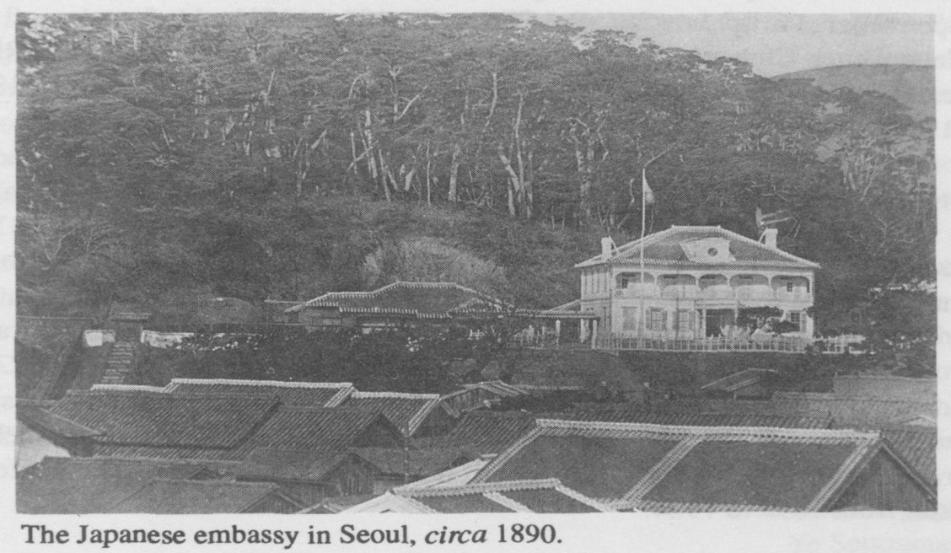

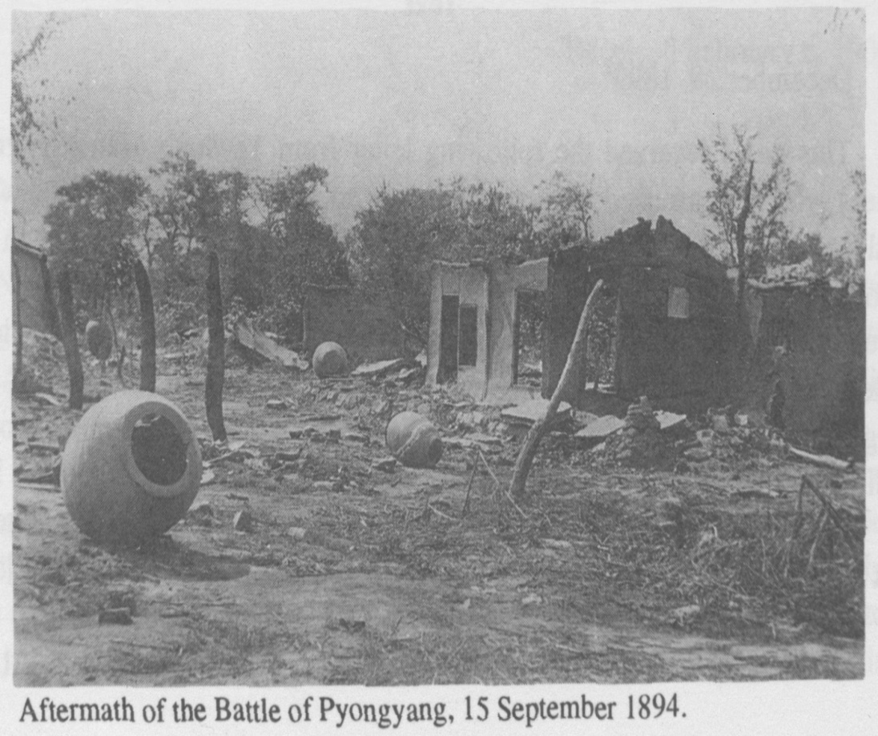
[page 32]

Syngman Rhee’s Letter to Henry G. Appenzeller

INTRODUCTION

Syngman Rhee (Yi Sung-man, 1875-1965) entered Henry G. Appenzeller’s Paichai school in 1894, at the age of 19. Rhee quickly emerged as a student leader in Paichai, working closely with Philip Jaisohn and Henry G. Appenzeller. Philip Jaisohn (So Chae-p’il, 1864-1951), the founder of the Independence Club, taught Rhee comparative politics and worked with Rhee to establish a student branch of the Independence Club in Paichai from 1896 to 1898.
After Kojong terminated Jaisohn’s contract as advisor to the throne and as editor of the Independent newspaper in April 1898, Jaisohn departed Korea for the United States. He left the Independence Club under the leadership of Yun Chi-ho (1865-1945). Rhee, and other Paichai students, moved into a prominent role in the Independence Club at that time, working closely with Yun.
From October to December 1898, the Independence Club demonstrated for a constitutional government and to protest the arrest of Independence Club leaders. Kojong had Rhee arrested for his leadership role in those demonstrations. Rhee wrote the two letters to Henry G. Appenzeller reproduced below during his imprisonment. They provide a rare glimpse into Rhee’s life in prison from 1899 to 1904.

Text

December 28, 18991
This day I received the following letter from Ye Sung Man [Syngman Rhee] who was arrested eleven months or so ago [9 January 1899]2 while walking with Dr. [Harry C.] Sherman3 in Seoul. Ye was prominent in the People’s Meeting,4 made himself offensive to the people in power and was arrested by private detectives [9 January 1899].5 His arrest created considerable interest on the part of foreigners and just as he was on the point of getting out he was persuaded to break jail, failed to escape and returned to his cell. He was tried and sentenced to the chain-gang for life.6
In Christmas [1899] I sent him a little bedding and the following letter is his reply [Appenzeller recorded Ye’s letter below with errors uncorrected]:
December 28, 1899
[page 33] My dear teacher, Sir:—
As we have forgotten all about the European calendar, I cannot remember that which of these days is the great Holy Christmas day. Although i believe it should be about [blank] days. I beg you to accept and consider my letter as a Christmas present as I extend you all my best wishes for the New Year with this paper instead of valuable gift, happiness, good health, bless, and prosperity in all things for all the time.
I cannot say how graceful and thankful I feel to you for sending me the costly blankets and rice and fuel to my poor family! At the same time I thank God with all my heart for saving so miserable and sinful body as I from such unpromising conditions like this in jail, and moreover, for giving provision to my helpless family to live on. How wonderfully God has blessed upon me! My father expressed me, in his letter, his heartily thanks toward you for your great help, just when needed.
And here the dark and damp cells of dungeon is exceedingly chilly during the late days, as it is dead of winter. The most imprisioners are suffering from destitude of clothes, food, and everything, but I, partially through the grace of God and your mercy, am now in sufficience of clothes, so that no cold can torment me. Please accept my thinks once more for all these cares.
Expecting to write again some other day. I stop saying any more now.
Your beloved pupil
Ye Seungman
Received February 6, 1900
My Dear Teacher, sir;—
Now both of the foreign and national New Year’s days are over and the spring season is already commenced. I pray to God to give prosperity, bless and happiness, specially to you and all over Christian families throughout this year.
I respectfully beg you to remember me to Mrs. Appenzeller7 for the New Year greeting. Through my father’s letter I have often heard about you and also that you were making every effort to get me out of this bondage. It really made me feel thankful to you with all my heart and, of course, I intended to send you a letter expressing my feeling toward you, but I suppose that it is[page 34] useless for one to say thank, thank, thank all the time.
About six weeks ago, when the Ex-Prime Minister Mr Yun Yong Sun was holding his office, he helped me a great deal, directly or indirectly and issued it publicly in the So-called Government Gazzattee by the edict stating that all the imprisioners beside six criminals should be released. You know that six criminals mean such as conspirators, murderers, high-way-man, thieves, adulterers, and humbuggers.
According to this edict, all the people believed that I should be free out once, but unfortunately before this idea was carried out, Mr. Yun was disappointed and resigned from his position. Then all the small back-biters got their opportunity and made great harm to me as their usual habit.
Accordingly within three days after the Gazzette was published the Edict was changed. There is no one could say anything about me in the official class. The present condition of the Government is going worse and worse that there is not a bit hope of getting better. Now, I do not wait for getting out, but deeply believe that even though all the powerful people in the world stand against me, but God’s will will be done. And this belief makes me comfortable and happy in this miserable place.
Thus I spend my time in reading books and making some poetries. But only thing, which I cannot forget, is the unspeakable suffering of my old father and all my family.
[Syngman rhee]
[page 35]
NOTES

Introduction
1. The Henry Gerhard Appenzeller papers, Union Theological Seminary Library Archives, Missionary Research Library Collection, New York, New York (UTS in further citations). For works on Henry Gehard Appenzeller see William E. Griffis. A Modern Pioneer in Korea: The Life Story of Henry G. Appenzeller (New York: Fleming H Revell Company, 1912); Everett N. Hunt, Jr., Protestant Pioneers in Korea (maryknoll, N.Y: Orbis Books, 1980); and Daniel M. Davies, The Life and Thought of henry Gerhard Appenzeller (1858-1902): Missionary to Korea (Lewiston, N.Y.: The Edwin Mellen Press, 1988).

O.N. Denny Letter
1. Owen Nickerson Denny (1838-1900) to Henry G. Appenzeller (1858-1902)，30 March 1895, UTS #48.
2. For an excellent sketch of Denny’s life and career see Robert R. Swartout, Jr., ed.， “The 1886 Diary of Gertrude Hall Denny,” Transactions: Royal Asiatic Society; Korea Branch 61 (1986): 35-41 Idem. Mandarins, Lnmboats, and Power Politics: Owen Nickerson Denny and the International Rivalries in Korea (Honolulu: The University of Hawaii Press, 1980) (Swartout, Mandarins in further citations). Idem., ed., An American Adviser in Late Yi Korea: The Letters of Owen Nickerson Denny (Birmingham: University of Alabama Press, 1984).
3. The Japanese-backed Kabo reform program. For information on the Kabo reform movement see Lew Young-ick, Studies on the Kabo Reform Movement, 1894-1896 (Seoul: Hchokak, 1990) (Lew, 1894-1896 in further citations), and Idem in Lee Ki- baik, et al, Korea: Old and New; A History (Seoul: Ilchokak, 1990) (Lew, Old in future citations).
4. See Swartout, Mandarins.
5. Homer B. Hulbert, “Korean Reforms,” Korean Repository 1 (January 1895): 1-9 (KR in further citations).
6. The Denny’s departed Korea permanently January 1891.
7. The Korean King Yi Kojong (1852-1919), the last king (also the first and last emperor of the Yi dynasty (1392-1907), who ruled from 1864-1907.
8. i.e., The Korean aristocracy. An hereditary title, initially gained through winning a top government or military post by royal examination. In the later stage of the Yi dynasty, numerous out-of-office yangban refused to labor manually to earn a living believing such work below their aristocratic position.
9. Li Hung-chang (1823-1901), the chief Chinese statesman of the era. Denny developed a close personal relationship with Li while serving as American consul in China (1877-1883. Li directed China’s foreign policy toward Korea during the 1880s and 1890s. See Swartout, Mandarins, pp. 1-22. [page 36]
10. The Sino-Japanese war of 1894-95.
11. Yuan Shih-k’ai (1859-1916), resident Chinese ambassador in Korea while Denny served the Korean throne. Yuan became the president of China from 1912 until his death in 1916.
12. Treaty of Shimonoseki (17 April 1895).
13. J. Hunter Wells, MD., arrived from Portland, Oregon to join the Presbyterian Mission North on 3 June 1895, KR 2 (June 1895): 237.
14. Denny served as a receiver at the Portland Savings Bank from 1891 until his death in 1900, and as a senator in the Oregon state senate from 1892-1896. Swartout, Man- darins, pp. 146, 152 note 1.
15. Gertrude Hall Denny (1837-1933). See Swartout, “Diary of Gertrude Denny,” pp. 35-68.
16. The Seoul Union Club.

Appenzeller-Hioki Interview
1. For a recent investigative work on the Japanese role in Queen Min’s assassination see Fusako Tsunoda, Min Bi Ansatsu (The Assassination of Queen Min) (tokyo: Shinchosha Publishers, 1988).
2. Alexander Kenmure, agent of the British and Foreign Bible Society, arrived from Japan on October 7, 1895, the day before Queen Min’s assassination. HGA, “Notes and Comments,” KR (October 1895): 399. Kenmure, who understood Japanese, assisted Appenzeller by recording the conversation and by translating statements Hioki had difficulty saying in English.
3. Appenzeller corresponded with Eki Hioki at least two times prior to this interview; Eki Hioki to HGA, 19 July 1895 UTS #64, and idem., 9 September 1895 UTS #66).
4. HGA, dated 8 October 1895, “Letter From Korea,” Japan Weekly Mail (19 October
1895):410, also in UTS #13:212-14; Idem., “The Assassination of the Queen of Korea” KR 2 (October 1895): 386-392; Idem., dated 15 October 1895, “The Queen of Korea,” The (New York) Independent (28 November 1895): 8, also in UTS #13: 220-26; Idem., “The Fate of the Queen,” KR 2 (November 1895): 431-35; Idem., “Blazing Indignation,” KR 2 (December 1895): 476-478; Idem,. “The Queen’s Death Investigated,” KR (january 1896): 33-34; Idem,” “The Acquittal of Viscount Miura,” KR (February 1896): 78, 80; Idem., “The Outlawed Army Officers,” KR (February
1896):89-91; Idem., “The Queen’s Death Again Investigated,” KR (March 1896): 118-142; Idem., “The Conclusion of Remarkable Trials,” KR (April 1896): 170-171; Idem.” “The Official Report,” KR 2 (May 1896): 208-211; Idem, “Not Unbiased,” KR (June 1896): 250-253; Idem.” “The Remains of Her Majesty.” KR (September 1896): 372; Idem., “Her Majesty’s Funeral,” KR (January 1897): 30-31.
5. See H.N. Allen to Secretary of STate, 7 October 1895, no 155 in Spencer Palmer, ed., Korean-American Relations, vol 2 (Berkeley: University of California Press, 1963), p. 345 (Palmer, Relations in further citations) and H.N. Allen to Secretary of State, no. 156, 10 October 1895m Seoul, Korea, in Palmer, Relations, vol. 2, PP. 357-362 for the background to the conflict. [page 37]
6. The Kunrentai constituted a company of over 1000 soldiers trained by Japanese officers, under the command of Korean colonel Hong. (HGA, “Report,” KR 3 (February 1896): 128; Idem., “Assassination” KR 2 (October 1895): 386]
7. By “the faction,” Hioki referred to the old guard, under Col. Hyon, who protected the palace (HGA, “Assassination,” KR 2:386).
8. See HGA, “Official Report,” KR 3 (March 1896): 133.
9. William McEntyre Dye (1831-1899) received citations for braver during the Vicks- burg and Red River campaigns during the Civil War He served as a staff officer for the Egyptian army from 1873 to 1878. Upon General Sheridan’s recommendation, Dye accepted King Kojong’s offer of the post of chief military advisor to the Korean government, serving from 1888 to 1896.
10. i.e., Queen Min and her relatives.
11. The Taewon’gun (personal name, Yi Ha-ung, 1820-98 in Lew 1894-96, pp. 40, 55- 56), father and regent for his son, Kojong, during Kojong’s minority. The Taewon，gun，s son-in-law bitterly opposed the Taewon，gun. Horace Allen, five days after the assassination of Queen Min, wrote: “This morning the Inspector of Police and the Minister of Education, friends of the Queen and now refugees at this Legation, have been officially pardoned. The Inspector of Police is the son-in-law of the Tai Won Khun, but they are bitter enemies. The Minister of Education is his brother.” Horace N. Allen to U.S.A Secretary of State, 13 October 1895, in Palmer, Relations, p. 364.
12. An Kyung-su (1853-1900), Lew, 1894-96, p. 43.
13. Terasaki Taikichi (HGA, “Official,” KR 3 (March 1896): 125.
14. Miura Goro (1846-1926), Lieutenant-General in the Japanese embassy in Seoul, arriving in Korea 1 September 1895.
15. An Kyung-su
16. Kim Hong-jip. Lew, Old, p. 224.
17. J. Komura, Director of the Diplomatic Corps, arrived in Seoul Octosber 15, 1895. HGA, “Assassination,” KR 2 (October 1895): 392.
18. Karl Waeber, Russian ambassador in Seoul at the time of the assassination of Queen Min.
19. Although a Japanese court of inquiry in Hiroshima, Japan, found Viscount and others directly implicated in the 8 October 1895 murder of Queen Min, on 20 January 1896 the court released all the accused on the grounds or insufficient evidence, Yi Pom- chin, “Official,” KR 3 (March 1896): 122-125.

Rhee/Appenzeller Letters
- HGA, 28 December 1899 and 6 February 1900, UTS Diary #3:92-95.
- Yun Chi-ho, 9 January 1899, Diaty, vol. 5, (Seoul: National History Compilation Committee, 1975) p. 198: “This afternoon about 3 [p.m.], Yi Sung Man was arrested in the Japanese settlement and carried to the police station. It is believed that his name was mentioned in the confession, so called, of Yun Sei Yong. Jung Hang Mo came near being caught in front of Dr. Sherman’s hospital. Fortunately he escaped. [page 38]
Yi went out after having seen Jung, so that Yi had nobody to blame so much as his own foolhardiness.”
3. Harry C. Sherman, arriving in Korea with his wife on 14 February 1898, directed the Methodist Episcopal mission hospital in Seoul. HGA, “Notes and Comments,” KR 5 (February 1898): 80; Idem., KR 5 (August 1898): 310.
4. For the best accounts of the People’s Meeting, held between October 1898 to December 1898, see Yun Tchi-ho (the President of the Independence Club during that period), Diary, vol 5, 31 October 1898 through 27 December 1898，pp. 171- 192.; and Idem” “Popular Movements in Korea,” KR 5 (December 1898): 465-469.
5. For a brief treatment of Rhee’s part in the Independence Club and in the People’s Meeting see Robert T. Oliver, Syngman Rhee: The Man Behind the Myth (New York: Dodd Mead & Ca, 1954), pp. 36-45 (Oliver, Rhee in further citations).
6. For Appenzeller’s unsuccessful attempts to gain Rhee’s release from prison, his attempts to restore the ailing Rhee’s health, and his attempts to provide Rhee with work while in prison see HGa to Kwon Chai Hyeng, Minister of Law, 10 January 1900, UTS #14:30; HGA to Miss Wambold, 14 July 1900, UTS #14:142; HGA to Dr. A.R. Avison, 7 November 1901, UTS #14:429; HGA, A.R. Avison, H.B. Hulbert, and D.A. Bunker to Ye Pong Nai, Vice Minister Imperial Household, 9 November 1901, UTS # 14:431; HGA to Ye Pong Nai, 16 November 1901, UTS #14:445. See Oliver, Rhee, pp. 45-68 an account of Rhee’s arrest, failed escape attempt, and imprisonment from January 1899 to August 1904.
7. Ella Dodge Appenzeller (1854-1915).

