[page 35]
Amulets

KIM Jong-Dae

People used amulets before they recognized the existence of spirits (demigods), but amulets began to exercise great influence upon people after the concept of spirits was formed. Amulets and spirits depend on each other and amulets would be nothing without. “Poojuk” (부적), the Korean term for amulets sometimes called “poojak” (부작), play a double role for exorcism to drive out evil spirits and as lucky signs to prevent misfortunes. Chinese carry these amulets with travel-permits or I.D. cards, and use the amulets in their proper sense only when they are called “poo” (符 ).
We often use an analogical interpretation of amulets for their historical importance, origin, and content because there is scarcely any research or reference material on them in literature or historical records. For this reason perhaps, amulets are not taken as a proper subject for academic research, but are studied only for various modes or patterns in applied fine arts.
This paper, is limited to a discussion of functional methodology for amulets, and largely reflects my own view. The discussion is limited to those amulets drawn on paper.
It has often been speculated that amulets have not performed their function as signs in relation to spirits from the first. “Ipsan-poo” (入山符) meaning the amulet for entering mountains” in one of the chapters in “PopaKja (抱朴子) written by Kal Hong (葛洪 ) in the period of East Chin (東晉) in China is a case in point. This amulet has the function of protecting from beasts, harmful insects and other obstacles to asceticism in the mountains.
The function of amulets has changed and developed with changing society from this primitive function, but it is hard to know when the modification in content began to occur. Amulets roughly have two functions: exorcism (壁邪) and as a lucky sign (吉洋). In Murayama’s(村山) Spirits of Korea, we find amulets used as a way of praying to spirits，and amulets are supposed to be the strongest way of praying to a spirit. In this sense, amulets assume a similar role to that of reading the scriptures (經典 ). They show much similarity, because both are aggressive and the scripture called “Okchukyung “(玉構經) . [page 36]

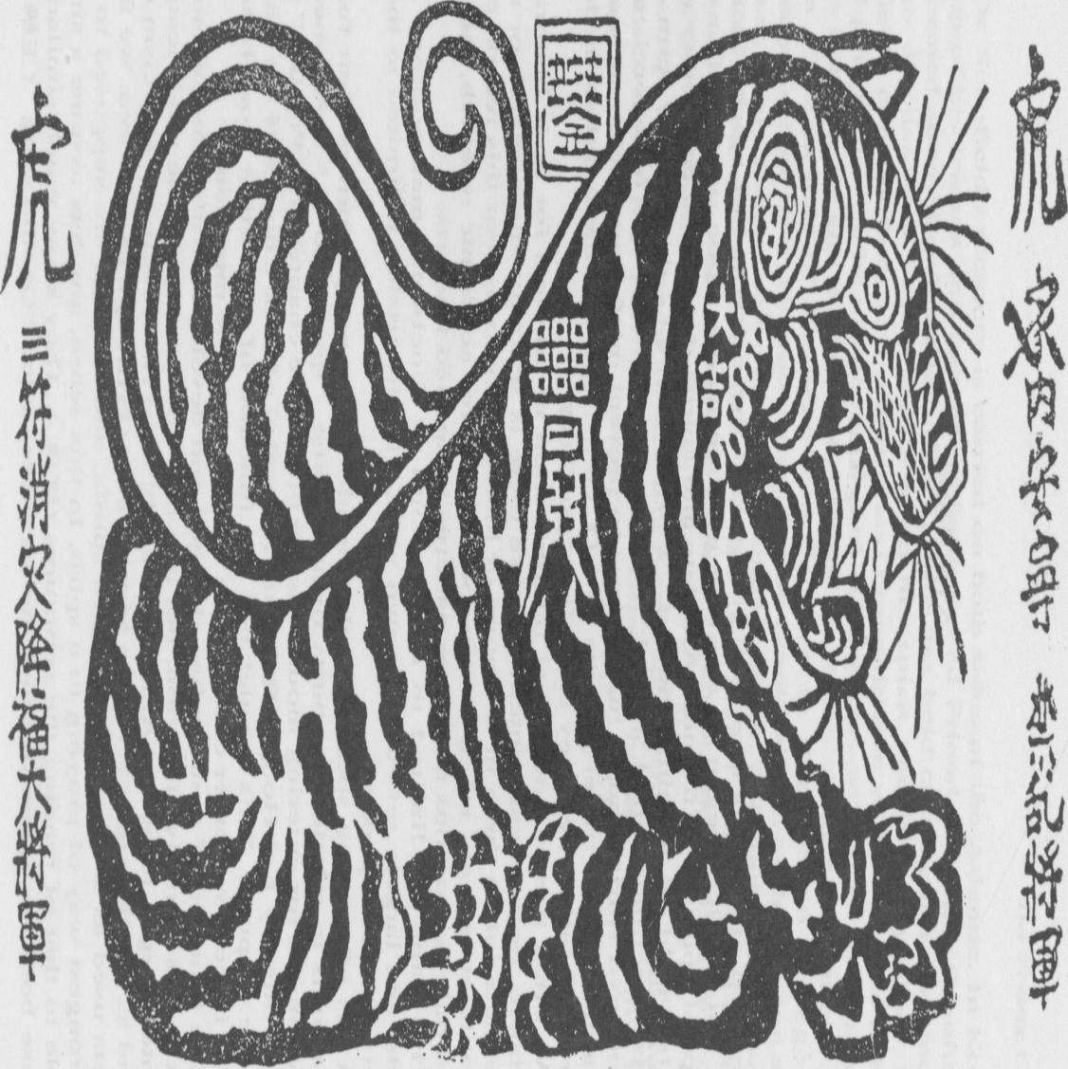

(An amulet used for exorcism. (災厄盡消符) It is used to drive out evil spirits and protect the family .) [page 37]
treats amulets and chanting the scriptures in the same manner.
The meaning of amulets pre-supposes the existence of spirits or a belief in them. Since they are used to repel the spirits, amulets would be of no use with-out the object, i.e. spirits. In the case of exorcism, the spirits are presumed to be evil harming people. The greatest problem in repelling or casting out the evil spirits is the efficiency of amulets. It is probable that men created religions and an omnipotent god along with them because they are vulnerable, and the same goes for the creation of amulets.
There are numerous kinds of amulets. This implies that there are correspondingly various kinds of evils to be coped with. The division of roles among spirits shows some shamanistic connec-tion. The diversity of shamans and the “division of labor” among spirits probably originated from the same archetype.
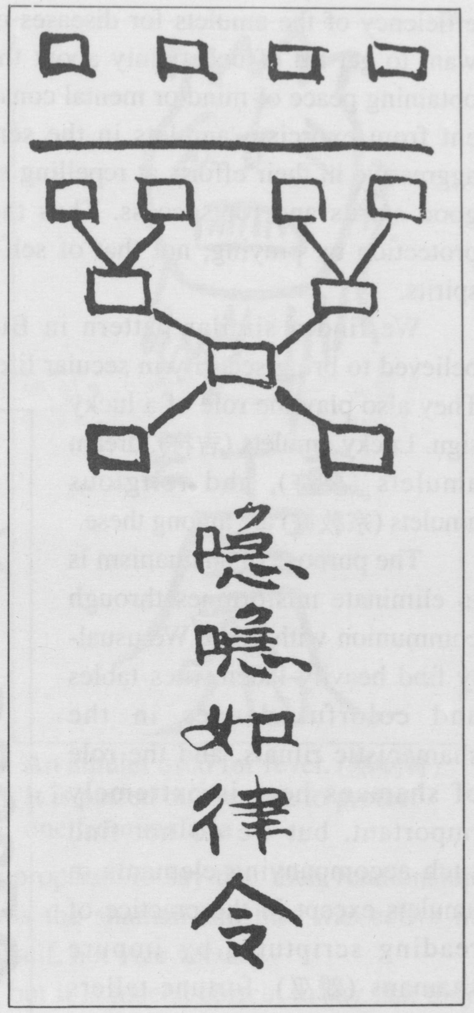

(An amulet used for love. (愛情符) It is used by both husband and wife or lovers for the revival of love).
Amulets are a sort of medium in coping with the spirits. Amultes in general display some aggressive character, and this aggression is more true in the case of exorcism. That is, amulets need to be a function of exorcism. Amulets always have, therefore, the capacity to dominate the spirits. The most typical amulets that represent the function of exorcism are the amulets for diseases (病符), amulets for preventing misfortunes (除厄) and amulets for casting out impure evil spirits (雜鬼不侵符).
The amulets most widely circulated in modern society are those used for good luck (吉洋符). This use results because people have come to doubt the [page 38] efficiency of the amulets for diseases or for repelling the evil spirits. People want to get rid of uncertainty about the future by using these amulets, thus obtaining peace of mind or mental consolation. Lucky sign amulets are different from exorcism amulets in the sense that the former are not so much aggressive in their efforts at repelling spirits as they are for the protection of good spirits and for success. Thus the amulets have the meaning of self- protection by praying, not that of self-salvation through confrontation with spirits.
We find a similar pattern in Buddhist amulets. These amulets are believed to bring security in secular life as well as eternal blessing in heaven. They also play the role of a lucky sign. Lucky amulets (吉符), dream amulets (夢符), and religious amulets (宗敎符) are among these.
The purpose of shamanism is to eliminate misfortunes through communion with gods. We usually find heavily laden, rites tables and colorful dances in the shamanistic rituals, and the role of shamans here is extremely important, but we do not find such accompanying elements in amulets except in the practice of reading scriptures by impure shamans (雜巫), fortune-tellers and the diviners who produce the amulets. We do not need mediums such as shamans because amulets have direct connections with gods.
The shamanistic rituals are a complex of inner and outer activities showing respect to the gods, but amulets recognize the existence of gods only negatively. The meaning of carrying or attaching the amulets amounts, therefore, to the denial of any

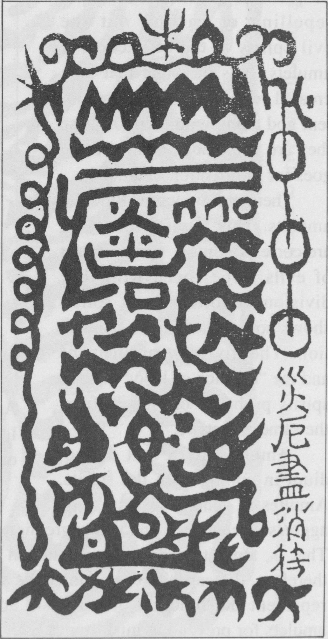
(An amulet used to prevent disaster (三災符) from three sources: wind， water and fire) [page 39]
relations with the gods. That is, amulets become factional in the proper sense only through a hostile attitude toward gods.
In the shaman rituals, there is a point during a post-ritual stage, when the shamans feed all the spirits. This feeding shows that all the spirits, even evil-spirits are aeined, but evil spirits are just evil spirits so far as amulets are concerned. It is clear, therefore, that the purpose of shamanism is salvation by prayer.
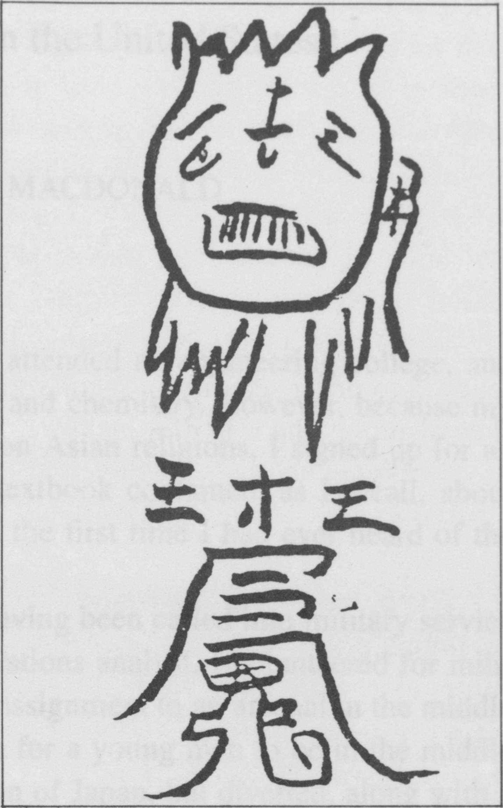
(An amulet usea ror fever. (熱病符) It is pasted on the gate to protect one from malaria)
The differences between the use of amulets and shamanism notwithstanding, shamans often produce amulets. Professor Seo Dae-Suk calls such shamans impure shamans (雜巫), but their relationship is not accidental if we consider the influence of
Taoism upon shamanism. It is more appropriate to say that their relationship is not bilateral, but unilateral — it was the shaman-ism that was active in introducing the Taoistic elements into itself, not vice versa.
Amulets are not a divine concept, but it is indeed correct to say that they are equal or superior to spirits so far as their functions are concerned. Amulets are, I believe, a medium through which our lives get better by overwhelming spirits with compromise, reconciliation or aggression, but they never pay respect to them.
I am afraid my essay can not go beyond sheer speculation due to the lack of academic foundation in the study of amulets in general. My hope is that there will be more systematic research on this subject among scholars in the near future.

