[page 27]
Strong Men and Virtuous Women: Changing Male and Female Roles in Korea

by Jack Balswick

Social scientists will tell you that there are always two views to under-standing human behavior - the insiders and the outsiders. Each view contains insights and blinders which are not contained in the other. My outsider’s view of Korean sex roles is hopefully informed by conversations I have had with insiders—my students and colleagues at Yonsei and Ewha Universities.

KOREAN SEX ROLES IN HISTORICAL PERSPECTIVE

Any attempt to understand the nature of sex roles in Korea today must begin with a brief consideration of the nature of sex roles in the past. Chart 1 depicts the relationship between the status of women and societal complexity as it has existed in most societies. As represented by the solid black line, the status of women is high in hunting and gathering societies, begins to decline in agricultural societies, continues to decline when societies begin to undergo industrialization, and improves only when societies reach a state of high industrialization.
It should be noted that women’s position has never been higher than that of men, but “high” only in a relative sense. Women’s status gets worse with increased societal complexity in that men gain control of the economically advantageous positions. Thus with the advent of agriculture, the ownership of land falls into the hands of men and men are the ones who assume the role of tiller of the soil, planter of the crop, or herder of the cattle. With the advent of industrialization, it is again the men who assume the key economic roles. Thus in most industrialized societies in the early 1900s telephone operators and typists were all men; these positions were relinquished to women only after such work became routinized and low paying. High technology societies cannot afford to distribute economic roles on the basis of sex. Where electronic and computer skills are needed, the best qualified persons regardless of sex are needed for immediate positions. [page 28]
The status of women in Korea, however, differs significantly from that described above. The dotted line in Chart 1 represents the status of women which has resulted from the acceptance of Confucian ideology in Korea. Prior to the 1600s Korean women had the right to inherit property on a near-equal basis with men (Peterson, 1981). With the acceptance of Confucian ideology in the 1600s women were effectively disfranchised by being forbidden to inherit property. They were systematically reduced to a position which was subordinate to men in most aspects of life.

CHART 1.
SOCIETAL COMPLEXITY AND THE STATUS OF WOMEN IN KOREA
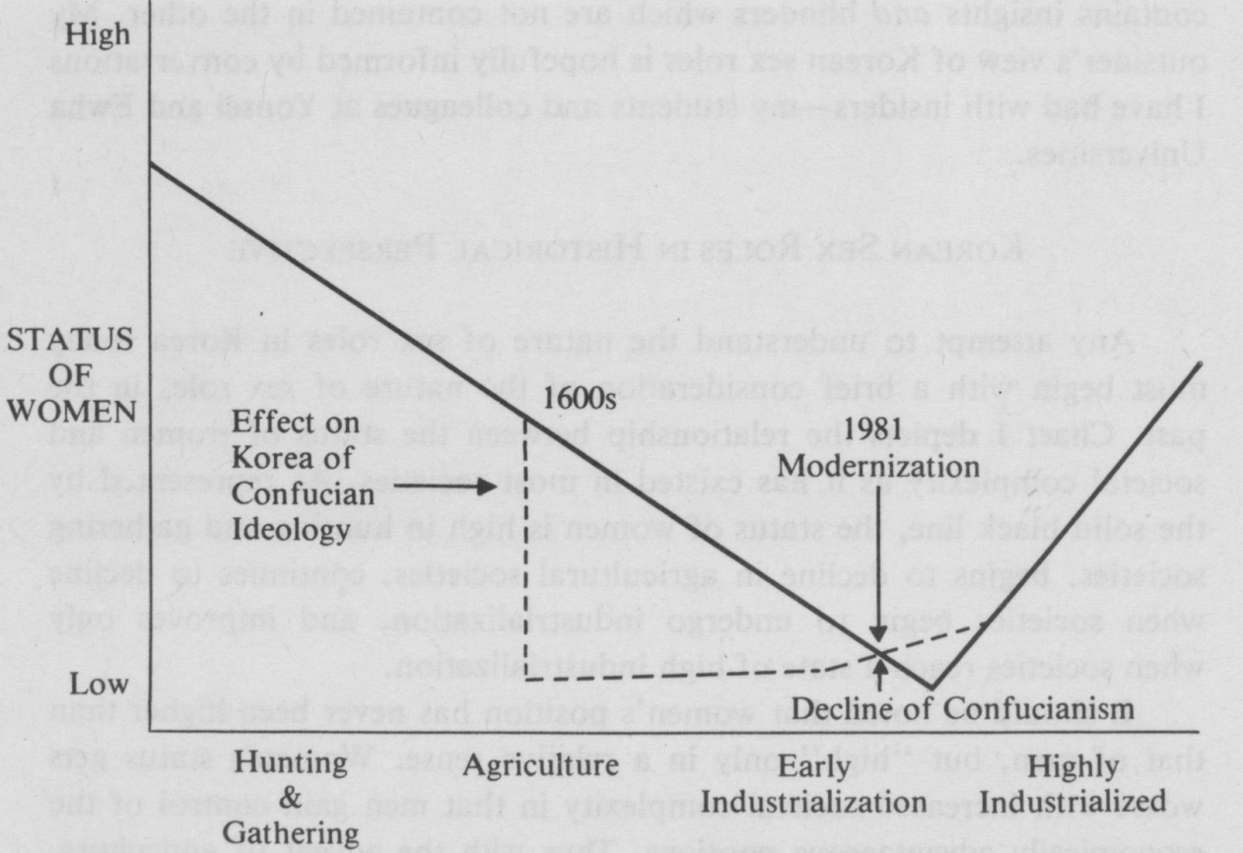

SOCIAL COMPLEXITY

As Korea is presently in a stage of rapid industrialization there are opposing forces which are affecting the status of women. The development of industrialization and western ideology is bringing about a decline of Confucianism, which is a force contributing to the rise in the status of women. At the same time however, modernization, contrary to much public opinion, is having a suppressive impact upon the status of women. [page 29] The vast majority of the well-paying positions which have resulted from modernization have been given to men. Modernization in Korea is benefitting men more directly than women. Evidence of this can be seen from the fact that the gap between what women were paid compared to what men were paid has widened between 1970 and 1980 in Korea. Further, Korean women (considered by some to be the weaker sex) work on an average of six hours more than men per month for this lower pay. I expect that this inequality in Korean women’s earnings will widen rather than narrow in the next 10 years. It will only be at the advanced stages of industrialization that the earnings of Korean women will become closer to those of Korean men.

THE CREATION OF KOREAN MALES AND FEMALES

An understanding of Korean sex roles must include a consideration of how Korean boys and girls are reared and socialized. As in most patriarchal societies, the nurturant caring for children in Korea is done by women rather than men. This has a significant impact on both males and females, who emerge into adulthood with distinctly different personalities and needs. Korean males tend to define their masculinity in negative terms, as that which is not feminine. In the process, males downplay the importance of women and feminine activity and attempt to portray themselves as self-confident and superior. Females learn to establish empathic relationships due to their identification with the mothering process and become adept as interpersonal relaters. They take on different roles, which often results in females being put into a suppressed position in society.
In the Korean family the care and nurturing of children is done primarily by the mother. The father typically has a more distanced relationship with his children. Honor rather than intimacy is the valued characteristic of the father-child relationship. While the status of father is more ascribed, the status of mother is more achieved. Fathers are given honor because they are male, and mothers must earn their position by virtue of hard work.
Infants begin life totally dependent upon their parents. However, since the mother does the caring, this dependent relationship is developed only with hen This strong dependence upon the mother profoundly affects the development of the infant’s self-concept. The developing self of the Korean child, then, is defined in relationship with the mother and not with the father. Once this strong dependence and attachment to the [page 30] mother is developed, children cling to their mother’s love. This close attachment to the mother affects sons differently than daughters.
For daughters, being cared for by a member of their own sex means that they can learn how to be a female in a personal relationship. A Korean girl learns her role in the context of personal identification with her mother and as a result emerges with a basis for “empathy” built into her self structure in a way that boys do not. Girls develop nurturant capabilities and a strong basis for being sensitive to the needs and feelings of others.
A boy must attempt to develop a masculine gender identification and learn the masculine role in the absence of a close relationship with his father. Rather than learning the male role in a personal way, Korean boys must identify with cultural stereotypes of the masculine role. Affectionate relating between father and son is usually non-existent. While the girl comes to find her femininity in her affectionate relationship with her mother, boys find their masculinity more in terms of denial of their relationship with their mother. They reject for themselves any behavior which might be considered feminine. The male personality is defined negatively, in terms of what a male should not be or do. In the process, it should not be surprising to find that the manner in which males develop their masculine self concepts also involves their devaluation of female activity and females themselves.
A boy’s dependence on, attachment to, and identification with his mother represents that which is not masculine. To affirm his masculinity, the motherly characteristics of nurturance, tenderness and expressiveness must be rejected. A boy represses those qualities he understands to be feminine within himself, and tends to reject and devalue women and whatever he considers to be feminine in the social world. It becomes important to achieve masculine identity by confirming certain social activities as masculine and therefore superior. Women are prevented from participating in these socially important activities because they are thought to be inferior and not able to perform them adequately. It becomes important for men to think that women’s economic and social contributions cannot equal men’s. Adult Korean males will often guard these particular activities and insist that these “realms” are superior to the activities performed by women.
The end result of the exclusive mothering of children is that males are prepared to assume a distinctly male dominated role in the family and in society. Females, on the other hand, are prepared emotionally for participation in family life and taught to uphold this traditional patriarchal system.
[page 31]

MALES AND FEMALES IN MARRIAGE

The lack of fathering in Korean society doesn’t do much to bring about intimacy in marriage relationships. A woman, because she was mothered by a woman, needs something more than a relationship with a male. She seeks to fill the emotional aspects of her relational needs either by establishing intimacy with other women or with her own children. As for the male, his marriage relationship with his wife completes his needs. However, his past struggle to obtain a masculine self identity by negating anything appearing to be feminine prevents him from establishing much intimacy with his wife- The wife, in failing to find intimacy with her husband,is further driven to meet her emotional needs through her children. Due to their early dependence upon their mothers, males reared in a Korean society may merely substitute one mother for another when they marry. The husband becomes his wife’s eldest son. As their mother waited on them and met their needs, so males may expect that their wife will do the same. Psychologically, many Korean men are still boys, perhaps incapable of entering into an intimate communicative relationship with their wives.
In spite of this immaturity, males possess a sense of self-confidence that is often unsupported by their own abilities. Close observation reveals that this “self-confidence” is an attempt to avoid losing face by pretending to be able to perform a task even when it is beyond their ability.
Ironically, in Korean society the male, instead of being the stronger sex, is in some ways the weaker. In reality, the male is frail. He has been coddled and pampered and given privileges when he was growing up. He was taught to think of himself as superior to his sisters, that they had a right to an education only after him, and that it was his parents’ lucky day when he was born. This pampered boy grew up dependent upon females yielding to his wishes and serving him. A girl, on the other hand, was not given a status of honor at birth, but had to achieve her status.

COWBOYS, PLAYBOYS, GOOD OL’ BOYS, AND LOCKER ROOM BOYS: KOREAN STYLE

Much of my recent research on sex roles in the United States has centered on identifying types of inexpressive male roles, Given the fact that part of the Confucian ideal is to not show one’s feelings, it might prove interesting to compare inexpressiveness as it is found among American males and among Korean males. [page 32]
In relating to females, many American males assume what I have called the cowboy role. The cowboy is a “John Wayne” type who believes that the mark of a real man is not to show any tenderness or affection toward women, because his culturally acquired male image dictates that such a show of emotions would be distinctly unmanly. The cowboy is the strong, silent type who wouldn’t dream of saying, “I love you” to the women he loves. I believe that most Korean men, in their relationship to the women whom they love and care for, are very similar to this cowboy type. It is a rare Korean wife who has ever heard her husband say, love you,” or who has even seen him cry. In his relationship with his wife Korean males are even less expressive of their tender feelings than are American males.
Whereas the cowboy has feelings towards the women he cares for, but cannot express those feelings, another type, the playboy, has no feelings towards the women, but pretends that he does for the purposes of sexual exploration. The playboy can say, “I love you” to a woman while remaining emotionally detached in the relationship. Playboys encounter women as if they were playing a game in which scoring (achieving a sexual conquest) is a means of ego enhancement. To the playboy, the woman becomes a playmate or plaything, dehumanized in the process. A successful “love affair” is one in which the bed was shared, but the playboy emerges having avoided any personal involvement or shared relationship with the women.
Among Korean males there are very few playboys of the sort described above. This is not to say that Korean males do not engage in impersonal sexual encounters; they do, but only in highly structured social situations. Korean males limit such impersonal sexual encounters to the kisaeng and the kisaeng parties or beer halls in which it is clearly understood by both the men and the women involved what the nature of the exchange will be. This is quite different from the western playboy who may be “on the make” in any hotel lobby, street corner, or bar. To pursue a woman other than a kisaeng is looked at by Korean men as stupid and foolish at the least, and possibly even insane or criminal.
The Good Ol’ Boy and the Locker Room Boy are two types of males which I have identified in American society in reference to ways in which males relate to other males. The good ol’ boy is the type of man who has warm and often deep feelings for other men, but who is unable to communicate these feelings verbally or physically. The locker room boy is similar to the good ol’ boy in that he has warm feelings for other men, but he is different because, in addition, he can verbally communicate [page 33] these feelings - but only in the masculine security of the locker room. He is dependent upon such masculine subcultures as men’s athletic clubs, sport teams, bars, and gaming rooms. In such environments, where masculine identity is secure, the locker room boy is better able to express his gentle feeling and even demonstrate his affection physically.
Although this is a much too brief introduction to these two types of American male roles, it at least provides us with a comparative basis to understand the importance of male friendships to Korean men. In relationships with each other, Korean males are a combination of both the above types. Like the good ol’ boy, Korean men establish strong, deep friendships with certain other men to the exclusion of others. But unlike the good ol’ boy they are able to freely express their feelings and affection to these men. By contrast American men have a homophobia or fear of closeness with a member of the same sex. Part of the “culture shock” most western males experience in observing Korean males is the ease with which they hold hands, put their arms around each other and in general physically express their affection for each other. It is as if the locker room boy subculture exists on a permanent basis for Korean men—their masculinity is not threatened by either showing or receiving affection from another man. Korean men achieve a degree of closeness and trust with certain other males that is generally absent among western males.
Intimate friendships between Korean males seem to be based upon friendships originating in the schools they have attended. Friendships established through membership in a common graduating class can last a lifetime. One thing which a Korean wife learns that she must not challenge or question is the time her husband spends with his “good ol” school boy” network. Whereas the western male will communicate most intimately with his wife, the Korean male will communicate most intimately with his “buddies.” I might add that the same is also true in the case of women, except for the fact that western females, like their Korean counterparts, are usually able to communicate intimately with other females.

THE PROSPECT FOR CHANGES IN SEX ROLES

Although there is strong resistance to sex role change in Korea, the current stirring for change is but part of a world-wide movement involving the redefinition of sex roles. In considering the possibilities for change in Korean sex roles, westerners should avoid two mistakes: (1) to hold to a romanticized view of the virtues of the traditional sex role division in [page 34] Korea; and (2) to interpret Korean values, desires, and discontents from their own western value system. It is true that Korean society has been and continues to be oppressive to women; Korean women are increasingly becoming cognizant of that oppression. It is also true, however, that not all Korean women experience the traditional sex role division in terms of oppression. A recent study conducted by the Korean Gallup Research Institute found that 53% of the people questioned think that there is no discrimination between men and women. Further, it was found that while 63% of the men questioned regarded men as superior to women, 67% of the women do so. Further, education does not decrease the percentage of those who believe in male superiority.

Chart 2. Feminist Ideologies and Strategies for Change
Ideology Explanation of sex role differences Proposed solution

Sociobiology Biology Eliminate culturally
Genetic produced differences
Liberal Feminist Inequal opportunity Work towards legal
and social equality
Marxist Private property Communism
Radical feminist Men have historically Change means of
oppressed women production, reproduc-
(size, childbirth, child rearing) tion, rearing
children, and sexual
regulations
Socialist Combine Marxist and radical position to see economic
feminist and sexual oppression as both primary
Dependency Peripheral (3rd world) Establish economic
theory countries dependence on independence (inter-
core capitalist countries dependence) for Korea
most adversely affects women and women’s inter-
dependence with men
Psychoanalytic Mothering, but little Joint parenting and
feminist fathering marital intimacy
Religious Sexism within religious Eliminate or redefine
feminist ideologies (Confucianism, religious ideology and
Christianity, Islam, behavior
Buddhism, etc.)

[page 35]
There are a number of alternative strategies which could potentially be utilized in Korea to bring about change in sex roles; these are summarized in Chart 2. As far as I have been able to detect there is a small but vital “underground” women’s liberation movement in Korea which is composed mostly of highly educated women. The most common attempted strategy change has been liberal feminism (see Chart 1), in which social and legal equality is sought. Liberal feminists have found change to be slow, as male-dominated educational, religious, political, and economic institutions have resisted granting qualified women equal opportunities. Due to the seeming unresponsiveness of male-dominated institutions, some Korean feminists have become very pessimistic about the prospects for meaningful change. Although some are advocates of more radical change strategies, we will have to wait and see if these attitudes culminate in action.
As long as only a few of the more educated Korean women and hardly any men are desirous of change, little will be forthcoming. The average Korean wife wants little more than a greater respect from her husband and for him to spend more of his time with her and the children. The hope that her husband will begin to communicate his feelings of love and affection to her exists only in the realm of an ideal. Change in sex roles in Korea will be a slow process. As change does take place, the Korean people will hopefully be able to retain the many positive traditional aspects of Korean manhood and womanhood, while at the same time incorporating needed new dimensions into each gender role.

NOTES
Peterson, M. Women’s Inheritance Rights in Traditional Korea. Paper presented at the International Congress on the Family; Seoul, Korea, 1981.

