[page 55]
Receiving the Samsin Grandmother : Conception Rituals in Korea

by Laurel Kendall

Whether the child is brought by the stork, foretold by an angel, or conceived by a totem animal or magical monk, myths and rites surrounding conception are certain to provoke a condescending smile on the lips of the sophisticated urbanite. For the social scientist, however, beliefs surrounding conception and birth are a fruitful area of inquiry (e.g., Blackwood 1935; Hart 1965; Topley 1974; and others). As the work of various anthropologists amply demonstrates, an appreciation of cultural factors influencing such “biological” events as conception, pregnancy, and birth is essential for those concerned with population policy, mother/child health, and the status of women (Mead and Newton 1967; Nag 1962; Raphael 1966, 1975; Philsbury 1976).
In this spirit, what follows should be something more than the presentation of an exotic custom. This account of conception rituals should lend some insight into the experience of being female in Korea, an experience that has broad implications for public policy.

CONCEPTION RITUALS AND THE STATUS OF WOMEN

In Korea, folklorists have recorded a wide variety of practices believed to induce the birth of sons: praying before potent rocks, lighting candles in the hollow trunks of old trees, making pilgrimages to mountain temples, and stealing the red pepper-studded hemp rope that announces the birth of a son. The noted Japanese folklorist, Akiba Takashi (1957) was perhaps the first to indicate the wealth of conception rituals found in Korea. More recently, the Korean Institute for Research in the Behavioral Sciences (KIRBS) presented a compilation of conception-related folklore as part of its massive

Research was supported by the Fulbright Program, the Social Science Research Council, and the National Science Foundation. Sohn Hak-soon and Lee Hyon-suk conducted some of the interviews. Sandra Mattielli, Prof. Lee Du-hyun, and the members of the Discussion Group on Medicine and Social Science in Korea provided constructive criticism.

[page 56] study on “boy preference” in Korea (Cha, Chung, and Lee 1974; 1977). In another recent study, Kinsler (1976) took the perspective of religious phenomenology in his study of conception rituals performed by shamans. (See also Kinsler 1977; Lee 1973; Lee 1974: 60-61.)
The KIRBS study rightly associates this profusion of conception rituals with the precarious status of the Korean wife (Cha, Chung, and Lee 1974: 77). An outsider in her husband’s family, her position is secure only when she produces a male heir to carry on the family line and offer chesa (祭祀) to the family ancestors. As the KIRBS study notes, being sonless is as much a “failure” as being childless (Ibid.: 4). Not only does the sonless woman contend with family scorn and a lowering of personal esteem, she faces the very real fear that her husband may cast her off or seek a secondary wife. Some fifty percent of the women in the KIRBS study indicated that they would acquiesce should their husbands take concubines to secure male issue (Ibid.: 160; see also Lee 1972).
While the KIRBS study aptly sees conception rituals as a reflection of the infertile or sonless woman’s agonizing situation, the random assortment of customs and beliefs they present conveys the impression that the childless woman, in her desperation, is the victim of naive belief and socially deleterious superstition. The study reflects an assumption that the ritual activities of Korean women, with or without the intercession of a professional shaman, are one indication of the ignorance and cultural backwardness of the Korean housewife. According to the KIRBS study: “...for most women, a process of regression starts with marriage as far as modernizing influences are concerned” (Chung, Cha, and Lee 1974: 270). Women are thus: “...an easy prey to superstitious beliefs”(bid.: 184).
This pessimistic view of female intelligence and judgment is, of course, to be expected in a society characterized by a profound separation of the sexes. The wife is the anae, the “one inside”; the husband is the pakkat saram, the “outside person”. Even in traditional times, only the most orthodox yangban (兩班) could afford to strictly observe the purdah-like restriction of women behind the great front gate, but the ideal was widely sought and, to whatever degree possible, approximated.1 Middle-aged rural women today consider the freedom of public appearance one of the most significant changes from the world of their youth.
If tradition holds that “woman’s place is in the home”, tradition also holds that the home is woman’s place. In the kosa (告祀) ritual, the senior woman of the household offers wine, water, and rice cake to the spirits of the household, spirits encoded into the structure of the house itself. One finds among the household spirits the Songju of the roof beam, the Chowang (竈王) [page 57] in the kitchen, and most significant for our concerns here, the birth spirit, or Samsin (三神) in the inner room.2 When the household is beset by ill luck, persistent sickness, or financial loss, the women consult a shaman who determines the offending spirit through divination. The shaman prescribes the appropriate ritual action to patch relations between human and spirit and restore the integrity of the house.
Thus, women serve the spirits of the house while men serve the ancestors of the family. The ritual functions of the two sexes are complementary.
There is, however, a significant difference between male and female rituals: male rituals are valued, female rituals are not. Korean social philosophers and social critics have, for centuries, hailed chesa, the ritual activity of men, as the quintessential expression of filial piety, hyodo (孝道),the foundation of the state. They have decried the ritual activities of women as wasteful, extravagant, lewd, and false (Yi 1976: esp. 84-100). The zealousness of the New Community Movement (Saemaul undong) in attacking “superstition”, misin (迷信),is merely the modern manifestation of an enduring posture.
Even with the current interest in shamanism as an indigenous Korean religion, one scholar suggests that these practices are now banalized for having been perpetuated over the centuries by ignorant country women (Chang 1974: 137-8).
This low regard for feminine ritual endeavor is pervasive. Village men mutter against the cost of ritual activity and visits to the shaman. Many of the women questioned in the course of this study greeted my initial inquiries with giggling embarrassment. Yet women’s rituals persist, conception rituals among them.
Why do women, fully aware of the biological nature of conception, resort to ritual to induce the birth of a son? Assuming that more is at work here than naive faith, what motivates these women? What do conception rituals do for them?

WHY CONCEPTION RITUALS? BACKGROUND AND THEORY

What follows is an analysis of one conception ritual commonly practiced in the Seoul region, “receiving the Samsin”, or Samsin pannun’got. A mansin (萬神), as shamans in this part of Korea are called, conducts the birth spirit into a gourd filled with rice grains, nuts, and seeds. When the Samsin is present, the gourd begins to shake in the hands of the woman who would become pregnant. The woman carries the gourd into the inner room of her home. The birth spirit is now an active presence; conception is possible.3 The mansin induces the Samsin to enter the gourd in the course of simple prayers [page 58] or as part of an elaborate day-long ritual (kut). But, as we shall see, it is also possible to receive the Samsin without the aid of a professional shaman.
Receiving the Samsin is one segment of a broad spectrum of shaman healing ritual. By “healing” I mean no more than an attempt, through ritual means, to favorably affect a culturally defined problematic condition. The Korean mansin addresses all manner of problems from illness and financial loss to adulterous husbands and disrespectful children. While the healing ritual may have no direct effect on a physical or social condition, it may have an emotionally theraputic effect. Numerous studies suggest that the process of ritual healing may rally social support around the afflicted person (Kiev et al. 1964; Turner 1967), induce the public abreaction of trauma (Levi-Strauss 1969), and transform the patient’s orientation from “ill”, “possessed”, or “unlucky”, to “cured” (Turner 1968).4
Recent observations of the Korean shaman’s ritual kut indicate that here, too, a healing process is at work (Kim 1973 ; Yoon 1976 ; Kendall 1977). Does receiving the Samsin also have a therapeutic effect? If so, how?
It is the task of the anthropologist, insofar as possible, to get inside the ritual, to try to view it from the experiences of the participants. I will thus draw on the accounts of four women who received the Samsin, and a mansin who recently induced the Samsin for a client. Background information on the nature of the Samsin comes from interviews with village women and local shamans.
Material presented here was collected in the course of a study on shamanism and rural women conducted in a village north of Seoul. In the course of my work, I soon realized that the mansin who was my main informant was drawing a significant number of clients from an urban center some twenty minutes away by bus.
I sent my assistant to survey ritual practices in an urban neighborhood that had yielded a sudden influx of clients. This urban survey revealed one more case of a childless woman receiving the Samsin (case 4). Another woman (case 5) came from an urban center southeast of Seoul to receive the Samsin in a rural shaman’s shrine. The conception rituals described here should not, then, be considered merely the tenuous survivals of traditional life in the countryside.
One final qualification is in order. The material presented here conies from the highly localized context of my field work and should not be taken as representative of all of Korea. While ritual manuals have gone a long way toward standardizing masculine chesa, women’s rituals and shaman lore are learned through observation and oral transmission, and the potential for variation is considerable.

[page 59]
THE SAMSIN GRANDMOTHER

An appreciation of conception rituals calls for a brief introduction to the cultural nature of birth and the temperament of the birth spirit.
As noted above, the Samsin, or Samsin Grandmother5 is associated with the inner room of the house, “woman’s place” in the traditional scheme of things. The Samsin oversees conception, birth, lactation, and the health of infants in the immediate postpartum period. During the birth itself and for three days immediately following the birth, the inner room, as the “birth room”, becomes a ritually separated space and the entire house is closed to the polluting influence of mourners. This inner room, or anbang, associated with woman as the annae, the “inside one”, could be considered a metaphoric womb within the structure of the house. It is here that the birth spirit resides, here that conception, gestation, and birth take place.
In the ideal, the mother-in-law, the new baby’s grandmother, assists at the birth and delivers the child. Other women from the neighborhood are often called in to help, and they are also described as “grandmothers”, older women who have had considerable experience both giving birth and attending deliveries.6
It is the mother-in-law, again in the ideal, who does the housework while mother and baby are sequestered in the birth room.7 If the mother should emerge too soon, she may catch ch’an param (lit.: “cold wind”) and later suffer from arthritis, general susceptibility to cold, and body weakness.8
The women say:
Your mother-in-law delivers you, who else would deliver you? She’s the senior member of the household, so you can trust her.
It’s painful; she does the massage. You can’t go out so she does the cooking. She keeps everything clean and protects you so you won’t catch ch’an param. Your mother-in-law is the best one to do all that.
On the third day9 after the birth, when the child is first placed at the breast, the mother-in-law/grandmother sets down rice and seaweed soup by the mother’s pillow and asks the Samsin Grandmother to make the milk flow. It is this involvement of the mother-in-law/grandmother in the birth process that leads, I believe, to the popular perception of the Samsin as a “white-haired grandmother”, an older woman whose experienced assistance is essential to guard the safety of mother and baby during the birth and postpartum period.10 [page 60]
But the mother-in-law/grandmother is not an eternally benevolent figure, nor is the Samsin Grandmother an eternally benevolent presence. She becomes angry when her commands are ignored and when she does not receive her proper due in offerings. When an infant sickens or dies soon after birth, the mansin will usually divine that the anger of the Samsin Grandmother is the cause, as in the following case:
An eight-day old infant suffered from persistent diarrhea and cried constantly. The child’s grandmother went to the mansin’s house for divination. The mansin scolded the woman. After the birth, they had brought meat and chicken into the house and the whole family had feasted without making a special offering to the Samsin Grandmother who had been responsible for the safe delivery of the baby boy. Angry at this neglect, the Samsin Grandmother did not protect the child from the ghost of the child’s grandfather’s first wife. The dead woman, pleased with the birth of her own grandchild, reached out a hand to stroke the baby. This touch of the dead, even though well-intended, caused the infant to sicken. The shaman prescribed a special ceremony, a Samsin me11 to patch relations with the Samsin Grandmother. The mansin urged the use of western medicine as well.
According to the mansin, if the family had made offerings to the Samsin Grandmother in the first place, the ghost of the grandfather’s first wife could never have touched the infant. There were, the mansin said, similar problems after the birth of the first grandchild, now a healthy toddler.
Like other spirits of the house, when the Samsin Grandmother drops her guard, restless ancestors (chosang mangmyong 祖上망명),wandering ghosts (yongsan 靈山),and other noxious influences will assume an active negative presence. A Samsin me, held before or shortly after the birth, will insure the good offices of the Samsin Grandmother.
This spirit, then, like any statused elder, is affronted by neglect and cajoled with feasts and flattery.
As the mansin views it, when the Samsin is an active presence, conception is possible. But even when the Samsin is present, other spiritual influences may interfere with the conception, birth, and survival of the child.
Sometimes the ghostly influences of a family member who died pregnant or in childbirth, haesan’goe (解產鬼) will hinder conception or threaten a successful delivery. The ghost of a woman who “was supposed to have a child but didn’t” is considered particularly threatening because the dead woman’s [page 61] sense of unfulfillment would be so great. Determining the presence of such a ghost through divination, the mansin will advise propitiating the ghost in the process of receiving the Samsin.
In some families the women have maintained through generations a tradition of petitioning the Seven Stars, Ch’ilsong (七星), spirits influential in the conception of sons and the successful rearing of children. When the tradition is broken, the Seven Stars withdraw their influence and no sons are born. When the mansin determines through divination that a broken tradition of praying to the Seven Stars is the cause of a woman’s infertility, she advises the childless woman to pray to the Seven Stars on an appropriate mountain and there receive the Samsin.
The mansin acknowledge that there is a limit to the efficacy of ritual. The spirits of the house exist within and are subject to the laws of the universe as governed by the abstract principles of Chinese cosmology—in other words, by fate. P’alja (八字),one’s horoscope as determined by the year, month, day, and hour of birth, simply decrees that some people will be childless. In the words of a mansin: “Even though they go to the mountain and pray, the Seven Stars don’t open their eyes. That’s because of their palja”
Either the husband’s p’alja or the wife’s may be deemed the cause of childlessness. In one of the divination sessions I witnessed, the mansin did not hesitate to attribute a couple’s long childlessness to the husband’s p’alja, although popular opinion ever holds the wife to blame for infertility.
We can now turn to the experiences of those women who received the Samsin for the birth of sons.

RECEIVING THE SAMSIN

Eighty rural women were interviewed concerning ritual practices. Most of them had honored the Samsin with rice and seaweed soup after the births of their children. Three women, confronted with prolonged infertility or sonlessness, undertook to correct their abnormal conditions by ritually receiving the Samsin (cases 1, 2, and 3).
In rural Korea, conception is expected to follow fast on the heels of every marriage. The appearance of a recent bride is certain to provoke mur- mers: “Is she pregnant yet?” or “They say she’s pregnant already.” In fact, most of the women questioned in a random survey of birth experiences reported that they had produced a child within the first or second year of marriage. In the cases described below, five years was the minimum amount of time any of the women allowed to elapse before receiving the Samsin. Of the three women in the birth experience survey who had their first child in the [page 62] fifth year after marriage or later, two were married at age fourteen, suggesting that a delayed assumption of conjugal life may have been a factor. The third was one of the women in the village who had received the Samsin (case 1).
Yoon (1977: 130-143) notes that in the Korean medicoreligious scheme of things, pregnancy is considered a “passive”, “secret” state. To the consternation of public health workers, the pregnant woman rarely seeks out medical assistance in the normal course of pregnancy and birth. Infertility, on the other hand, is an “active” state necessitating the active pursuit of a cure.
The women whose experiences are recounted below defined their childlessness or sonlessness as conditions that could be cured through appropriate ritual.
Case 1. Mrs. C. is now forty-four years old. She married at eighteen but did not have a child until she was twenty-six. On the advice of a woman in the neighborhood she did the following: Standing in the courtyard at midnight, she pounded rice grains seven times with a mortar and pestle, then took the grain to the well and washed it clean. She cooked the rice and took three bowls of it to the inner room. There, she bowed three times- After that, she put a dab of rice from each bowl in white paper and pasted the packet to the ceiling (as a placing for the Samsin). In the fall, she burned the packet. The next year, she became pregnant.
Case 2. Mrs. K. is now sixty-four years old and active in the local Christian church. Her daughter was amazed when Mrs. K. told me the following story : She was married at nineteen and gave birth to a son when she was twenty-one. For the next fifteen years she was unable to conceive a child She went to a Chinese herbalist, a hanyak bang (漢藥房), for treatment. She was told that she had a chronic condition of “cold”, naeng (冷),in her uterus and was thus unable to conceive. The druggist prescribed Chinese herb medicine for Mrs. K.’s condition and she had acupuncture treatments on her stomach, but nothing seemed to work. Once, a friend suggested that since Mrs. K. was bored sitting at home without a baby, they should go together to consult a posal (菩薩),a type of inspirational diviner. The posal told her, “You shall have a baby.” Mrs. K. was skeptical, but on the advice of the posal, she received the Samsin with the aid of a mansin in the neighborhood. Shortly thereafter, she conceived a child Over the next six years, Mrs. K. produced three more children.
Case 3. Mrs. H. is thirty-one years old. Her first child was a daughter. When she became pregnant for the second time, about two years ago, she went to the [page 63] neighborhood mansin shrine to receive the Samsin and insure that this time, the child would be a boy. It was.
Both Mrs. L. and Mrs. Y., whose cases follow, came from urban centers on the periphery of Seoul.
Case 4. Mrs. L. is thirty-five years old and has no children. On a friend’s advice she went with a mansin five years ago to pray to the Seven Stars on a mountainside. They brought rice, fruit, and seaweed soup up the mountain. Mrs. L. received the Samsin beside a mountain spring. Mrs. L. claims that although she was never able to conceive a child, the ritual on the mountainside made her “feel a bit happier”.
All three of the rural women attribute subsequent births to receiving the Samsin even though neither Mrs. C. nor Mrs. K. now actively patronize professional shamans. Equally noteworthy is Mrs. L.’s reaction: even though she didn’t become pregnant, she attributes positive benefits to receiving the Samsin on the mountainside.
We must look to the ritual process itself for an appreciation of the impression receiving the Samsin made on these women. Case 5 is a description by a mansin of a full kut performed for a woman who wished to receive the Samsin.
Case 5. Mrs. Y. is now twenty-seven years old and childless, although she was married at the age of twenty. She is a primary school teacher, and her husband works for a company. They live in an urban center southeast of Seoul. Mrs. Y.’s husband has been in America for the last several months on company business. Her own mother urged her to receive the Samsin so that she would be ready to conceive a child immediately upon his return. Mrs. Y.’s mother expressed her own desire for a grandchild and voiced the fear that if Mrs. Y. should remain childless, her husband might commit adultery. The kut was held in the shrine of a country mansin because, as a primary school teacher, Mrs. Y. must “...tell her students that there is no such thing as superstition.” If the kut were performed in her own home and any of her students knew about it, she would lose face.
Three mansin performed a full kut. Throughout the morning and afternoon they invoked and manifested all of the spirits and ancestors of Mrs. Y.’s family. In the course of the kut, the mansin dressed Mrs. Y. in one of their costumes and urged her to dance before the drum. During this dance, the supplicant’s personal spirit, her momju (몸主),is supposed to rise up and induce frenzied jumping. But Mrs, Y. was unable to dance. The mansin was [page 64] worried: “Some people just aren’t able to do that sort of thing. I thought ‘what if she can’t receive the Samsin ; what if the gourd doesn’t shake in her hands?’ “
When the kut progressed to the segment for Chesok (帝釋),the Samsin,12 a mansin dressed in flowing white Buddhist robes and peaked cowl, invoked the spirit. Mrs. Y. stood before the possessed mansin, holding a gourd dipper filled with carefully washed rice grains, nuts, and seeds: three walnuts because they look like the placenta, three dates as seeds for the continuation of generations, and three chestnuts so the baby will grow up tough and firm. Drum and cymbals pounded away. If the gourd should shake in Mrs. Y/s hands, the Samsin would be there.
Moments of anticipation passed. Then, sure enough, the gourd dipper began to tremble, ever so slightly, in Mrs. Y.’s hands. It shook and then it jerked up and down to the rapid beats of the drum. The Samsin was present.
Now Mrs. Y. was told to quickly eat three spoonfuls of seaweed soup and three spoonfuls of rice on the porch of the mansin home. She must not enter the inner room for she would bring in the Samsin who would settle there. Rather, she must go to her own home with her eyes cast down and not respond to anyone’s greeting—this on a trip that would include two buses and a subway. Once home, she must go straight to the inner room without a word and set the gourd dipper down wherever it should feel right to set it down.
I have yet to learn whether or not Mrs. Y. conceived a child upon her husband’s return from America.
The kut described above is the most elaborate context in which a woman may “receive the Samsin”, but, even if the mansin performs only a simple invocation, all of the crucial elements are there. The birth spirit is invoked by the shaman, the gourd shakes in the supplicant’s hands, and the woman carefully carries the gourd back to her own inner room.
As the climax of a ritual process, the sheer drama of the shaking gourd might communicate to the woman a graphic sense of transformation from “sonless” or “infertile” to “potentially son-bearing”. The seemingly involuntary shaking of the gourd suggests that the woman has suspended normal reactions and entered into the realm of ritual. She meets the birth spirit at the point of crisis, the culmination of her most immediate hopes and fears.13
It takes some time to reach the point of crisis. The rice grains must be washed immaculately clean and the offerings carefully prepared The woman bathes, then goes in secret up a hillside or to a mansin shrine, or she performs her own ritual at home in the dead of night. Finally, having received the Samsin, she must observe silence as she returns home lest she inadvertently

[page 65]
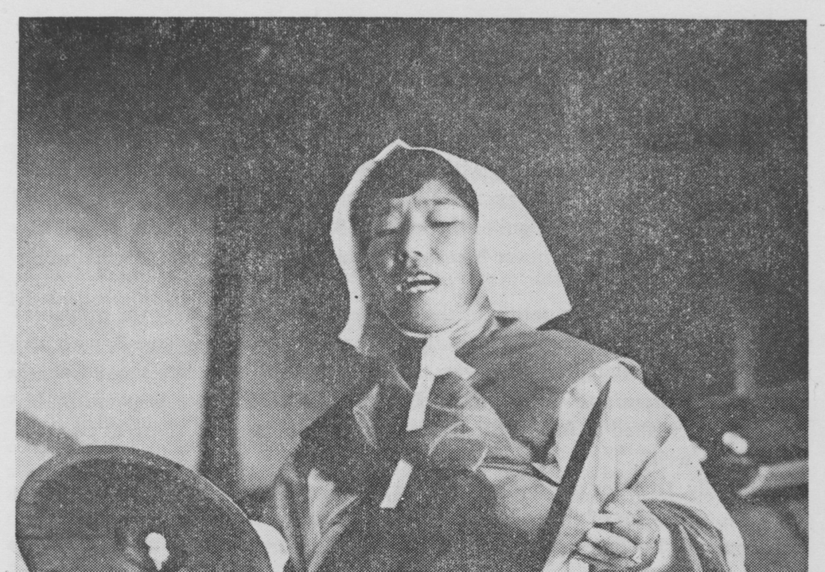
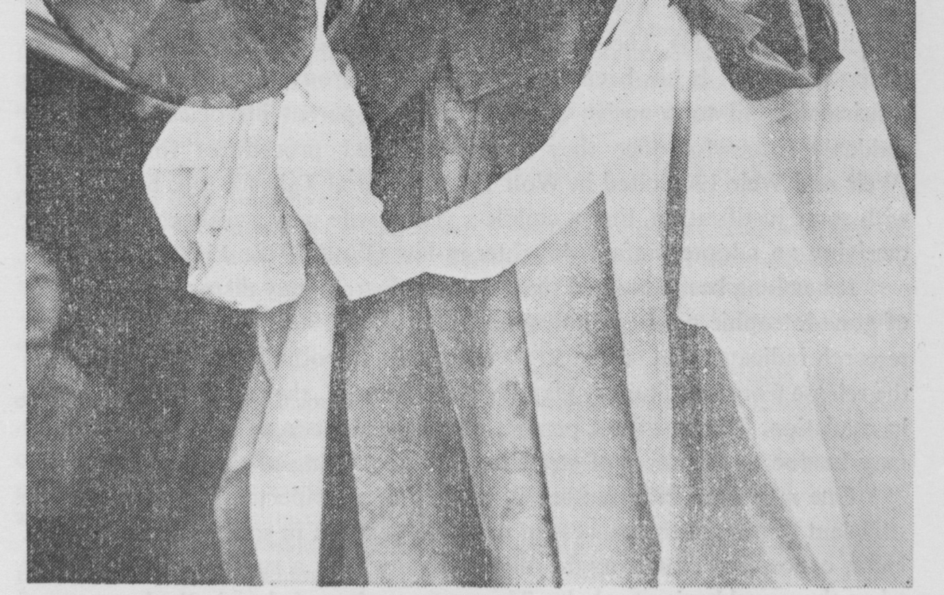

A mansin manifestin Samsin Chesok

[page 66] give the Samsin away. She conducts the birth spirit safely into her own inner room, metaphorically conducting the seed into her womb.
She has exerted considerable effort, and the successful completion of this ritual might leave a woman with the feeling that she has done everything humanly, indeed spiritually possible to secure the birth of a son. If feelings of guilt and failure are associated with sonlessness to the extent that the KIRBS study suggests, then receiving the Samsin might relieve women of some of their ponderous burden of guilt and anxiety. Significant here is the case of the woman who, though she never became pregnant, felt better after receiving the Samsin.
Nor does the perpetuation of these rituals necessarily imply the perpetuation of traditional pro-natalist attitudes. The young mother in case 3, who had given birth to a daughter and was already pregnant with her second child, received the Samsin to insure that this next child would be a boy—probably because she wished to follow the government’s injunction to “stop at two and raise them well”.
Finally, to enter a more speculative realm, anthropologists are becoming increasingly aware of the influence of cultural factors on seemingly biological phenomena. Lactation, for example, is not automatic and appears to be hampered when the new mother is not given sufficient moral support (Raphael 1966, 1973). There may well be more to conception than the biology textbooks imply. It has been observed that numerous American couples who consistently fail to conceive a child for no apparent biological reason are suddenly successful once they have completed procedures for adoption (Weir and Weir 1966 cited in Wolf 1972). In rural Taiwan, folk belief holds, with some justification, that a childless young wife may swiftly conceive after receiving an adopted infant daughter-in-law (Wolf 1972: 151).
It has long been assumed that emotional stress may disrupt the secretion of gonadotrophic pituitary hormones (Greenblat 1966 : 41, 44), More recent research indicates that severe stress affects the hypothalamus, thus inhibiting the release from the pituitary gland of LH and FSH, the two crucial hormones in ovulation. Ten to fifteen percent of recorded cases of women’s infertility may be due to the effect of stress on the functioning of the hypothalamus.
One may speculate that severe anxiety over suspected infertility may be sufficient to disrupt the process of normal ovulation in some Korean women. Here, conception rituals might relieve tension with a sudden cathartic burst when the gourd begins to shake. The woman acknowledges in the language of ritual her willingness and capacity to become a mother. She may feel “potentially pregnant”.
In short, maybe it works.

[page 67]
NOTES
1. Foreigners in Korea at the turn of the century frequently remarked at the extreme separation of the sexes, particularly among yangban. See, for example, the account of “Korean women” in Hulbert (1969).
2. While the conceptualization of household spirits is fairly consistent throughout Korea, there is considerable variation in the names of particular spirits and the mode of worship. For descriptions of this cult of the household, see Chang (1974: 163-170), Jones (1902), and Lee (1975).
3. For an appreciation of the variation in shaman-assisted conception rituals, see Kinsler (1976 : 43-47).
4. These points are made repeatedly in the extensive literature on healing rites. While this is not the place to produce a full bibliography, the following additional sources are suggested for those who might wish to pursue this topic further: Harris 1957; Middleton et al. 1967; Grapanzano and Garrison et al. 1977; Werbner 1964.
5. In the village where I did the bulk of my field work, the Samsin was most commonly conceptualized as Samsin Halmoni, a white-haired grandmother. However, one of the local shamans recognized a trinity: a yangban samsin, a monk samsin, and an ancestor samsin. One or the other of these birth spirits might appear in conception dreams. This portrayal follows the literal Chinese character rendering of Samsin as “three spirits”. Others suggest that the sam of samsin comes from samgolida, literally “tying off the umbilical cord”, an expression signifying birth. (Lee Du-hyun personal communication 5/10/78).
The mansin equate the Samsin with Chesok, a figure borrowed from Buddhism. Chesok is worshipped in the mansin shrine and manifested in kut. As one mansin explained: “Samsin Grandmother in the inner room is Chesok in the shrine.” Chesok is also concerned with the fertility of grain and with long life. See Chang (1974) for a more detailed description of the various manifestations of Chesok. See Kinsler (1976: 41 ; 1977: 30-31) for an appreciation of the varied conceptualizations of Samsin. See Jones (1902: 57-58), Sich (1977: 33), and Yi (1976: 137) for other descriptions of birth spirits.
6. In fact, only fourteen of the forty women in the birth experience survey were delivered of their first child by their mothers-in-law. Eight were delivered by their own mothers, five by midwives, three in the hospital, and the remainder by female relatives or neighbors. When a professional midwife or more experienced older woman was called in to perform the actual delivery the mother-in-law was often present in the birth room.
7. Those women who returned to their natal homes to deliver indicated that it was easier to rest and recover there because their own mothers were eager to minister to their needs. A mother-in-law might begrudge the effort Those women who had to rely on the help of other relatives, neighbors, or a husband for help with household tasks in the postpartum period were in the worst position. They felt that they had resumed housework “too soon” and suffered ill health as the consequence.
8. See Philsbury (1976) for a similar concept of “wind” as it affects the structuring of postpartum care among Chinese women.
9. Counting from the day of birth.
10. In some villages, an old and experienced midwife may actually be given the appellation “Samsin Grandmother”, although to my knowledge the usage was not current in the village where I did my work. (Dorothea Sich personal communication 4/30/78)
11. See Ch’oe and Chang (1967: 132) for a general description of the Samsin me. [page 68]
12. See note 5 above.
13. Kinsler (1975 : x, 101) provides a similar but not identical analysis of this ritual.

BIBLIOGRAPHY

AKIBA TAKASHI
1957 A Study on Korean Folkways in Folklore Studies (Tokyo) v. 16: 1-106.
BLACKWOOD, BEATRICE
1935 Both Sides of Buka Passage. New York: Oxford U. Press.
CHANG CHU-GUN
1974 Mingan Sinang in Lee Du-Hyon, Chang Chu-gun, and Lee Kwang-kyu; Hanguk Minsokhak Kaesol (Introduction to Korean Folklore). Seoul: Minjung Sawongwan.
CH’OE KIL-SONG and CHANG CHU-GUN
1967 Kyonggido Chiyok Musok (Shaman Practices of Kyonggi Province). Seoul: Ministry of Culture.
CHUNG BOM-MO, CHA JA&HO, and LEE SUNG-JIN
1974 A Study on Boy Preference and Family Planning in Korea. Seoul: Korean Institute for Research in the Behavioral Sciences.
1977 Boy Preference Reflected in Korean Folklore in S. Mattielli ed., Virtues in Conflict: Tradition and the Korean Woman Today- Seoul: Royal Asiatic Society, pp. 113— 127.
CRAPANZANO, VINCENT and GARRISON, VIVIAN eds.
1977 Case Studies in Spirit Possession. New York; John Wiley.
GREENBLATT, ROBERT B. ed.
1966 Ovulation: Stimulation, Suppression, Detection. Philadelphia: J. B. Lippincott.
HARRIS, GRACE
1957 Possession ‘Hysteria’ in a Kenya Tribe in American Anthropologist v. 59. pp. 1046- 66.
HART, DONN V. et al.
1965 Southeast Asian Birth Customs. New Haven: HRAF Press.
HULBERT, HOMER B.
1969 The Passing of Korea, (first publ 1906) Seoul : Yonsei U. Press.
JONES, G. H.
1902 The Spirit Worship of the Koreans in Transactions of the Korea Branch of the Royal Asiatic Society v. 2. pp. 37-58.
KENDALL, LAUREL
1977 Caught Between Ancestors and Spirits: Field Report of a Korean Mansin’s Healing Kut in Korea Journal v. 17 n. 8. pp. 8-23.
KIEV, ARI ed.
1964 Magic, Faith, and Healing. New York: Glencoe.
KIM KWANG-IEL
1973 Shamanist Healing Ceremonies in Seoul in Korea Journal v. 13 n.4. pp. 41-47.
KINSLER, ARTHUR W.
1976 A Study in Fertility Cult for Children in Korean Shamanism. Ph.D. Dissertation. Department of Theology, Yonsei University, Seoul.
1977 Korean Fertility Cult for Children in Korean Shaman Ritual and Myth in Korea Journal v. 17 n.2. pp. 27-34. [page 69]
LEE HYO-CHAE
1972 A Sociological Approach to Fertility Behavior. Unpublished report of the Korean Sociology Association’s 1972 evaluation of family planning. Subsequently published in Korean in Ewha Non Ch’ong, 1972.
LEE JUNG-YOUNG
1975 Shamanistic Thought and Traditional Korean Homes in Korea Journal v. 15 n. 11. pp. 43-51.
LEE KWANG-KYU
1974 Kuan, Hon, Sang, Che (Rites of Passage) in Lee, Lee, and Chang, above. LEE KYU-TAE
1973 Boy Preference in Korean Folkways in Research Bulletin n. 1. pp. 1-14 LEVI-STRAUSS
1969 The Sorcerer and His Magic in Structural Anthropology. New York: Basic Books. MEAD, M. AND NEWTON N.
1967 Cultural Patterning in Perinatal Behavior in S.A. Richardson ed., Childbearing: It’s Social and Psychological Aspects. Baltimore: Williams and Wilkins.
NAG, MONI
1962 Factors Affecting Human Fertility. New Haven: Department of Anthropology, Yale U.
PHILSBURY, BARBARA L.K.
1976 “Doing the Month”: Confinement and Convalescence of Chinese Women after Childbirth. Paper presented to the 75th Annual Meeting of the American Anthropological Association., Washington, D.C. 11/18/76.
RAPHAEL, DANA LOUISE
1966 The Lactation-suckling Process within a Matrix of Supportive Behavior. Ph.D. Dissertation, Columbia U.
1973 The Tender Gift: Breastfeeding. New York: Schocken.
1975 Being Female: Reproduction, Power, and Change. The Hague: Mouton.
SICH, DOROTHEA
1978 Some Aspects of Traditional Medicine and Illness Behavior in Korea in Korea Journal v. 18 n. 3. pp. 30-35.
TOPLEY, MARJORY
1974 Cosmic Antagonisms: a Mother-Child Syndrome in A. Wolf ed., Religion and Ritual in Chinese Society. Stanford: Stanford U. Press, pp. 233-250.
TURNER, VICTOR
1967 The Forest of Symbols. Ithaca: Cornell U. Press.
1968 The Drums of Affliction. Oxford: Clarendon Press.
WERBNER, RICHARD P.
1964 Atonement Ritual and Guardian-Spirit Possession among the Kalanga in Africa 34: 206-222.
WEIR, WILLIAM C. and WEIR, DAVID R.
1966 Adoption and Subsequent Conceptions in Fertility and Sterility v. 17 n.2.
WOLF, MARGERY
1972 Women and the Family in Rural Taiwan. Stanford: Stanford U. Press.
YI NUNG-HUA
1976 Choson Musok Ko (Korean shaman thought). Seoul: Paek-ruk.
YOON SOON-YOUNG
1976 Magic, Science and Religion on Cheju Island in Korea Journal v. 16 n.3. pp. 4-11. [page 70]1977 Su-Dong Project. Unpublished MS to be translated into Korean and published as a training manual for medical students in the Community Medicine Program of Ewha Womans University.

