[page 56]
The Postal History of Dynastic Korea

By John T. Nugent

Stituated on a peninsula between the two great Asian empires of Japan and China, Korea’s history has been that of a precarious balancing act between these giants. This geographical factor has been manifested through the years in the ebb and flow of Chinese, Japanese, and Western influences which has provided this small country with more than its share of wars, invasions, and political upheavals. The postal history of Korea’s dynastic period has reflected this turbulence.
The first evidence of a postal system in the Korean peninsula can be found in the royal post routes and mail stations (Wooyok) established in the ninth year of the reign of King Soji of the Silla Dynasty (487 A.D.).1 As the Korean kingdom was then a vassal state of the Chinese Emperor, the system initiated by King Soji was copied from the “I Chan,” the Chinese imperial courier system, which had been in existence as early as the Chou Dynasty (1027-256 B.C.).2 It was restricted to handling Court messages and was employed as an instrument of royal control over local magistrates and military forces.
During the Koryo Dynasty (918-1392), from which modern Korea derives its name, the royal system was greatly improved and expanded. The Wooyok were reinforced with more personnel, facilities were expanded, and a special courier system was set up to handle military dispatches exclusively. The speed of the system was enhanced by the introduction of horses to carry mail during the second year of the reign of King Songjong (983).3
The kings of the Yi Dynasty (1392-1910) initially extensively reformed the royal postal system to copy the efficient system in China [page 57] brought about by reforms introduced there by the Ming Dynasty. In the 30th year of the Yi King Songjong’s reign (1597), two main postal delivery systems were developed, the Horse post and the Foot post. The Horse post was set up along the State Highways with postal stations at 50-mile intervals. Each station was staffed by a station chief, five post­men, and five post horses. Over 5,000 horses were employed in this system. Horse post couriers were identified as to the importance of the mail they carried by the number of horses imprinted on their badge of office known as the “Horse Badge” (badges with from one to five horses are known to exist). Delivery of dispatches off the main high­ways was accomplished by the Foot post, which operated from postal stations at 30-mile intervals staffed by a station chief and two postmen.4
Further reform was carried out by another Yi Dynasty ruler, King Hyonjong, who in 1615 established the office of the Postmaster General, under whose control the country was divided into six semi- autonomous postal districts.5 This system, like the systems preceding it, restricted delivery of mail solely to government dispatches, military directives and reports, and other royal documents.
The first private postal system in Korea also materialized during the early Yi Dynasty. Packmen, those intrepid individuals who walked from marketplace to marketplace throughout the country carrying great amounts of parcels and merchandise on their backs in A-frame packs or in horse-drawn carts, acted as postmen for commoners and small businessmen. For a fee, the packman would deliver personal messages, either written or oral, to villagers throughout the peninsula wherever their wanderings took them. Correspondents were forced to depend on the sometimes questionable reliability of these traveling peddlers for proper delivery of their communications. Despite their drawbacks, these men provided such an efficient communications channel that in time of national emergency they were pressed into government service when the royal system became overburdened or [page 58] ceased to function. During the 16th century Japanese invasion of Korea, these packmen carried government dispatches between Seoul, the royal capital and government center, and Uiju, on the Yalu River, where the king had taken refuge.6
These private and royal postal systems fulfilled the communication needs of dynastic Korea well into the late nineteenth century when the growing numbers of Europeans and Japanese in Seoul pressed for the adoption of a Western-style postal system. In 1877, Japan established post offices at Pusan, Wonsan, and Chemulpo (Inch’ on)to handle mail between its citizens residing in Korea and their homeland. In 1882, a postal system of sorts was established between Customs Houses in Seoul, Inch’on (Jenchuan), Wonsan (Yuensan), and Pusan and the Treaty Ports of China (a generic term for the offices of the Shanghai Local Post system).7
Between 1880 and 1883, Mr. Hong Yong-shik, a middle-grade official with decidedly “reformist” or “progressive” ideas, traveled extensively in the United States and Japan to study the operations of their respective postal systems.8 On April 22, 1884, in the 21st year of the Yi Dynasty’s King Kojong, the Korean Postal Service was established by imperial decree and Hong was appointed Director-General of Posts. The Postal System was administered by the Armed Forces, under Hong, the royal postal system was drastically reorganized along Western lines. Post offices were established in Seoul and Chemulpo and this modern European style postal system, complete with postage stamps, opened for operation on November 18, 1884.9 The first Korean stamps (Scott #1-5),10 known as the “Moon series, were printed in JaDan by the Japanese Finance Ministry Printing Bureau in denominations of 5, 10, 25, 50, and 100 won and featured the Korean national symbol.
This first attempt at a modern postal system was shortlived, how­ever. The introduction of “foreign” (especially Japanese) influence in Korea did not sit well with Chinese-oriented conservatives. On Decem- [page 59] ber 4, 1884, a banquet was held in the new Post Office building to celebrate the successful opening of the postal service. Hong, in a conspiracy with Kim Ok-kyun, a senior grade official of the Foreign Office, and several others of pro-Japanese disposition (and with considerable help from Japanese authorities) planned to use this party as the starting point for their efforts to overthrow the existing pro-Chinese government. This plot, known as the “Emeute of 1884” or “Kapshin Coup,” failed to achieve the desired results. During the rioting which followed, the new Post Office was looted and burned, and Hong was captured and executed by Chinese troops sent to quell the disturbances. The other conspirators escaped to Japan under the protection of the Japanese Consul, Count Inouye.11 Continued political turmoil forced the Post Office to close on December 6, 1884, after only 17 days of operations. Because of this tragic series of events, only the 5- and 10- won stamps were ever available for use by the public. The shipment of the other denominations had been delayed in Japan and these were not put into use. Only six to ten copies of the 5- and 10-won stamps are presently known to exist post ally used, and these are ambitiously sought after by philatelists specializing in the stamps of Korea.
Increased political instability and the Sino-Japanese War, much of it fought in or near Korea, prevented the reintroduction of a postal service for eleven years. The old Horse post system was revived for this interim period. In 1893, Mr. Min Sang-ho was appointed Director-General of Posts and a law was promulgated governing the Royal Postal Service. The law established the General Office of Cable and Postal Service under the Ministry of Agriculture and Commerce, then headed by Mr. Kim Ka-chin.12
This system had its Central Bureau in Seoul and a total of 37 postal stations and 326 substations situated throughout the kingdom along the seven main highways. These stations were augmented by an additional 747 letter boxes which were serviced by daily courier runs. Each large postal station controlled several substations which were [page 60] usually staffed by local magistrates administered by the Interior Ministry. Mail delivery between stations was scheduled three times a week by foot post. Each postman carried a maximum of 20 kilo­grams and was required to cover at least 40 kilometers daily. If mail volume exceeded this limit, extra men or pack horses were em­ployed.13 On July 22, 1895, the new Post Office commenced operations between Seoul and Chemulpo. The service was gradually extended to outlying areas of the country when sufficient staff was re­cruited and trained. A new set of postage stamps were issued in denominations of 5, 10, 25, and 50 Poon (Scott #6-9).14 Printed by the American firm of Andrew H. Graham Banknote Company of Washington, D.C., these stamps carried the design of the national flag of Korea, the “T’aekuk.”
This postal system proved to be very successful and was popular among the large expatriate community in the capital and the countryside. Writing in September, 1895; the editors of the English language “Korean Repository” noted:
“The Korean Post Office is fairly launched. The day it was opened, 12 letters were cancelled, . . . the first month 616. Col­lected from sale of stamps ¥362.48. The Chongdong (section of Seoul near the royal palace where a majority of foreigners re­sided) rounds are made at 7 a.m. and 4 p.m. The mail for Chemulpo closes at 9 a.m. and arrives from Chemulpo at 5 p.m. Letters in the city (Seoul) require 10 poon or 2 sen stamps.”15
The new service handled a total of 192,000 letters in its inaugural year and derived a total of $2,200 from the sale of stamps.16
Modern technology was rapidly adapted with the assistance of the Japanese, who had gained the upper hand in Korea finally as a result of their defeat of China in 1894-95. A rail route was opened between Chemulpo and Seoul, reducing transit time from eight hours to one and three-quarters. The Korean government maintained con-

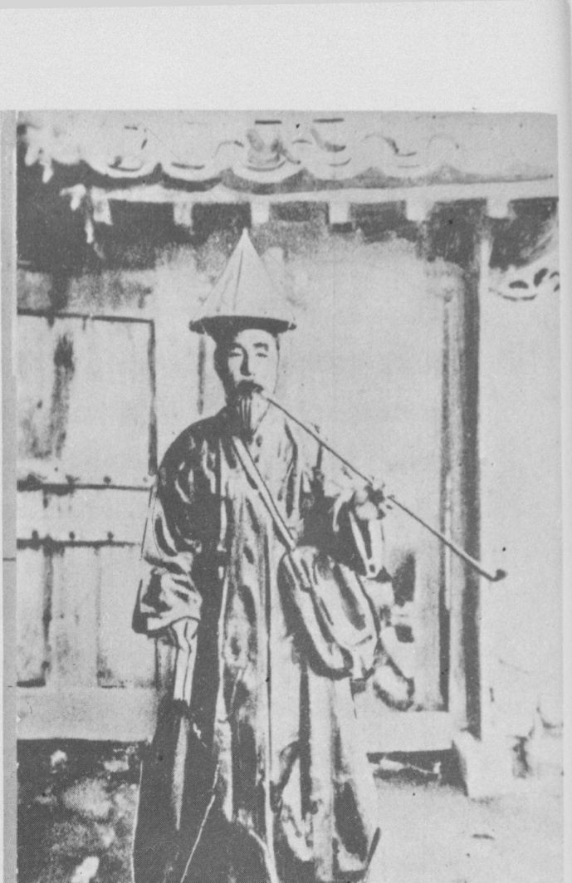
A Yi Dynasty postman in the uniform of his office.

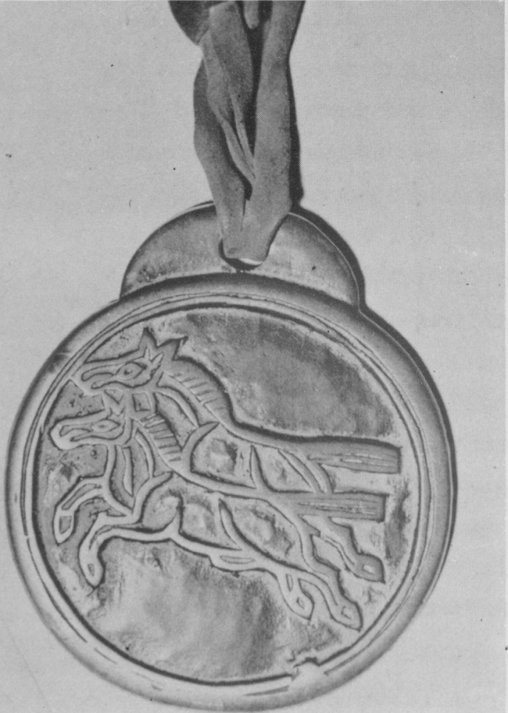
The Horse Badge identified postal couriers during the Yi Dynasty. The importance of the Courier was indicated by the number of horses stamped on his badge.

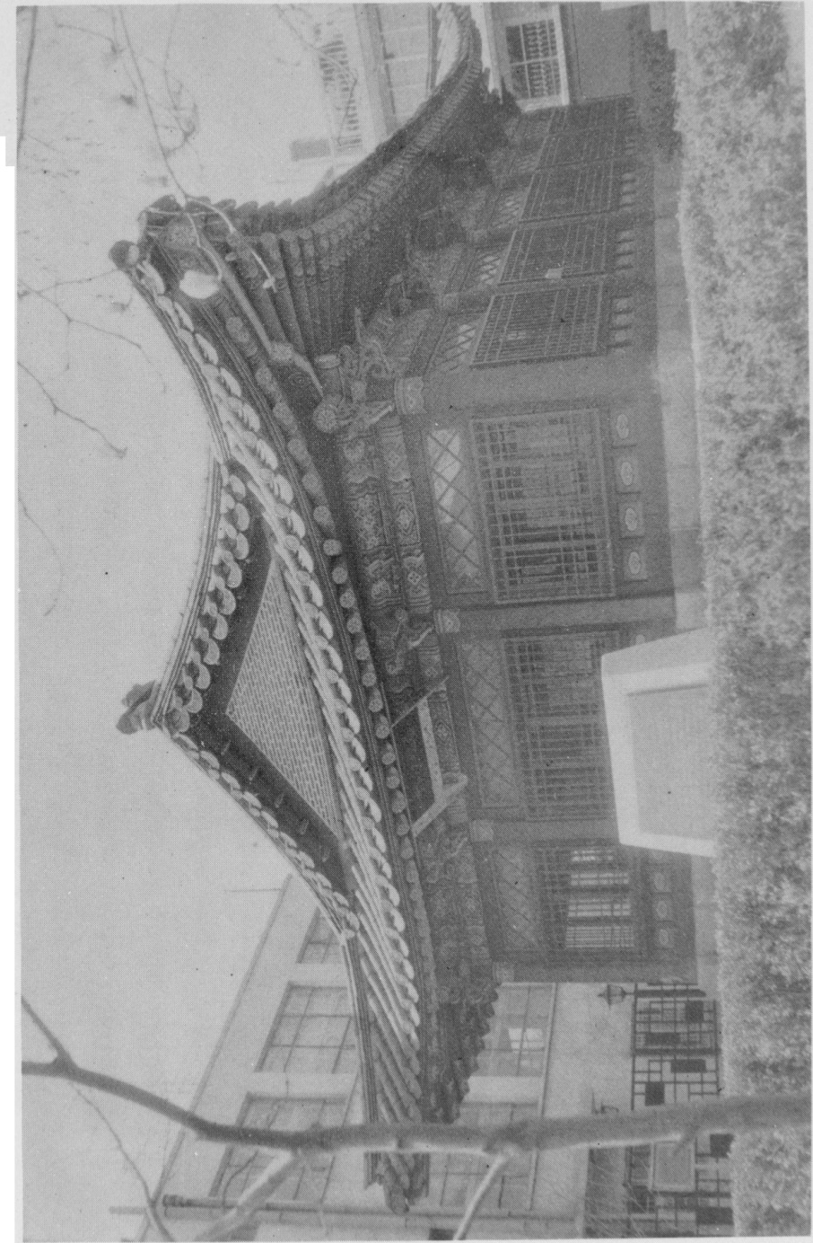

The Communications Memorial Hall is a restoration of the first Post Office in Korea. It was burned and looted during the “incident” of 1884. The museum holds artifacts from Korea’ s postal history and examples of all stamps issued by Korea.
[page 61] tracts with the concessionairies of railroads and turnpikes which provided for free and unimpeded transport of all mail accompanied by a postal agent. Maritime transport was also used to speed delivery among the various coastal cities on the peninsula. Japanese mail packets carried Korean mail between Kobe, Nagasaki, Pusan, Chemulpo, Taegu, Wonsan, Chefoo (China), and Vladivostok. The Chinese Eastern Railway Steamship Company carried mail between Shanghai and Vladivostok via Nagasaki, Chemulpo, Port Arthur, and Chefoo.17
That the Korean Postal System was only an internal system pre­sented a great amount of difficulty in the handling of international mail. Pressure on the authorities to join the Universal Postal Union built rapialy in the foreign business communities. A Korean delegation headed by Director-General Min attended the Congress of the U.P.U. held in Washington, DC. in 1897. In 1898, Min hired M.E. Clemencet, a former employee of the French Department of Posts and Telegraph, to act as an advisor and instructor at the Central Post Bureau in Seoul. He was commissioned by Min to introduce reforms and modify existing plans and policy to allow Korea to fit into the Universal Postal Union. Korea was admitted to full membership in the U.P.U. on January 1, 1900 and in the year that followed, the post office handled 1,300,000 letters and produced revenues of $20,600.18
In order to attain at least the appearance of independence and equality with China and Japan, on October 17, 1897, King Kojong declared himself emperor and established the Empire of Dai Han.19 Existing stocks of stamps were overprinted with Chinese characters and Hangul to publicize this fact. These overprints, quite naturally, are known to philatelists as the “Dai Hans”(Scott #10-15).
The first locally produced postage stamps were the “Plum Blossom” series of 14 denominations ranging from 2-ri to 2-won issued in 1900. These were designed by Han Chi-chang and printed [page 62] by typography at the Printing Bureau of the Agriculture-Commerce- Industry Ministry in Seoul. This firm also printed Korea’s first com­memorative stamp, a 3-chon denomination issued in 1902 to mark the 40th anniversay of King Kojong’s coronation. At M. Clemencet’s urging, the Korean Post Office replaced the “Plum Blossom” series with a set of 13 stamps of his own design known as the “Falcon” series after the stamps’ central design which were produced by the French Government Printing Office. The “Falcon” series was placed into general use in 1903.20
Japanese influence in imperial affairs became deeply entrenched during these later years. Defeats of the Chinese in 1895 and of the Russians in 1905 by the Japanese removed the last major obstacles to their expansionist policies in North Asia. In 1905 Japan forced Korea to sign the Joint Korea-Japan Communications Operation Treaty which effectively placed all of Korea’s communications faci­lities, including the Post Office, under Japanese control. Five years later, in 1910, the Yi Emperor was finally deposed and Korea was formally integrated into the Japanese Empire. Japanese stamps re­placed those of Imperial Korea until its liberation on August 15, 1945, by victorious Allied military forces.
Careful comparison of Korea’s postal development to the politi­cal events of the same time frame reveals, interestingly, the major role played by the postal system in the outcome of those events. As a vassal state of the Middle Kingdom, Korea copied the extensive Chinese courier system for its own use. The introduction of a modern, Western style postal system reflected the weakening of the Chinese position of influence in Korea, first in the “Emeute of 1884” and then in its permanent establishment in 1895. The various issues of stamps from 1895 to 1903 reflect the attempts of the Korean Kingdom to maintain its position of independence in the face of Japanese expansionism. It is interesting to note the first step toward integration of Korea into the Japanese Empire was the amalgamation [page 63] of their postal systems five years before the Emperor of Korea was finally deposed.

FOOTNOTES

1. Hwang Woo-sung, ‘A Brief History of Korean Postage Stamps,” Korean Postage Stamps, p. 19.
2. Carl H. Scheel, A Short History of the Mail Service, p. 16.
3. Chang Yang, “Telecommunications and Postal Service in Korea,” Korea Journal, vol. 8, no. 1 (January, 1968), p. 13.
4. Homer B. Hulbert, “The Korean Telegraph and Postal Services,” Korea Review, vol 2, no. 9, (September, 1902), p. 396.
5. Chang Yang, op. cit., p. 13.
6. Ibid., p. 13.
7. Hulbert, op. cit., p. 397.
8. “The Communications Memorial Hall,” R.O.K. Ministry of Com­-munication, p.l.
9. Hulbert, op. cit., p. 397.
10. See glossary of philatelic terms in the appendix for definitions of tech­nical terms.
11. Harold Cook, Korea’s 1884 Incident, p. 199. This book provides excel­lent background to this famous incident in both Korean political and philatelic history.
12. “Notes and Comments,” Korean Repository, August, 1895, p. 320.
13. Hulbert, op. ctt., p. 399.
14. See note 10.
15. “Notes and Comments,” Korean Repository, September, 1895, p. 359.
16. Hulbert, op. cit., p. 401.
17. Ibid., p. 400.
18. Homer B. Hulbert, Hulbert’s History of Korea, (Clarence D. Weems, ed.), vol. II, p. 576.
19. Hulbert, op. cit., p. 401.
20. Hwang, op. cit., p. 20.

BIBLIOGRAPHY

— — — — —, “The Communications Memorial Hall,” R.O.K. Ministry of Communications, Seoul, undated.
[page 64] — — — — —, “Notes and Comments,”Korean Repository, August, 1895, Seoul, p. 320.
— — — — —, “Notes and Comments,”Korean Repository, September, 1895, Seoul, p. 359.
— — — — —, Standard Korean Postage Stamp Catalogue, Korean Philatelic Society, Seoul, 1975.
— — — — —, Scott’s Standard Postage Stamp Catalogue, vol. III, Scott Publishing Company, New York, 1975.
Chang Yang, “Telecommunications and Postal Services in Korea,”Korea Journal, vol. 8, no. 1 (January, 1968), pp. 13-17.
Cook, Harold F., Korea’s 1884 Incident, Royal Asiatic Society, Seoul, 1972.
Hulbert, Homer (ed.), “The Korean Telegraph and Postal Services,” Korea Review, vol. 2, no. 9 (September, 1902), Seoul, pp. 396-401.
Hwang Woo-sung, ‘A Brief History of Korean Postage Stamps,” Korean Postage Stamps, R.O.K. Ministry of Communications, Seoul, 1975, pp. 19-23.
Scheel, Carl H., A Short History of the Mail Service, Smithsonian Institute Press, Washington, D.C., 1970.
Weems, Clarence D. (ed.), Hulbert’s History of Korea, vol. II, Hillary House Publishers, Ltd., New York, 1962.
Photography courtesy of the Korea Herald and the Korean-American Educa­tional (Fulbright) Commission

APPENDIX
GLOSSARY OF PHILATELIC TERMS

Catalogue numbers — arbitrary numbers assigned to stamps issued by a country to facilitate identification among philatelists.
Scott numbers — numbers assigned to stamps listed in the Scott’s Standard Postage Stamp Catalogue. This is the basic U.S. philatelic reference which lists all stamps issued in the world since 1840.
Used — in philatelic terms, a stamp which has been postmarked in such a manner that it indicates actual use as prepayment of postage.
On Cover — technical term meaning stamps and the entire envelope or letter to which they remain affixed.
Philately (-lc) — the hobby of stamp collecting, (pertaining to the hobby).

