[page 139]
ON THE STONE TRIAD FROM NAMSAN, KYONGJU
by Hwang Su-young

I

Visitors to the Kyongju National Museum will find a small courtyard where numerous stone carvings of the Silla Dynasty are displayed. On the western side of the courtyard is an oblong hallway, running south to north, called Chip Ko-gwan (Collection of Antiquities Pavilion), in which is placed, facing east, the Stone Triad which is the subject of this article.
There are, besides, a number of stone statues of the Silla Dynasty which were mostly moved out of old temple sites in and around Kyongju. Since these statues have been shifted from their original sites, they are no longer objects of veneration as in the old days, but instead have gained recognition as art objects.
The writer has long paid special attention to this Stone Triad among the numerous statues in Chip Ko-gwan, not merely because of its archaic style or the unusual sitting position of the main Buddha, but because of its refined carving technique, along with its babyish face, rare among discoveries in the Kyongju area, which together form an “archaic smile.”
Additionally, all three statues are rounded in high relief, typical of the Korean triad style discovered since the early period of the history of Korean Buddhist sculpture.
Although there appear to be differences in style and [page140] era between this triad and the stone triad of standing Buddhas restored at the site of the Sunbang-gok (禪房谷) Temple on Namsan, I consider both of these deserve an important place in the early period of Silla sculptural history. Particularly, the triad in the Museum has the advantage of easy access since its removal from the original site in Chang-ch’ang-gok (長倉谷), Mt. Namsan.
Attempts have been made in the past to determine the origin, name and period of the triad through numerous visits to the museum. It is easily presumed that the statues are the work of a well-known master who created for the benefit of ardent worshippers, and that they remained objects of worship by monks and laymen alike for centuries, hit is too much to expect the revival of the sincerity and faith of ancient days among people today, it is at least this writer’s humble desire to contribute to the study of ancient stone sculpture.

II

For proper comprehension of ancient art, it is essential not only to be familiar with the work itself but to study carefully the period and all the circumstances in which such work was created. This is even more true when such work has been shifted from its original site. The writer is of the opinion that the fact that we are relatively unfamiliar with this sort of art work is due mainly to our indifference and lack of effort to understand it, rather than any ambiguity in our tradition.
Of the three statues, the main Buddha is now placed on an oval lotus pedestal of stone. It has been said that this stone pedestal was found later at the house of a villager in [page141] Wolnam-ni (曰南里), Naenam-myon, Kyongju, and is, therefore, not part of the main Buddha. However, the writer’s investigation reveals that the pedestal is definitely part of the main Buddha and was removed from the original site to the villager’s house down the hill. As is well known, the nimbus serves as an ornamental piece together with the pedestal, thus comprising a three-part piece, along with the Buddha itself. In the case of this main Buddha, the round nimbus around its head forms part of the statue carved out of the same block of stone, and on it a single-petal lotus flower is carved in relief. There is still a trace of red paint.
The main statue faces front and is in a sitting position on a square seat, making it the oldest and indeed only example of rounded statue of stone in the Old Silla period. In proportion to the top half, the bottom from the knees down seems under-sized, giving an ill-balanced appearance, or somewhat unreal look to the carving. In other words, it is like a fat grown-up man trying to squeeze himself into a baby chain It has plain hair and also has a round Usnisa behind the crown of the head. Its long ears drooping over both shoulders give the appearance of a man with a head-cloth. Its face is quite round and lifelike, but there is no general impression of sensuality. Both eyes are extremely swollen, a unique method which is often found in gilt bronze and stone statues during the Three Kingdoms period The same method of carving is seen in the gilt bronze standing Buddha of Koguryo, dated 7th year of Yon’ga (延嘉), found in 1963 in Uiyong (宜寧), Kyongsang Namdo, and also in the seated softstone Buddha of Paekche, excavated earlier in a temple site of Kunsu-ri (軍守里), Puyo. In his dissertation Mt. Akio Koizumi, former curator of the Pyongyang Museum, referred to “Stone Buddhas of Silla with Unusual Eyes” (November, 1952, Volume I, No. 1 of Ko [page 142] Mun Hwa 古文化).
One large piece of drapery covers both the shoulders and knees, and it is noticeable that the crease of the drapery is expressed with thin, round line in relief. Especially around the knees it forms a whirl. This way of expressing the crease is also found in the main Buddha of the stone triad recently discovered in a cave on Mt. P’algong (八公山). Both hands rest on the lap. The four fingers of the right hand are held straight up and bending, palm to front. A hole formed between the thumb and the index finger indicates that the hand probably held the stem of a lotus flower or a similar object originally. The left hand is holding the tip of the drapery, also palm to front. At the belly is seen the knot of a string tying the inner cloth. In the center of the chest is a swastika, although not very clear in relief. Other examples of seated Buddhist statues bearing the swastika are the above cited softstone Buddha of Paekche discovered at Kunsu-ri, Puyo and the dated stone Buddha recently found in Pi-am Temple (碑岩寺), Yun’gi (燕岐, Ch’ungch’ong Namao. It is of particular interest to note that these are all works from late in the Three Kingdoms or early in the Unified Silla period. At the very bottom of the plain back of the statue part of a square seat shows. One can conclude from this that this front and plain back are special features common in statues of the Three Kingdoms period. Its height of 176cm, width of 99cm, and depth on the right hand of 46cm easily make it one of the major such stone works extant. The main Buddha may even be the foremost of the early stone-carved round statues. The style and method it reveals, together with the period of its origin and its technique make it a valuable art piece comparable with the main Buddha in Sokkul-am on Mt. To-ham, of the Unified Silla period.

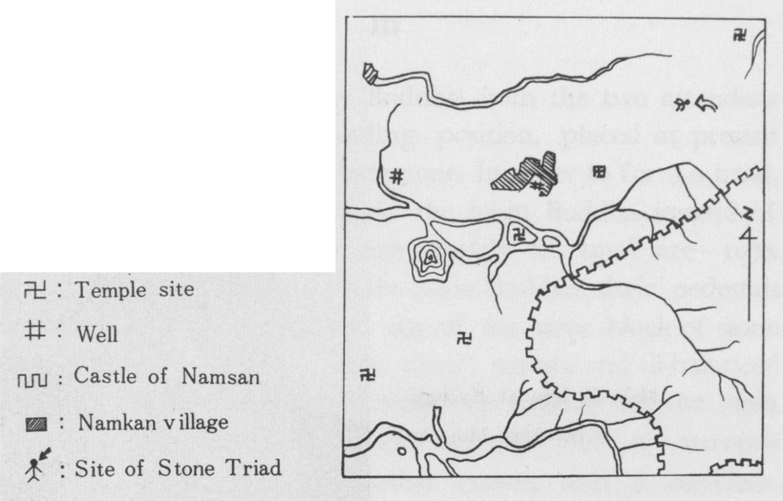
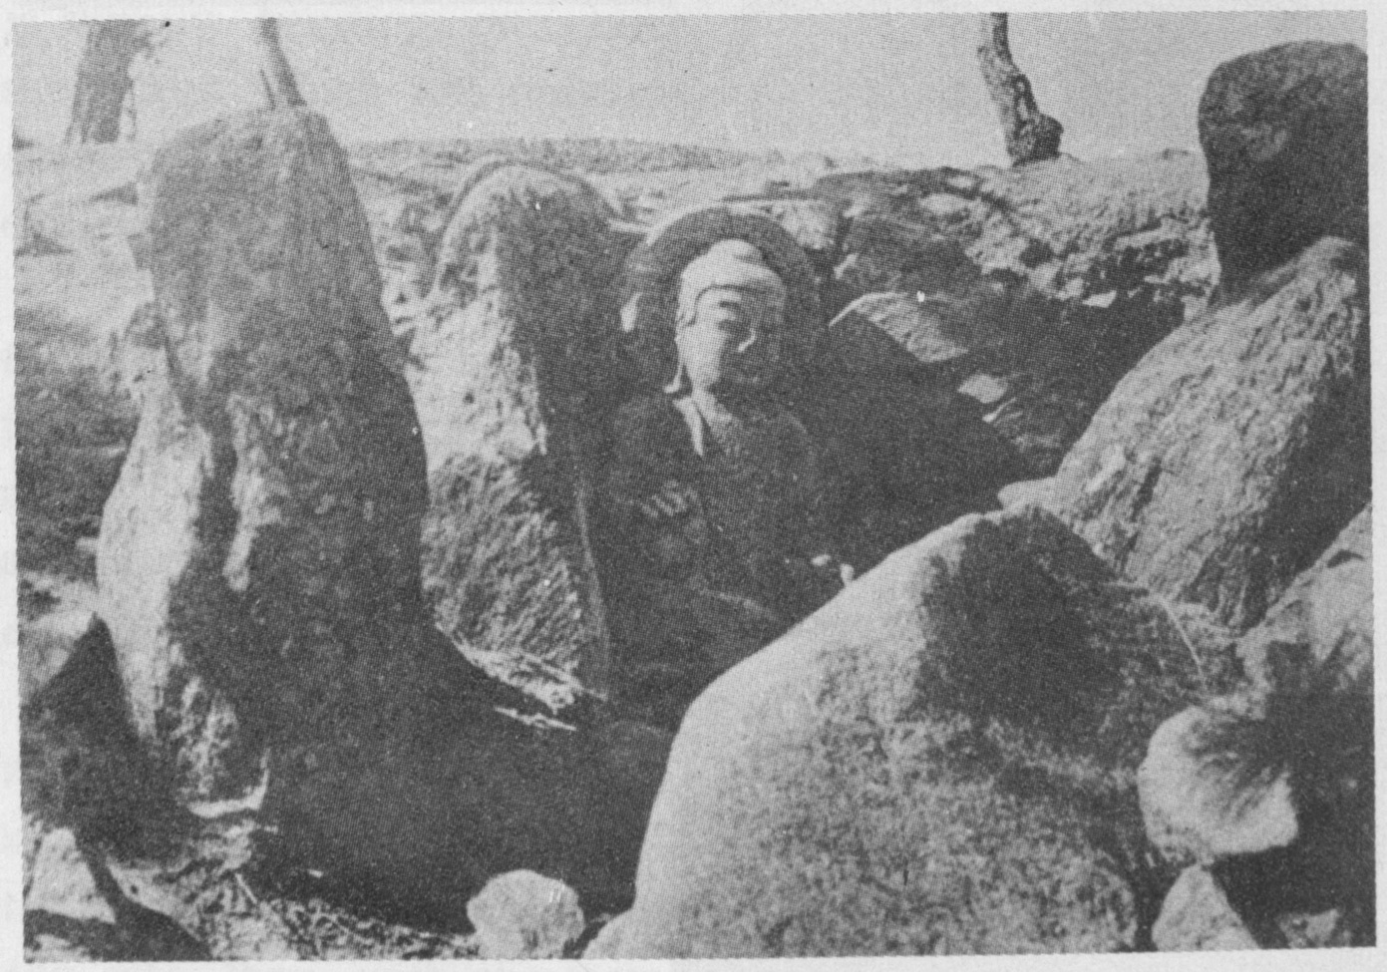
Main Buddha in Sone Chamber
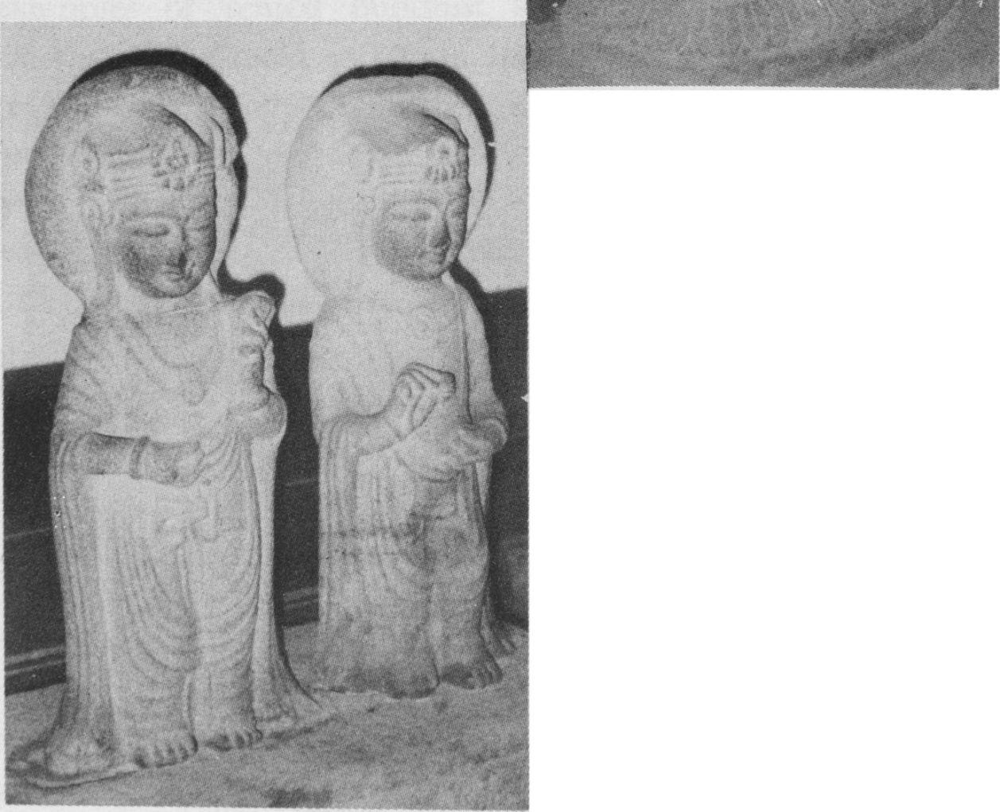
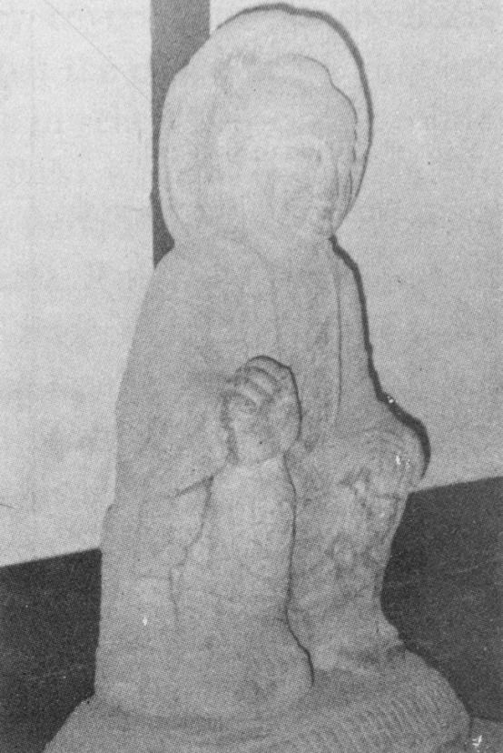
Attendant Bodhisattvas
At Kyongju National Museum
Main Buddha at Kyongju
National Museum

[page143]
III

Unlike the seated main Buddha, both the two attendant bodhisattvas are in a standing position, placed at present side by side on an oblong base-stone. In order to form a triad, these two statues must flank the main Buddha instead of being side by side. The two are roughly of equal size—107x 43x 20cm. Unlike the case of the main Buddha, their pedestals are missing. They are carved out of the same block of stone and each has a nimbus. Their dwarf stature and ill-balanced heads and bodies repeat the unrealistic manner of the main Buddha. Their heads are each adorned with a sam-myon bo-gwan or three-sidea bejewelled crown, and a necklace. Their drapery covers both shoulders and forms a double U-shape in front before finally dropping downward along the body. Each statue holds a lotus bud in one hand. Each is slightly bending one knee, either left or right, of their short legs, which not only gives a feeling of movement but suggests their subordinate (to the main Buddha) position, evidencing attentiveness to details on the part of the sculptor.
This method of frontality and plain back is seen in all the statues, and not the slightest difference in style is discernible from the main Buddha. Especially, the baby faces and the smiles at the edge of their mouths, along with their small size, are reasons why they have been called affectionately aegi puch’o, or baby Buddha, by villagers for ages.
The style of the seated Buddha flanked by standing attendant bodhisattvas has its parallel in the triad of a stone cave on Mt. P’algong. In the case of Mt. P’algong, the triad was placed adjacent to the innermost wall. What was the case, then, with the present triad? [page 144]

IV

Prior to discussing this question, it may be in order to find out first the circumstances leading to the removal of the triad to the present Museum site. The writer depended for this study upon various data such as the Museum’s relic cards, Study on Buddhist Sites at Namsan, Kyongju, and other Japanese books, and tales of Messrs. Choi Nam-chu and Park Il-hoon and other village elders.
These all lead to the conclusion that the statues of the triad had not been removed together, but that the main Buddha had first been discovered in a stone chamber on the mountain-top, northeast of Changch’ang-gok, north of Namsan, and then had been moved to the present Museum in April 1925. About the same time, it was discovered that two standing attendants had been hidden inside a villager’s house in Wolnam-ni, Naenam-myon, Kyongju. These were also later shifted to the Museum.
Although the three statues were found at two different places, there is a strong opinion favoring the contention that the two standing bodhisattvas had originally been together with the main Buddha in the same stone chamber 011 the mountain-top and were later moved down the mountain on A-frames, which was easy because of their light weight. Because of the proximity of the two locations and also of the similarity in style, on which everybody can readily agree, the writer has never doubted this. In support of this contention, the village elders confirmed that they had actually seen the two statues flanking the main Buddha, and explained how they had been moved down the mountain. They farther stated that all three statues were originally in the same stone chamber and were without doubt a triad. [page145]
The next question is where, then, was the original site? The writer must point out first that he has always taken exception to the Japanese view on this question. In brief, the Japanese scholar maintained that these statues were in an ancient tomb originally.
In the first place, would it be possible for a triad to be found in the stone chamber of a tomb, especially a tomb of the late Three Kingdoms period? Regardless of the era— whether ancient or modern—has placing statues in a tomb been a Korean practice at any time in history?
Study of Buddhist Sites at Namsan, Kyongju (慶州南山佛績) published by the Korean Government-General, in its chapter on the Changch’ang-gok Stone Triad (Page 9) states:
“In the area are found five or six tombs of Ancient Silla, devastated from plundering, some from which even usual covering earth is missing. Located northernmost is the largest of these tombs which is also in a state of devastation. It has a stone chamber 230cm square with an entrancevvay 132cm wide and 264cm long adjoining. In this stone chamber was discovered a seated stone Buddha which was moved to the Kyongju National Museum in April, 1925......
“The mystery as to why only the main Buddha was buried in an ancient tomb on the top of a mountain was never explained, except to presume that originally there was a triad of Buddhas, of which two lighter ones were moved down the hill by tomb plunderers. Stil, why such a triad was hidden in the tomb remains a mystery.”
Separately, Mr. Akio Koizumi in his “Stone Buddhas of Silla,” cited above, states: “The stone chamber (where the main Buddha was found) was not built for the purpose of enshrining statues, but they merely utilized the chamber in the existing tomb, built late in the Three Kingdoms period. It appears that a stone statue in a dilapidated temple nearby [page146] was moved to the stone chamber of an old tomb for worship. This is a practice prevalent in Korea and it is not believed to have taken place too long ago. At any rate, the Buddha was discovered buried properly positioned, with its back to the inside wall.”
Mr. Koizumi assumed that the stone Buddha was moved from an old temple ruin to the stone chamber of the tomb, and that such a practice was quite common in Korea. The writer must vehemently disagree with this assumption. He has never heard of nor come across any such instance. The only exception may be the tiny gilt bronze triad (Toksu Palace Museum) of the Three Kingdoms period unearthed from a tomb of the Koryo period. (Buddhist Sculpture Section of the Album of Photographs, Toksu Palace Museum.) This was nothing but a private talisman Buddha which was buried with the deceased and should not be construed as the same case.
On what ground, then, did Mr. Koizumi assume that the statue was carried from the temple site up to the mou ntain-top? What exactly did he mean by “not too long ago”?
The writer has been able to find out, on the basis of the village elders, information, that the site where the triad in question was found is known as Pucho-dong, or Peak of Buddha; and further, that it has been so known as long as anyone remembers. This clearly shows that the triad had been at the site for a long period of time and, therefore, the place was known as Peak of Buddha, contrary to the Japanese contention that it was not dug up until early in the Japanese occupation period. Since mutilation of tombs simply is not a traditional Korean custom, but was introduced after the Japanese occupation, the triad could not have been moved to the old tomb site until after the Japanese occupation began. [page 147]

V

As mentioned above, the writer has long taken exception to the Japanese view. In the meantime, the writer has recently participated in the renovation work of Sokkul-am on Mt. To-ham. Taking advantage of that opportunity, he was able to study fairly intensively the origin and system of stone caves in Korea. In the same light, the writer seriously studied the cave on Mt. P’algong for the first time. Judging from the fact that the stone triad was discovered inside it, he wondered whether it would not be possible to find some similarity in the present triad, which was removed from its original place in Changch’ang-gok—how it was enshrined inside the cave before its removal, and so on. The writer made two trips to the original site in Namsan, Kyongju, to collect data, focusing on villagers’ eye-witness versions as well as relevant local terrain and relics.
At present, the area in general is dotted with private tombs. The site of the main Buddha was also occupied by two such tombs. The village elders assured the writer that the three upright blocks of stone were gate-posts leading to the Buddha’s chamber. They continued that there used to be numerous blocks of stone forming the walls of the chamber as well as the entrance before the Buddha was moved, and that they were mostly taken away for anti-erosion work and for burial. As recently as 40 or 50 years ago, there still were a number of posts 90 to 120cm high, piled up to form a natural windbreak on the southern side. Far more than these stone blocks, the writer was surprised to find pieces of roof-tile scattered all over the site along the slope. The tile was unmistakably of late Three Kingdoms or early Unified Silla period. With this concrete evidence the long-remaining [page148] mystery, to the writer’s mind, is beginning to be solved. One of the village elders, Mr. Park, just turned 60, stated that there used to be square foundation-stones at each of the four corners, all of which have long since disappeared. Upon hearing it from the writer, he immediately refuted the Japanese contention, saying “this is Pucho-dong or Peak of Buddha and not Korijang-t’o or Old Tomb Site.”

The Following is a Summation of the Writers Views:
1. The stone relic was originally constructed for the purpose of enshrining the triad. Therefore, its floor-plan and construction technique are reminiscent of the typical style employed for stone tomb chamber construction at that time. The plan was the same as that employed at Mt. P’algong cave and caves in China, where this square floor-plan is usually. seen and has close relation to the construction style of the stone chamber of Sokkul-am on Mt. To-ham.
2. The roof -tile pieces scattered around the area indicate that there was wooden structure there—wooden building with tile roofing, probably serving as covering for the chamber or its ante-chamber. This is true in the case of Sokkal-am on Mt. To-ham, where wooden tile-roofed buildings were actually used to cover the ante-chamber as well as the main chamber. Until the Japanese undertook the repair of Sokkul-am in 1912, tile was used for roofing.
3. It is safe to presume that the construction of this stone chamber and wooden building occurred about the same time as the Stone Buddha period. This is compatible with the Japanese view of the late Three Kingdoms period, mistakenly based on the ancient tomb theory.
4. There were old tombs in this area with exposed round foundation-stones and triad Buddhas in the same [page149] place. They must have some bearing upon each other—a point requiring further exploration.
In the chapter on “Chukchirang” (竹旨郞, Volume II of Sam Guk Yu Sa (三國遣事 Three Kingdoms History), there is a passage reading, “a stone maitreya is placed in front of a tomb…”

VI

Finally, the writer hopes that there will be another opportunity to go over the problem concerning the title given these statues. Briefly, however, the writer is in favor of presuming them to be a maitreya triad, rather than Yaksa Yore (medicine Buddha) or Sakyamuni, as the Japanese seem to prefer. I do this because it is a chair-seated Buddha and, as is the case with Chinese Buddhas of the Sui and T’ang Dynasty, this peculiar chair-seated style of Buddha is considered a maitreya without exception. One cannot overlook the prevalence of maitreya worship in Silla during the Three Kingdoms period. At the same time, one should not underestimate the close relationship between maitreya worship and the Hwarang-do (knighthood) of the Silla period.
In this connection, another point needing special attention is the relationship between this site and Samhwa (三花嶺 Three Flowers) Peak. As stated above, the name “Peak of Buddha” is derived from the presence of stone Buddhas from ancient time. Also, a pass from this mountain-top to Inwang-ni and to the east of Mt. Namsan is known as Mindullae Pass. This spot commands an uninterrupted view from east to west, and toward the west down the hill is seen Namkan (南澗) Villages, beyond which is Onung (五陵), toward the east, Mt. Langsan as a whole, and then Mt. To-ham. If Namsan Samhwa-ryong (Chapter on Priest Chungdam, 忠 [page150] 談師, King Kyongduk, Volume II of Sam Guk Yu Sa) is located around this spot, visible from Panwolsong or Half-moon Castle, as can be easily presumed, what, then, will be the relationship between the famous maitreya to which Priest Chungdam dedicated a tea ceremony regularly on Double Three and Double Nine festivities (March 3 and September 9) and the present Triad?
At the same time there is a reference in Volume III of Sam Guk Yu Sa that the stone Buddha in “Stone Maitreya in Saengui Temple”(生議寺石彌勒) is the maitreya on Samhwa-ryong. If so, is it not possible that this is the very stone maitreya dug out in Namdong (南洞) and moved to the top of Samhwa-ryong, as mentioned in the above-cited book?
Judging from the style of the statue, the original site, the structure of the stone chamber, and other data, the writer is more and more persuaded to arrive at the conclusion that this triad is precisely the famous Samhwa-ryong maitreya. A final decision on this point must await cautious reinvestigation and excavation on the spot in the future.
Sam Guk Yu Sa says that the inauguration of the Saen-gui Temple took place in the 13th year of Queen Sundok, or 644 A.D. When the whole picture of this stone structure is brought to light in the near future, it is hoped that the mystery of the maitreya at Samhwa-ryong will also be revealed beyond the shadow of a doubt. The writer hopes that this may well lead to the complete solution of the questions surrounding one of the most important works in the early history of Korean sculpture.
This article has previously been published in Sa Hak Hoi Chi (Yonsei Historical Bulletin), No. 7, December 1964 and is here presented in a revised version.

