KIM SAKKAT (金笠) Vagabond Poet
By Father Richard Rutt
(盧 大 榮 神父)

[page 59]
KIM SAKKAT Vagabond Poet

Professor Kim Sayŏp, in his history of Korean Literature denies the right of Kim Sakkat to a place in the story of true literature.1 If the term is at all narrowly defined, the professor is doubtless right; but if anyone would understand Korean humour and the folk entertainment poetry of Korea, he cannot afford to ignore Kim Sakkat. Today in the city it maybe that Kim Sowŏl (金素月) is the first Korean poet whose name the foreigner will hear, but in the countryside and among the middle-aged, Sakkat is more often mentioned.
There has been a film about him. There are four or five inexpensive books about on the shelves of most of the bookshops, A popular song about him had its heyday five years or so ago, but it is still in the chapbooks and most of the youngsters know it. Anecdotes of him appear from time to time in the newspapers and in tourist literature. Many quips which appear in his collected works are frequently repeated without attribution. He is popularly believed to have had a genius for repartee, a fine taste in the composition of insults, a divine gift of poetry, and a wit polished beyond the achievement of any man before or since. He is spoken of with an ignorance about who he really was and what he really did, coupled with a liberal use of his name, that is the surest and ultimate guarantee of his popular standing in the folk mind.
He can be summed up as an exponent of ingenious and amusing poetry written in Chinese. Some of it is funny, much of it is satirical. Its interest lies more in its wide appeal to Koreans than in its literary value. It illuminates the character of Korean popular humour, and presents an important aspect of Korean sensitivity.
The literary history of his material is interesting.

1) Kungmun Haksa (國文學史) Seoul 1956, p. 501.

[page 60]
He died in 1863, leaving an oral record of his career and compositions scattered all over the peninsula. Yi Ungsu (李應洙) as a student, sixty years later, began to take an interest in him and spent much labour in collecting the poems attributed to him together with their accompanying anecdotes. He first wrote the material up in a number of newspaper articles during the thirties, eventually producing an anthology of the poems in 1939 and an enlarged and annotated edition in 1944.
But the real spread of Sakkat’s published popularity seems to have come after the Korean war when Yi Ungsu was no longer in South Korea. Several other people have made use of his material to produce shorter anthologies since that time.2
Of his existence there seems to be no reasonable doubt, but of the authenticity of the work attributed to him there is no sure check. The time lag between his death and the writing down of the oral tradition is in itself suspicious. The fact that many of the poems attributed to him survive independently of his memory suggests that the canon is not impeccable. There is no internal evidence by which the poems can be tested because the style is common to the compositions of the period and the country.
Indeed the corpus of poetry may represent a composite figure rather than the historical man Kim Sakkat. This is a marginal problem for the attention of the literary historian. For the student of folk culture the person of the poet is relatively umimportant in comparison to the appeal of his supposed compositions. Nevertheless the story of the man is part of the legend and part of the total impact of the poems, so it is worth while to record what is known of his life as well as what is said to have been his life.

The Life of Kim Sakkat

Yi Ungsu found five literary references to Kim Sakkat dating from his lifetime or shortly afterwards.

2) See bibliography p. 11.

[page61]
(1) Taedong Kimun (大東奇聞) “Odd Rumours from Korea”, contains a short reference to him saying his real name was Kim Pyŏngnyŏn (金炳淵) and he wore the wide reed hat of a mourner called sakkat (삿갓, in Chinese 笠, pronounced nip in Korean) because he dare not look up to heaven, and from this came his common name.
(2) and (3) The Haedong Sisŏn (海東詩選), “Korean Anthology” contains two poems, one about the reed hat and one about visiting the Diamond Mountains.
(3) The Nokch’a-jip (緣此集) of Hwang O (黃五) tells how he left home and wandered the country drinking, satirizing, poetizing and joking; how he knew a man called Ujŏn(雨田) Chŏng Hyŏnŏdok (鄭顯德) and visited the Diamond Mountains every year either in spring or in autumn. Here his name is given as Kim Sarip (金莎笠) which is merely an elaboration of his commoner name.
(5) Finally Sin Sŏgu (申錫愚) in his Haejang-jip (海藏集) vol 13, records the story of a Kim who is undoubtedly the same man as our poet. He gave his name in this tale as Kim Nan (金鑾), which suggests his literary name, Kim Nan’gu (金蘭皐); his cha (字) as Imyong (而鳴 probably a pun on 異名, meaning “another name”); and his literary name as the somewhat surprising Chisang (芷裳, “angelica skirt”). Since he is known to have concealed his identity, these slightly punning aliases do not succeed in disguising him very well, but the information in this passage adds little to the others except by way of anecdote.
Yi Ungsu gives a brief but coherent account of Sak-kat’s life, presumably gathered mostly from his surviving grandson of that time, Kim Yŏngjin (金榮鎭), then an old gentleman living near Yŏju (驪州) in Kyŏnggi province, and the two great-grandsons Kyŏnghan and Honghan who were then living, as well as descendants of Sakkat’s friends. There is no reason to distrust the meagre story.
Our hero was born in 1807 in the Changdong (壯洞) clan of Kim. His real name was Pyŏngnyŏn (炳淵), his cha was Sŏngsim (性深) and his literary name Nan’gu (蘭皐). In 1881 his grandfather, Kim Iksu (金益淳) who [page 62] was a military yangban, had just been transferred from a post in the provincial government of Hamhŭng (咸興) in the northeast to the post of military lieutenant (pangŏsa 防禦使) at Sŏnch’ŏn (宣川). In that year the rebellion of Hong Kyŏngnae (洪景來) broke out, an expression of local resentment at discrimination against northerners in the capital and government circles, and also a revolt against the extortions of the aristocratic bureaucracy. It was late autumn and the revolt spread like wild fire through North Korea. When the rebels came to Sŏnch’ŏn, Kim Iksun was asleep in a drunken torpor. Although the rebellion was quickly quelled, Iksun had nothing to do with the victory and in the Spring of the following year he was executed and his family dismissed from court.
Five-year-old Pyŏngnyŏn and his elder brother Pyŏngha (炳河) were taken to the house of a servant of the family named Kim Songsu (金聖秀) at Koksan(谷山) in Hwanghae Province. There the boy studied his letters, but after a while it was clear that no further reprisals were going to be taken against the family and so the boys were returned to the home of their father, Kim An’gun (金安根). Pyŏngnyŏn was duly married, and when he was about twenty years old a son was born to him, named Hakkyun (翯均). It was at the time of the birth that he left home and began his wanderings, supposedly because the family was socially in such bad straits.
Three years or so later he returned home and stayed long enough to beget his second son Ikkyun (翼均). For the remainder of his days he was a wanderer. Three times at least his second son tried to find him. The first time he found his father at Andong (安東) in Kyŏngsang province.
The old man laughed when they met, and during the night when the young one was asleep he slipped quietly away. The second time his father again gave him the slip at P’yŏnggang (平康) in the mountains of Kangwŏn province. The last time they met was at Yŏsan (礪山) in North Chŏ11a, where they were walking along together when Sakkat removed his great reed hat and went into a field of standing sorghum to empty his bowels. The son never saw him again. [page63]
It was said that Sakkat often approached the family place at Kyŏlsŏng (結城) near the coast of Ch’ungch’ ŏng, and enquired after his mother’s health, but he never let her see him. Finally he died at Tongbok (同福) in Chŏlla Province. His age at death is given as 56 and the year was 1863. Ikkyun buried the body on T’aebaek-san(太白山) near Yŏngwŏ1(寧越) in Kangwŏn Province.

The poems of Kim Sakkat

Yi Ungsu made a passionate declaration of belief in the authorship of the poems he collected and published. But he also collected a number of stories about his hero which have now, if they had not then, an existence independent of the story of Kim Sakkat. They are mostly jeux d’esprit involving hanmun (Chinese characters), usually punning on the Korean pronunciation. Some are poems, others are mere anecdotes.
An example of the anecdote form is the well-known story of the man named Chŏng (鄭), who asked Kim (or an unidentified friend, if you follow some other version of the tale) to write a signboard for his study. The sign was written as 貴樂堂 or “Hall of Noble Pleasure”. It was only later that that the owner of the house realized that if read in the reverse direction, which is quite possible with such a sign, the pronunciation becomes tangnagwi, which is pure Korean for “donkey.” (In some versions of the story the characters are given as 爲樂堂 which makes a more exact pun.) The point of the story is the fact that the character of the surname Chŏng is identified in Korea as the “donkey Chong” character, owing to the fancied resemblance of the two strokes at the top left-hand side of the character in its handwritten form to the ears of a jackass.
But the greater part of the Sakkat corpus consists of Chinese poems, composed, as Korean poems usually were, in imitation of the poetry of T’ang. Some of them are fairly straightforward poems about places, but many of them are highly insulting ones about people. Some have a tone of genuine compassion, but in that case they are about [page 64] beggars and other dregs of Yi society. The flea and the louse are typical subject matter for him. There are a number of animal poems, about cats and dogs and other lowly creatures, and also a whole section of poems about the Diamond Mountains.
Some of the poems have the kind of playing with characters which is so much enjoyed by Koreans. It can achieve an artistic effect when it is well done, or it can be merely clever. A simple couplet of repeated characters may evoke a fine poetic image, as in his mountain scenery poems, but a whole stanza composed of repetitions of two characters will yield sense only if the reader strains hard, and is a virtuoso performance more fitted for the amuse-ment of schoolboys than for preservation as literature.
On the whole the technique of the poems is normal. It is the content which makes them so much enjoyed. The usual Korean poem in Chinese is mannered, evocative and impressionistic, allusive and formal. The Sakkat poems are mostly witty, and even when they achieve more customary poetic effects they have an ingenuity that rouses admiration of a sort.
But at times he writes in broken metres. That is to say he divides the groups of characters in a line of verse differently from the classic pattern, or he uses as rhymes characters that are not strictly admissible as rhymes because they do not belong to the even tones(平聲). This gives a perverse and bizarre, sometimes amusing effect to his writing.
Finally, sometimes he mixes the Korean alphabet into his Chinese verse treating the Korean syllables as though they were Chinese characters. This is a kind of literary game which is far outside the realms of the high-minded conventional critic, but it can be very funny
Some of the poems make sense, at least of a kind, when read in the normal way as Chinese poems, but the real meaning is discovered only when the poems are read aloud and the sound is understood as Korean words having the same pronunciation. In the case of such punning poems the sense which is obscure to the eye, but evident to the ear, is usually scurrilous if not downright scatological.
[page 65]
The humour which is typical of most of Sakkat’s stuff is not refined. It is the humour of the farmhouse, where sex is taken for granted and the smell of the privy is hard to avoid When translated into English or repeated with whispered giggles in a city room it is scabrous, but understood against its proper rural background it is much less offensive than it appears on the printed page. Its earthiness is matched by the earthiness of country humour in many other lands as well as in Korea. It is not for the squeamish, but it is unlikely to inflame salacious inclina-tions in susceptible minds.
For various reasons then, the Kim Sakkat poems merit the attention of the western enquirer about Korea. They are an anthology of things that have entertained the semi-lettered people of the countryside for at least a century, and they still have common currency. Reading them will not ennoble a man, though it may beguile him. It may help to give insight into a stage of Korean culture which is now even more rapidly passing away than it was at the beginning of this century when men like Hulbert recognized that it was already moribund. This was the stage when a knowledge of Chinese was a vivid and important part of a man’s mental furniture. There are few people under twenty who read Sakkat with pleasure today. He has to be interpreted and explained. Explained jokes are dull jokes, and in a generation’s time they will almost certainly have died for good. But meanwhile there are men with young children of their own who enjoy them and still respond to the lively appeal which these compositions have had for Koreans.
It is perhaps hard to see through the stylized creations of an old oriental to the spirit of the beatnik that lies within. Undoubtedly the beatniks of the sixties of this cen-tury have rarely achieved the wit of Kim Sakkat. But there is in many of his poems a strain of nihilism, certainly a vein of bohemianism, that is properly beatnik. Yi Ungsu probably went too far in describing this in solemn terms full of -isms; but the fact that it is there is a significant factor in the appeal of the poems to Koreans. Most Koreans have a nostalgia for the perfect liberty [page 66] of the vagabond and anarchist. It shows through the most formal escape poems of the confucian literateurs of olden days, and is yet another reason why the student of Korean culture should find Kim Sakkat worth the trouble of understanding.
It would be possible to go further into an analysis of Kim Sakkat’s mentality. The insulting poems could be interpreted as symbols of the spirit of revolt that may be supposed to smoulder in the breast of every Korean, constrained as he is by a highly conventional society with restrictive mores. Insults, however, amuse most people if the insults are directed at somebody else and are sufficiently grotesque. It is enough to notice that pleasure derived from insults is never really elegant and then to recall that Kim Sakkat is representive of only part of Korean taste. It is an important part: but only a part, and not the nobler and finer part

[page67]
BIBLIOGRAPHY

A number of newspaper articles published chiefly by Yi Ungsu during the thirties seem to have been the first literary evidences of Kim Sakkat, but their substance was collected by him and used by others in producing the following books.
(1) Sanghae Kim Nip Sijip(詳解金笠詩集) edited by Yi Ungsu(李應洙) in the series Chosŏn Mun’go (朝鮮文 庫) Published in February 1939 and reprinted in May. The preface is dated February 1937.
(2) Taejŭng Sup’an Kim Nip Sijip(大增修版金笠詩集) edited by Yi Ungsu(李應洙), published in Seoul in May 1944, and reprinted in May of that year. This book with its introductory material is definitive and must be the main source for any study of Kim Sakkat. The date of publication of this Korean language work in Seoul is especially interesting.
The remaining volumes were published after the de facto division of Korea between the communists and the South, when Yi Ungsu was no longer in South Korea. All are based on his work.
(3) Kim Nip Sijip(金笠詩集) edited by Pak Oyang(朴午陽) Seoul 1948.
(4) Kim Nip Pangnang-gi(金笠放浪記) Kim Yongje(金龍濟) Seoul 1950.
(5) Kakchu Sanghae Kim Nip Sijip(脚註詳解金笠詩集) edited by Kim Irho(金ᅳ湖) Seoul 1953.
(6) Kim Nip Sihwa(金笠詩話) by Kim Yongsop(金龍燮) Seoul 1955. [page68]

A Brief Selection of Kim Sakkat’s Poetry

Yi Ungsu’s collection contains about 300 poems, some of them in the long form of old-style examination pieces. The very small selection given here represents most of the varieties of poem and illustrates the typical features re- marked on above. Many of the poems appear very flat when translated into English because they depend for their interest on puns and rhythmic features which defy rendering in another language. Those presented here are among those which lend themselves most easily to transla-tion and annotation. None of the examination style pieces has been done.

[page69]
向靑山去
水爾何來
I am going to the green hills.
Why water, do you run the other way?

松松栢栢岩岩廻
水水山山處處奇
Pines, pines, oaks, oaks, rocks, rocks, around,
Water, water, peak on peak, everywhere - wonderful!

綠靑碧路入雲中
樓使能詩客住笻
龍造化含飛雪瀑
劔精神削挿天峰
仙禽白幾千年鶴
潤樹靑三百丈松
僧不知吾春睡惱
忽無心打日邊鍾
Emerald, green, and jade the, road goes into the clouds;
The arbour invites my stick to stay awhile;
Nature the dragon drank at the waterfall of melting snow,
The spirit was the knife that cut the heaven-piercing peaks,
The Faery Bird is a white crane that has stood for thousands of years,
Beside the stream is a Green Pine 300 feet high,
The monks know nothing of my spring dreams;
Suddenly their noonday bell strikes my heart.

One of the Diamond Mountain poems, referring to some of the rocks by name. This is an example of eccentric metre, with the hiatus after the third character in each line.

[page70]
南國風光盡此樓 龍城之下鵲橋頭
江空急雨無端過 野濶餘雲不肯收
千里笻鞋孤客到 四時笳鼓衆仙遊
銀河一脈連蓮島 未必靈區入海求

Kwanghallu
Of all the glories of the Southland, none matches this pavilion,
Beneath the Dragon Hill, above the Magpie Bridge.
The showers make the dry stream flow unceasingly,
The fields are wide and the clouds race across them.
I come from far, a vagabond with stick and shoes of straw.
The dance of the seasons never stops, the spirits always sing.
The span of the Milky Way reaches the Paradise Isles;
But there is no need to go to the sea to reach the realm of the soul.

Kwanghallu is the pavilion with the Magpie Bridge beside it, where Ch’unhyang was first seen by the boy Mongnyong in the most famous of all Korean romances. It is at Namwon in the south of Korea.
The Paradise Isles were reputed to be the faery land in the Eastern sea, but the name is also given by extension to the Diamond Mountains in their summer foliage.

[page71]
三百君中秀爾才
乍來乍去不飛埃
行時見虎暫藏跡
走處逢狵每打腮
獵鼠主家雖得譽
捉鶴隣里豈無猜
南街北巷啻歸路
能劫千村夜哭孩

A Cat

Most brilliant of the furry kind,
Here and there you dart, but never disturb the dust.
See a tiger and hide yourself,
But meet a dog and you spank his face every time,

Catch the mice and your master praises you.
But take the neighbour’s chickens, and that’s another matter.
And when you go howling round the lanes and allies
It’s enough to make a thousand villages’ babies cry in the night.

乘夜橫行路北南
中於狐涯傑爲三
毛分黑白渾成繡
目挾靑黃半染藍
貴客床前偷美饌
老人懷裡傍溫衫
那邊雀鼠能驕慢
出獵雄聲若大談

Another cat

You range the night far and wide,
You, the fox and the wildcat are three heroes indeed.
Your fur is patterned nicely in black and white,
And your eye gleams indigo, yellow and green.
You pinch the dainties from the visitor’s table,
But you warm the bosom of the old man your friend,
Where is the bird or mouse laughs you to scorn?
When you set out to hunt what a row you do make!

[page 72]

不知汝姓不識名
何處靑山子故鄉
繩侵腐腐喧朝日
烏喚孤魂吊夕陽
一尺短笻身後物
數升殘米乞時糧
寄語前村諸子輩
携來一簣掩風霜

A beggar’s corpse

I don’t know your family, I don’t know your name,
Nor what green mountain sheltered your birth.
The flies are gathered busily on your rotting flesh,
The crows cawing in the sunset call your lonely soul.
Your only legacy is a short stick
And some begged rice in your bag.
I’ll ask the lads fom the next village
To bring a basket of earth to cover you from the frost.

[page73]
飢而吮血飽而濟
三百昆蟲最下才
遠客懷中愁午日
發人腹上聽晨雷
形雖似麥難爲麵
字不成風未落梅
問爾能侵仙骨否
麻姑接首坐天臺

The louse

When you are hungry you fill yourself with blood and then drop off:
You are the lowest of all insect species.
You trouble the breast of the wanderer under the noonday sun,
And hear the thunder in the belly of a poor man.
You look like a grain of barley, but you won’t make yeast;
You don’t make half a wind, so you’ll never make the plumblossoms fall.
I ask you, will you invade the bones of a fairy?
Old grandmother Ma Ku scratches her head and sits on Tien-shan.

The louse is half a wind because the character for wind is 風 and the character for louse is 風. Ma Ku is a Chinese taoist spirit and Tien-t’ai-shan a holy mountain in China.

[page 74]
沙白鷗白爾白白
不辨白沙與白鷗
漁歌一聲忽飛去
然後沙沙復鷗鷗

The sand is white, the gull is white, both are white, so white
I cannot tell the white sand from the white gull.
But at one note of the fisherman’s song, away it flies:
Now I see the sand is sand, and the gull is indeed a gull.

雪中梅寒酒傷妓
風前橋柳誦經儈
栗花已落狵尾短
榴花初生鼠耳凸

The plum blossom staggers in the cold snow like a drunken Kisaeng;
The willow bends before the wind like a monk rocking over a SUTRA;
The chestnut flowers drop like shaggy puppies’ tails;
The early pomegranate buds are sharp as the ears of mice

[page75].
探香狂蝶半夜行
百花深處摠無情
欲採紅蓮南浦去
洞庭秋波小舟驚

The crazy butterfly searching for fragrance half the night
Finds scant comfort among the hundred flowers,
So goes off to Namp’o to dig the red lotus,
Where the little boat is rocked upon the autumn waves of Tungting.

Red Lotus is a courtesan’s name. With this clue the poem becomes an erotic allegory. Tungting is a great lake of China.

邑號開城何閉門
山名松獄豈無薪
黃昏逐客非人事
禮儀東方子獨秦

If this town is called the Open City, why do you shut the gate?
If this hill is called the Pinetree Peak, why is there no firing?
Turning a guest away at twilight is no sort of greeting;
Korea is the Land of Courtesy, and you are its sole bloody brute.

On being refused food and lodging in Kaesŏng (開城 or Open City, so called after it ceased to be the capital at the beginning of the Yi dynasty). The last character refers to Ch’in Hsi-hwang (秦始皇), the legendary symbol of cruelty in oriental history.

[page76]
彼坐老人不似人 其中七子皆爲盜
疑是天上降眞仙 偷得碧桃獻壽筵

This old man sitting here is scarcely human:
You’d think he were a spirit descended from the skies.
Everyone of his seven sons is a thief:
They have stolen the precious peach to make a birthday feast.

This poem is said to have been written to beg a meal from a sixtieth birthday party (還甲). The first line of each couplet is an insult designed to shock, but the second line in each case turns it into a graceful compliment.
The green peach was found in the western paradise by Lao-tzu, who found it sweet, though on earth it is bitter. It confers immortality. A variant reading has 王桃with a similar meaning.

畏鳶身勢隱冠蓋 若似每人皆如此
何人咳嗽吐棗仁 一腹可生五六人

Strength that can hardly fly a paper kite is hidden under his hat,
He’s like a jujube stone that someone has spat out.
If every man were as small as this.
One belly could litter half a dozen of them.

An insulting poem about a very young lad wearing an adult’s hat, presumably because he had been married at a very early age.

[page77]
天長去無執 花老蝶不來
菊樹寒沙發 枝影半從地
江亭貧士過 大醉伏松下
月移山影改 通市求利來

When read according to the meaning of the Chinese:

The heavens are wide strive as you may, you’ll never encompass them;
The flowers are failing and the butterflies have not come.
The chrysanthemum blooms in the cold sand;
The shadow of its stalk lies half over the earth.
The scholar passes by the riverside arbour
And falls deep in drunken sleep under the pinetree.
The moon shifts and changes the mountain shadows
The merchants return come only for gains.

or, when read aloud and understood as pure Korean sounds:

There are spiders’ webs on the ceiling; bran is smelled burning on the stove; there’s a bowl of noodles and half a dish of soy sauce. There are some cakes and jujubes and a peach. Get away, you filthy hound ! How the privy stinks!
Note: T’ongsi is Kyŏngsang dialect for privy.

[page78]
主人呼韻太環銅
我不以音以鳥熊
獨酒ᅳ盆速速來
今番來期尺四蚣

When you call a rhyme it’s a stinker,
I cannot do it by Chinese readings, so I’ll use the Korean interpretations.
Bring a bowl of rice beer quickly now,
For in this wager you’re already the loser.

Three characters were given as rhymes for a poem in a wager over a bowl of makkŏlli (rice beer). The characters were 銅 brass, 熊 bear, and 蚣 centipede. Sakkat composed the poem by treating all these rhyme characters according to their interpretation in pure Korean, upon which he then punned. It is a very complex pun.
環銅 must be read in Korean as korigo kurini, meaning “ring” and “brass,” but a pun on “stinking”; 鳥熊 is read saegom, meaning “bird” and “bear”, but punning on “interpretation”. In the last line 來期 is read in its correct Sino-Korean sound as naegi, punning on the Korean word for “wager”. 尺四 are read with the Korean words of the same meaning as the Chinese, cha and ne, meaning “foot” and “four,” but taken together as chane, punning on “you”; while the last character is read as chine, which is Korean for centipede, but a pun on the word “to be beaten”.

[page79]
The simplest of phrases have been attributed to Kim Sakkat.
一怒一老 一笑一小
is attractive in Korean for its jingling sound:

Illo illo, ilso ilso
(Anger makes you old, but laughter makes you young)

柳柳花花

means simply willows and flowers. When read in pure Korean with the usual grammatical particles added, it becomes podul-podurhago, kkokkotchaydsso (stiffened after being flabby) a simple schoolboy giggle, even though the modern editions give it the title 訃告 “report of a death”. (花柳 is a sobriquet for venery).
When Sakkat called at a certain monastery the monks were prepared to feed him if he would write a poem. He feigned inability to compose in Chinese but offered to make an attempt in pure Korean if they would give a rhyme character. They gave 타, so he made the first line of a poem:
사면 기등 붉었타
The pillars on all sides are red.
and asked for another rhyme. Again they said 타, so he composed:
석양 행객 시장타
The evening traveller is hungry.
Again they gave him the same rhyme for the third line. So he said:
네 절 인심 고약타
Your temple’s welcome stinks.
They guessed the identity of their visitor and fearing a real insult did not ask him for the last line of the quatrain.

[page80]
腕下佩기억
牛鼻穿이응
歸家修리을
不然點디 귿
Stick your sickle (ᄀ) in your belt,
Put a ring (ㅇ) in the ox’s nose,
Go home and wash yourself (ᄅ),
Or else you’ll dot your ㄷ (i.e. make it 亡, meaning “to die”)

In the poem the names of Korean letters are introduced. The first two are to be understood as pictures of what they signify, and the last two are compared to Chinese characters and made to signify what the Chinese characters mean.
The poem is said to have been addressed to a rude herdboy.

[page81]
年年年去無窮去 日日日來不盡來
年去日來來又去 天時人事此中催
是是非非非是是 是非非是非非是
是非非是是非非 是是非非是是非

The years pass by without ending,
Day after day the days come, they never let up.
The years pass, the months come, they come and they go,
Heaven’s will and man’s affairs are all completed.
Right is right and wrong is wrong—this is not so,
Right is wrong and wrong is right, this is not not so.
To say what is not wrong is right is not wrong,
But right is right and wrong is wrong, that is not right.

The second part of this poem is composed entirely of the two characters 是 meaning “to be” or “to be right”, and 非 meaning “not to be” or “to be wrong”. It is probably also intended as an indecent pun on a low usage word in pure Korean.

[page82]
書堂乃早知
房中皆尊物
生徒諸未十
先生來不謁

Read as Chinese:
Arriving early at the cottage school,
I find all the furniture is excellent.
There are less than ten pupils,
But I could not meet the teacher.

According the sound understood as pure Korean:

The schoolroom; membrum meum virile,
The furniture: mictus canis.
The pupils: matrem futuentes.
The teacher: orchis meus.
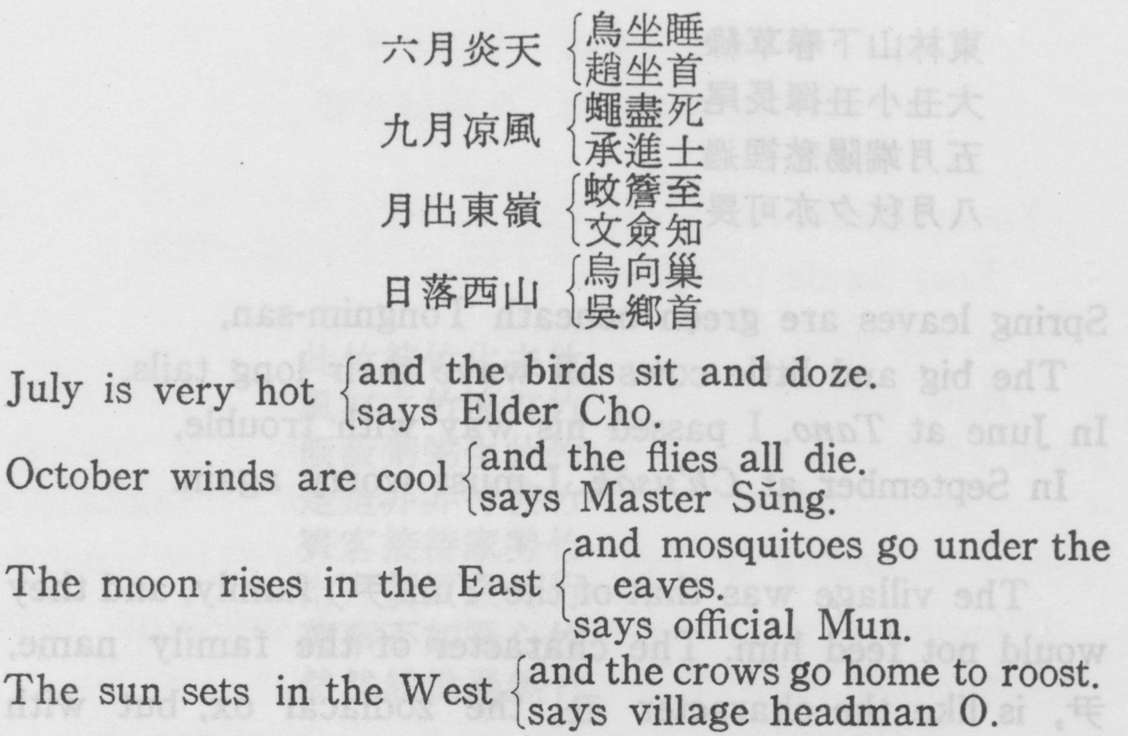
The particularly unsavoury phrase in the last line but one is a common form of Korean abuse. [page83]

Four men are discussing the weather. Their platitudinous remarks are made even more sillly by corresponding puns on their names.

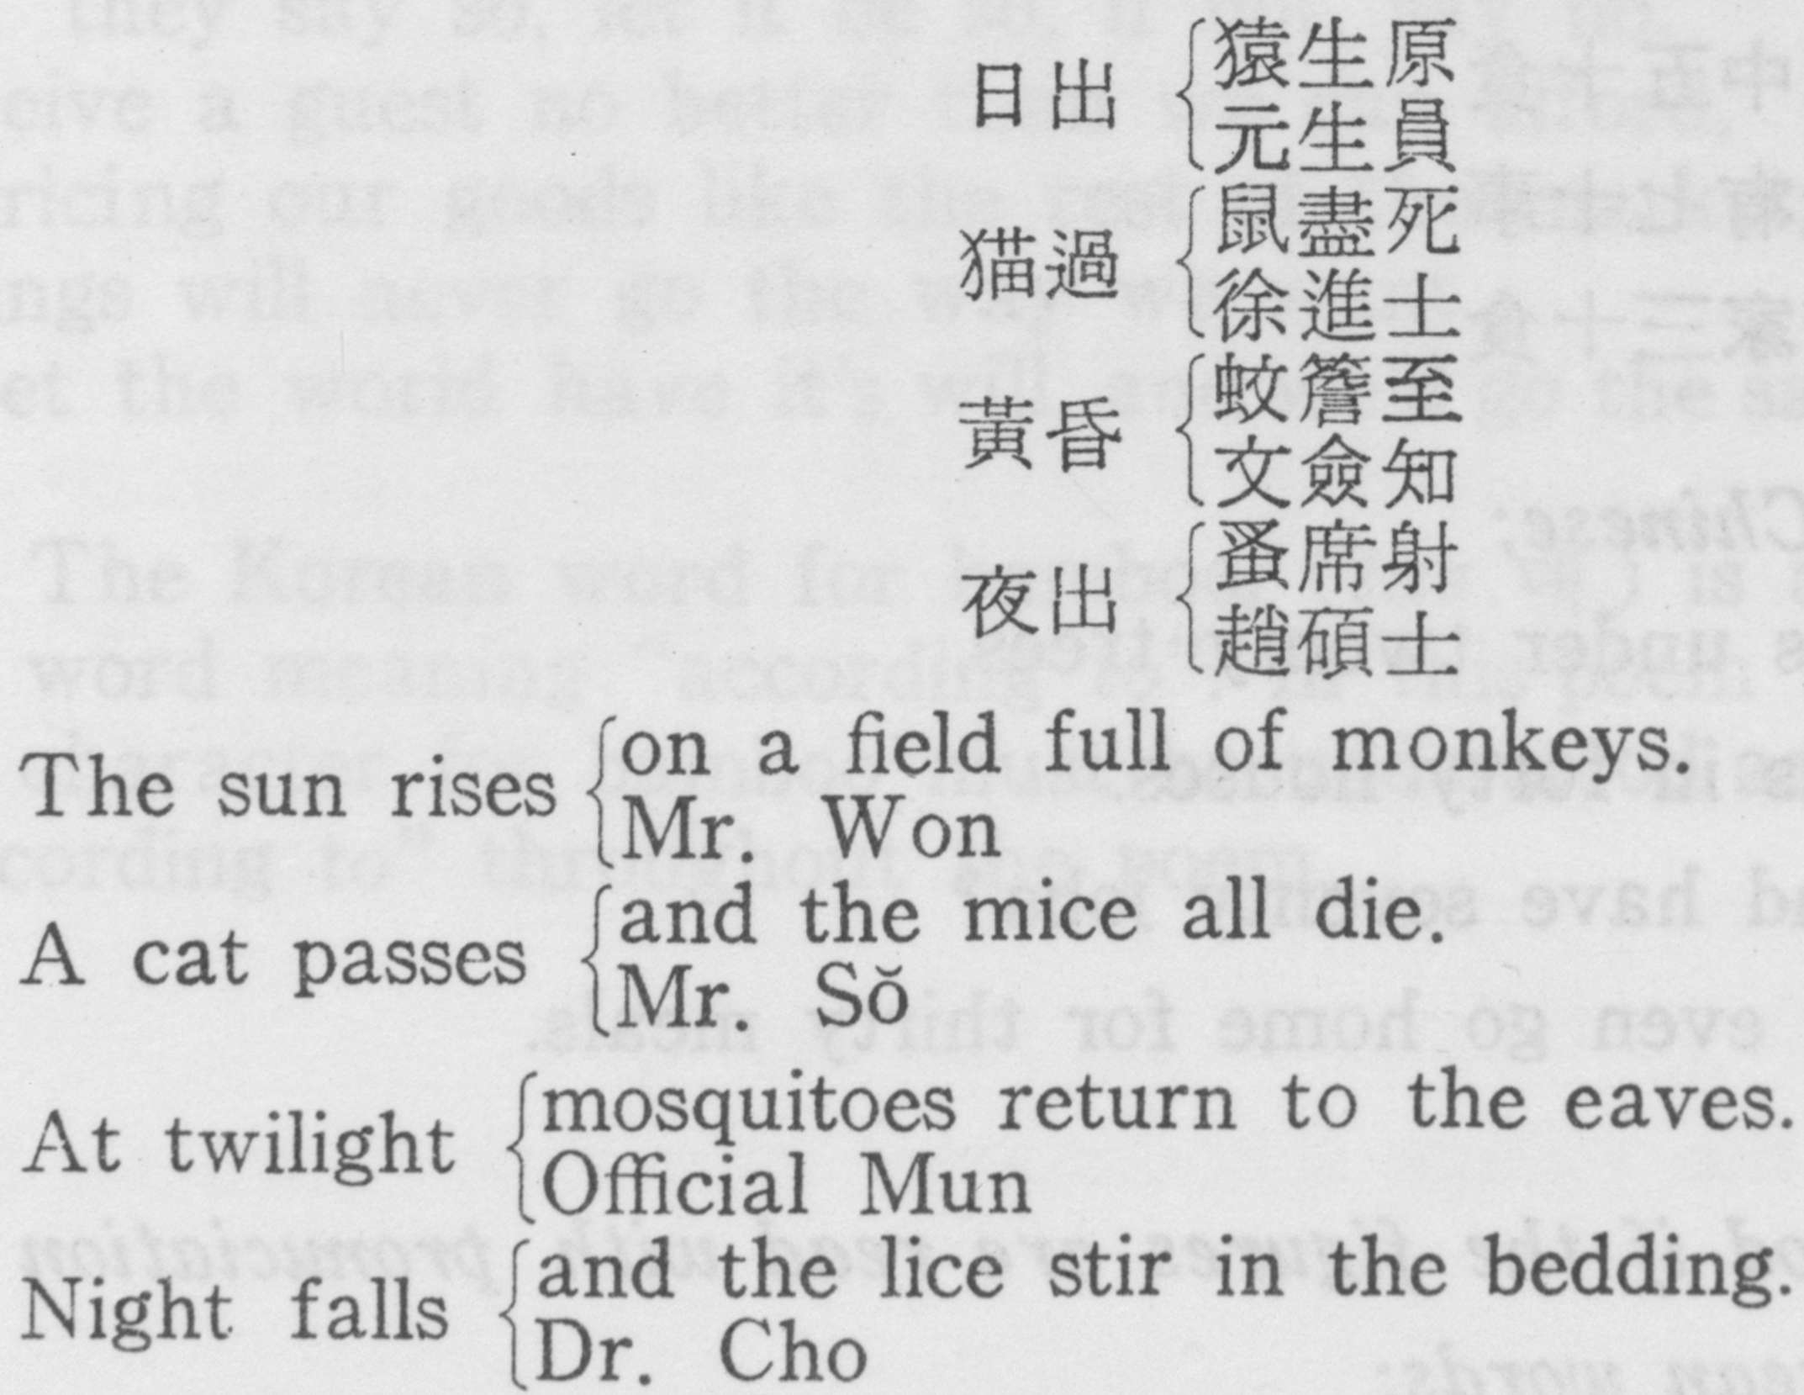
The last three characters in each line are puns on men’s names. The third line resembles that in the preceding poem. This may mean that one of the poems is not original, or that Sakkat repeated himself. The whole idea has passed into the realm of folk entertainment.

[page84]

東林山下春草綠
大丑小丑揮長尾
五月端陽愁裡過
八月秋夕亦可畏

Spring leaves are green beneath Tongnim-san,
The big and little cows all wave their long tails.
In June at Tano, I passed his way with trouble,
In September at Ch’usok, I must worry again.

The village was that of the Yun (尹) family, and they would not feed him. The character of the family name,
尹, is like the character 丑, the zodiacal ox, but with a long tail added.

二十樹下三十客
四十家中五十食
人間豈有七十事
不如歸家三十食

As read in Chinese;

Thirty guests under twenty trees,
Fifty meals in forty houses.
Does mankind have seventy jobs?
He cannot even go home for thirty meals.

As understood if the figures are read with pronuciation as pure Korean words:

The miserable stranger under the sumu tree
Gets mouldy food from the cursed houses.
Where on earth will you find such things?
It’s worse than going home to half-cooked rice.

[page85]
此竹彼竹化去竹
風打之竹浪打竹
飯飯粥粥生此竹
是是非非付彼竹
賓客接待家勢竹
市井賣買歲月竹
萬事不如吾心竹
然然然世過然竹

Like this, like that, however it goes,
As the wind blows, as the water flows;
If there’s rice, eat rice, if there’s gruel, eat gruel.
If they say so, let it be so, if not, say no.
Receive a guest no better than we can afford,
Pricing our goods like the rest of the market;
Things will never go the way we want,
Let the world have it’s will, and we’ll go the same way.

The Korean word for bamboo, (tae 대) is a pun on the word meaning “according to”. In this poem the Chinese character for bamboo must be understood as meaning “according to” throughout the poem.

[page86]
外貌將軍衛
中心太子燕
汝本地氣物
何事體天團

Your outside resembles General Wei,
Your inside the prince of Yen.
You are born of the earth,
How come you are round like heaven?

General Wei’s name was T’sing(靑) meaning green, and the prince of Yen was named Tan(丹) which means red. This is a description of a melon called in Korean komi or ch’amoe (苽).
Yi Ungsu puts this among the Sakkatiana, but I first learned it from a country scholar who told me that it was written by a child genius aged four.

許多韻字何呼覔
彼覔有難況此覔
一夜宿寢懸於覔
山村訓長但知覔

Of all the rhymes possible, how did you find myŏk?
It was hard enough to find the first one, how much more the second myŏk.
If a night’s rest depends on this myŏk,
Maybe the village schoolmaster knows no character but myŏk?

He was promised a night’s lodging if he would write a poem on the rhyme 覔, an obscure character unfit for use as a rhyme because it is not a level tone, and meaning “to seek and find”.

[page87]
仙是山人佛不人 鴻惟江鳥鷄鷄
水消一點還爲水 雨木相對便成林

Broken characters

A fairy is a man of the mountains, and a buddha is not a man.
A goose is a river bird, and a cock is a barnyard fowl.
One degree off freezing and you re left with water.
If two trees face each other at once you’ve got a forest.

A very simple conceit indeed. The Chinese characters are simply divided into their component parts and then read that way. 仙 meaning fairy divides into 山 “mountain” and 人 “man”. 佛 meaning Buddha divides into the legative 弗 and the radical 人 meaning “man”. The character for “river” 江 joined to the one for “bird” 鳥 nakes 鴻 meaning “a goose”, and the cock character is smilar. One stroke of the character for “ice” 氷 makes the character for “water” 水; and the “tree” character 木 doubled makes 林 “a forest”. [page88]

