IN MEMORIAM
DR RICHARD HERTZ PRESIDENT, KOREA BRANCH ROYAL ASIATIC SOCIETY
by Gregory Henderson American Embassy

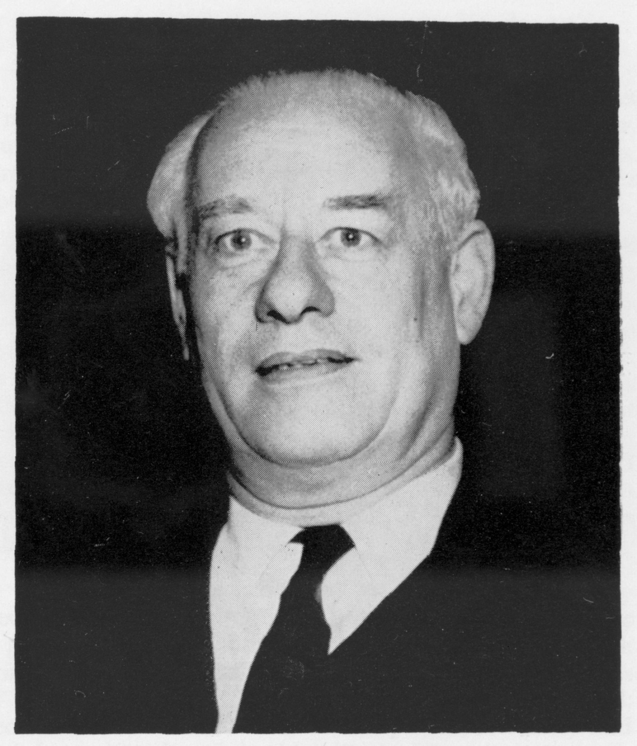
Dr. Richard Hertz (1898—1961)

[page 1]
IN MEMORIAM DR. RICHARD HERTZ PRESIDENT, KOREA BRANCH, ROYAL ASIATIC SOCIETY 1959-60

by Gregory Henderson American Embassy

The man whom death took so suddenly on August 2nd, 1961, in Mexico—German Ambassador, philosopher, author, teacher, friend to Korea and of so many of us, President and enthusiastic supporter of the Royal Asiatic Society for Korea—was a man of unforgettable qualities.
The natural elements to whom he felt so akin forged him from the beginning in a giant mold. Far over six feet tall, big-boned, amply girthed, large-voiced, his exuberant presence must have startled many a Korean villager or Chongno shopkeeper on whom he chanced, in his far-flung perambulations, to descend. Nor was this effect lessened with time though, for his friends, it became charged with great warmth. His habit of talking, arms akimbo, his eyes rolling and flung upward as if plucking the lightening from the clouds, made of this gigantic frame an apparition half Zeus, half Captain Ahab pursuing Moby Dick.
The likeness, the latter one, at least, (though surely Zeus would enjoy him) was hardly accidental. Born to a good bourgeois house in that citadel of the high bourgeoisie, Hamburg, he was the conscious antithesis of everything this background usually symbolized: decorous materialism, conservative opinion, formality and social stratification. Like Melville in Victorian times, he too was one born to look beyond the tasseled curtains of those drawing rooms, to roam with speculative inquiry, zest for storm, understanding for tragic fate. “The Hamburgers are my arch-enemies”, he would confide. (It sounded so wonderfully strong in his German). Then he would lean back and laugh with that deep-chested, warm laugh of his, full of wise fun, untinged with [page 2] rancor. Full of paradoxes, he still told his son to marry a Hamburg girl!
The Hertzian Moby Dick was, of course, pursued in the mind, but no less relentlessly, with no duller a harpoon. His thoughts were constantly poised over the problems of human existence, the forces of nature, the place of man, the understanding of cultures and of arts. Like the ancient Greeks and the philosophers and painters of the East, he was a Pantheist, seeing man in and through and subject to the endlessly thrilling mystery and renewal of the forces of nature. One felt always in him the inspiration, the afflatus, of this mystery and its words, now so rarely heard in our society, were constantly on his lips. Much influenced by Zen, he had no use for ‘ultimate’, let alone dogmatic solutions, no interest in redemption or redeemers, no taste for organized religion. He loved the play of the great natural problems, their art and the expression they imparted to men, as, in many ways (and he was the first to acknowledge this), the philosophers of China, Japan and Korea did and, sometimes still do. He felt deeply this bond with the Far East and loved its depiction of man, a small figure in a world of towering peaks.
He loved art, Korean art, all art that was deep-lodged in a folk; for him, art was a symbol of the spirtual, to be placed above all material things. Better nothing, inconvenience, emptiness, than something ugly. For months the guests in his spacious residence sat around on cushions, low, make-shift seats on the floor long after his Korean pottery was proudly lodged in its display cases. Yet it was amusing to see the apprehension with which he regarded the furniture which the German Foreign Office would send him. When it finally came, he was, perhaps, a little disappointed that it was rather handsome. All except for a kind of ceiling baldaquin of cut glass to catch light and add glitter to festivities. This opulent object was suspended immediately over its master as he hosted his dinner parties so that, as his eyes rolled upwards in their heaven-borne search for [page 3] the right phrase, they invariably encountered this misplaced symbol of earthly splendor. How often was Ahab’s spear blunted on this glass! Yet, fortunately, he had the gift, not always given to Goetheesque searchers, of finding mirth in and about himself so he tottered back to earth from his attempts to wrestle with the angels always happy in spirit, laughing at himself.
If his Korean guests, most of whom, it is safe to say, considered Western furniture a more intriguing symbol than Korean folk-art, were sometimes bewildered at his convictions, some were no less astonished at his taste. In this respect, too, he was, in contrast to most Korean collectors, utterly unconventional. Elaborate and expensive Koryo pottery he never assembled. He acknowledged the value of the finely-made objects of the official Yi kilns, but they, also, were not for him. In their place, great jars made by common people at local kilns with dragons full of fantasy and motion bedecked his room. Of simpler Koryo, he had a store when something about them besides elegance drew his eye. Over them, around all walls, was the largest collection most of us had ever seen in one place of the paintings associated with mudang and with shaman rites. Rough, colorful, direct, bold, unpretentious, these paintings appealed deeply to him in a way in which they appeal to virtually none of the Korean world in which he moved. But then, he had a love of shamanism, a seldom-found respect for it and rejoiced in no party more than a great shaman Kut, enlivened by cocktails and lantern-light, which one sympathetic western friend prepared for him on his departure. In shamanism and in the art which he assembled, old and modern, he admired the expressions of men in the thrall of the mys¬terious forces of nature, men who felt the need to strengthen, by religion or art, the bonds which them to these forces. Pedigree, reputation or even high technique had, for him, little interest.
In him, Korea has lost both a unique and a true friend, not less because he loved this people for the [page 4] quality closest to their own inner, spontaneous core; he loved their kibun. This quality lies farthest from the skillful adulation of Chinese culture which burdened, almost continually, the prestige arts of Korea. It is likewise distant from the earnest striving after western art which is the burden of today. It was thus the many things which modern Koreans find unmodern or even undignified which he, refreshingly, loved Uninterested in political nationalism, Dr. Hertz esteemed what Koreans drew from their own world of mountain, river, ancient worshipped tree, dance, rite and village: the villages which grow as naturally from the world around them as gourds do from their thatched roofs. He loved Korea for herself, not for what others made, or tried to make, of her or for what she sought to make of herself in another’s image. And this he did not do because he was ambassador or diplomat or German. He did it not for international relations nor for the propaganda of his country, though both these were superbly served thereby. What he loved in this country he loved because he had to; as a human being he could not exist without it. The Society is proud indeed to number such a man among its members, Council Members and Presidents. It is even prouder that, through his talks, his introductions of speakers and his wise counsel, given on many an unforgettable Council Meeting evening, this Society served as one of the chief vehicles through which his love and enthusiasm for Korea, during all the four years he stayed here (October, 1956-September, 1960), was expressed. All who knew him, inside the Society or out, especially, perhaps, his host of Korean artist friends, perceived that his love of this land and its culture lay deep in the unquenchable springs of his own heart They loved him for it and mourn the loss of a spirit unique and irreplaceable. The respect he brought for the last land in which he was destined to serve long was deeper than most men have it in themselves to give, and was imparted with a quality of spirit none could match.

