Tables of the McCune-Reischauer System for the Romanization of Korean

[page 121]
THE ROMANIZATION OF KOREAN ACCORDING TO THE McCUNE-REISCHAUER SYSTEM

Since it was first devised, and published by the Korea Branch of the Royal Asiatic Society in 1939*, the McCune-Reischauer system for the romanization of Korean has become the most widely used system among Western students of Korea.
The authors described it as “a compromise between scientific accuracy and practical simplicity”. They recognized that it was inadequate for phonetic or technical philological studies, and that it might not prove acceptable for all social purposes. Indeed it would be impossible to devise a perfect system of romanizing Korean which would serve all and every purpose. But McCune Reischauer has proved itself very successful for historical, literary, political and military uses, and in the general presentation of Korean proper names in romanized form.
The original article describing the system in detail is now out of print. It contains a great deal of material which is of considerable linguistic interest, and details the status of Korean spelling and pronunciation twenty years ago. Most of this is irrelevant to the practical purposes of present-day users of the system, since the Korean language has made great strides in unification and standardization of spelling and pronunciation.
The Council of the Society therefore thinks it desirable to publish this abbreviated account of the

*The Romanization of the Korean Language, based upon its Phonetic Structure by G M McCune and E O Reischauer, Transactions of the Korea Branch of the Royal Asiatic Society, Volume XXXIX, Seoul 1939. This work should be consulted for a full explanation and justification of the system.

[page 122]
system together with tables which can be available for ready consultation and convenient practical use. They describe the system only as applied to current standard Korean spelling and pronunciation.
These tables are also being published separately in pamphlet form.

PRINCIPLES OF THE SYSTEM

1 The McCune-Reischauer system aims at representing the pronunciation and not the spelling of Korean words. It is not a method of transcribing Korean script, letter by letter, into the latin alphabet, but takes full account of euphonic changes in the pronunciation of Korean letters.

2 The criterion for the phonetic values of the letters of the latin alphabet is, as in the widely-used Hepburn system for Japanese and Wade-Giles system for Chinese, “the vowels as in Italian and the consonants as in English”.

3 Since Korean has more vowels than the latin alphabet, it is impossible to avoid the use of diacritical marks without causing other complications. However, only one is used: the micron over o and u.
ŏ is used for ㅓ because it is “generally speaking, most readily identified as a short o”, and ŭ for — “because the pronunciation of — is closely related to u and is often confused with ㅜ (u) by Occidentals.” (It might be added that ㅓ is often confused with ㅗ (o) by both Koreans and Occidentals).

4 Several consonant letters in the Korean alphabet represent two or more different sounds according to [page123] their position in a word or phrase. A different letter is used in romanizing each sound: thus ㄹ may be written r, l, or n and ㄱ as k, g, or ng, according to the value given to it in pronunciation.

5 Strongly aspirated consonants are indicated by the addition of the apostrophe; eg 칭찬 is romanized ch’ingch’an (praise).
The apostrophe is also used to separate n and g when they do not form the single sound ng (Korean ㅇ).

6 The hyphen is reserved for subsidiary divisions within words, such as Toksu-gung (덕 수궁), Haein-sa (해인사).
The diaeresis (..) is used over e when ae or oe are not digraphs, ie, 애 is written ae, but 아에 is written aë.

7 The following is the devisers’ original example of a complete sentence romanized according to their detailed suggestions.
한글 운동은 연산군 조에 이르러 큰 액운을 당하였다.
Han’gŭl undongŭn Yŏnsan gun choë irŭrŏ k’ŭn aegunŭl tanghayŏtta.

8 It should particularly be noted that with the exception noted above the syllables of Sino-Korean words, and especially of proper names, are not separated by hyphens.

The comprehensive table with its notes has been prepared by Mr John Harvey. But since this material may prove unwieldy for ready reference by many who need to use romanization in their daily affairs, a simplified table, covering almost all cases occurring in the transcription of proper names (ie Sino-Korean words) has been appended In cases not covered by this simplified table, recourse can be had to the comprehensive table and its notes.

[page 124]

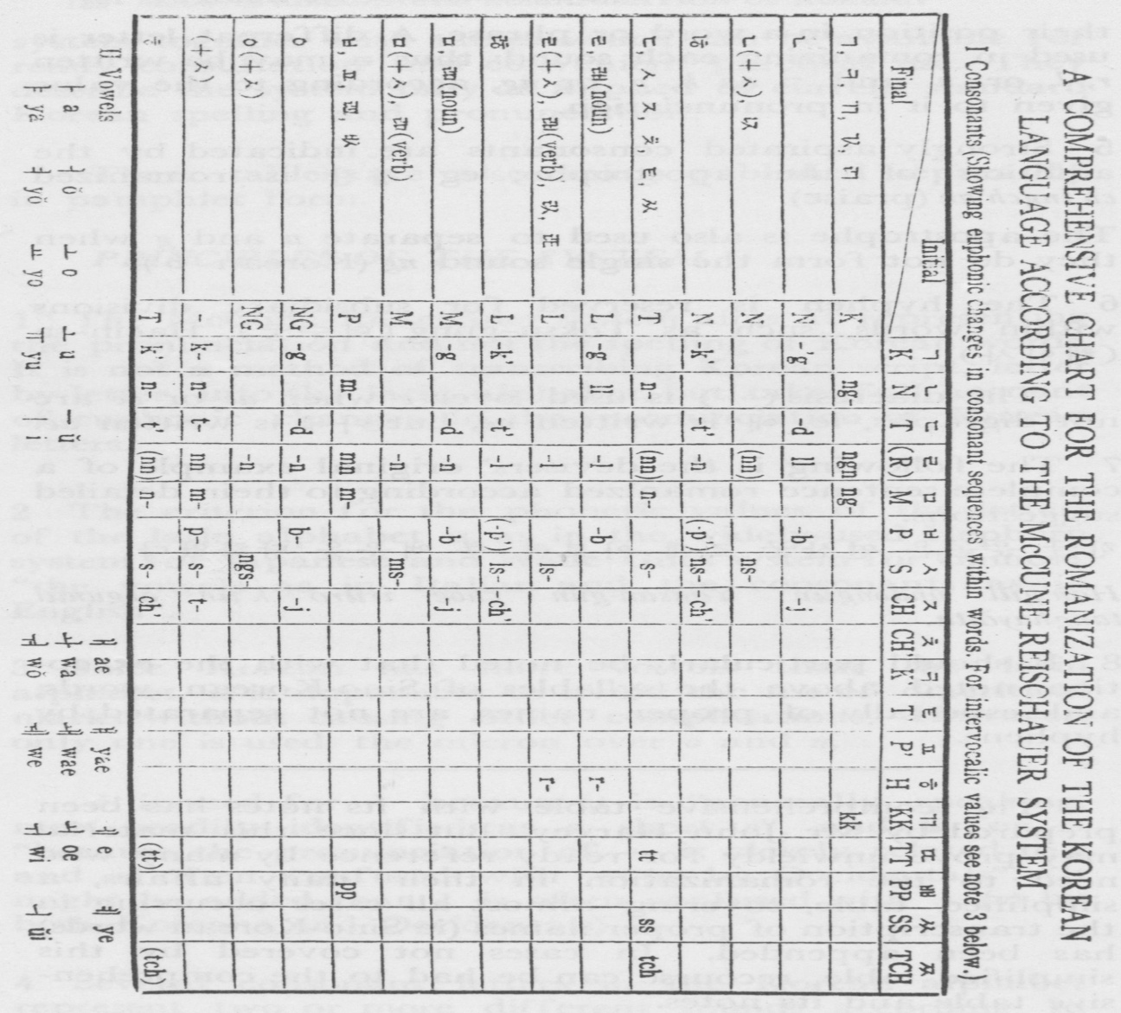

[page 125]
A. Irregularities in Consonant Combinations (See Chart)
1. ㄹ is written r before ㅎ.
2. ㄹ is written n after ᄀ, 口, ㅂ, and ㅇ.
3. ᄂ is written l before or after ㄹ.
4. ᄀ，ㄷ，and ㅂ are written ng, n and m before ᄂ, ㄹ or ᄆ.
5. ᄀ, ㄷ, ㅂ and ㅈ are written g, d, b and j after ᄂ，口 or ㅇ. ᄀ and ᄇ are written g and b after ㄹ.
6. Sat siot after a vowel is written with the same letter as the following consonant(but t before ch)
7. ㄷ, ㅎ and sai siot are written s before ㅅ.
8. ㅎ before ᄀ, ㄷ or ㅈ is written as an apostrophe after the initial.

B. Notes

1.The initial and final consonants of words are romanized as indicated by the capital letters in the chart. (Divisions between words do not prevent sound changes in spoken Korean, but for romanization purposes it is most practical to indicate them only within words, following the word envision in the standard orthography.)

2. Combinations of final and initial consonants of syllables within a word are romanized with their word final and word initial values unless otherwise indicated in the chart.

3. Between vowels, single consonants are romanized with their initial values except for ᄀ,ㄷ, ㅂ and ス which are romanized g, d, b, and j, and except for ㄷ and ㅌ as syllabic finals before 이 or palatalized vowels, which are romanized j and ch’; double consonants are romanized as if they were final and initial. (ㅅ, ㅈ, ㅊ and ㅌ have their initial value before vowels only when the vowels are in inflectional endings. Otherwise they are romanized d, just as in the same situation ㅋ and ㄲ are romanized g and ㅍ is romanized b.)
[page126]
4. As a syllabic initial, ㅇ is not romanized, since it stands for the absence of a consonant in this position.

5. The standard language pronounces and writes ㄹ as a word initial and ㄴ as a word initial before ㅣ or palatalized vowels only in a few native Korean words and foreign loanwords. If they are found in these positions in Sino-Korean, neither should be romanized before ㅣ or a palatalized vowel and ㄹ should be romanized n before other vowels.

6. Standard orthography does not indicate the presence of sai siot (+ㅅ in the chart) between consonants, and the provision for indicating it between a vowel and a consonant by adding a final ㅅ to the preceding syllable is not always followed. It is almost impossible to catch all these omissions without complete familiarity with the language, but doubtful cases should be checked. Sai siot occurs regularly between ㄹ and ㄷ, ㅅ or ス in Sino-Korean words, and sai siot always occurs between a native verb stem final ㄴ or ㅁ and ᄀ,ㄷ, a or ス as inflection initials. The possibility that a final a may represent sai siot should always be considered.

7. ス is romanized sh rather than s before ㅟ to indicate the lip-rounding which accompanies it in this position. (Its palatalization before ㅣ and palatalized vowels is not indicated.)

8. ㄵ, ㄺ and ㄼ combining with ㅎ should be written nch’, lk’, and lp’.

9. Some sequences of final and initial consonants within a word are so rare that their existence is doubtful. They are indicated with brackets on the chart.

C. Inconsistencies and Ambiguities

After consonants (other than homorganic stops) the letters k, t, p, and ch, which normally represent the unvoiced plosives, stand for the the forced plosives [page127] otherwise written kk, tt, pp, and tch. This device simplifies consonant clusters which would be unwieldy without being helpful. It also makes it possible to ignore the automatic change of the ordinary plosives (and ㅅ) into their forced equivalents after ㄱ, ㄷ and ᄇ. Since the ordinary plosives are also forced by sai siot, are aspirated by ㅎ, and are written g, d and b after ㄴ, ㅁ or ㅇ, and g and b after ㄹ to show that they are voiced, no ambiguity can results.
The application of this principle to forced consonants preceded by homorganic stops (or the identical reducing of “triple consonants”) means that these clusters are not distinguished from forced consonants. This is probably ambiguous more in theory than in practice, since it seems to be hard to confirm that this distinction, which analogy suggests, is consistent and significant in spoken Korean. Forced consonants, particularly after short vowels in native Korean words, frequently seem to be preceded by an intrusive homorganic stop.
Syllabic initial ㅎ is romanized h after k, t, and p for the sake of simplicity and because, while it would tempt mispronunciation if it replaced the apostrophe after initial aspirates, it can be read fairly correctly in this position. The combination of a plosive and ㅎ is traditionally considered to equal an aspirate, but a hom¬organic stop usually intrudes before it, as it often does before other aspirates, under the same conditions as before forced consonants. H in this position therefore indicates either aspiration or a homorganic aspirate.
The spelling of the names of the letters ㄷ, ㅈ, ㅊ, ㅋ, ㅌ, ㅍ, and ㅎ is artificial in that it does not conform to actual pronunciation in all cases. In the unlikely event of needing to romanize these names followed by inflectional endings they should be transcribed in accordance with the pronunciation. [page128]
