Census-taking under the Yi Dynasty
By Lee Kwang-rin (李光麟) Yonsei University

[page 33]
PREFACE

In a self-sufficient agricultural economy, such as existed in Korea during the Yi Dynasty, a complete census is essential to the government in order to tap the most important sources of revenue. The government during the Yi Dynasty, therefore, placed special emphasis on taking censuses. Every three years the government made tabulations of the population and kept the records in a census office. In most cases the military draft and labor mobilization were based upon the census.
However, most commoners, being burdened with large taxes and corvées, were scarcely able to feed their families. When official pressure became too great, they actually dared to evade taxes and corvees by taking refuge with overlords. As a result, the census was not taken in good order, so that, even though a census were taken, only half or less of the actual population was included.
In order to solve this problem the government was forced to enact a number of new regulations. The Hop’ae System(號牌法, Identity Tag System)and the Ogat’ong System (五家統法, Five Households System) were devised in order to reinforce the effectiveness of the census taking.
In this paper I shall briefly examine the fundamental system of census taking and then the subsidiary systems, the Hop’ae System and the Ogat’ong System.

[page34]
I. THE SYSTEM OF CENSUS-TAKING

The laws of both the Silla (新羅) and Koryŏ (高麗) kingdoms were mainly administered according to the imported T’ang Code.¹⁾
On the subject of the census the T’ang Code states:

“Every three years the government shall take a census. It shall begin in January and be finished by March. ²⁾
“The Chi Chang (計帳, The Census Report) was made every year, and the register once every three years. These were sent to the prefecture and then to the province and finally to the census office”³⁾

These articles show that during the T’ang Dynasty of China a regular register of the census was made once every three years while a report was made every year.
According to the Koryŏsa,

“A census of the nobles was made every three years without fail. Once it was made, one copy of the register was kept by the government office and one copy by each noble family.
“Each year in the ordinary prefectures and sub- prefectures the officials made records of the population and sent them to the census office.”⁵⁾

One scholar, basing his opinion on these quotations from the Koryŏsa, has asserted that the census for the noble class was made once every three years while the common and lower classes were registered yearly, thus emphasizing an apparent discrimination against these two classes.⁶⁾ Since the Koryŏ laws, however, followed closely laws of the T’ang we need not assume strong emphasis on class discrimination. Rather, it should be assumed that a regular census was held every three years throughout the country, and every year in the local districts the [page 35] officials made records of the population in order to obtain accurate information, regardless of the class.
This system was carried on throughout the Yi Dynasty. In the reign of King Yŏnsan-gun (燕山君 1495~1505 A.D.) some officials presented a memorial to the King, stating that the census should be enacted every six or nine years in. order to simplify official business. But the King did not allow this to be done.⁷⁾ In effect, from the first to the last days of the Yi Dynasty, the census was taken every three years.
Let us now examine the rules governing the census. Each householder was required to report on his family in detail.⁸⁾ Thereupon, each village headman collected the householders’ reports and sent them on to the official of the gun 郡, county. On receiving the reports from village headmen, the officials established a temporary census office in their gun and made a copy of the report on good paper.⁹⁾ Afterwards, they compiled “the official register (戶口正單).” The contents of the official register were as follows:¹⁰⁾
“Each housholder must write his address, official post, age, clan, and the names of his four consanguinal ancestors; if he has a wife, he must also write her name, her age, her clan and the names of her four consanguinal ancestors.
“Each member of the royal family must indicate his rank, the names of his four consanguinal ancestors and the name of the royal personage to whom he is married.
“The ordinary citizen is required to indicate his name, the name of his wife, and the names of the four consanguinal ancestors both from his family and hers. The common man who does not know exactly the names of his four ancestors is excused from giving full information.
“Persons living with a householder are required to give their ages. (In the case of a son-in-law, he is required to give his clan name as well)” [page 36]
“Slaves and artisans living with a householder are required to indicate their ages.”
When we examine this register, we can easily see the points of discrimination between the upper and lower classes. The upper class registration required them to show their official ranks and they were required to carry around an identification certificate. This certificate made it difficult to evade military service and taxes.
In the capital, two copies of the register were made. One was kept in the census office and the other in the city hall. In the local districts three copies were made, one being kept in the census office of the gun.¹¹⁾
The registers of the entire country were delivered to the official historian to record in the official annals.¹²⁾ Provincial governors who did not send in the registers within the legal period were liable to cross-examination. Officials of prefectures and gun were liable to dismissal from their posts. ¹³⁾
However, the system of census taking was not as effectively practised as it should have been. There were many violators of the law. At first the people floated to and fro without registration in order to evade taxes and services. Nevertheless the King took sterner action by promulgating the following edict:
“The registered population is decreasing day by day due to the increasing population of unregistered wanderers who do not possess a fixed estate of their own. Therefore, after the completion of official registration, there should be no wandering household for any reason. If any householder violates the law, he will be punished with one hundred strokes of a heavy rod, and the remainder of his family will be punished likewise. If the village headman should fail to report it immediately to his superior authority, he will be subjected to seventy strokes of a heavy rod. If the county superintendent should fail to persuade the family to return to its original address, and should receive them in his region, or if he should fail to trace the reason why the family [page 37]
left its own region, he will receive sixty strokes of a heavy rod and lose his office.”¹⁴⁾
Although the government tried its best to keep its floating population settled by devices, the confusion and turmoil of the times always impeded its progress. Checking stations had to be established on the provincial borders in order to prevent the ever-rising number of violators.¹⁵⁾ Almost every year the government had to take stricter and stricter action.
On the other hand, even though the people were registered in the census, they committed crimes like the following:¹⁶⁾
(1) Misreporting of households (漏戶)
(2) Misreporting of adult members (漏丁)
(3) Avoidance of registration (漏籍)
(4) False reporting of ages (增减年歲)
(5) Reporting of nonexistent households (虛戶)
(6) Forgery of registration (胃錄)
The last item was the one causing the most social disorder and administrative confusion, for a great number of the common people voluntarily placed themselves under the protection of the rich and the powerful in order to avoid their obligations of military service and corvee. ¹⁷⁾
The rapid development of large-scale farming in the Yi Dynasty demanded a large number of slaves. Some of the landowners did not hesitate to take away the slaves of other landowners, or illegally employ the common people, changing their control. In this way, some kept several hundred or more slaves on their plantations.¹⁸⁾ Unfortunately the officials as well as the people compiled dishonest registers. The village headman, representing the common people, would attempt to report a falsely reduced number of village men, at the same time bribing the officials in charge of the census, all of which resulted in a low potential corvee.¹⁹⁾ In order to check such malpractice, whenever the census was taken the government sent supervisors to the local districts. The govern¬ment particularly recommended nobles as inspectors.²⁰⁾ [page 38]
However, even in the halcyon days of the Yi Dynasty, according to the national census statistics of the time of Sejong (世宗) (1419~1450 A.D.), the registered population was scarcely one-tenth of the actual population of the time.²¹⁾
Thus, the government had to use subsidiary systems to obtain a full census report.

II. DEVELOPMENT OF THE SUBSIDIARY SYSTEMS

a. The Hop’ae System

The government officials found that the regular census taking was never entirely successful and was likely to continue to fail. They wanted, however, to record the population at any cost. At last a system was instituted which required each adult male to carry with him a small piece of wood. The tag was given by the government after registration had been accomplished. This was called the Hop’ae System and was first enforced in September of the thirteenth year of King Taejong (太宗) (1413). Such a system was used during five different periods of the Yi Dynasty.²²⁾ The regulations of the first enactment were:²³⁾
(1) Style:
Length: 3 ch’on 7 pun (三寸七分) (4.4 inches)
Width: 1 ch’on 3 pun (ᅳ寸三分) (1.5 inches)
Thickness: 2 pun (二分) (0.2 inches)
Shape: upper part round, lower part square.
For officials above the second grade the tag is made of ivory.
For officials above the fourth grade the tag is made of deer horn.
For officials above the fifth grade the tag is made of yellow poplar.
For officials above the seventh grade the tag is made of birch.
Upper grade officials are allowed to use materials [page 39] of lower grade tags but the lower grade officials are not permitted to use those of upper grade tags.
For common people and the lower class the tag can be made of any kind of wood.
In the capital the procedure is conducted by the Han song Bu (漢城府, Seoul City Hall). In the provinces, it is conducted by the local officials. The tag is made and presented to the office by the owner himself and then the officials brand the government seal on it. Those who can not make the tags by themselves are ordered to present pieces of wood with which the tags can be made and the tags are then made by public artisans.
(2) Inscriptions on the Tags:
On the tags of officials of the second grade and above, only the official rank is written, regardless of whether the official is serving or retired.
On the tags of serving officials of the third grade, the official rank is written.
On the tags of retired officials of the third grade, and on those of the lower officials, the name, address and title of their post, are written.
On the tags of common people the same items as above are required. In addition the complexion is to be stated.
On the tags of military servicemen, the company to which they are attached and height of the serviceman are to be written.
On the tags of slaves, working place, age, address, complexion, and height are to be recorded.
All the tags are branded with an iron seal except those of high ranking officials.
(3) Provisions:
On the first day of October the government will proclaim an order and admonish the people to follow the regulations. On the eleventh day of the month making and distributing the tags will begin. By the [page 40] first day of December the distribution of tags will be completed.

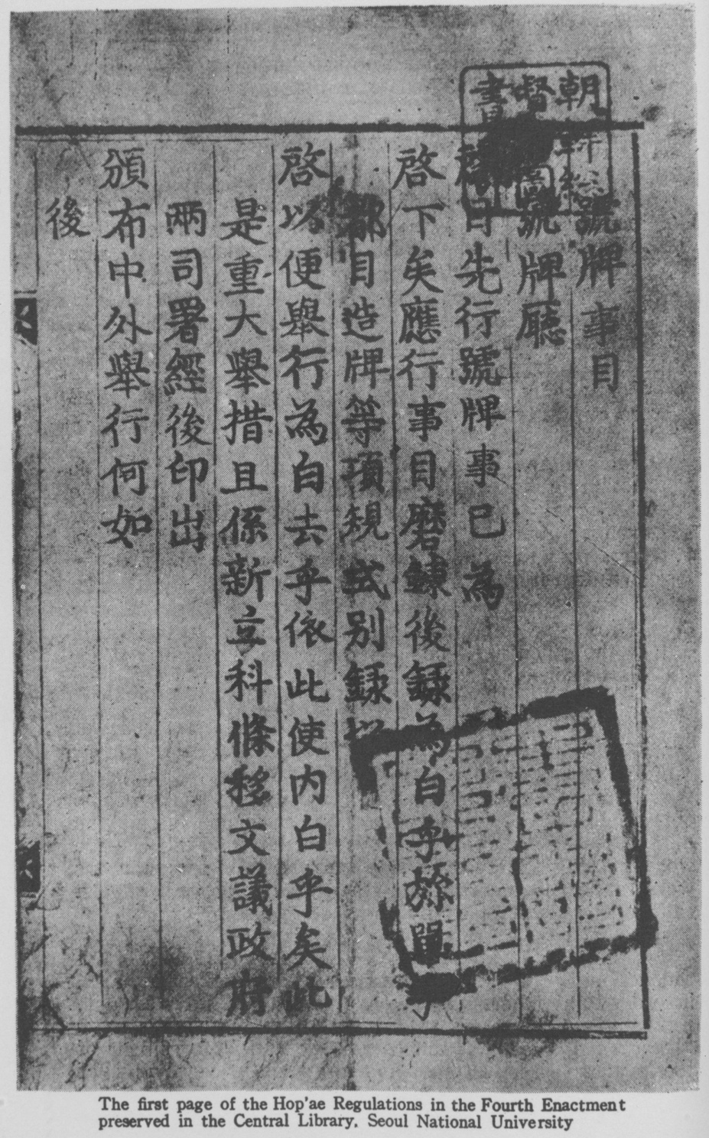
[page41]

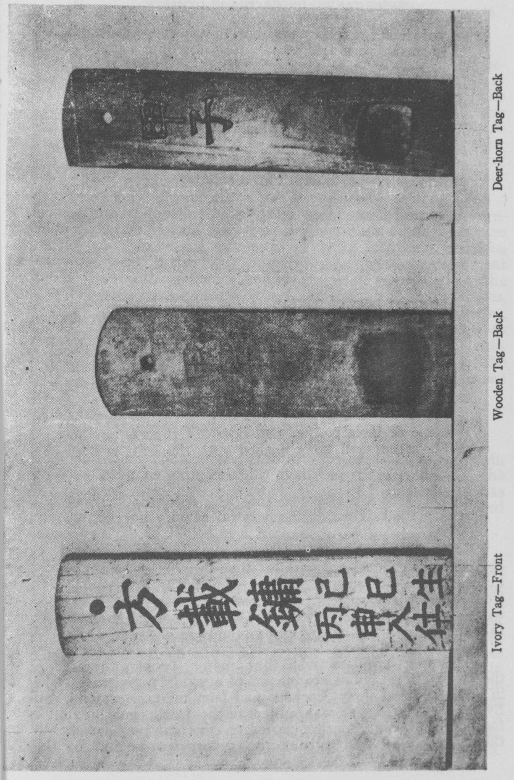
[page42]
If any one has no tag, he shall be punished with a heavy penalty.
After the period of distribution, one is to report any person found with no tag to the government. The offender shall be punished in accordance with the provisions of the law.
Any one that lends or borrows a tag shall be punished with a penalty mitigated by two degrees.
For wandering persons the above punishment shall be mitigated by one degree.
For village headmen and local officials who do not investigate and send these wanderers back home the penalty shall be mitigated by two degrees. For frontier guards and ferrymen who let persons without tags pass, the above punishment shall be mitigated by two degrees.
Whosoever loses his tag and does not report the fact to the office shall be punished with the light rod for disobedience.
Persons who are above seventy and under ten years of age do not fall within the purview of the enforcement.
At first the system was fully carried out. Many people obtained their hop’ae for fear they would offend the authorities.²⁴⁾ But soon the government found that people were abusing the system, and new detailed regulations were made. However, again the system proved to be a failure, the result of many cases of misuse.
The first problem was that many people forged the hop’ae with false statements of age, and social caste, in order to avoid heavy corvées and long military service. Even though a forger was subject to the death penalty,²⁵⁾ forgery continued. At this period of the enforcement of the system jails throughout the country were full of [page 43] violators of the Hop’ae System.²⁶⁾
The second problem was that many commoners became private slaves (私賤). The advantage of being private slaves under the protection of the nobles was the exemption from regular levies, corvees and military service. During the Yi Dynasty, private slaves were required to register as members of the household of their masters.²⁷⁾ In December of the accession year of King Yejong (睿宗) (1468), Kim Chil (金礩), a government official, stated the following:²⁸⁾
“Since the Hop’ae System was enforced, the govern¬ment has required commoners to show a certificate of the census which gives proof of their common status. If the certificate were genuine, the government gave them their identity tag. However, when the government pressed the commoners and public slaves, who had escaped the census, to show their certificates, a number of these people hastened to become private slaves under the safeguard of the overlords. Therefore, it can be said of this period that the Hop’ae System was the very system which increased slaves in overlords’ houses.”
He went on to say,
“In our country the Hop’ae System was enforced in order to gain control over the commoners. On the contrary, the official number of commoners has gradually decreased, while the nobles have acquired more slaves.”
The above shows how the Hop’ae System created a problem. Again and again the government proclaimed laws to prevent such illegalities. For example, the government gave notice that anyone who violated the law, regardless of the distinction of his status, should be exiled to the border and anyone who reported the offenders to the government should be given rewards.²⁹⁾ But the officials themselves made false reports and gave the commoners shelter in their houses.³⁰⁾ Even the top officials who supervised the entire system contributed to the offence by allowing commoners to become private slaves.³¹⁾ According to a petition filed by an official, Chu Kye-jŏng Sim-won (朱溪正深源) in April of the ninth year of King Sŏngjong (成 [page 44] 宗) (1478) we read:³²⁾
“At present, eighty or ninety per cent of the population are private slaves, and only ten to twenty per cent are ordinary citizens.”
The system itself, therefore, was quite ineffective.
The third problem was as follows: In the twelfth year of King Sejo (世祖) (1467) Yi Si-ae (李施愛), who protected hundreds of commoners in his house, led the people of Hamgyong Province in a rebellion against the government. At that time, the policy of the government was to restore the commoners to their former status, freeing them from the custody of the nobles and over-lords.³³⁾
The system was enforced only when an emergency called for it. Anyone who registered in the census and acquired a tag was called into service. People, therefore, wished to escape their burden and turned their backs on the government. Thus, the enemy was able to occupy the country without difficulty. The Hop’ae System was one of the significant causes of the disorders of that time.³⁴⁾

b. The Ogat’ong System

This system required that every five households, regardless of social caste, organize one administrative unit and make every household in the unit responsible for matters of census taking, of corvee, of taxation and of criminality. It has been considered as a local self-governing machinery, but in fact the system was controlled by the Seoul government to make centralization of administration effective through mutual responsibility. It did not originate in the Yi Dynasty, but was adapted from the Chinese system. In China the system had been carried out under the names of Li-chia (里甲制) and Pao-chia (保甲制) from earlier times. Japan also had borrowed this system from China and practised it strictly as the Gonin-kumi System (五人組制度) in the Edo period (江戶時代). The Yi Dynasty in its early decades, following the example of China’s Li-chia System (里甲制), instituted the Inbo [page 45] Chŏngjang System (隣保正長法). This system let every three to ten individual households organize one administrative unit and elect a trustworthy and capable man among the unit members, made him Chŏngjang (正長) and commissioned him to look after all the problems occurring in his unit, ranging from the responsibility of reporting to his superior office newcomers into his unit and those who left for other places, to the dutiful notice of births and deaths. ³⁵⁾ Soon after, this system came to be called the Ogat’ong System.
According to the Kyŏngguk Taejŏn (經國大典, the legal code of the Yi Dynasty), which was completed during the reign of Sŏngjong (成宗) (1470~1494), we find:³⁶⁾
“Both in the capital and in the districts, every five households make, a unit and elect a unit head (統主), and in the district every five units are placed under a village headman (里長) who is the highest administrative official in the village.”
Unfortunately the enforcement of this law was not successful in the early period of the Yi Dynasty. After the Hideyoshi invasions (1592~1598) and the Ch’ing invasions of 1627 and 1636, however, this system was enforced strongly in order to prevent commoners from evading government taxation ana corvée in the disorderly situation of the times.
This system was seriously discussed during the reign of King Hyojong (孝宗) (1650~1659)³⁷⁾ and from the first year of King Sukjong (肅宗) (1675), it came into force as law. The executive power of the system was given to the Pibyŏnsa (備邊司, Department of National Border Defence) and was drafted as a series of laws amounting to twenty-one articles for the purpose of successful enforcement of the system.³⁸⁾ Here is a selection of some of the typical articles contained in the laws:
“Every five households, regardless of the size of the individual households or the financial differences between them, should form one unit (統) and the head of the unit should administer the public affairs of the unit.” [page 46]
“A small village (小里) will be comprised of five to ten units; a middle village (中里) eleven to twenty units; and a large (大里) village twenty-one to thirty units. Each village should choose a headman who will be the responsible public servant of his village.”
“At the end of every year, every head of a unit shall compile a report of births and deaths and submit it to the office of the village, and the head of the village to the district office, and the head of the district to the county office, and the head of the county to the provincial governor. But in the case of strangers coming into any unit, on the contrary, they should be reported immediately to the related offices. In the case of false reporting of ages, or incorrect descriptions of the titles of obligatory services to the government found in annual reports, the persons responsible for the false and incorrect reports shall be punished according to the laws.”
“When a male citizen reaches sixteen years of age he should submit a personal family report to the village headman describing his address, occupation, name, and age on a thick paper prepared by the government for the purpose. After the approval of the headman, the paper should secure a seal of approval from the government. Without having this certificate, no person shall be allowed to enter public office, nor will he receive any government protection whatsoever—e.g. the right to appeal to the courts. Public and private slaves should write down the names of their employers. Anyone who does not possess a certificate should apply, in writing, for a new registration form to the responsible office. Any person who does not possess a certificate at all will be accused as a deliberate evader of the law.”
“If a member of any unit should intentionally neglect to report on strangers coming into his unit or should report falsely, all households of the unit will be accused as joint violators of the law. Moreover, the head of the unit will be severely questioned. If the head of a village, after receiving such a report from one of his units, should fail to refer the fact [page 47] to his superior office, he will be accused as a violator according to the regulations.”
“No person will be admitted to any new community without obtaining an official approval from the office of the district in which he wishes to reside. An immigrant who does not follow the required procedure will not escape the penalties of confinement or of questioning according to the laws. A person who receives any stranger from outside his own district without passing through the legal procedures required will also be guilty.”
It seems that the system provided sufficient regulations for the conducting of a census. At that time the political factionalism intensified and much confusion was brought to the government. According to the Left Councillor (左議政) Cho Hyŏnmyŏng’s (趙顯命) memorial to the king, in 1749 we find that the Ogat’ong System remained nominal only, not being enforced.³⁹⁾ Therefore it was not as successful nor effective as had been expected.
While this system failed it is remarkable that such civil cooperative units as the the Hyangyak (鄉約, a type of cooperative) and Kye (契, a mutual loan system) were quite popular among the commoners throughout the Yi Dynasty. The main reason for the difference is that the Ogat’ong System did not serve to protect the benefits of the commoners.

[page48]
CONCLUSION

We have given a brief survey of the census taking systems of the Yi Dynasty. By experimenting with various kinds of supplementary regulations, the government did not spare any efforts to make the system fully effective. However, such efforts were in vain. Even though successful cenus taking records could produce the favorable result of rapid promotion for the local administrative officials, the result of the enforcement of the system was always less than expected. The failure of the system was not due solely to the unwillingness of the people to cooperate but rather due to the confusion and inconsistency of the social, political, and economic structures of the time.
However, the military service system gradually changed. From the early seventeenth century persons were exempted from military service by paying cotton fabrics to the government.⁴⁰⁾ Instead of conscription, the government hired soldiers. Therefore, the census register and the hop,ae were regarded merely as certificates showing the different social castes and as a result, from that time on, census taking was more or less regularly carried out. ⁴¹⁾

FOOTNOTES
1. cf. Chŏn Pong-dŏk 田鳳德, Sillaŏi Yullyŏnggo 新羅의 律令考 (A Study of Silla Law), Universites Seoulensis Collectio Theseon, Humanitas, Scientia Socialis 서울大學校論文集 人文社會科學, Vol. 4, Seoul 1956, 10 pp. 311~358
and
Hanamura Miki 花村美樹, Korai Ritsu 高麗律 (The Koryo Penal Codes), Chosen Shakai Hoseisi Kenkyu 朝鮮社會法制史研究, compiled by Keijo Teikoku Daigaku Hogakkai 京城帝國大學法學會, Seoul 1937, pp. 3—127.
2. T’ang-Ling Shih-i 唐令拾遺, Bk, 9 (戶令).
3. T’ang-Liu-tien 唐六典, Bk. 3 (戶部員 外郎條).
4. Koryŏ-sa 高麗史 (History of the Koryo Dynasty), Vol. 1, Bk. 79, p. 2a. (Citation from ed. Yonsei University Press, Seoul 1956) (卷七十九 食貨志二戶口條).
5. Ibid. p. 3b.
6. Paek Nam-un 白南雲, Chosŏn Ponggŏn Sahoe Kyŏngjesa 朝鮮封建社會 經濟史 (Economic History of the Korean Feudalistic Society), Tokyo, 1937, p. 298.
7. Yŏnsan-gun Ilgi 燕山君日記, Bk. 29, p. 19b (卷二十九 燕山君四年 五月 庚申條).
[page 49]
8. Sejong Sillok 世宗實錄, Bk. 40, 16a (卷四十 世宗十年五月 癸丑條). [page49]
9. cf. Mongmin Simsŏ 牧民心書, (The Rules for the Conduct of Local Officials Written by Chong Tasan 丁茶山 (1762~1818), Bk. 6 (戶典 戶籍考).
10. Kyŏngguk Taejŏn (經國大典, The Legal Code of the Yi Dynasty), compiled in 1485 Bk. 3 (禮典戶口式條)
11. Ibid. Bk. 2. (戶典戶籍條).
12. Soktaejŏn (續大典. The Supplementary Legal Code of the Yi Dynasty), compiled in 1747, Bk. 2 (戶典戶籍條).
13. Ibid.
14. T’aejo Sillok 太祖實錄, Bk. 4, 13b (卷四 太祖二年十ᅳ月條).
15. Sejong Sillok 世宗實錄, Bk. 74, 13a. (卷七十四 世宗十八年八月 庚)
16. Soktaejŏn 續大典, Bk. 2 (卷二 戶典戶籍條). In each item listed, the penal regulations are also provided in detail.
17. Sŏngjong Sillok 成宗實錄, Bk. 240, 13a. (卷二四O 成宗二十ᅳ年五月丙 寅條). In regard to such a social phase, see Suto Yoshiyuki, 周膝吉之 “Raimatsu-Sensho ni okeru No-So ni tsuite 麗末鮮初に於け る 農莊に就い て”. (On the Manor from the Last Days of Koryŏ to the Early Days of the Yi Dynasty), Seikyu Kakso 靑丘學叢, No. 17, Seoul 1934.
18. Sŏngjong Sillok 成宗實錄, Bk. 40, 9a (卷四十 成宗五年三月庚戌條).
19. Referring to Mongmin Simsŏ 牧民心書, Bk.6 (卷六 戶典 戶籍條), we find an interesting quotation, that is, the officials of the personnel section in the subprefectures were considered by all as in the most profitable position, but whenever the census was taken the officials in charge of the census were second to none.
20. Soktaejŏn 績大典, Bk. 2. (卷二 戶典 戶籍條).
21. Sejong Sillok. Bk. 148, 5a (卷一四八 地理志 京幾條) 本朝人口之法不明錄于籍者 僅十之一二……
22. cf. Lee, Kwang-rin 李光麟, “Hop’aeŏgo—Ku Silsi Pyŏnjŏnŭl Chungsimuro 號牌考一그 實施變遷을 中心으로”. (A Study of the Hop’ae System from the Viewpoint of Enforcements and Changes), Paek Nak-chun Paksa Hwannyŏk Kinyŏm Kukhak Nonch’ ŏng 白樂濬博士還暦記念 國學論叢, Seoul 1955, pp. 551~612.
The five times the Hop’ae System were enacted are:
1st 1413~1416
2nd 1460~1469
3rd 1610~1612
4th 1625~1627
5th 1675~1910
23. Taejong Sillok 太宗實錄, Bk. 26. 20b. (卷三十六 太宗十三年九月 丁丑條).
24. Ibid. 47a. (太宗十三年十二月 丙午條).
25. Pojo-jip 浦渚集, written by Cho Ik 趙翼 (1575~1655) Bk. 14. (啓辭).
26. Taejong Sillok 太宗實錄, Bk. 31, 35a.(卷三十一 太宗十六年五月 癸卯條).
27. Sejo Sillok 世祖實錄, Bk. 36, 2lb. (卷三十六 世祖十ᅳ年七月 壬戌條).
28. Yejong Sillok 睿宗實錄, Bk. 2, 44b. (卷二 睿宗即位年十二月 丙申條).
29. Sejo Sillok 世祖實錄, Bk. 37, 22b. (卷三十七 世祖十ᅳ年十一月 癸丑條).
30. Ibid.
31. Sŏngjong Sillok 成宗實錄, Bk. 76, 3b. (卷七十六 成宗八年二月 丁丑條). Herein it is recorded that when Yi Sŏkhyŏng 李石亨, who was once mayor of the capital, was in charge of the Hop’ae regulations throughout the country, he drew many commoners as his own private slaves. [page 50]
32. Sŏngjong Sillok 成宗實錄, Bk. 98, 9b. (卷九十八 成宗九年四月 己亥條).
33. According to Sejo Sillok 世祖實錄, Bk. 43, 34a. (卷四十三 世祖十三年 八月 乙己條). we read: Yi Si-ae 李施愛 lived in Kilchu 吉州 for generations. His clan settled firmly in many districts in Hamgyong Province. Thus he became a landlord by drawing a considerable number of commoners and occupying many acres of land. When he was forced to free the commoners from slavery by government policy, he at last led the people of Hamgyŏng Province in a rebellion against the government.
34. In the supplementary volume, No. XII of the Yŏnyŏsil Ki-sul 燃藥室 記述 ed. Yi Kung-ik 李肯翊 (1736~1806), we notice that when the Manchu tribes invaded our country, in the year Chŏngmyo 丁卯(1622), all the people thought the hop’ae system invited the enemy. The citizens of Pyŏngyang (平壤) threw their tags towards the city wall and ran away.
35. Taejong Sillok, Bk. 15, lb. (卷十五 太宗八年正月 辛亥條).
36. Ibid.. Bk. 2. (戶典戶籍條)
37. Chŭngbo Munhŏn Pigo 增補文獻備考 (The Revised Encyclopedia) Vol. 2, Bk. 161. p. 14a (卷百六十一 戶口考 孝宗己丑備局啓中) (Citation from Tongguk Munhwasa Edition, Seoul 1957). According to a petition filed by Chŏng T’ae-hwa 鄭泰和, chief councilor 領議政, we read: Though it was a long while after the Ogat’ong System had been established the system was not in practice because of poor harvest... Upon receipt of the petition, the king ordered enforcement of the system from the coming year.
38. Sukjong Sillok 肅宗實錄 Bk. 4, 48b. (肅宗元年九月 辛亥條).
39. Chŭngbo Munhŏn Pigo, Vol. 2, Bk. 161. p. 22a.
40. cf. Asafu Takekame 麻生武龜, “Chosen Zaiseisi 朝鮮財政史.” (History of Finance in the Choson Period), in Chosen-shi Koza Bun-Rui-shi, 朝鮮史 講座 分類史. Seoul, Chapter 2, The Household Tax, pp. 113-152.
41. Richo Jidai no Zaisei 李朝時代の財政 (Finance in the Yi Dynasty) ed. 朝鮮總督府 Chosen Sotokufu (Government General) Seoul, 1936, pp. 197 ~200 and pp., 247~265.
41. The records of population can be found in Wangjo Sillok 王朝實錄 (The Dynasty Annals) and Chŭngbo Munhŏn Pigo 增補文献備考. For the oldest census register now remaining, reference can be made to the study by Professor Shigata Hiroshi 四方博 who observed and discussed the matter from the social and economic standpoint. “Richo Jinko ni kan suru Ichi Kenkyu 李朝人口に關する一研究” (A Study of the Population in the Yi Dynasty), Chosen Shakai Hoseishi Kenkyu 朝鮮社會法制史研究, compiled by Keijo Teikoku Daigaku Hogakkai 京城帝國大學法學會, Seoul, 1937, pp. 259~368.

