[page 62]
TRIPITAKA KOREANA
By Dr. Nak Choon Paik (Dr. L. George Paik)

Buddhism is a religion of vast amounts of literature. The Buddhist canon is called the Sam Chang 三藏 or tripitakaᅳthree baskets. It consists of (1) the Vinaya-pitaka 律藏 which gives the disciplinary rules by which monks and nuns are governed, (2) the Sutta-pitaka 經藏 or teaching basket, which professes to give the discourse uttered by the Buddha during his lifetime, and (3) the Adhidhama-pitaka 論藏 or Higher Doctrine basket, which includes a number of metaphysical and miscellaneous treatises. Certain authorities separate the miscellaneous treatises from the third and add (4) the Samykta-pitaka 雜藏 to include various Hindu and Chinese works. However, the tripitaka is not a canon in the strict sense of the word, but rather a collection of standard works.
The Sam Chang 三藏 or tripitaka has become the general title of all the collected works of the standard Buddhist literature, but it was originally meant to designate the Hinayana literature only. The Mahayana Canon does not ignore these baskets but it includes writings of later centuries as well. The term Tai Chang 大藏 or Maha-Pitaka has been in use to include both Hinayana and Mahayana works, since the tenth century A.D. in the East Asia Mahayana countries. However, we use the familiar term Tripitaka here in the sense of Tai Chang or Maha-pitaka.

INTRODUCTION OF THE TRIPITAKA INANCIENT TIMES
Introduction of the Buddhist Literature into the Korean Peninsula was synchronous with the coming of Buddhism. When the Buddhist priest Sundo 順道 arrived from China at the court of the northern Kingdom of Kokuryu in 372 A.D. he brought with him the Buddhist missionary’s usual impedimenta of books and images. The Buddhist missionaries who had subsequently come to Korea and the Korean pilgrims who had gone to China and India brought into Korea a vast amount of Buddhist literature of both countries. We can not now go into details of the most zealous acts of these devotees. There [page 63] are scattered records in history of the ancient kingdoms of Korea, of bringing in numerous volumes of the Buddhist Scriptures. However the earliest mention of the arrival of the complete Tripitaka (Sam Chang) was made in 643 A.D. It is recorded that Priest Cha Chang 慈 藏 of Silla brought it from Tang 唐 in China and that the set comprised more than 400 cases. These treasured volumes were stored away in the Tong Do Sa (通度寺) Temple. There is another notice that toward the end of the Silla dynasty Priest Po Yo (普耀) went for the second time to Wu-Yueh (吳越) in Southeast China and brought the Tripitaka (大藏). We note again in the Sam Kook Yu Sa (三國遺事) that in 928 still another set of the Tripitaka was brought from T’ang.
We do not know whether these sets were of printed books or manuscripts. We are told that there is a printed copy of the Diamond Prajna Paramita Sutra (金剛般若彼羅密經) in the British Museum and that it bears the publication date of A. D. 868. This is the earliest printed Buddhist scripture now in existence. Undoubtedly individual works were printed even prior to the tenth century, but printing of the complete set of the Tripitaka did not take place until the last quarter of the tenth century. It is, therefore, safe to assume that the Tripitaka sets brought into Korea in ancient times were manuscripts.

COLLECTION AND PUBLICATION OF THE TRIPITAKA IN THE MIDDLE AGES
The Koryu dynasty (918-1392) forms the middle ages in the history of Korea. The founder of the dynasty was a convinced Buddhist and his religion was the faith of the ruling class for a long time. The dynasty fell together with decline of Buddhism, but the work of collection and transmission of the Tripitaka remains one of the permanent achievements of that dynasty.
We do not know if the new dynasty inherited the Tripitaka sets collected by the preceeding kingdoms. The History of Koryu tells us in the record of the eighth moon of the eleventh year in the reign of King Tai Cho (太祖) 928 as follows: [page 64]
“Priest Hong Kyung (洪 慶) of Silla brought a set of the Tripitaka from Fu Chow (閩府) of T’ang and arrived at the Ye Sung River (禮成江). The King journeyed there to receive it and it was stored away in the Hall of Sakradevendra (帝释院).”
While the Koryu dynasty was laying foundations in Korea, change was also taking place in China. Political chaos of the Five Dynasties (五代) came to an end and the Sung (宋) Dynasty rose to unify China once again. The founder of the Sung Dynasty reinstated Buddhism which was suppressed during the previous era. He ordered to publish the complete set of the Tripitaka. This enterprise was undertaken at Chengtu (成者) the present capital of Szechwan province. The work required 12 years (971-983) of devoted labour, completing in 983. This set is known as the Shu (designation for Ch’engtu) edition (蜀版). All authorities recognise that this was the first printed edition of the complete set of the Chinese translation of the Tripitaka.
How “complete” was the set? In order to answer this question, we must examine Catalogues of the Chinese translation of the Buddhist Tripitaka made by order of the Emperors of China and obtain the number of works listed therein. The earliest one was made in 518 by order of Wu-ti (武 帝) the founder of the Liang (梁) Dynasty in China. But the standard work in the Middle Ages was Kai Won Suk Kyo Bok (大唐開元釋敎目錄) a Catalogue of the Books on Teachings of Sakyamoni compiled in the Kai Won Period (713-741) by Chi Seung ( 智昇 ) in 730. This Catalogue listed 5,048 volumes which were collected under the T’ang Dynasty. This Shu Edition (蜀版) of the Sung dynasty consisted of the same number of volumes listed in that catalogue. This set of the printed Tripitaka soon became parental to all later Chinese editions reproduced in East Asia.
Soon after the publication of the Shu Edition, Korea was able to secure the Tripitaka from the Sung Court. We read in the 387th book in the Dynastic History of Sung (宋史) an entry made in the year 989 A. D. as follows: [page 65]
“Prior to this (arrival of envoys headed by Han Nin Yyung (韓蘭卿) Ch’i(治) (name of the King) Sung Chong (成宗) of Korea sent Priest Yu Ka (如可) with a memorial of respectful salutations and requested a set of the Tripitaka. This request is now granted (i.e. 989).”
Two years later (991) the same King Sung Chong sent Han Eun Kong (韓彥恭) as an envoy to the Sung Court. We observe in the biography of the envoy recorded in Book 93 that he requested a set of the Tripitaka. The Emperor granted him a set consisting of 2500 volumes in 481 cases. He brought it with him when he returned home and presented the same to the King.
When these two sets were brought into Korea less than a decade elapsed since the publication of the Chu Edition. It may not be far from fact to state that these sets were reprints made out of the Shu Edition or one of the sets of the Shu Edition.
We have so far surveyed the record of collections of the Tripitaka made by early Kings of the Koryu Dynasty. Time has now come for publication of thus far collected scriptures. We read in the history of Koryu (高麗史) the following entry made on the 9th Moon of the 38th year in the reign of King Ko Chong (高宗) (1251):
“The King journeyed to the Hall of the Tripitaka outside of the West Gate and led his officials in burning incense there. The plates of the Tripitaka made during the reign of King Hun Chong (顯宗) (1010-1031) were burned in the Mongolian Invasion. The King and his ministers wishing for restoration of the set, appointed the commission on the Tripitaka. The work was completed in 16 years.”
We also find the following passage in the 15th volume of the collected works of Tai Kak Kook Sa (大覺國師集).
“The King Hun Chong published 500 rolls of his private collection of the scriptures and my royal sire Moon Chong (1046-1083) published a hundred million praises of the Khitan Scriptures.” [page 66]
The two above records state clearly that the Tripitaka was first published in Korea during the reign of King Hun Chong (顯宗) 1010-1031). However we have to go to other authority for the exact year of publication. Yi Kyu Po (李圭報) (1168-1241) was the great poet, scholar and statesman of the Koryu Dynasty. He drafted the official prayer offered by the King and his ministers at the occasion of commencing the work on the Tripitaka Plates for the second publication. He wrote in part as follows:
“Terrible was the destruction of the Tartars. Unspeakable was their cruelty and savagery. Their ignorance and stupidity was. worse than brutes. How can they appreciate the fact there is the Buddhist religion which is revered by all. They destroyed all the images of Buddha and Buddhist scriptures wherever they went. The plates of the Tripitaka stored away in the Poo In Sa Temple were swept away. Alas! years of labor suddenly became cold ash and the great treasure of the country was lost for ever.”
He continues in another part :
“The origin of the first undertaking (for the publication of the Tripitaka) was this: In the second year of the late King Han Chong the Lord of the Khitan dispatched a large force of army to invade the country. The King fled from the capital to the south. The Khitan army encamped in the city of Songdo, the Capital, and did not withdraw. The King and his Ministers made the most solemn vow for the completion of the Tripitaka plates. When the work was completed, the Khitan force made voluntary withdrawal Thus all were united in publishing the Tripitaka, in cutting the blocks and petitioning prayer for one consuming desire. This act of prayer was so efficacious as to cause voluntary withdrawal of the Tartars. Why should such a prayer be not so with the present day Tartars? All depends on how the Buddha in heaven should hear our prayers.” [page 67]
We can draw from the above statements the following points :
1. The first publication of the Tripitaka took place during the reign of King Hun Chong. The Work was probably begun in 1011 or thereabouts but there is no record of the year of completion.
2. This great undertaking was an act of prayer offered to Buddha for expulsion of the invading Khitan Tartars from the country.
3. The Tripitaka plates were stored away in the Poo In Sa (符仁寺) Temple in the Pal Kong (八公山) Mountain near the present city of Taegu.
4. These Plates were destroyed in the Mongolian In-vasion of 1231.

THE SECOND PUBLICATION OF THE TRIPITAKA
“There can be neither making nor unmaking of the golden sayings and precious doctrines. What is destroyed is the receptacles. Receptacles can be destroyed by force of nature. It is only proper to restore the destroyed. How much more so for us who revere Buddha in our home and country. We cannot afford to procrastinate to possess the great treasure. We must not hesitate to restore it because of stupendousness of the undertaking.”
These are the words of Yo Koo Po.
Undoubtedly such was the spirit and determination of the ruling class for restoration of the burnt Tripitaka Plates. The Korean Court lost no chance for collecting the best texts of the Tripitaka.
The Korean Khitan conflict closed with the former’s submission to the latter. But the great recompense given by the Tartars to Korea was the Khitan edition of the Tripitaka. We read the entry on the 4th day of the 3rd moon of the 17 th year of the King Moon Chong (文宗) (1067) as follows : “ [page 68]
“The Khitan sent a set of the Tripitaka. The King in the religious entourage journeyed to the West Gate suburb of the City to receive it.”
During the reign of the same king, the Tripitaka found its way to Korea not only though the northern land route from Khitan but also through the southern sea route from the Sung Court. We read again the entry on the 15th day of the 3rd Moon of the 37th year (1083) as follows :
“Ordered the Crown Prince to receive the Sung edition of the Tripitaka and to place the set in the Kai Kook Sa Temple (覺國寺).”
There are numerous references in the history of Koryu about the acquisition of rare works and new translations of the Buddhist scriptures. The most outstanding in the enterprise of collection and publication of the Buddhist scriptures in this period is Tai Kak Kook Sa to whom we have already referred. The part which he played was the collection and publication of his famous Supplementary Pitaka (續藏). A discussion on the Supplementary Pitaka will require a separate paper. We must leave the subject for later treatment.
We have seen that the Khitan invasion of the eleventh century gave an occasion for the first publication of the Tripitaka. The Mongol Invasion of the thirteenth century destroyed the former edition plates and prompted incentives for the second publication of the Tripitaka.
It will be recalled that when the Mongols invaded the country (1231) the Korean court was then under the sway of the notorious Choi (崔) family. The power behind the throne of the reigning King Ko Chong was Choi Wu (崔瑀) son of Choi Chung Hun (崔忠献) who enthroned four kings and abdicated two. Choi Wu persuaded the King to remove the capital to Kangwha Island (1232) and to resist the Mongols without submitting to them. The Mongols occupied the original capital, Songdo, and at times too they came down to the very landing of Kangwha to peer across at the King on the other side. Under such terror and distress the King and his ministers,” [page 69] taking lessons from the Khitan expulsion, resolved to depend upon the help of Buddha for expulsion of the Mongols from the country.
They believed as their forefathers did that a good work must be consecrated in support of their prayers to Buddha for help. The good work that they agreed to dedicate was also the choice of their predecessors, the preparation of the Tripitaka plates. Thus engraving of the plates for the entire text of the Tripitaka became the national undertaking for the second time in the Koryu dynasty.
The inauguration of the undertaking was marked with a religious observance. The King and his Ministers were united in offering prayers for the expulsion of the enemy and pledged themselves for living in gratitude to Buddha. For this occasion Yi Koo Po wrote the prayer from which we have already made extensive quotations.
The Commission on the Tripitaka was soon appointed with its headquarters in Kangwha, the temporary capital. A branch office of the Commission was set up in Nam Hai (南海) Island in the present South Kyong Sang Province. We read in the biography of a Chung An (鄭宴) in the History of Koryu that Chung, in view of courting favors of the Choi family (though he could not escape from exile and drowning) spent a good deal of his fortunes for setting up this branch office of the Commission in his retired country and for the actual work of making the Plates. The work of cutting blocks was carried on in Kangwha and Nam Hai islands. The original zeal for the Tripitaka plates had been burning for sixteen years when the completion of the work took place in 1251.
We are now most fortunate in that we have intact all the plates made for the second publication of our subject. The books that have been preserved and handed down to the present day are all told 81,258 pieces. Texts are engraved on both sides of each block making a total of 162,516 plates. They form 1,511 separate works in 6805 volumes. Each block is about ?? inches high, 2 feet 2 inches wide, and ?? inches thick. The material used is flawless hard Pak Tal tree (Betula Schidtii Regel) “ [page 70] (檀木) produced in distant islands of the country. Each block weighs about 3 1/2 or 3 3/4 kilogramme or 8.26 lbs. Four corners of each block are metal plated in order to protect from cracking and every plate is varnished to make it insect-proof. There are 22 lines on a page and 14 characters in each line. The calligraphy of the text and the technique in engraving are so excellent as to stand as a beautiful piece of art.
It requires no special imagination to conceive the stupendousness of the undertaking which crystalized the devotion and consecration of untold numbers of supervisers, laborers, carpenters, calligraphers, metal workers, engravers, painters and those who bore the necessary expenses. Furthermore this great work was begun in national crisis at the cramped capital on an island where the necessary resources were limited.

PRESERVATION AND TRANSMISSION
Preservation and transmission of these Tripitaka plates has been no mean task. Those plates that had been prepared in several places were assembled and stored away in the Plates Hall in the year of the completion of the work, that is in 1251. The Hall was located outside of the West Gate of the City of Kangwha. However, these plates were later removed to the Sun Won Sa (禪源寺) Temple in the same island, until they were brought to the mainland. We read the entry made on the 10th day of the 5th Moon of the 7th year of the reign of the King Tai Cho (太祖) (1398) founder of the succeeding Yi Dynasty, as follows :
“The King journeyed to the Yong San River (龍山江) where the Tripitaka Plates were brought from the Sun Won Sa Temple, Kangwha. Gave orders to the Captain and sub-captains and two thousand others to transport the Tripitaka Plates to the Chi Chun Sa Temple (支天寺).”
We read again the following entry made on the 9th day of the 1st Moon of the reign of the King Chung Chong (定宗) (1399)：” [page 71]
‘‘Issued orders to the Governor of the Kyong Sang Province to feed the Buddhist Priests who were engaged in making impressions of the scriptures in the Hai In Sa (海印寺) Temple. The former King (who abdicated in favor of the heir apparent) intended to print the Tripitaka at his own expense.”
From the authorities quoted above we can make the following conclusions:
1. The Tripitaka Plates were originally stored away at the Tripitaka Hall outside of the West Gate of the City of Kangwha.
2. They were later removed to the Sun Won Sa Temple whence they were transported in the spring of 1398 to the Chi Chun Sa Temple outside of the West Gate of the City of Seoul.
3. The storage of the Plates in the Chi Chun Sa Temple was only temporary perhaps for an examination by the founder of the new (Yi) dynasty (李祖)
4. These Plates were soon removed to the present depository at the Haein Sa Temple in the same year of 1398, for we have the record of printing of the Scriptures from these plates as early as the 1st Moon of 1399.
The Koryu King Won Chong (元宗) (1260-1274) returned to the original capital of Songdo in 1270 following the peace with the Mongols, but neither he nor his successors brought the Tripitaka Plates to the capital. The Kingdom of Koryu had lately been invaded by the Khitans, Nuchens and Mongols from the north. The Koryu Kings evidently believed that Kangwha Island was an impregnable stronghold as well as a place of safe keeping of the Plates. Thus these Plates remained in Kangwha while the Mongolian Empire in 1368 and the Koryu Dynasty in 1392 disappeared. Kangwha was no longer an unapproachable island before Wakoᅳthe Japanese pirates who pestered the Chinese and Korean coasts towards the end of the Koryu Dynasty. When the new Dynasty came [page 72] to power in Korea in 1392 the earliest attention that they paid was to the selection of the best suited place for the Tripitaka Plates. The Haein Sa Temple in the magistracy of Hap Chun (陜川) in Kyong Sang Province was selected for the depository of the Plates. The Temple had long been an outstanding monastery in the land. It is situated deep in the south to escape possible invaders from north and distant enough to avoid raids from the sea.* It has proven that the selection was the wisest for these plates have been preserved under the shadow of the monastery ever since their removal there in 1399. There now stand two spacious Tripitaka Plates Halls which have housed the Scripture blocks. We can not go into a description of these Halls which were most ingeniously constructed for the safe keeping of the sacred blocks. This New Koryu National Edition of the Tripitaka was soon spread in the neighboring countries in East Asia. We have record that it was sent in 1108 to Yuan, Mongolia in 1312 and to Japan in 1394.
EXCELLENCE OF THE TRIPITAKA KOREANA PLATES
Excellence of the Tripitaka Koreana is above all in the accurateness of the text. This excellence was attained by using the best Buddhist Scripture texts available in East Asia for the parental text and by the most carefu] editing of the same. We must remember that the Koryu Kings collected the best editions of the Tripitaka from Sung, Khitan, Loa and Japan. Furthermore Priest Soo Ki (守其) of the Kai T’ai Sa (開泰寺) Temple was appointed redacteur. He made careful comparisons with the Sung, Khitan and Koryu national editions for redaction and correction. The scholarly redacteur left for us 30 volumes of “Redactorial Record of the New Edition of the Tripitaka of the Kingdom of Koryu.” He used all the three sets but mainly followed the Khitan edition. In this redactorial record, we come across frequent notices such as “For those who read from the old Sung edition we inset the following passages from the Khitan and our national editions.” “For those who read from the Sung and our National editions we insert the following passages from [page 73] the Khitan edition.” “For those who read from the Khitan edition we add the following passages,” etc. Thus Soo Kii compared texts in the three sets of the Tripitaka and added missing works, supplied omitted passages and corrected errors “
* The Haein Sa area was occupied by the northern invaders in 1950 but fortunately the plates survived this occupation. Editor. .
This Redactorial Record shows that the Sung Edition was inferior, while the Khitan one was the better and the Koryu National Edition was the best among the three. The new Koryu Edition is a product of the best scholarship in textual criticism at that time.
Nanjio Bunjiu, who translated and edited the catalogue of the Chinese Translation of the Buddhist Tripitaka, bears testimony on the Tripitaka Koreana in the following words:
“There are three nearly complete copies of as many different collections or editions of the Buddhist Canon, still preserved in the Library of the Monastery of Zo-Zio-Zi Temple. The first of these three collections is the best and oldest copy of all the different editions now in existence, at least in Japan. It was published in Korea at the beginning of the eleventh century A. D. by the order of the Korean King. The Sramana Su Ki and others were appointed by the King as the revisers of his new edition which was completed after 14 years labor.”
There are certain obvious minor discrepancies in the above account but the statement of the fact that the Tripitaka Koreana is the oldest and the best edition is undisputable. The existence of the very plates of the Tripitaka text must be said to be at least remarkable. There is no wonder about the current sayings amongst the inmates of the Haein Sa that preservation of the sacred text blocks in such absolutely perfect condition is due to the miracle of Buddha. The Tripitaka Koreana together with its text plates stands unique amongst its sister sets of the Tripitaka, in age, in content, in preservation and transmission, in artistic value and above all in the accurateness of the text. We do not hesitate to conclude that Tripitaka Koreana is the oldest and best of all the Chinese translations of the Buddhist Tripitaka now in existence in the world.

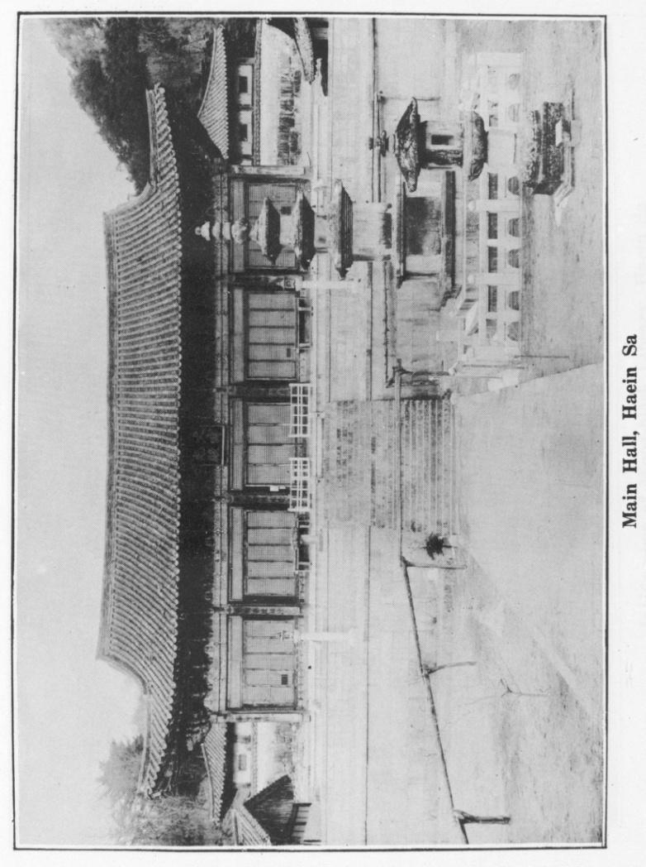
[page75]

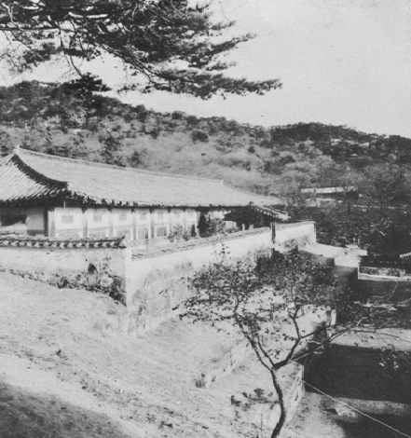
[page76]

Wood-block Library, Haein Sa
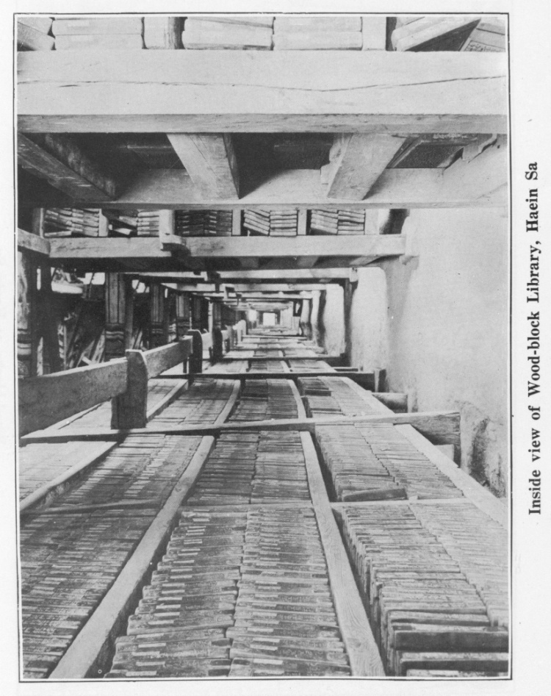
[page77]

Inside view of Wood-block Library, Haein Sa

[page78]
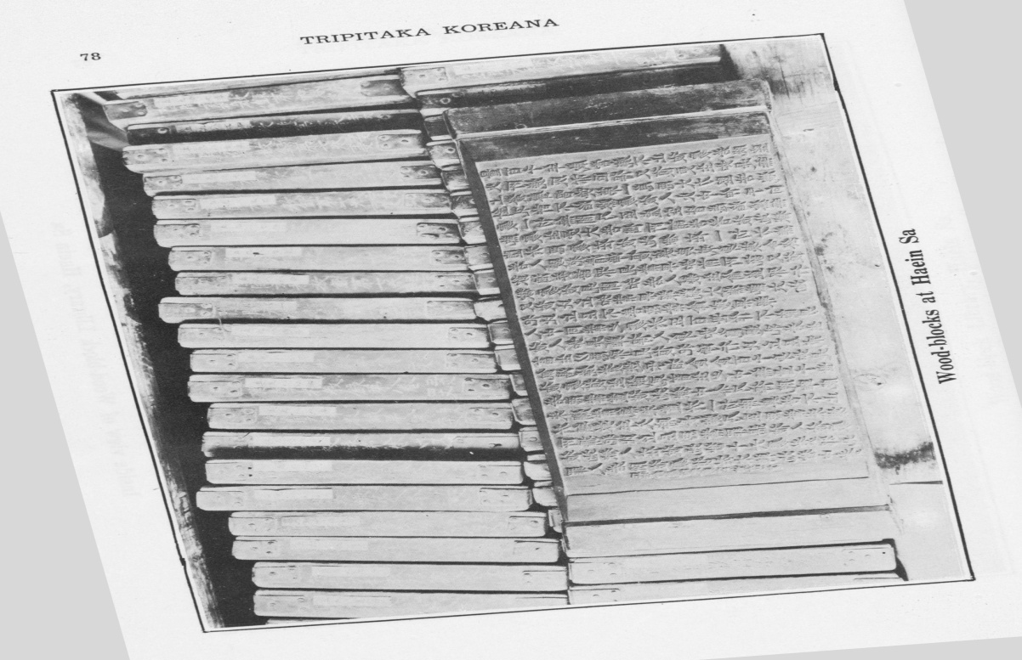

Wood-blocks at Haein Sa
[page79]

