[page 47]
ANNUAL MEETING

June 14, 1939

The Annual Meeting of the Royal Asiatic Society, Korea Branch, was held on June 14, 1939, at 5 P. M. at the Seoul Union.
Tea was served at 4:30 by the ladies of the Council.
The President, Dr. H. H. Underwood called the meeting to order at 5 o’clock. There were about 25 present Dr. Appenzeller acted as Recording Secretary.
The President made a report on the year’s work.
The minutes of the previous meeting were read and accepted.
Miss Wagner’s paper on “The Ghost Cult of Korea” was presented by Dr. Underwood, who read extracts. The paper was accepted.
Mrs. McLaren gave her report as librarian, and this was accepted with thanks.
Mr. Hobbs presented the treasurer’s report from June 1, 1938 to Mar. 31, 1939, and it was accepted with thanks.
New members were elected as per the Council report.
Mr. C. A. Sauer made the report of the Nominating Committee, and this was adopted as read.
The amendment to the constitution with regard to life membership was accepted to be voted on at the next annual meeting.
The meeting adjourned.

REPORT OF THE PRESIDENT
June 14, 1939

The President’s report for the past year can well be very brief, as the members of the Council and, you, the members of the society have all been working under conditions which did not lend themselves to the conduct of research work. In addition to this these same conditions [page 48]
have made it seem unwise to hold any more meetings than were necessary. For these reasons this annual meeting is the only open meeting which has been held during the year. The Council has met to discuss the work of the society and to plan for the publication of papers already read and to consider applications for membership but on the whole the year has been a quiet one with little to form material for a report.
However, the members of the society have not been idle and the Publications Committee in particular has been and is busy. Volume XXVIII was published as our 1938 publication and has been in your hands for some months. This work by Dr. E. M. Cable on “Korean American Relations” in the early days before Korea was opened to the world is one of the largest and most important papers which the society has published. The illustrations which were secured through the kind offices of Mr. H. B. Hulbert are particularly interesting as are the translations from the old Korean records on these matters. It is a matter of deep regret that in the publication of the paper a number of page s were duplicated, but though we regret this technical error it in no way injures the value of the material published. It gives for the first time a complete and accurate record of Korean American Relations from the official records of both countries. The total cost of publishing this volume came to well over ¥800. This is a larger sum than the society can well afford to invest in a single volume, but the peculiar historical value of this paper made it seem to the Council well worthwhile to publish it in full and with the very valuable illustrations, which accompanied it Volume XXIX consisting of two papers by Prof. McCune, “The Romanization of the Korean Language,” and a paper on the “Annals of the Yi Dynasty” is now in the press and will be ready for distribution in July. By special request from Prof. McCune the section on the “Romanization on the Korean Language” was printed sometime ago and Prof. McMune was permitted to have a number of reprints of this section made for his [page 49] use in the United States, although it will not appear officially as one of our Transactions until this summer. You will be interested to know that Mrs. Boots’ interesting paper on “Korean Musical Instruments and an Introduction to Korean Music” is now in the press and this will appear sometime in the fall, as volume XXX. In the same volume, we expect to publish a paper on “Sino Korean Relations at the End of the 14th Century” by Prof. Goodrich of Columbia.
I am also happy to announce that Rev. Charles Hunt tells me that he expects to be ready to present his paper on ‘‘Korean Drama” to you this fall. Letters from Dr. Koons inform us that he has done considerable reading and research on the subject of Dolmens during his furlough in America ana that he hopes to have his notes which he read before the society ready for publication soon after his return.
I should also say a word in regard to the paper to be read today, “The Ghost Cult in Korea” by Miss E. Wagnen This paper was prepared as a thesis for the degree of Master of Arts and it was our hope that Miss Wagner herself would read sections from the paper to you today. Unfortunately, Miss Wagner’s illness prevents her being with us and she has asked that I read certain selections of her choosing to you. The subject is a very interesting one and Miss Wagner’s presentation and views should be interesting to us all whether we accept her conclusions or not.
It is to be hoped that these papers published and read for the society will stimulate more of you to undertake investigation and research of different phases of ancient Korea. The other offices of the society will make their own report but I cannot refrain from saying a word in regard to the very fine work done by our Treasurer, Mr. T. Hobbs and our Librarian Mrs. McLaren. It is to be hoped that members of the society will make more and more use of the library which contains a great deal of very valuable material
In conclusion I would wish to express my gratitude to the society for the honor done me in electing me to this [page 50] position and my hope that as a society we may continue to build an increasing storehouse of research on Korea which shall be worthy of the work to be found in the 28 volumes, which the society has had the honor of publishing and which form a unique contribution to the study of the Far East.
Respectfully submitted,
UNDERWOOD,
President.

REPORT OF THE LIBRARIAN
June 14, 1939

The work of the Librarian for the past year has been largely conservative. Only one addition has been made to the Library, an illustrated work on spirit worship in Korea. None of the transactions have been bound in the past year and no correspondence has been undertaken.
The unfortunate illness of previous librarians has necessitated a considerable amount of work in cataloguing back numbers of the magazines. All the bookcases have been carefully gone through and all books and magazines put in order.
The Librarian suggests that limited space for magazines makes it advisable to purchase one bookcase suitable for larger size transactions.
Members of long standing have doubtless read most of the books in the Royal Asiatic Society Library but newer members may be glad to know that there is valuable material in both books and magazines and that such may be borrowed from the Society.
Respectfully submitted,
JESSIE MCLAREN,
Librarian.

[page 51]
CASH STATMENT
June 1 1938—March 31, 1939
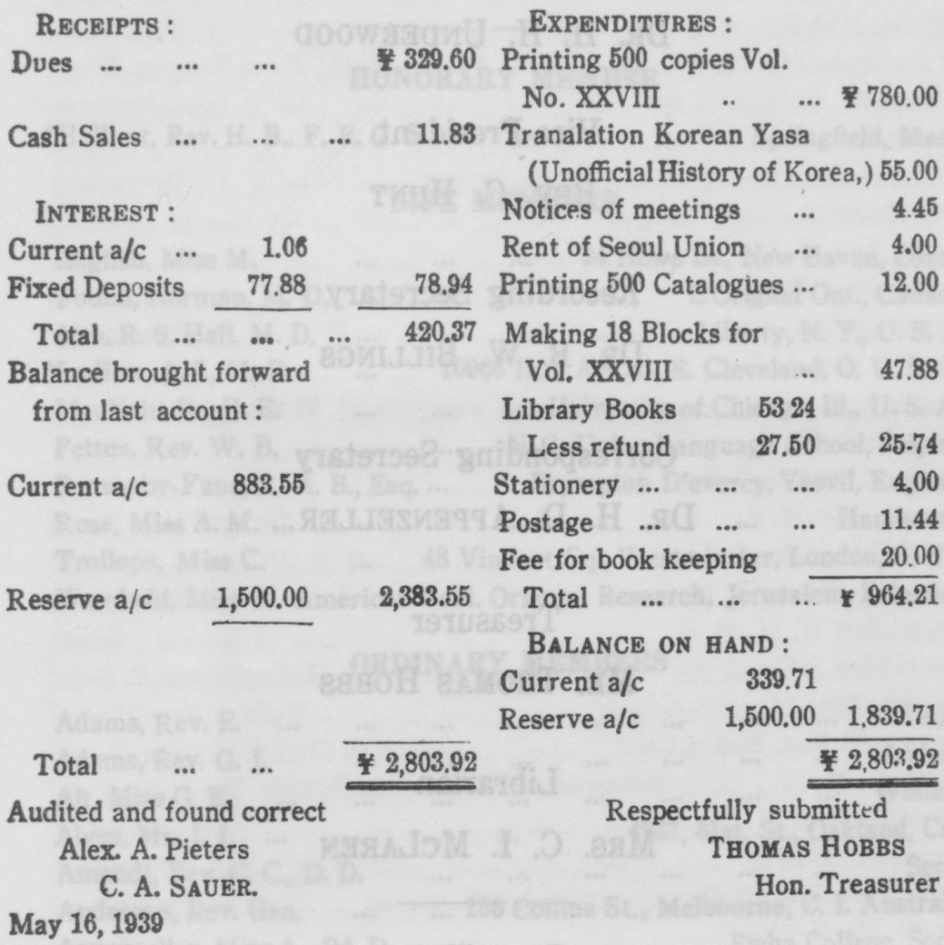

[page 52]
OFFICERS FOR 1939

President
DR. H. H. UNDERWOOD
Vice-President
REV. C. HUNT
Recording Secretary
DR. B. W. BILLINGS
Corresponding Secretary
DR. H. D. APPENZELLER
Treasurer
MR. THOMAS HOBBS
Librarian
MRS. C. I. MCLAREN
Councillors
DR. E. M. CABLE
DR. E. W. KOONS
REV. A. A. PIETERS

