[page 83]
ANNUAL MEETING June 1st, 1938

The annual meeting of the Korea Branch of the Royal Asiatic Society met at the Seoul Union on Wednesday, June 1st, 1938, at 4:30 p. m. with an attendance of about 30 members.
Tea was served by the ladies of the Council: Mrs. Cable, Mrs. McLaren, Mrs. Koons, Mrs. Underwood and Mrs. Hobbs.
The Acting President, Dr. Koons, called the meeting to order at 5 p. m.
The minutes of the previous meeting were read and approved.
President Koons presented a report which was accepted with thanks. (See report attached.)
Mr. Hobbs presented the report of the Treasurer and it was accepted with thanks. (See report attached.)
There being no Librarian, due to the absence from Korea of both Mr. Whittemore and Dr. Clark, the Chairman made a few remarks in regard to the Library and the use of the Library by its members.
It was moved, seconded and carried to recommend to the Council that a small catalogue, or list of books in the Library, be printed and made available to the members and friends.
Dr. Underwood reported for the Publications Committee. (See report attached.)
Mr. C. A. Sauer, Chairman of the Nominating Committee, read the report of that Committee nominating the following Officers and Councillors for the coming year :
President Dr. H. H. Underwood
Vice-President Dr. E. M. Cable
Recording Secretary Rev. Wm. C. Kerr
Corresponding Secretary Dr. H. D. Appenzeller
Librarian Mrs. Chas. L McLaren
Treasurer Mr. T. Hobbs
Councillors Dr. B. W. Billings
Dr. J. L. Boots Rev. A. A. Pieters. [page 84]
Nominations from the floor were called for and as none were forthcoming, it was moved, seconded and carried that the Secretary cast a ballot for the nominations as made by the Committee. This was done thus electing all the nominees. Miss Shirley Cable, Miss H. A. Hachler of the Salvation Army, Rev. Thompson B. Southall of Soonchun Mr. P. D. Perkins of Kyoto, were elected to membership.
There being no new business, Dr. Koons proceeded to read a very interesting paper on “Notes on Some of the Dolmens in Whanghai Province.’’
Mr. J. H. Morris showed some moving pictures illus-trating some points in his discussion.
The meeting adjourned at 6:15 p. m.

PRESIDENTS REPORT
Report to the Annual Meeting on June 1, 1938

In the absence of the President, I have the honor of summing up the year’s work of this organization. The most striking feature of the year has been the number of Council Members who have been obliged to relinquish their connection with the Society. Dr. W, M. Lee, Vice-President, found it necessary to resign. Mr. Ralph Cory, Corresponding Secretary, was transferred from the U. S. Consulate-General in Seoul to Tokyo. Dr. W. M. Clark, President, was sent to the U. S. A. on emergency health leave. Mr. Whittemore the Librarian, has resigned from the Northern Presbyterian Mission, so putting an end to our hopes of his return to work in this country. Rev. Charles Hunt is taking his furlough.
At present, the place of President is being filled by one of the Councillors. Dr. Underwood is combining the work of Corresponding and Recording Secretaries, Mr. Hobbs that of Treasurer and Librarian, and by action of the Council. Dr. Cable and Mr. Pieters have been asked to serve with Mrs McLaren, as Councillors, till this meeting.
Nominations for the ensuing year will be presented by [page 85] the Secretary. I wish, on behalf of the Society, to thank all who have risen to the occasion in this way, and have carried on for the duration.
Volume XXVII, containing “Some Notes on Father Gregorio De Cespedcs. Korea’s First European Visitor,” by Mr. Cory, and “A Biographical Sketch of Archbishop Mutel,” by Mr Gompertz, was published in 1937.
One open meeting was held, at which Prof. McCune of the University of California, and Prof. Reischauer, of Harvard, presented their plan for a System of Romanization of the Korean language, based upon phonetic science. This naturally caused the most intense differences of opinion among some of the auditors. The system has been some- what modified, and their paper will shortly be published as part of Volume XXIX, with a foreword by Dr. Underwood.
The catalogue of Transactions has been brought up to date, and will be put in your hands this afternoon. I trust that each member of the Society will be diligent making known to others the variety and richness of our published Transactions, and encouraging them to become owners of such as arouse their interest.
The Council is planning, while the writer of this report is on furlough, to allow him to arouse interest in the Society, among Libraries and similar institutions, in the belief that wider distribution of our Transactions will benefit the Society in more than one way.
1938 promises well for publications, for the Council plans to issue two volumes to contain: United States- Korean Relations, 1866-1871 and “A System of Romaniza-tion of the Korean Language.
E. W. KOONS

[page 86]
THE PUBLICATIONS COMMITTEE
The Chairman of the Publications Committee, Rev. Charies Hunt left on furlough in March and at that time I was asked to temporarily fill his position. The chief duty remaining is that I make this report to the Society.
Since last annual meeting Volume XXVII of the Society’s Transactions, containing Mr. Cory’s paper “Gregorio de Cespedes” and Mr. Gompertz’s paper “Biographical Sketch of Archbishop Mutel” was published and distributed. The Treasurer has also on the advice of the Publications Committee put out a little catalogue of our Transactions. Some copies of which are on hand here today.
A variety of circumstances has delayed and prevented the publication of the additional volumes during the present year, but at the last meeting of the Council held on May 12th the following publications were decided upon :
Volume XXVIII, Dr. E. M. Cable’s paper on “United
States-Koreau Relations between 18664871.”
Volume XXIX, Prof. McAfee, McCune, and Dr. Reischauer’s paper on a “System of Romanization of Korean Sounds” and Dr. Koons, paper on “Notes on Korean Dolmens.” It is possible that a brief paper by Prof. McCune on “The history of the Records of the Yi Dynasty” may be included in this volume.
Volume XXX, Mrs. Boots’ paper on “Korean Musical
Instruments” and Prof. Goodrich’s paper on “Sino-Korean Relations at the end of the 14th Century.”
It is our hope that Volume XXVIII and XXIX can both appear in print before the end of the calendar year and that Volume XXX may be published early in 1939.
Dr. E. M. Cable’s paper is already in the press and we have good reasons to hope that the above schedule may be carried out promptly.
Respectfully submitted,
HORACE H. UNDERWOOD

[page 87]
RULES FOR THE LIBRARY
1. Members residing in Seoul may keep books for one month only. For each additional day, the fine is ¥ .05.
2. Out-of-town members may keep books for two months only. For each additional day, the fine is ¥ .05.
3. If it is necessary to keep books longer, the librarian must be asked for permission.
4. Books may be renewed on expiration of the allotted time.
5. Not more than two books may be taken out at a time, unless special permission is granted by the librarian.
6. The keys may be obtained from “In formation’’ in the C. L. S. offices, and the books given to him to be dated and the cards placed in the box. He must also be given returned books.
7. Magazines may not be taken out of the Board Room except when they are bound and numbered as ordinary books.
8. Please be careful to return books and magazines to their proper places after reading them, or else place them on the desk and the librarian will replace them.
9. A complete index will be found on the desk. Kindly make use of it. [page 88]
ROYAL ASIATIC SOCIETY
Cash Statement
June 1 1937―May 31 1938
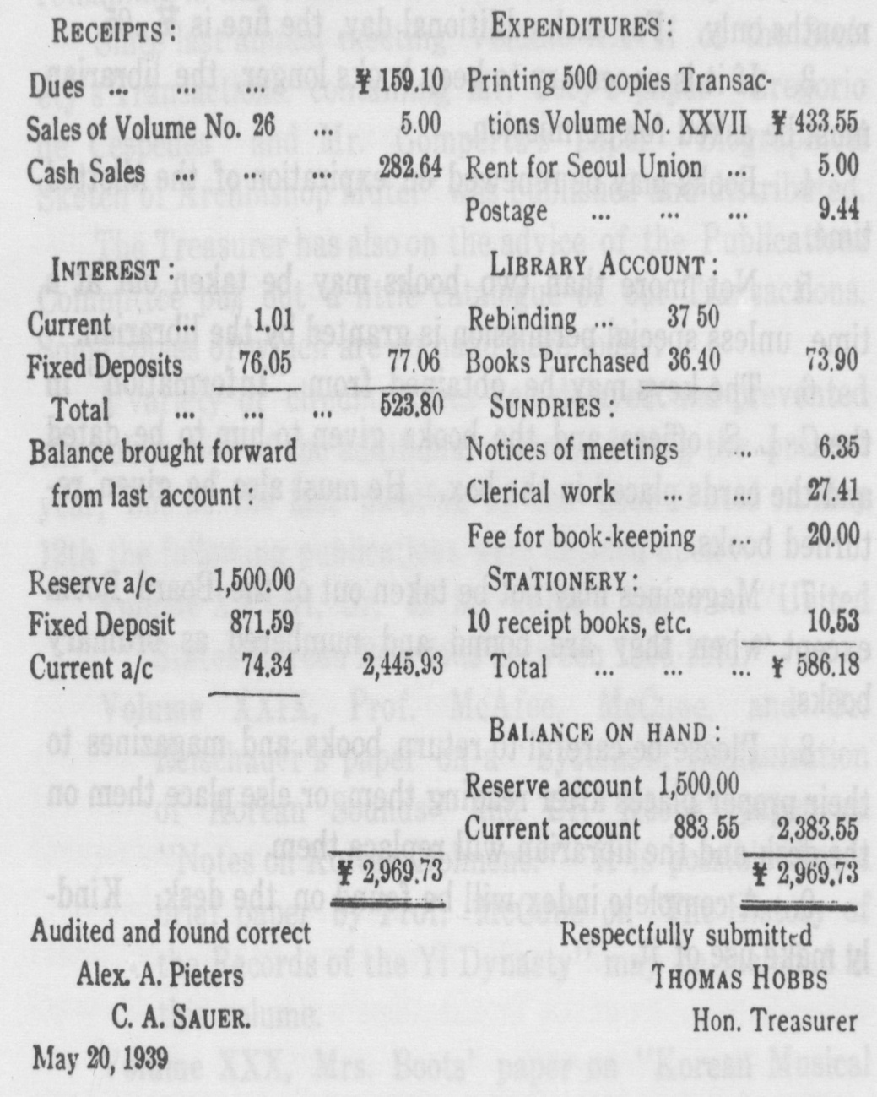

[page 89]
OFFICERS FOR 1939

PRESIDENT
DR. H. H. UNDERWOOD
Vice-President
REV. C. HUNT
Recording Secretary
DR. B. W. BILLINGS
Corresponding Secretary
DR. H. D. APPENZELLER
Treasurer
MR. THOMAS HOBBS
Librarian
MRS. C. I. MCLAREN
Councillors
DR. E. M. CABLE
DR. E. W. KOONS
REV. A. A. PIETERS
7 Vol.29

