[page 231]
ROYAL ASIATIC SOCIETY

Cash Statement
June 1/37—May 31/38
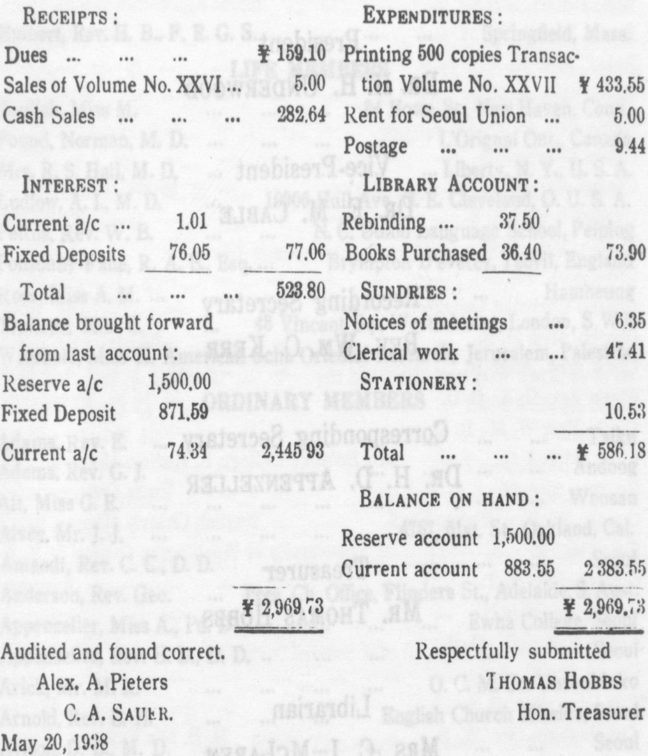
18 Vol. 28 [page 232]
OFFICFRS FOR 1938
President
DR. H. H. UNDERWOOD
Vice-President
DR. E. M. CABLE
Recording Secretary
REV. WM. C. KERR
Corresponding Secretary
DR. D. APPENZELLER
Treasurer
MR. THOMAS HOBBS
Librarian
MRS. C. I. MCLAREN
Councillors
DR. B. W. BILLINGS
DR. J. L. BOOTS
REV. A. A. PIETERS

