[page 133]
ANNUAL MEETING

May 31st, 1937

The annual meeting of the Korea Branch of the Royal Asiatic Society was called to order at 4:50 P. M. at the Seoul Union, the President Mr. Hugh Miller presiding, about 60 members and guests being present.
The minutes of the 1936 Annual Meeting were read and approved.
President Miller presented his report which on motion was accepted with thanks accompanied by hearty applause.
Mr. Miller reported that since the departure on furlough of Mr. Thomas Hobbs, the Treasurer : the had himself served in this capacity and that he had prepared a report which Dr. W. M. Clark was asked to read. Dr. Clark read the report which showed a very satisfactory state of the financial situation of the Society. The report was accepted with thanks. See report.
Dr. Clark presented the report of the Librarian including a number of suggestions for rules governing the use of the library. After a few questions, the report including the suggested rules was accepted and adopted. See report attached.
Dr. E. M. Cable, Chairman of the Nominating Committee read the report of that Committee nominating the following as officers and counsellors for the coming year:
President Dr. W. M. Clark
Vice-President Dr. M. M. Lee
Recording Secretary Dr. H. H. Underwood
Corresponding Secretary Mr. Ralph Cory
Treasurer Mr. Thomas Hobbs
Librarian Mr. Norman Whittemore
Counsellors Rev. Charles Hunt
Dr. E. W. Koons Mrs. C. I. McLaren
Nominations from the floor were called for and as none were forthcoming, it was moved and seconded and carried that the secretary cast a ballot for the nominations as made [page 134] by the Committee. This was done thus electing all the nom- minees. Messrs. John and James Uuderwood were proposed as members and elected.
There being no new business the Chairman introduced the speaker of the afternoon, Mrs. J. L. Boots. Mrs. Boots spoke on Korean Music and Musical Instruments, giving a brief sketch of the history of Korean music as introductory to her discussion of Korean instruments. The lecture was illustrated with photographs of various Korean instruments.
The retiring Chairman called on the newly elected President, Dr. W. M. Clark to take the chair which he did and after making a few remarks expressing the thanks of the Society, to Mrs. Boots for her excellent paper, to Mrs. Miller and Mrs. Underwood who had served refreshments before the meeting be declared the meeting adjourned.
[page 135]
PRESIDENT’S REPORT

Report to the Annual Meeting on May 31, 1937
The current year has been one of the most interesting years we have had in the history of the Society. Our season opened with Dr. Cable reading: a paper on Uuited States and Korea relations, but this paper is not yet ready for publication. Then we had the unique experience of having a paper read on the life of one who went in and out among us for many years This paper on Archbishop Mutel was prepared by Mr. Gompertz and extracts read from it by his father-in-law, Dr. Koons. This in itself was an unusual experience.
Today we are to have a paper read by Mrs. Boots on Korean Musical Instruments. This paper has been wanted for many years, and we are indebted to Mrs. Boots for having been willing to prepare it.
I think few of us realize the amount of work involved in the preparation of these papers. Much has to be done before a sentence can be committed to paper.
We are grateful to all those who have added to their re-sponsibilities by undertaking to prepare these papers and thus making it possible for many now and the oncoming generations to know something of the civilization of the Hermit-Kingdom. Dr. Gale once wrote that Korea was the last custodian of the civilization of the wonderful Chinese people and it is good for us to know what it meant to the people of Korea. We are living in a new worlds Old things are passing away very rapidly. I would like to urge upon the younger folks especially to have as a hobby some phase of this old world for investigation and study and to put the results in such a form that they will be available for all English speaking students.
The Japanese are making available a good deal of material in Japanese that will be helpful to those making studies of the civilization that conserved much of the best things in life for this Far East. [page 136]
During the years I have been a member of the Society, I think I have held all the offices of the Society and now I am at the end of the route and out I go. I thank you all for the pleasures you have given me.
[page 137]
THE PUBLICATIONS COMMITI’EE REPORT

The members of the Publications Committee for the past year were the Reverend Charles Hunt, Chairman, Mr. Hugh Miller and Mr. Ralph Cory.
During the year Volume XXVI “Korean Astronomy” by Dr. Carl Rufus was published.
Volume XXVII is in the press. This volume will be a large size one, containing Mr. Ralph Cory’s paper on “Gregorio Cespedes”, and Mr. St. G. Gompertz’s “Biographical Sketch of Archbishop Mutel”. It was hoped that this volume would have been in your hands at this meeting, but owing to lack of type at the press and other causes there has been a delay in the publication. Volume XXVII should be ready for distribution at the end of June.
The Council gave permission to the Publications Com-mittee to republish such volumes of the Transactions as are out, or almost out, of print, but time has not allowed these reproductions to be made up to the present Such necessary reproductions will be made as soon as possible.
Dr. Cable’s paper which he read in two parts should be ready for the press this year. This paper on “Korean-American Relations 1866-1871” will be illustrated with some valuable photographs secured in America through the kindness of Dr. Hulbert in co-operation with Dr. Cable and at the expense of the Society.
We are hoping to publish as soon as possible Mrs. Boots’ Paper on “Korean Music”, and the following papers promised to the Society, but not yet presented to the Society.
“Corean Costumes” by Mrs. Crane.
“Dolmens” by Dr. Koons.
“Corean Drama’’ by the Reverend Charles Hunt.
“Butterflies in Corea” by Bishop Cecil Cooper, or Mr.
Snyder.
“Corean Medicine” by Dr. Borrow. [page 138]
“The Art of Nak Yang” by Mr. G. Gompertz, in cooperation with Dr. G. Paik who has already given us paper on Nak-Yang, although the paper is not yet ready for publication.
We are grateful to the Press of the Korean Y. M. C. A. for the excellent work done in connection with the printing of the Transactions of the Society.
CHARLES HUNT
Chairman of the Publications Committee.
[page 139]
REPORT OP THE LIBRARIAN

to the Royal Asiatic Society, Korea Branch
May 31, 1937
The work of the librarian for the past year contains much of interest to those who desire to see the library of the Korea Branch of the R. A. S. made more accessible to the general public. During the term of Mr. Whittemore as librarian, he was able to add a great many valuable books to the library.
Your librarian has endeavored to carry forward the work that Mr. Whittemore was doing but has. emphasized the securing of missing numbers of the transactions of the Japan and China branches, the binding of many transactions and the better cataloguing and organization of the library. The work has entailed a great deal of correspondence. Some forty letters have been written in the past few months and progress has been made in completing the cataloguing of the magazines. This work would have been impossible had it not been for the efficient and intelligent work done by Miss Frampton and the credit for the increasingly satisfactory condition of the library is largely due to her efforts.
It became necessary to move two sections of the bookcases in order to cut a door through the wall of the Board Room. These two sections, however, were moved to one side of the room and minor repair made at the expense of the C. L. S. In this connection it should be noted that we need three additional bookcases. The former book space was entirely inadequate when we began to arrange the magazines so as to make them accessible. The C. L. S. has supplied three bookcases of the same type and finish which the Society should buy at this time. These bookcases are offered to us at ¥80, which is below the cost price.
22 volumes have been rebound at a cost of ¥22.95 and 9 additional copies are being bound at the cost of ¥11.30. All of the important magazines and transactions should be [page 140] bound as rapidly as possible so as to protect the books and make them accessible. About ¥50 has been spent on transactions from Japan and about the same amount is being spent for transactions from China. In addition, considerable money has been spent for work in cataloguing and indexing. The council ordered some time ago that the librarian should prepare and print a catalogue of the books. Such a catalogue is at hand in manuscript form prepared in 1928 but a great deal of work is yet necessary in the way of reindexing according to proper subjects before an up-to-date catalogue can be printed and, in order to facilitate this, we shall probably have to stop the borrowing of books from the library until the work is done. A number of letters have recently been written asking for the return of books that have been out for some time.
The suggestion has been broached that the small Library of the Federal Council might well be turned over to the Royal Asiatic Society and this seems to be a good suggestion in case the Royal Asiatic Society is willing to take over the books and include them in its library. This matter might well be discussed at the Federal Council meeting in September.
The librarian submits herewith a suggested list of rules for the conduct of the library and asks that they be approved.
We may summarize our suggestions as follows :
I. That ¥80 be appropriated to buy three additional bookcases.
II. That ¥250 be appropriated for the ensuing year.
III. That the Council approve the policy outlined above :
1. Of securing complete sets of the transactions of the Japan and China branches ana publications of special interest in other Oriental lands.
2. Of continuing the work of indexing and preparing for the publication of a catalogue. [page 141]
3. Of the rebinding of as many magazines
as possible each year.
4. Of approving the rules suggested covering the issuance of books from the library.
A list of recent accessions to the library are as follows :
“Thriving Chosen” Presented by:
Rev. W. M. Clark, D.D.
“Report on Administration
of Chosen” Presented by:
Government General of Chosen
“Transactions of the Asiatic Purchase
Society of Japan.” Vols.
47; 43 pt 2; 44 pt 1, 2;
45, pt, l, 2; 46 pt. 1
‘‘Undiplomatic Memories” (Sands)
“Japan and the United Presented by:
States” (Treat) Rev. N.C. Whittemore
“Story of Nations: Japan”
(Murray) Presented by:
“Korean Conspiracy Trial” Rev. N.C. Whittemore
“Transactions of the Asiatic Purchase
Society North China
Branch:” Vols. Old Se-
ries: Vol. 1 pt. 3; 2, pt.
1; New Series: Vol. 2; 5;
9; 12; 14; 16 pt. 2; 17 pt
2; 18; 19 pt 1; 20 pt 206;
21 pt 1-2, 5-6; 22 pt 6;
24. Extra Volumes 1, 3,
4, 5, 6.
Respectfully submitted,
W. M. CLARK,
Librarian
[page 142]
RULES FOR THE LIBRARY

1. Members residing in Seoul may keep books for one month only. For each additional day, the fine is ¥ .05.
2. Out-of-town members may keep books for two months only. For each additional day, the fine is ¥ .05.
3. If it is necessary to keep books longer, the librarian
must be asked for permission.
4. Books may be renewed on expiration of the allotted
time.
5. Not more than two books may be taken out at a time, unless special permission is granted by the librarian.
6. The keys may be obtained from “Information” in the C. L. S. offices, and the books given to him to be dated and the cards placed in the box. He must also be given returned books.
7. Magazines may not be taken out of the Board Room except when they are bound and numbered as ordinary books,
8. Please be careful to return books and magazines to their proper places after reading them, or else place them on the desk and the librarian will replace them.
9.A complete index will be found on the desk. Kindly make use of it. [page 143]
KOREA BRANCH OF ROYAL ASIATIC SOCIETY
Cash Statement
June 1st 1936-May 31st 1937
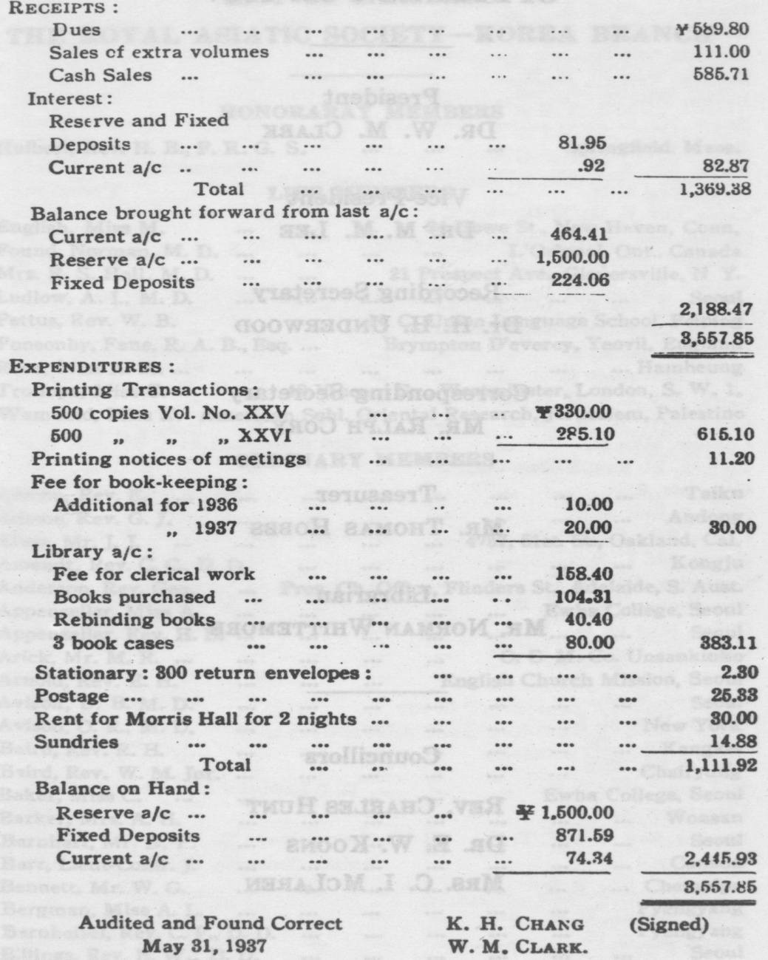
[page 144]
OFFICERS FOR 1937
President
DR. W. M. CLARK
Vice-President DR. M. M. LEE
Recording Secretary
DR. H. H. UNDERWOOD
Corresponding Secretary
MR. RALPH CORY
Treasurer
MR. THOMAS HOBBS
Librarian
MR. NORMAN WHITTEMORE
Councillors
REV. CHARLES HUNT DR. E. W. KOONS MRS. C. L MCLAREN

