ANNUAL MEETING June 16, 1936 MINUTES

The annual meeting of the Korea Branch of the Royal Asiatic Society was held on June 16th, 1936, with the President, Rev. Charles Hunt, in the chair.
The meeting was called to order at 5:15 p. m. with about 50 members present
The minutes of the 1935 annual meeting and of the open meeting of 1935 were read and approved.
The President read his report which was accepted with thanks, (See report attached).
Mr. G. Bonwick the Treasurer, read his report which was accepted with thanks. (See report). The Treasurer moved that the Society increase the fee paid to the Korean Bookkeeper by Y 10.00. Passed.
Rev. W. M. Clark presented the Librarian’s report, including the recommendation that the usual appropriation of Y150 made for the Library ; also including certain suggestions in regard to the housing and care of the library. The report was accepted with thanks and the suggestions in regard to the library were referred to the Council.
Rev. Charles Hunt made the report for the Publication Committee. (See report attached)
The Nominating Committee reported on nominations for officers for the coming year. The Chairman called for nominations from the floor and as none were forthcoming, it was moved and seconded and passed that the secretary cast a ballot for the nominations made by the Committee. This was done, thus electing the following as Officers and Councillors : [Page 50]
President Hugh Miller, Esq.
Vice President Rev. Charles Hunt
Recording Secy H. H. Underwood, Esq., Ph.D., Litt. D.,
Corresponding Secy Ralph Cory, Esq.
Treasurer … … Thomas Hobbs, Esq.
Librarian Rev. W. M. Clark, D. D.
Councillors Rev. H. D. Appenzeller, Dr. L. G. Paik,
Dr. M. M. Lee

Mr. and Mrs. G. H. Phipps, Mrs. J. D. Davis, Mrs. G. H. Rue and Miss E. Gill were proposed as members and elected.
The President then introduced Mr. Ralph Cory who read a most interesting paper on “Gregorio de Cespedes”, the first Occidental visitor to Korea.
The meeting adjourned at 6:30 p. m. with a vote of thanks to Mrs. Underwood, Mrs. Pieters, Mrs. Appenzel- ler and the other ladies who helped to serve tea.
H. H. UNDERWOOD,
Recording Secretary

THE PRESIDENT’S REPORT 1935-1936

A Society such as ours does not necessarily show its purpose and usefulness by the number of open meetings held during the year. If such were the case people might reasonably complain that two open meetings held during the year hardly shows a keen and vigorous condition. The real purpose however is shown rather in the useful matter published in the Transactions, and in the certain knowledge that several members of the Society are pursuing their studies and research in the history, literature and sciences of this country, with a view to presenting papers to the Society at some future date. It is true that two public meetings have been held, one the Annual meeting last summer when Dr. Paik read us his notes on the Korean Record of the visit of Captain Basil Hall in 1816, and Dr. Boots gave us a talk on Korean Archery, and in December when Dr. Rufus gave us a lecture on Korean Astronomy. Until to day no other public meetings have been held.
The Council of the Society has met four times during the year and found on each occasion useful agenda to be discussed. The reports of the Treasurer, Librarian, and Publications Committee will be presented to you at this meeting and you will I think after hearing these Reports agree that the Society is not in a moribund condition, but active and fulfilling its purpose.
Shortly after the election of Officers at the last annual meeting, the Librarian, the Rev, N. C. Whittemore had to resign on his leaving for America, and Dr. W. M. Clark kindly consented to take his place. The Corresponding Secretary, Mr. Ralph Cory was absent for several months in U. S. A, and during that time Mr. Pieters kindly acted in that office.
At the last meeting of the Council, Mr. Hugh Miller, Dr. Cable and Mr. Barnhart were asked to act as a Nominating Committee to select Officers for the coming year, and you [Page 52] will hear shortly the names suggested by the Committee and have the pleasure of voting on the same.
I am glad to be able to report that Mrs. Crane of Soon-Chun has been approached on the question of preparing a paper on Corean Costumes. Mrs. Crane says that during the 20 years she has been in Corea she has collected about 280 sketches of Corean Costumes. It may be possible to persuade her to present a paper before the Society and to be allowed to print her interesting and valuable collection of sketches of Corean Costumes.
Mr. Gompertz of Japan has compiled a most attractive and interesting Biographical Sketch of the late Archbishop Mutel whose life and work in Corea covered the momentous years 1880-1933— over 50 years. It may be possible, and I certainly think it desirable, to publish this Biographical Sketch in the Transactions of the Society. It would form interesting reading at an open meeting of the Society.
Other subjects such as Dolmens ; Corean Music ; Corean Drama ; Corean Medicine are being studied with a view to presenting papers to the Society. Dr. Cable has yet to give us the second part of his paper on Korean-American Relations 1866-1871, and promises to do so in the autumn.
However I again beg members seriously to consider the future usefulness of the Society which can best be served by taking up some special subject of study recommended by the Society, or of his own choice, and presenting papers before the Society to be considered at an open meeting and perhaps published in the Transactions of the Society.
I thank you for the patience with which you have endured two years of my Presidency, and I hope that under a new President the Society will renew its strength and fulfil the purpose for which the Korea Branch was founded thirty five years ago.

THE LIBRARIAN’S REPORT June 16, 1936

Your librarian was asked to take up this work after Mr. Whittemore left unexpectedly for America last July. He took it with the understanding that he would have little or no time to devote to it, as he had meanwhile fallen heir to Mr. Whittemore’s work in the Christian Literature Society as well as his own.
With regard to the library, little has been done during the past year toward the purchase of books, but a few books have been aquired both by gift and purchase. Mrs. McLaren devoted some time to putting the library books in proper shape, and some few people have used the library during the yean
The Society owns some very valuable books, and it is a pity that these books are not used more by the community. The only constructive suggestion your librarian can make is the desirability that the various bodies in Seoul that have libraries should come together and devise ways and means whereby a half-time or a full-time librarian might be employed to make all the books in the community available to all, under reasonable rules and regulations. This would require some money on the part of each body and might well be considered. For example, the Seoul Foreign School, the Seoul Women’s Club, Federal Council Library, Royal Asiatic Society, and perhaps other organizations might be expected to combine in furnishing a half-time or a full-time librarian, with the library at some central place, probably at the Seoul Foreign School.
W. M. CLARK,
Librarian.

THE PUBLICATIONS COMMITTEE’S REPORT 1935─1936

The members of the Publications Committee for the year were the Rev. Charles Hunt, Rev. A. A. Pieters and Mr. Gerald Bonwick. The members of the Committee gave a good deal of time to the reading of proofs and Mr. Pieters kindly provided the Chinese Characters of the many Corean Books mentioned in Courant’s Introduction to Bibliographie Core- enne.
During the year the following Transactions were re-printed :ᅳ
Vol. X. “The Climate of Korea, and its probable effect on Human Efficiency.’’ By Dr. J. D. Van-Buskirk.
Vol. XI. “Captain Basil Hall’s Account of his voyage to the west coast of Corea in 1816
“Arboretum Coreense. Part II and Part III by Bishop Trollope.
Volume XXV was issued in August, 1936.
The volume contains a “Translation into English by Mrs. Massy Royds of Courant’s Introductions to Bibliographie Coreenne,” an article on “Book Production and Printing in Corea” by the late Bishop Trollope and “an Index to Titles and Authors of papers published in the Transactions of the Korea Branch, R. A. S, Volumes I─ XXV.” by H. H. Underwood, Esq., Ph. D, Litt D.
In the press, Volume XXVI containing Dr. Carl Rufus’ paper on “Korean Astronomy” with 34 illustrations.
CHARLES HUNT,
Chairman

CHARLES HUNT, Chairman THE TREASURER’S REPORT 7 Vol. 26
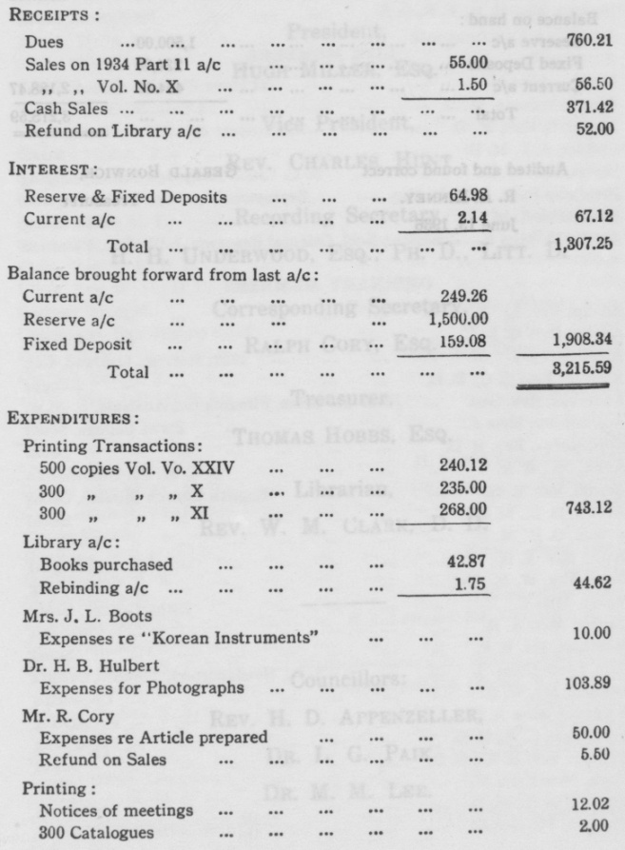
Cash Statement June 1, 1935ᅳ─May 31, 1936
[Page 56]
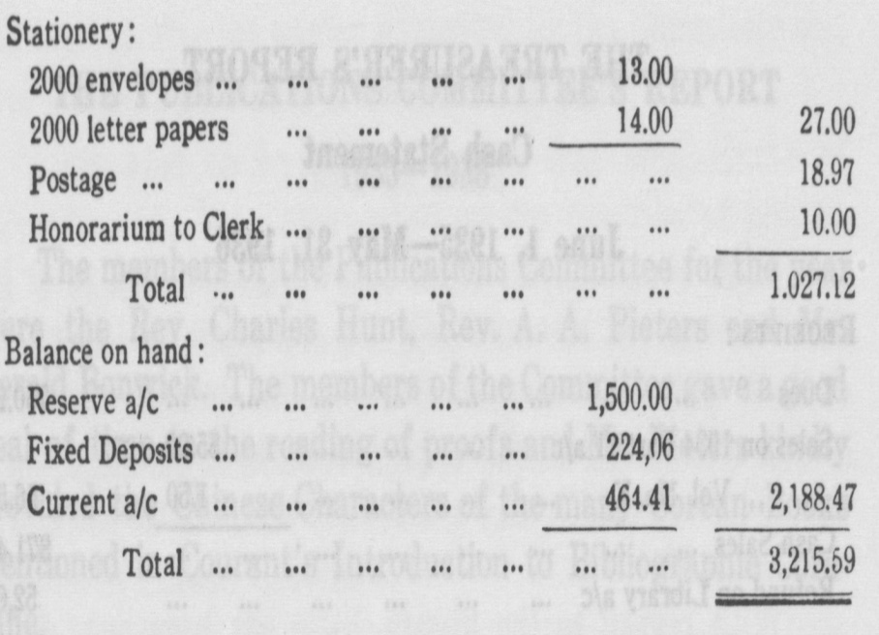
Audited and found correct GERALD BONWICK,
R. A. KINNEY, Treasurer
June 13,1936

OFFICERS FOR 1936
President,
HUGH MILLER, ESQ.
Vice President,
REV. CHARLES HUNT
Recording Secretary,
H. H. UNDERWOOD, ESQ., PH. D., LITT. D.
Corresponding Secretary,
RALPH CORY, ESQ.
Treasurer,
THOMAS HOBBS, ESQ.
Librarian,
REV. W. M. CLARK, D. D.
Councillors:
REV. H. D. APPENZELLER,
DR. L. G. PAIK

LIST OF MEMBERS THE ROYAL ASIATIC SOCIETY—KOREA BRANCH
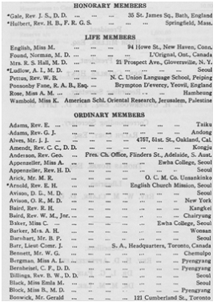[Page 59]
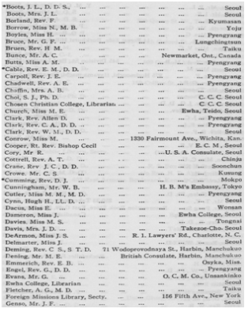[Page 60]

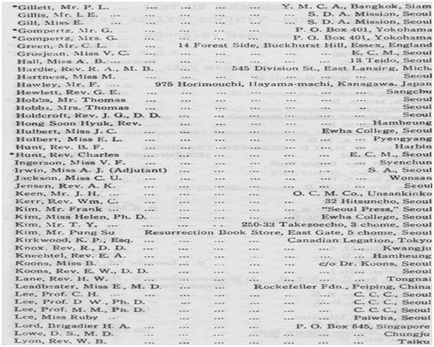[Page 61]
[Page 62]
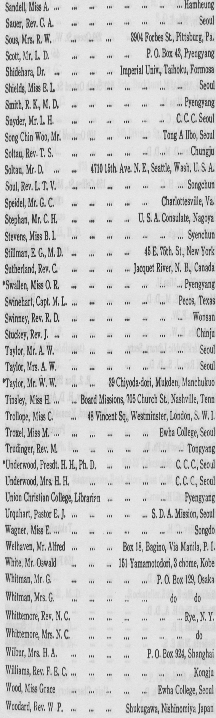 [Page 63]
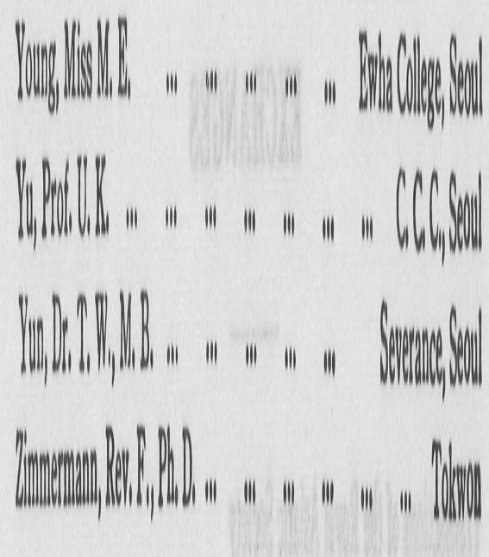
NOTE—Those having an Asterisk (*) before their names have read Papers at meetings of the Society.

EXCHANGES
Transactions of the Royal Asiatic Society
74 Grosvenor Street,
London, W. 1, England
Journal Asiatique 13 Rue Jacob, Paris VI.
France
Journal of the American Oriental Society
c/o Yale University Press, New Haven, Conn., U. S. A.
Proceedings of the American Philosophieal Society
104 South Fifth Street, Philadelphia, Pa., U. S. A. Geographical Journal Royal Geographical Society,
Kensington Gore, London, S. W. 7, England. Geographical Review American Geographical Society of
New York, Broadway at 156th St, New York City, U. S. A. Bulletin of the Geological Institute of Sweden
University of Upsala, Sweden Journal of the Ceylon Branch of the Royal Asiatic Society Ceylon Branch of R. A. S.,
Colombo, Ceylon. Journal of the Bombay Branch of the Royal Asiatic Society,
Bombay, India. Annual Report of the Smithsonian Institution
Washington, D. C., U. S. A. Transactions of the Asiatic Society of Japan
Osaka Building, 3 Uchisaiwai Cho, Ichome, Kojimachi-Ku, Tokyo. Journal of the North China Branch of the Royal Asiatic Society
20 Museum Road, Shanghai, China. Archiu Orientalni, Orientalni Uslav N. Praze
Oriental Institute, Prague, Praha, III-347 Czecho Slovakia.
Sign Direttore Archiv Hist S. I.
Borgo S. Spirito 5, Rome 113, Italy.

