KOREA BRANCH OF THE ROYAL ASIATIC SOCIETY

Annual Meeting, June 12th, 1935

The Korea Branch of the Royal Asiatic Society met at the Seoul Union on June 12th, for its annual meeting. Tea was served from 4 until somewhat after 4 :30 m. by Mrs. H. H. Underwood, assisted by Mrs. E. W. Koons and Miss Hermie Lewis.
The meeting was called to order at 4 :50 p. m. by the Rev. Charles Hunt, about 35 members being present
The minutes of the 1934 annual meeting were read and approved, after which the president read a brief report which was received with much applause. See report at-tachequ.
The report of the liorarian, Mr. N. C. Whittemore, was read and accepted with thanks. See report
The treasurer’s report, showing a very satisfactory condition in the treasury, was also read by Mr. Bonwick, and accepted with thanks. See report.
Rev. C. Hunt, as chairman of the publication committee, reported on the volumes of transactions now in the press and the council’s plans for publications. The report was accepted with thanks. See report.
Dr. H. A. Rhodes reported for the nominating committee. The chairman called for nominations from the floor. As no nominations were forthcoming Dr. E. W. Koons moved that the secretary be instructed to cast a ballot for the nominations as made. Passed. The secretary cast the ballot, thus electing as officers and councillors for 1935-
1936, the following ]
President Rev. Charles Hunt
Vice President Rev. A. A. Pieters
Recording Secretary Mr. H. H. Underwood, Litt. IX
Corresponding Secretary Mr. Ralph Cory
Treasurer Mr. G. Bonwick
Librarian Rev. N. C. Whittemore
Councillor Rev. H. D. Appenzeller
do Mrs. C. I. McLaren
do Rev. B. W. Billings, D. D. [page 50]
Rev. E. I. Carroll was nominated for membership in the Society and duly elected.
The president then called on Dr. L. G. Paik to read his Notes on the Korean Records concerning the visit of Basil Hall in 1816. Dr. Paik, after a few introductory remarks on the history of the visit, read some very interesting notes, including a translation of the report of this visit from the Chronicles of the Yi Dynasty. Dr. Paik brought and showed maps, locating definitely the ports where the ships touched at that time.
Following Dr. Paik’s remarks, the chairman called on Dr. Boots who gave a very interesting talk on Korean archery and the construction and use of the Korean bow. Br. Boots then introduced the archery coach from one of the large archery clubs of the city, who demonstrated the stringing, use and care of the bow, and added some interesting remarks concerning Korean archery. The meeting adjourned shortly after 6 m. after thanking all those who had contributed to making it a success.
H. H. UNDERWOOD, Secretary.

THE PRESIDENT’S REPORT 1934-1935

During the past year the Council of the Korea Branch of the R. A. S. has met four times, and there have been two open meetings of the Society ； on 7th December, 1934, when Dr. Underwood read extracts from Mrs. Massy-Royds’ translation of Courrant’s Bibliography of Corean Literature ； and on the 20th March, 1935, when Dr. Cable presented Part I of his paper on American-Korean Relations, 1866-1871.
The Reports of the Treasurer, Librarian, and Publications Committee will be presented to you at this meeting and you will be able to judge from these Reports that the Society is in a healthy and vigorous state.
I would like to urge members of this Society to study again the printed list of the suggested subjects for study and presentation in lecture form, and perhaps for publication in the Society’s Transactions. Unless these subjects and others of an historical, literary or scientific nature are made subjects of research or study, the Society cannot function to any useful purpose and will of its own inertia cease to exist, as it did for some years—from 1902 until it was re-orgained in 1911 ； nine years without an open meeting, no papers read and no Transactions printed. However, I am thankful to report that at present the Society shows a little more vigour and a few keen members are preparing papers of interests. In actual preparation are the following papers ：一
“Gregory de Cespedes” by Mr. Ralph Cory.
‘‘Libraries of Korea” by Dr. M. M. Lee.
‘‘Korean Drama’’ by the Reverend Charles Hunt
“An Enquiry into the Dolmens of Korea’’ by Dr.
Koons.
‘‘Musical Instruments” by Mrs. Boots.
Several members have offered to prepare papers on the following subjects, to be presented some time in the dim and unknown future :—
“Butterflies of Korea” by Bishop Cecil Cooper (assisted by Mr. Yun) [page 52]
“Corean Medicine” by Dr. Ann Borrow. “A Translation of Dallett’s “History of Korea” by Mr. Gompertz.
“A Memoir of the late Archbishop Muter”, covering an interesting period of Korean History from 1880- 1933, by Mr. Gompertz. One of the most important subjects for study is that of Corean Costume, and although several members have taken a bite at the bait no-one so far has been secured to give serious attention to it.
In membership about 14 members have resigned or dropped out of the list, whilst about 12 new members have joined during the past year.
I should like to suggest that members who are adepts in the Corean or Japanese languages should try and make translations of some of the Corean and Japanese books on Archaeology and Art Mr. Gompertz of Yokohama says that such works as Sekino’s ‘‘History of Corean art” and Imanishi’s “Introduction to Corean History’’ are recent and valuable books, and should be translated into English if possible.
It may be that the Society could see its way clear to make grants towards the work of translating these and similar works -一a rough estimate of the cost of getting the translating done is Yen 50 per 150-200 page s. In the long run this would pay and would be very well worth while doing.
This meeting will have the pleasure of electing the Officers for the year 1935-1936. At the last Council meeting of the Society the following were elected members of the Nominating Committee: Dr. H. A. Rhodes, Miss Appenzeller and Mr. R. Cory, and doubtless they will present names acceptable to you to act as Officers for the coming yean
I thank the Society for the honour it has done me and wish my successor the support that the past year has brought to me.

Charles Hunt,
President: Korea Branch, R. A. S. [page 53]
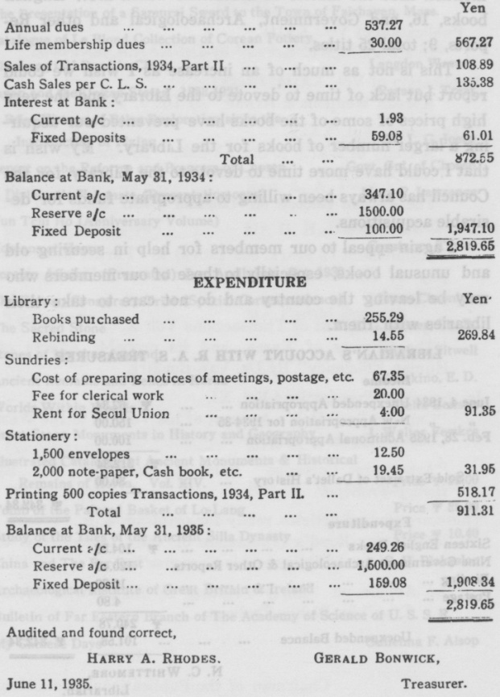

REPORT OF THE LIBRARIAN

In making my Annual Report to the Society I would mention first the matter of accessions which are:-English books, 16, and Government, Archaeological and other Reports, 9; total 25 titles.
This is not as much of an increase as I wish we could report but lack of time to devote to the Library and the very high prices of some of the books have prevented our acquiring a larger number of books for the Library. My wish is that I could have more time to devote to the Library for the Council has always been willing to appropriate funds for desirable acquisitions.
I again appeal to our members for help in securing old and unusual books, especially to those of our members who may be leaving the country and do not care to take their libraries with them.
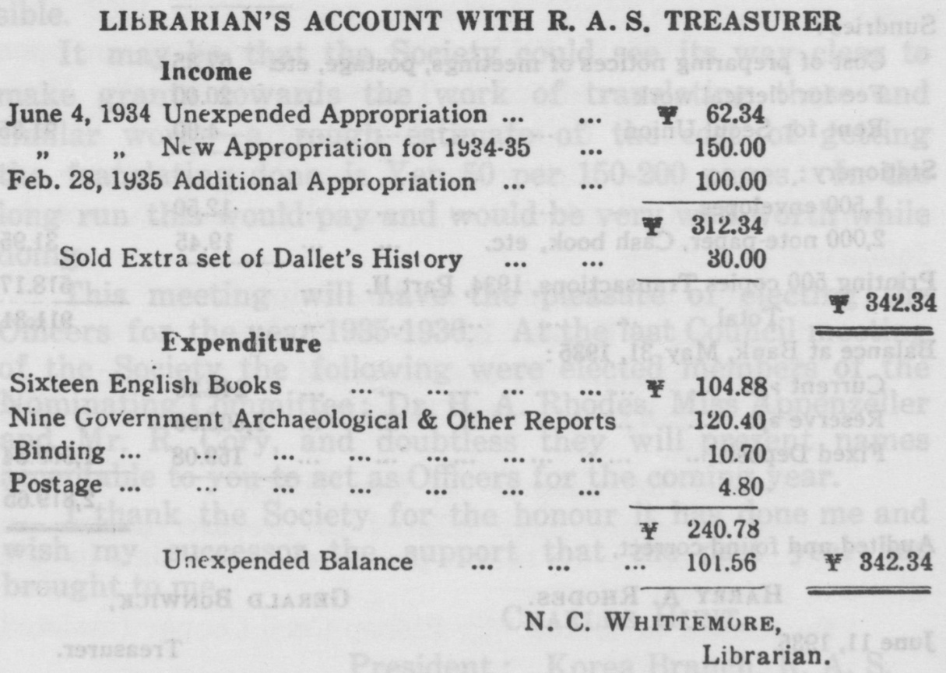

R A. S. ACCESSION LIST
June, 1934-May 31, 1935
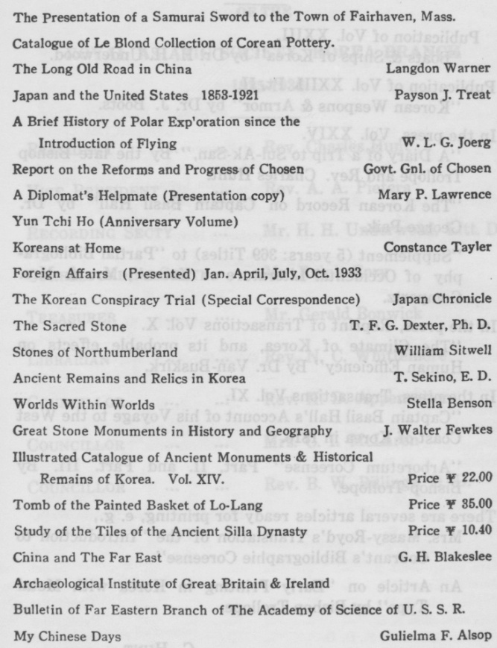

REPORT OF THE PUBLICATIONS COMMITTEE

1934-5.
Publication of VoL XXIII.
“Boats & Ships of Korea” by Dr. H. H. Underwood.
Publication of VoL XXIII. Pt. II.
‘‘Korean Weapons & Armor” by Dr. J. Boots.
In the press, Vol. XXIV.
Diary of a Trip to Sul-Ak-San,” By the late Bishop Trollope and Rev. Charles Hunt.
“The Korean Record on Captain Basil Hall” by Dr. George Paik.
“Supplement (5 years: 369 Titles) to “Partial Bibliography of Occidental Literature on Korea”, Mr. & Mrs. Gompertz.
In the press, Reprint of Transactions Vol. X.
‘‘The Climate of Korea, and its probable effects on Human Efficiency” By Dr. Van-Buskirk.
In the press, Transactions Vol. XI.
“Captain Basil Hall’s Account of his Voyage to the West Coast of Korea in 1816”
“Arboretum Coreense” Part II. and Part III. By Bishop Trollope.
There are several articles ready for printing, e. g.,
Mrs. Massy-Royd’s Translation of the “Introduction to Courant’s Bibliographie Coreense”
An Article on “Early Printing in Korea with Metal Type” by Bishop Trollope.
C. HUNT,
Chairman of the Publications Committee

OFFICERS OF THE ROYAL ASIATIC SOCIETY, KOREA BRANCH
1935-1936
