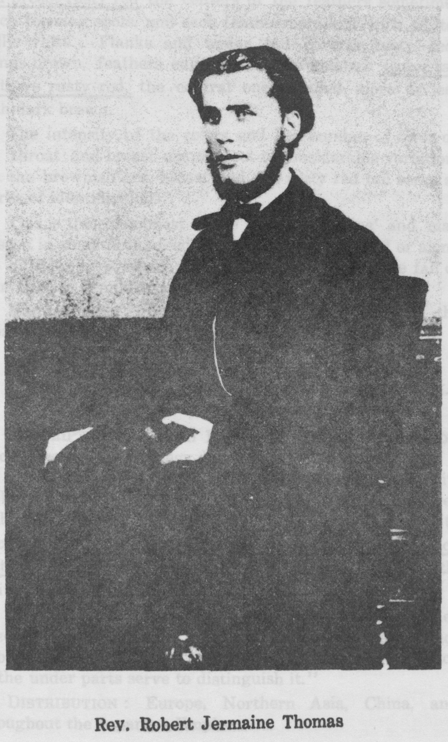

THE TWO VISITS OF THE REV. R. J. THOMAS TO KOREA

BY MR. M. W. OH
READ BEFORE THE SOCIETY MAY 6th, 1932

I am very much interested in a British young man, who, some sixty odd years ago, tried hard to enter Korea, and at last succeeded in entering, only to lay down his life. The time was that of the so-called “Pyengyang Foreign Trouble” in the year 1866. It gives me great pleasure to be here and tell you about a few interesting points of his life in Korea. My grandfather saw him, and quite a good many old people are still living in the district of my native village who met him, were entertained by him, and shook hands with him on board the “General Sherman,” on which he was a passenger. I refer to the Rev. Robert Jermain Thomas, B. A., the Agent of the National Bible Society of Scotland, a missionary of the London Missionary Society, the pioneer who studied the Korean language systematically, and the first, and so far the only, Protestant martyr in Korea.
I first heard of his coming, of his preaching, and of his death, in my childhood, but I began to make a real study eight years ago. As most of you know, he came to Korea only twice, and stayed here only about four months altogether. Hence the field of research concerning him has been rather confined. But I am happy to think that I have been able to collect quite a number of interesting details of his life by writing over three thousand letters to his relatives and friends, mostly in England and China, and by calling on nearly two hundred old people who met him along the coast of the three western provinces of Korea, Whanghai, South and North Pyengan Provinces.
His life can be divided into three parts : first, his life in England ; second, in China ; third, in Korea, in which we here are most interested. I shall first briefly speak of his life spent in England and China before dealing with his evangelistic efforts in Korea.
According to the archives of the London Missionary Society to which he belonged, he was born September 7th, 1840, [page 98] at Rhayader, Radnorshire, Wales. I gave this information in my little book in Korean on his life which I published in 1928, and other authors have done the same. But as a result of my inquiries I find that a mistake has been made in giving the year as 1840. Some years ago in reply to my letter sent to the Vicar of Rhayader for correct information about his birth, the Rev. H. W. Lewis, M. A., wrote : “I searched the Baptismal Registers in Rhayader Church in vain, but I enquired at the Registry of Births and Marriages and found found an entry to the following effect: September 7th, 1839 (not 1840 as you suggest) Robert Jermain, son of Robert Thomas and Mary his wife (formerly Williams), East Street, Rhayader, a Minister among the Independents.’’ And last year Mr. R. C. L. Thomas, the nephew of Robert Jermain Thomas, wrote to me about the year of his uncle’s birth as follows : “ With regard to the two questions you ask me, my father was an elder brother of my uncle, as my father was born in 1838 and my uncle Robert was born in 1839.” Hence there can not be any doubt but that he was born in 1839, and that the record of the London Missionary Society and of others following its lead needs to be corrected.
With regard to his early life in Wales and England, I shall quote some phrases from a letter of the Rev. Mr. Davies of Llanvapley, who was at one time assistant to his father, Rev. Robert Thomas. He says, “the Rev. Robert Jermain Thomas was the son of the Rev. Robert Thomas, minister from 1848 to 1884 of Hanover Church, Llanover, near Abergavenny, Wales. In his youth he spent three years at Land- overy College, then presided over by the well-known Welsh scholar Archdeacon Williams. Later on he acted as assistant-master at the Rev. Alfred Newths’ school at Oundle, North-hampshire. At 15 he was made a member at Hanover, and soon began to preach, his first text being Heb. 13 :8; at 16 he matriculated, and at 17 became a student at New College, spending five years there, securing his B. A. at London University on leaving. On June 4, 1863, he was ordained at Hanover, to be a missionary with the London [page 99] Missionary Society in China.” Only two of Mr. Thomas’ College friends are still living in England now. One is the Rev. W. R Clarkson, and the other the Rev. J. B. Blomfield. Both are over 90. I will quote some lines from their letters about his college life. Mr. Clarkson says, “Mr. Thomas was as you mention, a fellow student of mine at New College, London, and for one session from 1858 to 59, we lodged in the same house with two or three other students, the College itself being a non-resident one. I settled in my first charge as a minister at Essex in July 1861, and my friend preached for me two or three times when I was laid aside by temporary illness. But after he left England, we had no correspondence with one another. I loved and esteemed my friend and fellow student very much.”
Mr. Blomfield writes, “We lived in lodgings in the same neighbourhood. He was some three years my senior. I remember he had a high reputation for his ability in the acquisition of foreign languages, and that he was said to be of an adventurous spirit, and likely to a missionary in some distant part of the world, probably in China. He was married while at College, a very unusual event even if he was in his last year.” The College archives contain the following note about him :
Robert Jermain Thomas,
Son of the Rev. Rovert Thomas, Hanover.
Age 18.
Member of Hanover Church Abergavenny, of which the Rev. Robert Thomas was pastor.
Under graduate London 1857. B. A. 1859
Mills Scholar 1862
Admitted on probation, September 28th, 1857
Admitted full, February 1st, 1858.
Left, Midsummer 1863
Missionary to China 1863
Deceased (murdered) in Corea July 1866.”

Mr. Thomas with his wife embarked for China in the ship Polemaise, at Gravesend, on July 21st, when he was [page 100] presented with a Travelling Writing Desk by the Pastor and 24 fellow members of the Westminster (Congregational) Church, which he had been attending while he was studying at College. The Travelling Writing Desk, now in the possession of the nephew of Mr. Thomas, is inscribed in the following manner :
‘‘Presented to the Rev. Robert Jermain Thomas, B. A., Missionary to China, on the occasion of his leaving England, by his Pastor and a few of his fellow members in the Church at Westminster, July 20th, 1863.
— “The Lord Bless and Keep Thee.”
In the first week of December of the same year the young couple landed at Shanghai, and their real missionary life began. In the following month of March Mr. Thomas went up to Hankow and visited Dr. Griffith John, who later became one of his best friends. One of the objects of his visit to Hankow was to find a house in which to spend the summer with his wife. On February 4th, 1929, Dr. C. G. Sparham, the China Secretary of the London Missionary Society and the son-in-law of Dr. Griffith John sent me the original letter which Mr. Thomas had written to Dr. John about finding the above mentioned house. In speaking of his visit some years later, Dr. John said, “He was one of the finest linguists that I ever met He had a remarkable knowledge of Russian, of both the spoken and the written language. I took him to see some Russian merchants, and they conversed for a long time. At the close, one of the Russian merchants told me that but for one sound which he failed to make accurately, there was nothing in his speech to differentiate rum from a native Russian. It is said by the Russian people that the one sound that he failed to make has never been made by a non-Russian. He also spoke Chinese remarkably well” This other fact that he could speak Chinese well after only 4 months in the country is deserving of special notice. But alas! Mrs. Thomas was taken from him by death in premature child-birth. This sudden and sad [page 101] event brought intensive sorrow to his mind, and for a time he was prostrated with gloomy thoughts, approaching to melancholy. Tninking that a charge of locality would improve his health and spirits, he applied for permission to change his place of residence. It may be that his request had been refused and this ; would account for the fact that for a short time he had severed his connection with the London Missionary Society, and had gone to Chefoo.
At that time there was stationed at Chefoo the Rev. Alexander Williamson, the Agent of the National Bible Society of Scotland and a minister of the United Presbyterian Church of Scotland. Mr. Thomas had travelled on the same steamer with Dr. Williamson on his voyage from England, and had lived together with him in Shanghai during his first year. So they know each other well by the time Mr. Thomas visited Chefoo. At this visit Mr. Thomas received his first contact with Korea. At that time two Roman Catholic Koreans had come to Chefoo to trade. They were both from the Whanghai Province. At this time Mr. Thomas, while awaiting a reply from London to his request for a change of location, was working temporarily in a trading company, which, I am inclined to think, was the Cornabe and Eckford Company, Chefoo. it is very likely that he met the two above mentioned Koreans there. From them he learned many interesting stories and facts about Korea ana its people, and soon picked up bits of the Korean language, and put his resolution into action. He introauced the two Koreans to his good friend Dr. A. Williamson. So one day they were invited to afternoon tea at Dr. Williamson’s house, on which occasion Dr. Williamson consented to supply Mr. Thomas with a large stock of Bibles and portions of the Scriptures in Chinese and send him to Korea as the Agent of the National Bible Society of Scotland. I have been so fortunate as to be able to obtain a picture of Dn Williamson’s house in which that tea party with two Koreans took place. I am also happy to give you the contents of a letter which Mr. Thomas wrote to the British Consul at Chefoo on August [page 102] 31st, 1865 (just 5 days before his embarkation for Korea) in which he applied for a passport
Yent’ai, August 31st, 1865
Sir,
I beg to apply to you for a Passport for the Provinces of Kwantung (關東) and Peichili (北直隷). It is my intention to travel through the above mentioned Provinces, as a Missionary,
I am,
Sir,
Your humble and obedient Servant,
(Sd) R. Jermain Thomas.
Chinese name 托馬涘
R. J. T.
As you know, there was no treaty between Korea and Britain at that time. So he could not ask for a passport for travel in Korea but only in Manchuria and Chili Province through which he proposed to go back to Peking. Let me quote his own letter about his journey, written at Peking when he came back from Korea.
London Mission, Peking,
J anuary 12th, 1866.

My dear Dr. Tidman,
We left Chefoo on the 4th of September, on board a small Chinese junk, and arrived off the mainland of Corea on the 13th. We spent two months and a half on the coast I had acquired, through the assistance of a Corean Roman Catholic, sufficient knowledge of the colloquial to announce to these poor people some of the most precious truths of the Gospel They are, as a whole, very hostile to foreigners, but by a little chat in their own language, I could persuade them to accept a book or two. As these books are taken at the risk of decapitation, or, at least, fines and imprisonment, it is quite fair to conclude that the possessors wish to read them. The storms that blew along the west coast of Corea [page 103] through last autumn, according to the testimony of Chinese pilots who have traded with Corea for twenty years, have been unparalleled. I should fatigue you were I to narrate our hair-breadth escapes A gracious Providence preserved us. I had intended visiting the capital, “Wang King” but the Corean junk in which I had taken a passage was dashed to pieces by one of these terrible gales. No life lost Leaving Corea in the beginning of December, I landed on the coast of Manchuria, and found that I had only escaped the dangers of the sea to fall, perhaps, into those on land. You are aware that the entire country of Manchuria is in a state of agitation. Long since, small bands of mounted robbers were the terror of the lonely highways of the Far East Latterly these bands have combined together, and assumed such alarming proportions as to characterize the movement a downright rebellion. I landed at a port called Pi-tz-wo ; two days after leaving, it was occupied by the rebels. I had spent three very pleasant days in distributing the Scriptures and preaching the Gospel. The people were more than merely civil and attentive. A Mohamedan, named Likwo Fa, bought a copy of each kind of book I had, and insisted on sending me dinners daily free of expense.
Passing through Kaichou, I arrived at Tingtz (New Chwang) where I was very hospitably entertained by H. B. M.’s Consul, T. Taylor Meadows, Esq. Thence, travelling partly on horseback aud partly in carts, rounding the northern part of the Gulf of Laiu Tung (遼東), and passing the great wall off Shan Hai Kwan (山海關), I entered the province of Chi’Li’ and breathed freely, for thither the robbers could not follow us. The Chinese Government had despatched some four thousand troops to tranquillize Manchuria.
To sum up, I have been four months, away from European society and travelled by sea and land nearly two thousand miles. I am well acquainted with the coast of the two western provinces of Corea and have made numerous vocabularies and dialogues in the colloquial of the capital, which [page 104] will be useful in any future negotiations with that people.
I can hardly express to you how glad I am to be here. By God’s help I will try to bear part of the burden which Mr. Edkins has borne so long and so well I wish to convey to the Board my grateful thanks for their kindness. Will you, too, accept my best thanks for the kind encouraging words you have uttered from time to time, pending the ultimate decision of the Board ?
The first week of my residence in Peking has necessarily been taken up in making the usual calls on the foreign residents. Our week of prayer-meeting hitherto has been well attended.
Next week I purpose commencing in earnest a course of study which will fit me for the Chinese pulpit.
With kind regards to the Directors,
Believe me, dear Dr. Tidman,
Very sincerely yours,
R. Jermain Thomas

Rev. Dr. Tidman.
We can thus get from the letter an idea of his work on his first journey to Korea.
I am inclined to think from what I have been able to find out, one of the two Koreans whom he met at Chefoo and who guided him to Korea, was Kim Ja Pyung (金子平), and the master of the Chinese junk who took him as passenger was Yu Wen Tai (于文泰). He arrived off the mainland of Korea on the 13th of September. Even though we can not tell the exact spot where he landed on the mainland, it might be near Merin Island or Sorai Beach, because those coasts were well known to foreigners at that time, and Chinese merchants and fishers frequently came to those parts. From there he went on southward to Ongchin Beach. The Navy report to the Korean Government says that he stopped at a place called Charari (紫羅里) which is an old name. Nobody knows of it now. Pastor Cho of the Masan Methodist Church, Whanghai Province, told me when I visited there two years ago that it might be near Nyonghodo [page 105] (龍湖島), I tried to find out from the District Headman where Charari was, but so far I have had no reply from him. Mr. Thomas tried to go to Seoul by sea from there, but the boat on which he had embarked was dashed to pieces by the terrible gales, and he had to give up any hope of reaching Seoul on that trip. He had changed his boat three times on his first journey : when he left Chefoo he was on board the Chinese junk of which Yu Wen Tai was the master, then on the Korean coast he took a Korean boat, which I have said, was wrecked, and after that he went back to the Chinese junk. It is my opinion that :he Chinese junk could not take him to the south near Seoul because that would have taken it out of its way. As he mentioned in his letter, he learned the Korean language from the natives and also distributed a fair number of copies of the Scriptures. In his letter he said, “I had acquired, through the assistance of a Korean Roman Catholic, sufficient knowledge of the colloquial to announce to the poor people some of the most precious truths of the Gospel They are, as a whole, very hostile to foreigners, but by a little chat in their own lang-uage, I could persuade them to accept a book or two.” What a wonderful ability he had in the acquisition of the Korean language ! After only a few months of study he was able to converse with Koreans in their own language.
I have tried very hard to find some trace of the Bibles which Mr. Thomas distributed at this time, but I am sorry to say all these books with other documents were burnt at the time of the Tong Hak trouble.
After leaving Korea, Mr. Thomas set out for Peking via Pi-tz-wo, Kaichou (now Kaiping), Newchwang, and Shan-haikwan. To sum up, on this first journey he succeeded in three ways : first, he was able to distribute the Scriptures ; secona, he collected many colloquial idioms of the Korean language from the natives ; third, he had made personal contact with individual Koreans, to whom he made the promise to return the following year.
When he arrived at Peking, there was waiting for him a[page 106] letter from the London Missionary Society informing him that they acceded to his request and stationed him at Pe-king. There he took charge of the Anglo-Chinese School while Dr. Martin was absent, and also of the street chapel But he could not forget Korea and its people. At the beginning of the year 1866, he had an opportunity of meeting the annual Korean embassy to the Emperor of China, the representative of the King of Korea. On April 19th, 1866, when Dr. A. Williamson was at Tein-Chang-Tai (田庄臺), a large town on the river Lian-Ho (遼河), he met the Korean embassy returing home. In conversation with them he found out that they had met a missionary at Peking and had visited the London Mission. They said that they had received some Christian books and heard a little of the doctrine from him. No doubt the missionary whom they had met at Peking was Mr. Thomas. Although it must have been difficult to get access to them, he had managed to obtain one or more interviews. Not only did Mr. Thomas succeed in distributing the Scriptures while he was on Korean soil the year before, but he also succeeded in sending the Scriptures into Korea through the hands of the Korean embassy. We can imagine how glad he must have been when he thought of his success. Even before I had found Dr. Williamson’s book and read of his dealings with the Korean embassy, I had heard the same facts from many old people near Pyengyang, namely that that embassy had brought back with them a good many Bibles, which they, no doubt, had received from Mr. Thomas, he being the only missionary at Peking who knew Korean.
In Feb. 1866 there had broken out in Korea the severe persecution of the Roman Catholics, with the facts of which we are all familiar, and the French Government dispatched an admiral to deal with Korea for the murder of nine French priests. But the admiral needed an interpreter, and he hoped to secure the services of Mr. Thomas, on account of his knowledge of the Korean language. The position of official interpreter was offered to Mr. Thomas. Needless to

Title page of New Testament which is believed to be one of those distributed by Mr. Thomas.

Hong Sin Kil, one of the persons who went on board the “General Sherman,” and received a Bible from Mr. Thomas when the ship stopped at Chang Sa Po, on its way to Pyeng Yang,

Anchor chains of the General Sherman, now preserved on a pillar in the East Gate of Pyeng Yang.
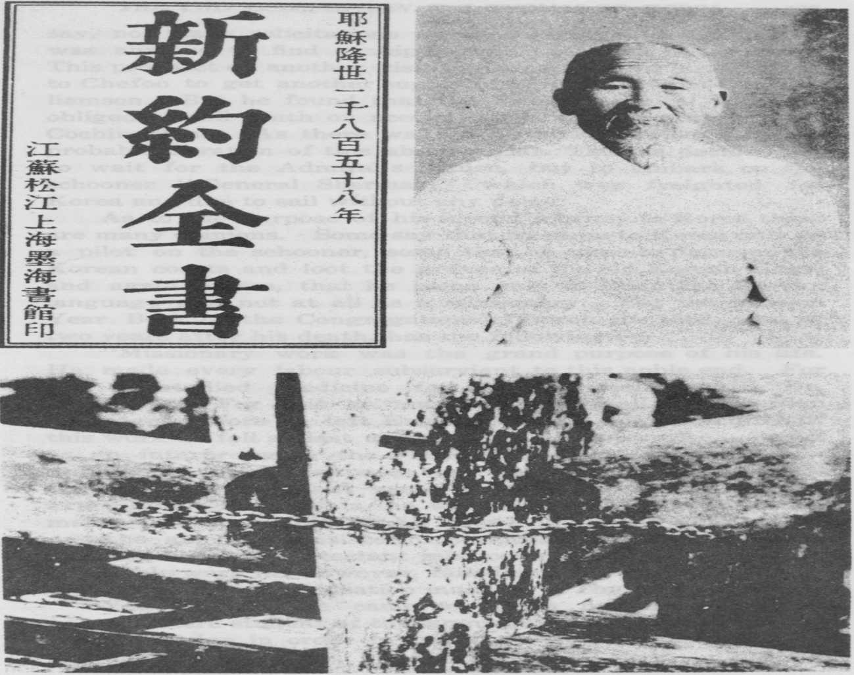

[page 107] say, not many solicitations were necessary with a man who was anxious to find a ship in which to reach Korea again. This prospect of another visit to Korea brought Mr. Thomas to Chefoo to get another supply of Scriptures from Dr. Williamson. But he found that the French Admiral had been obliged to sail south on account of political disturbances in Cochin-China. As there was no definite knowledge of the probable duration of this absence, Mr. Thomas decided not to wait for the Admirars return, but to embark on the schooner “General Sherman,” which was freighted for Korea and due to sail without any delay.
As to the purpose of his second journey to Korea there are many opinions. Some say that he came to Korea only as a pilot on the schooner, some that he came to discover the Korean coasts and loot the graves of the old Korean kings, and again others, that he came only to learn the Korean language and not at all as a missionary. But the Mission Year Book of the Congregational Church for 1868, that is, two years after his death, has the following : ―
“Missionary work was the grand purpose of his life. He made every labour subservient to this noble end. For this he studied medicine for eighteen months with Dr. Waterman. For this he mastered nearly all the European languages before he left England, and in the prosecution of this work he fell at last a martyr to the enterprise. To act as an interpreter to the French expedition was only subordinate to higher purposes, or else he would not have left Chefoo in a merchant vessel instead of staying for the expedition. The fact is, he wanted to go to Corea by some means in order to perfect his knowledge in the language, so as to be able to translate the Scriptures into that language, and establish a Protestant mission in that dark land. In this noble work he, however, failed and fell ; ana our language in this dark dispensation must be, “Thy will be done!”
You see that he came to Korea neither as a pilot nor as a mere student of the language. He came to perfect his knowledge in order to preach the Gospel and establish a [page 108] Protestant Mission in this land. You will also be interested in hearing that he had a special despatch from the Prince Regent of China to the Korean authorities instead of a passport.
As regards the purpose of the “General Sherman’s” visit, the sub-joined letters of the Meadows Company, to which the “General Sherman’’ was consigned, may throw some light on it They read as follows : —
Messrs. Meadows & Co. to Mr. Burlingame.
TIENTSIN, October 27, 1866

Sir:
We, the undersigned British firm, beg leave to bring to your Excellency’s notice the following circumstances, in order to obtain your Excellency’s assistance in getting redress.
During the latter half of July last the American Schooner General Sherman arrived at this port, and was consigned to our care by Mr. Preston, the owner, who had come passenger on the vessel for the sake of his health. After we had taken delivery oi inward cargo, Mr. Preston and we came to an arrangment that we should load her with a cargo of foreign merchandise, and despatch her to Corea with a super-cargo to sell the goods there. We accordingly loaded her with foreign merchandise, and on the 29th of July last she left Tientsin. Mr. Hogarth, one of our clerks, who went as super-cargo, left previously in the steamer Shaftesbury for Chefoo, in order to have a pilot and shroff ready on the General Sherman arriving there, and thus save delay. On the schooner reaching Chefoo, Mr. Hogarth, accompanied by a Chinese pilot and a Cantonese shroff belonging to our firm, went on board ; also Mr. Thomas, who having expressed a wish to visit Corea again, in order to extend his knowledge of the Corean language, went as passenger. From the day the vessel left Cheefoo till now we have received no written advices from Mr. Hongarth or Mr. Preston, or in fact, from any one on board when she left Chefoo. [page 109]
On the 8th of October current we received letters from the partners of our firm in Chefoo, with the news that the King of Corea had caused the General Sherman to be burnt with all on board, while proceeding up the Ping Yang river.
We immediately addressed Dr. Williams on the subject copy of our letter herewith enclosed.
On the 20th of October current we received further advices from our partner in Chefoo, informing us that he had seen a junk captain who had piloted the schooner for four tides up the Ping Yang river, when he left her and returned to the mouth of the river to his junk, and finally to Chefoo. This man stated that the Coreans had told him their king was opposed to foreign intercourse with his country. We imagine that this man, who understands some thing of the Corean language, knows something more about the vessel than he is inclined to divulge, fearing, Chinese-like, to mix himself up in the matter with the authorities to question him later on the points.
As the act of visiting Corea for the purposes of trade was not an act which could, in the eyes of civilized western nations, justify the Corean government in destroying those who committed it, we, the undersigned, have taken the liberty of addressing you for the purpose of bringing the above matters to your Excellency’s notice, with the request that you will be pleased to beg his Excellency Admiral Bell to make inquiries regarding the destruction of the vessel and her people, and take steps to cause the Corean Government to make redress as far as such in the nature of things is practicable.
We have the honor to be, sir, your Excellency’s most obedient servents,
Meadows & Co.
Hon. Anson Burlingame,
United States Minister Plenipotentiary.
P. S.—We beg to enclose copy of our letter to H. B. M’s consul, Mr. Mongan, on the loss of the General Sherman, [page 110] and requesting the British admiral’s assistance in the matter, Mr. Hograth and Mr. Thomas being both British subjects.
M. & Co.
Messrs. Meadows & Co. to Mr. Consul Mongarn.
TIENTSIN, 23rd, October, 1866.

Sir:
We take the liberty to communicate to you the following matter, in which two British subjects are concerned, in order that you may report the same to Admiral King, the British Naval Commander-in-Chief in China, that he may take much steps as may be best in accordance with his duty, in a position where the lives and properties of his countrymen are concerned.
About three months back the American schooner “General Shermen” arrived at this port, and the owner, Mr. Preston, who had come on board the vessel, consigned her to our care. After we had discharged her inward cargo, which was sent to our care, Mr. Preston, who resided on shore in our house soon after his arrival, and during his stay in Tientsin, we came to the determination to see if any business could be done in a venture to Corea; we consequently loaded the vessel and despatched her on a trading voyage to Corea. One of our clerks, Mr. Hogarth, was sent by us as supercargo and to assist Mr. Preston in making the trip a profitable one. Mr. Thomas, a friend of the writer, having expressed a desire again to visit Corea, in order to improve his knowledge of the Corean language, went a passenger in the vessel He and Mr. Hogarth: going on board at Chefoo. We may now state that both Mr. Hogarth and Mr. Thomas were natives of Great Britain, Mr. Preston, the owner of the ‘‘General Sherman’’ was an American citizen. The Master of the vessel, Mr. Page , was an American citizen, and the mate, Mr. Neilson, was a naturalized American citizen. Mr. Hogarth took from our firm in Chefoo one of our Cantonese employees, by profession a shroff, to assay the silver or gold which he might receive from the Corean merchants as pay- [page 111] ment for our merchandise. Mr. Thomas, we understood, took two Pekingese with him, and the crew was formed of Malays and southern Chinese, and two Shantung men as pilots.
From the time the “General Sherman” left Chefoo till the arrival of one of the French Men-of-war at Chefoo, we received no written advices from the “General Sherman.” On the French vessel’s appearance unpleasant rumours commenced to be current regarding the loss of the vessel and the fate of her people ; and Mr. Mackey and Wadman, the representative of our firm in Chefoo, wrote us as follows :—
(Extract from Mr. Wadman’s letter of 7th Oct 1866.
“I am really afraid the “General Shermany is lost and that her crew have met with an untimely death一the vessel being burnt and all hands cruelly murdered. It is a very sad affair,”
(Extaact from Mr. Mackey’s letter of the 7th Oct 1866.)
“I must not let this steamer leave without mentioning that the very worst rumours are current regarding the fate of the ‘General Sherman’ and all on board. The French Admiral’s vessel just returned from Corea, is the bearer of the report which is undoubtedly very circumstantial The French have already been fighting in Korea. Now they are going in stronger force than before, and intend to blockade the whole coast They have sent for more men and ships from Saigon.”
The “General Sherman” being an American vessel, we lost no time in a addressing Dr. Williams, the U. S. Charge’ d’ Affairs. Copy of our letter herewith enclosed on the subject Having now received some further details regarding the “General Sherman” from Mr. Mackey, and considering it now time to bring the matter to your notice officially, we beg to give you below the additional news now received per “Nanzing.”
(Extract from Mr. Mackey’s letter dated Chefoo 8th
Oct. 1866. : [page 112]
“Since writing to you yesterday I have had a long conversation with the pilot of a junk, regarding the General Sherman.’ It appears that he met the ‘General Sherman’ at the mouth of a very large river called Ping-yang. He knew Mr. Thomas very well and so consented to act as pilot to the ‘General Sherman.’ He conducted her for four tides which occupied three day, up the river, and then left her to pursue her own way to Ping Yang city―a large trading mart on the river about six days journey from its mouth, going day and night It is between five and six hundred li by land. He left her about midway between the mouth of the river and the trading mart above referred to. This on the third day of the eighth moon (11th Sept. 1866.) He has never seen the vessel since. He left piloting the ‘General Sherman’ because her appearance had created alarm, the Coreans being a simple people, and all trade was stopped between the Coreans and the Chinese. The Coreans asked him about the “General Sherman’ and her intentions’ He replied she was a peaceful trader, but they said ‘she has not come to buy our goods.’ He goes to Corea from Shantung sometimes three times a year. He is 43 years of age, and has traded for many years with Corea. ‘Mr. Thomas con-stantly wanted to land and ramble about, but the pilot advised him against doing so.’ Thomas wished to keep the pilot and let his junk return to Shantung, but his junkmen would not hear of it, saying they could not face his family without him. On the pilot reaching the mouth of the Ping Yang river (he had some conversation with the Coreans there, and they told him that their Sovereign would by no means trade with foreigners.”
“My teacher acted as Interpreter during the above conversation, which lasted a good time. My teacher’s impression is that the man concealed something unpleasant below all his statements, as if he feared to divulge it. He left the schooner half way up the river, [page 113] and testified plainly to the general state of alarm which her appearance created. Whether this man knows of the fate of the vessel is a secret known only to himself A gunboat could run over to this river and soon clear up the mystery.”
“The French Admiral’s account is that when the “General Sherman” appeared at Ping Yang, the father of the King of Corea asked what was to be done with her, and the King replied, let her be burnt with all on board of her ; and that this was exececuted accordingly. ‘ “
Two British subjects having gone to Corea in the “General Sherman.”—one as supercargo of our merchandise, and the other to a certain degree to aid in obtaining a knowledge of the country for the use of civilization, and to assist Hogarth in explaining the object of the vessel visiting Corea, we consider it our duty to lay the above details before you without loss of time, that you may take such steps as may be best to ascertain the fate of your countrymen.
Should we later obtain any additional news regarding this matter we shall not fail to communicate the same to you immediately.
We beg to suggest that it would be well to address the French Admiral on the subject, as well as reporting the matter to the British Admiral.
We are,
(signed) Meadows & Ca
It is clear, then, that the object of the “General Sherman” in visiting Korea was that of trade, and also that Thomas went as a passenger, not as an interpreter.
On August 9th, Thursday, the ‘‘General Sherman” with Mr. Thomas and a complement of 23 men, officers and crew, left Chefoo. The London Mission at Peking, on account of the persecution in Korea, did not approve of his decision to make the voyage at that time,and under those circum- [page 114] stances even his best friends tried to dissuade him from it But he was determined to go and did not consider the risks, thinking only of the chance thus offered to get an entrance for the Gospel into Korea.
On their way to Korea they called at White Wings Island (白翖島). The spot at which they anchored was Too- Moo-Chin (두무진) On hearing of the arrival of a foreign vessel at that place, the Mandarin in charge of this island ordered his garrison to attack them. But Mr. Thomas, wishing to give the Scriptures to the people on shore, came out with an armful of New Testaments and distributed them not only among the people, but also among the soldiers. When I visited the island two years ago, Mr. Choi Ik No (崔益魯) , one of the oldest people on the island and a Christian, said, “When the foreign vessel came here, I went out with other friends to see it One of the foreigners was very kind, and we were entertained by him. We did not know what kind of food he was giving us at that time, but I know now that it was cakes. I also received some books from him but later on owing to the threatening attitude of the soldiers we had to throw them away or give them up. While we were still near the vessel, the foreigners rubbed something and made fire. And when they were pulling a string, it be came longer ana longer. When we saw all of these things, we could not help being surprised. But I think now those things might have been matches and a rubber string. The Mandarin ordered all the books the foreigner had distributed to be taken to his office on three bull-carts (rather small ones on this island), and later sent all of them to the Ongchin Naval Office.”
Their next port of call on their way to Pyengyang was Tot-Chum (Mat Island, 席島). Here Mr. Thomas met the Chinese sailor Yu-Wen-Tai, who had brought him to Korea the year before. Mr. Thomas asked the sailor to guide the General Sherman” up the Dai-dong river to near Pyeng― sang, to which the sailor agreed, But when they reached Moon-U-Koo, some of Yu-Wen. Tai’s crew objected to his go- [page 115] ing as far as Pyengyang ; for they apprehended some danger by being associated with foreigners in their attempt to enter the “Hermit Kingdom.’’ For this reason Yu-Wen-Tai refused to go further and returned to Chefoo. Thus the “General Sherman” was left to itself to make its way zigzagging up against the stream, which was swollen with the rains. The people on the schoooner were all charmed with the beautiful sights of the forbidden land, while the country people dressed in white clothes were all attracted to the river banks by the strange appearance of the visitors. Mr. Thomas tried several times to go into the villages to preach the Gospel to the people ; but the schooner did not stop long enough in one place for him to do so. On August 17th, a Friday, the schooner anchored at a place called Songsan (松山) in Whangju county. At this time the Mandarin at Whangju sent three officials to the schooner to find out what kind of schooner it was and what was the object of her visit Their very concise reports, which can still be found in Seoul run as follows :— “Thomas, age 36, seven feet and five inches tall, yellow hair, black beard, grey clothes, felt hat, black shoes, a British subject ; Hogarth, age 37, seven tall, yellow hair, fine whiskers, hat lined with white cloth, yellow silk clothes, barefoot, sandals, a British subject ; Preston, age 48, seven feet and five inches tall, yellow hair, curling whiskers, black felt hat, white cloak, yellow silk trousers, coloured woven shoes, an American ; Page , age 45, seven feet and five inches tall, yellow curling hair and beard, black hat, purple cloak, white trousers, black shoes, a Danish subject The schooner is one hundred and eighty feet long, fifty feet wide and thirty feet high. There are two masts, one fifteen feet high and the other thirteen feet Both the two big sails and two small sails are white. There is also a life boat, coloured blue, no masts, sixteen feet long and eleven feet wide.” In the above report there is nothing said about Wilson, the other American, and it was a mistake to say that Mr. Thomas was 36 years old at that time, as he was only 26. No doubt, the officials made a mis- [page 116] take in writing the characters. I don’t know whether Mr. Page was formerly a Danish subject or not, but I find that he was an American citizen. At this time over two thousand people were crowded on both banks of the river. Mr. Thomas came out to the shore on the life boat, and distributed quite a good many copies of the Scriptures and other religious books. One of the young men who received his books there is still living now and tells interesting stories about his preaching. Some years ago when I visited there he pointed to the spot where Mr. Thomas was standing. His name is Pak Min Oo (朴敏祐), who is one of the first Christians in that part of the county.
On August 20th, the schooner went up a little farther, to a place called Chang Sapo (填沙浦). A very interesting event took place at this place. It happened to be market day at Taipyiung (太平) near by. A boy named Hong Shin Kil (洪信吉), who had been at the Market, heard the news of the coming of a foreign vessel. He went home and persuaded two other boys to go with him to the foreign boat in a boat rowed by themselves. Mr. Thomas, who was looking out for Koreans, was very glad to see them. They were received by him on deck and taken to his room. There were many book-cases there, The boys were given some cakes first, and then a few copies of books. Mr. Hong says that there he saw potatoes for the first time in his life. After two or three hours they came back home with the books. One of the three boys named Pai Chakun Nom showed these books to his grandfather, Pai Chuk Chun (裴則天), who was a teacher of Chinese in the village, and told the story of his meeting with the foreigners. Pai Chuk Chun, a learned man, who had heard of the persecution against the Christians, scolded his grandson severely for having accepted such dangerous books, and ordered him to throw them into the river. So Chakun Nom had to do as he was told by his grandfather. But Hong Shin Kil and the other boy kept their books for some time.
On the same day nine people from the village of Sookkai [page 117] (艾浦) called on Mr. Thomas by night Their names were Chang Nin Kook (張麟國), Pyo Young Bo (表榮賓), Chi Tal Soo (池達洙), Chi Tal Che (池達濟), Chi Taik Poong (池宅 龜), Chi Taik Poong (池宅朋), Chi Taik Chou (池宅周), Chang Nyong Kook (張龍國), Chi Tal Hai (池達海). They were all Roman Catholic Christians except Chang Nong Kook, a sailor. Of these Chi Tal Hai had been baptized by Bishop Daveluy in 1864, and he himself had preached the Gospel to his relatives in the village, with the result that they had all become Christians.
Now, before the arrival of Mr. Thomas, they had been very anxiously looking for help from the French Government, to enable them to escape the persecution, as they believed that the French navy would come to deal with Korea for the murder of the French priests. So Mr. Chi Tal Hai was to be found daily on the river bank looking out for a foreign ship that might be coming up the river. On that day when he found the “General Sherman,” he thought that it must be the French ship coming to save them. He could not help clapping his hands and praising God for sending deliverance. He soon gathered all the Christians in his village secretly to discuss steps to welcome this foreign ship. They had different plans at first, but at last agreed to send the above-mentioned eight representatives with a case of melons, for which that district is especially noted.
By this time the sun had set over the mountain, and the stars were shining. Mr. Thomas, even after his supper when he might have rested, was excited and could not sit still in his room. He was walking up and down on deck, when he encountered the nine people who had boarded the schooner. When they informed him that they were Roman Catholics, Mr. Thomas gladly welcomed them and invited them to his room. Chi Tal Hai, their leader, thinking the schooner to be a French man-of-war and Mr. Thomas a Frenchman, told him by writing Chinese characters all about the severe persecution ; but to his surprise he discovered that the foreigner could speak Korean and that remarkably [page 118] well. In reply to Mr. Chi’s questions, Mr. Thomas stated that he was neither a Frenchman nor a Roman Catholic but a Protestant missionary, and comforted him by telling him not to trouble about the persecution because religious liberty would soon be won. He also gave them a good many copies of the Scriptures and other religious books together with a silver coin bearing the portrait of Queen Victoria. Although Mr. Thomas told them that he was a Protestant missionary, they failed to understand the difference between the two sects. They went home with delight because they still could help thinking that the foreigners were after all Frenchmen. In this idea they seemed to be confirmed by imagining that coin bore the image of the Virgin Mary. They placed the books and coin in a box and hid the same. But I am sorry to say that on the 23rd of September most of the nine people were arrested, because they had negotiated with the foreigner, and on the 22nd of January 1867 Chi Tal Hai and Chi Tal Soo were beheaded just out side the Po Tong Gate (普通門) at Pyengyang. Chi Taik Chou, the son of Chi Tal Hai and one of the above mentioned nine people, is still living in a village called Pyung Chun Lee (平川里) situated on the Daidong river just below the Pyengyang railway station. He told me that he himself shook Mr. Thomas’s hand, was entertained by him, and received his Bibles and religious books. Though he is now nearly 90 years of age, it is surprising how well he remembers every minor detail of his meeting Mr. Thomas. This is easily explained when we consider that the events of those stiring days followed by his father’s arrest and eventual death must have deeply impressed themselves upon his memory.
At about half past ten o’clock in the morning of the next day, an official came from the city of Pyengyang to ask what the purpose of the schooner was in coming to Korea. Mr. Thomas explained to him in Korean that they had come merely for trade and not at all in order to fight. He then tried to find out the reasons why the Koreans were persecuting the Roman Catholics. He also seized the opportunity [page 119] and, emphasizing some points of the truth of the Gospel, explained to him that the Protestant Church was not the same as the Catholic.
In the afternoon of that day the schooner went up a little farther, and stopped at a place called Shukhochung (石湖亭), where many people were crowding together to see the foreigners. Here also Mr. Thomas distrituted many books. A young man in the crowd named Kim Young Sup (金永變) received one of the books distributed by Mr. Thomas. The title of that book was “Easy Introduction to the Truth (眞理具知).” He took it home and kept it secretly in his book box, reading it stealthily from time to time. He at last got to know the truth of Christianity from this book, taught it to his son Kim Chong Kwon (金宗權) and his nephew Kim Sung Chip (金成集), both of whom later on became elders of the Presbyterian Church. Though the latter died some years ago, the former is still preaching in the western part of Choongwha (中和) county. Elder Kim Chong Kwon kept that book until 1823, but I am sorry to say that it was destroyed in the great flood of that year.
The people in the near villages were at that time building a wall on the mountain called Mankyung-Tai (萬景臺) to protect themselves from being attacked by the foreigners. Police-men in a patrol boat were warning the people on shore against dealing with foreigners. Thus the atmosphere between the natives and the supposed invaders was charged with electricity, and the former looked upon the crew of the “General Sherman” as their enemies. We don’t know what their purpose was, but one of the persons on the “General Sherman”, perhaps Mr. Preston or Mr. Page , asked the chief police man, Lee Hyun Ik (李玄益) to come on board the schooner, and there took his official seal away from him. This was the origin of the trouble. According to the law of Korea, anyone who lost his official seal was to be beheaded or exiled. This then was nothing less than a calamity which had happened to Mr. Lee. As the schooner was coming up the river with Mr. Lee on board, other police men and the [page 120] people on shore were shouting and demanding his release, but the schooner kept on her course up the river, the captain promising in a letter written in Chinese by Mr. Thomas that they would surrender him after they had seen the Governor. This answer, of course, did not satisfy the enraged people on shore, and before long their pent-up feelings found vent in attacking the invaders. The order of the Prince Regent, in answer to the beacon signals, had reached the hands of the Governor after a few days ; the report of the latter about this invasion was already on its way to Seoul ; the soldiers stationed in different parts of the Province were all gathering in and around Pyengyang ; and soon numerous arrows and gun shots were aimed at the schooner and answered by the cannon balls from the schooner. The wearisome contest lasted for two weeks. Meanwhile the river, swollen with the rains, came down in full flood and, on its subsidence, the schooner grounded on a sand bank near the western shore of the western branch of the river, a few stone’s throws south of the present railway bridge. Thus the ship was within easy arrow shot of the river bank. Moreover the Koreans sent burning pine boats (not rafts) floating down to the schooner, which soon took fire. To save themselves, the crew had to jump into the water or get to land some how. On shore they were met by the soldiers ready to pierce them with their spears.
During these events Mr. Thomas, of course, did not try to escape from the danger, nor could he have got away anywhere to safety. As well as opportunity allowed, he kept on with his sacred task of distributing the Scriptures from the boat, for which purpose he had come, and which he thought he must accomplish by all means. After he had distributed all the books but one, he left the schooner, when it was already in flames, with his last copy of the Bible. He humbly knelt down before the soldier waiting for him, begged him to accept the Bible, and shut his eyes to pray. The soldier hesitated to execute him, but at last he had to do his duty, and so Mr. Thomas gave his life for the Gospel, on

The spot where Mr. Thomas is buried, authenticated
by the old man in picture.

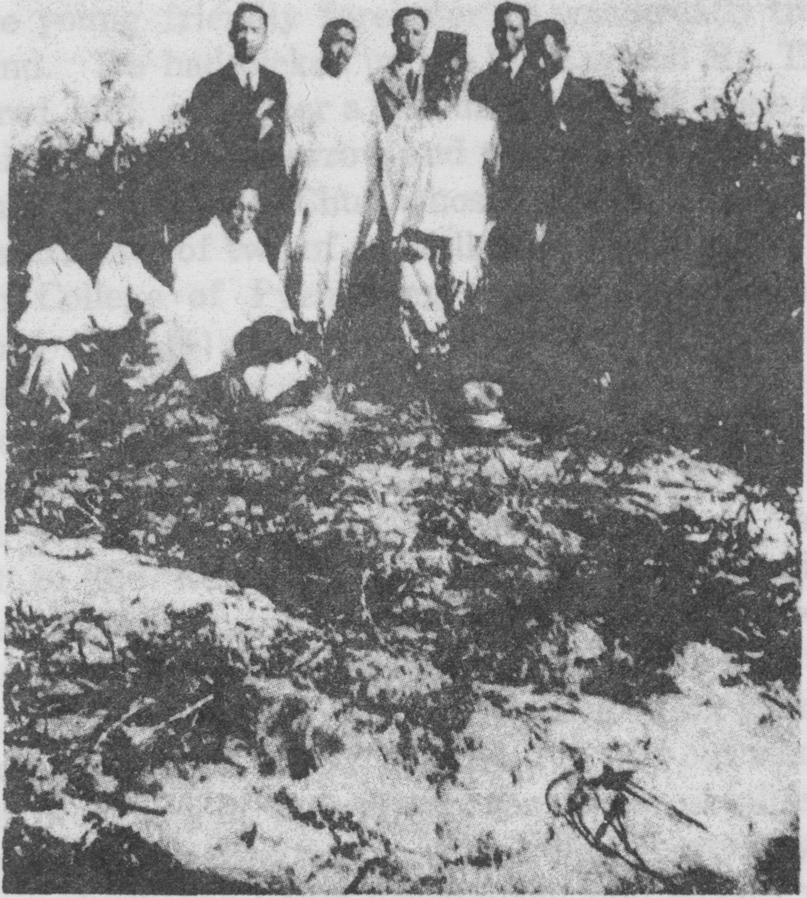

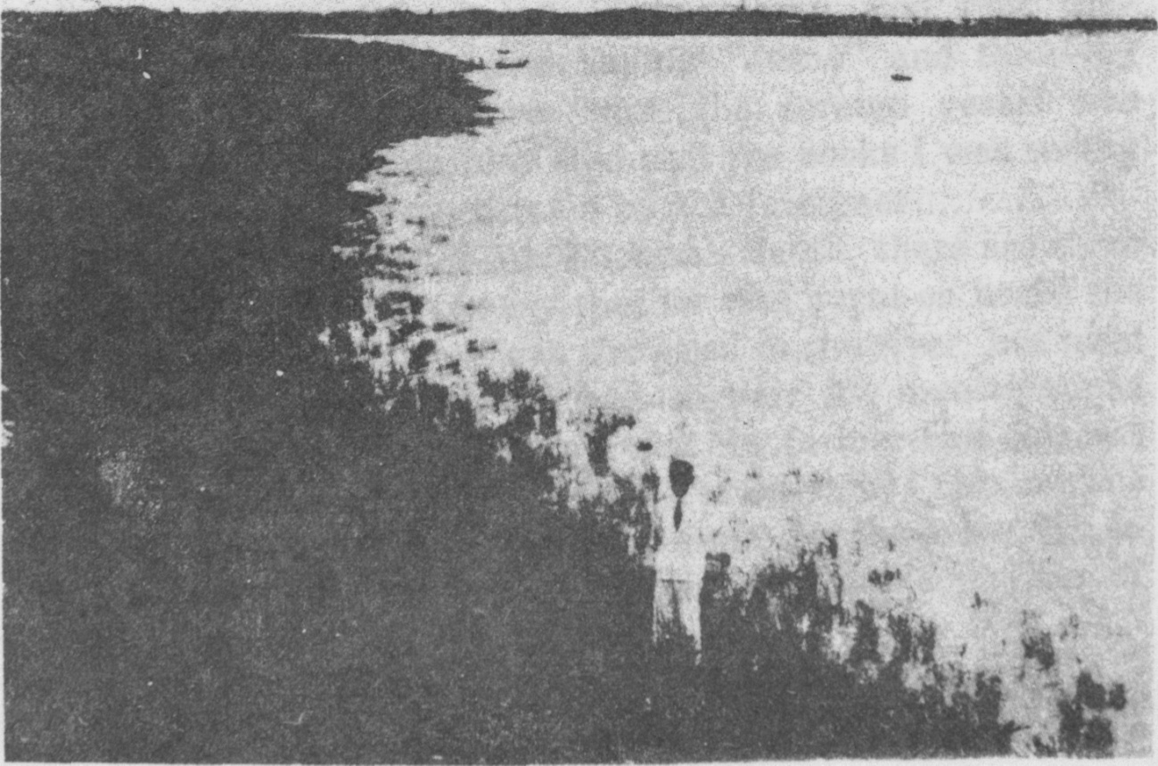

[page 120] Sept 3rd on the soil of Korea. After some weeks his body with the rest of his companions was buried on the island called Sook Syum (蓬萊島). As for the soldier, who had killed the young friendly foreigner he was greatly troubled in his mind. He had picked up the book which Mr. Thomas had offered him, .and after a few days he went home taking it with him, still full of sorrow and regret that he had killed a good man. He was a Chun whose brother-in-law was the great grandfather of two of my fellow students in the Union Christian College of Pyengyang, sons of the late Rev. Lee Chai Poong (李在豊).
Regarding his last moments spent in distributing the Scriptures, let me quote a few phrases from the letter (dated 16th Jan. 1928) of the Rev. Han Suk Chin (韓錫晋), one of the first seven Presbyterian ministers in Korea, and an assistant to the Rev. Dr. S. A. Moffett in establishing the Presbyterian Church in Pyengyang. It reads as follows :―
“I came to Pyengyang for the first time in October, 1892. That was only twenty-five or six years after Mr. Thomas’s death. If I had tried to find out something about his preaching at that time, I could have obtained quite a good many interesting facts. But I did not pay any attention to it at all, and I only heard about him when I was going round that district to preach as a colporteur. The people who had witnessed the events of that time, said that they had seen a foreigner on deck saying “Jesus” and throwing out many books to the shore when the foreign vessel was being burnt, and they also said that the books I was selling were the same as those thrown by the foreigner....................”
As to the manner of Mr. Thomas’s death, there are three different versions ; some say that he was burnt on board the schooner, some that he was drowned in the river, but most people say that he was killed by a soldier. My investigations have led me to the conclusion that the former two versions are entirely based on rumour. Not only did I obtain some details of his death five years ago from the above mentioned relatives of the soldier who killed him, but a number of [page 122] people who were present at that time near the spot where he was killed and who are still living, maintain that he was killed by a soldier.
At that time, an eleven year old boy named Choi Chi Ryang (崔致良) went down to the river banks with his uncle to see the foreigners, and brought back three copies of the Scriptures. Another person, a woman named Lee Shin Haing (李信行) also came back with a book, and a man Kim Chang Koo (金昶九) got hold of several copies and brought them home. These are only a few of the people who have personally told their surviving relatives of their experiences of those days, but many more people had got one or more copies of the books which Mr. Thomas distributed. However, after a few days an edict was issued threatening with arrest any person who might be found possessing such books. Naturally every man threw them away, but a clerk of the Prefectural Office named Pak Young Sik (朴永植) gathered them up and used them as wall-paper in his house just inside the East Gate of Pyengyang, which was later bought by the above mentioned Choi Chi Ryang.
Success? Failure? What is to be our verdict about the two visits of the Rev. R. J. Thomas? The blood flowing from his body dyed the water red, and the smoke from the books which, before they could be distributed, had caught fire on deck, was only a fine sight to the people on the banks, It seemed then that all his plans had ended in smoke. If he had stayed at his work in China, he might have done excellent work ; but the Almighty and All-wise God, who sees all tnings from the beginning, planned otherwise. Twenty-five or six years after Mr. Thomas’s death, the Rev. S. A. Moffett with his helper, Mr. Han Suk Chin (韓錫晉), visited Choi Chi Ryang’s house, the walls of which were still papered with the Scriptures which Mr. Thomas had brought to Korea. How many people may not have read and carried away some of the seed thus sown in their hearts! The missionary on this and other occasions preached the Gospel to Mr. Choi Chi Ryang and some of his friends with [page 123] the result that before long the first Protestant Church was established just inside the East Gate, where the anchor chains of the “General Sherman” are still preserved. And among the first believers, the Rev. S. A. Moffett found a man having a Bible which his father had received from Mr. Thomas. As I mentioned befere, from among the people who received Bibles from Mr. Thomas, have come a number of the early Christians all along the banks of the Daidong river, and they have helped to lay the foundations of the Korean Church, and some, as ministers and elders, have proved to be pillars in the Church. It is also worthy of special note that the banks of the Daidong river have become the center of Christianity in Korea.
I am very happy to think that I have been able to gather a few details of his labors during his two visits to Korea in the years 1865 and 1866. In closing I feel that nothing sums up more fittingly what we have been considering to-night than these words from the Scriptures :
“For all flesh is as grass, and all the glory of man as the flower of grass. The grass withereth, and the flower thereof falleth away : But the word of the Lord endureth for ever. And this is the word which by the Gospel is preached unto you.’’

