[page 15]
A ROYAL FUNERAL IN KOREA

by HUGH MILLER.

All funerals are sad and especially so if it brings to an end a family, clan or dynasty. It was so with that of Prince Yi which took place on June 10, 1926, for he was the last to sit upon Korea’s throne. The first royal funeral in Korea was probably that of Kija who had come over from China in 1122 B. C. and he was doubtless buried according to the then prevailing customs of the Chinese, and these still continue to affect Korea in the deeper affairs of life and death.
The funeral of Prince Yi, as he was known after the an-nexation of Korea by Japan in 1910, had projected into it some Japanese and Western customs which I will omit My effort is to have in English a record of a royal funeral as held before Korea was affected by Japan or the West. Prince Yi saw many changes and practically all of the events which have so altered the course of the court and country have taken place since he was born on March 25, 1874. I have been helped in the preparation of this paper by my friend, Mr. E. T. Chung, and by the writings of Dr. Landis and Mr. Hulbert.
I have attempted to describe what takes place from the time of the death of a royal person until the interment and the mourners return to the city. There is a saying among the clerks of the bureaus in charge of a royal funeral that “it takes ten years to master the details of their duties” and I lay no claim to having mastered them, although I can say I have striven for accuracy and have given some time to its study.
The rites are usually the same for a king or a queen and it may be noted that the chief mourner is always a king. “The King is dead ! long live the King.”
The death of Prince Yi took place on the morning of April 25, at 6:10, in the presence of close relatives and some eunuchs. As death approaches, the Crown Prince, relatives and eunuchs and the “ladies in waiting” gather in the room and the Crown Prince appoints one of the relatives or [page 16] a eunuch to make sure that death has taken place by placing a piece of teased cotton against the nostrils. If the fibres do not shake, the breathing has stopped, and all the people in the palace wail. Then a eunuch is appointed to superintend the closing of the eyes, the insertion of the “Kaksha” (角柶), a piece of horn cut and fitted so that it keeps the upper and lower teeth apart, and the other dressings of the body, after which the body is laid upon a board Absolute stillness is observed at the moment of death. After death the superintendent orders three pots of rice to be prepared, and the three pots containing the rice, three bowls of water, three nyang of money and three pairs of straw shoes are placed on a sacrificial table outside the room in the court and facing north, to supply refreshment, travelling expenses and footwater for the three spirits that are to accompany the spirit of the deceased to the next world.
Then one of the eunuchs goes up on the roof of the palace with a coat that had been worn by the dead, thrown over his left shoulder and facing the north ; he waves the coat, as he cries: Please return, O King,—a last request for the spirit of the deceased to return. When the eunuch comes down, the coat is put on the body until the third day when it is put into the spirit palace (魂殿) until the day of the funeral. Then it is taken in the spirit chair to the tomb. From thence it is brought back to the palace with the royal spirit and when the spirit finds its last resting place, the coat is again taken to the tomb and buried underneath the wall that partially surrounds the grave mound. At the same time that the eunuch goes up on the roof, a trumpeter (嗽叭手) stands at the main gate of the palace and blows three blasts. After the death has been thus announced, the Princess or in other days, the queen, and other near relatives put off any colored clothing they may have on and dishevel their hair For three days all the main shops in the city are closed. Dancing and all forms of musical entertainments are stopped as well as marriages, sacrifices and the slaughtering of animals.
Three bureaus, each under the direction of a high official and responsible to the Prime Minister, make all the prepara- [page 17]tions for the funeral. One of these makes all arrangements concerning1 the body and all ceremonies connected therewith up to the time of the farewell service on the morning of the funeral The second takes charge of and arranges for the funeral procession. The third has the responsibility of preparing the grave and of the ceremonies at the grave, and also has charge of erecting a residence for the official who will become the keeper of the tomb.
The grave site is selected by the geomancer (地理學官) appointed by the Ceremonial Department, and great care is exercised to secure a propitious site and much attention is paid to the placing of the coffin in the most favourable position on the selected site.
On the third day after death, the body is washed with water in which red sandal wood has been boiled and the hair is shampooed with water in which unboiled rice had been washed. The “Kaksha” is removed and one spoonful of uncooked rice with a pearl is inserted in the right side of the mouth and a second spoonful on the left and a third in the middle, and left there. The hair is combed, the finger nails trimmed and the face and hands are bound with pieces of silk padded with teased silk cocoons, a full suit of new silk clothes and socks are put on. The death is now announced to the ancestral spirits at Myodong by the reading of a document prepared by the Ceremonial Bureau.
On the fifth day the body is placed in a coffin made of pine wood and lacquered inside and out. The pine being an evergreen is a symbol of manhood, for it never withers or casts its needles until it dies and serpents and other reptiles will not go near it. It never rots at the core leaving a shell and when placed in the ground rots rapidly and evenly which is a prime consideration, for the Korean, contrary to most peoples, considers anything unpropitious that hinders or retards dissolution. The inside of the coffin is lined with red and green silk. The bottom is spread over with broom com ashes, as is commonly done, on this the “seven starred” board (七星板) is laid and over it is placed the usual silk mattress and pillow and on this the body is laid. The empty spaces in [page 18] the coffin are filled with the clean clothes of the dead and rolls of pure silk. A king’s hat, (翼善冠) imperial robe (袞龍袍) and quilt (衾) are also put into the casket. The lid is put on and pegged down with wooden pegs for no metal enters into the construction of the coffin. The coffin is then covered with a red silk coverlet upon which are painted in white twenty axes, the heads being on the middle of their handles. The axes are the emblem of power. The coffin is then taken to the pavilion specially prepared for it in the palace grounds where it remains until the day of the funeral. The room is artifically cooled by the use of ice. In a room adjoining that in which the body lies is placed a chair upon which are placed two rolls of white silk, the temporary resting place of the spirit, and two umbrellas made of white silk, two fans, the comb and other toilet articles used by the deceased are placed in front of it The spirit tablet, when brought back from the grave rests before this table and food is placed in front of it and the family gather twice daily for two full years. The daily offerings are as per the diagram following this paper. For the same period, on the first and fifteenth of each month, special offerings as per the diagram are made by the chief mourner or some one appointed by him. The offerings consist of wine, fruits, rice, bread, vermicelli, meats and cakes. The arrangement can best be understood from the diagram which is taken from the Book of Funeral Ceremonies. The special offerings take place in the presence of the family, relatives and the officials of first, second and third rank.
On the sixth day the whole family and officials put on hemp mourning clothes, “sackcloth,” and the common people don the national mourning costume, which is white. As the people ordinarily dress in white, now all that is necessary is to secure a white instead of the black hat usually worn, but the poor who cannot afford a new white one paste a piece of white paper on the crown of the black hat and the mourning requirements are met. Offerings, the same as those made on the first and fifteenth of each month, are made. Crowds of high officials gather inside the palace and the people [page 19] gather before the palace gate and lying prostrate on the mats give vent in public to their grief by wailing and lamenting the departure of their king (see plate No. 1).
Heretofore money was sent up from the provinces to meet the expenses of a funeral and guilds were informed that their services would be required, but the cost of Prince Yi’s funeral was met by a grant from the Government.
Prince Yi was buried 46 days after his death, though the prescribed period for the interment of the royal dead was five months from the time of death.
A king would sometimes leave instructions, either verbal or written, simplifying the ceremonies but in the absence of these the form laid down in the Book of Funeral Ceremonies would be carried out.
For days previous to the funeral, squads of men parade the streets, marching with empty biers, carrying banners and flags and doing other features of the procession so that there may be no hitch on the day of the funeral.
On the day previous to the funeral, the bureau in charge of the funeral procession erects a number of resting places or shelters.
The first is erected for the king beside the road and just within the city gate and directly east and west, and the second is erected just outside of the gate. The third is erected where the Road Offerings are made. The fourth is erected near the third and here the bier rests while the farewell service is performed. This is made to face the south unless one of the other points of the compass is more propitious. Next to this is erected the shelter where the king bids farewell to the body, for the king does not usually accompany the body to the place of burial. Mats and rugs are arranged for the king and to the rear of these are places for all the civil and military officials who accompany him.
On the day of the funeral, a farewell service consisting of an invocation and an offering of food to the spirit is made. Each service is in charge of an official especially appointed for it.
Early on the morning of the funeral, under the direction [page 20]of the minister of the second bureau, the covered sedan chair (輦) usually used by the deceased is placed outside the middle gate of the palace and a chair without a covering (舆) is placed outside cf the inner gate. The covered chair is used by His Majesty when he goes outside of the palace gate and the chair without the covering is used when he goes out within the palace grounds.
The officials who act as an escort to the king all take up a position outside the inner gate of the palace and wait until the coffin is placed on the bier.
The Master of Ceremonies then advances to the specially prepared hut that has been made of straw. This corresponds to the hut of the common people, erected in front of the grave where mourners are supposed to spend the days of the first year of mourning, but in the case of a king this is impossible and the hut is built inside the palace grounds. The Master of Ceremonies falls on his face and calls out in a sing-song tone, “The spirit chair (神帛愛輦) will now proceed.” After a little while he again calls while still kneeling “Wail” (哭). After which the eunuchs escort the king clad in mourning robes and leaning on a staff to the uncovered royal sedan chair. He takes his seat, and holding the mourner’s screen (布扇) before his face, the procession starts with the same attendants and guards as on ordinary occasions. The Master of Ceremonies leads the way until the miadle gate is passed when he calls out “Descend from the royal sedan chair”—the one without a covering “and mount the enclosed chair (椅),” This done, the Master of Ceremonies calls out, “Proceed” whereupon the procession moves on.
The first to move are the torch bearers who light the bundles of faggots (炬) that have been placed at regular intervals along the route to the tomb, by the use of lighted bundles which they drag along the street When there is danger of the fire being extinguished in the dragged bundle the bearer will raise it above his head and wave it back and forth until it bursts out again into flames. These flares are about eighteen inches in diameter and eight feet long and are made of, a variety of the locust (束柴); we [page 21] get acquainted with it in the shape of brooms used for sweeping yards. These were doubtless used because the streets were not lighted in the “good old days.” The faggots placed inside the city are provided by the merchant guilds and those placed outside are provided by the villagers living along the route.
Then comes the mayor of the city, who for the day is the inspector of roads, and he is followed by the Master of Ceremonies. Both are mounted on richly caparisoned horses and accompanied by many uniformed attendants and soldiers.
On either side of the cortege are men clad in black clothes with red trimmings carrying lanterns made of red and blue brocaded silk and each containing a candle. Usually the procession began in the dark hours of the early morning when lanterns were needed in addition to the flares but are now carried even in the day time (see plate No. VIII.) Red and blue are the king’s colours and yellow and red an emperor’s. Red is emblematic of the sun and blue of the moon and both together typify day and night Blue is the preferred colour, meaning the east or spring ; red, the south or summer ; white, the west or autumn ; black, the north or winter ; yellow the center.
Then come chairs in which are pen, paper, inkstone and ink,—the four friends of the scholar,—valuable books, important documents covering the life of the deceased, seals, favourite musical instruments, decorations and the sword of the dead, each in charge of an official appointed for the purpose and mounted on a horse. Some of the chairs are decorated with a flower, usually a rose.
These are followed by banners. The largest ones are of white silk or cotton, ten feet by four feet, with the name of the village sending them written in black and surrounded by a coloured border. From the end of the cross bars hang ornaments and bells surmounted by a lantern and a bunch of peacock and pheasant tail feathers. Small ones, forty-eight in number, in the form of Chinese poems and written by the most famous scholars in the land, are provided by individuals and express regret for the death of the deceased and extol [page 22] his virtues. many other banners are provided by the cere-monial bureau.
The next in the procession is the incense burner and con-tainer for the incense, in a chair, and this is followed by a musical band. After the band comes a very large umbrella or canopy, made of red silk in case of a king and yellow if the deceased bad been an emperor, and this is followed by the sedan chair in which the spirit rests ; it is carried on the shoulders of thirty six men and followed by another musical band and a military guard. The next are four fierce looking spirit exorcists, “devil chasers” (方相氏), men with false faces three feet wide with four hideous bulging eyes and protruding tusks, borne on four heavy carts dragged by men (see plate No. IX.) If evil spirits can be driven away from their intended victims by hideousness, these four fellows will win. These are followed by six horses fearfully and wonderfully made of wood and bamboo covered with paper (see plate No. IX.) Two each are painted white, brown and grey, the favourite colours for horses. Four have saddles and two are without them to act as reserves in case of need, as the body is carried to that bourne from which no traveller returns. After the interment the horses are burned as are the other things used in the furneral that cannot be used again.
After these is the small bier which is used for carrying the body through the gates of the palace and through narrow streets or up and down steep hills where the large bier containing the body cannot be carried smoothly. On it are two reddish wooden bowls each containing one package of fruit. It is half the size of the larger bier. It is borne by 108 men assisted by 150 men pulling on the ropes attached to the poles. I have heard it said that it was unknown whether the remains were on the small bier or on the large one as it was desired to outwit any evil spirits who might wish to injure the body but I am assured that this is not the intention.
Behind this catafalque are the bearers of banners in varying sizes eulogising the deceased. These are sent by officials, guilds and private persons and form an obituary of the dead. [page 28]
The large bier now follows. It has two lateral poles forty feet long and seventeen cross ones twenty-two feet long. Interwoven with these are flat hemp ropes, padded so as not to gall the men’s shoulders. Five rows at each end have thirteen men abreast and six rows on either side of the coffin have five men each, making a total of 190 men. To the front and back poles hemp ropes are fastened and these are held by 270 men who assist the bearers by pulling up hill or holding back down hill as the case may require (see plate IV.) These men are dressed in sack-cloth coats and caps and wear straw shoes. On these poles is erected a frame about fifteen feet long by eight which is covered with beautiful brocaded silks. The under one is red. Over this and hanging half way downis a curtain made of dark brown, red and green silks. This is decorated with stripes of dark brown red and green silk hung in order. Over all is a curtain made of twenty-two pieces of yellow and green silk gauze. Four pieces are used in the front and four for the back and seven pieces for each of the sides. Each of these has had three male pheasants painted on them. The bright colours of the curtains show through the gauze and the tassels and other trimmings produce an effect of rich oriental splendour. The wooden base of the frame is painted white. The border (欄干) surrounding this is twelve inches high and is painted with red, white, green, yellow and violet. On the roof are painted six Chinese characters which stand for wisdom in judgment—two on each side and on one each end. Six is the number called for in the book of Funeral Ceremonies but the bier used when Prince Yi was buried had only four—one on each side and each end. The top ornament is a guilded lotus in bud.
Both on the front and back stands a man with a bell in one hand which is rung to help the bearers to keep in step. In the other hand is a long pole with a brush attached which has been dipped in red water paint These men are the “foremen” of the carriers and when one of the latter does something wrong, the foremen must not speak to him, so he marks the man with his brush and he is attended to later !
On either side of the bier there are three pairs of “fans” [page 24] each borne by a man (see plate No.IV) These fans are made of orange wood, two feet wide by two feet four inches high. They are covered with white linen pasted on, and the long handles are made of bamboo painted black. The first pair are called “Pusap” (黼鋪) and on either side is painted a picture of an axe head with the handle partially drawn through it, representing power. The second pair are called “Pulsap” (黻鋪) and on them are written the two Chinese characters for two bodies backed against each other which mean wisdom in judgment The third and last pair are known as “Oonsap” (雲鋪) which on either side have the pictures of clouds—the emblem of shelter—painted on them. Following the large bier, the one that usually contains the body, is the military guard. Then come two officers from the Bureau which is responsible for the procession. They ride side by side on richly dressed horses, for they are officials of high rank. Following them is a blue cloth curtained enclosure in which some of the palace women servants ride on horses. The curtain or screen is to prevent the women being seen by the on-lookers en route. After these follow the eunuchs of the palace all mounted on horses. They are followed by forty eight bearers of banners with Chinese poems inscribed on them. These walk twenty four on each side of the procession.
Then come the two heads of the bureaus in charge of the body and procession. Relieved men these heads of bureaus must be when it is all over, even if during this time they hold the power of life and death. Under them are three hundred men to see that all the arrangements are carried out as prescribed by the thousands of men who have some part to do- Next comes the chief mourner, who is always a king, dressed in sackcloth and carried in a chair on the shoulders of thirty six men. In the days now long since horses were used. After His Majesty there come the civil and military officials in the order named, for the civil official ranks higher1 than the military, on horseback or in sedan chairs and there may be four or five hundred of them.
By the time the bier has reached the city gate the royal [page 25] chair will have reached the first resting place. An assistant Master of Ceremonies goes to the bier (大麥) and bowing low says, “Please take a short rest”. Then a Master of Ceremonies goes to his Majesty’s chair and bowing low says to the king, “Please come down from the chair”. The king does so and the Master of Ceremonies leads the way into the shelter. After the bier has rested long enough to allow the bearers to change the long cross poles to shorter ones that will allow the bier to pass through the gate, it again proceeds at the word of the assistant Master of Ceremonies. At the same time the Master of Ceremonies calls out to His Majesty “Please come forth from the shelter.” The king comes forth and the Master of Ceremonies leads the way to the royal chair. When this is reached he calls out, “Please ride the chair” and the king enters it.
Then the M. C. calls out “Proceed” and again the cortege moves on as before until the second resting place is reached and where the shelter had been prepared as already men- tioned. The shorter cross poles are now exchanged for the longer ones and the procession moves to where the road
offering is made. Then an assistant director (攝左通蘎) asks the Spirit of the deceased to come down from the chair (輦) in which it left the palace to the smaller one (轝) and again he asks it to leave this chair (轝) and be seated on the high chair (座). Then the M. C. proceeds to the front of His Majesty’s chair and bowing, says, “Please come down from the chair.” The king does so and is accompanied by the M. C. to the inside of the shelter. After this the Master of Ceremonies arranges the officials according to their rank and they advance to the appointed place in front of the shelter where the “Road Sacrifice” is to be offered. Then the “Road Sacrifice” is offered in front of the chair upon which the Spirit rests. The offerings had been sent on some time ahead of the procession. The arrangement of the offerings and their character as prescribed in the Book of Ceremonies can be seen from the accompanying diagram.
An official (引儀) who has accompanied the procession now advances and burns incense by placing three sticks on [page 26] the live charcoal already in the incense brazier (香鸠). An official takes the three empty wine cups, one at a time, and places them in the hands of an elder statesman, next to the king in rank (班首). He pours wine into them and hands the cups to an attendant who returns them to their proper places on the table. A specially appointed official reads the invocation. A director asks the chief mourner to prostrate himself and then stand up. An assistant director asks the officials to do the same thing.
Then the Master of Ceremonies leads the chief mourner to the shelter prepared for him. The assistant Master of Ceremonies now calls upon the officials to prostrate them- selves and wail. After a suitable time the same director orders the officials to stop wailing and stand erect. Then he asks them to bow down four times. The assistant director now asks the spirit to come down from the seat which it occupied during the ceremony and enter the small chair and it is asked to leave the small chair and ascend the large one (輦). The two rolls of silk in which the spirit has taken up its abode is carried by the official who read the invocation, as directed. The assistant director now advances to the front of be spirit chair and prostrating himself asks the spirit to proceed. Then he comes to the front of the bier and does the same thing. Then the procession moves on as before to the grave site. According to the book of Royal Funeral Ceremonies provision was made for the chief mourner to accompany the remains to the grave site if he choses to do so, or he could return to the palace after the “Road Sacrifice” was offered and this he usually did. The Master of Ceremonies asks his Majesty to ascend his chair and if he has decided to return to the palace he does so accompanied by his retinue. But if he is to accompany the remains to the grave his chair takes its place in the procession which now continues on its way to the grave. The site, as already mentioned, was carefully selected by geomancers and has been carefully prepared according to the instructions in the Book of Ceremonies. The inner tomb is entirely built of stone of which there are eighty-four pieces. Twenty-four pieces form the base and [page 27] over these twelve more pieces are laid, the sides are formed of twelve pieces each and the roof is formed of one piece.
The inside measurements are twenty-nine feet and five inches long and ten feet deep. The ceiling is made to represent the sky and the four cardinal points of the compass are carefully marked on the wall There is one entrance through which the coffin is brought on a wheeled carriage. In the centre is an outer case for the coffin, made of pine wood and lacquered, into which the coffin containing the remains is placed. The Minister of the Right having washed his hands removes with a cloth any dust that may have accumulated on the coffin in its journey from the palace to the grave, and lays on the coffin three coloured covers, green, blue and red. Then the banner of red silk on which the king’s name had been written in letters of gold, and which had been carried in the front of the procession is laid on the coffin. The coffin is now placed on a wheeled carriage and taken into the grave where it is placed in the outer case. If His Majesty accompanied the remains to the grave site the Master of Ceremonies asks him to prostrate himself and wail in front of the grave. Then the king, princes and the tomb keepers prostrate themselves also in front of the tomb and wail. The assistant director now orders relatives and officials who are already in their assigned places to prostrate themselves and wail. The director after a suitable time asks the king, princes and tomb keepers to cease wailing, to stand up, and bow down four times, which they do. The assistant director orders the relatives and all the officials to do the same thing. Then the outer casket is carefully closed by the Prime Minister pasting a piece of parchment, upon which has been written the Chinese characters (謹封) meaning “carefully sealed,” on the lower end of the casket The “minister of the right” places nine shovelfuls of earth mixed with lime on the top of the closed casket Newly made imitations of furniture, such as desk, bookcases, musical instruments, with pen, paper, inkstone and ink are placed beside the coffin and then the entrance is hermetically closed with stones set in mortar. The outside is covered with earth and carefully sodded. [page 28]
Two generals, two civil officials, two horses, four sheep, four tigers, one table, one lantern, all of stone are placed around the grave. After all the work is completed the spirit tablet is written by an official appointed for the purpose and after a offering, the same as the road offrering, is made, it is started on its way back to the palace. On the way it is usually met by the king who thus pays the mark of highest respect to the deceased spirit. For two full years the daily offerings of food as well as the special offerings on the 1st and 15th, of each month are made before this tablet After this time it is placed with the other ancestral tablets in the Myodong Palace.
For the funeral from the beginning to the finish con-siderable time is required. For instance, the funeral of Prince Yi started from the palace on the morning of June 10, at 6:30. The spirit chair containing the tablet accompanied by the relatives, officials, and others left Keum Kok, the burial place, on the 12th at 10 o’clock and reached the palace at 6 P. M. Fifty-nine hours and thirty minutes were thus consumed from start to finish.
If His Majesty has not accompanied the remains to the grave, on the day of interment the Royal attendants arrange a place facing the north for His Majesty to mourn, by spreading mats and blankets outside of the royal mourning straw hut in the palace. Outside the In Chong Palace, the Ceremonial Hall, are places for the officials according to their rank, those of the civil class being on the east and the military class on the west. These all face the north. The attendants on the king are all dressed in mourning and take a position in front of the royal mourning hut When the time appointed for placing the coffin into the grave arrives a Master of Ceremonies leads all the officials to their appointed places near the royal mourning hut. The M. C. now advances to the hut and falling on his face calls out, “Come forth.” The king dressed as a mourner and leaning on his staff comes out of the hut in which he lives during the days of special mourning. The mourners of the populace are supposed to live in a corresponding hut on the grave site for two full [page 29] years and during which time an official is relieved of all official duties. But a king must attend to the affairs of government and officially is only a mourner on the days when “sacrifices” are offered. The Master of Ceremonies escorts the king to the place set apart for him to wail. When this place is reached the M. C. falls on his face and calls out, “Prostrate yourself and wail.” The king does so and an assistant M C. calls out, “Prostrate yourself and wail” whereupon all the officials fall on their faces and wail After they have wailed for the time determined by the Master of Ceremonies, he calls out, Cease wailing and arise, make four prostrations and stand erect.” The king does so, where upon an assistant M. C. repeats the order which is followed by all the officials. The M. C. now escorts the king back to the mourning hut whilst all the officials take up a position on the east side of the but. One of the chief ministers then advances to the king and kneeling, hands His Majesty a list containing the names of all the officials who have been present, after which they all retire. After the funeral ceremonies have been completed the officials who have been assigned duties by any of the three bureaus are usually promoted in rank.
Alt plates except Nos. 1V. and VIII. are reproduced by the ecurtesy of Mr. Sim Woo Taik.
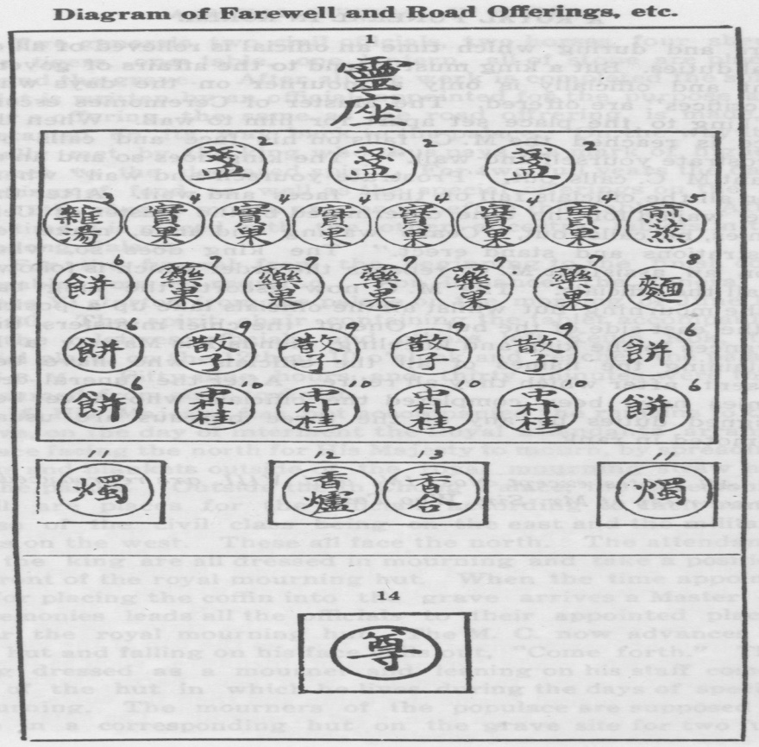
Key to Diagram of Farewell and Road Offerings, etc.
1. Seat for spirit
2. Wine cups
3. Soup
4. Fruit
5. Cooked Meat
6. Rice bread
7. Cakes mixed with honey
8. Vermicelli
9. Puffed Rice Cakes
10. Cakes cooked in oil
11. Candlesticks with candles
12. Incense Burner
13. Incense Container
14. Wine pot.
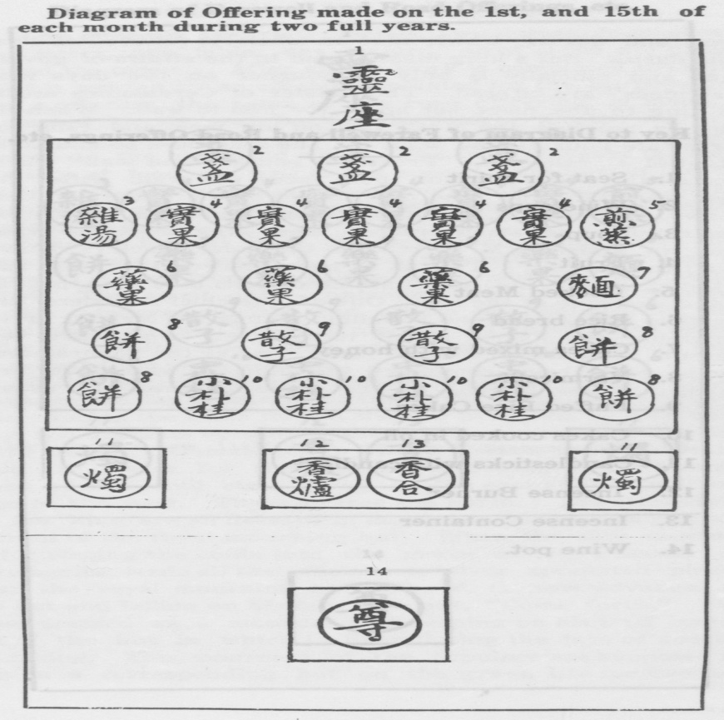

Key to Diagram of Offering made on the 1st, and 15th of each month during two full years.
1. Seat of spirit
2. Wine Cups
3. Soup
4. Fruit
5. Cooked meat
6. Cakes mixed with honey
7. Vermicelli
8. Rice bread
9.Puffed Rice Cakes
10. Cakes cooked in oil
11. Candlesticks with candles
12. Incense Burner
13. Incense Container
14.Wine pot

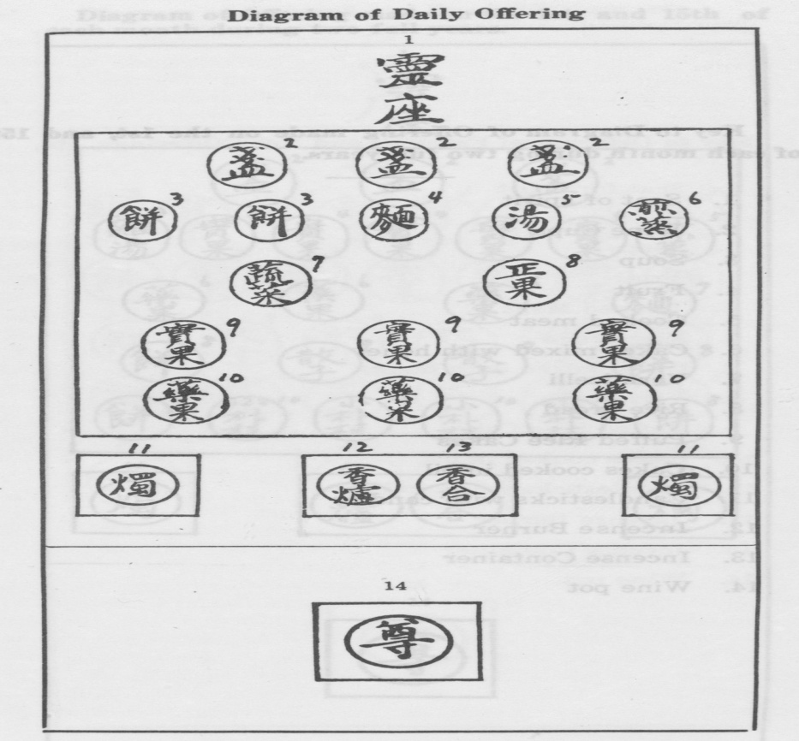
Key to Diagram of Daily Offering

1.Seat of spirit
2.Wine cups
3.Rice bread
4.Vermicelli
5.Soup
6.Cooked meat
7.Vegetables
8.Fruit mixed with honey
9.Fruit
10.Cakes mixed with honey
11.Candlesticks with candles
12.Incense Burner
13.Incense Container
14.Wine pot
