OLD KOREAN BELLS

REV. E. M. CABLE, A. M., D. D.

When I first promised to write a paper upon this subject I assumed it would not take very much time. I soon discovered, however, the fallacy of my assumption. I found that it involved the translating into readable English a large number of old Chinese inscriptions, so old that most modern students are almost as ignorant of them as a Hottentot is of Xenophon’s Anabasis. What a pathetic thing it is, that the average Korean boy or girl to day, cannot read the secrets these wonderful monuments of the past reveal. It is a most interesting fact that some of these inscriptions are perhaps older than Korea’s most ancient literature I cannot guarantee, that in every case, I have given the accurate translation. I have certainly done my very best. I discovered that it was almost impossible to get all the Chinese teachers I used to agree upon a translation. However, I do feel that I have given you very nearly the original. I trust the paper will help you, as it has helped me, to appreciate better the civilization of Korea’s past. The inscriptions upon these old monuments give us wonderful glimpses into the customs, literature, art, religious and political ideals of the past
I am quite sure that anyone who studies the history of the origion of bells will be forced to conclude that they were made to use in religious worship, for the use of bells for call-ing political gatherings, or announcing times and seasons, does not seem to have obtained in antiquity. We do know however, that from the earliest time, cymbals and bells have had a very large place in the worship of the gods. History records that in Egypt the feast of the god Osiris was announced by the ringing of bells. In Athens the feast of the god Cybele was announced by the same method, students of Old Testament history know that to the vestments of the High Priest were attached golden bells. Perhaps the history of other nations, if fully known, would reveal similiar testimony. It is a strange fact however, that in all the ancient monuments of Egypt we find no bells. It is quite different when we turn to Assyria. Here a considerable number of bronze [page 2] bells have been discovered among its ancient monuments. They range in size from two to three inches in height and one to two inches in diameter. They are also provided with iron tongues. No doubt they too, were used in religious worship. The testimony of the history of the Christian church convinces us that bells have been most intimately associated with its services, and therefore, have acquired somewhat of a sacred character. We are told that the introduction of bells into the Christian church is generally ascribed to Paulinius, bishop of Nola, in Campania (351-431). However, we have no absolute evidence of their actual existence until nearly a century later. They were introduced into Gaul in 500 A. D.. Their use in monasteries and churches soon spread throughout Christendom. They were founded with a religious ceremony. Names were given to them. They had sponsers. They were sprinkled with water, and then anointed. Finally they were covered with white garments of chrism like infants. This ceremony dates from the time of Alcuin, (725—804) and is still practiced in some Roman Catholic countries.
The oldest bells used in the churches seem to have been hand bells. They were made of thin plates of hammered iron, bent into a four sided form, fastened with rivets, and brazed or bronzed; No doubt the most remarkable one of this character in existence is the one still preserved at Belfast, and is reported to have belonged to saint Patrick. It is six inches high, five inches broad, and four inches deep. For a long period the bells were small. We are told that a certain king in the eleventh century presented a bell to the church at Orleans which weighed two thousand six hundred pounds. Not until the fifteenth century do we find bells of considerable size.
It stands to reason that the art of casting large bells quires no little skill and any people who are able to make such wonderful bells as we see here deserve our profound respect I am told that the art of casting bells has made little progress, if any, as the result of modern inventions. It seems almost impossible to make better sounding bells than were [page 3] made centuries ago. This fact should help to inspire our respect for the people of ancient Korea. A few words about bell metal and the process of moulding will better help us to appreciate this.
The material of which most bells are made is a kind of bronze known as bell metal It consists of an alloy of copper and tin. The proportions vary. Some authorities give eighty parts of copper to twenty parts of tin, or four to one. Others give three to one. It has been said that silver mixed with bell metal will give a sweeter tone. This is an error. The addition of an appreciable amount of silver would seriously injure the tone. Bells have been, and are even now, cast of steel. Their tone is not inferior to those cast of bell metal, but the vibration of the steel is not so great, and the tone is of much shorter duration. Bells have been made of glass. They give an extremely fine and clear tone, but are too brittle to withstand the continual use of the clapper.
We are informed that the quality of the tone of a bell depends, not only upon the composition of the metal, but very much upon its shape, and on the proportion between its height, diameter and thickness of the metal. The experienced bell maker has rules of his own, which have been worked out from experience, and confirmed by science.
The making of a bell after the metal has been properly prepared, is a process of founding. A core is first construct-ed of brick work, in Korea clay, which is covered with layers of clay which by means of a template is formed to the exact size and dimensions of the interior of the bell to be cast Upon this mold is then laid a model of earth and hair which is the exact counterpart of the bell to be cast. A thick and heavy shell is then built over the model, which when completed is lifted, and the model is broken away from the core, and the outside shell is then placed, leaving a space between it and the core, of the exact size and shape of the model. Into this space the molten metal is poured and allowed to cool You see, therefore, that the process of casting a bell is a very difficult one and requires great skill. [page 4]
Bells in all ages and among all peoples bear inscriptions of one sort or another. No doubt the majority of such in-scriptions are connected with religious worship. They are pious, and very frequently, indicative of the wide spread belief in the mysterious virtue of the sound of the bell.
In the history of our own ancestors, there was a time when it was believed that the sound of the bell possessed peculiar power and charm to disperse storms, pestilence, extinguish fire etc..
The tolling of the church bells to day for the dead is the remnant of an old superstitious custom. Bells were tolled for the dying, because it was the prevailing superstition that they had power to terrify the evil spirits. This custom of ringing, what was called the passing bell, grew out of the belief that devils troubled the dying and lay in wait to afflict the soul the moment it was released from the the body. After all, how much humanity has in common. We see the same idea prevailing in Korea to this very day. The bell ringers in the Korean funerals, either proceed the cortege, or stand upon the hearse, violently ringing a bell to frighten away the evil spirits which are supposed to be maliciously dogging the body to the grave.
The use of bells, according to the Roman Catholic Church’s idea, might well be summed up in the words often inscribed upon them.
“Laudo Deum verum ; plebem voco ;
Congrego clerum ; defunctos ploro ;
Pestem fugo ; festalque honoro.
I praise the true God ; I call the people ; I assemble the clergy I lament the dead ; I drive away infection ; I honor the festivals.
Judging from the great development in China and India in Buddhist worship, it seems more than probable, that the use and process of casting bells, came from the East rather than the West. I am, moreover, of the opinion that the founding of large bells, came from India, the home of Buddha to China and thence to Korea.
It is no less interesting than instructive to note some of [page 5] the great bells of the world, and remind ourselves that all of them are not in the West.
The Kyung Ju bell was made in 773 A D. It weighs 158,000 lbs. and is eleven feet high, twenty three feet four inches in diameter, and the metal is nine inches in thickness. The great Moscow bell (Czar Bell) cast in 1735, weighs one hundred and ninty nine tons, is over sixty feet in circumference around the rim, and nineteen feet high. The great Burma bell in Mandalay weighs two hundred and sixty thousand pounds. The big bell at Peking, cast in 1420, weighs one hundred and twenty thousand pounds, is fourteen feet high, thirty four feet in circumference and the metal is nine and one half inches thick. The Chongno bell, Seoul, is eight feet seven inches high, twenty three feet four inches in circumference, and is said to weigh one hundred and twenty thousand pounds. The great bell in the Diabutusa, Kyoto is said to weigh one hundred and twenty six thousand pounds. It is fourteen feet high, nine feet in diameter and the metal is nine inches thick. Another great bell in Japan is located in the Chinonian temple in Kyoto. It weighs one hundred and forty-eight thousand pounds, is ten feet high, nine feet in diameter and the metal is nine and a half inches thick. Still a third large bell in Japan is in the temple of Todaiiji, Nara. It is said to weigh one hundred and twenty thousand pounds. It is thirteen and one half feet high, nine feet in diameter, and the metal is eight inches thick. I think there are no bells in North America that approach these in size.
The bells in Korea, and I think it is true of all the bells in the East, do not have clappers. The bell is rung by striking it with a wooden beam swinging on the outside. A smooth round surface is generally prepared on the bell near the lip for this purpose. A casting, in the shape of a dragon, is attached to the top of the bell when it is founded, and by this it is suspended to a beam in the bell tower or temple.
I am not able to state the time when the first bell was cast in Korea. A certain Buddhistic record says that a large bell was made in the year seven hundred and fifty four. It states that the bell was one and one third the height of a man [page 6] and that it weighed four hundred and ninty seven thousand five hundred and eighty one pounds. This is surely a fanciful piece of imagination and requires no serious consideration. It seems quite probable, however, that bells were cast, about the middle of the eight century A. D. They were no doubt brought in with Buddhism, in which they play so prominent a part. Many of the inscriptions on the bells are dyed in Buddhistic thought and phraseology. We know that Buddhism was introduced into the Ko Ku Ryu kingdom about the year three hundred and seventy two A. D. Ten years later it found its way into the kingdom of Paik Chey, and some thirty five years or more later, it was established in the kingdom of Silla.
The purpose of this paper is to give a brief history of the location, time of casting, and the substance of the records upon the old Korean bells. In the preparation of the same I have made large use of the Chosen Keum Syuk Chong Nam, (朝鮮金石總覽), an admirable work on Old Korean Monuments prepared by the Government.
In my search for old bells I made the surprising discovery that there are none coming down from the kingdom of Ko Ku Ryu. Whether they had not discovered the process of making bells I have no way of finding out. This paper will therefore, be confined to a survey of the bells from the kingdoms of, Silla, Koryu and Chosen. We will consider those coming down from the kingdom of Silla first.

(1) Pyung Chang, Sang Won Sa Bell.
This bell is in the temple of Sang Won, in the village of Tong San, Chi Poo Myun, Pyung Chang Kun, Kang Won province. It was cast on the twenty eight day of the first moon of the twenty fourth year of King Syung Tuk, of the cycle of Ool Chook. This makes the bell nearly twelve hundred years old. It is the oldest bell of which we have any record and antedates the Kyung Ju bell by nearly forty years.
It was made of green bell metal and weighs three thousand three hundred pounds. It is five inches high, and three feet in diameter. The letters on the bell are inscribed upon its shoulder and are seven poon in height.
[page 7]
(2) Kyung Ju Bell.
Of all the old Korean bells this one offers the greatest attraction because of its great size, age, perfect workman-ship, and interesting inscription. Prof. H. B. Hulbert says, “This monster bell that for centuries tolled for the opening and shutting of the gates of Kyung Ju, or Sa-ya-bul as it was then called, from which by contraction, is possibly derived the modem word Seoul At the height of the Silla power that capital contained upwards of 178,900 houses giving an approximate population of nine hundred thousand people. In its immediate vacinity, were forty eight royal tombs. The whole list of Silla kings is fifty six, forty eight of whom were buried and rest were cremated. This great city was far greater than the present town of the great bell.” The height of the bell as given by the Japanese authorities is eleven feet, circumference twenty three feet four inches, and thickness of metal nine inches. Prof. Hulbert gives the measurements as height nine feet three inches, diameter at lip seven feet, and three tenths inches. Near the top its diameter is five feet The dimensions as given by Prof. Hulbert are nearer correct I think. It is made of what Koreans call green copper, and it is said to weigh one hundred and fifty eight thousand pounds. I fancy this is purely an estimate. The bell is so old that some of the characters written upon its side are difficult to dechiper. The bell certainly argues for the high development of arts during the Silla Kingdom.
In the tenth moon of the forth year of Tai Chyung, about eleven years ago, the bell was removed from the old site to the bell tower located in the village of No Tong, Poo Nai Myun, Kyung Ju Kun, North Kyung Sang Province.
It was cast in the seventh year of the reign of great king Hey Chyong. The bell is about eleven hundred and sixty years old, and could it speak, what wonderful tales it would tell.
The king’s favorite minister, Kim Pii Moon, was instructed by His Majesty to prepare a suitable inscription for the bell, the substance of which is as follows : [page 8]
The all prevading truth of Buddha lies beyond the realm of visible things : The source can never be seen with the eyes. Like a great sound penetrating beyond the fartherest reaches of the universe it can never be fully heard and understood. Therefore, to make better known its deep mystery, it is necessary to cast and set up in some lofty place, the spirit bell, that it may awaken the call of the Buddha. By its aid the seeker is conducted into the mystery of religion. If I were to speak of the origin of the bell I would say that it is to be found in the home of Buddha. If perchance one should care to investigate further in the land of the emperor, he will discover that it was made in the time of Koryun.
From its vast hollow form issues forth an never ceasing sound. It is so great it cannot be rolled away and being so very heavy it cannot be easily moved. Having such great permanency it thus becomes a most fitting place to inscribe the virtues of the great king. The bell possesses the myster-ious power to chase away the cares and sorrows of the peopie. I most humbly beg to say, that the deeds of his Majesty Sung Tuk, were as lasting as the eternal hills and streams and the glory of his name as the sun and moon in the heavens. He possessed the qualities which destined him to become a great king. During his benovelent reign the cus-toms of the people were made beautiful. Fitting ceremonies and music were in evidence everywhere. The manners of the people were refined. The farmers were taught to enjoy their work and became prosperous. The merchants were encouraged in the art of honesty and the marts lacked in none of the luxuries of the time. Gold and precious jewels were accounted as nothing in the sight of the king, but learn-ing and skill were prized above everything. The elders were highly respected and their counsels and admonitions gratefully received. During the forty years of the king’s reign the nation was absorbed in the arts of peace. The people were not even once alarmed or disturbed by the rumors of war. The fame of Sung Tuk spread far and wide. Representatives came from afar, not to spy and make war, but to seek his counsel and revere him for his worth. But who [page 9] among men can fortell the years of a king. The night of the Lord of Heaven is always nigh. Great king Sung Tuk died and his son Kyung Tuk, who was thirty four years old, ascended the throne to continue the work of his illustrious father. Unfortunately he had not always been a filial son. Often he had disregarded the wishes of his parents. But now that he was king of the realm, he was filled with remorse at the thought of his unworthy deeds, and desiring to make an atonement for the same, he purposed to cast a great bell. He collected twelve thousand pounds of brass, but alas ! just as he was ready to have the bell cast he died. He was succeded by Hey Kong, a virtuous man, who was most desirous of maintaining the illustrious traditions of his ancestors. It is said that wonderful omens attended his birth. A great dragon mist veiled the palace grounds. The thunders of the nine heavens shock the golden palace walls. A brilliant light flooded the capital city. The queen mother was a most remarkable woman. Her benovelence was like a great peace in the earth. She conducted the people in ways of peace and prosperity. Her mind was like a mirror and she adorned the virtue of filial piety. The king too, was most considerate of his ministers. His great aim was a well ordered life. The request of the former emperor having been brought to his attention, he at once ordered his stewards to make ready to execute the same. The work was begun in the Tai Ryu moon of the year Tai Yun. It was considered a most auspicious time. All the universe seemed to be in harmony and ready to lend assistance to the work in hand. Metal was collected and a great bell was cast. Its form arose like a lofty mountain peak and its moan was like unto that of the great dragon. Its echoes soared to the highest heavens and penetrated the lowest depths. All who beheld it exclaimed how wonderful ！ All who hear its sound will know the blessings of the Buddha. I pray that the great soul of Sung Tuk too, may hear its tones and awaken in him the three beautiful minds, so that be may be ushered into the very presence of the Buddha. I also pray that the descendants of the great king may issue forth abundantly as branches of gold. [page 10]
May his kingdom, enduring as steel, continue to prosper, and all ignorant and foolish thoughts become like a wave in the sea of wisdom, so that all may travel the highway of know-ledge together. I, Kim Pil Moon, the kings minister, undes-erving and without knowledge, was ordered by his majesty Hey Hong to prepare a fitting tribute for the bell As I take up my pen for the task, I pray for the genius of a Pan Cho’s pen, and in keeping with the saying of Yook Chwa, I venture to write these lines,
The heavens make known the kings,
And the earth fixes the bounds of their realms.
The mountains and the rivers spring forth,
The earth and the seas stand divided.
Above the great Eastern Sea,
Stands veiled a great host of faries,
The realm is fixed in the richest of lands,
Its borders unite with the great Eastern Universe.
This then is our country.
All united in one it becomes a great state.
The wonderful deeds of its illustrious kings.
Refreshes every passing generation.
Their excellent and upright rule,
Though hailing from far comes nigh to all,
Since their gracious favor is vouched safe to all,
All nature is made to rejoice.
Thou king, luxuriant as the Chyun Hyup,
Upon all is shed thy benevolent goodness.
But suddenly a cloud of grief o’er cast the sky,
And the beautiful day was robbed of its spring.
Then the gentle and filial son of the emperor,
Succeded his father as king of the realm.
He too, ruled as his virtuous father had done,
And cared not to change the customs of the land.
Daily he pondered over his father’s counsels,
And longed for the instructions of his mother.
When once again he sought to atone for his wrongs,
It was through the casting of a great bell.
His deed how glorious.

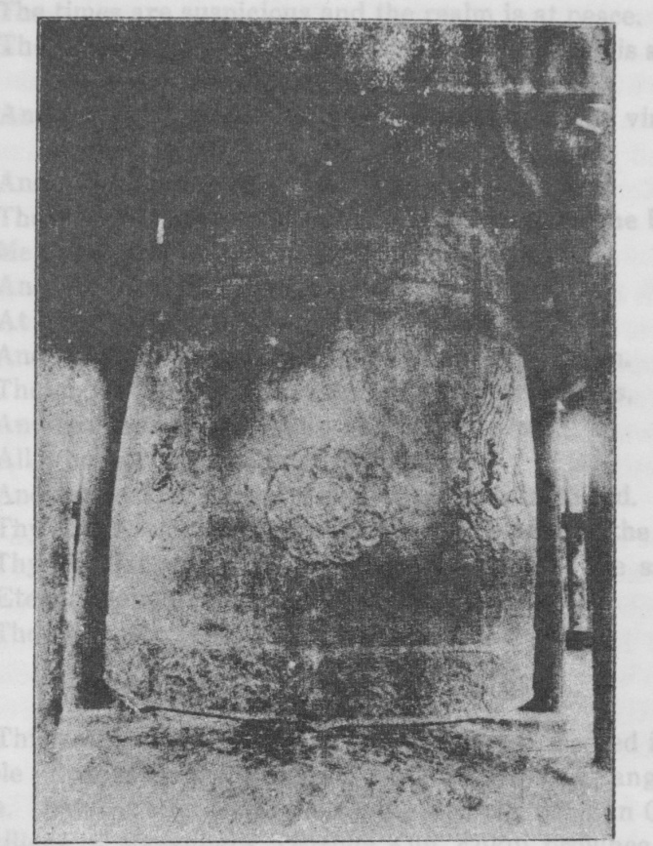
KYUNG JU BELL
Cast under Hey Kong 773 A. D. Height nine feet, three inches. Circumference twenty three feet, four inches. Thickness of metal nine inches. Estimated weight 158,000 lbs. [page 11]
Wonderful omens appeared from time to time,
And spiritual guidance was never lacking.
The king is virtuous and heaven assists him,
The times are suspicious and the realm is at peace.
The king diligently reflects upon the deed of his ancestors
And seeks to console his mind by copying their virtuous deeds.
And now desiring to comply with the kings wish
These words are composed and inscribed upon the bell.
Men and gods united in their strength,
And the form of the precious bell appeared.
At its sound the devils are subdued,
And salvation is vouched safe even to the dragon.
The majesty of its tones shake the eastern valleys,
And scales the mountain crags of the north,
All who hear and behold it believe,
And a beautiful and perpetual bond is established.
Thy round, empty form reveals the substance of the gods,
Thy angular shape makes known the work of the saints.
Eternal happiness comes from thee.
Thou unchangeable and eternal bell.
(3) Chinju Ju, Yun Chi Sa Bell.
This bell is the one which was originally located in the temple in the magistracy of Chin Ju, South Kyung Sang province. Later it was removed to the temple of Yun Chi, in the village of Maysubara, Tsuruga Kun, Fukui province Japan. It was cast in the seventh year of great Heung Tuk, of the cycle of Kei Chook. The bell is nearly eleven hundred years old.
The inscription upon the bell is very short and says, In the third moon of the seventh year of Tai Wha, the metal for the bell was collected and the bell cast The Home Department of the government contributed seven hundred and thirteen Chyung, the Department of the Treasury four hundred ninty eight Chyung and and one hundred and ten Chyung were voluntarily contributed by the people. This makes the[page 12] total weight of the bell one thousand three hundred and twenty one Chyung (whatever a chyung may be).

We will next consider the bells coming down from the kingdom of Koryu (918-1392), This kingdom was established in nine hundred and eighteen and continued for a period of four hundred and seventy five years. Its capital was located in the city of Songdo. The ruins can still be seen and it is well worth a trip to this interesting city to view the same. From Koryu we obtain the English name Korea.

(1) Yung Am Syu Won Bell.
This bell was originally in the Syu Won Temple, Yung Am Kan, South Chulla province, and was later removed to the temple of Chyo Yun in Takebara Machi, Nishinari Kun, Hiroshima province, Japan.
It was cast in the fourteenth year or King Kwang Chyong of the cycle of Key Hai. The bell is one thousand sixty years old.
The record on the bell says, that the inscription on the bell in the temple of Syu Won in Ko Mi Hyun, was made on the eighteenth day of the ninth moon of Choon Poong, of the cycle of Key Hai. Those who had charge of the casting of the bell were the head priest of the temple and his associates, Young Hyun, Sin Om Yum, and Ho Ayun. Here the rest of the inscription is undreadable.

(2) Yang Pyung, Chyun Heung Sa Bell.
This bell was in the temple of Pey Pong Tuk, Yang Pyung, Kwang Ju Kun, Kyung Kei province. It was removed from there to Prince Yi’s Museum in the winter of the 44th year of Meiji. 1911. It is a beautiful bell and well worth the trip to see it. It can be seen in the large brick building in the Museum. The room was so dark I was not able to take a photograph of it neither was I able to secure a cut, although such cuts are in existance.
The bell is made of green metal and is in a very fine state of preservation. It is four feet three inches high, and nine feet eleven and one half inches in circumference. I[page 13] could not get the measurement of the thickness of the metal as the bell is setting flat upon a pedstal and cannot be moved.
It was cast in the first year of king Hyun Chyong, of the cycle of Kyung Sool, about nine hundred and fifteen years ago. The only other characters inscribed upon it are the twenty eighth year of Tong Wha, the second moon of the cycle of Kyung Sool.

(3) Kyu Chei, Pook Sa Bell.
This bell was first cast and placed in the temple of Pook, South Kyung Sang province. Later it was removed to the temple of Seung Nak, in the village of Kagami, Higashi Matsuura Kun, Saga province, Japan. Finally it became the private property of a Japanese by the name of Ha Ma Matsu until about the first year of Meiji, when it was broken up. We are told that it was cast in the seventeenth year of king Hyun Chyong, of the cycle of Pyung In. The metal in the bell weighed one hundred and twenty pounds.

(4) Syup Chin, Hak Man Sa Bell.
This bell is at present in the temple of Hak Man, in the village of Toyosaki, Nishinari Kun, in the prefect of Osaka, Japan. It was cast in the twenty first year of king Hyun Chyong, of the cycle of Kyung O. Another reckoning is the second moon of the tenth year of Tai Pyung. This makes the bell about eight hundred and ninty five years old.
The inscription in substance, is as follows :—A certain priest (name has been erased) had a bell cast of copper weighing three hundred pounds. The following words seem to be the prayer of a priest I pray that all who hear the sound of the bell, may have their fears allayed, and their wisdom enlarged. Being imbued with the mind of the posal let them depart from Hades and the pit of fire, and grant that they, burning with the desire to become a Buddha, may go out to rescue mankind. Let all who hear the sound of the bell honor the king, praise the realm, and strive to make the wonderful day of Buddha still more glorious. Grant that the tones of the bell may bring peace to our great king and[page 14] tranquility to the four seas. May the faith of the donors of Buddha be greatly increased^ Let the root of goodness take still deeper hold and awaken in all the desire to possess the two worlds. Grant that peace may prevade the environs of the temple and fill the hearts of mem Happiness will surely come to those who carefully guard their actions, and from those who walk according to the teachings of the great Buddha, satan will surely depart Then, and only then, will the wisdom of a Pan Yak (Posal) be theirs for aye. Thus will they be able to repay the four favors and the way for the Three Blessings will be paved Moreover, having received the mind of the Buddha, they will become like unto him, perfect wisdom,
Written in the fifth year of Young Wha, of the cycle of Kei Mi.

(5) Kon Kang, Won Syung Sa, Won Man Won Bell
This bell is located in the temple of Won Syung in Otsu Shi, Shiga Province, Japan#
It was cast in the first year of king Tuk Chyong of the cycle of Im Sin# The inscription, which is very short says, that in the twelfth moon of the twelfth year of Tai Pyung, of the cycle of Im Sin, a bell weighing one hundred and sixty pounds was cast

(6) Chook Chyun, Seung Chyun Sa Bell
This bell is in the temple of Seung Chyun now located on Tsujido Machi, in the city of Fukuoka, Fukuoka province, Japan. It was cast in the ninteenth year of king Moon Chyong, of the cycle of Ool Sa, about eight hundred and fifty nine years ago.
The inscription says that in the third moon of the cycle of Ool Sa, in the eleventh year of Cbyung Yung, the blacksmith Kim Soo Poo, and an assistant (here the record is obliterated) were orderd by the head priest of the temple of Kei Chi to cast a bell weighing one hundred and fifty pounds. The bell was made and placed in the Nak Won Room of the temple of Seung Chyun to call the priests to worship. The [page 15] bell was ordered hung by the priest Chyung Chin Soo on the seventh day of the cycle of Moo 0, in the seventh year of Myung Eung. The chief priest in charge of the temple was Tong Chyong.

(7) A Pa, Tai San Sa BelL
This bell was originally cast in Korea and then taken to the temple of Tai Sa, in the village of Anakui, Umbi Kun, Tokushima province, Japan. Later it became the private property of a Japanese by the name of Kume Taminosuke.
It was cast in the twenty sixth year of king Myung Chyong, of the cycle of Pyung Chin, about seven hundred and eighteen years ago.
The record says that in the fourth Moon of the cycle of Pyung Chin, of the seventh year of Myung Chang, the priests all united in securing sixty pounds of metal with which they cast a bell for the temple of Tuk Heung. It was hung in the temple to commemorate the virtue of the king and to wish him happiness and long life.

(8) Syung Kang, Nam Poo Ka BelL
This bell is at present the private property of a Japanese by the name of Nambu Rijunf who secured it from Rikuchu Heiei Kun, Sendai, Miygai province, Japan.
It was cast in the second year of Heui Chyong, of the cycle of Pyung In. It is now about seven hundred and twenty five years old-
The record says that Yak Chin and his wife, Han Si, collected metal and had a bell made weighing seventy-five pounds which they had hung in the temple of Syung Kyung Won, in the magistracy of Sip Im, to commemorate the great virtue and merit of the king. This record was made upon the bell in the first moon of the sixth year of Tai Wha, of the cycle of Pyung In.

(9) Kai Syung, Yun Pok Sa BelL
This bell is of very great interest. It is now located in the tower of the old South Gate, but was originally in the Yun Pok temple, outside the South Gate- In the zenith of[page 16] Ko Ryu’s Power the city of Songdo comprised about 200,000 houses with a population of perhaps a million and a half of people^ The population of the present city is forty one thousand seven hundred and ninty five, making it the fifth largest city in the Peninsula. After the fall of the kingdom of Korea and the rise of the kingdom of Chosen, the people of Songdo were prohibited from taking any part in official life, and were therefore, shut up to the vocation of mercantile life. They became very proficient in this profession, as the testimony of the present city verifies. It is practically the only large inland city that is purely Korean. Many monuments of historical importance are still to be seen here. The Bamboo Bridge, where the loyal Cheung Pok Keung was murdered, is still kept in a good state of preservation. A few paces directly ahead of the bridge is the Weeping Stone Tablet, erected to the memory of this man. It is given this name because the Koreans say it is weeping for Cheung, being always damp. Some little distance to the rear of the bridge is a fine pavil- lion housing two very remarkable tablets erected to the memory of Cheung by the Yi Dynastyt The tablets are set upon the backs of two huge turtle stones, which I am told were brought from south Korea- How they were transported with out modern conveniences is a marvel Then too, there is the site of this old palace. Only the great terrace and a few stones remain, mute sentinels of a once magnificant and powerful kingdom. I am told by Koreans, that so vast and commodius were the palace inclosures, that on a rainy day, one could walk for thirty Li under cover. The truth of this I cannot prove. I was informed by Koreans that a much larger bell than the one in Yun Pok lies buried in the ground and that Korean supersticion will not permit its being unearthed.
During this kingdom Buddhism flourished and inside the royal city many Buddhist temples were to be found. The priests frequently took a very active part in the affairs of the government Tradition says, that even Song Ak San, the guardian mountain of the city, assumed the appearnace of a Buddhist priest in robes, and when the kingdom fell, it

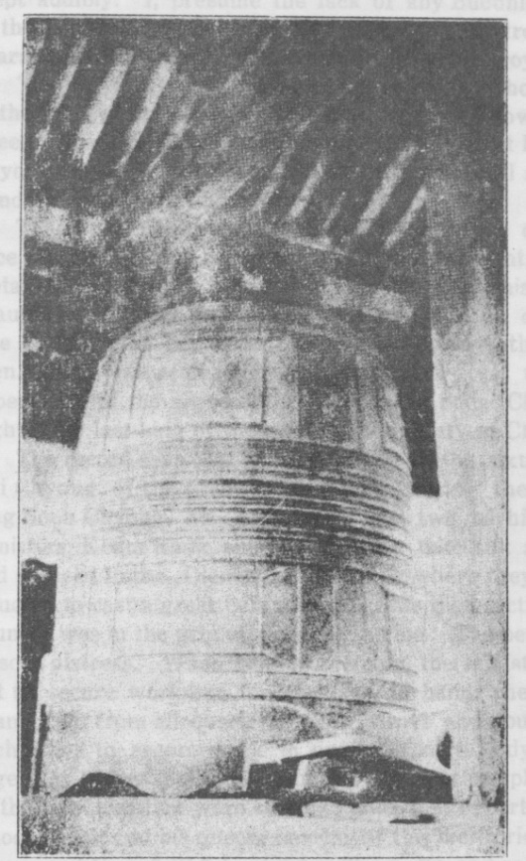
YUNG POK BELL
Located in Songdo City Cast under Choong Mok 1346 A. D. Height eight feet, one inch. Circumference nineteen feet, eight inches. Thickness of metal eight and one half inches.

[page 17] wept audibly. I, presume the lack of any Buddhist temples in the city is due to the fact, that owing to the troublesome character of the priests, the temples were all destroyed.
The bell was cast in the second year of king Choong Mok, in the cycle of Pyung Sool. It is interesting to know that the queen of Choong Mok was the daughter of great king Soon Chyong, of the Won Dynasty. This makes the bell about five hundred and seventy nine years old.
The bell is nineteen feet and eight inches in circumference at the lip, eight feet and one inch in height, and the metal is eight and one half inches in thickness. This is a very beautiful bell. The workmanship is of exquisite character. The style of the bell is so different from any other I have seen. You will remember this was the bell cast under the supervision of the representatives of king Soon Chyon, the eighth and last king of the great Won dynasty of China.
The record says that in the spring of the sixth year of Chi Chyung, of the great Won Dynasty, during the reign of king Soon Chyong, his Majesty ordered two of his trusted ministers, Keum Kang, and Sin Yea, to take silk and gold, and proceed to the Diamond Mountains where they were instructed to cast a great bell. At this time that section of the country was in the grip of a severe famine. The people were in sore distress. When the order from the ministers went out to secure workman for the task in hand, there was a grand rush from all quarters. Men strove and fought with each other to secure work in order to keep body and soul together. After some little time the bell was completed, and as the two ministers were about to take their departure, King Choong Mok and his queen, hearing of this meritorious work, summoned their faithful minister Tong Yo and said to him, What is this we have heard about the casting of a bell in the Diamond Mountains ! Are not these mountains a part of our realm ? How does it come that we have allowed the emassaries of a foreign country to go there and perform this great work of merit to Budddha, while we ourselves have had no part in it ! Minister Tong listened attentively and then said, Perhaps your Majesty, we can atone for our sin of negligence [page 18] by casting a great bell ourselves. In the temple of Yun Pok is an old bell which has not been in use for a long time. Suppose we invite these bell experts to come to our capital and instruct us in the casting of the same. Providing we do this we can fulfill the desire of your Excellency and provide a memorial that will last for all time. The king was greatly pleased with the counsel of his minister and the two emissaries of king Syun Chyong, Kang Keum Kang and Sin Yea, were invited to come to Songdo and take charge of the work of casting the bell. In due time the work was completed and Choong Mok ordered his minister, Yi Kok to prepare a suitable inscription for the bell It is about as follows :—
If one would have men hear to the best of advantage there must be the sound of a bell.
It sets in order the imperial guards and harmonizes the pal eum.
The saying of the old priest Koo Tam is indeed profound.
Beneath the earth is hades and terribly dark it must be.
Even a thousand births and deaths are surely hard to endure.
They are like an intoxication, a dream, like one being born deaf and dumb.
But when once the sound of the bell is heard the heart will respond, O thou great bell in the capital of the king.
At the boom of the bell all who dwell in the vicinity tremble, It echoes soar to the far flung silent heavens, and reverberates even in the solitary and darkest deeps of earth.
It heralds the wonderful blessings of Buddha, and like the prayers of Wha Pong In, it assists the petitions of the king and his ministers.
May the king be blessed with long life and great posterity,
And let peace and eternal beauty always abide with the realm.
This is inscribed upon the bell at the command of the king in the sixth moon of the cycle of Pyung Sool.
[page 19]
(10) Yu Ju, Sin Neuk Sa, Po Chei Syun, Sari Syuk Bell Monument.
This is not a bell proper. It is only a stone monument in the shape of a bell. There are a number of these coming down from the kingdoms of Korea and Chosen. This one is located in the temple of Sin Neuk, in the village of Chyung Syong, Poo Nai Myun, Yu Ju Kun, Kyungkei province. It was made in the fifth year of king Sin Oo of the cycle of Keui Mi. It is about five hundred and forty five years old.
The record upon the monument says, that the bell was made to contain and preserve the sari (gems) of the priest Po Chei, and is located in the Sin Neuk temple, Yu Heung Kun. This was the old name of Yu Ju. There was a renowned priest by the name of Po Chei Chyon. Daring his lifetime he was an unusual man and revealed many remarkable spiritual qualities. We are told that by his devoted life the doubting were strengthened and the number of believers greatly increased. Therefore, it was most fitting that a portrait of his likeness be made and hung in the temple, and that his precious sari (gems) be collected, and deposited in the stone bell monument. A priest by the name of Kak Sin, eager to consumate this undertaking, secured the help of another priest by the name of Kak Choo, to prepare the monument, upon which were inscribed the virtues of the great priest. The record on the monument says, A certain priest from Young Chyun, chanced to visit the temple of Sin Neuk and the priest Kak Choo requested him to prepare a fitting tribute for the monument. Young Chyun was greatly pleased with the honor shown him and replied, I will go to Seoul and interview the famous scholar Yi Sak ; I am sure he will not refuse if asked to prepare such a memorial. The tribute as prepared by Yi Sak is as follows :—
Kang Wol Hun was the home of Po Chei. Though be is dead and buried, and we behold him no more, yet the river and the moon, are the same as yore. The great temple of Sin Neuk stands firmly upon the river bank and its great stone bell monument towers majestically above the water. When[page 20] the moon rises the great monument casts its shadow upon the face of the water and its form is mirrored upside down. The light of heaven, meeting the light from the temple, is mingled with the gently rising smoke of the ever burning incense, and thus does the memory of Po Chei, of Kang Wol Han go on forever. The sari of the great priest have been scattered to the four points of the compass. They are to be found upon the peaks of the highest mountains and in the crowded cities. Truly, is not the possession of these gems as real as the presence of Po Chei. However, since the temple of Sin Neuk containes the monument guarding the precious sari, it become imperative that Kak Choo guard well its treasure. Not only is the temple built securely, but the great stone bell monument likewise, will endure to the end of time. Further, the river and the moon will continue on for even It is a well known truth, that the blooming flowers are but for a season ; but the life and death of man are not a vain and empty thing. The most ignorant well understand this. The rise and fall of an age is possible but the character of man goes on forever the same.

(11) Yengbyen An Sim Sa, Chi Kong and Na Ong, Sari Syuk Bell.
This is another stone bell monument and is located in the temple of An Sim in the village of Ha Yang, Pook Sin Hyun Myun, Yengbyen Kun, North Pyengyang province. It was made in the tenth year of king Sin Oo, in the cycle of Kap Cha. This makes the monument about five hundred and forty years old.
The height of the stone bell is three feet eight inches and the width two feet The length of the letters cut into the stone are five Poon. The temple of An Sim Sa is on the mountain of Myo Hang, Yun San Poo.
The record on the monument was prepared by the clebrated scholar Yi Sak ; the same man who prepared the one for the monument in Sin Neuk temple. In substance it says, that in the fifth moon of the eleventh year of king Sin Oo, a priest by the name of Kak Chi, dressed in a black robe [page 21] and wearing straw sandals, approached one of the kings ministers and begged to say, that when the celebrated teacher of our own Syu Chyun Chi Kong died most wonderful sari (gems) appeared. Furthermore, when our own Na Ong, was cremated many remarkable gems came forth from the fire, and desiring to have these precious gems preserved, he with Chang Mil Cheuk Yru, and his wife Kang Si, prepared a stone bell and placed it in the temple of An Sim on Myo Hyang mountain. In the making of the monument the one in the temple of Sin Neuk had been copied. However, if the record of the deeds of these two celebrated desciples are to be preserved to succeeding generations, it is necessary that their deeds be inscribed upon the stone monument But alas ! Kak Chi had no approach to the kings closest ministers. In despair he sought Cho Chang Young, one of the kings secretaries, who fortunately symathized with his desire, and was glad to place the matter before the king. The king gave his hearty consent to the project, and on the twelfth day of the eight moon, Pan Tuk Hai, one of the king’s ministers, ordered the celebrated scholar Yi Sak to prepare a fitting memorial to be inscribed upon the bell monument. The queen too, was delighted with the project, as she wished to make prayers before it in behalf of the Crown Prince. The priest Kak Chi, visited Yi Sak, and urged him to make haste in preparing the memorial. Yi Sak replied, if you wish me to do this at once, it will be necessary for you to give me the facts. Upon this request Kak Chi related to Yi Sak the salient facts in the lives of the two great teachers. He said, I became a disciple of Na Ong in Moo Sool, in the year of Chi Chyung, while he was residing in the temple in the West Capital. He was the teacher of the king. He lived in Whoi Am and there he built the temple. It was my pleasure to assist him in the construction of the same. When the king died it was mooted that the temple was too near the capital Great crowds of people continually visited the temple. It was feared that this might interfere with the studies and meditations of Na Ong. It only proved too true. The famous teacher begged that he might be permitted to remove to another temple. Just as he was ready [page 22] to depart, he summoned me, and asked me to accompany him. I gladly consented and together we came to the temple of Sin Neuk, in Ryu Heung. It was here on the fifteenth day of the fifth moon, of the cycle of Pyung Chin, Na Ong died. He was held in high esteem. It is said that a priest by the name of Kak O, who after he had guarded his monument for three years, refused to surrender the task and continued to do it for some time longer. Kak Chi said that from the time he had first met Na Ong in the West Capital a great many people had been influenced by his life, and now that he was gone and there was no memorial to preserve the memory of his virtuous life, it had become a matter of great grief. I would like to have his deeds inscribed upon the monument so that those who read them and behold the sacred gems the bell contains, may do reverence to the great teacher. It is true, that paying obesience to the gems, is the same as serving the living Na Ong. Furthermore, one must remember, that the Myo Hyang mountain is the place where the Po Hyun posal dwelt It has become as famous as the Diamond mountains. It reaches to Yo Dong (Manchuria) on the north and on the left it unites with Chang Paik. The deeds of Na Ong were truly wonderful. They fill the universe. Since there is no place where there influence has not been felt, it becomes exceedingly dif-ficult to locate a site for the monument. However, having seen the form of this mountain, the choice was made. This mountain is truly wonderful. In its environs more than three hundred temples are to be found. It holds many ancient landmarks and will offer much for reflection to those who visit it The name of Chi Kong was Syun Chyun. His father’s name....................and he was a descendant of the royal line.
It is said that he studied with the celebrated Po Myung Chon. Our teacher, Na Ong too, was the descendant of A Sey Koo and he studied with the famous priest Pyung San Chyu Rim Syun Sa. It was the latter who wrote the history of Chi Kong and Na Ong. This record is to be found inscribed in the temples. We also must remind ourselves that it was Na Ong who gave the name for the temples, viz. Chi Ak San, So Pak San, Sa Pool San, Yong Moon San, Koo Ryong San, Myo Hyang San, [page 23] and Furthermore, of the many things presented to Na Ong from the emperor the following still remain and can be seen by those visiting the temples. In the temple of Chyung Yang, in the Diamond mountains, a priest’s sash and Jade. In the temple of Whoi Am a priest’s sash, bowl and robe. In the temple of Sin Neuk a priest’s robe, bowl and fan. In the temple of O Tai San a priest’s robe and a fan. In the temple of Hyun Am a priest’s sash. In the temple of Eui Pong a priest’s sash and cane. In the temple of Po Hyun a priest’s sash, robe and chain The precious gems of Na Ong are to be found in all the temples, and a great multitude reverences them. How would it be possible to speak of each gem. I pray that long life may be vouchsafed to the royal house and that the land may be free from all distress and the people enjoy great blessing. May even the dumb creation be delivered from the curse of cunning and restored to the perfect sphere. May the land be forever free from all that disturbs from without and enjoy enduring peace. It is true that men have forsaken religion and departed from the teaching of our great sage and have thus continued in sin. If we are to have a revival of religion, then the relation of minister to king, friend to friend, son to father, wife to husband, young men to elders, must be the same as yours to your teacher ana his to his teacher. Surely with the realization of this peace will come.
In the West it is Chi Kong,
And in the East it is Na Ong.
Their purposes were the same though their history differs,
And their gems are alike beautiful and precious.
Men behold their gems and wonder,
Truly their blessings are manifold.
Thou High and majestic Myo Hyang,
Multitudes of peaks are weighed down by thee.
(Here a number of lines are erased)
The years of the king are many,
And the life of the queen is likewise long.
And the virtue of the Crown Prince is replete. [page 24]
The ministers of state perform their duties faithfully
And the people honorably follow their several callings.
May our ever increasing desire be,
That our nation may enjoy perfect peace.
(Here again a few lines are erased)
I, Yi Sak, have prepared this record and written this ode trusting that our prayer may always be for heaven’s blessing. Written in the ninth moon of the cycle of Kap Cha in the seventh year of Hong Moo of Tai Pyung.

(12) Sa Ra Sa Bell.
This is another stone bell monument located in the temple of Sa Ra in the village of Yong Moon Myan, Yang Pyun Kun, Kyung Kei province. It was made in the twelfth year of king Sin Oo, in the cycle of Pyung In. It is nearly 540 years old. A number of the characters are obliterated so that an exact translation of the inscription on the bell is impossible. The substance of it seems to be to the effect that during the Koryu kingdom there was a celebrated priest by the name of Yi Ong Chon Cha. Upon his death, while the body was being cremated for burial, as was the custom with priests, ten wonderful sari (gems) came forth from the fire. In order to preserve these precious stones, an official by the name of Kang Man Chan, had a stone bell monument prepared in which were placed the gems and the monument was put in the temple of Sa Ra.

(13) Kyung Ju, Whoi Chin Sa Bell.
It is interesting to note that this bell was originally in che Tong Kyung capital, now Kyung Ju. It was later removed to the temple of Chyung Ryun in the village of Hoki chi, Yatsuka Kun, Shimna province, Japan. It is impossible to ascertain the time of its casting as the characters have been marred and it is not possible to read them. The record on the bell says that a disciple of Buddha in the temple of Whoi Chin by the name of Syuk was ordered to prepare a fitting inscription for the bell. It runs about as follows ;—
In order that the years of the king may be many, his kingdom strong, and the people might enjoy permanent peace, three thousand men were ordered to cast a bell. This was recorded upon the bell on the eight day of the fourth moon of Sin Hai.

The last bells to be considered are those coming down from the kingdom of Chosen. Upon the fall of Koryu in 1392 A. D. the kingdom of Chosen came into existence, with its capital at Seoul It continued over four hundred years. During this time twenty kings sat upon the throne. A number of interesting bells belong to this period.

(1) Heung Chyun Sa Bell.
This bell is at present in Prince Yi’s museum. I have been told, I cannot vouch for the authenticity of it, that it was above the great gate in front of the Kyung Pok Palace for more than a hundred years. We do know that seventeen years ago it was taken to the Museum, where it can now be

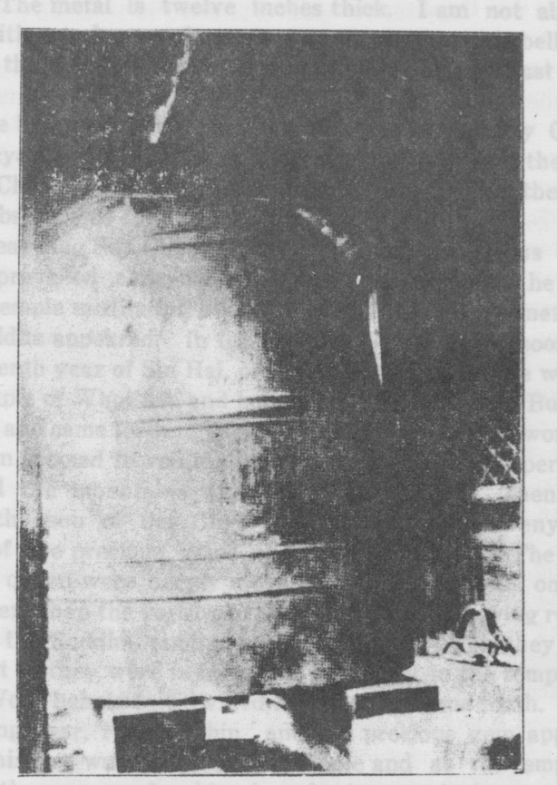
HEUNG CHYUN BELL
Cast in time of Sey Chyo, 1464 A. D. Located in Prince Yi,s Museum, Seoul. Height seven feet.
Circumference seventeen feet. Thickness of metal one foot[page 25].
seen. It is in a fine state of preservation. The workmanship id good. It is seventeen feet in circumference and seven feet high. The metal is twelve inches thick. I am not able to state with any degree of accuracy as to whether this bell was ever in the present Heung Chyun temple outside of East Gate or not.
The bell was cast in the seventh year of king Sey Chyo, of the cycle of Im O. It was the same king who had the big. bell at Chongno cast six years later. The record on the bell is in substance as follows :
Great king Sey Chyo reigned in a most auspicious time. Peace prevailed everywhere. Once upon a time, as he was in the temple meditating upon the truth wonderful omens of the Buddha appeared. In the summer of the fifth moon, of the seventh year of Sin Hai, of the cycle of Im Cha, he was in the temple of Whoi Am and behold ! the gem in the Buddha divided and came forth. The glory and power of this wonderful omen seemed to veil the heavens and a strange perfume covered the mountains and filled the valleys. Then too, when the son of Sey Chyo was in the temple, tweny five more of the precious gems of Buddha appeared. The king and his queen were deeply moved by this propitious omens. Still later when the royal pair were in the act of paying reverence to the Buddha another gem appeared. This they took and just as they were in the act of placing it in the temple of Ham Won, behold ! it divided and another came forth. The following year, Pyung Chin, another precious gem appeared. This too, was placed in the temple and as the empress was in the process of making her obesience to it, it once more divided. Now the total number of the gems which had appeared were one hundred and two. Indeed they had been so many that it was difficult for the priests to keep track of them. The king was so happy over these wonderful omens that he granted an amnesty to all prisoners and vowed that he would personally translate the sacred scriptures of Buddha and rule the realm wisely and justly. He proposed to make a portrait of the Buddha in order to pay reverence to his illustrious ancestors. Before this was realized however, he[page 27]. had a dream in which two female Buddhas Kwan Eum Sa and Chi Chang appeared. They stood facing each other. One of them was the dispenser of mercy and blessing to the living. The other the giver of strength and life to those in Hades. The king was deeply impressed by this vision and had two portraits made, to represent each of these Buddhas, and had placed in them the precious gems which had from time to time appeared, and set up in the temple of Heung Chyun. Then the king and his queen burned incense before them and offered sacrifice. The king further ordered a large bell to be cast and had it rung six times each day so that those imprisoned in hades might hear its sound and wake to life and happiness. The inscription further reads:
Our king was early instructed in the sacred writings of Buddha,
And seizing the golden wheel came to the throne of power.
He was stern, reverent and fearful,
And never would allow himself to be idle.
The times were auspicious ； men and gods lived in harmony,
And spiritual and temporal blessings flowed together.
The king was endowed with unusual insight,
And great understanding of spiritual things was his.
From the Buddha came forth many precious gems,
Rare and wonderful omens filled the land.
Those who heard ana beheld them were amazed and con--founded,
The heavens and the earth were filled with light
And the earth trembled at the sight.
Never was there such a time.
The heart of the king was filled with joy,
And it pleased him to make a great vow.
A portrait of the Buddha was fashioned and hung in the temple,
And the scriptures of the same were expounded.
Prayers for the ancestors were offered,
And truly their blessings were vouchsafed even to the people. [page 27].
The realm is founded securely,
And its glory will outlast a billion years.
The doctrine of Buddha is truly wonderful,
It brings salvation even to the darkest depths.
And our king following the example of Buddha,
Is wonderfully compassionate and his grace is extended to all.
The metal is melted in the furnace and the bell is cast:
The minds of men are enlightened ; their prison door is opened ;
Their anxiety has been forever removed ;
all the hard things have been made clear.
Recorded in the tenth moon of the sixth year of Chyun Soon.

(2) Kyung Sung, Po Sin Kak Bell.
This is the famous bell located at Chongno in the center of the city. The record on the bell says it was cast in the thirteenth year of Sey Cho, of the cycle of Moo Cha. The dimensions of the bell are, height, eight feet seven inches, circumference, twenty three feet four inches, and the tmckness of the metal is twelve inches. Nowhere is the weight of the bell given. I think it must weigh almost as much as the Kyung Ju bell because while not so high, the metal is several inches thicker.
Dr. H. N. Allen, in the second volume of the Korean Repository, says of this bell, “When Tai Cho, the founder of the present dynasty was having excavations made for building the East Gate Seoul, a bell was found. Tai Cho decided to produce this bell upon a larger scale and gave orders to all the governors and magistrates to collect the necessary metal. While the collection was being made in An Eye district of Kyung sang Province, the collector called at a house where he saw an old woman with a three years old boy, strapped on her back. The old woman said she had no metal, but the man might take her boy, or more properly, “Shall I give the boy?” signifying consent by her tone. The man went on but told of the strange incident and it evidently became known in Seoul. [page 28].
The metal being collected, crucibles made, and the mold prepared, the bell was cast, but on cooling it cracked. The process was repeated and the bell cracked again. This happened several times and the king finally offered a great reward to anyone who would solve the difficulty. One of the workman agreed to do so, and relating the incident of the old woman and the child, he said that the bell would continue to crack, until the offer of the old woman should be accepted, as she was doubtless a witch. The king sent for the child, the metal was melted, the child was thrown into the molten mass and the bell was cast. This time the process was a complete success.
The deep rich tones of the bell as they rolled across the quiet city seemed to say with long drawn cadence, “Ah Mey La,” the la being especially prolonged. This means, ‘‘Mother’s fault” and is the cry of the child who was dropped into the molten metal to secure the proper cast.
Professor H. B. Hulbert, in the 1901 number of the Korea Review has given the Korean legend on the ‘Spirit of the Bell. This is hard to secure so I give the legend.
The master-founder stands with angry brow
Before his bell, across whose graven side
A tissure deep proclaims his labor nought.
For thrice the furnace blast has yielded up
Its glowing treasures to the mould, and thrice
The tortured metal, writhing as in pain,
Has burst the brazen casement of the bell.
And now like a dumb bullock of the lists,
That stands at bay while nimble toreadors
Fling out the crimson challenge in his face,
And the hot, clamoring crowd with oaths demand
The fatal stroke, so hangs the sullen bell
From his thwart beam, refusing still to lend
His voice to swell the song hymeneal,
To toll the requiem of the passing dead
Or bid the day good-night with curfew sad.
The master founder said “If but an ounce
Of that rare metal which the spirits bide[page 29].
From mortal sight were mingled with the flux
It would a potion prove so powerful
To ease the throes of birth and in the place
Of disappointment bring fruition glad.”
And lo ! a royal edict, at the band
Ot couriers swift, speeds o’er the land like flame,
Across the stubble drift of sun dried plains.
“Let prayer be made to Spirits of the earth
That they may render up their treasure,
Lest our Royal city like a Muslim route
Shall have no tongue to voice her joy or pain.”
The great sun reddened with the altar smoke,
The very clouds caught up their trailing skirts,
And fled the reek of burning hecatombs ;
But still the nether Spirits gave no sign.
Not go ! A mother witch comes leading through
The city gate a dimpled babe and cries,
“If to the molten mass you add this child
‘Twill make a rare amalgam, aye so rare
That he who once has heard the bell’s deep tone
Shall after hunger for it more
Than for the voice of mother, wife, or child.”
Again the furnace fires leap aloft,
Again the broken fragments of the bell
Cast off their torpor at the touch of flame.
Unpitying are the hands that cast the child
Into that seething mass, fit type of Hell !
Nay, type of human shame that innocence
Should thus be made to bear the heavy cross
For empty page antry. How could it be
That Justice should permit the flowing years
To wash away the memory of that shame ?
Nor did she. Through that seething metal coursed
The life blood of the child. Its fiber clothed
A human soul. Supernal Alchemy !
And when the gathered crowd stood motionless
And mute to hear the birth note of the bell,
And the great tongue beam, hung by linked chain[page 30].
Aloft, smote on its brazen breast, ‘twas no
Bell cry that came forth of his cavern throat.
‘Twas “Emmi, Emmi, Emmi, Emmille.”
“O Mother, woe is me, O Mother mine !
No little interest was attached to the ringing of this great bell. Twice each day, morning and evening, its deep rich tones floated in cadence o’er the great city. At the break of day it was struck thirty three times. The significance of this particular number was fixed by Buddhism. According to the teaching of Buddha there are thirty three heavens ; six in the Yook Kei (육계) world of desire, eighteen in the Sak Kei (삭게) world of light, four in the Moo Sak Kei (무삭계) world of darkness, one each for the quarter of the compass and one for the central sky—making thirty three in all. The bell was struck once for each heaven. The ringing of the bell in the morning was called Pa Ra (파라) originally Pa Roo (파루) meaning the leaking of the Clepsdea has ended.
In the evening the ringing of the bell was called In Kyung (人磬) originally In Chyung (人靜), meaning director of men. It was struck twenty eight times. This number was fixed by the principal stars visible at that time which were supposed to exercise great influence over the destiny of men. The names of the stars are, Kak (角) Hang (充), Chyu (氐), Pang (房), Sim (心)Mi (尾), Keui (箕), Too (斗), Oo (牛) Yu (女虛), Eui (危), Sil (室), Pyuk (壁), Kyu (奎), Eui (婁), Noo (胃), Myo (昴), Pil (畢) ,Cha (觜), Sam (參), Chyung (井), Kooi (鬼), Noo (柳) Syung (星), Chang (張), Ik (翼), Chin (軫).
It was the custom when the bell was rung in the evening for the guards at the great East and South gates to call out in a stentorian voice Moon ta-nan-ta, Moon ta-nan-ta. This was repeated a number of times. The guards then approached the gates and as they begun to close them they continued to repeat the same formula. People who were anxious to get in or out hastened their steps for when once the gates closed only the boom of the great bell in the morning could again swing them upon their hinges. Not only was the[page 31]. ringing of the bell a signal for the closing of the gates but it was also a warning for all to seek their homes and clear the streets. Any one found parading the streets when the bell ceased to ring was arrested as a dangerous person and placed in the dungeon, a prison under ground, for the night.
The names of the thirty three heavens are, world of Desire six ; Sa Whang Chyun (四王天), To Ri Chyun (忉利天), Soo Yum ma Chyun (須燄摩天), To Sol Ta Chyun (究率陀天), Nak Pyun Wha Chyun (樂變化天), Ta Wha Chai Chyun (他化自在天), The eighteen worlds of light were Pyun Choong Chyun, (梵条天), Pum Po Chyun (梵補天), Tai Pum Chun (大梵天), Kwang Chun (光天), Moo Ryang Chyun (無量天), Kwang Eum Chyun So Chyung
Chyun (小净天), Moo Ryang Chyung Chyun (無量净天) Pyun Chyung Chyun (遍淨天), Pok Saing Chyun (福生天), Pok Ri Chyun (福愛天), Kwang Kwa Chyun (廣果天). Moo Syung Chyun (無想天), Moo Pun Chyun (無煩天), Moo Yul Chyun (無热天), Syun Kyung Chyun (善見天), Syun Hyun Chyun (善現天), Sak Koo Kyung Chyun (色究竟天) The four worlds of darkness were, Kong Moo Pyun Chyu (空無邊處), Sak Moo Pyun Chyu (色無邊處), Moo So You Chyu (無所有處), Pi Pi Syang Chyu (非非想處).
The heavens of the four cardinal points were called Sa Pang Chyun (사방텬) and the central heaven was called Cheung-Ang-Chyun (즁앙텬).

(3) Yang Yang, Nak San Sa.
This bell is in the temple of Nak San in the village of Chyun Chin, Kang Hyun Myun, Yang Yang Kun, Kang Won province. It was cast in the first year of king Yea Chong, in the cycle of Kei Chook. It is four hundred and fifty-six years old.
The record on the bell was prepared by minister Kim Soo Won and written by minister Chyung Nan Chyong. In substance it says, now that the doctrine of Buddha has been promulgated, it becomes necessary to build a temple, and place in it the image of Buddha in order that the people may behold it and believe. Further the drum and the bell in the[page 32] temple are necessary to arouse the minds of the people. It is true that we who are influenced by sensations desire to cultivate the senses.
When Sey Chong had been on the throne twelve years he made a journey to the east, and while visiting the Diamond Mountains he came to a celebrated priest by the names of Mool Kal. After visiting him he then continued his journey to the south by sea. Coming to land he entered the temple of Nak San. While the king and his queen stood before the great Kwan Eum Tai Sa (Buddha), ready to pay obesience to the same, the gem in the Buddha suddenly flashed out brilliant colors. The royal couple was deeply moved by this propitious event. The king vowed that he would build a temple where he might have a place to pray for blessing and help. Orders were given to a priest by the name of Tuk Kak Yul to prosecute the work. In due time the building was completed. The great temple was one hundred kans in all and its furnishings were most complete except a bell. Alas ! none could be found. As the body cannot properly develop without form and reality neither can the mind be aroused to the knowledge of the truth without sound and the senses. If the bell is necessary to direct the many priests in their round of duties is it not also a fitting in-strument to perpetuate the deeds of our great king ?
The sensations spring from the senses
And determine the rise and fall of saint and sinner,
Since our great Buddha fathoms all mysteries,
Ii is fiting that we build and furnish the temple.
The sound of the bell in the temple court makes hell tremble,
All living in its vicinity, startled as in a dream, awake.
Twenty were present at the first great Neung Eum Council
And so perfect was their wisdom that they were all posals.
But Kwan Eum Tai Sa’s wisdom was greater than them all.
I too, would like to hear the sound of the bell
And like the great Kwan Eum be filled with infinite compassion. [page 33]
Would that all men, though they be as the sands of Hong Ha Sea
Might come to know and worship the Buddha,
And have every virtue made complete.
The deeds of great king Sey Cho for surpass all kings ;
And since the throne has been securely established for all time
Let luster be added to splendor.
‘Tis true Sey Cho ascended the throne in regal glory
And since a saint succeeds a saint,
‘Tis he who governs the great Tong Pang, and truly it is most fitting.
This great bell is to endure through all time
And I beg that all future generations may behold and read these words inscribed upon it.
Written by Kim Soo On, in the fourth moon of the fifth year of Syung Wha, of the cycle of Keui Chook.

(4) Yang Ju, Pong Syun Sa Bell.
This bell is in the temple of Pong Syun, in the village of Poo Pyung, Chin Chyup Myun, Yang Ju Kun, Kyung Kei Province. It was cast in the first year of king Yea Chyong, in the cycle of Kei Chook. This makes the bell about four hundred and fifty six years old.
The record on the bell was prepared by minister Kang Heui Maing, and written by minister Chyung Nan Chyong. It says, that Sei Cho, called to be king of the realm, was a devout follower of the truth, wise, brilliant in art and literature, possessed of great moral worth, reverent, stern, yet kind and filial. He assumed the duties of a king and drove the chariot of state with unusual brilliancy. Great culture was in evidence everywhere. Men and nature seemed to be in perfect harmony. Happiness reigned everywhere. For fourteen long years the court and the realm had not been called upon to observe a national mourning. But suddenly the occasion came, and the king fearing least there might be a lack of proper filial piety and reverence among his subjects, and deeply desiring to foster for all time to come such a[page 34] spirit, he searched in the Book of Ceremonies for a fitting rite. It was finally decided to locate the royal grave site on the corner of the north mountain and erect a temple at its foot, to be known as the Pong Syun Sa. A great bell was cast and placed in the temple, and one of the ministers of the king was ordered to prepare a record to be inscribed upon it. The inscription is as follows :—
The bell is a most important instrument in religious worship,
Its deep resounding tone brings terror to those afar, And fills with fear even those who are nigh.
Its sound soars to the far flung heavens,
And descends to the deepest of earth’s prisons.
Ta Wang himself was transmigrated and in this state he called for enlightenment,
The great bell resounded twice and he was greatly instructed
Now the bell is rung six times daily,
It makes possible a clear understanding of the truth.
And how will the sinner be able to free himself from its annoying judgment.
Surely it penetrates even to the dark tomb of the king,
And assists him to better understand the truth of Buddha.
In order that the great deeds of Sey Cho and the fame of his filial son may long be remembered, and the greatness of their glory perpetuated, we have had this bell cast and rely upon its permanency to fulfil our great desire. I Sin Heui Maing, with great caution, bowed head, and reverent hand, record these following lines :—
The temple by the royal tomb stands complete
Its golden walls and towers rise in glorious majesty.
The music of the temple service shakes the heavens and the earth
Its beautiful sound harmonizes the darkness and the light.
In height it reaches to the highest heavens
In breadth it encompasses all the sands of the great Hong Ha Sea. [page 35]
It is said that it rescues earth’s millions
And of it blessings there can be no end.
Since our emperors have been faithful followers of Buddha,
Surely the realm is as secure as the eternal rocks.
Until the mountains be levelled and the sea runs dry,
The memory of their virtuous deeds will ever be.
Written in the seventh moon of the fifth year of Syung Wha.

(5) Yengbyen, Po Hyun Sa, Woan Ho Tang, Ta Sa Stone Bell.
This is another stone bell monument in the temple of Po Hyun, which is located in the village of Ha Hang, Pook Sin Hyun Myun, Yengbyen Kun, North Pyengyang province. It was made in the tenth year of king In Cho, in the cycle of Im Sin. It is now four hundred and fifty six years old.
The record says, that Kim Syun, a propagator of Buddhism in the twenty eight generation of its establishment in India, came to China when Buddhism there was in its sixth generation and spent some time in the propagation of the same. After his departure it is said that Buddhism divided into six different bodies. All of them laid claim to the truth but none was so celebrated as the one sponsered by Im Chei. It is said that this Im Chei proceeded to the east, in all probability Chosen, where he expounded the doctrines of Buddhism, which by the way had been established for some time. He became so popular he was given the clan name of Pyu and the surname of Won Chun. He lived in Hong Won. Concerning his birth, it said that his mother had a strange dream, in which she saw an Indian priest present her a rosary, where upon, she instantly became pregnant and on the thirteenth day of the fourth moon, in the cycle of Yun Kong, she gave birth to a son. When he reached the years of maturity, he essayed forth to visit an old priest by the name of Chyung Kong, living in the recesses of Koo Wol San. While residing here he received the tonsure and was given the book of prayers. Some time later he visited another[page 36] priest by the name of Chyun Kong living in Paik Too Saiu Here it is said he remined ten years, during which time he was deeply absorbed in the practice of virtue, and untiring in his search for the truth of Buddha. The old priest, Chyun Kong observed the initate with strange curiosity, and being deeply moved by his virtuous and industrious life, provided him with the necessities of life. He also placed in his hands the Written Laws and raised him to the position of a teacher of the same. Soon h근 became very celebrated and there was none like unto him. Even the followers of the old priest flocked to him for help and instruction. Having reached a ripe old age, he foretold his demise, and after having recorded his will in the Book of Laws, he departed this life on the twenty third day of the first moon of the forty-seventh year of Man Kyuk, at the age of ninty two.
His disciples gathered about the dead priest and for fourteen days and nights, with tears and fasting, prayed for his return. While the body was being cremated, in preparation for the burial, it is said that a number of wonderful gems came forth from the fire- These were affectionately gathered up and placed in the stone bell monument which was prepared for thenu This was to be a permanent memorial to the great priests
This monument was erected in Pon Hyun$ on the south slope of the mountain, a fitting memorial to the priest who though an old man, had obtained such an illustrious name. The ode on the bell says:
The life of man is like the fleeting changes of a dream And the passing shadows upon the foam.
The beholding of the Buddha, Is like falling to sleep and waking from a dream.
Behold ！ Our beloved Woan Ho, He has truly become the incarnation of Im Chei- His power and wisdom in judgment is unsurpassed, Truly his understanding is marvellous.
Through the thousands and ten thousands of worlds, He sees clearly without so much as the discrepancy of a bair. [page 37]
Though there be thousands and ten thousands of Buddhas,
They all spring from the great original one.

(7) Ha Ya, II Kwang Sa Bell.
This bell is located in Toshogu, Nikko Machi, Kamitoea Ken, in the province of Shimne, Japan. It was cast in the twentieth year of king In Cho, in the cycle of Im O, about two hundred and eighty-two years ago. It seems to have been sent as a present to the emperor of Japan.
This bell can now be seen in Nikko. It is called the moth-eaten bell because it has a small hold in the top. Some of the residents in Chosen have already seen it and any one going there after the reading of this paper should be sure to look it up.
The record states that the bell was cast to commemorate the deeds of the celebrated Tai Kwan Hyun. It is said he was a man possessed of unusual virtue and it was only fitting that he should be shown extraordinary respect. His heart was not set upon the things of the world. He was especially renowned for his acts of piety to his ancestors. King In Cho, having heard of his illustrious deeds, was deeply moved by them, and ordered a bell cast as a memorial to the celebrated man. He also commanded his minister Yi Sik to prepare a suitable inscription for the bell. It says,
Thou hast opened up the spirit and the truth.
Therefore we rear to thee a great temple,
And hang therein a precious bell
It will assist in the worship of Buddha,
And proclaim the blessing of deliverance to those in darkness.
Its sound is like the spouting whale and the roaring lion.
It scatters the darkness and subdues Satan,
It is not merely the form of a bell
But an instrument to proclaim the truth of Buddha.
Since the dragon and heaven protect the bell,
Like a great blessing it will continue forever.
Composed by Yi Sik and written by O Chyun, in the
tenth moon of the cycle of Im O in the year Soo Chyung.
[page 38]
(9) Whoi Yang, Chang An Sa Bell.
This bell is located in the temple of Chang An, in the village of Chang In, Chang Yang Myun, Whoi Yang Kun, Kang Won province. It was cast in the fourteenth year of king Sook Chyong, in the cycle of Moo Cha, two hundred and sixteen years ago. Another date given is the fifth moon of the forty-seventh year of Kang Heui, in the cycle of Moo Cha.
This bell has had the misfortune of being destroyed and recast four times. A survey of the record says, that in the sixth year of Ka Chyung the temple was destroyed by fire and the bell melted. In the spring of the fourth year of Ool Sa, a priest by the name of Il Chyung rebuilt the temple but did not then recast the bell. Later on a priest by the name of Chi Hyun, made a vow that he would cast a new bell and taking his cane he set out to tramp the country in an attempt to secure funds and metal with which to make the bell. His labors were well rewarded. With eight hundred pounds of copper, together with two thousand and two pounds of metal collected by another priest by the name of Soo Kan, they cast a bell, in the year of Chyung Mo All went well until the fifth day of the fifth moon of Kei Sa, when another fire destroyed both the bell and the temple. Some time after the disaster, a priest whose name is unknown, rebuilt the temple and recast the bell. Still later for some unknown reason the bell was again destroyed. This time a priest by the name of Keui Ok, burning with zeal to have a new bell cast, left the temple and travelled far and wide collecting metal and carrying it upon his own back. With fourteen hundred pounds of newly collected metal and eight hundred pounds of copper, together with the eighteen hundred pounds of the old bell metal, he cast a new bell weighing four thousand pounds. However, like adding insult to injury this temple and the bell were destroyed for the fourth time by fire. Again in the fifth moon of the fourth year of Pyung Sool, a priest by the name of Eui Hoon made a solemn vow that he would again recast the bell. He collected a goodly sum of new metal and with the metal of the old[page 39] bell he cast a new one, to the delight of all, in the fifth moon of Moo Cha. In order that this achievement might never be forgotten this record is inscribed upon the bell.

(10) Pyeng Yang, Tai Dong Moon An Bell.
This famous bell is located on East Gate street, inside the great East Gate of the city of Pyengyang. The bell is now enclosed in a low tower and is not easily seen unless one’s attention is called to it. It is six feet nine inches in height, seventeen feet in circumference at the lip and fourteen feet and two inches at the top, and the metal is nine and one half inches in thickness. It is in a very good state of preservation, The workmanship is good. The bell was made in the second year of king Yung Chyong, in the cycle of Pyung O. It is now two hundred and fourteen years old. The object in casting the bell was simillar to the one at Chongno, Seoul. It boomed for the opening and closing of the gates and also to give the time of day. The bell weighs twenty one thousand five hundred and twenty two pounds and fifteen yang. The record on the bell is of unusual interest because of the manner of collecting the metal used in its casting. At the conclusion of the record a very long list of names of prominent men is given.
The record says, in order to secure the desired amount of metal to cast the bell the Government Treasury exchanged zinc for fifteen hundred pounds of unrefined copper. To this was added three thousand five hundred and seventy three pounds and four yang of old coin metal, three hundred and forty one pounds of tin, two thousand one hundred and twenty pounds of old broken bell metal. The government ware house supplied three hundred and eighty two pounds of lead and brass. The War Department contributed three hundred and seventy pounds, five yang of copper vessels and twenty nine pounds thirteen yang of refined copper. The merchants of Seoul contributed old iron vessels to the amount of one thousand two hundred and ninety six pounds and eight yang. The sub-prefectures of the country gave one thousand two hundred and sixty eight pounds and eight yang of old coin metal. The priests contributed two hundred and eighty[page 39] two pounds and five yang of iron. The merchants of the country gave four thousand one hundred and sixty one pounds and eight yang of wrought iron, one thousand pounds and twelve yang of refined copper. The various prefectures throughout the country exchanged their surplus grain for four thousand eight hundred and ten pounds and eight yang of lead and old coin metal.
The actual work of casting the bell was begun on the first day of the sixth moon of the fourth year of Ong Chyung in the cycle of Pyung O, in Poo Pyunk Noo, South Pyengan province, and the work was completed in the same year.

(5) Whoi Yang, Pyo Hoon Sa Bell.
This bell is in the Pyo Hoon temple in Chang Yung. village, Chang Yang Myun, Whoi Yang Kun, Kang Won province. It was cast in the first year of king Yea Chyong, of the cycle of Kei Chook.
The record states that a number of ministers of state and other officials, whose names are all given, were ordered by the king to proceed to the Diamond Mountains and cast a bell. They came to the temple of You Chyum Sa, and here executed the work. The bell remained here for some time. Unfortunately in the fall of Ool Mi, a cyclone or tempest, suddenly visited the place and the bell was destroyed. In the fifth moon of the thirteenth year of Soon Chi, in the cycle of Pyung Sool, the priest Hey Hey and Tan Chyung, together with the priests Sin Teung and Heup Sin, collected fifteen hundred pounds of metal and cast a new bell. All went well until the ninth day of the second moon of the sixth year of Kyun Noong, the cycle of Im Sool, when fire destroyed the temple and the bell was melted. Later a priest by the name of Po Won vowed that he would make a new bell and set out to accomplish the project. With his own contribution and those he secured from other sources, he cast a new bell weighing thirteen hundred pounds. This was placed in the temple amid the rejoicing of all. However, on the twenty fifth day of the eighth moon of the fortieth year of Kyung Noong, in the cycle of Chyung You, a great flood suddenly came and washed the temple away, and the bell was des- [page 41] troyed by rolling stones. Then another priest by the name of Sim Po started out and collected fourteen hundred pounds of metal with which he cast another bell, in the fourth moon of the cycle of Im In.

(8) Kong Ju Kap Sa BelL
This bell is located in the temple of Kap Sa in the village of Wol Am, Key Ryong San, Kong Ju Kun, South Cheung Chyung province. It was cast in the seventeenth year of king Sun Chyo in the cycle of Kap Sin. This makes the bell 265 years old.
It will be remembered that Key Ryong San, was the site prophesized to be the next capital of the kingdom succeeding the Yi dynasty. It is a beautiful mountain and the site to the south of the mountain would have made an ideal location for a capital.
The record on this bell says, that a grevious war broke out and all the bells and metal instruments in the temples in the Three provinces were collected, melted and made into instruments of war. Everywhere there arose a sigh from the people because there were no bells to announce the blessings of the king. Therefore, in the fourth moon of the cycle of Kap Sin, a great bell of eight hundred pounds was cast at Kap Sa and placed in the temple, with the fervent prayer that it might endure to the end of time.

Unclassified Bells.

No. I. I am not able to say where this bell was originally placed, I was told that it came from the vicinity of Mokpo. It is not a large one, but the workmanship and appearance of the bell is fine. It is now in Prince Yi’s Museum.
The inscription on it says it was made on the twenty third day of the third moon of Pyung O, in the fourth year of O Chyung. This would make the bell cast in 1679 A. D. sometime near the accession to the throne of king Sook Chyong. It weighs three hundred and thirty pounds.

No. II. I am not able to secure any information concerning this bell. I tried my best through the authorities at the Museum to do so but they do not seem to have accurate data [page 42] of it either. It is an old bell and looks very much like it might have come from the Koryu kingdom.

I have given you an account of twenty six bells. There are two unclassified ones. I have do doubt that there are many more in Korea which have not yet been cataloged. trust in a few years, more of these ancient bells will come to light
We have discovered that these bells were largely cast during the flourishing period of Buddhism in Chosen. History tells us that many of the kings were ardent worshippers of Sakimona and some of them immortalized themselves to their people by the casting of great bells, or the erecting of remarkable monuments to Buddha, some of which remain to this day.
It is not only an interesting but a very significant fact, that out of the bells mentioned in this paper, ten are in Japan. One of the ten was a gift of the king of Chosen in appreciation of the life of a great disciple of Buddha in the Island Empire, but how, and why, the other nine have found their way into temples and private homes in Japan is a question which might well be investigated.
A glance at the map shows that the bells have been pretty well distributed over the peninsula No one locality can claim such monuments to the exclusion of others.
We think enough has been said to convince the most skeptical that the ancient people of Korea possessed a high state of civilization and culture. No one can read these monuments of the past with an open mind and not be convinced of this truth. While our forefathers were emerging from the forests and wilderness of barbarism the Chosenese were enjoying the fruits of a well developed civilization. I wonder whether those who in the distant future, cataloging the monuments of the present scientific civilization, wiil have any more wonderful bells to record than did the Koreans twelve hundred years ago.

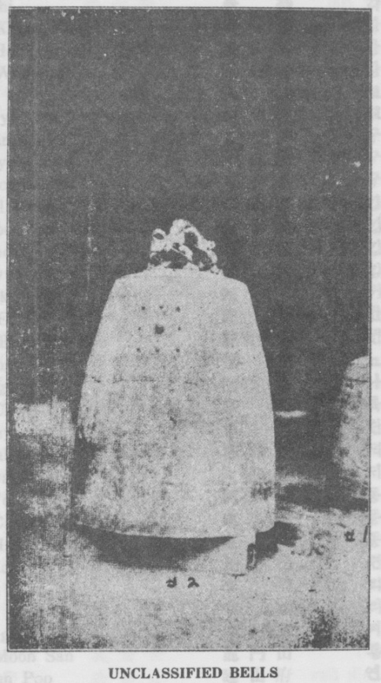 [page 43]
Kak Sin 覺 信 각 신
Kak O 覺 悟 각 오
Kak Choo 覺 珠 간 쥬
Kak Chi 覺 持 각 지
Kang Keum Kang 姜 金 剛 강 금 강
Kang Heui Maing 姜 希 孟 강 희 맹
Kang Wol Hun 江 月 軒 강 월 헌
Koryu 高 麗 고 려
Ko Kuryu 高 句 麗 고 구 려
Koo Tam 九 潭 구담
Koo Ryong San 九 寵 山 구 룡 산
Koo Wol San 九 月 山 구 월 산
Kim Pil Moon 金 弼 文 긴 필 문
Kim Soo Poo 金 水 副 김 수 부
Kim Soo On 金 水 溫 긴 수 온
Kim Syun 金 仙 김 선
Keui Ok 歸 玉 귀 옥
Kwan Eum 觀 音 관 음
Kwan Eum Tai Sa 觀昔大師 관음대사
Nyo Dong 遼 東 뇨 동
Na Ong 瀬 翁 나 응
Youk Chwa 陸 佐 륙 좌
Tan Chyung 坦 淸 탄 경
Tuk Hak Yul 德 學 悅 덕 화 열
Tai Kwan Hun 大 觀 軒 대 관 헌
Tong Yo 同 僚 동 뇨
Tong Chyong 東 從 동 죵
Tong Han 東 漢 동 한
Youn Kong 蓮 公 련 공
Yi Kok 李 穀 리 곡
Yi Sak 李 穡 리 색
Yi Eung Chon Cha 李雄尊者 리웅존자
Yong Moon San 龍 門 山 룡 문 산
Yun San Poo 延 山 府 연 산 부
Yo Hyun 曉 玄 요 현
Moo Kal [page 44]
Myo Hyang San 妙 香 山 묘 향 산
Pan Cho 班 超 반 쵸
Pan Yak 般 若 반 약
Pan Tuk Hai 潘 德 海 반 덕 해
Pyung San Chu Rim 平山處林 평산쳐림
Po Chai 普 齋 보 재
Po Myung Chon 普 明 尊 보 명 존
Po Hyun 普 賢 보 현
Posal 菩 薩 보 살
Po Won 普 圓 보 원
Poo Pyuk Noo 浮 碧 樓 부 벽 루
Paik Too San 白 頭 山 백두산
Pyo Won Choon 表 圓 俊 표 원 쥰
Sa Pool San 四 佛 山 사 불 산
Syuk 释 셕
Syu Chyun Chi Kong 西天指空 서쳔지공
So Paik San 小 白 山 소 백 산
Soo Kan 守 間 수 간
Silla 新 羅 신 라
Sin Teung 信 登 신 둥
Sin Yea 辛 裔 신 예
Sim Po 心 抱 심 포
Sik 植 식
Yak Chin 躍 珍 약 진
Young Hyun 領 現 영 현
You Chum Sa 檢 贴 寺 유 덤 사
Yo Dong 遼 東 요 동
Youn Kong 逮 公 연 공
Im Chei 臨 濟 림 졔
Il Chyung 一 淸 일 청
Eui Hoon 義 訓 의 훈
Won 原 원
A Sei Koo 牙 世 具 아 셰 구
Chang Paik San 長 白 山 장 백 산
Chyun Chin Soo 傳 莫 壽 젼 진 수
Chyun Young 천 영[page 45]
Chyung Nam Chyong 鄭 蘭 宗 뎡 난 종
Chyung Kong 靜 公 졍 공
Chyo Chyang Young 曹 昌 寧 조 챵 영
Chi Kong 指 空 지 공
Chi Hyun 志 玄 지 현
Chi Chang 地 藏 지 장
Chi Ak San 雉 岳 山 치 악 산
Chang Mil Chik Yuh 張密直呂 쟝밀직여
Chyun Hyup 千 葉 천 엽
Hey Hey 蕙 慧 헤 헤
Hang Ha Hai 恒 河 항 하 해
Heup Sin 洽 信 흡 신
Hong Won 洪 原 홍 원
Wha Pong In 華 화 봉 인
O Choon 吳 较 오 쥰
Pyo Won Chyun 普 賢 殿 보 현 젼
Hyun Am 玄 巖 현 암

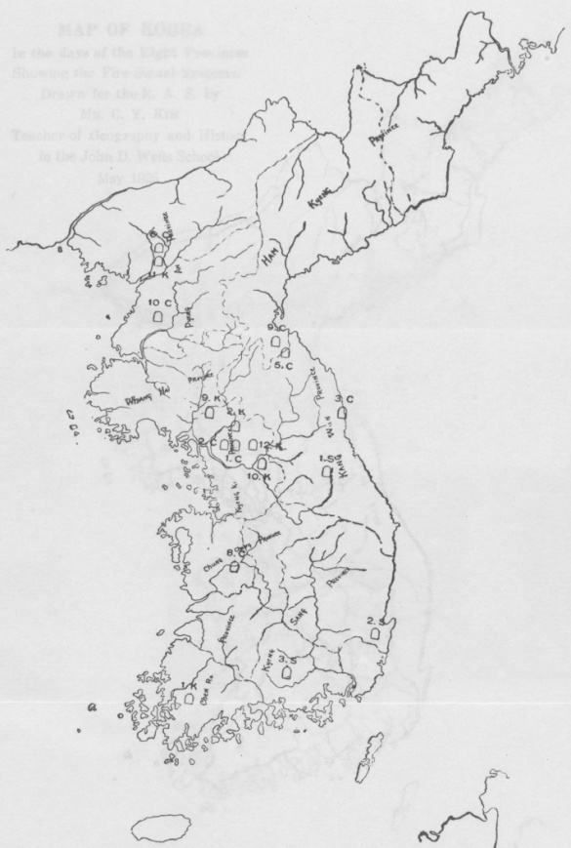
Map of Korea Showing Location of Old Korean Bells

NOTE. The numbers indicate the order of the bells in each Dynasty and the Letters, S. K. C. indicate the Silla, Koryu and Chosen Dynasties.
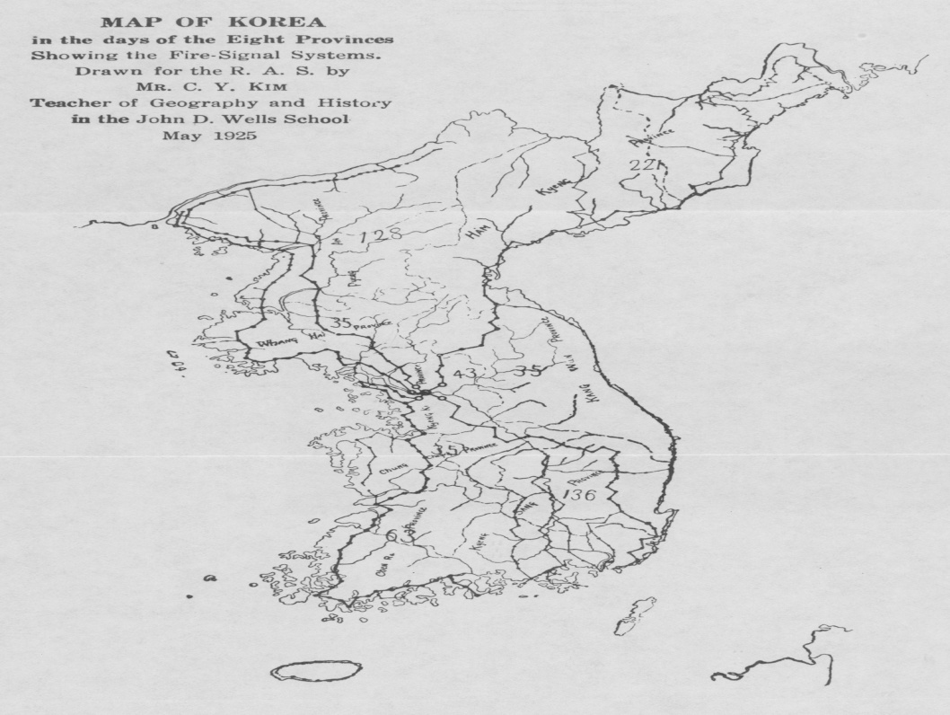

LIST OF OLD KOREAN BELLS

(See Article by Dr. Cable)
Silla Kingdom

1. Sang Won Bell. - - - - - - - - 6
2. Kyung Ju Bell. - - - - - - - - 7
3. Yun Chi Bell. - - - - - - - - 11

Ko-Ryu Kingdom
1. Syu Won Bell.- - - - - - - - 12
2. Chyun Heung Bell. - - - - - - - 12
3. Pook Sa-Seung Nak Bell. - - - - - - 13
4. Hak Man Bell. - - - - - - - - 13
5. Won Syung Bell. - - - - - - - 14
6. Seung Chyun Bell. - - - - - - - 14
7. Tai San Bell. - - - - - - - 15
8. Nam Poo Ka Bell. - - - - - - - 15
9. Yun Pok Bell. - - - - - - - - 15
10. Sin Neuk Bell. - - - - - - - - 19
11. An Sim Bell. - - - - - - - - 20
12. Sa Ra Sa Bell. - - - - - - - - -
13. Whoi Chin Bell. - - - - - - - - 24

Chosen Kingdom
1. Heung Chyun Bell. - - - - - - - 24
2.Po Sin Kak Bell. - - - - - - - - 27
3. Nak San Bell. - - - - - - - - 31
4. Pong Syun Bell. - - - - - - - - 33
5. Pyo Hoon BelL - - - - - - - - 40
6. 6. Po Hyun Bell. - - - - - - - - 35
7. Il Kwang Bell. - - - - - - - -37
8. Kap Sa Bell. - - - - - - - - 41
9. Chang An Bell. - - - - - - - - 38
10. Pyengyang Bell. - - - - - - - - 39

Unclassified Bells
1. No. I - - - - - - - - - 41
2. No. II - - - - - - - - - 41

No. | Name of Bell | King and |  |  | Time of | Age of |  | Japanese
 |  | Time of Reign |  |  | Casting Bell | Bell |  | When Made
 |  | SILLA KINGDOM
 |  | 37. B.C. 936 A.D.
1 | Sang Won | Syung Tuk 702-737 |  |  | 24th yr. 726 | 1199 |  | Whang Keui
 | 上 院 | 聖 德 |  |  |  |  |  | 1385
2 | Kvung Ju | Hev Kong 766-781 |  |  | 7th yr. 773 | 1159 |  | WhangKeui
 | 度 州 | 惠 公 |  |  |  |  |  | 皇祀 1431
3 | Yun Chi | Heung Tuk 827-837 |  |  | 8th yr. 834 | 1091 |  | Whang Keui
 | 蓮 池 | 興 德 |  |  |  |  |  | 皇祀 1493
 |  | KOYRU KINGDOM 918 A. D.-1392
1 | Syu Won | Kwang Chong 950-976 |  |  | 14th yr 964 | 1061 |  | Whang Keui
 | 西 院 | 光 宗 |  |  |  |  |  | 皇祀 1629
 | Chyo Yun
 | 照 蓮
2 | Chyun Heung | Hyun Chong |  |  | 1st yr. 1010 | 915 |  | Whang Keui
 | 天 興 | 1010-1032 顯 宗 |  |  |  |  |  | 皇祀 1670
3 | Pook Sa | Hyun Chong 1010-1032 |  |  | 17th yr. 1027 | 898 |  | Whang Keui
 | 北 寺 | 顯 宗 |  |  |  |  |  | 皇紀 1686
 | Seung Nak
 | 勝 樂
4 | Hak Man 鎮 滿 | Hyun Chong |  |  | 21st yr. 1030 | 895 |  | Whang Keui
 |  | 1010-1032 顯 宗 |  |  |  |  |  | 皇祀 1690
5 | Won Syung | Tuk Chong 1032 1035 德 宗 |  |  | 1st yr. 1032 | 893 |  | Whang Keui
 | 園 城 |  |  |  |  |  |  | 皇祀 1692
6 | Seung Chyun | Moon Chong |  |  | 19th yr. 1066 | 859 |  | Whang Keui
 | 承 天 | 1047-1083 文 宗 |  |  |  |  |  | 皇祀 1725
7 | Tai San | Myung Chong |  |  | 26th yr. 1197 | 718 |  | Whang Keui
 | 大 山 | 1171-1198 明 宗 |  |  |  |  |  | 皇祀 1856
8 | Nam Poo Ka | Heui Chong 1205-1212 |  |  | 2nd yr. 1207 | 725 |  | Whang Keui
 | 南 部 家 | 熙 宗 |  |  |  |  |  | 皇祀 1866
9 | Yun Pok | Choong Mok 1345-1349 忠 穆 |  |  | 2nd yr. 1346 | 579 |  | Whang Keui
 | 演 福 |  |  |  |  |  |  | 皇祀 2006
10 | Sin Neuk 神 勒 | Sin (Jo 1375-1389 辛 稱 |  |  | 5th yr. 1380 | 545 |  | Whang Keui
 |  |  |  |  |  |  |  | 皇祀 2430
 | An Sim | Sin Oo 1375-1389 |  |  | 10th yr. 1385 | 640 |  | Whang Keui
11 | 安 心 | 辛 碼 |  |  |  |  |  | 皇祀 2414
12 | Sa Ra | Sin Uo 1375-389 |  |  | 12th yr. 1387 | 538 |  | Whang Keui
 | 舍 那 | 辛 稱 |  |  |  |  |  | 皇祀 2416
13 | Whoi Chin | (?) (?) |  |  | (?) (?) | (?) |  | Whang Keui
 | 廻 眞 |  |  |  |  |  |  | 皇祀 (?)
 | Chyun Ryun
 | 天 倫
 |  | CHOSEN KINGDOM 1392-1910
1 | Heung Chyun | Sey Cho 1457-1469 |  |  | 7th yr. 1464 | 461 |  | Whang Keui
 | 興 天 | 世 祖 |  |  |  |  |  | 皇祀 2422
2 | Po Sin Kak | Sey Cho 1457-1469 |  |  | 13th yr. 1469 | 456 |  | Whang Keui
 | 普 信 閣 | 世 紐 |  |  |  |  |  | 皇祀 2128
3 | Nak San | Yea Chong 1469-1488 容 宗 |  |  | 1st yr. 1469 | 456 |  | Whang Keui
 | 山 洛 |  |  |  |  |  |  | 皇祀 2129
4 | Pong Syun | Yea Chong 1469-1488 審 宗 |  |  | “ “ | “ |  | Whang Keui
 | 泰 先 |  |  |  |  |  |  | 皇祀 2129
5 | Pyo Hoon | Yea Chong 146J-1488 容 宗 |  |  | “ “ | “ |  | Whang Keui
 | 表 訓 |  |  |  |  |  |  | 皇祀 2129
6 | Po Hyun | In Cho 1623-1650 |  |  | 10th yr. 1633 | 292 |  | Whang Keui
 | 普 賢 | 仁 祖 |  |  |  |  |  | 皇祀 2292
7 | 11 Kwang | In Cho 1623-1650 |  |  | 12th yr. 1636 | 290 |  | Whang Keui
 | 日 光 | 仁 祖 |  |  |  |  |  | 皇祀 2302
8 | Kap Sa | bun Cho 1660-1675 宣 祖 |  |  | 1st yr. 1660 | 265 |  | Whang Keui
 | 鉀 寺 |  |  |  |  |  |  | 皇祀 2244
9 | Chang An | Sook Cnong 1675-1721 |  |  | 34th yr. 1709 | 216 |  | Whang Keui
 | 長 安 | 肅 宗 |  |  |  |  |  | 皇祀 2368
10 | Pyengyang | Young Chong |  |  | 2nd yr. 1727 | 214 |  | Whang Keui
 | 平 壤 | 1725-1777 英 宗 |  |  |  |  |  | 皇祀 2386
Name of Temple |  |  | Province | Magistracy |  |  | Myun |  | Village
or place
SILLA KINGDOM
Saner Won Sa |  |  | Kangwon | Pyung Chang |  |  | Chin Poo |  | Tong
上 院 寺 |  |  | 江 原 | 平 昌 |  |  | 玲 富 面 |  | 東 山 里
KyungJu Chon Sin Kak 慶 州 |  |  | N. Kvungsang | Kyung Ju |  |  | Poo Nai |  | No
 |  |  | 慶 倚 北 道 | 度 州 |  |  | 府 內 面 |  | 路 東 里
Yun Chi Sa |  |  | S. Kvune Sang | Chin Ju |  |  |  |  | Matsubara
速 池 寺 |  |  | 度 尙 南 道 | 晋 州 |  |  |  |  | 松 原 村
 |  |  | Fukui | Tsuruga
 |  |  | 福 井 縣 | 敦 賀 郡
KORYU KINGDOM
918-1392
Syu Won |  |  | S. Chulla Hiroshima | Young Am |  |  |  |  | Takebara Street
西 院 寺 |  |  | 廣 鳥 縣 | Kamo |  |  |  |  | 竹 原 町
Chyo Yun Sa |  |  |  | 賀 戍 郡
照 漌 寺
Chyun HeungSa |  |  | Kyung Kei | Seoui Prefect
天 興 寺 |  |  | 京 畿 | 京 城
Pook Sa |  |  | Sapa | Higashi Matsuura 東松浦郡 |  |  |  |  | Kagami
北 寺 |  |  | 慶 尙 南 道 |  |  |  |  |  | 鏡 村
Seung Neuk Sa
勝 樂 寺
Hak Man Sa |  |  | Osaka Prefect | Toyosaki Nishinari |  |  |  |  | 豊 崎 村
鶴 滿 寺 |  |  | 大 阪 府 | 西 成 郡
Won Syung Sa |  |  | Shiga |  |  |  |  |  | Otsu City
園 城 寺 |  |  | 滋 賀 縣 |  |  |  |  |  | 大 津 市
Seung Chyun Sa |  |  | Fukuoka | Fukuoka City |  |  |  |  | Tsujido Machi
承 天 寺 |  |  | 福 岡 縣 | 福 岡 巾 |  |  |  |  | (Street)
 |  |  |  |  |  |  |  |  | 辻 堂 町
Tai San Sa |  |  | Tokushima | Umobi |  |  |  |  | Anakui
大 山 寺 |  |  | 德 島 縣 | 海 部 郡 |  |  |  |  | 穴 喰 村
Nam Poo Ka |  |  | 南部利淳氏蔵 | Private Individua 陸中閉伊郡
兩 部 家
Yun Pok Sa |  |  | Kyune Kei | Songdo City |  |  | Songdo |  | South-gate
演 福 寺 |  |  | 京 畿 道 | 松 都 郡 |  |  | 松 都 面 |  | 南本町南大門
Sin Neuk Sa |  |  | Kyung Kei | Yu Ju
神 勒 寺 |  |  | 京 畿 道 | 驪 州
An Sim Sa |  |  | North PyengYang 平安北道 | Yengbyen |  |  | Pook Sin hyun |  | Ha Haing Tong
安 心 寺 |  |  |  | 窜 邊 郡 |  |  | 北斯峴面 |  | 下 杏 洞
Sa Ka Sa |  |  | Kvuner Kei | Yung Pyung |  |  | Young Moon 龍 門 面 |  | Yun Soo Ri
舍 那 寺 |  |  | 京 畿 道 | 楊 平 |  |  |  |  | 延 壽 里
Whoi Chin Sa |  |  | Shimane | Yatsuka |  |  |  |  | Hokichi
廻 표 寺 |  |  | 島 根 縣 | 八 束 郡 |  |  |  |  | 法 吉 村
Chyun Kyun Sa
天 倫 寺
CHOSEN KINGDOM
1392-1910
Heun Chyun Sa |  |  | Kyung Kei | Seoul Prefect
興 天 寺 |  |  | 京 畿 道 | 京城市内
 |  |  |  | 李王職博物館
Chongno Po Sin Kak |  |  | Kyuner Kei | Seoul Prefect
鐘路普信閣 |  |  | 京 畿 道 | 京城鍾路
Nak San Sa |  |  | Kang Won | Yang Yang |  |  | Kang Hyun降 視 面 |  | 前 津 里
洛 山 寺 |  |  | 江 原 道 | 襄 陽
Pong Syun Sa |  |  | Kyung Kei | Yang Ju |  |  | Chin Chyup 棒 接 面 |  | 富 坪 里
奉 先 寺 |  |  | 京 畿 道 | 楊 州
Pyo Hoon Sa |  |  | Kanp Won | Whoi Yang |  |  | Chang Yang |  | 長 淵 里
表 訓 寺 |  |  | 江 原 道 | 淮 陽 |  |  | 長 陽 面
Po Hyun Sa |  |  | N. Pyengyang | Yengbyen |  |  | Pook bin Hyun |  | 下 香 洞
普 賢 寺 |  |  | 平安北道 | 寧 邊 |  |  | 北 薪 視
Il Kwang |  |  | Shimne | Kamitoga |  |  |  |  | Nikko Machi
日 光 |  |  | 栃 木 縣 | 上都賀郡 |  |  |  |  | 日 光 町
Kap Sa |  |  | S. Cheung Chung 忠 请 南 道 | Kong Ju |  |  | Kei Ryoung San
岬 寺 |  |  |  | 公 州 |  |  | 鷄 龍 山
Chang An Sa |  |  | Kang Won | Whoi Yang |  |  | Chang Yang |  | 長 淵 里
長 安 寺 |  |  | 江 原 道 | 淮 陽 |  |  | 長 陽 面
Pyengyang Poo |  |  | S. Pyengyang | Pyengyang Prefect
平壊東大門內 |  |  | 平 安 南 道 | 乎 壊 市

