[page 102]
LIST OF MEMBERS KOREA BRANCH, ROYAL ASIATIC SOCIETY.
ORDINARY MEMBERS.
HONORARY MEMBERS.
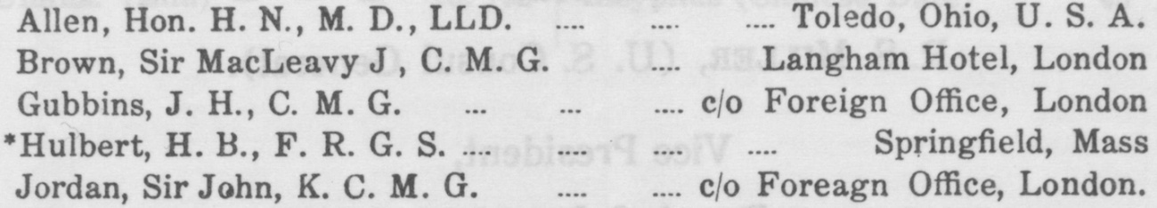
ORDINARY MEMBERS
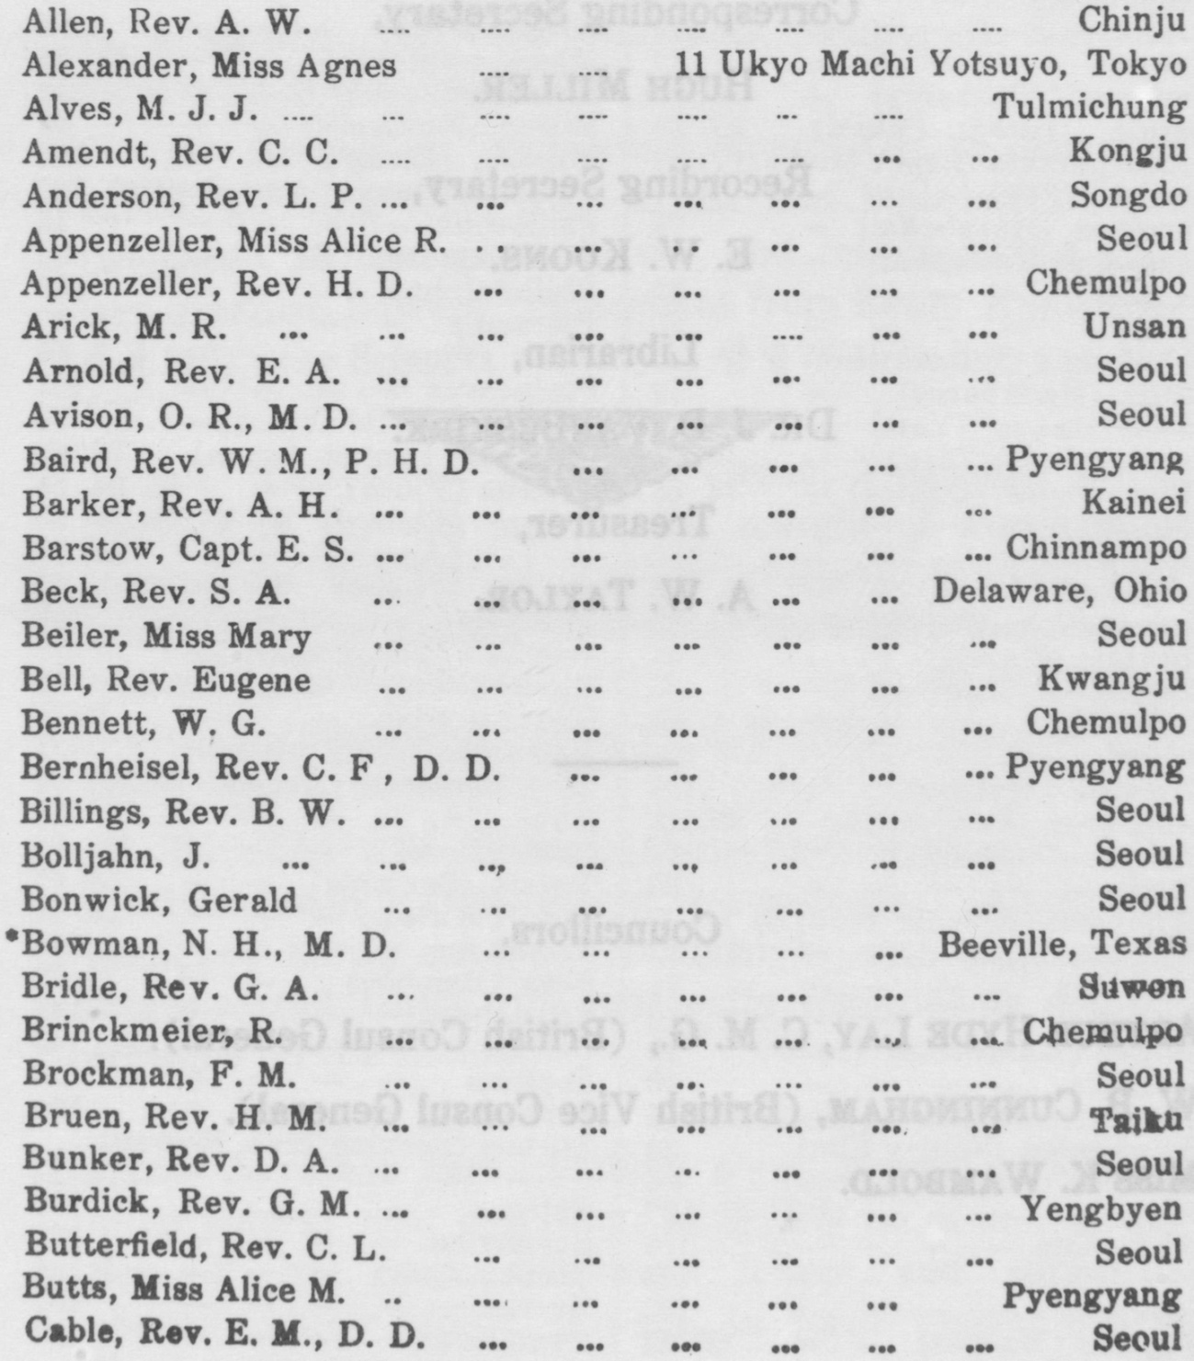
[page 103]

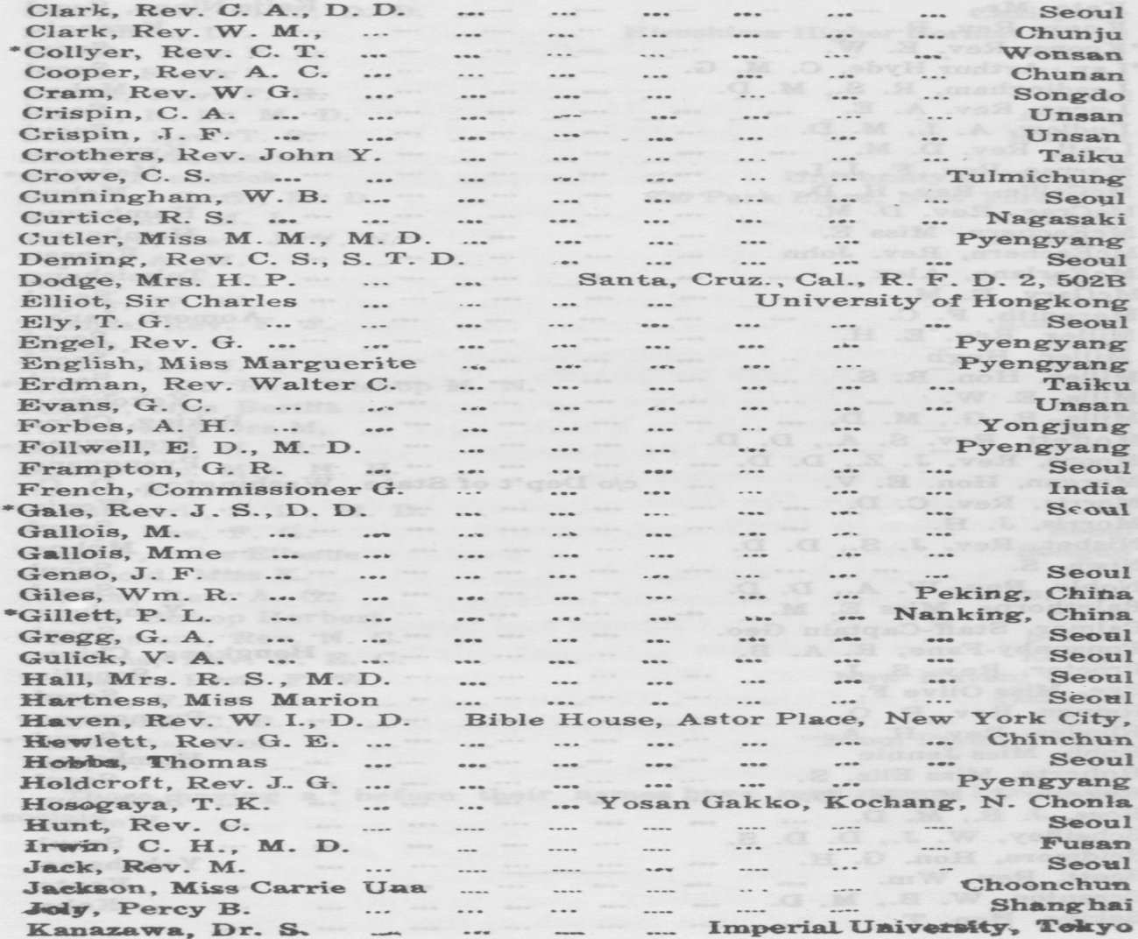
[page 104]
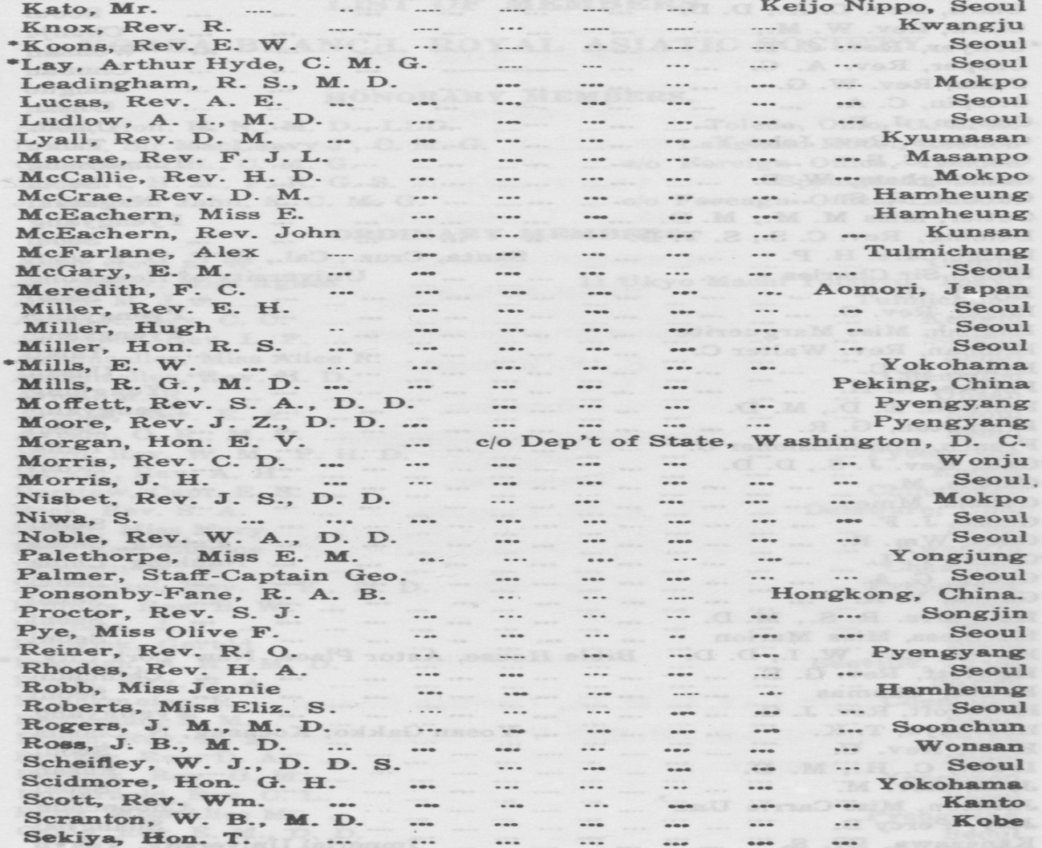
[page 105]
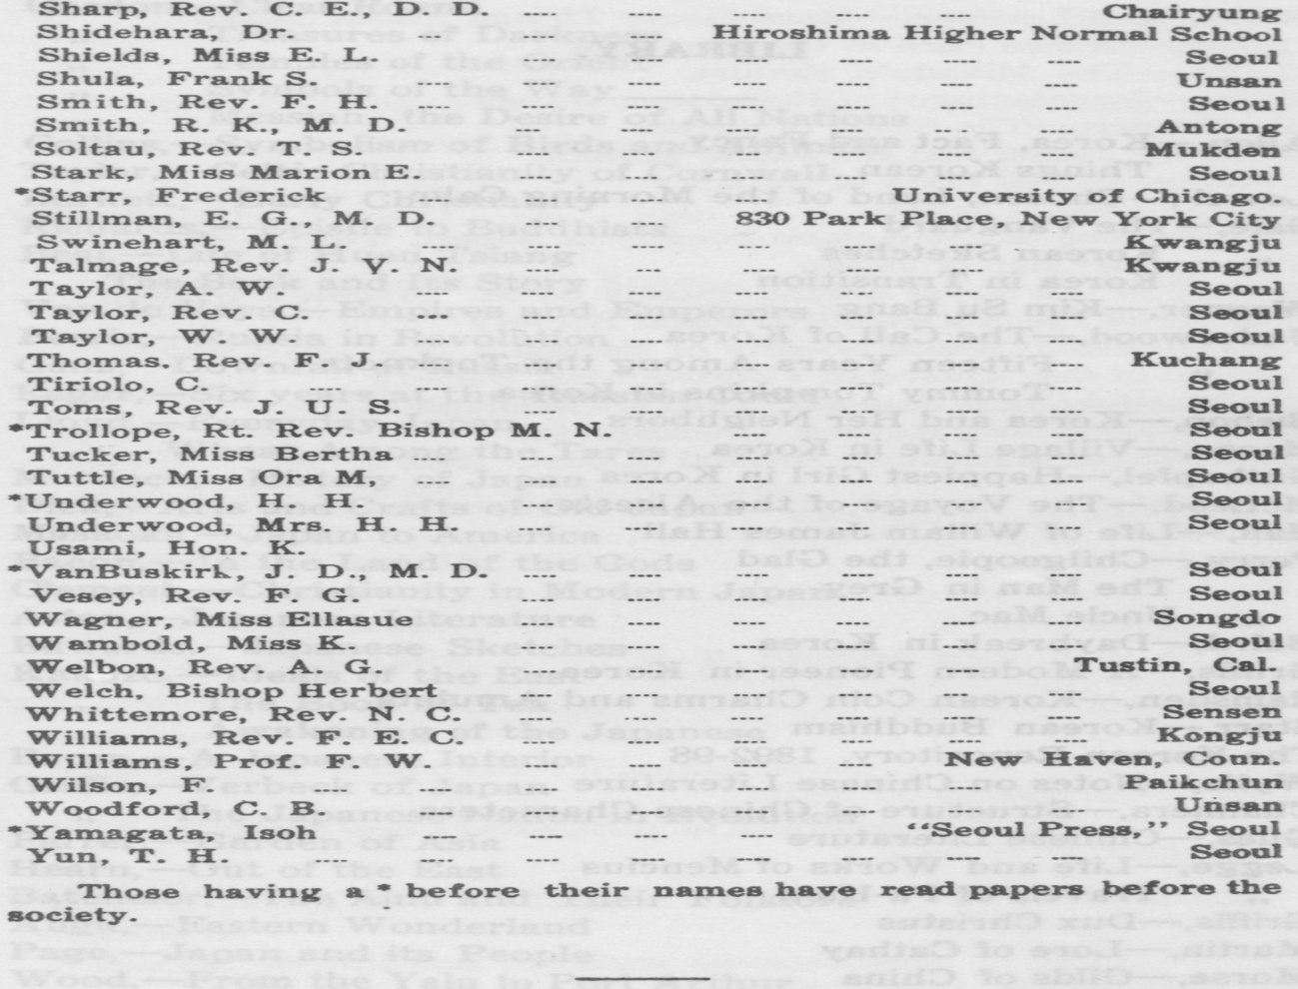

[page 106]
LIBRARY.
Allen,—Korea, Fact and Fancy
,, Things Korean Lowell,—Chosen, Land of the Morning Calm Gale,—The Vanguard ,, Korean Sketches
,, Korea in Transition Wagner,─Kim Su Bang
Underwood,—The Call of Korea
„ Fifteen Years Among the Topknots „ Tommy Tompkins in Korea Bishop,—Korea and Her Neighbors Moose,ᅳ─Village Life in Korea Guthapfel,—Happiest Girl in Korea
McLeod,一─The Voyage of the Alceste
Hall,—Life of Willam James Hall
Perry,—Chilgoopie, the Glad
,, The Man in Grey ,, Uncle Mac
Baird,—Daybreak in Korea
Griffis,—A Modern Pioneer in Korea Ramsden, —Korean Coin Charms and Amulets Starr, —Korean Buddhism The Korean Repository, 1892-98
Wylie,—Notes on Chinese Literature Chalmers,Structure of Chinese Characters Giles,—Chinese Literature
Legge,—Life and Works of Mencius
,, Travels of Fa-Hien
Griffis,─Dux Christus
Martin,一─Lore of Cathay
Morse,─Gilds of China
Allen,一─Early Chinese History
Journal of the North China Branch of the R. A. S. [page 107]
Gordon, ─Clear Round
,, Treasures of Darkness
,, Temples of the Orient
,, Symbols of the Way
,, Messiah, the Desire of All Nations
Collins,─Symbolism of Birds and Animals
Taylor,ᅳ─Celtic Christianity of Cornwall
Burkett,—Early Christianity
Richards,—Epistle to Buddhists
Beal,—Life of Huen Tsiang The Book and Its Story
Vay de Vaya,—Empires and Emperors
Perris,—Russia in Revolution
Ganz,—Downfall of Russia
Eagar,—Six years at the Russian Court
Lloyd,—Everyday Japan
,, Wheat Among the Tares Murdock,—History of Japan
Dick, — Arts and Crafts of Old Japan
Masaoka,—Japan to America
Bacon,—In the Land of the Gods
Clement, ─Christianity in Modern Japan
Aston, ─Japanese Literature
Edwards, ─Japanese Sketches
Kakuzo, ─Ideals of the East
,, The Book of Tea
,, Awakening of the Japanese
Bacon, ─A Japanese Interior
Griffis, ─Verbeck of Japan
„ The Japanese Nation in Evolution Farrer, ─Garden of Asia
Hearn, ─Out of the East
Batchelor,ᅳ ─The Ainu and Their Folklore Augu,—Eastern Wonderland
Page ,—Japan and its People
Wood,—From the Yalu to Port Arthur
Dening,—Japan in Days of Yore Awdry, ─Daylght for Japan [page 108]
Sladen and Lorimer,—More Queer Things About Japan
Gulick,—White Peril in the Far East
Griffis,—The Mikado’s Empire
Knox,—Development of Religion in Japan
VanBergen,—The Story of Japan
G. F. S., Japan and the Japan Mission
Gubbins,—Civil Code of Japan
Bing,—Artistic Japan
Transactions of the Asiatic Society of Japan, Vol 1- 42
Commercial Map of Japan
Journal of the Royal Asiatic Society of Gt. Britain & Ireland
Journal of the American Oriental Society
Journal of the Asiatic Society of Bengal
Journal of the American Philosophical Society
The Geographical Journal, 1910 ff (incomplete)
The Geographical Review (incomplete)
Smithsonian Institution Annual Report, 1908 ff
Books or magazines may be secured by members upon application to the Librarian.

[page 109]

CATALOGUE.
‘‘TRANSACTIONS OF THE KOREA BRANCH OF THE
ROYAL ASIATIC SOCIETY.”
VOLUME I. PART I. only. 1900. . Price Yen 3.00.
Contents
Influence of China upon Korea, Rev. J. S. Gale, B. A.
Korean Survivals, . H. B. Hulbert, Esq., F. R. G. S. Colosal Buddha at Eun-jin, . . Rev. G. H. Jones.
VOLUME II. PART. I. 1901. . Price Yen 2.50 .
Contents
Kang-Wha, . . . Rev. M. N. Trollope, M. A,
The Spirit Worship of the Koreans,
Rev. G. H. Jones, M. A.
VOLUME II. PART II. 1902. . . Price Yen 3.00.
Contents
Han-Yang (Seoul) , . . . . J. S. Gale, B. A.
Korean Folk-Tales, . H. B. Hulbert, Esq., F. R. G. S.
VOLUME III. PART I. only. 1903. . Price Yen 2.50
Contents : 一
Ch’oe Ch’e Wun: His Life and Times,
Rev. G. H Jones, Ph. D.
The Culture and Preparation of Ginseng in Korea,
Rev. C. T. Collyer.
VOLUME IV. PART I. 1912 . Price Yen. 1.50
Contents
The Old People and the New Government,
Midori Komatsu, LL. B., M. A.
The Korean Alphabet, . . Rev. J. S. Gale, D. D. [page 110]
VOLUME IV. PART II. 1913. . . Price Yen 2.50
Contents
Japanese-Korean Relations after the Japanese Invasion of Korea in the 16th Century,
I. Yamagata, Editor, Seoul Press.
The Village Guilds of Old Korea, . . P. L. Gillet. Coinage of Old Korea, . . M. Ichihara, Ph. D.
VOLUME IV. PART. III 1913. . . Price Yen 2.50.
Contents :—
Marriage Customs of Korea, . . Arthur Hyde Lay.
Selection and Divorce, . . . . J. S. Gale.
The Celestial Planisphere of King Yi Tai-Jo,
W. Carl Rufus.
VOLUME V. PART L only. 1914. . . Price Yen 2.50
Contents :—
Some Recent Discoveries in Korean Temples and their Relationship to Early Eastern Christianity,
E. A. Gordon.
A Plea for the Investigation of Korean Myths and Folklore,
Cecil H. N. Hodges.
VOLUME VI. PART I. 1915. . . . Price Yen 2.50
Contents :─
The History of Korean Medicine, N. H. Bowman, M. D. Afforestation in Korea, . . Rev. E. W. Koons.
VOLUME VI. PART II. 1915. . Price Yen 2.50.
Contents : —
The Pagoda of Seoul, . . . . . J. S. Gale. Hunting and Hunter’s Lore in Korea, H. H. Underwood.
VOLUME VII. PART I. only. 1916. . Price Yen 2.50.
Contents :一
Gold Mining in Korea, . . . Edwin W. Mills. [page 111]
CATALOGUE
VOLUME VIII. 1917 Price Yen 2.50.
Contents :一
Introduction to the Study of Buddhism in Korea,
Rt. Rev. M. N. Trollope, D. D., Bishop in Korea.
Korean Charms and Amulets, . . Frederick Starr. VOLUME IX. 1918 Price Yen 2.50
Contents :一
The Vegetation of Korea, . Ernest H. Wilson, M. A.
Arboretum Coreense,
Rt. Rev. M. N. Trollope, D. D., Bishop in Korea. Account of the Shipwreck of a Dutch Vessel on the coast of the Isle of Quelpart, with Description of the Kingdom of Korea, (Trans.) Hamel.
VOLUME X. 1919 Price Yen 2.50.
Contents
The Climate of Korea and its Probable Effects on Human Efficiency, . . . J. D. VanBuskirk, M. D.
Index to volume 11 in volume 17

