[page 69]
ARBORETUM COREENSE, BEING A PRELIMINARY CATALOGUE OF THE VERNACULAR NAMES OF FIFTY OF THE COMMONEST TREES AND SHRUBS found in Chosen.

As I listened to Professor Wilson’s lecture, it seemed to me that some such step as is here taken was necessary to bring home to us who live in Chosen the interesting facts which he had to teach us. As he himself said, the difficulty is that, as a rule, the people who know the language have little or no knowledge of botany, while those who have the botanical knowledge are (as he confessed that he was) ignorant of the language. Even the makers of our great Corean Dictionaries have suffered from this limitation and I have Dr. Gale’s permission to say that the English and Latin names in his “Korean-English Dictionary” have no claim to scientific accuracy and are in some cases demonstrably incorrect. The same is also true of the Dictionnaire Coreen Francais, that magnificent pioneer work of the French Fathers. For myself I must disclaim any right to dictate to anybody on such a subject, as my own bent lies in other directions than those of natural science. I am a learner among learners and was grateful for the opportunity of sitting at the feet of such an acknowledged master of his subject as Professor Wilson. The course I took was the simple one of collecting twigs and branches of all the common trees and shrubs I came across, affixing to them labels with the vernacular names given to them by Coreans [page 70] and then asking Professor Wilson to identify them and supply their proper botanical equivalents. I am only sorry that I began to do this so late in the season, when most of the trees had lost their leaves and flowers and fruit, and when the little time at his disposal and mine made it only possible to make the merest beginning of the work. I have been however encouraged to print this first list here as it stands, with all its inevitable incompleteness, in the hope that it may pave the way for a more extended study of the subject by others. Under each heading I have given firsty the vernacular name, secondly, the ordinary English name (where it exists) and thirdly, the correct botanical designation (where ascertained). In cases where the identification was supplied by Dr. Wilson, I have added the initial W to these designations. In other cases the letter M signifies that the identification was made by Dr. Mills of the Severance Hospital, who has for some years been making a study of Corean botany, from the point of view of materia medieca, and from whom (as from Dr. Gale with his unrivalled knowledge of the language) I have received the greatest help. In addition to the above mentioned names given, where possible, in the case of each tree or shrub, I have also supplied the Chinese character, when there is no doubt about it, and I have added the descriptions (even when inaccurate) given of the plant in question in Dr. Gale’s Dictionary and that of the French Fathers, with a few other memoranda. The list, which only claims to be a first list and which will, we hope, be followed by others, is printed with generous ‘ spacing,’ so as to enable students to fill up the many gaps, as their knowledge grows. It deals moreover only with “ woody “ plants. And it is greatly to be wished that some one else would make a beginning with a list of Corean flowers and other “ herbaceous “ specimens. Lastly it should be noted that it does not profess to make even a beginning of enumerating all the species of flora in Corea. It [page 71] starts from the philological, not the botanical, end, simply taking the commonest names of trees and shrubs in use by Coreans and endeavouring to identify these and to determine as nearly as possible their European or American equivalents.
A real difficulty arises from the fact that the same Chinese character (and we are still dreadfully dependent on Chinese characters in the Far East) is often used to describe different plants in different places. This is one of the few cases in which the “ideograph” fails in its task of conveying the same meaning to the eyes of those who cannot converse by word of mouth. Owing largely to Nature’s wilfulness in confining certain plants to certain areas and supplying their place with others in other areas, we are left face to face with the fact that a single Chinese character does duty for one tree in Chosen, for another in Japan, and for yet others in different districts of China. The character 括 or 相, for instance, which is used in Chosen to describe the Pinus koraiensis or Nut-pine, appears from Giles’ Dictionary to be used in one part of China for arbor vita, in another for cypress, and in yet another for the junifier, while in Japan (according to Inouye’s Dictionary) it stands for a species of oak. In the subjoined list of course the characters, where given, have their Corean value.

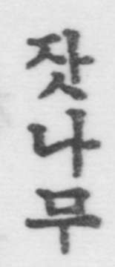
MARK NAPIER TROLLOPE,
Bishop in Corea,
President, Korea Branch of the R.A.S.
N.B.— To save space I have used the following abbreviations ：--
D.C.F. =Dictionnaire Corean Francais (188o). Gale=Dr. Gale’s Korean English Dictionary
pt. i. (1911).
pt. ii. Chinese characters (1914).

[page 72]
I. THE PINE. Pinus densiflora S. & Z. (W).
D.C.F. 松木 “ Arbre de sapin : bois de pin.”
Gale pt. i. 松木 “ The pine tree,” pt. ii, under the character 松 숑 “ The genus pinus.”
This is the staple timber tree of Chosen and clothes most of the hill sides. It is sometimes known as “ the red pine.” When allowed to do so, it grows to a considerable size, in this case usually assuming the weirdly crooked and fantastic shapes, so dear to the Oriental artist. More often, thanks to the wood cutter’s chopper, its proportions are very much dwarfed.
N.B.—Pine or Cr-cones are called 솔방울.
2. THE FIR. Abies holophylla Maxim. (W).
D.C.F. (No character given) “ Esp: de cedre ou de sapin.”
Gale. pt. i (word omitted by accident), pt. ii, under the character 檜 회 “The Chinese Juniper, Juniperus
Clunensis. A species of pine (Thuya obtusa).”
[ These identifications appear to be incorrect].
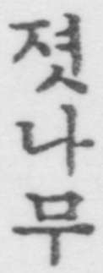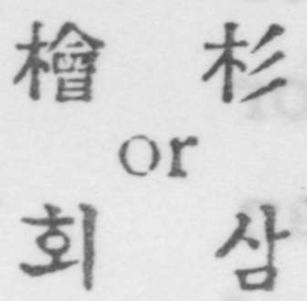
This tree may easily be recognized by its straight stem with branches sprouting upwards at a somewhat acute angle to the trunk, as suggested by the three strokes on the right hand of the second of the two Chinese characters, used to designate it.
3. THE COREAN NUT-PINE. Pinus koraiensis S. & Z. (W.)
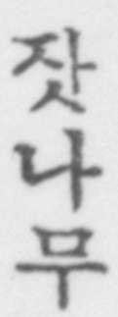
D.C.F. 栢木 “ Pin (qui produit une grosse pomme de pin), qui donne des amandes comestibles appelees 잣 Tjat. Esp : de cedre.” [page 73]
Gale pt. i. 栢木 “ The great hooked or Coulter’s pine.” [This identification appears to be inaccurate, as that particular pine is said to exist nowhere outside a limited district of North America]. pt. ii. Under the character 栢 백 “ In North China the arbor vitca, Thuya orientalis. An oak.”
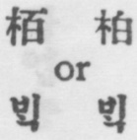
This tree, sometimes known as “ the blue pine,” is famous in Chosen for the delicious little nuts 잣 which it produces. In Japan it appears to be known under the characters 海松木 i.e. Sea pine tree. Vide Bretschneider Botanicon Sinicum. p. 336.
4. THE JUNIPER. Juniperus rigida S. & Z. (W.)
D.C.F. (No character given). “ Gentevre, genevrier commun (arbre): arbuste dont les feuilles sont comme des epines.”
Gale. pt. i. 枯 “ The Juniper, Juniperus Chinensis.” But in pt. ii. 枯팔 is given as the character for 졋나무 and described as “ a kind of pine.”
Commonly found on hill sides, in shape of a shrub, with needle like leaves.
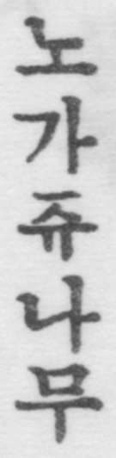
5. THE CHINESE JUNIPER. Juniperus chinensis L. (W.)
D.C.F. 香木 “ Arbre odoriferant, cypres.”
Gale. pt. i. 香木 “ The Putchuk-used for medicine and incense.”
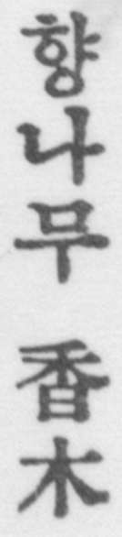
The name both in Chinese and Corean signifies the “ fragrant tree.” The wood, in the shape of shavings or sawdust, is used as incense in religious sacrifices. [page 74]
The tree is commonly found planted by the side of wells in Chosen.
The Chinese Arbor Vitae (Thuya Orientalis. L.) is used for incense in China, and appears to have been imported by the Buddhists into Chosen, where it is possibly sometimes confused with Juniperus chinensis.
6. THE YEW. Two varieties :
(a)The Foetid Yew. Cephalotaxus drnpacea
S. & Z. (W.)
(b)The Korean Yew. Taxus cuspidata S. & Z. (W.) ‘
D.C.F. 비자 榧子 “ Nom d’une espece de noisette qui- vient dans de grands arbres resineux (elle a la propnete de tuer le ver solitaire.”)
Gale : pt. i. 비자 榧子 “ The nuts of a kind of yew- tree, Torreya Nucifera.” pt. ii. under the character 棐 비 “ The Torreya Nucifera, a species of yew.”
N.B. —The Torreya Nucifera does not exist outside Quelpaert in Chosen.
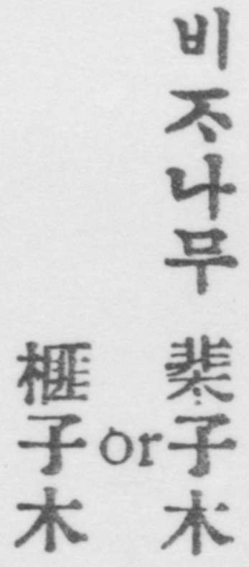
7. THE BOX. Buxus microphylla, var. riparia Mak. (W.)
“D.C.F. 檢陽木 “ Buis (arbre).”
Gale, pt. i. 黃楊木 “ Box wood.”
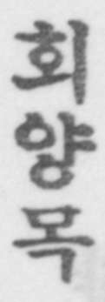
The wood of the Corean box tree is very hard and much used for making seals and stamps. [page 75]
D.C.F. 眞木 “ Chene (arbre)” Gale. 樣木 “ The oak.”
The oak shares with the pine the greater part of the duty of clothing the hill-sides of Chosen. When allowed to do so, it attains to considerable proportions and becomes a handsome tree. More often it shares the fate of the pine, being kept in a dwarfed state by the wood cutter’s chopper. Acorns are called 상쉬리 or 도토리，either of which is used as the Corean rendering of the character 橡 상. Hence the tree, commonly known as 참나무 or “ the true tree”，，is sometimes also known as 샹수리나무 or 도토리나무, i.e. the acorn tree.
N.B.—Besides the Common Oak (Mongolica) and the Tan-bark or Bread-leaf oak (Dentata), at least four other species are known to the Coreans, apparently by the same name, Quercus aliena Bl. and Quercus glandurifera Bl., Quercus serrata Thunb, (chestnut oak) and Quercus varia-bilis, Thunb. (the Cork-oak of Corea). Q. aliena and Q. glandulifera are sometimes apparently distinguished as 자라리참나무
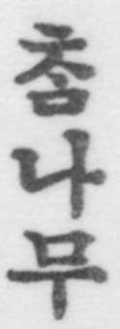 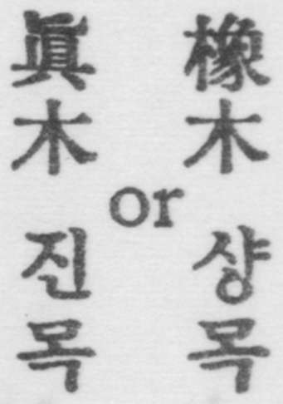 [page 76]
10 THE BROADLEAF OAK QUERCUS DENTATA 71 IN NB. (W.)
D.C.F. 槽木 “ Arbre de chcne, chene a feuilles tres- grandes et tres larges.”
Gale. pt. i. 木 “ The burr-or overcup oak. Quercus macrocarpa.”
The foliage of this tree, which is seldom allowed to grow to any size, is largely cut down in the spring and scattered as a fertilizer over the paddy fields. The bark is used for tanning.
In Gale pt. ii. the character 槽 is said to be the same as 複 both pronounced 가, and the meaning is give a as “ a small shrub” or “ Catalpa Bungei, which does not tally with the description given in pt. i.
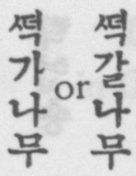
11. THE KEYAKI TREE Zelkowa serrata Mak. (W.)
D.C.F. 槐 “ Esp: de grand arbre. Sophora du Japon.
Orme. Syn : 피목 Koimok.”
Gale pt. i. 槐 “ The Sophora Japonica. See 피목”
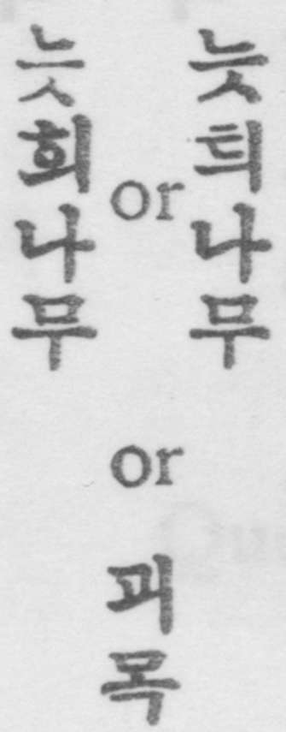
Under 피목 the D.C.F. gives the same character and the same rendering as under 느티나무 : so also does Dr. Gale. There seems however to be no doubt that both dictionaries are wrong, the character 槐 and the title “Sophora Japonica” really belonging to the next-tree (12) on our list In Japan the Zelkowa (Keyaki) is written with the character 棒. Both in Japan and Chosen the tree is highly prized for cabinet making and other ornamental purposes, on account of its beautiful grain. [page 77]
12. THE SOPHORA TREE. Sophora japonica L. (W.)
D.C.F. for (I) gives 檜花木 “ Nom d’une esp. d’arbre dont les fleurs sont blanches “ : And for (2) 槐花” Arbre semblable a l’acacia, avec la fleur du quel on fait une teinture jaune (peutetre le gaiac.)”
Gale pt. i. for (1) gives 槐 “ A variety of the Sophora japonica.” And tor (2) 槐 花 “ The blossoms of the Sophora japonica from which a yellow dye is made.” In pt. ii. he gives both 槐 회 and 櫰 피 as a variety of the Sophora japonica, but makes the Korean equivalent which is the Zelkowa.
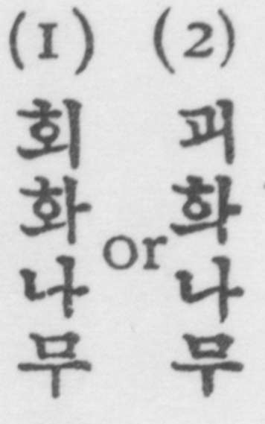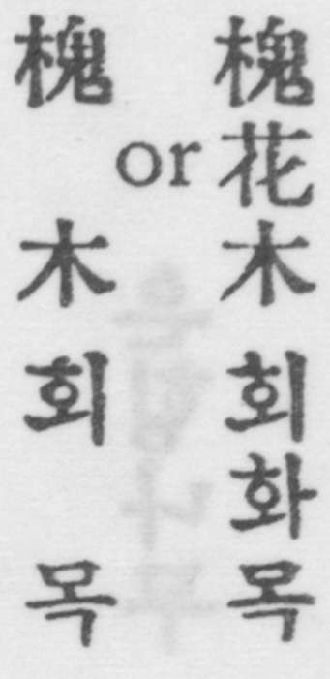
The Sophora 회화나무 and Zelkowa 눗회나무 two of the largest and best known timber trees in central Chosen. It is strange that they should be so confused with one another, as they have hardly anything in common.
13. THH ELM. Ulmus lapomca Sarg. (M)
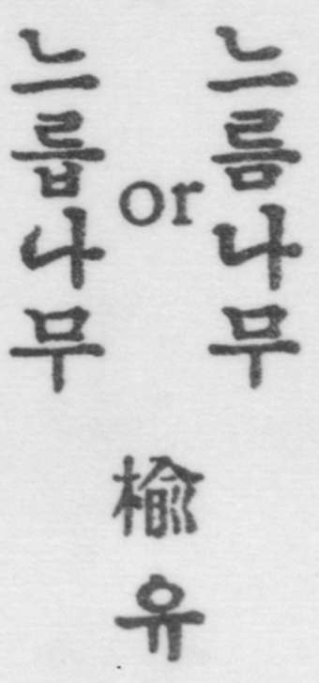D.CJF. 偷 “ Nom d’un arbre dont recorce est em-ployee a faire des cordes, et la seve sert denduit, de vernis，pour les murs”
Gale pt i. 會 “ rhe elm. Ulmus campestris “ pt 11. The same
I4 THE ALDER TWO species (a) Alnus japonica
S. & Z. (WO)
(b) Alnus siberica Turcz. (W.) 棟瓜木” Esp : d’arbre dont le bois est rouge, qui vient le long des ruisseaux ; c’est peut-etre 1’aune ou verne’
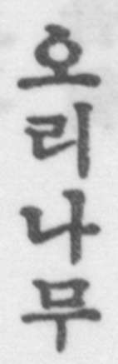
6 Vol. 9 [page 78]
Gale pt. i. 棟瓜木 “A tree with red wood—found along streams.”
The Alder is commonly used for making Corean 나목신 or Sabots.
I5. THE MAIDENHAIR TREE GINKGO BILOBA L. (W.)
D.C.F. 銀杏 “ (Argent, abricot). Esp. de grand arbre qui a des fruits dont la graine est blanche. Le Ginko
biloba V. Sym 백과.”
Gale pt. i. 銀杏 “ The Salisburia adiantifolia. See 은웅，” 銀杏樹 “ The Maidenhair fern tree. Also 은응나무.”
Under 백과 the D.C.F. gives 白果 “Arbre aux quarante ecus : Ginko biloba : Salisburia adiantifolia ; arbre du ciel”. And Gale pt. i. gives 百葉
“The Gingko biloba.”
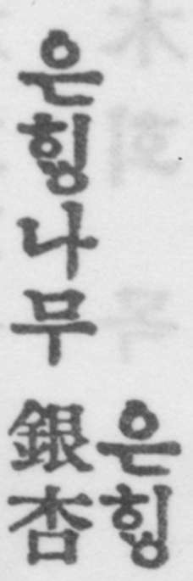
The maidenhair tree is one of the largest and handsomest timber trees in Chosen. There is a good specimen in Dr. Gale’s compound in Seoul.
16.THE PAULOWNIA Panlownia tomentosa Baill. (M)
U.C.F. 梧桐 “ Nom d’une espt d’arbre dont les feuilles sont tres larges. Jatropha curcas. Medicinier curcas. Alisier des bois (?) Platane V. Syn
머귀나무 Me-kouinamou
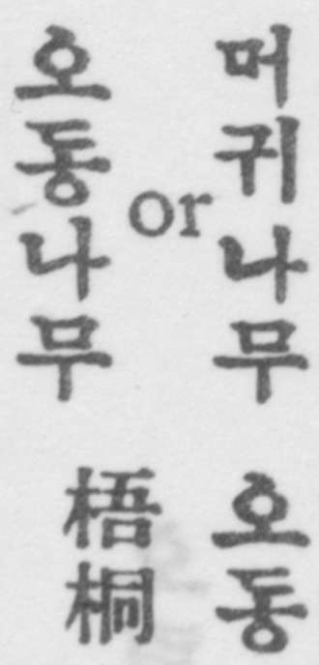
Gale pt. i. 桐 “ The Sterculia platanifolia “, pt.ii under 梧 and 桐 ； M The name of a tree A name applied to various trees. (The Panloivnia iinperialisy) [page 79]
Under 머귀나무 The D.C.F. gives 梧桐 “Esp. d’arbre, peut-etre le platane: alisier des bois (?) Syn ;
오동나무 : while Gale under the same word gives 梧桐 “ The sterculia platanifolia-on which the phoenix is said to alight on the birth of a sage”.
The Paulownia is one of the most beautiful shade-trees of Chosen, with very broad leaves and a large mauve-coloured flower. The wood is much prized by Japanese for making their “geta “ or wooden clogs.
The Chinese appear to use the characters 梧桐 for the Sterculia platanifolia, which is not the same as the Paulownia.
17. THE PAK TAL TREE Betula Schmidtii Regel. (W)
D.C.F. 擅木 “Especede bois tres dur avec lequel on fait des maillets. Espece d’arbre.”
Gale pt. i. 擅木 “ The Dalbergia hupeana tree ; a variety of the Sandalwood “. And so also in pt. ii. under 檀 단.
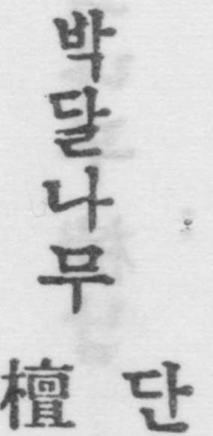
The Pak tal tree is famous in the early legends and myths of Korean history.
The wood of the Pak tal tree is exceedingly hard and heavy一so heavy that it will not float in water. It is much used by Koreans for making the rollers 홍두께 and mallets 방망이 used in the process of “ ironing “ clothes.
Near Seoul the name Pak Tal appears to be applied to the Cornell Tree, Cornus Kousa. In China the character 擅 is applied to the Dalbergia Hupeana, which is not the same as the Pak Tal. [page 80]
18. THE LINDEN OR LIME TREE
Tilia mandshurica Rupr. & Maxim (W)
This tree, which is not mentioned either in D.C.F. or Gale, is the sacred tree of Corean Buddhists and is found chiefly in Temple grounds. Curiously enough it is not known to the monks ordinarily by the name 보리슈 (Porisyou) which is the Corean equivalent of the Boadhi Tree一that name being given to the oleaster (see No. 31), but by the name 넘쥬나무 or Rosary Tree, prayer-beads being made out of the fruit Another species of Lime, Tilia amurensis, is known to the Coreans at 피나무.
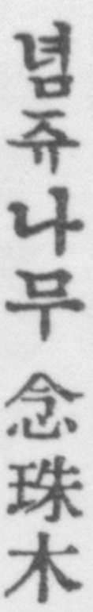
19. THE BIG ASH TREE Fraxinus mandshurica Rupr. (W.)
D.C.F. 摘木 “ Nom d’une espece d’arbre ; esp : de
cedre propre a faire des poutres, des bascules.”
Gale pt, i. 楠 “ The machilu called also the cedar. The Ash.” And in pt. ii under 楠남
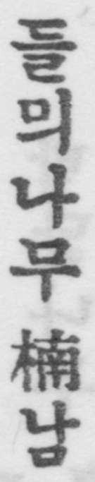
“ The ‘ cedar,’ Machilus nanmi. A camphor tree.”
20. THE EVODIA TREE Evodia Daniellii Benn. (W.)
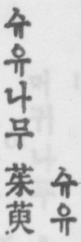
D.C.F. 菜英木 “ Nom d’une sorte d’arbre dont la graine sert a faire de l’huile excellente a bruler. Syn. 소동 So-tong.” Gale pt. i. 菜英木 “ A species of Zanthoxylum. The Evodia rutoecarpa, the seeds of which are usea as medicine.” pt. ii the same. [page 81]
21. THE “TREE OF HEAVEN.”
Ailanthus glandnlosa Desf. (W.)
D.C.F. 樗木 “Nom d’un arbre. V. Syn. 기죽나무 “ Ailanthe glanduleux qui sert a nourrir le lequel produit la soie appelee 츙 경 ㅅ.”
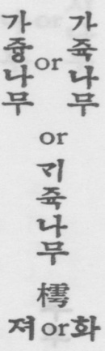
Gale: pt. i. 樗 “ The Ailanthus glandulosa.” The
same in pt. ii under the character 樗 with the sound 져 : but the same character with the sound 화 is given as the equivalent of 벗 나무 “ The birch.” An alternative name for this tree appears to be 뚱 which is described in D.C.F. as 樗 “ Ailanthe. Syn. 기쥭나무”, and in Gale pt. i. as “ Tne Ailanthus.” Both Dictionaries refer to the 중나뷔 as the “ Papillon du 중” and “ The Ailanthus silkworm respectively.
There appears to be a great deal of confusion between this and the next tree on the list (apparently regarded as ‘ true ‘ 참 and ‘ false , 가 varieties of the same tree).
22. THE “ ONION TREE.” (M.)
Cedrella sinensis A. Juss. (M.)
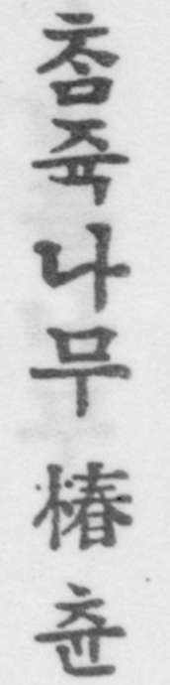
D.C.F. (Not given).
Gale pt. i. (without character) “ A kind of red oak.” But in pt. ii. three different characters are given under 츈 for the which is described as
“ A wood from which guitars are made.” The three characters are 杶,橁,櫄.
The Corean dictionary 字典釋耍 under the character 樗 gives two sounds and two explanations (a) 화 meaning 가 죽 which it describes as the same as and
(b) 져 meaning 못슬나무 (the useless tree) described as “ an evil tree of no use.”
See Bretschneider’s Botanicon Sinicum pp. 352-3 for a [page 82] discussion of these trees as known in China, their original habitat. He gives yet another character 椿츈, which is described in the above mentioned Corean dictionary as being a fragrant form of the 樗 or ailanthus, and the equi-valent of 참죽나무.
23. THE COMMON ASH.
Fraxinus rhyncophylla Hance (W.)
D.C.F. 靑鞭木 “ Frene. Arbre dont le bois est dur et dont l’ecorce sert a faire la teinture noire.”
Gale. 水靑木 “The Ash, Fraxinus Chinensis.”
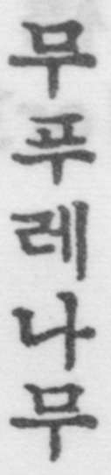
24. THE SPINEY ELM.
Hemiptelea Davidii Benth. & Hook. fiu. (W.) D.C.F. (Not given).
Gale pt. i. 樞” The name of a thorn tree.”
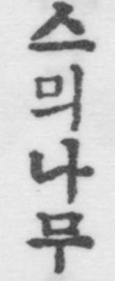
25.THE RED BIRCH Betula dahurica Pall. (W.)
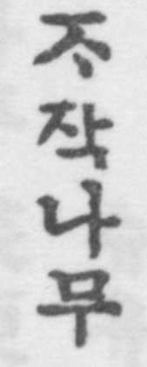
This tree which does not appear to be noticed either in D.C.F. or Gale is fairly common on the hill-sides. Its thin outer bark is constantly peeling off, as with birches elsewhere. [page 83]
26. THE KALOPANAX
Kalopanax ricinofolius Miguel. (W.)
D.C.F. Spelling it 업 나무 “ Esp. d’arbe epineux.” Gale. pt. 海桐” The thorny ash.”
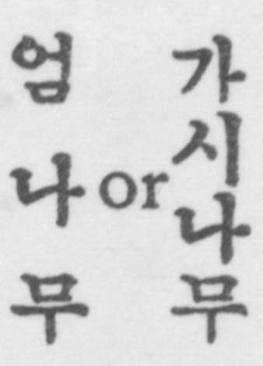
In its young state, the stem of this tree is covered with thorns : and the sticks, gathered into bundles are laid along wall-tops, as a protection against trespassers. ,
27. THE BAMBOO . Sasa spiculosa Mak. & Shib. (W.)
D.C.F. 竹 “ Bambou : pipe : tige creuse : tuyau.” Gale. pt. 竹 “A bamboo. The numerative of stalks, long objects. See 참대” Pt. ii. under 竹죽 “ The bamboo of which there are some sixty varieties.” The only native bamboos in Chosen are a low scrubby species of Sasa.
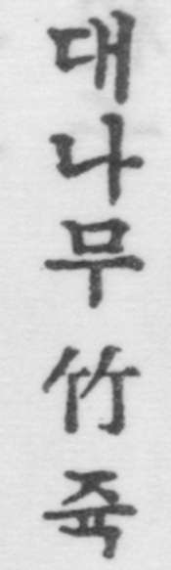
28. THE WILLOW, Salix koieensis Anders (W.)
D.C,F 柳木 “ Saule, arbre.”
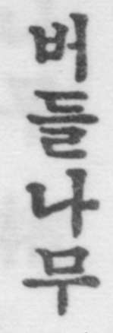
Gale pt. i. 柳 “ The Willow.” pt ii. Under 柳류 “ The Willow tree, Salix babylonica.” Under 楊양 “ The poplar, the willow, the aspen.”
29. THE ASPEN. Populus tremula L. (M.)
D.C.F. 白楊 “ Nom d’une espece d’arbre (peut-etre le tremble).”
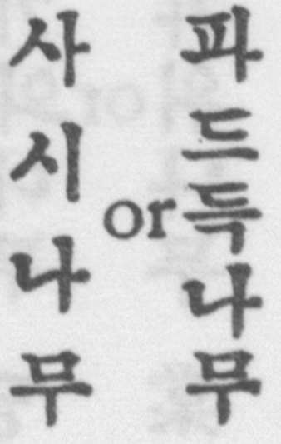Gale. 白楊 “ The white willow.” [page 84]
The Koreans have the same metaphor as the English “ tremble like an aspen.” 사사시떨닌듯하다.
30. “THE MATRIMONY VINE “ Lycium chinense Mill. (W.)
D.C.F. 枸杞子 “ Nom d’un arbre; esp. d’epine- vinette; esp. de petit fruit en grappe comme le raisin (remede).
Gale pt. i. 枸杞子. “ The seeds of a kind of aspen— the Lycium Chinense.” pt. ii. under 枸 구 and 杞긔 ‘ A kind of water willow. A medlar tree.”
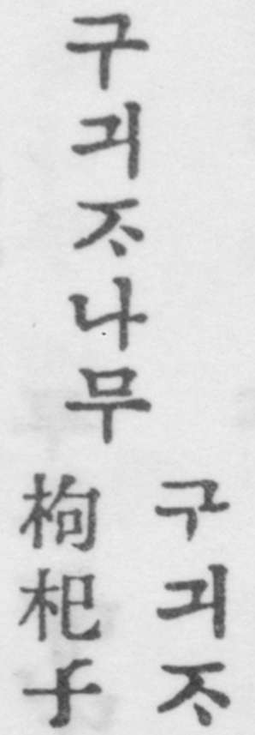
31. THE OLEASTER Ela’agnus umbellata Tlnnb. (W.)
D.C.F. (No character) “ Petit arbuste a fleurs blanches, baies rouges.
Gale pt. i. 扶老樹 “ A kind of tree from which walking sticks are made.” A shrub with a fragrant white flower and red berries and silvery backs to the leaves. 보리슈 is the name given by Corean Buddhists to the Bodhi tree of Buddha, without however apparently any reference to the Oleaster. The sacred tree of the Corean Buddhists is the Linden (see
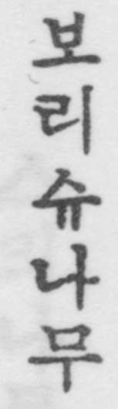
32. THE HAWTHORN. Crataegus pinnatifdia Bunge (W.)

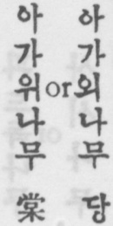D.C.F. 棠 “ Aubepine.” “ Nom d’un petit fruit dont la forme est semblable a celle d’une poire, mais d’un gout amer. Esp : de petite poire sauvage.” [page 85]
Gale. pt. i. 棠 “ Various species of pyrus ; the haw- thorn.” Also in pt, ii. under 棠당 “ Various spe- cies of pyrus -wild and cultivated.”
33. THE NUT-GALL TREE. RHUS JAVANICA L. (M.)
D.C.F. 五陪子木 “ Espece d’arbre qui produit le 오비ㅈ peut-etre la nolx de galle.”
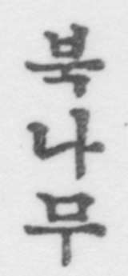
Gale. (No character) “ The Rhus semi-alata.”
Under 오비ㅈ五陪子 D.C.F. gives “ Esp. de noix de galle (qui, dit-on vient sur le murier). Esp. de graine d’arbre remplie d’insectes qui servent a faire l’encre noire. Sert en teinture et en medecine.” Gale gives Chinese galls—the nut galls of the tariff, formed on the Rhus semialata.”
34. THE COREAN PAPER MULBERRY.
Broussonettia kazinoki Sieb. (W.)
D.C.F. 楮木 “ Arbrisseau dont les branches, en forme . d’osier, sont coupees chaque annee pour en avoir l’ecorce, qui sert a faire un papier solide. Murier a papier.”
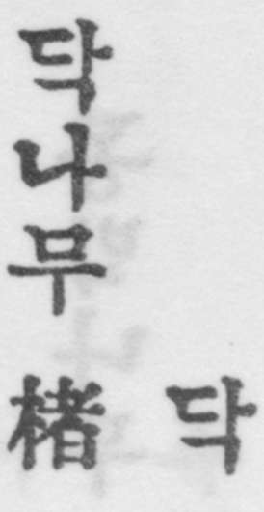
Gale. pt. i. 楮木 “A species of mulberry from which paper is made —Broussonettia Papyrifera.” Prof. Wilson says that the B. kazinohi is common in Japan and Chosen, and differs from the B. papyrifera which is not found in Chosen, except in Quelpaert. [page 86]
35. THE VARNISH OR LACQUER TREE.
Rhus ueniciflua D. C. (W.)
D.C.F. 漆木 “ Esp. d’arbre, d’on se tire le vernis. Sumac (?) Il a une seve tres active ; son attouche- ment suffit pour faire naitre sur la peau des pustules qui causent une grande demangeaison et deviennent une plaie.”
Gale. pt. I. 漆木 “The varnish tree.” pt. ii. “ The varnish tree, Rhus vermicifcra.”
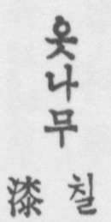
36.THE EVERGREEN EUONYMUS.
Evonyvius radicans Tlnmb、(W.)
D.C.F. (No character) “ Nom d’une espece d’arbre.”
Gale. pt. i. (No character) “ Boxwood “
An evergreen shrub, as its Chinese name (winter-green- tree) implies.
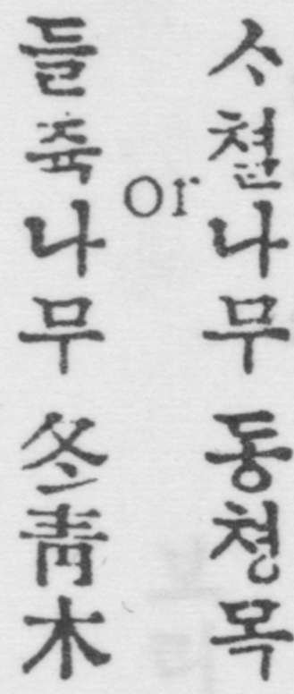
37. THE COREAN BENZOIN,
Benzoin obtusilobvm O. Kuntze (W.)
D.C.F. 冬柏 “ Stramonie, datura s(ramonium, herbe du diable, herbe des magiciens. Syn. 당석 Tang Kkai.”
Gale. pt. i. 桐柏 “The Camela, the datura stramonium.”
An oil produced from this tree is used for dressing the hair of women and children being sometimes mixed with oil from the seeds of the Evodia (see 20).
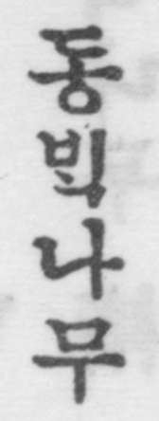
N.B.—The identification with datura stramonium appears to be wholly inaccurate. [page 87]
38. THE WILD CITRON. Poncirus trifoliata Swingle (W.)
D.C.F. 枳子 “ Sorte d’arbre a grandes epines et qui produit des especes d’oranges sauvages: petite orange sauvage”
Gale, 枳子 “The sweet orange tree, Citius anrantium.”
A shrub with a smooth light green bark and very sharp thorns, producing small wild oranges, used in Corean medicine.
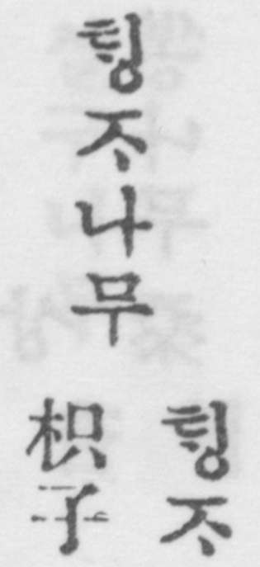
39. THE COMMON PRIVET. Ligustrum Ibota Sieb. (W.)
D.C.F. 鼠屎木 “ Arbre de crottes de rat (ainsi appele a cause de ses graines qui ont la meme forme. II fournit la matiere dont en fait la cire blanche : les Coreens ne la tirent pas de la graine meme d’un arbre). Troene, vulg: duvet.”
Gale. (Same characters) “ The privet.”
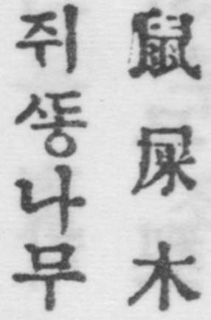
40. THE COREAN HONEY-LOCUST TREE.
Gleditsia horrida Mak. (W.)
D.C.F 朱髶木 “ Nom d’un arbre dont les fruits sont comme des cosses de pois, mais plus grands.” Gale. (Same characters) “ The Acacia. See Under 죠각 the D.C.F. gives “ Graine d’acacia (en me-
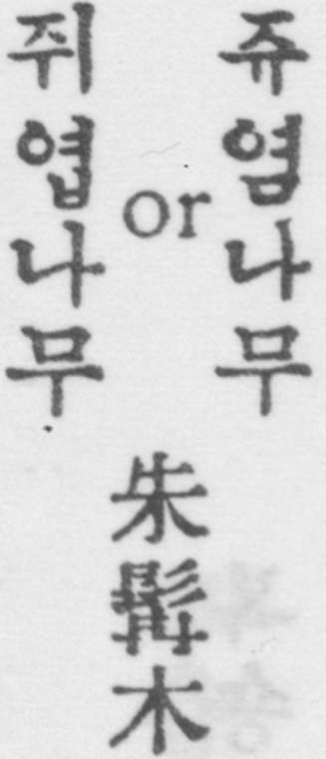
decine, remede) Gale gives 皂角” Black horns—the pods of the Gleditschia sinensis . [page 88]
41. THE MULBERRY
Two varieties : (a) Morns alba L. (M.)
(b) Morns bombycis Koidz. (M.)
D.C.F. 桑木” Muri”
Gale. pt. i. and pt. ii. 桑木 “The Mulberry tree. morns alba. See 상목.”
“The fruit of the mulberry “ is also known as 오듸 and is so given both in D.C.F. and Gale pt.i. and pt. il. under 심.
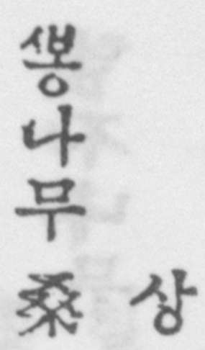
42. THE PEAR. TWO VARIETIES:
(a) Fynis serotina, var: auita Rehd. (W.)
(b) Pyrus ussuriensis Maxim. (M.)
D.C.F. 梨木 “Poirier.”
Gale. pt. i. 梨木 “ A pear tree.” pt. ii. “ The Chinese pear : pyrus sinensis. “ The P. serotina is the common cultivated pear of Chosen : but the usserieusis is also found, both wild and cultivated. Another and less common species of pear in Corea is the Pyrus Faurei, Schncid (or calleryana). F. us- suriensis is known to Coreans as 돌빈나무, P. Faurci as 동비나무.
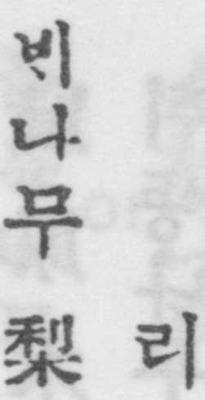
43. THE PEACH. Frunus Persica Stokes (W.)
D.C.F. 棰 “ Peche “(fruit a noyau).”
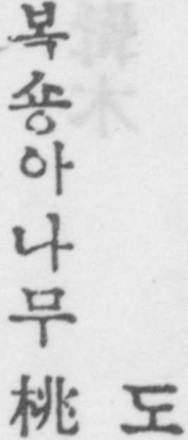
Gale. pt. i. 桃 “A peach.” pt. ii. “The peach: Prunus fersica.” [page 89]
44. THE APRICOT. FRUNUS ARMENIACA L. (W.)
D.C.F. 杏木 “ Abricotier.” “ Esp. de fruit semblable a la peche, peut-etre abricot ou prune.”
Gale. pt. i. 杏 “ The apricot : the almond.’ pt. ii. ditto.
The wild apricot, Frunus mandshurica is known as
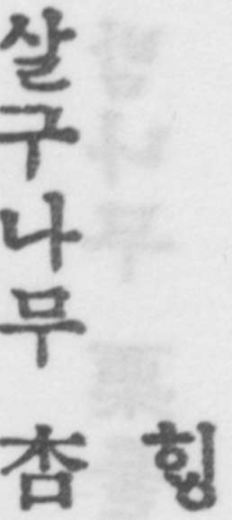
45. THE CHINESE DATE OR JUJUBE.
Zizyphus sativa Schneidcr (W.)
D.C.F. 大棗 “ Jujube (fruit).”
Gale. pt. i. 大棗 “ Dates.” pt. ii. “ Several varieties of the common jujube. Zizyphus vulgaris.”
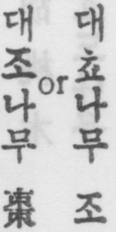
46. THE PERSIMMON. DIOSPYROS KAKI L. (W.)
D.C.F. 柑木 “ Sapotillier. Arbre qui produit le kam.
(Lotus Diospyros).” Gale. pt. i.杮 “A persimmon,”
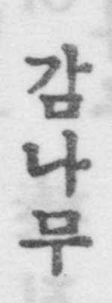
47. THE LOTUS PERSIMMON TREE. DIOSPYROS LOTUS L. (W.)
D.C.F. 假柑木 “ Esp d’arbre qui ressemble au kaki. kaki sauvage.”
Gale. pt. i. 杮 “ Small natural growth persimmons “. Used as a stock on which to graft Diospyros kaki, which is the edible persimmon. [page 90]
48. THE CHESTNUT. Casianca crcnata Bl. (W.)
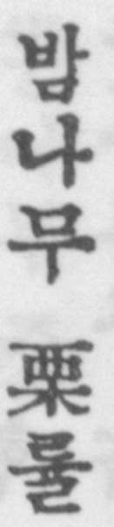
D.C.F. 粟木 “ Chataignier
Gale. pt. i. 粟木” The Chestnut.”
In Pyongyang and neighbourhood it is the Chinese chestnut (Castanea mellissima Bl.) which is commonly cultivated.
49. THE COMMON WALNUT. JUGLANS REGIA L. (M.)
D.C.F. 胡桃木 “ Noyer (arbre).” Gale. pt. i. 胡桃木 “Walnuts.”，
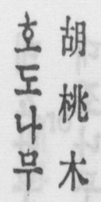
50.THE HAZELNUT OR FILBERT.
Corylus heterophylla Fisch (W.)
D.C.F. 榛 “ Noisettier. Avelinier.”
Gale. pt. and pt. ii.榛 “ The hazelnut or filbert tree
(Corylus heterophyiylla.)”

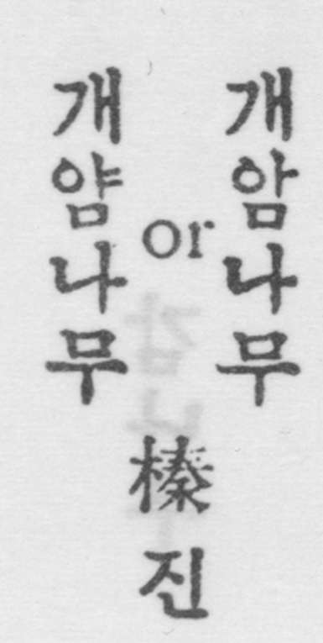
[TO BE CONTINUED]

