[Page 85]
LIST OF MEMBERS, KOREA BRANCH, ROYAL ASIATIC SOCIETY.

HONORARY MEMBERS.
Allen, Hon. H. N., M.D., LL.D. ............... Toledo, Ohio, U.S.A.
Brown, MacLeavy J., C.M.G. ................... London.
Gubbins, J. IL, C.M.G c/o Foreign Office, London.
Hulbert, H. B., F.R.G.S Springfield, Mass., U.S.A.
Jones, G. H., D.D. 150 Fifth Ave., New York City.
Jordan, Sir John, K.C.M.G...................... Peking, China.
ORDINARY MEMBERS.
Albertson, Miss M. H. Seoul.
Asakawa, Prof. K New Haven, Conn., U.S.A.
Asami, R. Judge of Supreme Court, SeouJ.
Avison, O. R., M.D. Seoul.
Badcock, Rev, J. S. Seoul.
Baird, Rev. W. M., Ph.D Pyeng Yang.
Beck, Rev. S. A Seoul.
Bell, Rev. Eugene Kwangju.
Bennett, W. G Chemulpo.
Bolljahn, J Seoul.
Bon wick, Gerald Seoul.
Bowman, N. H., M.D. Beevilie, Texas.
Brockman, F. N. Seoul.
Bridle, Rev. G. A Suwon.
Brinckmeier, R Chemulpo.
Bunker, Rev. D. A Seoul.
Bunker, Mrs. D. A Seoul.
Burdick, Rev. G. M. Seoul .
Cable, Rev. E. M Seoul.
Cameron. Miss Christine Seoul.
Collyer, Rev. C. T. Wonsan.
Cram, Rev. W. G ....... Songdo.
Crispin, J. F London, England.
Cunningham, Rev. W. B Chinju.
Curtice, R. S. Seoul.
Cutler, Miss M.M., M.D. Seoul.
Cynn, Prof. Hugh H. . Seoul.
Deming, Rev. C. S Seoul.
Elliot, Sir Charles ................................. University of Hongkong.
Erdman Rev.. Walter C. ......... Taiku. [Page86]
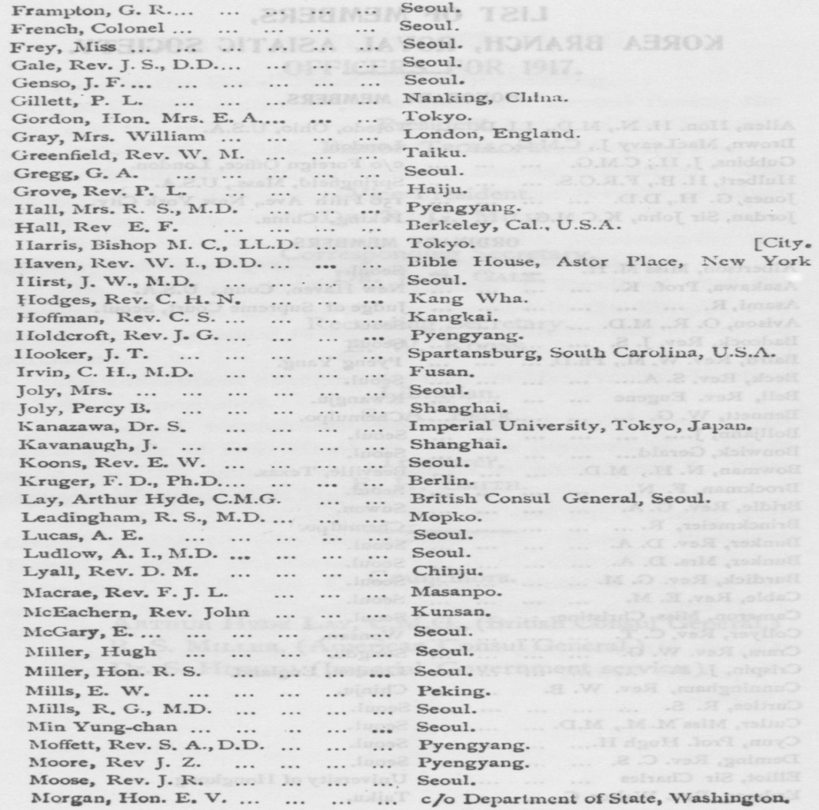
[Page87]
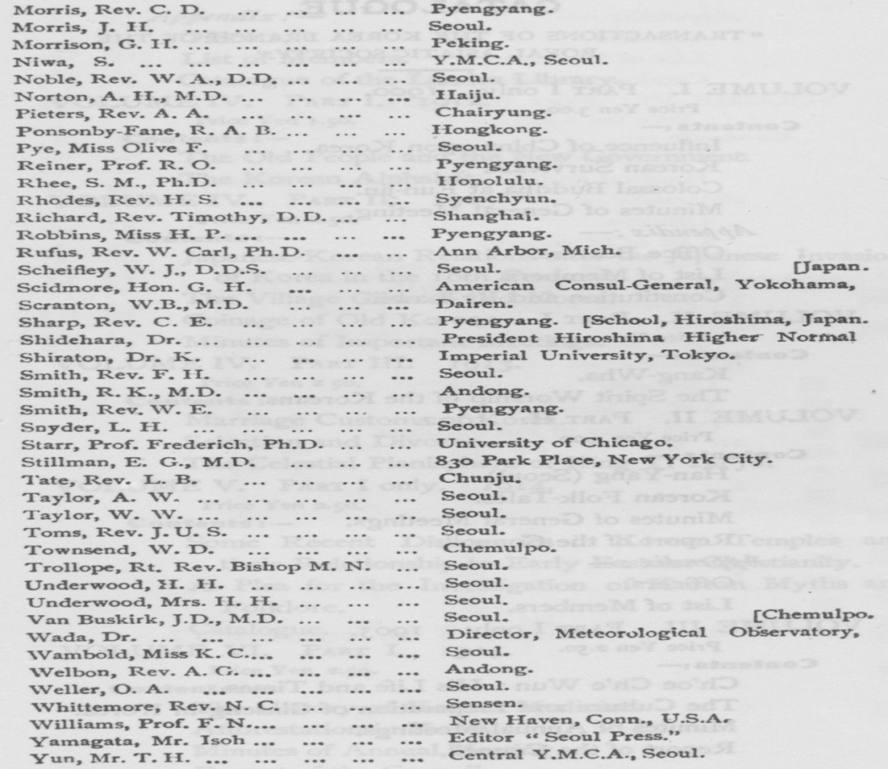
[Page88]
CATALOGUE.
“ TRANSACTIONS OF THE KOREA BRANCH OF THE
ROYAL ASIATIC SOCIETY."
VOLUME 1. PART I only. 1900.
Price Yen 3.00.
Contents :一
Influence of China upon Korea.
Korean Survivals.
Colossal Buddha at Eun-jin.
Minutes of General Meeting.
Appendix:—
Office Bearers.
List of Members.
Constitution arid By-Laws.
VOLUME II. PART I. 1901.
Price Yen 2.50.
Contents:一
Kang-Wha.
The Spirit Worship of the Koreans.
VOLUME II. PART II. 1902.
Price Yen 3.00.
Contents ：—
Han-Yang (Seoul).
Korean Folk-Tales.
Minutes of General Meetings.
Report of the Council.
Appendix : —
Officers.
just of Members.
VOLUME III. PART I only. 1903.
Price Yen 2.50.
Contents :—
Ch'oe Ch'e Wun : His Life and Times.
The Culture and Preparation of Ginseng in Korea. Minutes of Annual Meetings.
Report of the Council. [Page89]
Appendix :-
Officers.
List of Members.
Catalogue of the Landes Library.
VOLUME IV. PART I. 1912.
Price Yen 1.50.
Contents :-
The Old People and the New Government.
The Korean Alphabet.
VOLUME IV. PART II. 1913.
Price Yen 2.50.
Contents :一
Japanese-Korean Relations after the Japanese Invasion
of Korea in the 16th Century.
The Village Gilds of Old Korea. Coinage of Old Korea.
Minutes of Important Meetings. VOLUME IV. PART III. 1913.
Price Yen 2 5o.
Contents ：一
Marriage Customs of Korea.
Selection and Divorce.
The Celestial Planisphere of King Yi Tai-Jo. VOLUME V. PART I only. 1914.
Price Yen 2.50.*
Contents :一
Some Recent Discoveries in Korean Temples and
their Relationship to Early Eastern Christianity.
A Plea for the Investigation of Korean Myths and
Folklore. Catalogue.
VOLUME VI. PART I. 1915.
Price Yen 2.50.
Contents :一
The History of Korean Meaicine.
Afforestation in Korea.
Minutes of Annual Meeting.
Report of the Council. [Page90]
Appendix :—
Officers.
List of Members.
Catalogue of PuWkations.
VOLUME VI. PART II. 1915.
Price Yen 2.50.
Contents. :―
The Pagoda of Seoul.
Hunting and Hunter's Lore in Korea.
Appendix :—
Officers.
List of Members.
Catalogue of Publications.
VOLUME VII. PART I. 1916.
Price Yen 2.50.
Contents :一
Gold Mining in Korea.
Appendix :—
Officers.
List of Members.
Catalogue of Publications.
Index to volume 8 in volume 17
