[page 42]
LIST OF MEMBERS, KOREA BRANCH, ROYAL ASIATIC SOCIETY.

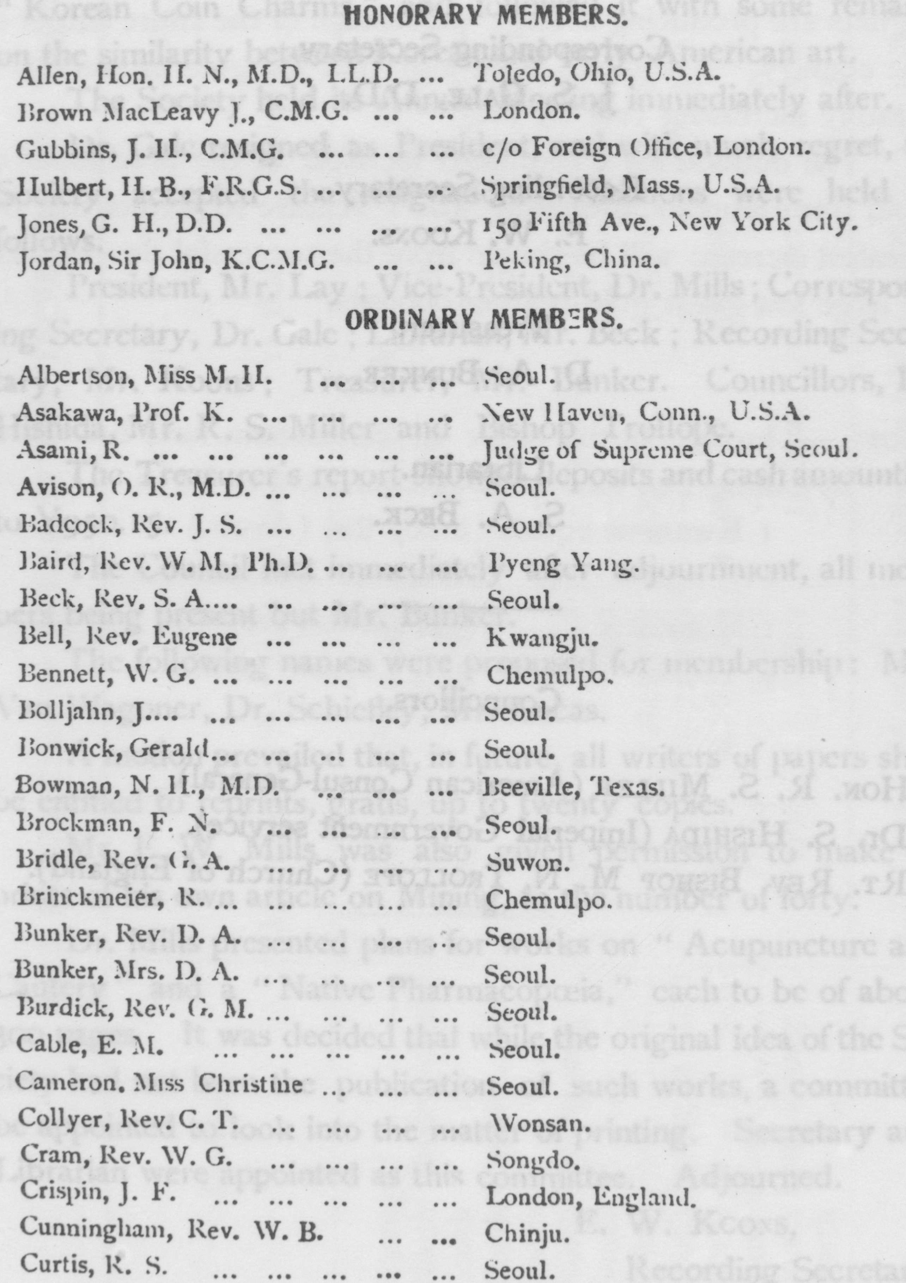
[page43]

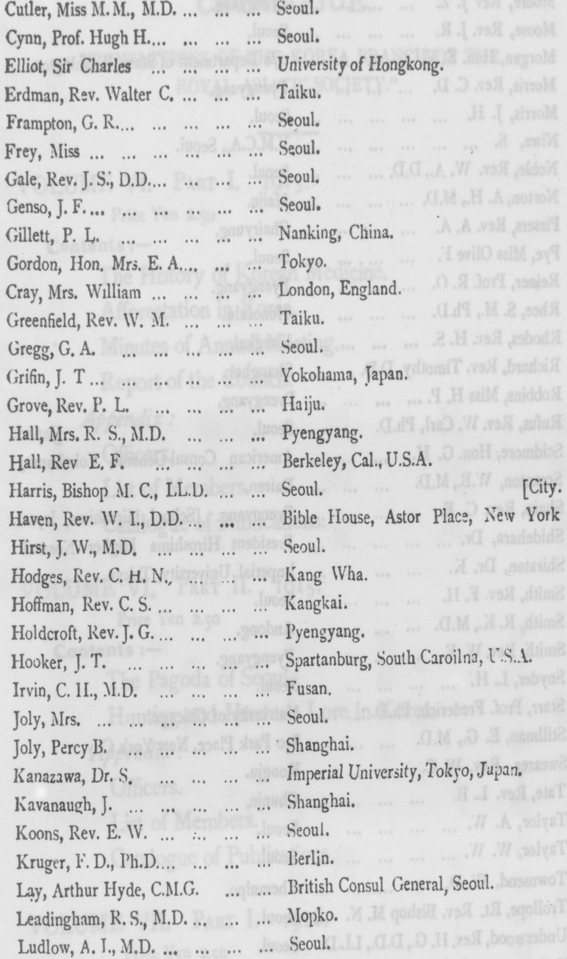
[page44]
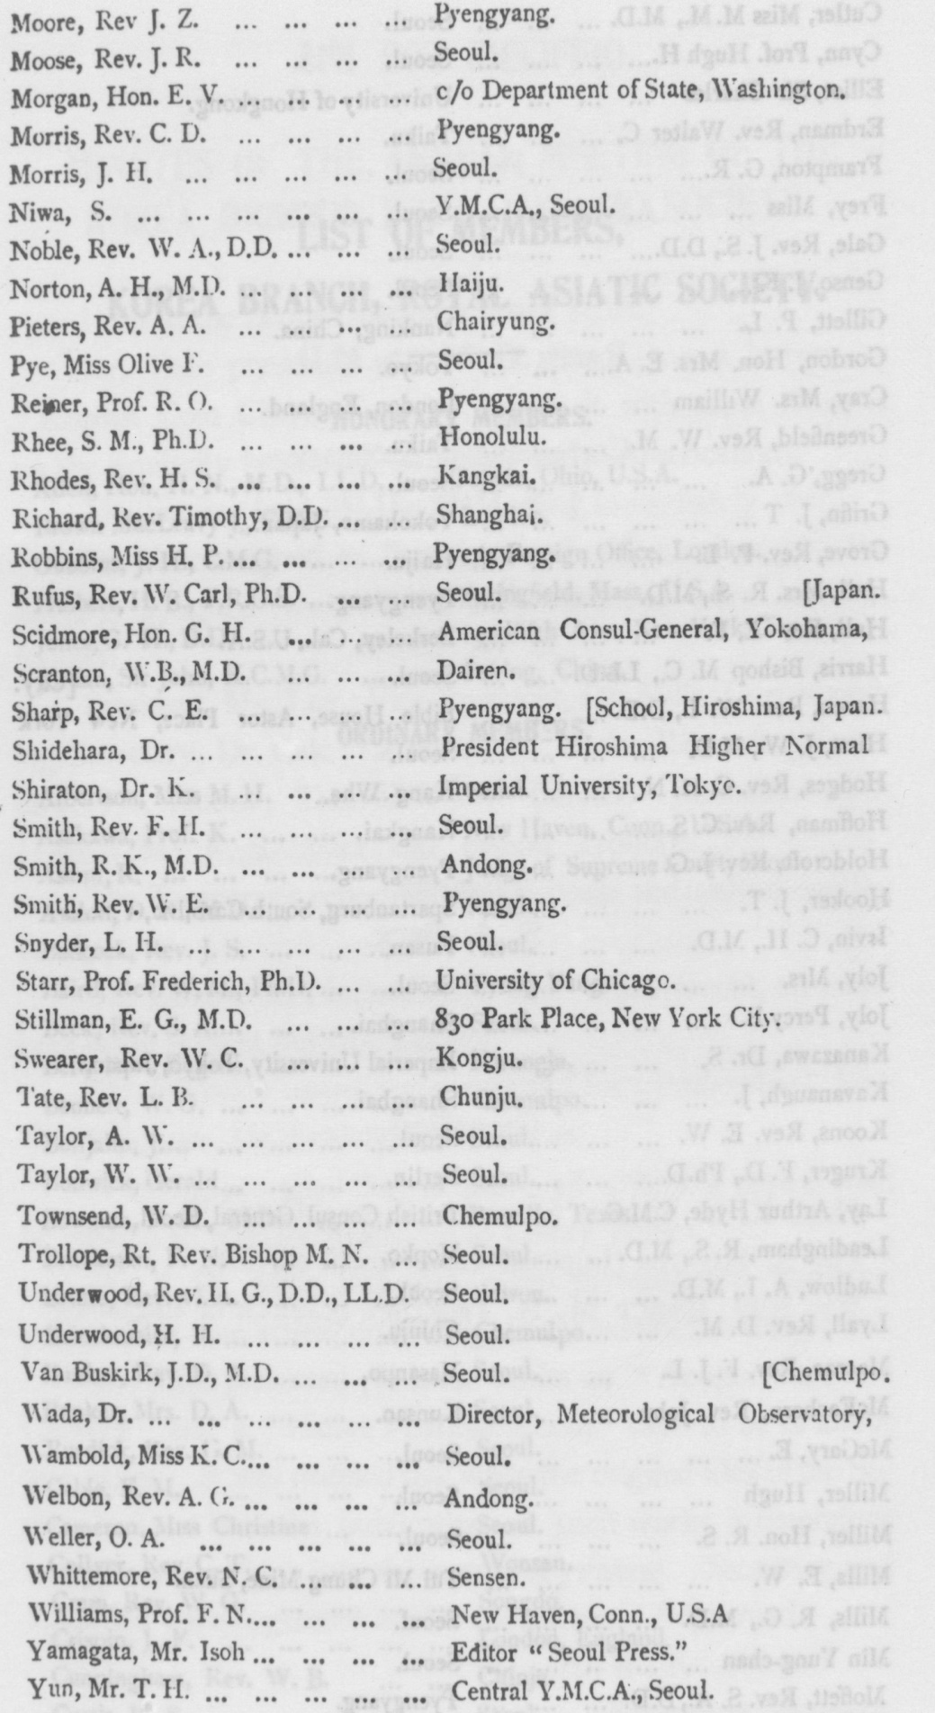
[page45]
CATALOGUE.
“ TRANSACTIONS OF THE KOREA BRANCH OF THE
ROYAL ASIATIC SOCIETY."
VOLUME VI. PART I. 1915.
Price Yen 2.50 Contents: —
The History of Korean Medicine. Afforestation in Korea. Minutes of Annual Meeting.
Report of the Council.
Appendix :
Officers.
List of Members.
Catalogue of Publications.
VOLUME VI. PART II. 1915.
Price Yen 2.50 Contents s:一
The Pagoda of Seoul
Hunting and Hunter's Lore in Korea.
Appendix : Officers.
List of Members.
Catalogue of Publications.
VOLUME VII. PART I. 1916.
Price Yen 2.50 Contents :一
Gold Mining in Korea.
Appendix :
Officers.
List of Members.
Catalogue of Publication.
Index to volume 7 in volume 17

