JAPANESE-KOREAN RELATIONS AFTER THE JAPANESE INVASION OF KOREA IN THE XVIth CENTURY.

BY I. YAMAGATA,
EDITOR, Seoul Press.

Mr. Chairman, ladies and gentlemen :— Some time ago Dr. Gale kindly suggested to me that I should read a paper before a meeting of this learned society. I was very much flattered, but well knowing that I am but slightly qualified to undertake the task suggested I hesitated to reply in the affirmative and gave him a rather vague reply. My hesitation was all the greater because I knew too well what a bad speaker of English I was. Moreover, I knew that the lecturers who preceded me were all gentlemen possessing profound knowledge of the subjects they dealt with. Mr. Komatsu, Prof. Starr of Chicago University, Dr. Gale and Mr. Gillett— these were the gentlemen who spoke before me and the lectures they gave were all of absorbing interest After these learned gentlemen, I was sure I should make myself a langhing stock. For these reasons, I hesitated to accept the suggestion thus made to me by Dr. Gale, though an extremely flattering one. On second thought, however, I decided to agree to it, for this reason, that I possess one great advantage which is denied to all the learned lecturers who preceded me. By the advantage I mean, paradoxical though it may sound, the very fact that I am a bad speaker of English. Now as you may have already noticed I speak English in an extremely outlandish way and without endeavouring to be amusing, I can amuse you by simply talking in my quaint Japanized English. All my learned predecessors had to say something interesting in order to delight you. [page 1] Your humble servant, however, has only to speak in English and it is enough to make you smile.
I remember having spoken before a great assembly of students in Tokyo some four years ago. The speakers on the occasion were, besides myself, the late Rev. Dr. Lloyd, of the Imperial University, Mr. Iwaya, who is the best writer in Japan for young people, and Captain Sakurai, hero of Port Arthur and the famous author of “Human Bullets.” I may say I am a better speaker in Japanese and I believe I made a pretty good speech. Mr. Iwaya and Captain Sakurai are eloquent speakers and were, as usual, eminently successful. But the laurels of the day were won by Dr. Lloyd, and he was accorded the loudest applause by the audience. It was not because his speech was specially good, but it was because he spoke in Japanese and that in very quaint Japanese. The late Dr. Lloyd was a great scholar of Japanese literature, but I must say he spoke very funny Japanese. Every sentence he uttered was greeted with immense delight by his hearers and for half an hour, during which he spoke, he received round after round of thunderous applause. I do not venture to hope to score such sucess as was won by him that day, but I do hope that the quaint English in which I speak will prevent you from sleeping for half an hour.
With this rather long introduction, I now propose to read my little paper, which, I assure you, is not such a long one as my introduction may suggest. The paper I am going to read deals with the intercourse between Japan and Korea immediately after the Japanese invasion of Korea in the 16th century and during the Tokugawa or feudal government of Japan. As you are no doubt well aware, the Japanese invasion of Korea in the 16th century was a dismal failure. Toyotomi Hideyoshi, often called the Napoleon of Japan, undertook it with no higher motive than satisfying his boundless ambition. The expedition was at first quite successful. It was on May 24, in the year 1592, that the advance guard, of the Japanese army under the command of Konishi landed at Fusan. By the way, it is interesting to note that Konishi was a Christian. He and the nineteen thousand

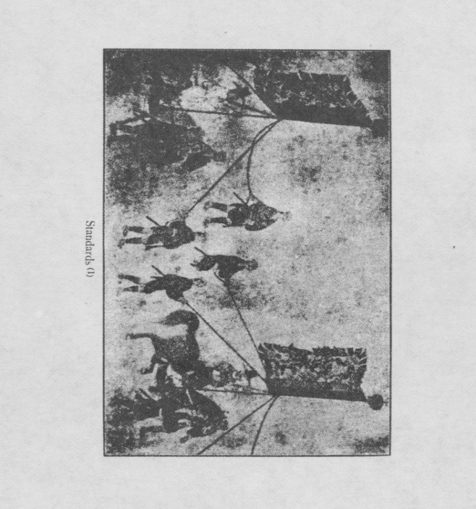

[page 3] men under him were almost entirely Christians. Within less than twenty days after landing at Fusan, Konishi, and Kato, Commander of the Second Contingent of the Japanese Army, oc- cupied Seoul, and the Korean King fled to Pyongyang. The Japanese generals did not stop long in Seoul. Kato marched into the province or North Hamkyong and went as far north as Hoilyong on the Manchurian border, while Konishi pursued the King to Pyongyang, which town he occupied on July 16，that is only fifty-four days after he had set foot in Korea. In the mean- time the whole of South Korea was overrun by other Japanese generals and everything looked rosy for them. But the Japanese success stopped there. Konishi could not march northward beyond Pyongyang and was ultimately driven back to Seoul by a vast army sent from China to help the Koreans. The Japanese were also greatly harassed by guerrilla warfare waged by Koreans. They were especially placed in difficulty by the great Korean admiral Yi Sun-sin, who wrested from them the command of the sea and frequently cut off the supply of men and provisions from home. On land, however, they mostly got the better of the Koreans and Chinese. And thus the war dragged on for seven long years until the end of October of the year 1598, with the exception of a short interval when unsuccessful peace negotiations were carried on. In September of that year Hideyoshi died, and the Japanese invaders weary of the war withdrew without accomplishing anything, except the ruin of nearly the whole of Korea, from which the poor country has never recovered. It is true that the Chinese who came to help Koreans against the Japanese contributed not a little to the devastation of the country ; but of course the main part of the blame must be borne by the Japanese. Before that disastrous Japanese invason, Korea was the equal, if not the superior, of Japan in wealth, in culture and in civilization. That war was a death blow to poor Korea and the country has since been growing weaker and weaker. To day we are endeavouring to revive Korea. It is a case strongly illustrative of the Japanese proverb which says: “The sin of a father is atoned by his [page 4] children.” We are today doing our best to atone for the sin committed by our ancestors in Korea three centuries ago. In this connection, in the name of Japan I must thank you, ladies and gentlemen, for the great and valuable help you give us in our Work to restore life to Korea.
Having been so cruelly dealt with by Japan, as described above, it is but natural that after the war Korea did not regard Japan as her good friend and was in no mood to resume friendly relations with hen In fact it was Japan who first made overtures to become friends again. Tokugawa Iyeyasu, who became the virtual ruler of Japan after the death of Hideyoshi, was bent on restoring peace to the country which was in a perturbed state in consequence of the passing away of the Japanese Napoleon. In order that his attention to domestic affairs might not be distracted by foreign complications, he wished to restore friendly relations with Korea and instructed the Daimyo or feudal lord of Tsushima to put forth efforts for that purpose. This order was a very welcome one to the Daimyo of Tsushima, for that island lying midway between Fusan and Shimonoseki had been suffering a great deal on account of the suspension of its tradal relations with Korea. Being a mountainous country and not having enough land to produce rice crops to support its people, Tsushima had been accustomed to send trading vessels to Fusan, fifty in number annually, and to import Korean rice in exchange for various commodities. The Japanese invasion of Korea interrupted this tradal relation to the great inconvenience of the people of Tsushima. For this reason, the order from Iyeyasu to try to restore friendly relations between Japan and Korea was received by the Daimyo of Tsushima with great joy. In the year 1599, that is only two years after the Japanese troops withdrew from Korea, the Daimyo of Tsushima sent a messenger to Korea with the purpose of sounding the feeling of the Korean Court towards Japan. This messenger and two others, who were sent one after another with the same purpose, were all made captives by the Chinese troops then still stationed in Chosen and sent to Peking. A
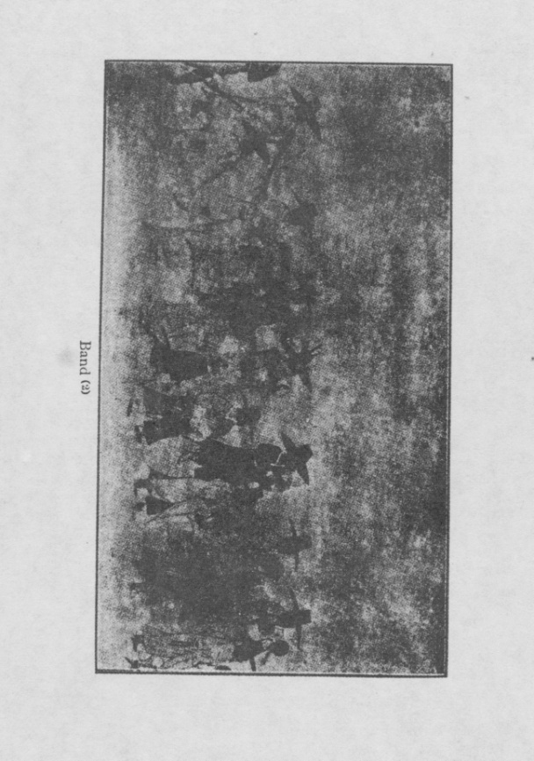

[page 5] fourth messenger, sent in the year 1601, succeeded in reaching Seoul and returning home with a reply from the Korean Court. In that reply Korea demanded of Japan the return of Korean prisoners if Japan really wanted peace. The Daimyo of Tsushima, therefore, collected some Korean prisoners and sent them back to Korea and otherwise endeavoured to win the good will of the: Korean Court. On the part of Korea, she also wished to conclude peace with Japan, if for no other reason than that of getting rid of the Chinese braves stationed in the country, who constantly acted outrageously and caused great suffering to the Korean people. In the year 1603 Korea sent to Tsushima an envoy in order to see if Japan was really in earnest in wishing peace and in the following year again sent two messengers for the same purpose. The Daimyo of Tsushima accompanied these Korean messengers to Kyoto, where in the spring of the following year they were received in audience by Tokugawa Iyeyasu, the first Shogun. On this occasion, Iyeyasu consented to the request made by the Korean messengers to return the Korean captives. In consequence, more than 3,000 Korean captives were allowed to return to their country during the same year.
This substantial proof of the desire for peace on the part of Japan was sufficient to convince Korea of its reality and the latter now showed herself ready to respond to Japan’s friendly overtures. In the year 1606 the Korean Court sent a note to the Daimyo of Tsushima, in which two demands were expressed. The first of these demands was that Iyeyasu should first send a formal letter to the Korean Court asking for peace and the second was that sonic Japanese soldiers who had opened some Royal tombs during the Japanese occupation of Seoul should he arrested and surrendered to the Korean Court Upon the receipt of these two demands, the Daimyo of Tsushima found himself in n dilemma. It would be easy enough to send to Korea sonic criminals pretending that they were the men wanted by her, but how could lie induce Iyeyasu to send a letter to the Korean Court first? It amounted to Japan sueing for peace—a great blow to Japan’s pride, which Iyeyasu would[page 6] never consent to receive. The mere mention of such a demand having been prefered by Korea would drive the Shogun Iyeyasu into a violent fit of anger and all efforts put forth by him for restoring peace between Japan and Korea would come to no purpose. The poor Daimyo of Tsushima was at his wits’ end, when Yanagawa, his prime minister, came to his rescue, by devising a tricky solution to the difficult problem. It is not known whether or not the Daimyo of Tsushima connived at his prime minister’s act, but it is known that this crafty and unscrupulous Yanagawa fabricated a state letter in the name of Iyeyasu, the virtual ruler of Japan. He sent this forged letter to Korea along with some criminals whom he pretended to be the men who had desecrated the Royal tombs and who were wanted by the Korean Court. Now the funny thing was that these criminals were all young men little more than twenty-five years of age, so that at the time of the desecration of the Royal tombs some fourteen years before they were still children and could scarcely have committed the heinous crime with which they were charged. The Korean Court easily detected the trick but failed to see that the alleged state letter of Iyeyasu was a forgery and accepted it in good faith. As for the criminals referred to, Korea no less eager than Japan for peace, was glad to overlook the minor point and received and executed them as the real offenders.
The two demands preferred by Korea having thus been satisfied, the Korean Court concluded that it was in duty bound to respond to Japan’s courtesy. Accordingly early in the year 1608 it despatched a mission to Japan. It consisted of an Ambassador, a Vice-Ambassador and a Councillor, with a suite of about 270 men, and carried with it a state letter and some presents to the Shogun from the King of Korea. This letter of the Korean King was naturally worded in the form of a reply to the letter of Iyeyasu, which, as before said, was a fabrication by Yanagawa, Prime Minister of the Daimyo of Tsushima. Hence if the Korean Kings letter were presented to the Shogun in the
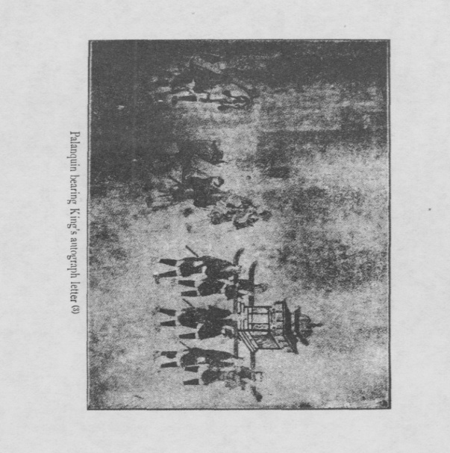

[page 7] original form, the little trick played by Yanagawa would at once be discovered. Under the circumstance, the crafty Yanagawa did not hesitate to alter the wording of the letter in a way convenient to himself and likely to be pleasing to the Shogun. Not only that, he also added many costly articles to the presents from the Korean King and said that all came from His Majesty.
Having thus completed preparations for the presentation of the Korean mission, the Daimyo of Tsushima accompanied the Koreans to Yedo, that is the present Tokyo, the seat of the Government of the Tokugawa Shogunate. They left the island of Tsushima on the 21st day of the 3rd moon of the year 1608 and arrived at Yedo after spending about sixty days on the way. Iyeyasu had retired from the office of the Shogun two years before and his son Hidetada had succeeded him. The three superior Korean representatives were received in audience by the Shogun Hidetada, when they presented him with the king’s autograph letter and some presents, including 300 kin of ginseng, 20 tiger skins and other Korean products. The reception of the Koreans by the Shogun was very cordial. They were entertained at dinner and presented with 600 pieces of silver and 15 swords. They were also entrusted with a reply by the Shogun Hidetada to the Korean King. The Korean mission, on its way home, stopped at Sunpu, which is the present city of Shidzuoka, at the foot of Mt. Fuji, where Iyeyasu had retired. Here the Korean messengers were received in audience by the ex-Shogun and besides being dined and wined were given some presents. One good result of this Korean mission was that several hundred Korean prisoners, who still remained in Japan, were allowed to return home and many Japanese retained in Korea were allowed to come back.
In this way friendly relations between Japan and Korea were at length restored. In recognition of the service rendered in this connection, the Daimyo of Tsushima was rewarded with an increase in his revenue and promotion in Court rank. Besides this, the Daimyo of Tsushima had the satisfaction of being[page 8] allowed by Korea to send 20 trading vessels every year to the port of Fusan to sell Japanese products to Koreans and buy Korean rice. All this was the good result of the little trick played by Yanagawa, his ingenious and unscrupulous prime minister. I may add that Yanagawa again tampered with state letters exchanged between Japan and Korea in the year 1624. Some years later, this and former crimes were discovered, with the result that Yanagawa and some subordinate officials, who were concerned in the business, were tried and found guilty. Yanagawa was stripped of his position and exiled, while some of his subordinate officials were beheaded.
As I have already said, peace was formally restored between Japan and Korea in the year 1608, the latter having sent a mission to the former. It was quite natural, however, that the relations between the two countries were not all that could be desired. Korea still harboured suspicion against Japan and for some time continued to respond rather indifferently to courtesies shown by Japan. In the year 1615 a great civil war in Japan resulted in the downfall of the House founded by Toyotomi Hideyoshi, who undertook the invasion of Korea. This event was utilized by the Tokugawa, who was now supreme ruler of Japan in reality as well as in name, to win the goodwill of the Korean Court A special messenger was despatched to Korea with a message that the enemy of the Korean Court was destroyed by the Tokugawa, and Korea should congratulate the House for this. The Korean Court was pleased and in the year 1617 sent another mission to Japan. From this time down to the year 1763 Korea sent ambassadors to Japan on the occasion of the appointment of a new Shogun. Altogether such missions arrived in Japan eleven times. On the part of Japan, she also sent envoys on the occasion of the death of a Korean King and the accession to the throne of a new King. These Japanese envoys were usually sent from the Island of Tsushima and men appointed as envoys were chief retainers of the Daimyo of Tsushima.
Let me now give you a brief account of the Korean mis-
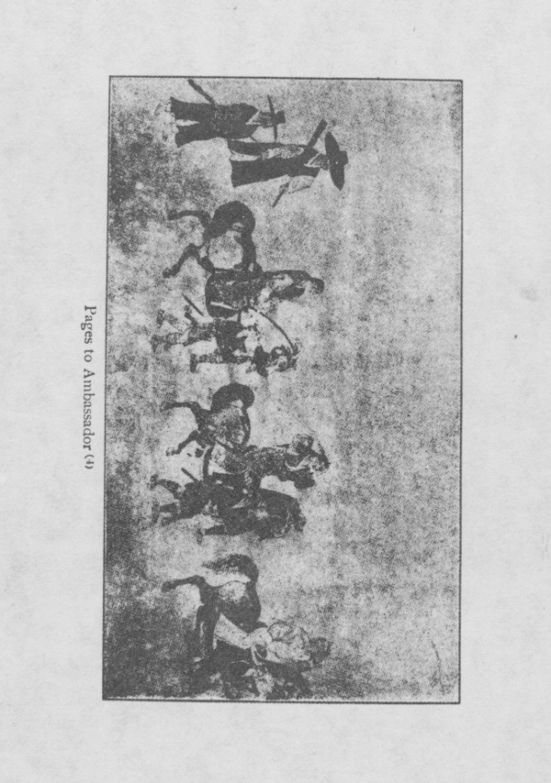

[page 9] sions in Japan. The mission was invariably composed of three superior dignitaries, that is Ambassador, Vice-Ambassador and Councillor, beside a very large suite, which exceeded 300 and sometimes totalled nearly 500. The mission came to Japan via Fusan and Tsushima. From Tsushima to Yedo the Koreans were accompanied by the Daimyo of the island. They took the sea-route as far as Osaka through the Inland Sea. Landing at Osaka, the party proceeded to Kyoto and thence passing through the province of Omi, which is my native place, and the neighbouring province of Mino, went to Nagoya and then travelled along the Tokaido highway until it arrived at Yedo. After an audience with the Shogun, the Korean party visited Nikko and then went home by the same route they took in coming. The journey took seven or eight months to complete. From the time the Koreans set foot on the Island of Tsushima, they were treated as guests. All the Daimyo or feudal lords along the route on which they travelled appointed special com-missioners to welcome and entertain them. On their arrival at Yedo, they were very cordially received, some big and fine temples being assigned as their hotels, and the entertainment given them in the castle of the Shogun was of the most cordial nature. The fact was that the visit of the Korean mission came to be regarded as the chief event attendant upon the appoint-ment of the new Shogun and was made very much of. The expenses incurred by the feudal lords and the Shogun-in con-nection with the visit of the Korean mission were great. For this reason, about the end of the XVIII century, when the finances of the Tokugawa Government were in a crippled state, the Government could not afford to receive the ceremonial visit of the Korean mission at Yedo and made arrangements to receive it in the Island of Tsushima. From this time the visit of the Korean mission to Yedo was discontinued.
On the occasion of the audience with the Shogun at Yedo, the Korean Ambassador presented him with the King’s auto-graph letter, besides a large number of presents. The wording of the letter was almost identical every time and expressed [page 10] cordial congratulations on the appointment of the Shogun. On the part of the Shogun, he also gave in trust to the Ambassador a reply to the King, acknowledging and returning his courtesy. The Shogun also sent many presents to the Korean King by the same Ambassador. He also gave the Ambassador and all the members of his suite valuable presents. I have brought here with me some pictures showing the procession of the Korean Ambassador on the occasion of his formal call on the Shogun. These pictures are reproductions from an old painting in the possession of Viscount Akimoto of Tokyo, whose ancestors probably took part in the reception of the Korean mission. I hope those pictures will give you some idea of the gorgeous procession.
I am now about to conclude my little paper. In doing so, let me tell you a little story. I was born in the province of Omi, near Kyoto, through which the Korean mission passed in going to and returning from Yedo. My native place is a little feudal town called Minakuchi, a post station on the Tokaido highway. Travellers going to Yedo from Osaka and Kyoto along the Tokaido highway usually passed through my native town. Oddly enough, however, the Korean mission did not pass my native town, but swinging to the left from the town of Kusatsu, some ten miles away from my native place, they followed a highway known as Chosenjin Kaido or highway for Koreans. The reason that the Korean mission did not honour my native town with a visit was probably that the feudal lord of the place was too poor to entertain them. At any rate while passing through the province of Omi and the neighbouring province of Mino, the Korean mission did not travel on the regular Tokaido highway, but followed the Chosen-jin Kaido or highway for Koreans. This highway is a fine road with rows of pine-trees growing along both sides. I remember having travelled on foot along this road in my boyhood with my father. I was tired and foot sore and the road seemed to be un-reasonably long and winding. I asked my father why the road was so winding and the reply given me was : “Don’t you see,
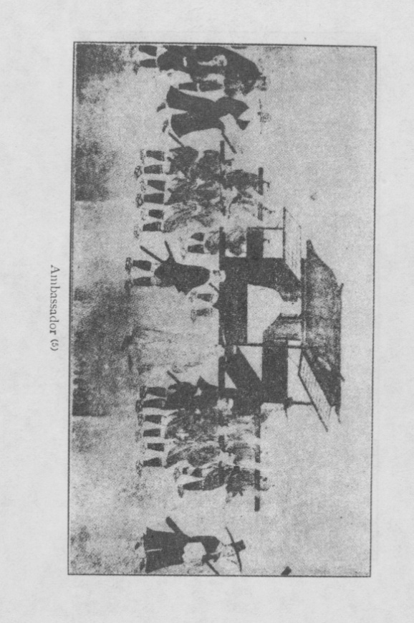

[page 11] my boy, that this is a road specially made for Koreans to travel along? It is made long and winding in order to impress them with the extensiveness of our country. I don’t know whether the road was really made with such a purpose, but, I tell you, I thought on the occasion that if it was, it was really a very foolish policy.
Ladies and gentlemen, I beg to thank you all heartily for the patient attention with which you have followed my paper.

